Cloud Infrastructure And Services – PCS221
Lab Assignment 5
Name – Kudrat Noor Singh
Subgroup – CS2
Roll No. – 8025320049

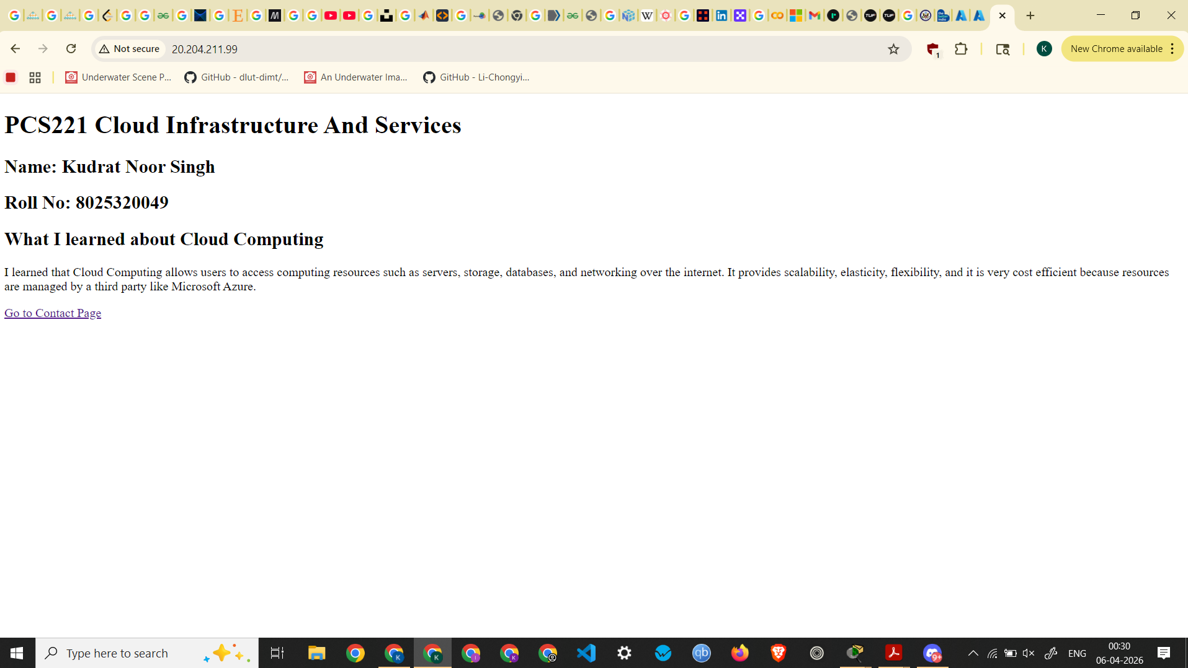index.html before performing VM migration

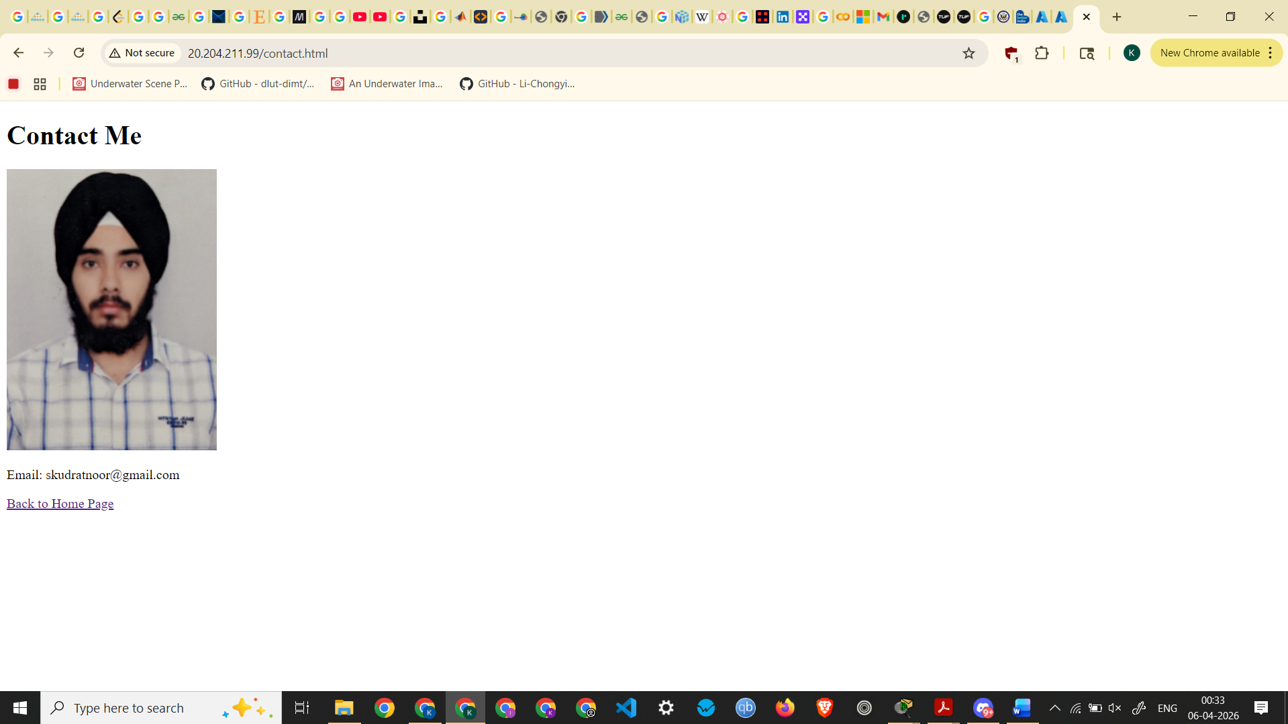
contact.html before performing VM migration

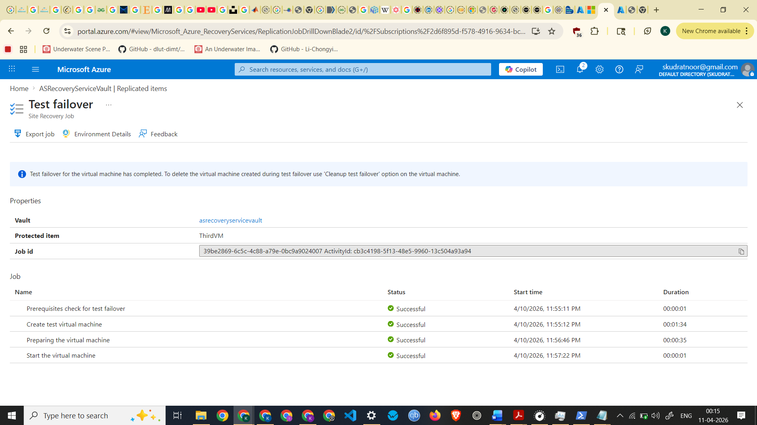
Test Failover Completed

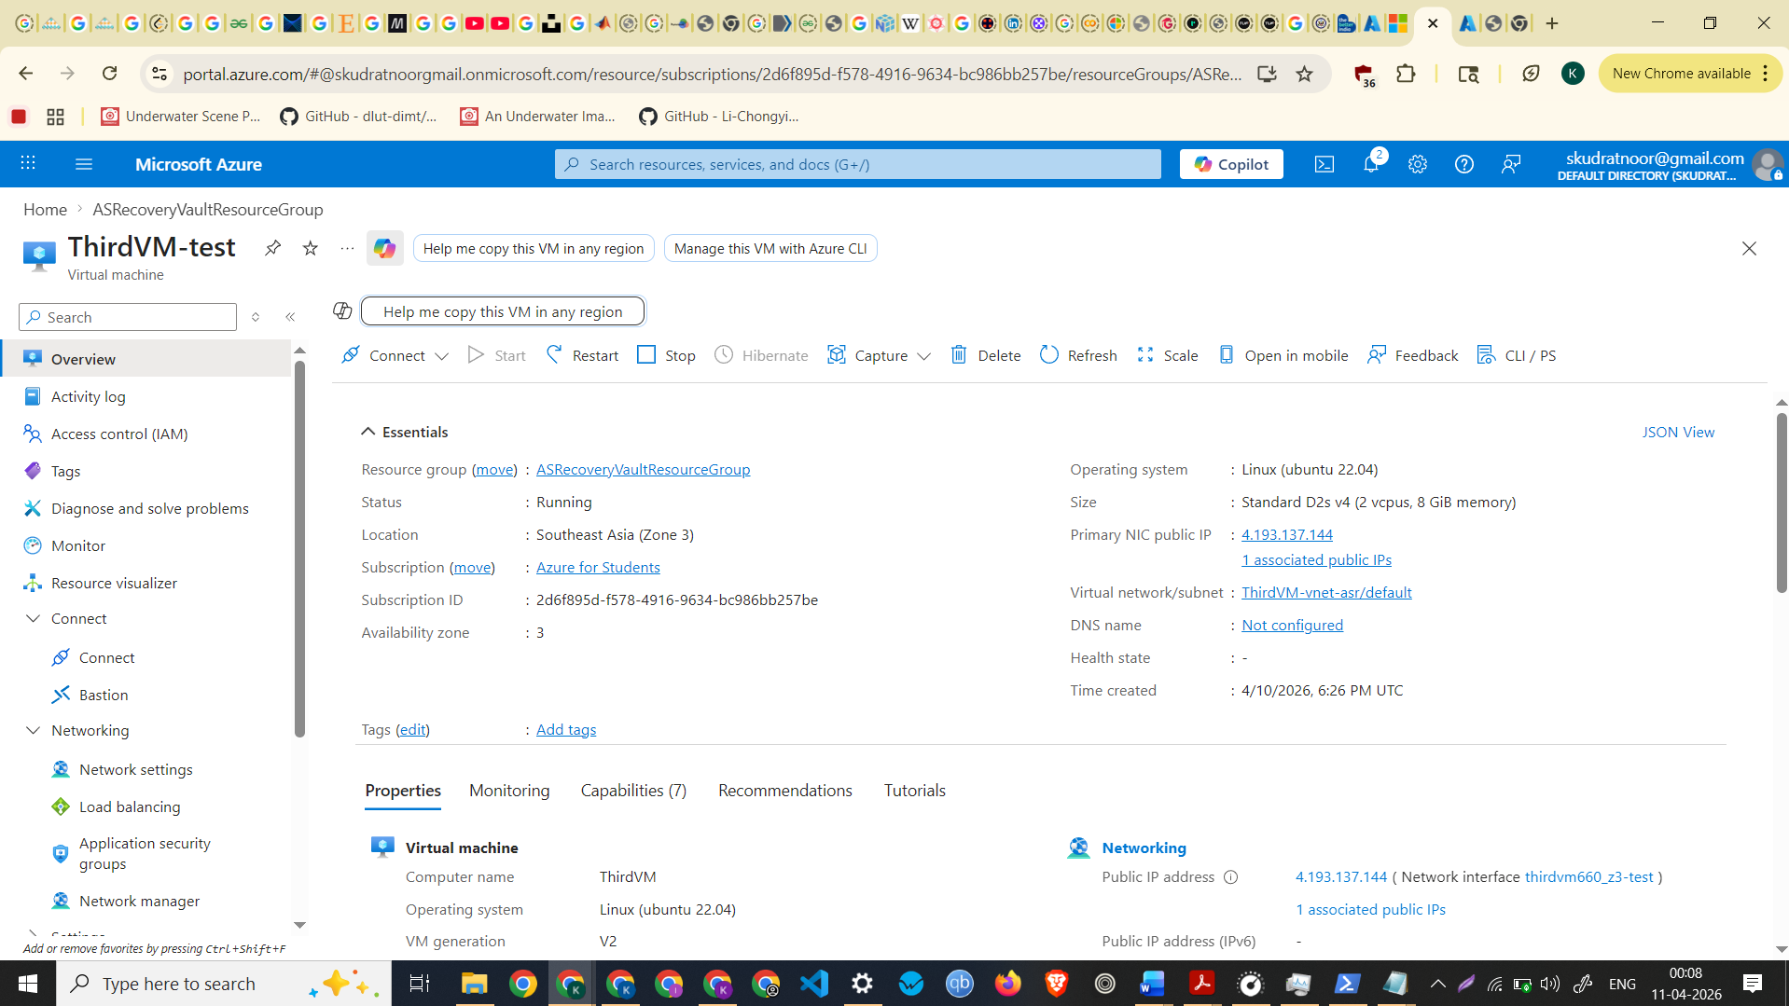
Screenshot of Test Failover VM

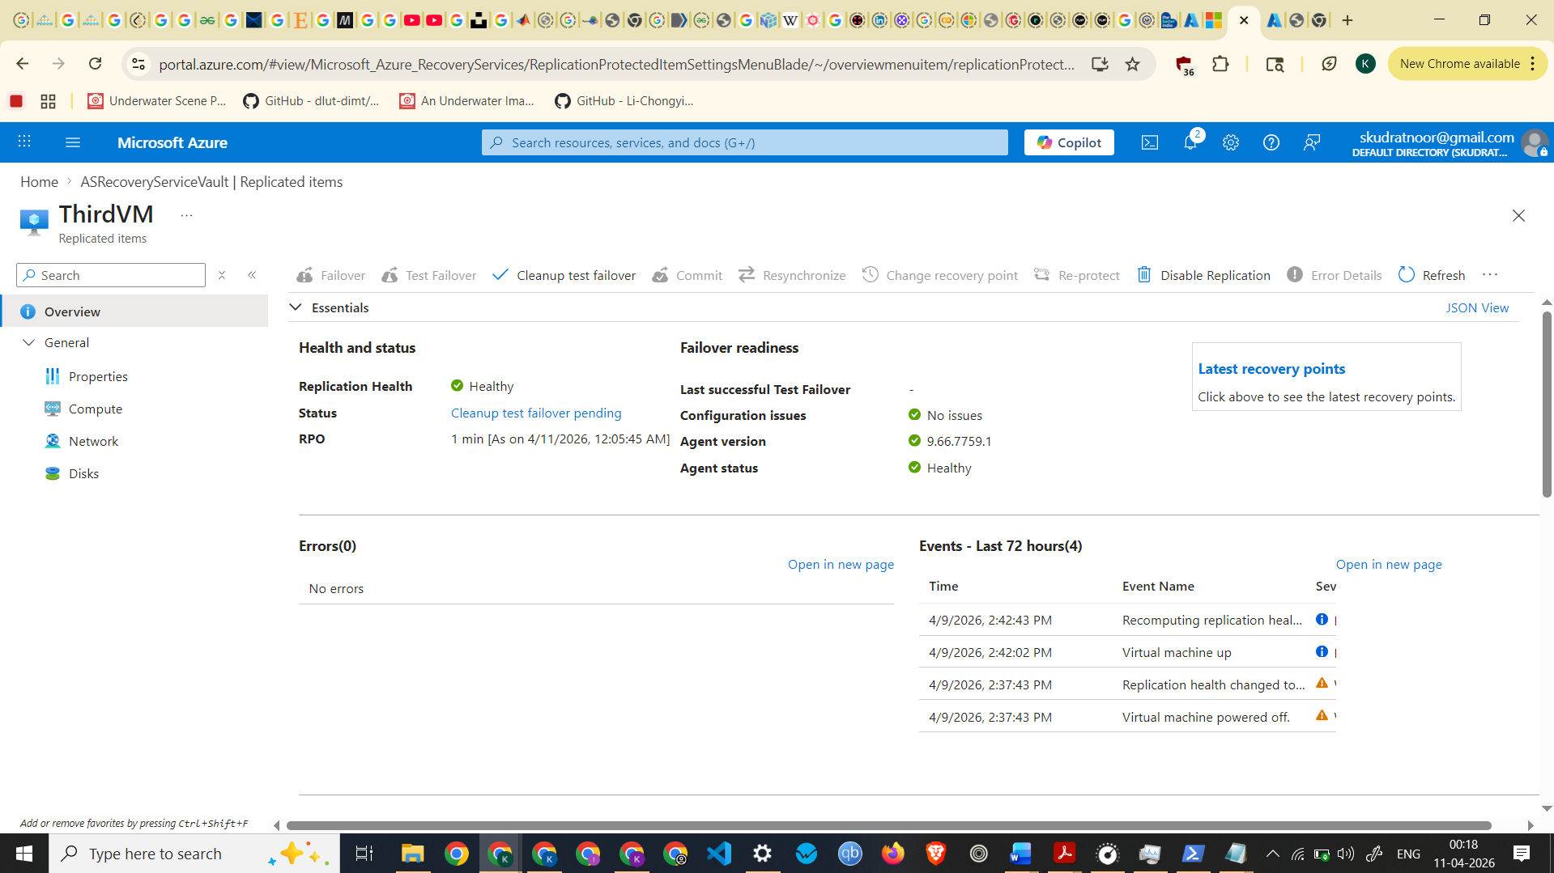

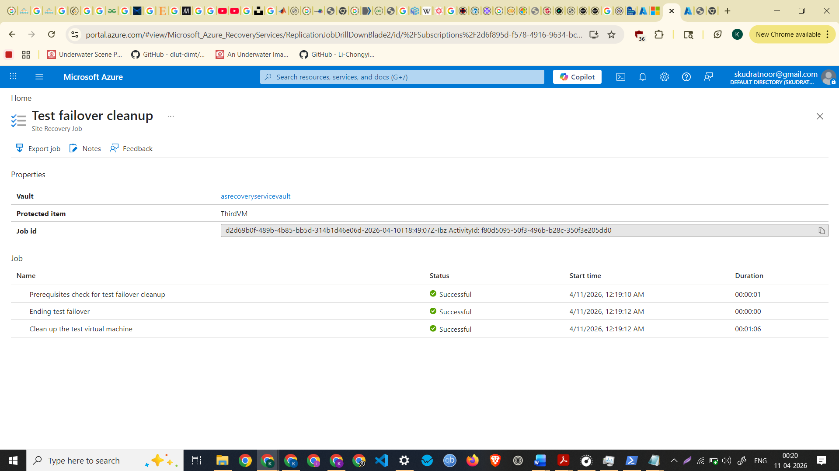
Test failover cleanup completed
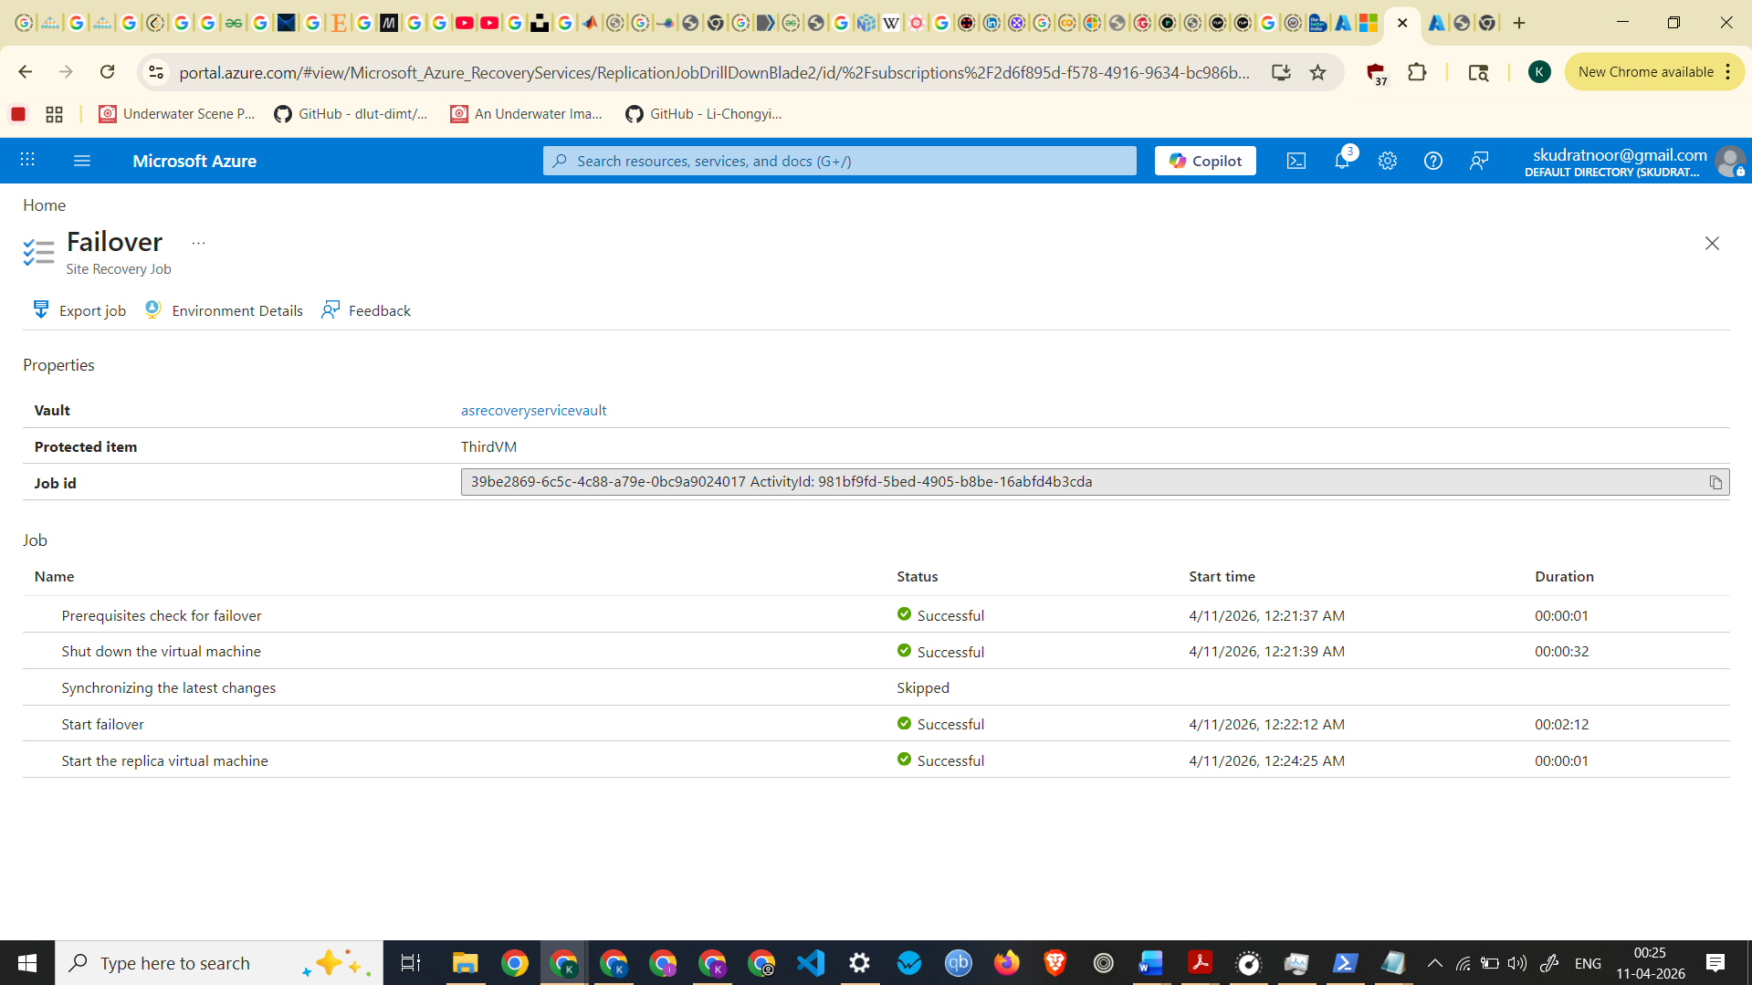
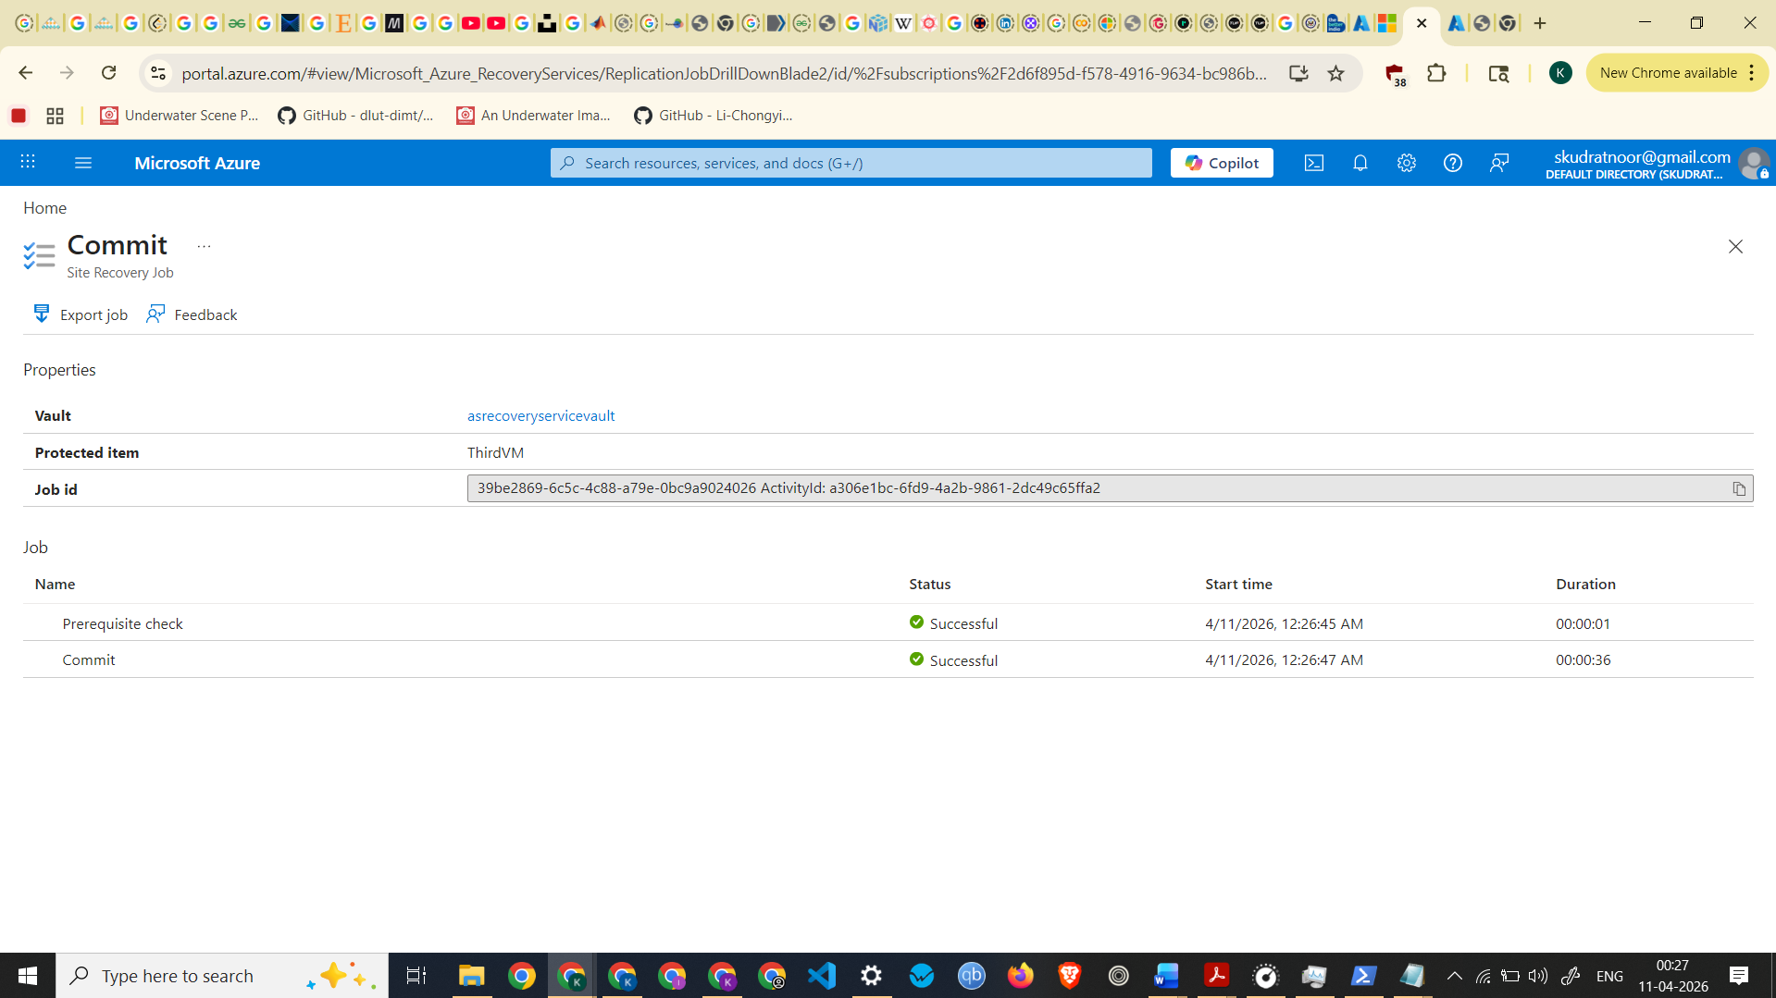
Screenshot of Failover Committed
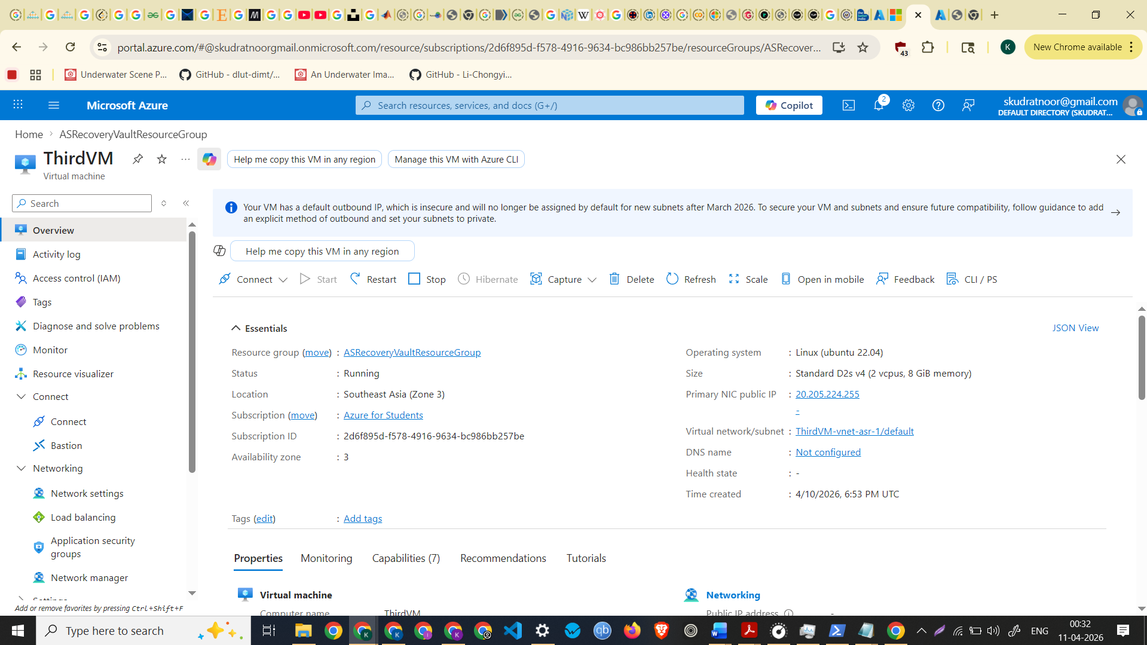
Screenshot of Migrated VM
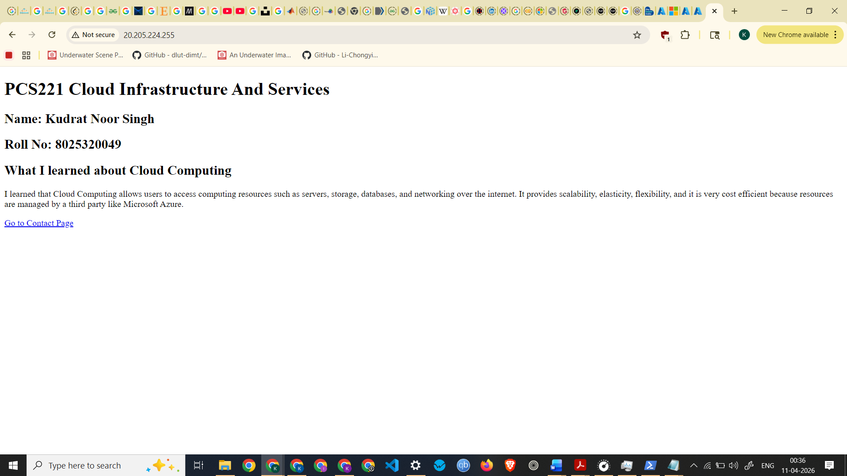
index.html on the migrated VM
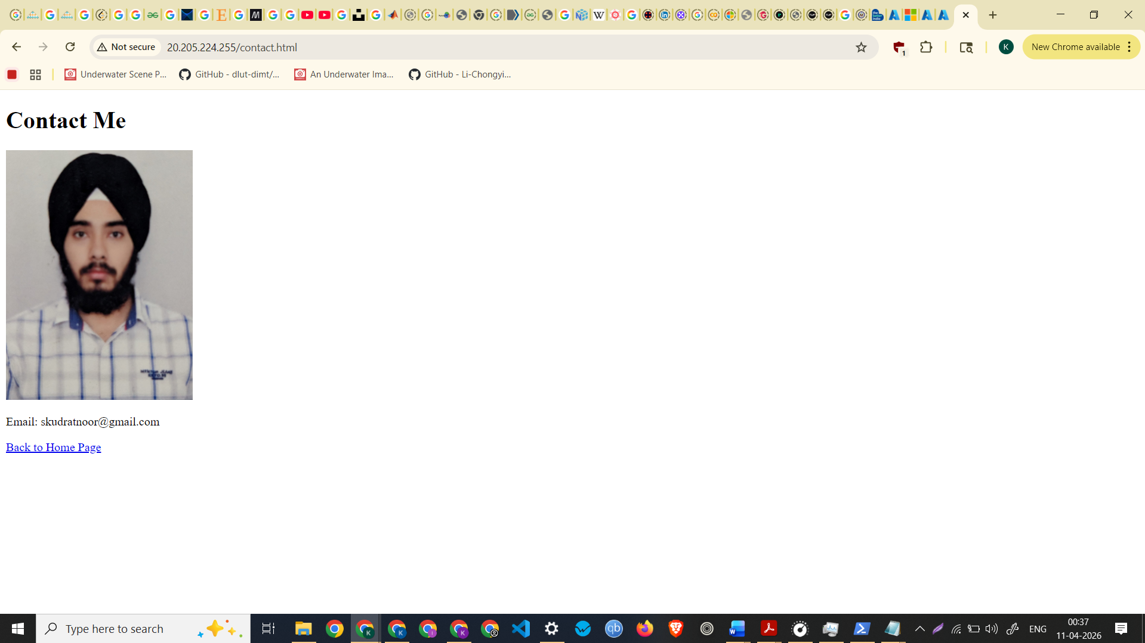
contact.html on the migrated VM

