所需模组的全部下载指令：

conda install python=3.11

conda install -c huggingface transformers datasets evaluate huggingface_hub optimum

pip install accelerate

Huggingface登录和确认：

huggingface-cli whoami

huggingface-cli login

python下载代码：

import os

os.environ["HF_HUB_DISABLE_SYMLINKS_WARNING"] = "1"

from huggingface_hub import snapshot_download

# 定义模型名称和保存路径

model_name_or_path = "meta-llama/Meta-Llama-3.1-8B-Instruct"

save_directory = r"C:\Users\xxc13\Coding\LlamaFile\Meta-Llama-3.1-8B-Instruct"

# 下载模型

snapshot_download(repo_id=model_name_or_path, cache_dir=save_directory)

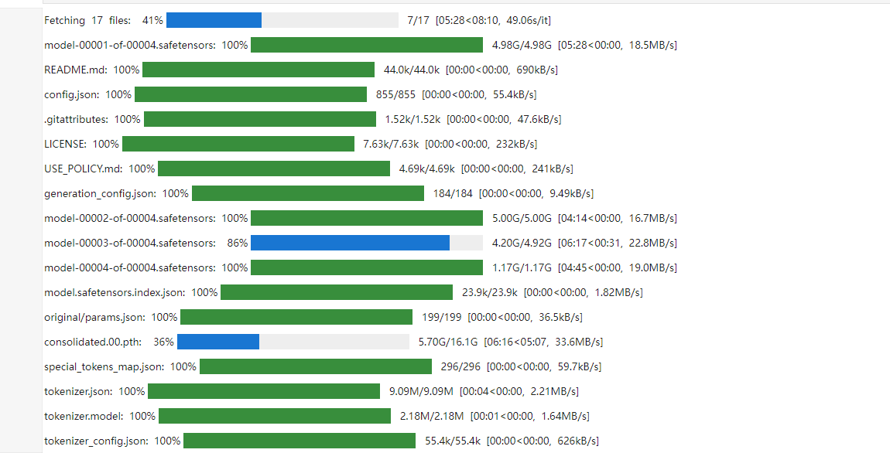

Cuda的安装：  
conda install pytorch torchvision torchaudio pytorch-cuda=11.8 -c pytorch -c nvidia