Working with notebooks in Visual Studio Code
- Make sure you have installed Visual Studio Code and (mini)Conda. Pick the right installation dependent on your operating system (Windows, Linux or MacOS).
- Download the zip-file with the code for practical 1 from Ultra. Unzip the file in a logical folder on your laptop.
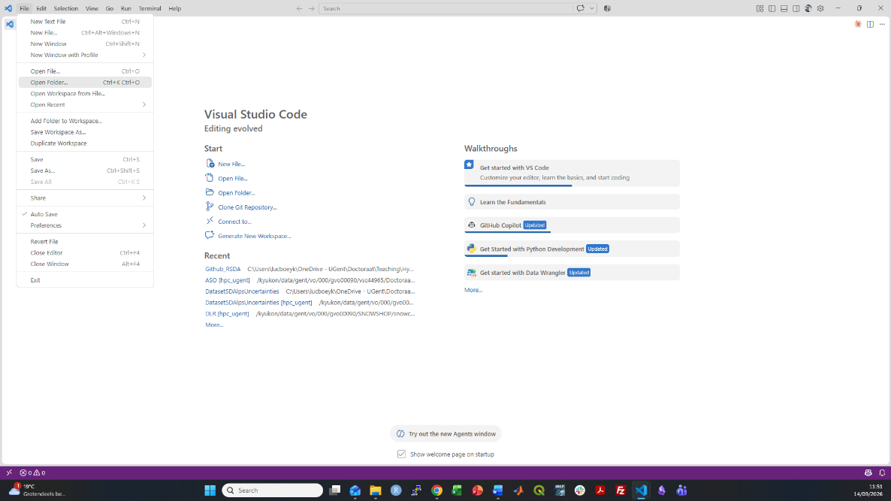
- Open VScode and navigate to the right folder (“path/to/Practicals_Hydrological_Processes”, in which “path/to” depends on where you unzipped the code.
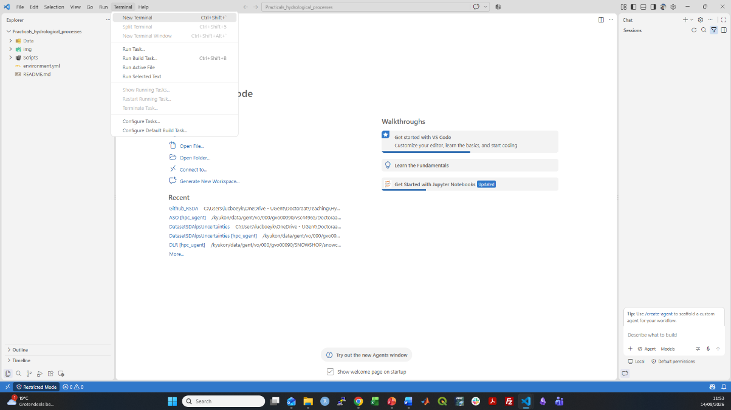
- Once you have opened the folder “Practicals_Hydrological_Processes”, open a terminal (terminal -> new terminal). Note that the terminal might look different on your operating system (Windows vs. Linux/MacOS).

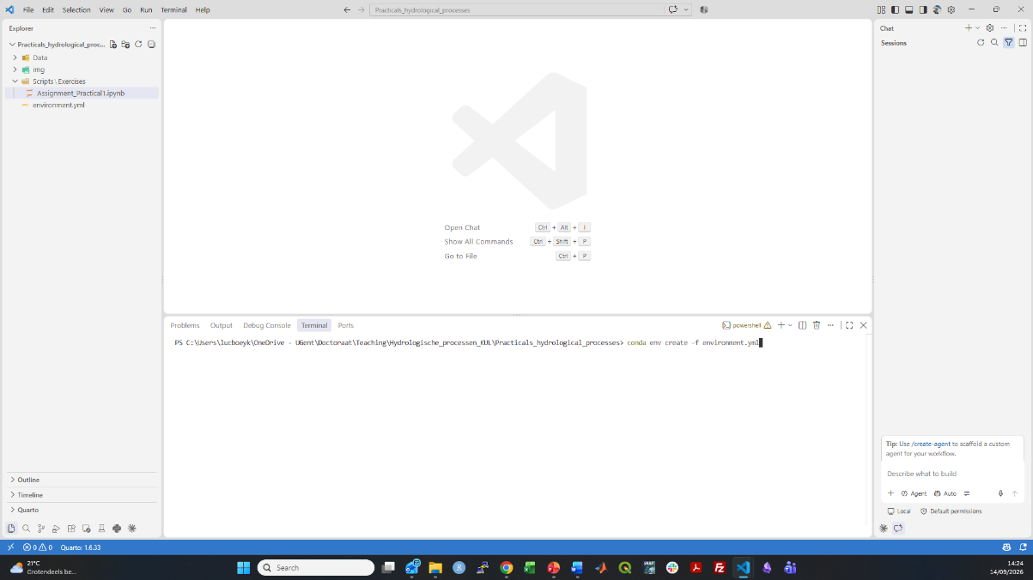
- To create the python environment used within this practical, type in the terminal “conda env create -f environment.yml”. Press enter and the python environment will be installed. This might take a while! If you get an error that “environment.yml” does not exists, this means you did not open the correct folder.
- Install the Jupyter extension on VSCode (watch ONLY the first 30 seconds). Do the same for the Python extension.
- Once installed, open the assignment for the first practical and select the terminal. Select python environments and search for the correct environment. If the environment (called hydroprocess_env) does not pop up at all, you can manually insert this as follows: press “ctrl+shift+P” -> type: “Python: Select Interpreter” -> “Enter interpreter path” -> type in the full path to the python interpreter. This path typically consists of “path/to/(mini)conda/envs/hydroprocesse_env/python.exe” in which “path/to/(mini)conda” depends on where you have (mini)Conda installed on your laptop.
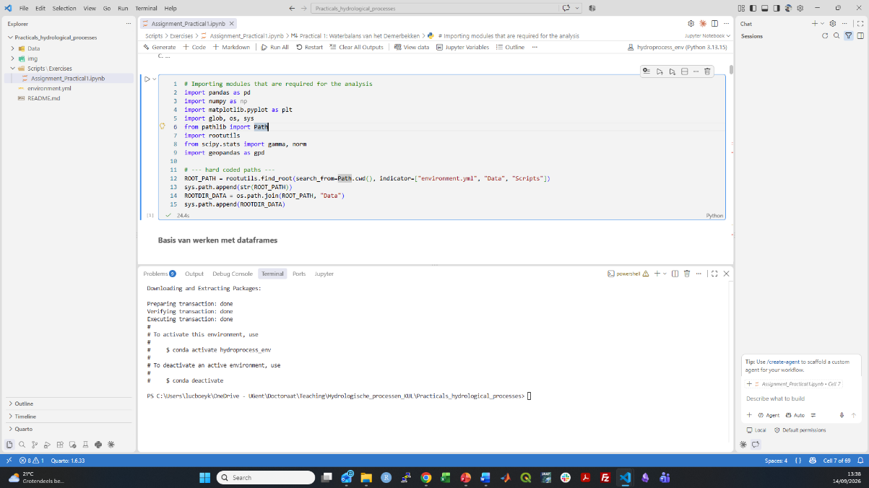
- Run the first code block. If everything went correctly, you should get something similar as the figure below:

