

# Investigation of the E-Retail factors Affecting Customers Retention and Consumers purchasing decision in Indian E-Commerce

# Submitted by:

# KULDEEP

# ACKNOWLEDGMENT

In this article I have investigated the E-Retail factors that affect the consumers buying decision and their retention. I have analysed all the factors that affect the consumers buying decision. For this purpose we have used the survey of 269 online shoppers from different regions of the India. I am very thank full to my friends and family who helped me through this study.

I have used online resource and articles [1] [2] [3] [4] [5] [6] and [7] for literature search and investigated the various factors which affect the consumers buying decision and their retention with E-retailers.

# INTRODUCTION

In this article we will investigate various e-retail factors which affect the consumers buying decision. Due to advancement in the technology and easy to access internet services e-retails industry in India has emerged one of the most dynamic and fast growing industry. According to a report of grant Thornton “E-commerce in India continues to gain traction, with total market size expected to reach USD 188 billion by 2025”, “974 million internet users, 220 million online shoppers in India by 2025”. According to a Cyber Media Research (CMR) report, the average usage of smartphones in India is estimated to have increased by 25% to almost seven hours a day, as people depend on gadgets for work/study from home and entertainment amidst the pandemic. With growing use of internet and mobiles, consumers have switched from shopping malls, shops and supermarkets to online marketplace for the purchase of products from basic commodities to branded goods. Various online retailers like Amazon, Flipkart etc. are enticing customers through innovative marketing strategies and services. In this fast growing and competitive industry making trust and retaining customers is very big deal for e-retailers. In this article we will mainly focus on the factors which make the trust of the customers and help the customers to make a buying decision.

## Problem Statement

E- Retails industries emerged rapidly from past decades and it has grown faster during Covid-19 pandemics. The completion has increased. We have giants like Amazon, Flipkart, Myntra, Snap deal and Big Basket etc. who are capturing Indian market rapidly through their online platform.

* In such competitive market retaining customers and winning trust is very big challenge for e-retailers.
* Understanding various factors that influence buying decision
* Understanding customer’s perception regarding selected online retailers.

## Conceptual Background of the Domain Problem

Our main problem statement is to investigate the factors affecting the customer’s retention and buying decision. Due to competitive market it become more challenging for e-retailers to retain the customers. During investigation we will study factors like Return and replacement policy, webpage content easiness, website and application interface etc. which are more important for attracting customers and retaining.

## Review of Literature

On this section of the article we will investigates the literature from online sources and make some relevant conclusion.

The using of information technology in business applications is not only able to change the nature of the services that provided by the company but has also been able to make changes to the process of providing services. Factors that influence decisions of online shopping, are trust factor, which comprises the trust factor, security, e-service quality, and the convenience factor, price factor, which comprises price factor and web quality factors; and time factor which consisting of time and convenience [6].

The rapid changing Internet environment has formed a competitive business setting, which provides opportunities for conducting businesses online. Availability of online transaction systems enable users to buy and make payment for products and services using the Internet platform. Customers’ involvements in online purchasing have become an important trend. According to author there are various factor which affect the buying decision but there are eight factors, return policy, trust, cash back warranty and cash on delivery are factors that affect consumers purchase decision strongly. According to author e-retailers need to focus on trust, after sale service, cash back warranty and management of return in order to attract more consumers to transact on their site [7].

Main factors influencing consumers to shop online are convenience, simplicity and better price. Analysis of socio-demographical characteristics such as gender has shown that men shop more often online because of the lower price. The most beneficial factor of shopping online was identified as a possibility to compare prices and buy at a lower price. [1]

Retail industry in India has emerged as one of the most dynamic and fast-paced industries due to the entry of several new players. It is over 10 per cent of the country’s Gross Domestic Product (GDP) and approx. 8 per cent of the employment. Customers have increasing choice of products at the competitive rates. E-commerce is probably creating the biggest revolution in the retail industry, and this trend would continue in the years to come. Factors that influence buying decision are website design and website response, access of retailers staff in case of any issue or problem, Assurance of security and confidentiality of data, Actual service provided by Online retailers and final price of product [4].

With the fast development of the web, sellers think that it is simpler to sell their products and services on the web. In the Indian e-retail area a great deal of changes has come up because of the organizations like Flipkart, Jabong, Olx, and so forth offering their product and services to the buyers over the web. Brand information, the safety of online transaction processing mechanism, and COD facility attract and retains customers for online shopping. [2]

In order for e-vendors to gain market shares and utilize the market capacity of the hyper-competitive emerging markets, the factors web site design, e-marketing and vendor contact alternatives are essential to address due to their positive impact on the consumers purchase decision. Here author used SPSS software to analyse the collected data [3].

Study shows that internet consumer trust and perceived risk have strong impacts on their purchasing decisions. Consumer`s trust, privacy concerns, security concerns are the major factors for using internet for shopping, the trust on websites influence to the purchasing decision of any consumer. More specifically, the empirical result suggests how the E-commerce companies make marketing strategies according the research data and analysing result [5].

From the literature search we came to conclusion that majority of the shoppers believe trust, privacy, support after and before service are main factors which lead to make buying decision. Another factors which affect buying decisions are website design, Assurance of security and confidentiality of data.

## Motivation for the Problem Undertaken

The main aim is to investigate the E- retailer’s factors which lead to customer’s retention and Influence the buying decision. With increase in the various online platforms like Amazon, Flipkart, Myntra, Olx, and Snapdeal etc. shoppers are having multiple choice. These days’ shoppers compare price and all the services provided by the E-retailers before making online purchase. In such situation it become more interesting to study the factors which influence shoppers to make buying decision.

# Analytical Problem Framing

## Data Sources and Format:

The data was collected from Indian online shoppers from different regions of India. Data set consist entry of 269 online shoppers which represent the raw of the data and the question asked from the shoppers are the columns of the dataset. Dataset having 71 columns which are the questions asked during the survey. These questions includes some personal information questions, Recommendation questions, personal views and questions related to marketplaces. All the data is of object type. We have two type of data files normal file which having object type data and encoded format file with encoded data. Data consist of the customer’s ratings and some recommendation made by the online shoppers.

## Data Inputs- Logic- Output Relationships

In this article we are investigating e-retailers factors which affect the customer’s retention and influence the buying decision. So the factors described in the data set are input factors to investigate the buying decision.

## Assumptions:

* As we have not collected the data, we are assuming it was collected from actual online shoppers.
* All the ethical measure followed during data collection process.

## Hardware and Software Requirements and Tools Used

Hardware Requirements: We need a laptop with minimum 4 GB RAM and 500 GB of heard dish.

**Software Requirement**: we need anaconda installed in our hardware. It comes with all the packages required for data analysis and visualization. Anaconda having Jupyter Notebook, the best environment for data analysis.

Library Used: We have used mainly four libraries for data analysis, mathematical calculation and Visualization of data. Numpy is used for Numerical calculation and pandas is used for making data frame and pre-processing of the data.

For visualization part we have used Matplotlib and Seaborn package. Both the package provide a wide variety of the graphs for data visualization and analysis.

Coding Language: Python

## Data Analysis and Visualisation:

In this section of the report we will analyse the data and visualize it using tools available in python. In Jupyter Notebook we first import all the required libraries. We need Numpy for numerical calculation, pandas data frame to read and process the data files. Our dataset having 269 rows and 71 columns. All the data is of object type. Data is not having any null values. We have seen from 269 online shoppers 67.2862 % shoppers are female and 32.71 % are male. Which indicates females prefer online shopping.

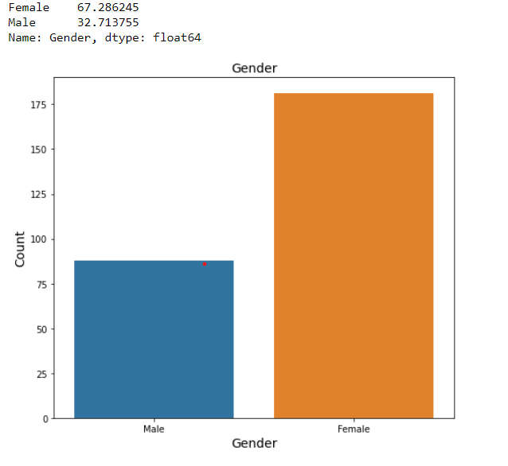

**Figure 1: Gender**

Majority of the online shoppers are between 21 years to 50 years. People below 20 years and above 51 years shop less.

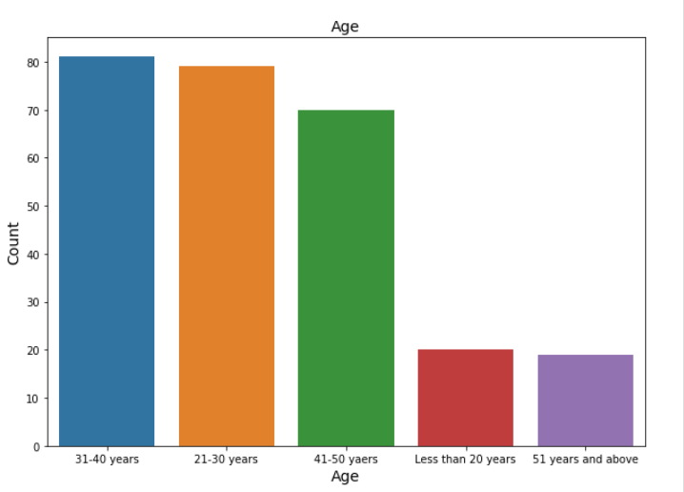

**Figure 2 Age**

If we see the city wise data majority of the shoppers are from Delhi and Noida.

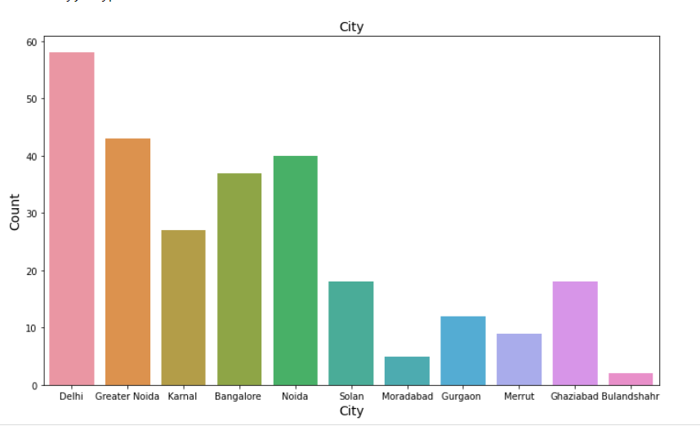

**Figure 3: City**

More than 63% of the shoppers are from Delhi, Noida and Bangalore.

And majority of the shoppers are shopping online for more than 4 years. We can see in the below graph.

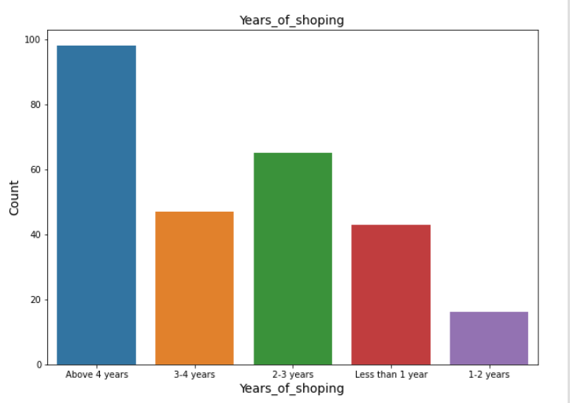

**Figure 4: Years of Shopping**

If we talk about internet access 70 percent shoppers use mobile internet for shopping online. We can see this in Figure 5.

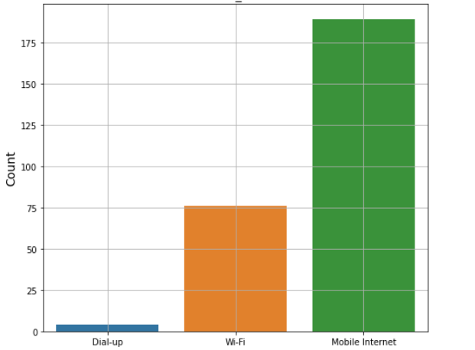

**Figure 5: Internet Access**

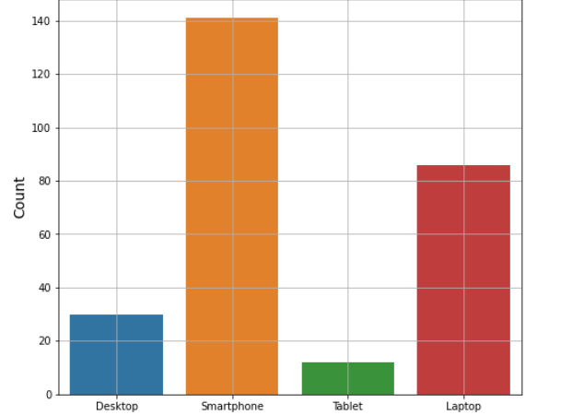

**Figure 6: Device**

From the above Figure 6 we can see majority of the people use smartphone for shopping online. Let’s check the decision time for making purchase decision. Figure 7 showing the graphs for decision time which indicates majority of the shoppers take more than 15 mins to make a purchase decision.

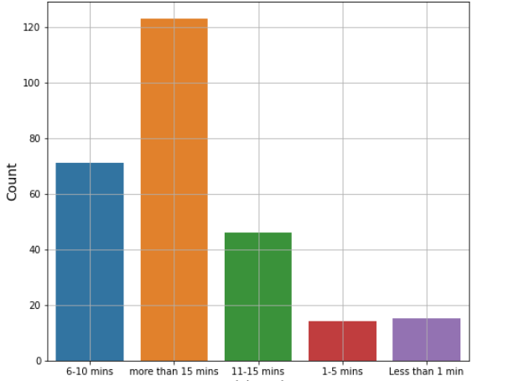

**Figure 7: Decision Time**

Here more interesting thing is to analyse who take more time to make buying decision. Figure 8 showing the graphs for male and female with their decision time.

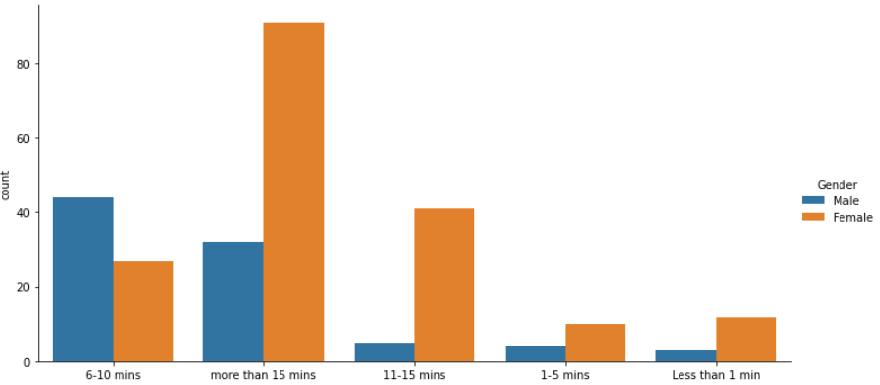

**Figure 8: Decision Time for male and Female**

We can see females are more as compare to male who take more than 15 min before making any purchase.

Let’s analyze the reason for abandon during shopping. Figure 9 showing the reason for abandon. Majority of the shoppers having Better alternative as reason for abandon.

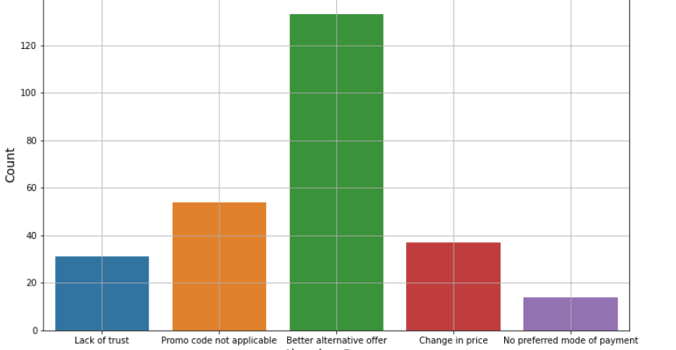

**Figure 9: Reason of Abandon**

In our literature we have seen shopper’s decision is depend on the content and web information. Let’s visualize.

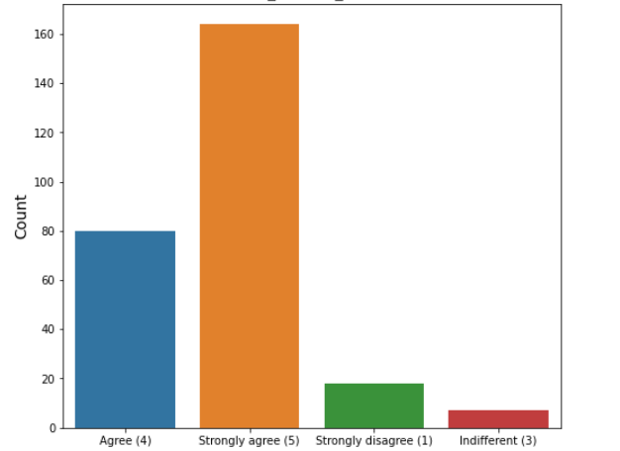

**Figure 10: Content Easiness**

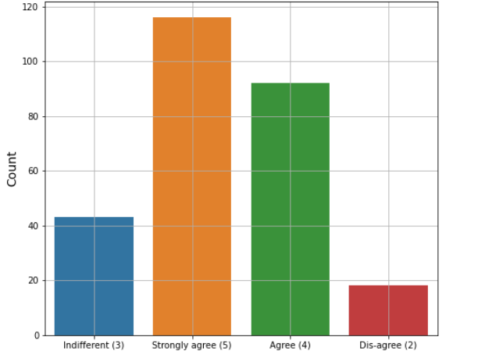

**Figure 11: Information for Comparison**

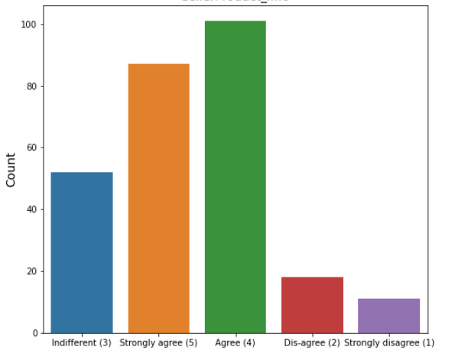

**Figure 12: Seller Product Information**

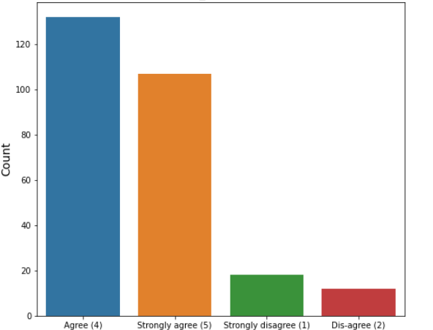

**Figure 13: Clear Information**

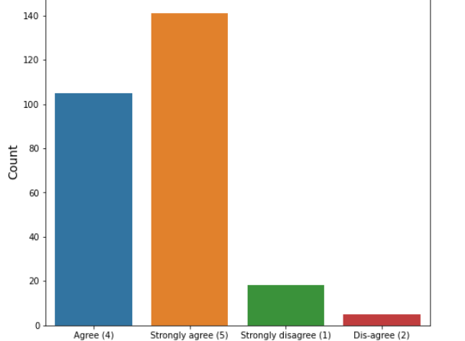

**Figure 14: Ease of Navigation**

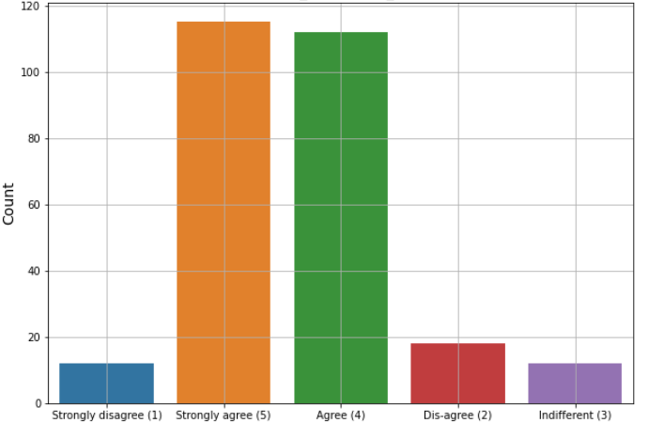

**Figure 15: Loading and Processing Speed**

In above graphs we can see shoppers are strongly agree that website should be easy to navigate, content should be easy , loading and processing speed should be fast and in the end product and seller information. All these factor affect the buying design and retention of the shoppers.

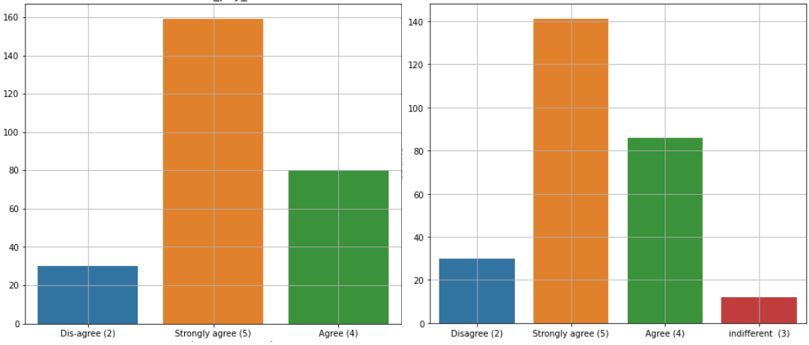

**Figure 16: Payment Mode and Trust**

Figure 16 shows convenient payment mode and Trust during payment is very important factor for shopper’s retention and making a buying decision. Majority of the shoppers are strongly agree on factors like, Empathy to Customers, Privacy of the customers, Communication channel responsiveness, monetary benefits and discounts, Enjoyment and Convenient and flexible affect the buying decision.

The most important is return policy and loyalty program.

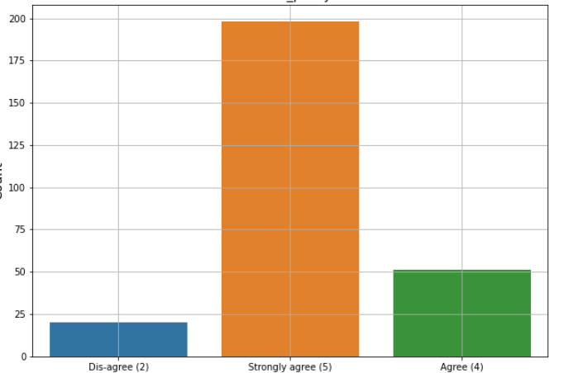

**Figure 17: Return Policy**

Majority of the shoppers are strongly agree a good return policy have higher impact on buying decision.

Let’s analyze some recommendation made by the shoppers.

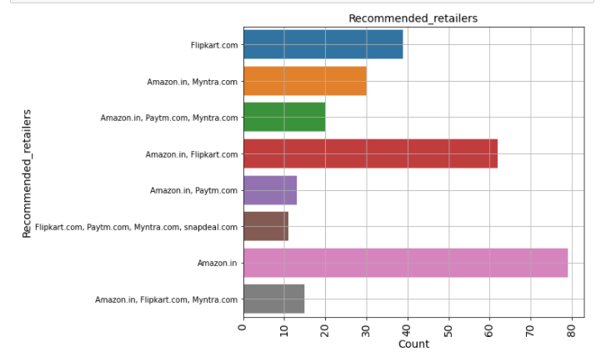

**Figure 18: Recommended Retailers**

From figure 18 we can see majority of the customer’s first choice is Amazon and second choice is Flipkart.

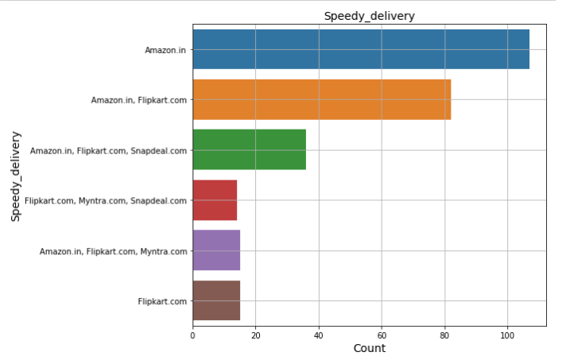

**Figure 19: Speedy Delivery**

Majority of the shoppers recommend Amazon for speedy delivery.

Majority of the customers are satisfied with services provided by the Amazon and Flipkart.

## Interpretation of the Results:

We have seen in our survey and data analysis majority of the shoppers are females and majority of the shoppers come from Delhi, Noida, Bangalore and Karnal. The online shopping increased due to use of mobile because majority of the shopper are using mobile phone for accessing internet service. A very good insights we can see for Decision time, majority of the shoppers take more than 15 min to make a buying decision and shoppers abandon shopping because they find better alternative.

When it comes about the content and website easiness, shoppers are strongly agree that website content easiness, loading speed, seller product information, ease of navigation, User friendly interface and convenient pay mode and trust are important to make buying decision, which lead to customer’s retention also.

Support before and after purchase, communication channel responsive also play a big role in customer satisfaction. Last but not the least is return policy, a better return policy increase the trust and retention of the customers.

Majority of the shoppers doing online shopping because they are agree that online shopping gives value of money, convenience of patronizing, Monetary saving, wide variety and satisfaction and trust.

Majority of the shoppers are recommending Amazon, Flipkart and Myntra. Amazon is the first choice for majority of the customers due to wild variety of product, timely delivery, website easiness, variety of payment options and quickness purchase. Return policy also making Amazon the first choice for majority of the customers. After Amazon Flipkart is the second choice of the shoppers, they prefer Flipkart and Myntra.

## CONCLUSION

* Key Findings and Conclusions of the Study

With increase in the internet access and mobile shoppers are switching form offline mode of shopping to online mode of shopping. Majority of the shoppers find it adventures, time saving and value of money. The main factors which affect the customer’s retentions are Trust, return policy, privacy of the user payment details, Fast delivery and return policy.

* Learning Outcomes of the Study in respect of Data Science

It was very interesting to study and visualize the data using tool available in python. We have visualized the data very deeply and come to conclusion what customer need and what factor cause the retention of the shoppers.

* Limitations of this work and Scope for Future Work

The data set was very small and the all the conclusion are based on this small dataset. For better and more clarity we can perform same steps on big dataset to make some clear and more accurate decision.

# Bibliography

|  |  |
| --- | --- |
| [1] | Ž. B. a. G. Gulevičiūtė, “E-COMMERCE FACTORS INFLUENCING CONSUMERS ONLINE SHOPPING DECISION,” *SOCIAL TECHNOLOGIES,* vol. 1, no. 1, pp. 74-81, 2015. |
| [2] | Y. K. a. R. K. Kapil Sharma, “An Analytical Study of Factors Affecting Online Shopping in Ambala,” *Revista geintec ,* vol. 11, no. 4, pp. 2307-2321, 2021. |
| [3] | G. H. &. S. Krysén, “Factors influencing the consumer purchase decision within e-commerce in emerging markets,” *International Business,* vol. 1, pp. 1-70, 2015. |
| [4] | D. Y. D. Mahajan, “A Study of E-retailing: Analysing the Factors and Perceptions of Indian Millennials for Online Retailers,” *Indira Management Review,* vol. 9, no. 1, pp. 59-66, 2017. |
| [5] | A. Mittal, “E-commerce: It’s Impact on consumer Behavior,” *Global Journal of Management and Business Studies,* vol. 3, no. 1, pp. 131-138, 2013. |
| [6] | R. A. A. D. a. N. F. W. Muhammad Edwar, “The Factors That Affecting the Product Purchasing Decision Through Online Shopping,” *International Journal of Educational Research Review,* Vols. Volume-1, no. 1, pp. 54-64, 2018. |
| [7] | T. T. K. a. R.R.K.Sharma, “Factors Affecting Consumers’ purchasing Decision through E-Commerce,” *International Conference on Industrial Engineering and Operations Management,* vol. 1, no. 2, pp. 159-165, 2016. |