SE&SD LAB-ASSIGNMENT -2
Name : B.Kumaraswamy
HALL TICKET :2503A52L08
BATCH : 15
USER diagram:

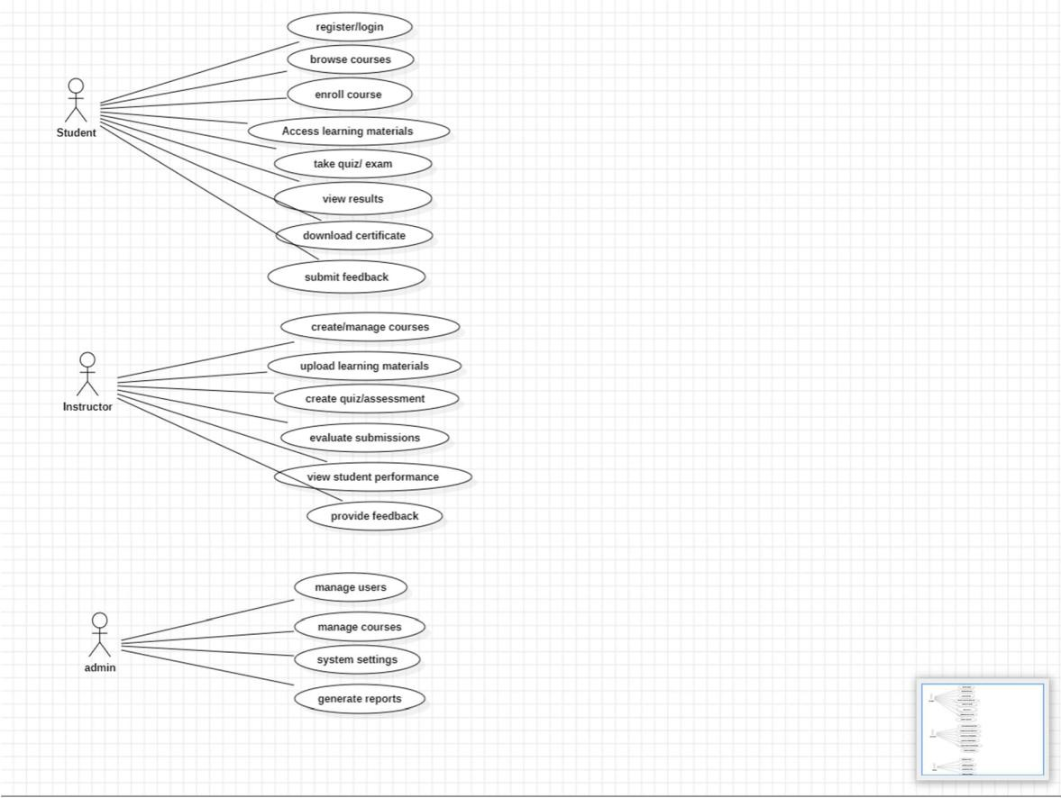

Class diagram:

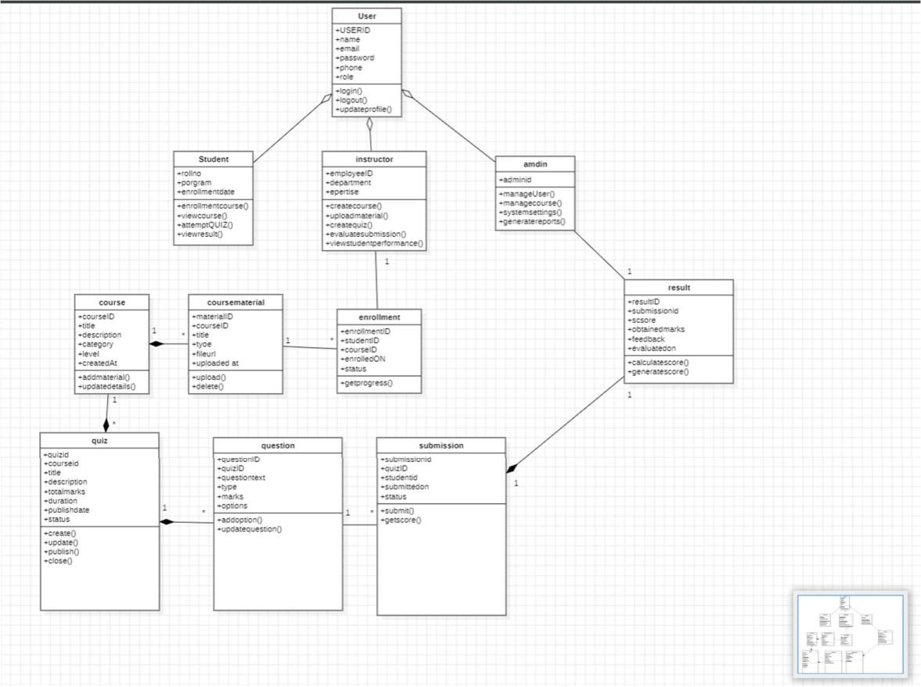

Activity Diagram:
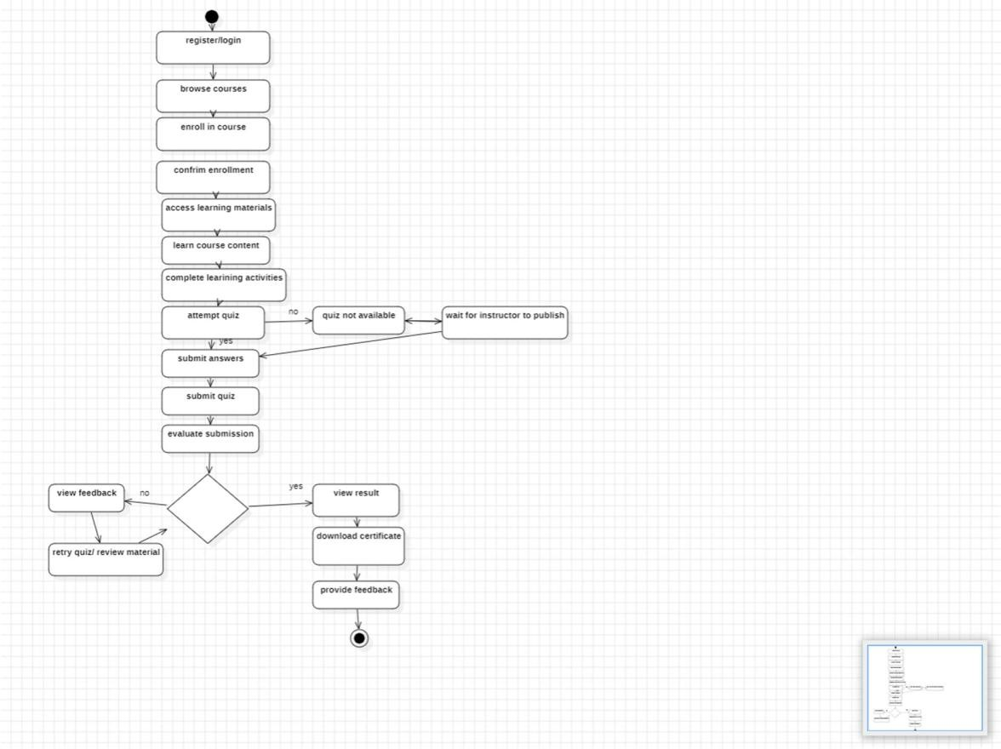
Sequence diagram:
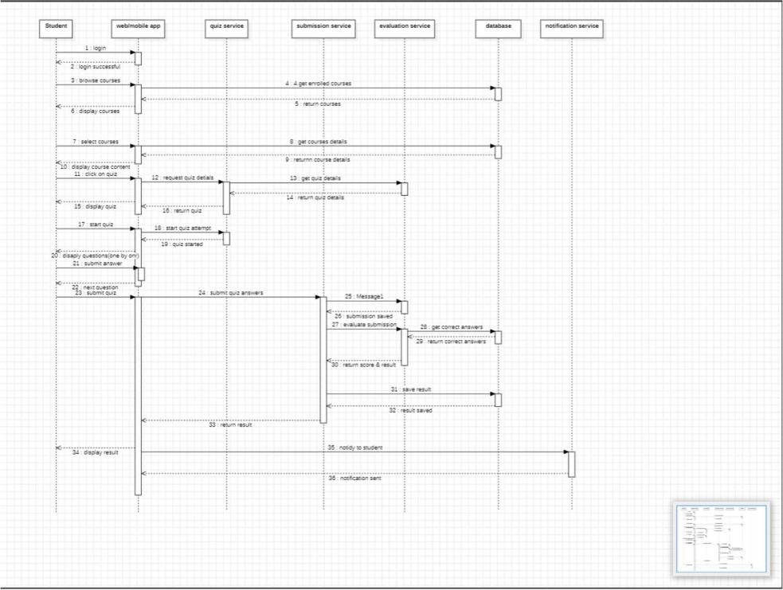

STATECHART DIAGRAM:



