WEEK 6 | FINAL INTERNSHIP REPORT

Comprehensive Evaluation of
Cybersecurity Preparedness
For a Hypothetical E-Governance Digital Platform

Prepared by | Ritesh Kumawat
Task | Week 6: Comprehensive Evaluation and Final Reporting
Assessment date | 28 October 2026
Platform model | Illustrative citizen-service portal with staff workflows and external APIs
Assessment type | Scenario-based desk assessment; no live testing performed
Prepared using publicly available cybersecurity frameworks and official guidance. The readiness scores and risk estimates in this report are illustrative planning judgments, not proof of implemented controls or legal compliance.

Document Control and Assessment Disclaimer
Item | Description
Document owner | Cybersecurity programme / platform owner (hypothetical)
Audience | Service owner, IT operations, security team, procurement, privacy/legal, auditors and senior management
Purpose | Evaluate the hypothetical platform’s preparedness and recommend a risk-prioritised improvement programme
Review cadence | Quarterly for risk and metrics; annually for full preparedness review; after material architecture or threat changes
Status | Educational planning report; not a certification, penetration test, legal opinion or independent assurance report

Critical limitation
This report does not claim that Wazuh, Suricata, Greenbone, policies, backups or response procedures have actually been deployed. Tools are evaluated as candidate components and scores are scenario assumptions. An operational assessment must validate them with asset inventories, configurations, logs, test results, interviews and service-owner approval.

Contents
- Executive Summary and Overall Conclusion
- 1. Purpose, Scope and Hypothetical Platform
- 2. Assessment Method and Scoring Model
- 3. Framework and Regulatory Alignment
- 4. Reference Architecture and Security Dependencies
- 5. Preparedness Scorecard and Interpretation
- 6. Critical Evaluation by Security Domain
- 7. Consolidated Priority Risk Register
- 8. Tool Integration and Control Effectiveness
- 9. Strategic Recommendations and Roadmap
- 10. Resource Allocation and Capability Plan
- 11. Metrics, Governance and Assurance Evidence
- 12. Continuous Improvement and Reassessment
- Conclusion
- References
- Appendix A. Evaluator-Friendly Submission Description

Executive Summary and Overall Conclusion
This report evaluates the cybersecurity preparedness of a hypothetical e-governance service that allows citizens to create accounts, submit applications and documents, pay fees through an external provider, track case status and receive service notifications. Government staff use a separate administrative workflow to review and process applications. The platform is assumed to handle identity attributes, contact details, application records, uploaded documents, audit events and payment references. Its failure could affect citizen privacy, equitable access to public services, trust in government and continuity of essential workflows.
A framework-led desk assessment was constructed from public guidance, principally NIST Cybersecurity Framework (CSF) 2.0, NIST SP 800-30 Rev. 1, NIST SP 800-61 Rev. 3, NIST SP 800-53 Rev. 5, OWASP Top 10:2025, GIGW 3.0 and CERT-In directions. The document independently develops its hypothetical ratings; it does not use previous weekly deliverables as evidence of implementation. [1–8]
The scenario-based maturity estimate is 2.65 out of 5, equivalent to 53/100 on a simple linear scale. This indicates a developing preparedness design with important gaps likely to remain until implementation and independent validation. Governance and response planning are comparatively stronger in the model, while detection coverage, asset completeness, recovery assurance and third-party visibility need the greatest attention. The score is not an empirical measurement and should not be interpreted as a real system audit result.
The main conclusion is that cybersecurity preparedness cannot be inferred from having documents or installing tools. A strong outcome requires controls to be implemented, tested, monitored and owned. Wazuh can consolidate host and application telemetry, Suricata can add network visibility, and Greenbone/OpenVAS can identify many infrastructure weaknesses; however, they do not replace application penetration testing, cloud-native controls, fraud monitoring, secure design, identity governance, backups or skilled incident responders. [9–11]

Key findings at a glance
Area | Assessment finding | Priority response
Governance | A framework and owners can be defined, but evidence of funding, risk acceptance and control ownership is not assumed. | Approve risk appetite, named owners, service criticality and exception process.
Identity and access | Citizen and staff accounts are high-value targets; privileged access is a likely single point of compromise. | MFA for all privileged/remote access, least privilege, rapid revocation and quarterly reviews.
Applications and APIs | Broken access control, insecure configuration, injection and software supply-chain risk could expose data or alter cases. | Threat modelling, secure CI/CD, dependency/SBOM controls and independent testing.
Detection | Monitoring tools can help, but only if logs are complete, time-synchronised, protected and triaged. | Define critical log sources, alerts, on-call ownership and monthly detection tests.
Resilience | Backups are not proof of recoverability unless isolated and successfully restored. | Immutable/offline copies, restore exercises and approved RTO/RPO.
Privacy and suppliers | Third-party APIs, processors and broad data collection can create exposure beyond the platform boundary. | Data mapping, contracts, minimisation, supplier assurance and incident notification clauses.

Overall recommendation
Decision
Treat the platform as “conditionally prepared at design level, not yet verified for production readiness.” Proceed with a controlled pilot only after critical access, vulnerability, logging, backup and incident-response gates have evidence. Production approval should be a risk-owner decision backed by testing, not by this report’s score alone.

1. Purpose, Scope and Hypothetical Platform

1.1 Purpose and evaluation questions
The objective is to judge whether a representative digital government service has the governance, preventive controls, monitoring, response capability and recovery arrangements needed to manage likely cyber risks. The evaluation asks: (a) are the most important risks recognised; (b) do controls cover each relevant layer; (c) can the platform detect and respond to a meaningful incident; (d) can it restore trusted service; and (e) are recommendations measurable and feasible?

1.2 In-scope service components
Layer | Assumed components / data | Security concern
Public access | Citizen web portal, responsive mobile interface, account recovery and online forms | Bot abuse, phishing, account takeover, session handling, accessibility during disruption
Edge and network | DNS, CDN, WAF, load balancer, firewalls, VPN/zero-trust access | DDoS, exposed management ports, weak rules, misrouting and denial of service
Application and API | Business services, REST APIs, document upload, workflow engine, notification service | Broken object-level authorisation, injection, insecure design, abuse of APIs
Identity and privilege | Citizen identity, staff SSO, MFA, privileged/admin accounts, service identities | Credential theft, overprivileged roles, stale accounts, token compromise
Data platform | Relational database, object/document storage, audit records, backups | Data disclosure, unauthorised alteration, weak encryption, retention and restoration failure
Hosting and endpoints | VMs/containers, operating systems, cloud control plane, staff endpoints | Unpatched software, configuration drift, malware, cloud identity compromise
External dependencies | Payment gateway, identity verification, messaging/email and outsourced support | Supplier breach, API trust failure, unclear responsibility and delayed incident notification
People and operations | Help desk, case workers, developers, administrators, contractors and service desk | Phishing, social engineering, error, insider misuse, weak handovers and unsafe emergency changes

1.3 Assumptions and exclusions
- The platform is fictional and has no known actual incident history. Threats and scores describe plausible scenarios, not confirmed findings.
- No live scan, penetration test, source-code review, configuration review, interview or evidence collection was performed.
- No specific hosting provider, state department, service volume, budget, data category or production deployment has been verified.
- Legal and regulatory applicability must be confirmed by the responsible department and legal counsel against current official notifications, contracts and sector-specific directions.
- All targets, timelines and staffing levels in this report are proposed internal planning targets; they are not presented as statutory deadlines unless explicitly labelled as such.

2. Assessment Method and Scoring Model

2.1 Method overview
The assessment uses a repeatable desk-based method adapted from NIST SP 800-30 risk assessment principles. It identifies assets and service outcomes, credible threat events, weaknesses, likely consequences, current control assumptions, treatment options and residual risk. The CSF 2.0 functions provide the reporting structure. The model is designed to help leaders prioritise validation; it is not a substitute for evidence-based assessment. [1, 2]
Step | Activity | Output / evidence needed in a real assessment
1. Define context | Confirm mission, service criticality, stakeholders, legal obligations and trust boundaries. | Approved system boundary, data-flow map, service catalogue and risk criteria.
2. Identify assets | List endpoints, applications, APIs, identities, data stores, suppliers and recovery dependencies. | Owner-assigned inventory and data classification.
3. Identify threat events | Assess account compromise, exploitation, data misuse, denial of service, supplier and human risks. | Threat scenarios tied to assets and business outcomes.
4. Rate risk | Score likelihood and impact before treatment; note assumptions and existing safeguards. | Risk register, matrix, named risk owner and treatment decision.
5. Evaluate control readiness | Check whether control design exists and can be evidenced and tested. | Policy, configuration, log, test and exercise evidence.
6. Prioritise treatment | Select reduce, avoid, transfer/share or accept; set due dates and owners. | Approved remediation plan and exception records.
7. Validate / reassess | Retest remediated controls and update risk after material change or new threat. | Retest evidence, residual-risk approval and revised score.

2.2 Likelihood and impact scales
Score | Likelihood description | Impact description
1 | Rare: unlikely in normal operating conditions; strong evidence of controls. | Negligible: short local inconvenience with no meaningful data or service effect.
2 | Unlikely: plausible but requires unusual circumstances. | Minor: limited records or function affected; manageable workaround.
3 | Possible: realistic attack path or recurring operational weakness. | Moderate: measurable service disruption, limited sensitive exposure or manual recovery.
4 | Likely: credible accessible attack path, known weakness or repeated near misses. | Major: extended outage, sensitive data exposure, fraud, regulatory response or widespread citizen impact.
5 | Almost certain: active exploitation, repeated abuse or very weak control. | Severe: prolonged essential-service failure, large-scale compromise, material integrity loss or serious public harm.

Inherent risk score = Likelihood × Impact. Suggested bands are 1–4 Low, 5–9 Moderate, 10–15 High and 16–25 Critical. The bands are a management convention for this report and must be approved before operational use. A score is a prioritisation aid, not a precise probability.
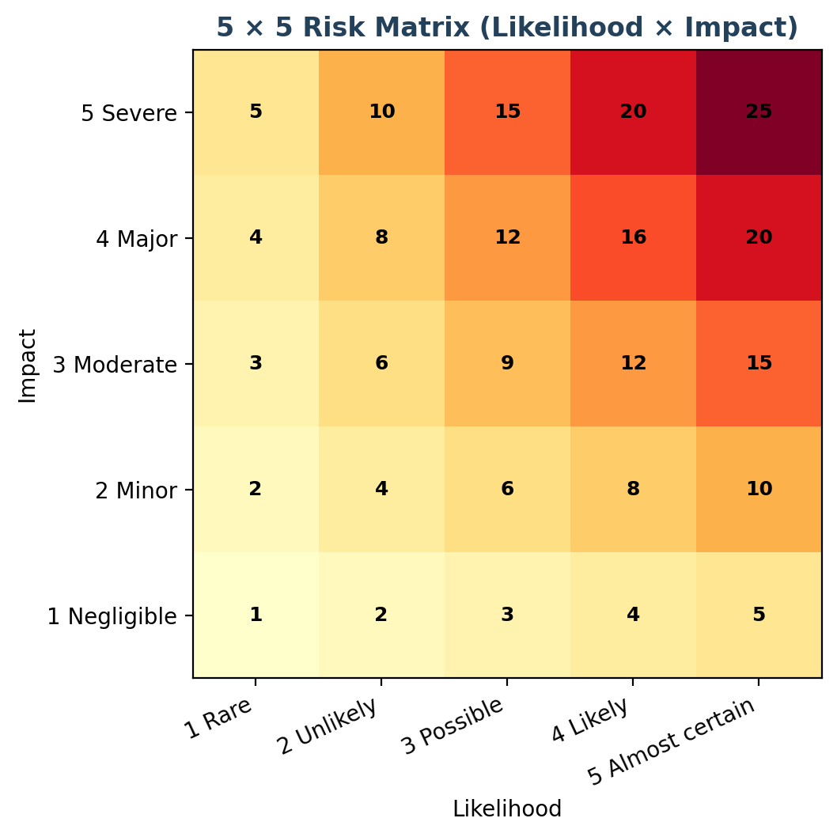
Figure 1. Example 5 × 5 likelihood-impact matrix. Higher scores require faster review and explicit ownership.

2.3 Preparedness maturity scale
Level | Name | Interpretation
1 | Initial | Ad hoc or undocumented; activities depend on individuals; little repeatable evidence.
2 | Developing | Some practices exist but coverage, ownership, consistency or testing is incomplete.
3 | Defined | Approved processes and owners exist; implementation is repeatable for most in-scope assets.
4 | Managed | Controls are measured, consistently operated and tested; exceptions are tracked.
5 | Optimised | Continuous improvement is data-driven; exercises and lessons learned materially improve outcomes.

For the scenario scorecard, each function receives a judgement from 1 to 5. The average is converted to a percentage by multiplying by 20. The function scores are planning estimates only. They should be replaced with evidence-backed ratings after a real control assessment.

3. Framework and Regulatory Alignment
Reference | Use in this report | Practical application
NIST CSF 2.0 [1] | Organises the overall preparedness review into Govern, Identify, Protect, Detect, Respond and Recover. | Set current/target profiles, identify gaps, assign owners and report progress to leadership.
NIST SP 800-30 Rev. 1 [2] | Supports risk context, threat events, likelihood, impact, treatment and residual-risk reasoning. | Use documented assumptions and a repeatable risk register rather than intuition alone.
NIST SP 800-61 Rev. 3 [3] | Connects incident response with wider cybersecurity risk management under CSF 2.0. | Exercise incident response across prevention, detection, response, recovery and improvement.
NIST SP 800-53 Rev. 5, update 5.2.0 [4] | Provides a broad control catalogue for access, logging, configuration, contingency and supply chain. | Tailor relevant controls to system criticality; do not treat a mapping as certification.
OWASP Top 10:2025 [5] | Highlights current web application risk areas including access control, misconfiguration, software supply chain, cryptography, injection, insecure design, authentication and logging. | Map secure coding, testing, API review and release gates to actual application risks.
GIGW 3.0 [6] | Provides Indian government website/app guidance and relevant quality, accessibility and security practices. | Include usability/accessibility, secure publishing, ownership, review and certification requirements as applicable.
CERT-In Directions under Section 70B [7] | Provides India-specific cyber incident reporting and specified security practices for entities within scope. | Maintain reporting contacts, clocks, logs and an incident decision procedure; validate applicability and current FAQs.
DPDP Act and Rules [8] | Informs personal-data governance and obligations where provisions have commenced and apply. | Map purposes and data flows, minimise data, define processor duties, prepare breach handling and verify phased commencement.

Legal interpretation caution
The report is not legal advice. CERT-In directions and the Digital Personal Data Protection framework have specific scope, definitions and commencement provisions. Before production use, the department should verify currently operative sections, notification deadlines, record-retention rules, contracts, sector-specific obligations and the approved reporting pathway against official primary sources.

4. Reference Architecture and Security Dependencies
The architecture below shows a target-state concept, not a verified deployment. The service owner should maintain a current diagram that includes data movement, trust boundaries, administrative access, suppliers, backup paths and telemetry routes. Security monitoring and vulnerability management should follow the asset and data model rather than operating as isolated tools.
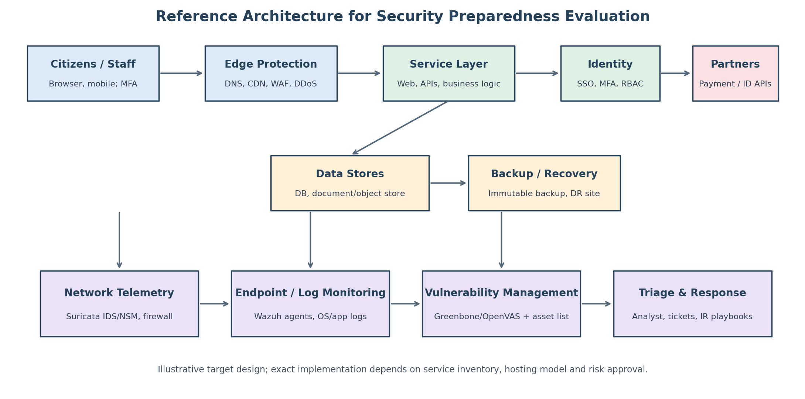
Figure 2. Illustrative reference architecture tying citizen access, application/data layers, monitoring and response together.

4.1 High-value security dependencies
Dependency | Why it matters | Minimum preparedness evidence
Identity and privileged access | One compromised staff/admin account can bypass several application controls. | MFA settings, role matrix, privileged access inventory, joiner/mover/leaver records and access review results.
API and application authorisation | A valid login does not guarantee a user is allowed to access each record or action. | Threat model, server-side authorisation tests, API inventory, rate-limit rules and negative test cases.
Asset and software inventory | Scanning, patching and monitoring are unreliable when assets and owners are unknown. | Reconciled asset list, software/dependency inventory, SBOM where appropriate, supplier ownership.
Telemetry and time synchronisation | Incomplete or inconsistent logs delay triage and undermine incident reconstruction. | Critical source list, coverage dashboard, clock sync, retention/access controls and alert tests.
Recovery dependencies | Backups fail to help if credentials, keys, configuration or restore procedures are unavailable. | Isolated backups, clean rebuild instructions, restoration test, RTO/RPO approval and contact list.
External providers | A provider may hold data, credentials or an operational dependency outside direct control. | Due diligence, contractual security clauses, evidence of assurance, contacts and incident-notification SLA.

5. Preparedness Scorecard and Interpretation
On the hypothetical facts assumed for this report, the estimated average maturity is 2.65/5, or 53/100. The distribution is designed to represent a platform with basic governance awareness and response planning, but with incomplete evidence of operational monitoring, asset coverage, recovery testing and third-party assurance. It is not evidence that a real service currently performs at this level.
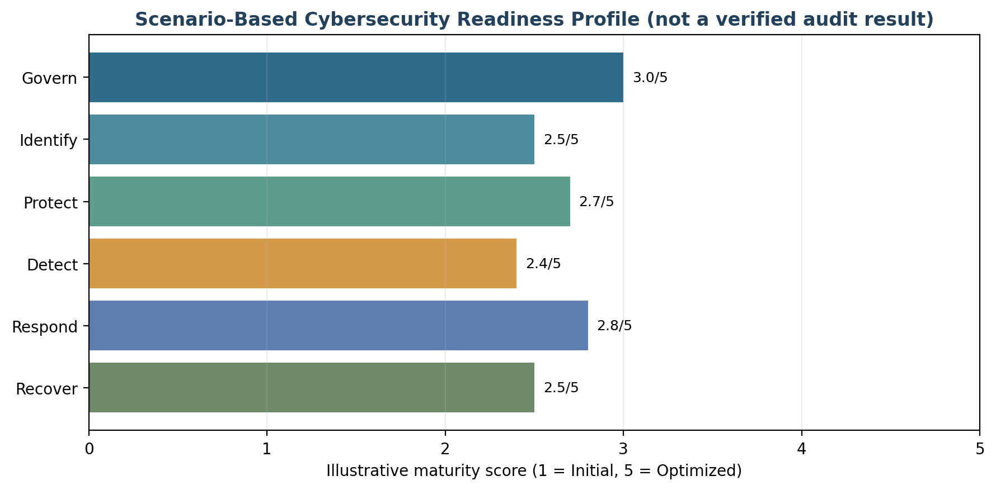
Figure 3. Scenario-based maturity estimates by NIST CSF 2.0 function. Ratings must be validated with evidence before being used as assurance.
CSF function | Score / 5 | What the score assumes | Most important validation
Govern | 3.0 | Roles, draft policies and leadership awareness can be defined; risk acceptance and metrics need evidence. | Approved risk appetite, budget, policy sign-off, exceptions and supplier accountability.
Identify | 2.5 | Some service components are known; complete asset/data/dependency mapping is not assumed. | Inventory coverage, criticality, data flows, suppliers and owners.
Protect | 2.7 | Baseline controls are feasible, but consistent enforcement across identities, apps and infrastructure is unverified. | MFA, least privilege, secure build/release gates, configuration baselines, encryption.
Detect | 2.4 | Tool options exist, but source coverage, alert quality and staffed triage are not proven. | Log source coverage, alert test results, time synchronisation, on-call rota and triage records.
Respond | 2.8 | A response workflow can be designed; drills, reporting clocks and evidence handling need testing. | Tabletop results, contact tree, case records, notification decisions and lessons learned.
Recover | 2.5 | Backups and recovery concepts are assumed, not proven by restore evidence. | Restore tests, immutable copies, clean rebuild, RTO/RPO, service-owner sign-off.

5.1 How to read the result
- The score identifies where validation effort should start; it should not be treated as a percentage chance of being breached.
- The average hides severe single-point failures. A critical risk can block production approval even if the overall score improves.
- An approved policy is design evidence, not operating evidence. Effective assurance requires logs, configurations, test results, tickets and signed decisions.
- Target profiles should be set by service criticality and risk appetite. A citizen service handling sensitive records may need stronger recovery and detection assurance than a low-impact information site.

6. Critical Evaluation by Security Domain

6.1 Governance and risk ownership
Strength: a framework-led review allows senior management to discuss security in terms of citizen harm, service availability, public trust, and legal obligations rather than tool counts. Weakness: a framework mapping can become a paper exercise if risk owners do not fund remediation, approve exceptions, or review overdue risks. Improvement: assign one accountable service owner, named control owners, a risk committee or equivalent governance forum, and a documented acceptance rule for high residual risk.

6.2 Asset visibility and data governance
Strength: a shared inventory can connect vulnerability results, log coverage, backup status and application ownership. Weakness: unmanaged domains, shadow APIs, forgotten test systems, unknown software dependencies and duplicate data stores reduce control coverage. Improvement: reconcile cloud/network/endpoint inventories with procurement and DNS/API sources; classify data and record purpose, access, retention, processor and deletion responsibilities.

6.3 Identity, application and API protection
Strength: MFA, least privilege, secure sessions, server-side authorisation, rate limits and secure coding address high-impact risks. Weakness: login controls alone do not prevent an authenticated user from accessing another citizen’s records; manual reviews can miss API-specific object-level authorisation flaws. Improvement: threat-model critical workflows, test positive and negative authorisation paths, separate staff administration from citizen access, protect service identities and integrate application security tests into the release process.

6.4 Vulnerability and configuration management
Strength: scanning and asset-based remediation give the team a repeatable way to identify known weaknesses. Weakness: a scanner may miss logic flaws, authenticated-only paths, ephemeral resources or business-process abuse; false positives and maintenance windows can also create operational risk. Improvement: combine authenticated scanning, configuration checks, dependency analysis, penetration testing and risk-based triage. Prioritise known-exploited vulnerabilities and exposed critical assets, not only CVSS scores.

6.5 Detection, monitoring and response
Strength: centralised event analysis and network telemetry can create useful signals. Weakness: collecting logs is not the same as detecting an incident. If alerts are not tuned, assigned, tested and staffed, the result may be noise or an unnoticed attack. Improvement: create detection use cases for admin logins, privilege changes, repeated failed logins, unexpected exports, unusual database access, malware, suspicious egress, high error rates and backup tampering. Test alerts using authorised simulations and record the outcome.

6.6 Resilience and recovery
Strength: immutable backups and recovery objectives limit the consequence of destructive incidents. Weakness: backup existence does not prove that data is complete, keys are available, restored systems are clean, or integration dependencies will work. Improvement: restore a representative service regularly in an isolated environment, verify data integrity, reissue secrets where necessary, record actual recovery times and obtain business-owner approval before declaring service restored.

6.7 Suppliers and shared responsibilities
Strength: external payment, identity, hosting and messaging providers can offer specialist capability. Weakness: responsibility can fall between procurement, the department and supplier; security clauses may lack measurable evidence or incident timelines. Improvement: classify suppliers by criticality, check access and data flows, require notification and cooperation clauses, review assurance reports, test exit/continuity options and revoke access at contract termination.

6.8 People, privacy and emerging threats
Strength: clear procedures can help staff recognise suspicious activity and report promptly. Weakness: annual awareness training alone is not enough against targeted phishing, help-desk manipulation, deepfake-assisted impersonation, malicious insiders or fatigue. Improvement: run short role-specific exercises, secure help-desk identity-verification, use dual approval for high-impact actions, limit data exports, record emergency access, and establish an approved process for AI tool use and disclosure of data to external services.

7. Consolidated Priority Risk Register
The following register is an illustrative baseline to demonstrate how risks can be prioritised. Scores assume no evidence that strong controls are operating. “Residual target” means the expected target score after successful treatment, not an achieved score. Owners and deadlines should be validated by the actual service owner.
ID | Risk scenario | L | I | Inherent | Impact summary | Owner
R1 | Privileged account compromise / weak MFA | 4 | 5 | 20 Critical | Phishing or stolen token gives administrative access; large-scale data or service compromise. | CISO / IAM lead
R2 | Broken access control in portal/API | 4 | 5 | 20 Critical | A citizen can view/change another person’s case or document; integrity/privacy harm. | Application owner
R3 | Exploitation of internet-facing vulnerable software | 4 | 5 | 20 Critical | Remote compromise, ransomware, data theft or persistent foothold. | Infrastructure lead
R4 | Incomplete logs / unstaffed alerts | 4 | 4 | 16 Critical | Attack persists undetected; weak evidence and slow reporting/containment. | SOC / security lead
R5 | Ransomware and backup compromise | 3 | 5 | 15 High | Service outage, record integrity loss and prolonged restoration. | IT operations / DR owner
R6 | Supply-chain/dependency compromise | 3 | 5 | 15 High | Malicious package, compromised vendor or untrusted update affects production. | DevSecOps / procurement
R7 | Cloud/network misconfiguration or exposed admin plane | 3 | 5 | 15 High | Public exposure of data/services or takeover through management interface. | Cloud/network lead
R8 | DDoS or dependency outage | 4 | 4 | 16 Critical | Citizens cannot access essential forms, status or payment workflows. | Service owner / SRE
R9 | Excessive data collection or unauthorised export | 3 | 5 | 15 High | Citizen privacy harm, legal exposure, public distrust. | Data owner / privacy lead
R10 | Third-party API token or credential leakage | 3 | 4 | 12 High | Fraud, record changes or data leakage through a partner connection. | Integration owner
R11 | Insider misuse / help-desk social engineering | 3 | 4 | 12 High | Unauthorised access, account resets, data disclosure or abusive case changes. | HR / service operations
R12 | Recovery objectives untested / single points of failure | 3 | 5 | 15 High | Prolonged outage after cyberattack, provider failure or data corruption. | Continuity owner

7.1 Risk treatment register
Use the risk IDs below to connect each treatment with the priority matrix above. Close a finding only after the control owner supplies validation evidence and the risk owner accepts any residual exposure.
ID | Primary treatment / control improvements | Owner | Target | Residual target
R1 | 100% MFA for privileged/remote access; separate admin accounts; phishing-resistant MFA for critical admins; PIM/JIT; quarterly reviews; session revocation exercise. | CISO / IAM lead | 0–30 days | 5–9 Moderate
R2 | Server-side object/action authorisation; deny-by-default; tenant/citizen boundary tests; API inventory and abuse tests; independent test before release. | Application owner | 0–60 days | 5–8 Moderate
R3 | External attack-surface inventory; authenticated scans; risk-based patch SLA; check CISA KEV and vendor advisories; verify fixes and remove unsupported assets. | Infrastructure lead | 0–30 days | 5–9 Moderate
R4 | Define tier-1 sources; centralise and protect logs; time sync; alert ownership and 24/7 escalation model for critical systems; monthly test alerts. | SOC / security lead | 0–90 days | 6–9 Moderate
R5 | Immutable/offline backups; separate backup identity; EDR/monitoring; clean rebuild runbook; quarterly restore test; approved RTO/RPO. | IT operations / DR owner | 0–90 days | 5–8 Moderate
R6 | Dependency inventory/SBOM where appropriate; signed builds; protected CI/CD; pin/review dependencies; supplier due diligence; emergency rollback. | DevSecOps / procurement | 30–180 days | 6–9 Moderate
R7 | Hardened baselines; restrict management plane; configuration drift checks; secure secrets; separate environments; change review. | Cloud/network lead | 0–90 days | 4–8 Low–Moderate
R8 | DDoS/WAF/CDN capability; capacity limits; provider escalation; degraded/read-only mode; load testing; communication and continuity plan. | Service owner / SRE | 30–180 days | 6–9 Moderate
R9 | Data minimisation; purpose/access mapping; export controls; encryption; data-loss detection; retention/deletion schedule; breach workflow. | Data owner / privacy lead | 30–180 days | 5–9 Moderate
R10 | Vaulted secrets, short-lived scoped credentials, rotation, mTLS where appropriate, egress controls, supplier incident contacts and usage anomaly alerts. | Integration owner | 30–90 days | 4–8 Low–Moderate
R11 | Role separation; identity proofing for resets; dual control for sensitive actions; just-in-time access; audit review and role-based exercises. | HR / service operations | 30–180 days | 4–8 Low–Moderate
R12 | Business impact analysis; approved RTO/RPO; isolated restore tests; alternative contacts; failover test; restore integrity checks and sign-off. | Continuity owner | 30–180 days | 5–8 Moderate

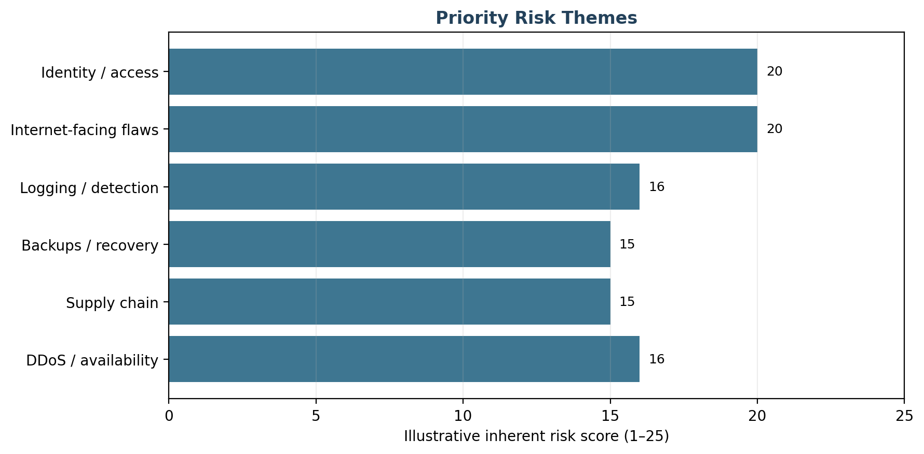
Figure 4. Priority themes in the scenario register. Values are illustrative inherent risk scores.

7.2 Risk treatment and acceptance rules
- Critical risks (16–25): assign an executive risk owner immediately; implement short-term safeguards and do not approve production exposure without documented senior risk acceptance.
- High risks (10–15): assign a named remediation owner, target date, evidence requirement and weekly tracking until the risk is reduced or explicitly accepted.
- Moderate risks (5–9): schedule treatment according to service criticality and dependencies; monitor for changes in exploitability or exposure.
- Low risks (1–4): retain an owner and review during scheduled reassessment or when the context changes.
- Residual risk must be rescored after evidence-backed remediation. A closed ticket alone is not proof: retest the control and link the result to the risk register.

8. Tool Integration and Control Effectiveness
The three tools below form a possible monitoring and vulnerability-management stack. They are recommendations for a pilot, not evidence that controls are already operating. Tool choice should be confirmed through a proof of concept using actual asset counts, log volumes, supported platforms, hosting constraints, staff skills and procurement requirements. Product documentation explains core capabilities, but effective outcomes depend on configuration, integration and operations. [9–11]
Candidate | Primary contribution | Important limits / failure modes | Operational success condition
Wazuh | Host and selected application/cloud telemetry; log analysis; file-integrity, configuration and vulnerability-related capabilities; central dashboard. | Agents do not see every network or application event; tuning and storage are required; alert floods or missing agents weaken coverage. | Critical endpoints onboarded, agent health monitored, alerts assigned, retention protected and use cases routinely tested.
Suricata | Network IDS/NSM and optional inline IPS; protocol metadata and signature/anomaly alerts. | Encrypted traffic limits payload inspection; sensors only see paths where deployed; IPS blocking can disrupt business if rules are not validated. | Correct sensor placement, rule/feed updates, time sync, tested alert forwarding and staged passive-to-inline rollout.
Greenbone / OpenVAS | Vulnerability scanning and central scan-result management for reachable infrastructure. | Scanning can miss application logic, credentials, ephemeral assets or vulnerabilities without suitable checks; scans can affect fragile systems. | Authorised scan scope, safe scan windows, credentialed coverage, ownership of findings, patch/mitigation tracking and retests.

8.1 How the tools work together
- Asset register assigns a stable asset identifier, owner, criticality, exposure and permitted scan/monitoring window.
- Greenbone results are triaged using asset criticality, exploitability, internet exposure, known-exploited intelligence and business impact; confirmed findings become tracked remediation tickets.
- Wazuh collects host security events, endpoint health, file integrity and relevant application/authentication logs; its rules raise alerts for suspicious activity and gaps in control coverage.
- Suricata provides network alerts and protocol metadata from approved observation points; the security analyst correlates time, asset, identity and destination with Wazuh events.
- The SOC or designated on-call responder validates alerts, records severity and executes an approved playbook; active blocking actions require change control unless pre-authorised for a defined emergency.
- Post-incident findings update detection rules, vulnerability prioritisation, secure design controls, response runbooks and risk ownership.

8.2 Integration guardrails
- Use a common time source and consistent asset identifiers; retain event provenance and avoid silently overwriting source evidence.
- Protect the monitoring platform itself with MFA, least privilege, network segregation, patching, backup and tamper alerts.
- Limit sensitive data in logs; redact tokens, passwords, full identity values and unnecessary citizen content. Restrict analyst access and retention.
- Begin network monitoring in passive mode. Test inline prevention and automated response in staging before enabling blocking in production.
- Do not assume a clean scan means the application is secure; use manual review, application/API tests, configuration review and independent penetration testing where appropriate.
- If integration requires custom scripts or APIs, version-control them, authenticate integrations, log failures, test upgrades and assign an owner.

9. Strategic Recommendations and Roadmap
The roadmap is staged to reduce the most consequential exposure first and to build repeatable operations before broad automation. The target dates are proposed programme windows from approval; they should be adjusted to procurement and service-change constraints without allowing critical risks to remain unowned.
Window / priority | Actions | Accountable roles | Exit criteria / evidence
0–30 days: urgent foundation | Name service/risk owners; confirm system boundary; inventory internet-facing assets and privileged accounts; enable MFA on privileged/remote access; review critical known-exploited vulnerabilities; test backup isolation; establish incident contacts and reporting decision checklist. | Service owner, CISO/security lead, IAM, infrastructure, legal/privacy | Approved risk register; named owners; MFA evidence; exposed-asset list; critical patch tickets; backup isolation evidence; tested call tree.
31–90 days: visibility and control | Pilot Wazuh and Suricata on representative systems; deploy safe authenticated vulnerability scans; onboard critical logs; define first detection use cases; baseline configurations; create incident severity and triage workflow; run tabletop exercise. | SOC/security analyst, network, endpoint, app owner, DR owner | Telemetry coverage report; alert test records; scanner coverage; severity matrix; tabletop actions assigned.
3–6 months: secure engineering and resilience | Integrate SAST/dependency checks/secret scanning into CI/CD; test API access boundaries; implement secrets vault and supplier security checks; conduct recovery restore and failover exercises; review privacy/retention map. | DevSecOps, application, data/privacy, procurement, continuity | Release gates passing; API test evidence; supplier register; restore time measured; data inventory and retention decisions.
6–12 months: assurance and optimisation | Independent application/security assessment; red/purple-team or scenario-based detection validation; tune alert quality; test DDoS/provider failover and emergency communications; measure target profiles; close repeat findings. | CISO, service owner, internal audit, suppliers, management | Independent findings and closure evidence; revised CSF profile; updated residual-risk acceptance; annual improvement plan.
Continuous | Review threats, patch status, access, supplier changes, KPIs, incident learnings and architecture changes. | All control owners; risk committee | Monthly dashboard; quarterly risk review; annual preparedness assessment; review after material event/change.

9.1 Production readiness gates
Gate | Minimum condition to pass | Decision owner
Identity gate | All privileged and remote access covered by MFA; emergency accounts protected and tested; access reviews completed. | IAM owner + service owner
Vulnerability gate | No unresolved critical internet-facing issue without approved compensating controls and explicit risk acceptance; high-risk findings have owners and deadlines. | Security lead + system owner
Detection gate | Critical log sources onboarded; time sync verified; at least one end-to-end alert test completed; monitoring rota and escalation contacts active. | SOC/security lead
Recovery gate | Backups isolated and restore-tested; service RTO/RPO approved; clean rebuild and integrity validation documented. | Continuity owner + business owner
Response/compliance gate | Incident plan exercised; roles and external contact path confirmed; legal/regulatory reporting trigger checklist reviewed. | Incident commander + legal/privacy
Application gate | Independent risk-based test completed; critical issues closed or formally accepted; authorisation and upload paths validated. | Application owner + independent tester

10. Resource Allocation and Capability Plan
Because no verified system size, budget or staffing baseline is available, the figures below are planning options rather than a cost quote. A small service may combine roles; a high-impact, 24/7 platform may require a dedicated SOC or managed service. Outsourcing does not transfer the department’s accountability for risk decisions, data protection, service continuity or contract oversight.
Role / capability | Illustrative allocation | Primary responsibility
Executive service owner / risk sponsor | 0.1–0.2 FTE plus monthly governance | Approve priorities, risk appetite, service impact, funding and residual risk.
Security lead / risk manager | 0.5–1.0 FTE | Maintain CSF profile, risk register, policy oversight, reporting and improvement plan.
SOC / monitoring analyst | 1–2 FTE for business-hours pilot; 24/7 coverage requires rota or MSSP | Triage alerts, investigate events, maintain detections and evidence.
Infrastructure / cloud / network engineer | 0.5–1.0 FTE shared | Hardening, patching, segmentation, backup architecture, sensor placement and restore support.
Application security / DevSecOps | 0.5–1.0 FTE shared | Threat modelling, secure pipeline, API tests, dependency remediation and release gates.
Privacy/legal and compliance | 0.1–0.3 FTE shared | Applicability review, breach decisions, contracts, records, notices and regulatory coordination.
Procurement/vendor manager | 0.1–0.2 FTE shared | Supplier assurance, contract clauses, service-level reporting and exit plans.
Business continuity / service operations | 0.2–0.5 FTE shared | RTO/RPO, continuity exercises, operational communications and service restoration acceptance.

10.1 Indicative budget allocation
Budget area | Planning share | Reason
People and operational support | 30% | Skilled responders, engineering time, alert triage, control owners and governance.
Monitoring and platform infrastructure | 25% | Log storage, monitoring stack, sensor deployment, secure management and retention.
Security testing and remediation | 15% | Independent testing, vulnerability validation, code review and fix verification.
Resilience and recovery | 10% | Isolated backups, restore environments, failover testing and continuity tooling.
Training and exercises | 10% | Role-specific training, incident table-tops, secure development and awareness.
Contingency / improvement reserve | 10% | Urgent remediation, unexpected supplier changes or additional test scope.

This allocation totals 100% and should be refined after discovery, quotes and a total-cost-of-ownership review. Open-source software may reduce licence costs but still needs infrastructure, engineering, feed/update management, secure operations, retention, support and staff time. The service owner should compare self-managed deployment with managed support using measurable service levels.

10.2 Training plan
Audience | Minimum exercise / training | Cadence / evidence
All staff and contractors | Phishing/social engineering, reporting suspicious activity, safe handling of citizen records and approved AI use. | Onboarding + annual refresher; completion and simulation follow-up.
Developers / API teams | Secure coding, threat modelling, access-control tests, secrets handling, dependencies and incident-ready logging. | At onboarding and per major framework change; secure design/review records.
Administrators / cloud / IAM | Privileged session handling, emergency access, hardening, key management, backup security and change control. | Quarterly mini-exercise; admin access review and restore evidence.
SOC / incident team | Alert triage, evidence preservation, escalation, CERT-In/legal decision workflow and shift handover. | Quarterly table-top; annual technical simulation; tracked improvement actions.
Executives / communications | Service impact decisions, incident command, accurate citizen messages, risk acceptance and media coordination. | At least annually; signed action log and revised call tree.

11. Metrics, Governance and Assurance Evidence
Metrics should measure control operation and citizen-service outcomes, not simply tool deployment or number of alerts. Targets below are proposed internal service levels and must be approved against criticality, staffing and legal requirements.
Metric | Proposed target | Frequency | Evidence / owner
Critical asset ownership | ≥ 98% of tier-1 assets have owner, criticality and monitoring/backup status recorded. | Monthly | Reconciled asset inventory / service owner
Privileged MFA | 100% of interactive privileged and remote access protected by MFA, with approved emergency exception. | Monthly | Identity provider report / IAM
Known-exploited exposure | All internet-exposed known-exploited vulnerabilities triaged within 1 business day; urgent remediation/mitigation plan approved within 72 hours. | Weekly | Scanner, vendor/CISA advisory review and ticket timestamps / vulnerability owner
Critical patch SLA | ≥ 95% of critical findings remediated within the approved internal SLA (suggested ≤ 7 days when feasible); exceptions risk-approved. | Monthly | Vulnerability dashboard / infrastructure and app owners
Security log coverage | ≥ 95% of required tier-1 log sources healthy; critical ingestion failure alerted within 15 minutes. | Weekly | Collector health and synthetic event tests / SOC
Detection validation | All priority use cases tested at least quarterly; missed alerts are root-caused and assigned. | Quarterly | Exercise logs / detection engineering
Incident triage | P1 alerts acknowledged ≤ 15 minutes during contracted coverage; initial severity/owner assigned ≤ 30 minutes. | Monthly | Incident/ticket system / incident manager
Containment readiness | A critical-severity tabletop reaches agreed containment decision within 60 minutes; actual target set by scenario. | Quarterly | Exercise report / incident commander
Backup restoration | 100% of scheduled critical-service restore tests meet approved integrity and time objectives. | Quarterly | Restore reports, hash/integrity checks / DR owner
Access reviews | 100% of privileged access reviewed quarterly; stale/terminated accounts removed within agreed time. | Quarterly | IAM review evidence / system owners
Supplier assurance | 100% of critical suppliers have owner, data/access map, incident contact and current risk assessment. | Quarterly / renewal | Supplier register / procurement
Repeat findings | Reduce overdue high-risk findings quarter-on-quarter; all repeat root causes have corrective action. | Quarterly | Risk and remediation register / CISO

11.1 Governance rhythm
Cadence | Meeting / activity | Required decisions / outputs
Weekly | Critical vulnerability and incident review | Overdue critical risks, blockages, escalations and compensating controls.
Monthly | Security operations and service resilience review | KPI trends, alert coverage, asset drift, service impact, backup health and supplier issues.
Quarterly | Risk committee / management review | Risk acceptance, resource alignment, CSF profile, access reviews, exercise results and policy exceptions.
Semi-annual | Tabletop or technical scenario exercise | Test cross-team response, external notifications, recovery and evidence handling.
Annual and after major change | Independent preparedness assessment | Revalidate scope, threats, controls, supplier dependencies, service tier, RTO/RPO and improvement roadmap.

12. Continuous Improvement and Reassessment
Cyber preparedness changes as applications, vendors, threat actors and citizen-service dependencies change. The platform should maintain a living risk register and a control-evidence repository. Reassessment must be triggered not only by an annual calendar, but also by material change or incident.

12.1 Required reassessment triggers
- New service, major code release, new API, new data category, new hosting region or major architectural change.
- New critical supplier, identity/payment integration, outsourced support arrangement or change in the provider’s responsibility model.
- Confirmed incident, near miss, material vulnerability advisory or known exploitation of a relevant technology.
- Change to applicable law, official direction, contractual reporting clause or department risk appetite.
- Failed backup restore, missed detection test, overdue high-risk remediation, repeated access-control failure or unexplained data export.

12.2 Learning cycle
Stage | What should happen | Expected output
Observe | Collect asset, vulnerability, alert, incident, privacy, supplier and resilience evidence. | Fresh facts, owners and timestamps.
Evaluate | Compare evidence with approved targets and re-score risk. | Updated risk register and control maturity profile.
Decide | Approve treatment, accepted residual risk, funding or temporary compensating controls. | Recorded decision with accountable owner and expiry date.
Implement | Change technology, process, training, contracts or monitoring rules. | Change record and updated procedure.
Verify | Retest the control and measure if the intended outcome improved. | Evidence linked to finding and closed only after validation.
Learn | Update threat model, response playbooks, engineering standards and training. | Lessons-learned actions, not just a closure meeting.

13. Critical Reflection: Limitations and Emerging Threats

13.1 Limitations of this evaluation
- The platform is hypothetical; no production evidence, scan output, configuration, source code or interview was available. The maturity score is a planning model, not an audit opinion.
- Likelihood-impact scores use broad categories and can hide uncertainty, correlated risks or differences across citizen-facing and internal systems.
- Tool feature descriptions are based on public product documentation. Real integration complexity, licence/support cost, operating fit and detection quality require a proof of concept.
- Legal requirements may be scoped by entity type, data, sector, contract and commencement schedule. Counsel must validate obligations against official instruments at the date of use.
- Operational capacity depends on service criticality, log volume, support coverage and procurement conditions that are not specified in the scenario.

13.2 Emerging threats to include in the next review
Threat trend | Likely effect on e-governance | Preparedness response
AI-assisted phishing and impersonation | More convincing messages, help-desk manipulation, fraudulent reset requests or targeted social engineering. | Verify identity using independent channels, require dual control for sensitive resets, train on reporting, and monitor risky account changes.
Software supply-chain compromise | Malicious dependency, compromised build pipeline or vendor update enters otherwise trusted production systems. | Protect CI/CD identities, review dependencies, sign and provenance-check artifacts, limit build permissions and exercise rollback.
API abuse and automated fraud | Rapid enumeration, credential stuffing, scripted applications and misuse of legitimate API paths. | Rate limits, behaviour analytics, server-side authorisation, abuse monitoring and privacy-aware anti-fraud rules.
Cloud identity and control-plane compromise | Attacker changes access policies, storage permissions, snapshots or logging. | Strong identity controls, cloud audit logs, separation of duties, configuration drift detection and backup isolation.
Ransomware plus data extortion | Attackers threaten both service availability and disclosure of citizen information. | Immutable backups, egress monitoring, data minimisation, incident legal workflow and tested clean restoration.
Third-party / concentration risk | One critical provider outage or compromise affects multiple citizen services. | Map shared dependencies, establish alternate procedures, test provider escalation and maintain exit/continuity options.
Cryptographic and protocol change | Legacy algorithms, weak key handling or future cryptographic transition challenge. | Maintain crypto inventory, follow authoritative standards, manage keys, and plan changes through formal cryptographic agility.

Conclusion and Final Management Decision
The hypothetical platform’s risk profile is dominated by identity and authorisation failures, exposed software weaknesses, insufficiently tested detection, ransomware-related recovery risk, and external dependency risk. These are interdependent: a weak access boundary can enable data compromise, missing logs can extend attacker dwell time, and untested recovery can turn a contained incident into a prolonged service outage.
The recommended toolset—Wazuh for host/event monitoring, Suricata for network visibility, and Greenbone/OpenVAS for infrastructure vulnerability assessment—can contribute meaningful capability when anchored to asset ownership, carefully tuned detections, safe scanning, secure operations and an accountable remediation process. None of these tools independently proves application security or complete preparedness. Framework alignment provides structure, but it must be converted into operational evidence and measurable outcomes.
Management should authorise the first 30-day foundation phase, resolve critical identity and exposed-asset risks, establish a verified service inventory, and require evidence for the production-readiness gates in Section 9. A pilot should be expanded only after alert tests, access controls, patch/mitigation evidence and backup restoration are demonstrated. High residual risk must be explicitly accepted by the named risk owner and reviewed on an expiry date.
Final position
Based on this scenario-based design review, the platform is not yet demonstrated to be production-ready. It can progress toward readiness through staged implementation, evidence-backed validation, regular exercises and continuous improvement. The next meaningful assurance step is an authorised evidence review and technical validation—not merely a higher self-assigned score.

References and Public Sources
The following public sources informed the report. Sources should be checked again at implementation time for current versions, amendments, official scope and applicability. Accessed 27 October 2026.
[1] National Institute of Standards and Technology (NIST). The NIST Cybersecurity Framework (CSF) 2.0, NIST CSWP 29, 26 February 2024. https://doi.org/10.6028/NIST.CSWP.29
[2] NIST. Guide for Conducting Risk Assessments, Special Publication 800-30 Rev. 1, September 2012. https://doi.org/10.6028/NIST.SP.800-30r1
[3] NIST. Incident Response Recommendations and Considerations for Cybersecurity Risk Management: A CSF 2.0 Community Profile, SP 800-61 Rev. 3, April 2025. https://doi.org/10.6028/NIST.SP.800-61r3
[4] NIST. Security and Privacy Controls for Information Systems and Organizations, SP 800-53 Rev. 5; see current update information. https://csrc.nist.gov/pubs/sp/800/53/r5/upd1/final
[5] OWASP Foundation. OWASP Top 10:2025. https://top10.owasp.org/2025/
[6] Government of India, Guidelines for Indian Government Websites and Apps. GIGW 3.0. https://guidelines.india.gov.in/gigw3/
[7] Indian Computer Emergency Response Team (CERT-In), Directions under Section 70B of the Information Technology Act, 2000, including 28 April 2022 directions and related FAQs. https://www.cert-in.org.in/Directions70B.jsp
[8] Government of India, Ministry of Electronics and Information Technology. Gazette notification G.S.R. 843(E), 13 November 2025, commencement schedule under the Digital Personal Data Protection Act, 2023. https://egazette.gov.in/WriteReadData/2025/267647.pdf
[9] Wazuh. Official Documentation: architecture, monitoring, agents, alerts, integrations and use cases. https://documentation.wazuh.com/current/index.html
[10] Open Information Security Foundation. Suricata User Guide and documentation. https://docs.suricata.io/en/latest/
[11] Greenbone. Community Edition documentation and architecture for Greenbone Vulnerability Management / OpenVAS. https://greenbone.github.io/docs/latest/
[12] Cybersecurity and Infrastructure Security Agency (CISA). Known Exploited Vulnerabilities (KEV) Catalog. https://www.cisa.gov/known-exploited-vulnerabilities-catalog
[13] NIST. Assessing Security and Privacy Controls in Information Systems and Organizations, SP 800-53A Rev. 5. https://doi.org/10.6028/NIST.SP.800-53Ar5

