WEEK 1 | CYBERSECURITY STRATEGY

Strategic Planning for
Cybersecurity in E-Governance
A risk-led, citizen-centred strategy for resilient digital public services in India
STRATEGY REPORT
Prepared by: Ritesh Kumawat
Report date: 20 October 2026
Context: Hypothetical government department or multi-department digital service ecosystem in India
PREVENT | DETECT & RESPOND | RECOVER & IMPROVE
CONFIDENTIALITY NOTE
This is an educational strategy proposal based on public sources and planning assumptions. It is not an audit, legal opinion, or representation of the security posture of any specific government body. Legal and regulatory applicability must be confirmed by the responsible department before implementation.

Document Control
Item | Description
Purpose | Propose a feasible cybersecurity strategy for Indian e-governance services.
Audience | Department leadership, IT and security teams, application owners, procurement, privacy/legal, service providers.
Planning horizon | 12-month initial implementation with continuous improvement thereafter.
Scope assumption | Public websites, citizen portals, mobile apps, APIs, identity systems, internal administrative systems, data stores, hosting, endpoints, suppliers and disaster recovery.
Method | Public-source research, qualitative risk assessment, control mapping and phased implementation planning.
Review cycle | Quarterly risk review; annual strategy refresh; immediate update after material incidents, legal changes or major service changes.

Executive Summary
E-governance services deliver essential public value: citizens use them to apply for benefits, pay fees, obtain certificates and licences, track applications, access public information, and interact with government. This reliance creates a high-stakes security environment. A cyber incident can expose personal information, disrupt benefits or payments, undermine trust in official communications, and prevent people from exercising their rights. Cybersecurity must therefore be treated as a service-continuity and public-trust responsibility, not only as an IT procurement function.
This report recommends a risk-led strategy built around six mutually reinforcing outcomes: govern, identify, protect, detect, respond and recover. It uses NIST Cybersecurity Framework (CSF) 2.0 as the strategic organising model; the Guidelines for Indian Government Websites and Apps (GIGW 3.0) as a direct government-web reference; CERT-In directions under the Information Technology Act, 2000 for incident reporting and logging obligations; and the Digital Personal Data Protection Act, 2023 and Digital Personal Data Protection Rules, 2025 as privacy and data-protection references. The DPDP Rules use phased commencement, so the department must track the notified timeline rather than assume that every rule is already operative.
The highest-priority actions are to establish accountable governance; inventory and classify assets and data; enforce multi-factor authentication (MFA) and least privilege; test and remediate internet-facing systems and APIs; centrally monitor critical logs; strengthen backups and recovery; run incident-response exercises; and improve supplier assurance. For Indian government websites and applications, GIGW 3.0 includes security guidance and calls for security audit clearance before production hosting. CERT-In directions include specified incident-reporting timelines and requirements for maintaining logs; implementation teams should validate the exact applicable requirements and current advisories.
A 12-month roadmap is proposed. The first 30 days establish ownership, baseline assets and emergency controls. By 90 days, priority identities, logging, backups, external exposure and incident playbooks should be addressed. Months 3-6 strengthen application security, segmentation and detection. Months 6-12 test resilience, supplier controls, assurance and metrics. The plan is designed to be scalable: smaller departments can share SOC and specialist services through approved government or managed arrangements, while critical services require stronger availability, monitoring and recovery capabilities.
Strategic outcome: Secure and reliable digital public services that preserve confidentiality, integrity, availability, citizen privacy, accessibility and public confidence.

Report Map
- 1. Purpose, scope and success criteria
- 2. E-governance context and threat landscape
- 3. Regulatory and framework alignment
- 4. Risk assessment method and threat scenarios
- 5. Risk register and priorities
- 6. Strategic control plan
- 7. Target-state security architecture
- 8. Incident response and continuity
- 9. Twelve-month roadmap
- 10. Resource allocation and governance
- 11. Risk, impact and feasibility analysis
- 12. Performance measures and review
- 13. Conclusion and immediate action plan
- References

1. Purpose, Scope and Success Criteria

1.1 Purpose
The purpose is to define a practical cybersecurity strategy for an Indian e-governance environment. The strategy should protect citizen-facing services and sensitive government information while preserving usability, accessibility, service availability and lawful processing. It connects strategic goals to operational controls, accountable owners, measurable outcomes and a staged roadmap.

1.2 Scope
- Citizen-facing web portals, mobile applications, public information sites, digital forms, payment interfaces and service APIs.
- Identity and access services, single sign-on (where used), administrator accounts, service accounts and authentication workflows.
- Databases, document repositories, personally identifiable information (PII), application records, audit logs, cryptographic keys and backups.
- Hosting platforms, networks, endpoints, cloud services, data centres, disaster recovery environments and integrations with other departments or approved national digital platforms.
- Suppliers and outsourced service providers, software development and deployment pipelines, help desks, call centres and authorised administrative users.

1.3 Out of scope and assumptions
This report does not assess an actual agency’s systems, provide penetration-test results, or determine legal applicability for a particular service. It assumes a representative multi-service government environment and uses qualitative risk scores to help prioritise investment. Before execution, the agency should validate system inventories, data flows, hosting contracts, threat intelligence, service criticality, existing controls, applicable laws, current CERT-In/NIC-CERT instructions and budget constraints.

1.4 Strategic objectives
Objective | Desired outcome | Illustrative success evidence
Protect citizen data | Personal information is collected and used appropriately, access is controlled, and records are protected against unauthorised disclosure or alteration. | Data classification; access reviews; encryption coverage; tested breach workflow.
Keep services available | Essential services remain operational or recover within approved targets after disruption. | Service availability; backup restore tests; documented RTO/RPO; annual DR exercise.
Reduce exploitable exposure | Known vulnerabilities and unsafe configurations are identified and resolved according to risk. | Internet-facing asset inventory; patch SLAs; risk-based VA/PT; secure release gates.
Detect and respond quickly | Potential attacks are monitored, escalated and handled consistently. | Central logging; alert triage; playbook exercises; measured detection and containment time.
Build public trust | Citizens can identify official services, use accessible channels and receive accurate incident communications. | GIGW alignment; accessible design; tested notifications; published support channel.
Maintain accountability | Security decisions, exceptions, supplier obligations and residual risks have named owners. | Approved policy; risk register; committee minutes; exception expiry and review.

2. E-Governance Context and Threat Landscape

2.1 Why e-governance has a distinct risk profile
Government platforms often combine high public visibility, large and diverse user populations, sensitive records, strict service deadlines, legacy technology, inter-departmental integrations and outsourced operations. A single weak API, privileged account, supplier update or exposed backup may affect multiple services. A security decision must balance protection with lawful access, accessibility, multilingual usability, low-bandwidth access and continuity for people who depend on government services.

2.2 Key threat scenarios
Threat scenario | Likely attack path / weakness | Potential public-service impact | Strategic response
Account takeover or phishing | Credential reuse, social engineering, weak MFA, stolen session tokens or excessive privileges. | Unauthorised access to citizen or staff accounts; fraudulent submissions; data access. | Phishing-resistant MFA for privileged/high-risk roles, conditional access, session controls, awareness and account-recovery hardening.
Web/API exploitation | Broken access control, injection, unsafe uploads, poor API authorisation, exposed debug interfaces or unpatched components. | Record exposure or alteration, fraudulent transactions, portal compromise or outage. | Secure SDLC, threat modelling, code review, API inventory, automated tests, independent security audit, WAF/API gateway.
Ransomware / destructive malware | Compromised endpoint or remote access, lateral movement, exposed backup infrastructure. | Unavailable citizen services, potential data theft, long recovery and public disruption. | EDR, segmentation, least privilege, application control, offline/immutable backups, tested recovery and incident playbooks.
DDoS and service exhaustion | Volumetric or application-layer flooding, resource-intensive endpoints or dependency overload. | Portal inaccessible during application deadlines, benefit windows or public emergencies. | DDoS protection, caching, rate limits, autoscaling where appropriate, runbooks and alternate citizen communication channels.
Data breach / misconfiguration | Public storage, excessive database permissions, weak encryption/key handling, verbose logs or unapproved exports. | Privacy harm, identity theft risk, loss of trust, legal and operational consequences. | Data mapping, minimisation, encryption, restricted exports, secure configuration baselines, access monitoring and retention controls.
Insider misuse / privilege abuse | Excessive rights, shared accounts, weak separation of duties, poor audit trails. | Tampered records, improper access, fraud or concealed changes. | Role-based access control, privileged access management, dual approval for high-impact actions, tamper-evident audit logs.
Supplier or software supply-chain compromise | Compromised update, vulnerable third-party library, weak vendor remote access or subcontractor failure. | Cross-system compromise and difficult attribution; disruption beyond one department. | Supplier due diligence, contract security clauses, SBOM where practical, signed artifacts, restricted supplier access and exit plans.
Cloud / identity configuration error | Publicly accessible resource, overly permissive identity policy, exposed keys or disabled logging. | Broad data exposure, unauthorised changes or compromise across environments. | Secure baselines, policy-as-code, key rotation, least privilege, continuous configuration monitoring and independent review.
Fraudulent content / site defacement | CMS compromise, stolen publisher account or insecure change process. | Citizens misled by false notices, reputational damage or malicious downloads. | Separate publisher and administrator roles, MFA, signed/approved content workflow, integrity monitoring and rapid rollback.
Integration dependency failure | Failure or compromise of identity, payment, messaging, document or interdepartmental API services. | End-to-end workflows fail even when the department’s own systems remain online. | Dependency mapping, API authentication, timeouts/circuit breakers, contract SLAs, graceful degradation and joint exercises.

2.3 Threat analysis approach
Use a lightweight threat-modelling process for each critical service: identify assets and trust boundaries; list users and service identities; map data flows; consider misuse and adversary goals; identify controls and likely failure points; assign a risk owner; and record treatment decisions. For deeper technical modelling, use STRIDE or an equivalent method and reference the current OWASP Top 10 for application design and implementation risk. At the time of writing, OWASP identifies its 2025 Top 10 as the current released version, including broken access control, security misconfiguration, software supply-chain failures, cryptographic failures, injection and authentication failures [6].

3. Regulatory and Framework Alignment
The following table summarises the main references for planning. The department’s legal/compliance lead should confirm applicability, amendments, sector-specific instructions and commencement timelines before treating any item as a binding obligation.
Reference | Relevance to the strategy | Practical implementation action
Information Technology Act, 2000; CERT-In directions under Section 70B | Provides the statutory context for CERT-In’s directions on information security practices, prevention, response and reporting. CERT-In’s public directions page identifies the 28 April 2022 directions and related FAQ [1]. | Maintain a documented incident-reporting workflow; identify applicable reportable incident categories; assign a point of contact; retain relevant ICT logs for the required period; preserve evidence.
CERT-In Cyber Security Directions (28 April 2022) | Directions include a six-hour reporting requirement for specified cyber incidents after noticing or being informed of them and maintenance of logs for a rolling 180 days within Indian jurisdiction, subject to the direction and applicable scope [1,2]. | Create an incident decision tree and escalation contacts; do not wait for full forensic certainty before making a legally required report; validate exact applicability and current official guidance.
Digital Personal Data Protection Act, 2023 | Establishes a legal framework for processing digital personal data, subject to commencement notifications and applicable provisions [3]. | Map personal data and purposes; define accountability; coordinate privacy and security; prepare data-principal rights and breach workflows as provisions become applicable.
Digital Personal Data Protection Rules, 2025 | Final Rules were notified in November 2025 and use phased commencement. Rules 1, 2 and 17-21 commenced on publication; Rule 4 follows after one year; Rules 3, 5-16, 22 and 23 follow after 18 months, as stated in the Gazette [4]. | Track commencement dates and corrigenda. Prepare technical and organisational safeguards early, but distinguish current legal duties from future effective provisions.
GIGW 3.0 – Guidelines for Indian Government Websites and Apps | Direct government guidance covering quality, accessibility, lifecycle management and cybersecurity. The guidance includes security audit clearance before production hosting and security measures for hosting, logging and backups [5]. | Use GIGW 3.0 in requirements and release checklists; schedule security audits; maintain certificates and remediation evidence; align website/app accessibility with WCAG 2.1 AA guidance.
NIST Cybersecurity Framework 2.0 | A flexible outcomes-based framework with six functions: Govern, Identify, Protect, Detect, Respond and Recover. Governance and supply-chain risk are explicit focus areas [7]. | Build current and target profiles, record gaps, assign owners, prioritise work by risk and report outcomes to leadership.
ISO/IEC 27001:2022 (supporting management-system reference) | Offers a structured approach to an information security management system, risk treatment and continual improvement. Certification is a separate decision, not assumed in this report. | Use risk assessment, statement of applicability, documented procedures, internal assurance and management review proportionate to service criticality.
OWASP Top 10:2025 / ASVS (application security references) | Helps translate web-application risks into developer and assurance requirements; GIGW 3.0 also references OWASP and industry practices [5,6]. | Define service-appropriate application verification requirements, include testing in the delivery pipeline and remediate findings before production.

Compliance caution: This report is strategic guidance, not legal advice. Because the DPDP regime has phased commencement and regulatory directions can change, the current Gazette, CERT-In advisories, GIGW materials and departmental legal guidance take precedence over summaries.

4. Risk Assessment Method and Threat Scenarios

4.1 Assessment method
Risks are scored using a qualitative 5×5 method. Likelihood reflects the chance of the scenario occurring within the planning period given the assumed environment and current control maturity. Impact reflects consequences for service availability, citizen harm, data confidentiality/integrity, government operations, legal obligations and public trust. Score = likelihood × impact. Scores are planning estimates and must be recalibrated using the agency’s inventory, incident history, vulnerability findings and service impact analysis.
Score | Band | Treatment expectation
1-4 | Low | Manage through routine controls and monitor during scheduled reviews.
5-9 | Moderate | Assign an owner and target date; implement proportionate controls.
10-15 | High | Prioritise for near-term treatment; leadership visibility and documented residual risk.
16-25 | Critical | Immediate risk-owner action; consider compensating controls, restricted exposure or service changes until risk is reduced.

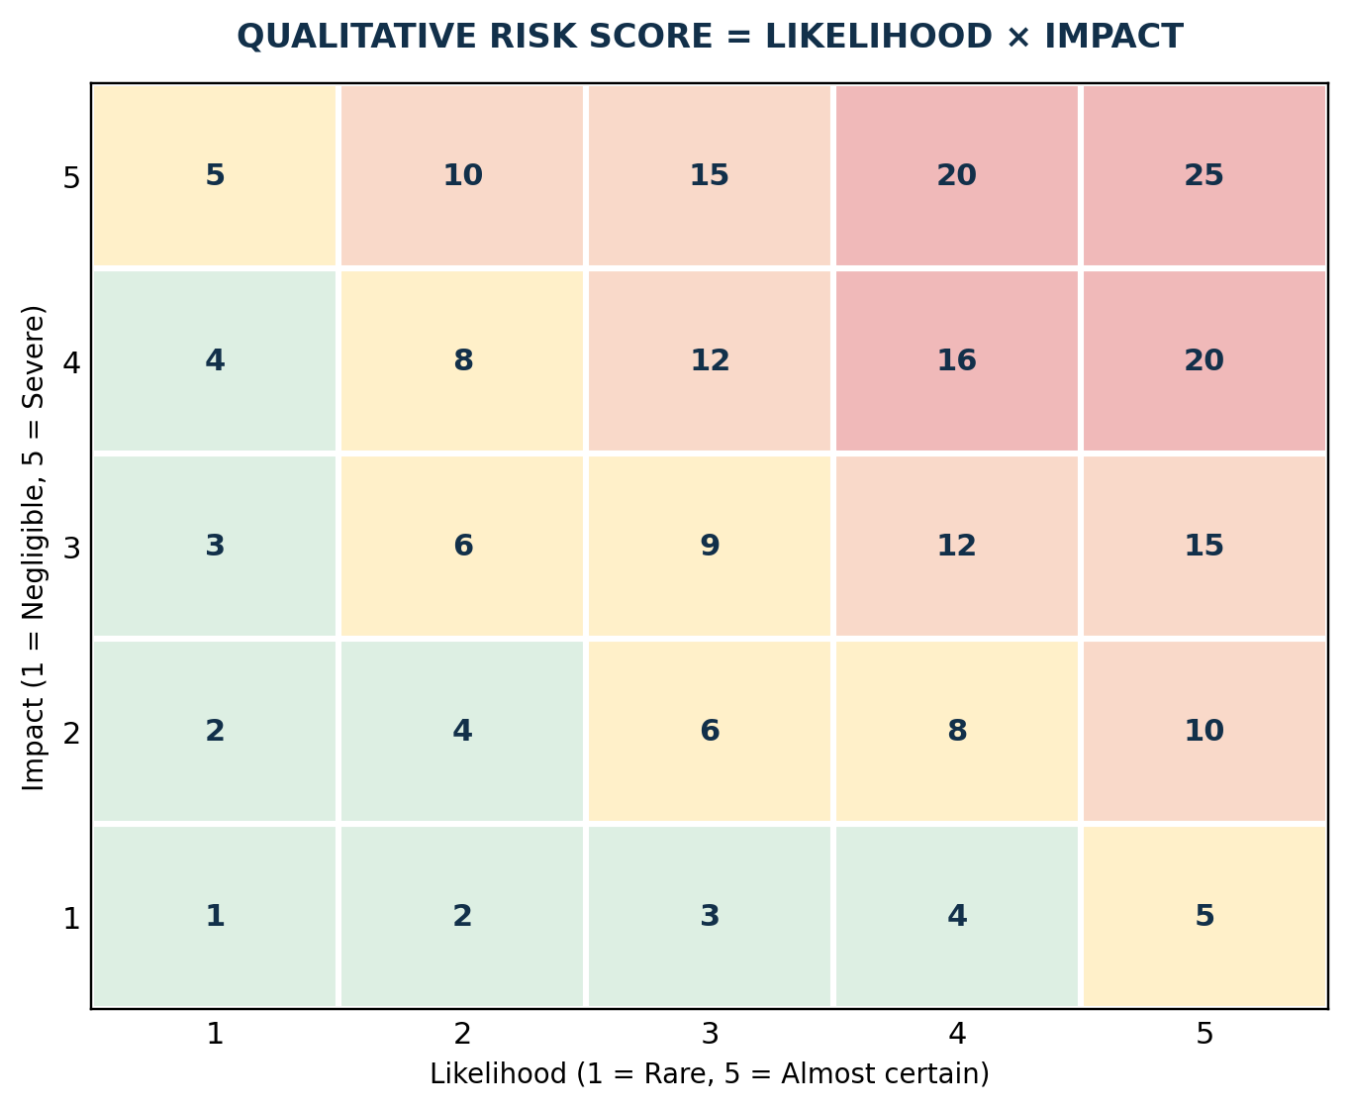
Figure 1. Qualitative risk scoring grid. Each cell shows impact × likelihood.

4.2 Critical assets and trust boundaries
Asset / service | Security priority | Risk questions
Identity provider and administrator accounts | Critical | Can a compromised account reach multiple services? Is MFA enforced? Are emergency accounts monitored?
Citizen records and document stores | Critical / high | What personal data is present? Who can read, change or export it? Can access be audited?
Public portal and APIs | High / critical | What is exposed to the internet? Are object-level authorisation and rate limiting tested?
Payment and benefit workflows | Critical | Can amounts, payees, status or eligibility be altered without authorisation? What is the reconciliation process?
DNS, network edge and hosting | High / critical | Can denial-of-service or misconfiguration interrupt all services? Are changes controlled?
Backups, cryptographic keys and recovery systems | Critical | Can ransomware or an administrator delete recovery copies? Are restores tested?
Supplier access and shared integrations | High / critical | Can one supplier or integration compromise multiple departments? Are access and exit rights controlled?

4.3 Threat scenario walkthrough: ransomware affecting a citizen portal
- Initial access: a staff member is phished, a vulnerable public-facing component is exploited, or a supplier account is compromised.
- Privilege escalation and movement: the attacker abuses excessive permissions or weak network segmentation to reach application servers and administration tools.
- Impact: records or backups are encrypted, data may be exfiltrated, and the citizen portal becomes unavailable.
- Detection opportunities: endpoint alerts, unusual identity activity, unexpected mass file access, abnormal database exports, backup deletion attempts and network traffic anomalies.
- Prevention and containment: MFA, patching, least privilege, EDR, segmentation, protected backup credentials, network isolation and pre-approved blocking actions.
- Recovery: preserve evidence; validate clean backups; restore in a controlled environment; confirm record integrity; prioritise essential citizen workflows; communicate verified service status; conduct a lessons-learned review.

5. Prioritised Risk Register
The ratings below represent an initial planning baseline for a hypothetical digital government environment, not measured findings. Residual risk should be reviewed after controls are implemented and tested.
ID | Risk event | L | I | Inherent score | Main exposure | Treatment / key controls | Accountable owner | Target
R1 | Compromise of privileged or staff accounts | 4 | 5 | 20 Critical | MFA coverage gaps; excessive privileges; social engineering. | MFA, PAM, least privilege, privileged session logging, phishing-resistant methods where feasible. | Head of IT / IAM Lead | 30-90 days
R2 | Exploitation of public application or API | 4 | 5 | 20 Critical | Broken access control, injection, vulnerable components, inadequate release assurance. | Inventory APIs; threat model; secure SDLC; SAST/DAST/dependency scanning; independent audit; remediation SLA. | Application Owner / CISO | 0-180 days
R3 | Ransomware disrupts critical service | 4 | 5 | 20 Critical | Weak segmentation, endpoint compromise, accessible backups. | EDR, network segmentation, controlled admin access, immutable/offline backups, recovery exercises. | IT Operations / SOC | 0-180 days
R4 | Personal data breach or unauthorised export | 3 | 5 | 15 High | Excessive access, poor data classification, storage misconfiguration. | Data mapping/minimisation; encryption; access monitoring; export controls; privacy incident playbook. | Data Owner / Privacy Lead | 0-180 days
R5 | DDoS or infrastructure outage | 4 | 4 | 16 Critical | High traffic concentration, resource exhaustion, dependency failure. | DDoS service, WAF, rate limiting, capacity planning, alternate communication, failover plan. | Service Owner / Hosting Provider | 0-120 days
R6 | Supplier or software supply-chain compromise | 3 | 5 | 15 High | Weak vendor access, unreviewed components, unverified updates. | Risk-tiered due diligence, contract clauses, SBOM where feasible, signed build artifacts, supplier access expiry. | Procurement / Vendor Owner | 0-270 days
R7 | Cloud or hosting misconfiguration | 3 | 5 | 15 High | Public storage, exposed secrets, permissive service identities, disabled logging. | Baseline templates, CSPM/config checks, secrets management, least privilege and change approvals. | Cloud / Hosting Lead | 0-180 days
R8 | Insider misuse or record tampering | 3 | 4 | 12 High | Shared accounts, inadequate audit trails, no separation of duties. | Named accounts, role design, dual control, immutable logs, exception review and periodic access recertification. | Department Head / Data Owner | 30-180 days
R9 | Incident reporting or evidence preservation failure | 3 | 4 | 12 High | Unclear ownership, late escalation, incomplete or short-retention logs. | CERT-In/NIC-CERT decision tree, 24×7 contacts, 180-day log baseline where applicable, evidence procedure and exercise. | Incident Commander / Legal | 0-60 days
R10 | Digital service unavailable after disaster | 3 | 5 | 15 High | Untested recovery, shared failure domains, incomplete runbooks. | Business impact analysis, approved RTO/RPO, isolated backup copies, annual DR drills and dependency mapping. | Service Continuity Owner | 0-365 days
R11 | Fraudulent content or defaced website | 3 | 4 | 12 High | Compromised CMS/editor account, poor change approval. | MFA and role separation, content approval, integrity monitoring, rollback and citizen communication playbook. | Web Publisher / App Owner | 30-120 days
R12 | Citizen harm from confusing or inaccessible security controls | 3 | 3 | 9 Moderate | Inaccessible CAPTCHA/authentication, unclear outage notices, exclusion of low-bandwidth users. | Accessible MFA alternatives, GIGW/WCAG testing, assisted channel, multilingual service notices and usability testing. | Service Design / Accessibility Lead | 90-270 days

Priority recommendation: Start with identity security, external attack surface, logging/incident reporting, protected backups and application/API security. These measures reduce several high-consequence scenarios at once and create the baseline for more advanced monitoring.

6. Strategic Control Plan

6.1 Govern: ownership, risk and assurance
- Appoint a senior accountable executive and a security lead (CISO or equivalent) with authority to escalate material risks. Create a cross-functional cybersecurity steering group including IT, application owners, legal/privacy, procurement, business continuity, communications and service delivery.
- Approve a concise policy baseline covering acceptable use, access control, data classification, logging, vulnerability management, secure development, incident response, backup, supplier security, remote access and exception handling.
- Maintain a single risk register. Each item must have an owner, treatment decision, due date, evidence and residual-risk acceptance signed by an authorised official. Exceptions must expire and be reviewed.
- Integrate security and privacy requirements into project initiation, procurement, design approval, change management and production release. Budget for operations and maintenance, not only one-time implementation.

6.2 Identify: assets, data and dependencies
- Maintain an owner-backed inventory of domains, IP ranges, applications, APIs, cloud accounts, endpoints, software, data stores, certificates, service identities and suppliers. Discover internet-facing assets continuously where tools allow.
- Classify information by sensitivity and service criticality; identify personal data, high-impact records, payment/benefit transactions, cryptographic material and records requiring statutory retention.
- Map end-to-end data flows and service dependencies, including identity providers, payment gateways, SMS/email gateways, document repositories and other government platforms. Document manual fallback where dependencies fail.
- Conduct a business impact analysis for critical services and set approved recovery time objectives (RTOs) and recovery point objectives (RPOs).

6.3 Protect: identities, data, applications and infrastructure
Control area | Recommended baseline | Implementation notes
Identity and access | MFA for all administrators and remote access; prioritise MFA for all staff and citizen accounts where proportionate. Use RBAC, least privilege, managed service identities, strong account recovery and quarterly privileged-access review. | Avoid shared admin accounts. Store emergency credentials securely, monitor use and test lockout/recovery paths.
Data protection | TLS in transit; encryption at rest for sensitive stores and backups; central key management; secrets vault; data minimisation; retention/deletion rules; controlled exports. | Key access should be separate from data access. Do not place passwords, tokens or personal data in application logs.
Application and API security | Threat modelling; secure coding; code review; dependency scanning; secret scanning; SAST/DAST; API authentication and object-level authorisation tests; input validation; secure session management. | Risk-based testing before release and after significant code changes; remediation evidence must be retained. Follow current OWASP guidance and GIGW requirements.
Internet edge and network | WAF, DDoS protection, secure DNS, rate limiting, network segmentation, secure remote access and deny-by-default administrative paths. | Protect high-risk endpoints and APIs; review rules, exceptions and traffic patterns regularly.
Endpoint and server | Supported operating systems, central patching, EDR/anti-malware, hardening baselines, local admin reduction, secure configuration and vulnerability scans. | Prioritise actively exploited and internet-facing vulnerabilities; record compensating controls when immediate patching is unsafe.
Cloud and hosting | Separate development/test/production; central identity; configuration monitoring; private storage by default; immutable audit logs; protected secrets; controlled changes. | GIGW 3.0 calls for suitable hosting security, monitoring, backups and applicable log retention; verify current hosting contract and official requirements.
Backups and recovery | 3-2-1-oriented backup design where feasible; at least one logically isolated or immutable copy; protected credentials; routine restore tests; runbook and recovery environment. | Back up configuration, identity dependencies and data. Confirm restoration integrity, not merely backup job success.
People and process | Role-based security training; phishing exercises used for learning; secure handling of records; joiner/mover/leaver workflow; supplier awareness. | Train staff to report suspicious events immediately without blame. Give developers secure coding and API-specific training.

6.4 Detect: central logging, alerting and analysis
Build monitoring from a defined use-case list rather than collecting logs without operational purpose. Centralise important events from identity systems, administrator actions, endpoints, firewalls/WAF, DNS, VPN, cloud control planes, critical servers, APIs and databases. Synchronise time, restrict log access, protect integrity, document retention, and forward relevant events to a SIEM or shared SOC capability. If a full 24×7 SOC is not feasible immediately, start with critical assets, an on-call escalation rota and an approved shared monitoring service.
Initial detection use case | Signal examples | First response
Privileged identity misuse | New admin, impossible/atypical login, MFA fatigue, emergency account use. | Validate with account owner; suspend or step up authentication; preserve identity logs.
Data exfiltration / abnormal access | Bulk export, unusual query volume, repeated denied access, access outside normal role. | Confirm business need; disable token or export path if warranted; preserve database and API records.
Ransomware indicators | Mass file changes, suspicious encryption behavior, endpoint alert, backup deletion attempt. | Isolate affected host using approved procedure; protect backups; activate incident commander.
Web/API attack | WAF spikes, repeated 4xx/5xx, injection patterns, IDOR-like access anomalies, token abuse. | Rate-limit/block where safe; inspect correlated application and identity logs; assess record exposure.
Configuration drift | Public storage, disabled audit logs, exposed secret, permissive firewall rule. | Revert or restrict configuration; rotate exposed secret; open a tracked remediation item.
Service availability degradation | Latency and error-rate increase, DDoS alerts, dependency timeouts. | Activate service runbook; engage hosting/provider; issue verified status updates and prioritise core flows.

6.5 Respond and recover
Maintain a common incident process but tailor playbooks for account compromise, ransomware, data breach, DDoS, website defacement, cloud-key exposure and supplier incidents. Define the incident commander, technical lead, legal/privacy lead, service owner, communications lead and authorised reporting contact. Establish evidence-handling steps and reporting decision points, including CERT-In and NIC-CERT channels where applicable. Communications should be approved, timely, factual and accessible; do not disclose sensitive investigative details or speculate about attribution.

6.6 Secure suppliers and software supply chain
- Classify suppliers by data sensitivity, system privileges, service criticality and substitutability; apply enhanced due diligence to vendors with production access or citizen-data access.
- Include contract clauses for security incident notification, cooperation with investigations, log availability, vulnerability remediation, subcontractor controls, audit evidence, data return/deletion and secure termination.
- Use named, time-bounded supplier accounts with MFA, approved remote access, session logging, restricted network paths and periodic entitlement reviews.
- Require secure build and release practices. Use a software bill of materials (SBOM) and artifact-signing controls where feasible and appropriate to risk. Evaluate third-party components and patch ownership.
- Plan exit and continuity for critical supplier dependencies. Avoid assuming that vendor certification alone proves an integration is secure.

7. Target-State Security Architecture
Figure 2 illustrates a logical target state, not a required product stack. Departments may use approved government platforms, existing NIC/State Data Centre services, commercial services or a shared SOC where permitted by applicable policy. The essential design principle is layered controls with clear ownership and observable security events.
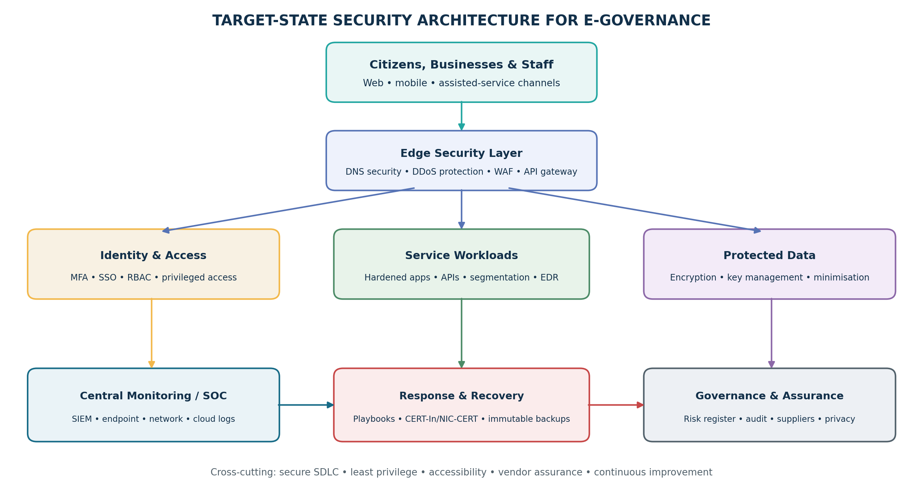
Figure 2. Logical security architecture for citizen-facing and administrative digital services.

7.1 Architecture decisions
Decision | Recommended principle | Reason / trade-off
Public entry points | Route through managed DNS, DDoS controls, WAF and API gateway where appropriate. | Reduces exposure and gives shared control points; must be configured to avoid blocking legitimate or assistive-technology traffic.
Identity boundary | Centralise identity where practical; apply MFA, least privilege and workload identity. | Reduces inconsistent account security; requires resilient identity service and well-tested fallback.
Segmentation | Separate public-facing, application, database, admin and recovery zones. | Limits lateral movement; additional routing and policy management are required.
Telemetry | Send security-relevant logs to controlled central monitoring. | Enables correlation; storage, privacy, access and alert-fatigue need governance.
Data stores | Minimise sensitive data; encrypt and restrict access; keep keys separate. | Reduces impact of compromise; key recovery, application latency and operational controls must be designed.
Resilience | Use independent recovery copies and test end-to-end recovery. | Limits downtime; requires additional cost, capacity and disciplined recovery procedures.

8. Incident Response, Reporting and Business Continuity
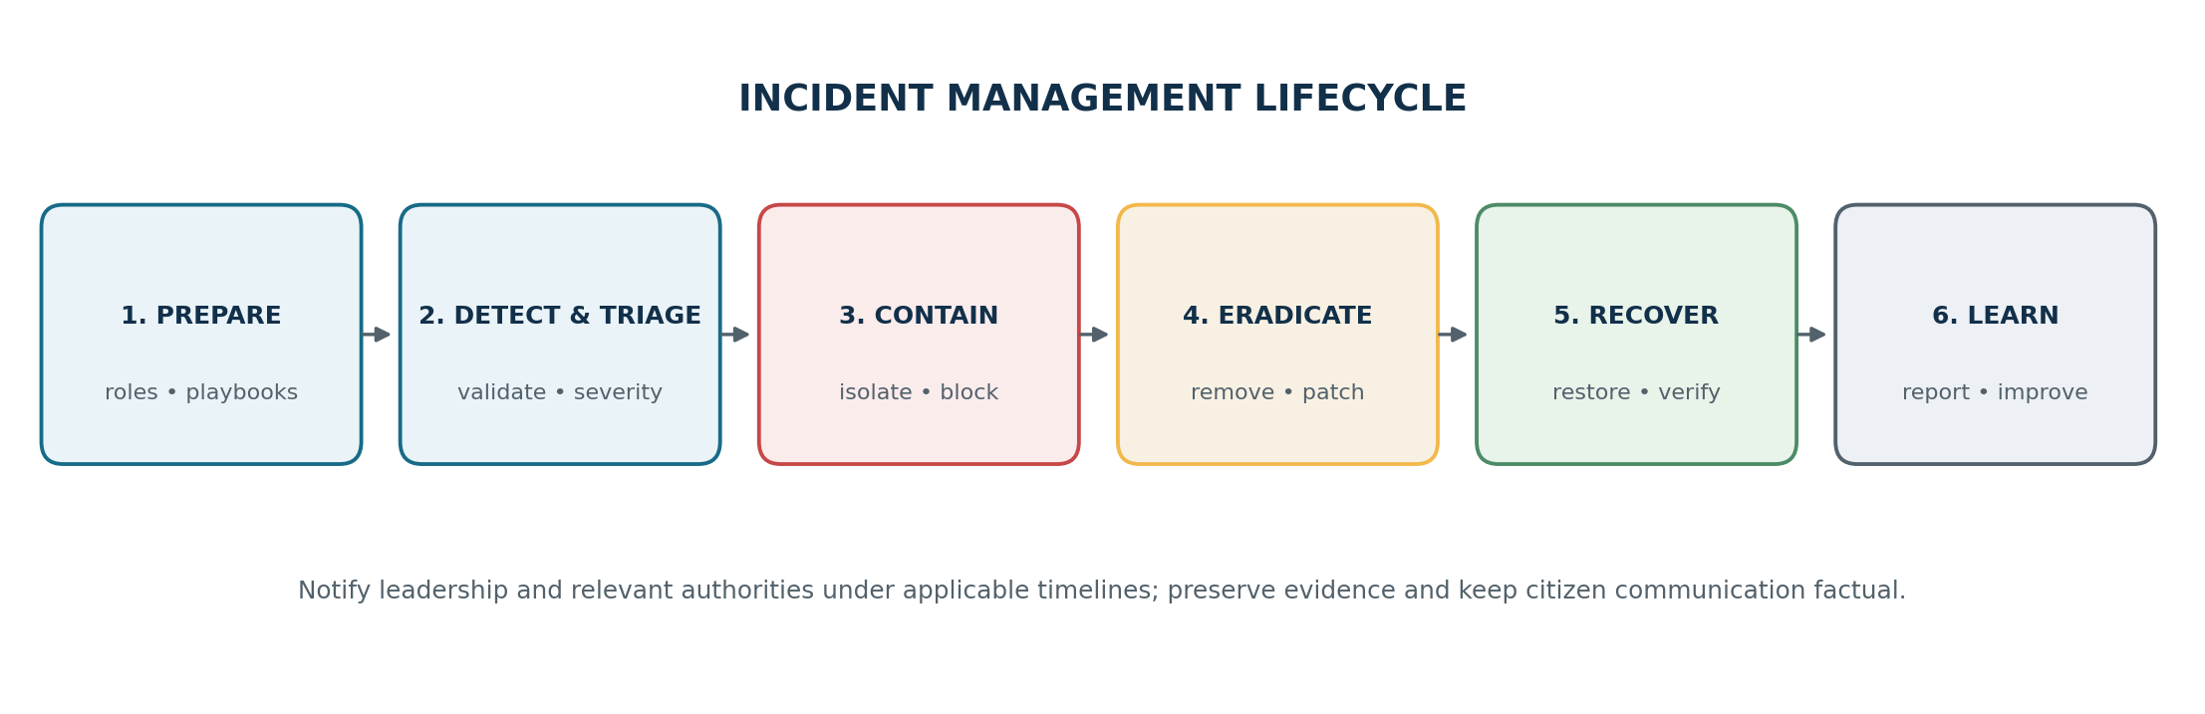
Figure 3. Incident management lifecycle.

8.1 Minimum incident playbook contents
- Purpose, scope, severity definition and examples of critical service or citizen impact.
- Primary/alternate contacts, on-call responsibilities, delegated authority, legal/privacy and communications escalation.
- Triage questions: what service and data are affected; what is known; what is uncertain; whether containment could interrupt essential service; and which external parties must be notified.
- Containment options with approvals: disable an account/token, isolate an endpoint, block a malicious source, restrict an API, roll back a release or fail over service.
- Evidence preservation: record timestamps and actions; preserve relevant identity, application, endpoint, network and cloud logs; calculate hashes for collected evidence where appropriate; restrict access and maintain chain of custody.
- External reporting decision tree: identify the applicable CERT-In incident category and deadline; notify NIC-CERT/hosting provider/sector authority as applicable; coordinate privacy breach notifications under the provisions in force at the time.
- Recovery validation: restore from a clean source, rotate credentials and keys as necessary, scan recovered assets, validate data integrity and business transactions, then obtain service-owner sign-off.
- Post-incident review within a defined period: timeline, root causes, impact, response gaps, actions, owners and dates. Share lessons without exposing sensitive information.

8.2 Continuity and recovery targets
Set RTO and RPO per service through a business impact analysis rather than applying one target everywhere. A public information website may tolerate a different outage window from a benefit-payment service or a citizen identity service. Recovery planning must include DNS, identity, certificates, network routes, secrets, third-party APIs, operational runbooks, staff availability and citizen communication, not only application servers and databases.
Service tier (illustrative) | Example service | Planning target approach | Minimum validation
Tier 1: mission-critical | Benefit/payment workflows, identity dependencies | Leadership-approved aggressive RTO/RPO based on legal and citizen impact; tested failover or recovery path. | At least annual end-to-end recovery exercise; restore transaction integrity and reconcile records.
Tier 2: important | Certificates, licences, application status, document workflows | Documented recovery window aligned with service obligations and available alternatives. | Restore drill and dependency test at least annually; verify access and audit trail.
Tier 3: standard | Public information content, lower-impact internal utilities | Longer approved restoration window may be acceptable if public information remains accurate and alternative channels exist. | Backup restore test, domain/content integrity and service status process.

9. Twelve-Month Implementation Roadmap
The proposed roadmap deliberately front-loads basic protections and governance, then expands into application security, monitoring, resilience and assurance. Sequencing should be adjusted to the agency’s risk profile, procurement lead times, existing contracts and statutory deadlines.
Phase / timing | Priority actions | Deliverables / exit criteria | Owner(s) | Priority
Phase 0: Days 0-30 | Name accountable executive and security lead; establish steering group; identify critical services and known external exposure; confirm incident contacts and reporting procedure; verify backups and urgent patch status; check MFA for administrators. | Approved charter; initial asset and service list; contact tree; critical exposure backlog; emergency access/backup check. | Department leadership, IT head, security lead | P0 Immediate
Phase 1: Days 31-90 | Build asset/data inventory; classify data; baseline privileged access; centralise critical identity/WAF/endpoint/OS logs; define vulnerability SLAs; review internet-facing apps/APIs; write ransomware/data-breach/DDoS playbooks. | Initial risk register; privileged access review; minimum monitoring; response playbooks; backup restore evidence; security audit plan. | Security lead, service owners, hosting provider | P0/P1
Phase 2: Months 3-6 | Run risk-based VA/PT; close critical/exploited findings; deploy or tune WAF/API protection; segment admin and recovery systems; establish secure SDLC gates; improve encryption, secrets and export controls; run tabletop incident exercise. | Remediation evidence; tested release gates; network segmentation plan/results; tabletop report; data flow register; defined RTO/RPO for Tier 1. | Application owners, IT operations, SOC, privacy/legal | P1
Phase 3: Months 6-9 | Integrate more logs and alert use cases; formalise supplier risk tiers and contract clauses; implement configuration monitoring; test restoration of Tier 1 service; rehearse external notification and public communications. | Monitoring coverage report; supplier register; control exceptions with expiry; DR exercise report; communications templates. | SOC, procurement, continuity lead, communications | P1/P2
Phase 4: Months 9-12 | Perform independent assurance against GIGW/target profile; measure residual risk; test cross-department dependencies; train roles; report KPI trend; approve year-two roadmap and budget. | Target-profile gap assessment; updated risk register; management review; next-year investment plan; audit and remediation closure evidence. | Steering group, internal audit, service owners | P2
Continuous after Month 12 | Monthly vulnerability and alert review; quarterly risk and access review; annual service continuity exercise; update threat scenarios and legal applicability; repeat audit after major change. | Evidence of continual improvement and risk acceptance decisions. | All control owners | Ongoing

9.1 Priority levels
Level | Meaning | Examples
P0 | Urgent risk reduction or minimum compliance foundation. | Admin MFA; incident contacts/reporting flow; critical vulnerability triage; reliable backups; owner for each critical service.
P1 | High-value security controls required to reach a durable baseline. | Central logs; risk-based VA/PT; application/API security; segmentation; EDR; incident tabletop.
P2 | Maturity and resilience improvements after critical gaps are managed. | Broader SIEM use cases; automated configuration policy; supplier assurance expansion; advanced threat hunting and metrics.

10. Resource Allocation and Operating Model

10.1 Illustrative staffing model
A smaller department may share security operations and specialist services with an approved government SOC, NIC-CERT or managed provider rather than building every capability in-house. FTE values below are illustrative planning ranges for a medium-sized department or a shared multi-service environment, not a mandatory staffing standard. A critical national or state platform may need substantially more dedicated coverage.
Role / capability | Indicative allocation | Core responsibilities | Delivery model
Executive sponsor / service risk owners | 0.1-0.3 FTE combined | Risk acceptance, prioritisation, service impact decisions, budget and accountability. | Internal leadership
Security lead / CISO function | 1.0 FTE | Strategy, risk register, controls, audit coordination, reporting and security exceptions. | Internal or formally assigned shared function
Security operations / SOC analysts | 2-4 FTE equivalent or contracted shared coverage | Alert triage, incident coordination, threat detection, logging and escalation. | Shared SOC/managed service can reduce initial staffing burden
Infrastructure / cloud / endpoint engineers | 1-3 FTE across teams | Patching, hardening, network rules, EDR, configuration baselines, backups and recovery. | Internal service team plus hosting provider
Application security / secure development | 1-2 FTE equivalent | Threat modelling, pipeline checks, secure design, test coordination and remediation support. | Internal champion plus specialist testing provider
Privacy/legal and compliance | 0.2-0.8 FTE combined | Data protection, regulatory interpretation, evidence preservation, notifications and contracts. | Internal legal/privacy lead; consult specialists as needed
Procurement / vendor / continuity coordination | 0.3-1.0 FTE combined | Supplier assurance, contract controls, BCP/DR coordination and exercises. | Internal business functions
Independent audit / penetration testing | Planned external engagement | Independent security assessment, retesting and audit evidence. | NIC/STQC or suitably qualified / CERT-In-empanelled lab as applicable

10.2 Budget allocation principles
Because system count, hosting model, procurement rules and current maturity are unknown, this report avoids inventing a rupee budget. The agency should obtain quotes and estimate total cost of ownership over three years, including licences, integration, staff, support, training, testing, storage, incident retainer, backup capacity and exit costs. An illustrative first-year allocation of the incremental cybersecurity budget is shown below; percentages should be tailored after the baseline assessment.
Investment category | Illustrative share | Why it matters
Identity, endpoint, patching and secure configuration | 20% | Reduces common initial access and lateral movement risk.
Monitoring, logging and incident response | 20% | Improves detection, evidence preservation and escalation.
Application/API security and independent testing | 18% | Reduces risk in public-facing services and release changes.
Backup, disaster recovery and resilience | 17% | Limits downtime and improves restoration confidence.
Network edge, segmentation and hosting hardening | 12% | Controls internet exposure and reduces attack spread.
People, supplier assurance and exercises | 8% | Reduces process, human and third-party risk.
Contingency and remediation reserve | 5% | Allows urgent fixes and unexpected requirements.

These percentages are an example allocation, not market pricing or a requirement. The risk owner should adjust funding if critical applications, regulatory deadlines, existing capabilities or major architecture gaps justify a different allocation.

10.3 Responsibility and decision rights
Activity | Accountable | Responsible / consulted
Cybersecurity strategy and risk appetite | Department head / governing committee | Security lead; service owners; finance; legal/privacy
Asset inventory and classification | Service/data owner | IT operations; application team; data stewards
Secure application release | Application/service owner | Developer; QA; security lead; independent tester
Incident command and reporting | Named incident commander / designated authority | SOC; IT; legal/privacy; communications; CERT-In/NIC-CERT contacts as applicable
Business continuity and disaster recovery | Business continuity owner | Service owner; hosting provider; data centre; communications
Supplier security and exit planning | Contract owner / procurement authority | Security lead; legal; service owner; supplier
Residual high/critical risk acceptance | Authorised senior official | Risk owner; security lead; legal/compliance as needed

11. Risk, Impact and Feasibility Analysis

11.1 Expected risk reduction and public impact
Proposed action | Expected risk effect | Public / operational impact | Feasibility
MFA and privileged access control | Reduces account-takeover and abuse of privileged roles. | Less unauthorised access and stronger traceability. | High; prioritise administrators and remote access first, plan citizen usability carefully.
Asset inventory + vulnerability management | Reduces unknown exposure and time-to-remediation. | Fewer avoidable outages and exploitable weaknesses. | High to medium; needs asset owners, reliable scanning and maintenance windows.
Secure SDLC and independent audit | Reduces design/code flaws before release. | Protects citizen records and transaction integrity. | Medium; may change project timelines and require developer training.
Central logs and incident playbooks | Improves speed and quality of detection, escalation and reporting. | Can shorten disruption and improve evidence-based communications. | Medium; alert tuning, staffing and log storage are ongoing costs.
Protected backups and tested recovery | Reduces likelihood of prolonged service loss after ransomware or destructive events. | Faster restoration and continuity of essential services. | High to medium; actual recovery testing is essential and may require extra capacity.
Supplier assurance and segmentation | Reduces third-party blast radius and shared dependency risk. | Improves cross-service resilience and accountability. | Medium; contracts and architecture may need renegotiation or phased change.
Accessible citizen authentication and communications | Reduces exclusion and confusion when controls or incidents affect service access. | Maintains access for people using assistive technology, low-bandwidth channels or assisted service. | Medium; requires user testing, alternate flows and service design coordination.

11.2 Key constraints and mitigation
- Legacy applications and end-of-life systems: isolate them, restrict access, apply compensating controls, schedule replacement and document risk acceptance with a date.
- Procurement lead times and limited budgets: begin with policy, MFA for privileged access, exposed-asset cleanup, backups and incident contacts while procurement proceeds; use approved shared services where appropriate.
- Security skills gap: use standardised baselines, external tests and shared SOC services, while developing named internal control owners to avoid total vendor dependence.
- Availability concerns from security changes: test in staging, use canary/rollback plans, set maintenance windows and monitor user impact; do not deploy untested blocking rules across critical services.
- Alert fatigue: begin with a small set of high-value detections, define clear severity and ownership, tune false positives and review outcomes monthly.
- Privacy and excessive monitoring: collect only logs needed for security and legal requirements, restrict access, specify retention and review whether telemetry includes unnecessary personal data.
- Inter-departmental dependency risk: document service-level commitments, escalation contacts, joint exercise arrangements and manual fallback options.
- Legal transition and changing guidance: have counsel/compliance track DPDP commencement, CERT-In updates, GIGW changes and sector-specific instructions; update procedures and contract clauses accordingly.

11.3 Feasibility judgement
The strategy is feasible if leadership sponsors risk-based implementation and treats the roadmap as an operating programme rather than a one-time purchase. Its highest-return early steps rely more on ownership, configuration, identity security, inventory and tested process than on expensive tooling. Specialist monitoring, independent testing and disaster recovery may require procurement and recurring cost, but these can be scaled through approved shared services. Feasibility is lowest where asset ownership is unclear, legacy systems cannot be patched, no staff member is accountable for incidents, or service providers cannot supply logs and recovery evidence; these are governance and contract issues as much as technical ones.

12. Performance Measures and Review
Metrics should measure risk reduction and service outcomes, not just product deployment. Establish a baseline during the first 30-60 days, then set targets approved by service owners. Avoid reporting a percentage without defining the denominator, measurement window and exceptions.
Measure | Definition / calculation | Initial target direction | Review
Critical asset ownership | Percentage of critical assets with named owner, service tier and inventory record. | 100% of known Tier 1 assets assigned by Day 90. | Monthly
Privileged MFA coverage | Privileged and remote access accounts with enforced MFA ÷ total in scope. | 100% of privileged/remote access; document approved exceptions. | Monthly
Critical vulnerability SLA | Critical findings remediated or protected by approved compensating control within defined SLA ÷ critical findings. | Set SLA by exposure and exploitability; trend toward full compliance. | Weekly/monthly
Internet-facing audit status | Critical public services with current required security audit/clearance and closed critical findings. | All production services in scope have documented status. | Monthly / release gate
Critical log coverage | Critical systems sending required security logs to monitored storage ÷ critical systems. | Prioritise identity, edge, endpoint, server, cloud and database events. | Monthly
Detection and containment time | Median time from observable signal to triage; and from confirmed incident to containment. | Baseline first; improve quarter over quarter. | Monthly / after incident
Backup restoration success | Successful restore tests ÷ restore tests performed, with integrity checks. | All Tier 1 recovery tests successful or corrective plan approved. | Quarterly / annual DR
Incident exercise completion | Critical playbooks exercised and action items closed. | At least one tabletop in first six months; close high-priority findings. | Quarterly
Access review completion | High-risk role/access reviews completed by deadline ÷ reviews planned. | 100% for privileged and sensitive-data access. | Quarterly
Supplier assurance coverage | Critical suppliers with risk tier, security clauses, contacts and continuity assessment. | All critical suppliers mapped and reviewed. | Quarterly
Citizen-facing service availability | Service uptime and successful transaction rate against agreed service objectives. | Targets approved per service tier; publish verified status during incidents. | Monthly
GIGW/privacy remediation status | Open high/critical findings from applicable audits or privacy reviews. | No unresolved critical finding without formal risk acceptance and compensating control. | Monthly / quarterly

12.1 Review cadence
Cadence | Forum | Purpose
Weekly | Security/IT operations | Critical vulnerabilities, major alerts, overdue response actions and changes.
Monthly | Cybersecurity steering group | KPI trends, risk register, audit findings, incidents, suppliers and budget constraints.
Quarterly | Senior management / risk committee | Residual high/critical risk acceptance, service continuity, legal updates and roadmap re-prioritisation.
Annually and after major incidents | Management review / independent assurance | Update threat model, test disaster recovery, reassess policy and confirm next-year investment.

13. Conclusion and Immediate Action Plan
Cybersecurity for e-governance is ultimately about protecting people’s ability to access government services safely and reliably. A strategy limited to firewalls or antivirus would leave critical gaps in identity, application design, supplier access, privacy, detection and recovery. The recommended programme combines clear governance with layered technical controls and tested operating procedures. NIST CSF 2.0 provides a flexible management structure, while GIGW 3.0, CERT-In directions and applicable Indian law provide important local requirements and guidance.
The immediate action plan is to: (1) appoint a senior sponsor, security lead and service risk owners; (2) identify the Tier 1 services, accounts, public endpoints, data stores and suppliers; (3) enforce MFA for privileged and remote access; (4) verify backups and restore one critical service; (5) confirm incident escalation/reporting contacts and preserve relevant logs; (6) establish vulnerability triage and a plan for security audits of public-facing systems; and (7) approve a 90-day remediation backlog with weekly ownership review. The department should then execute the remaining roadmap, measure risk reduction and revisit priorities as threats, services and legal requirements change.
Decision requested: Approve the 12-month phased roadmap; assign accountable owners; authorise urgent P0 controls and an initial risk-based assessment; and require monthly reporting of critical risks, remediation progress and service resilience.

References
[1] Indian Computer Emergency Response Team (CERT-In). “Directions under Section 70B of the Information Technology Act, 2000.” Includes directions dated 28 April 2022 and related FAQs. Official source
[2] CERT-In. “Frequently Asked Questions on Cyber Security Directions of 28.04.2022.” Official source
[3] Government of India, India Code. “Digital Personal Data Protection Act, 2023.” Official source
[4] Ministry of Electronics and Information Technology (MeitY). “Digital Personal Data Protection Rules, 2025,” Gazette of India Extraordinary, November 2025; check official corrigenda and enforcement timeline. Official source
[5] Guidelines for Indian Government Websites and Apps (GIGW 3.0), developed/hosted by NIC with MeitY and STQC/CERT-In involvement. See security guidelines and attributes. Official source
[6] OWASP Foundation. “OWASP Top 10:2025 – The Ten Most Critical Web Application Security Risks.” Official source
[7] National Institute of Standards and Technology (NIST). “NIST Releases Version 2.0 of Landmark Cybersecurity Framework,” 26 February 2024. Official source
[8] NIST. “The NIST Cybersecurity Framework (CSF) 2.0,” official publication. Official source
[9] W3C. “Web Content Accessibility Guidelines (WCAG) 2.1.” Official source
[10] International Organization for Standardization. “ISO/IEC 27001:2022 Information security management systems — Requirements.” Official source
Access date for online sources: 18 October 2026. Official guidance and legislation may be updated after this date; verify the current source before operational use.

