Redis Spring notes

https://github.com/Java-Techie-jt/spring-data-redis
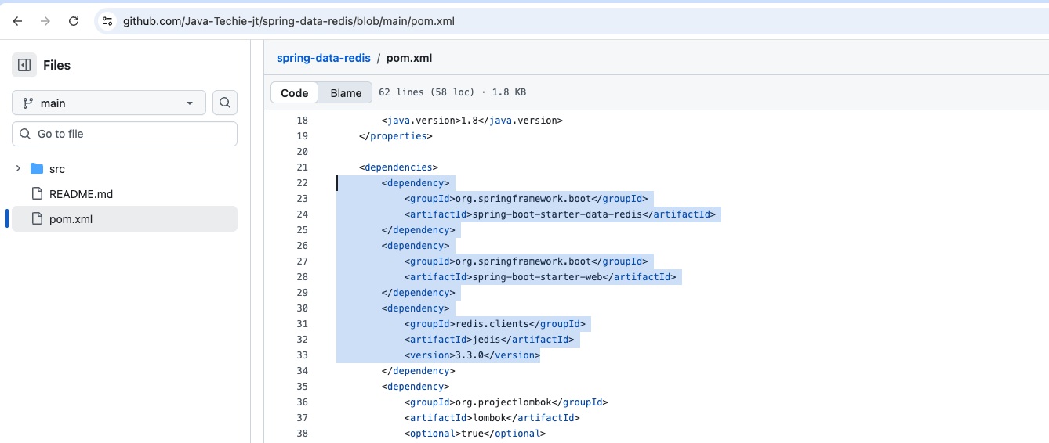
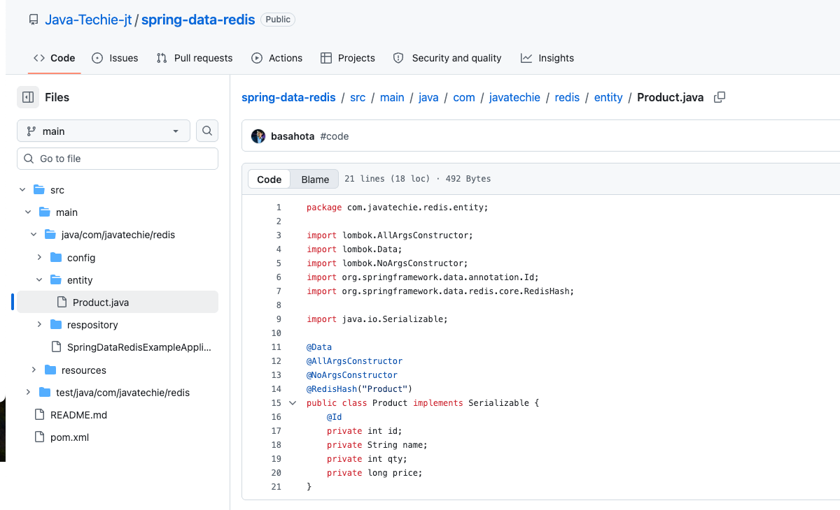

Jedis is to connect our application to Redis server
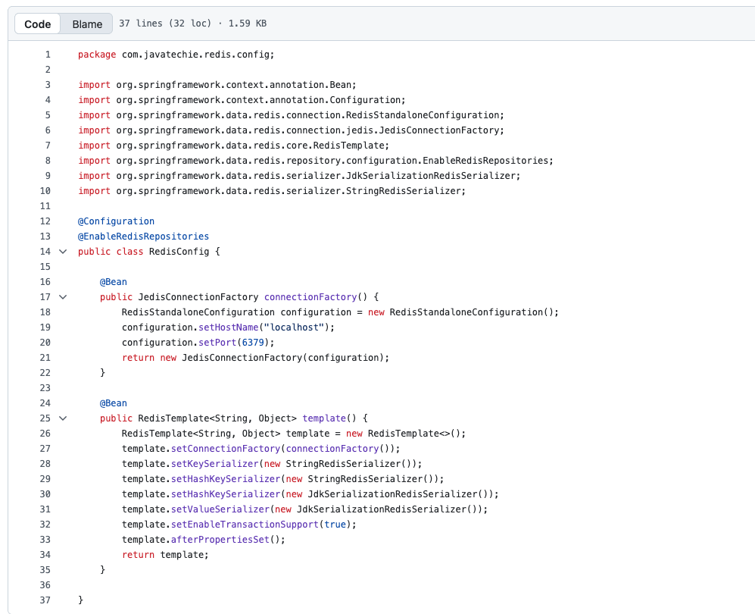

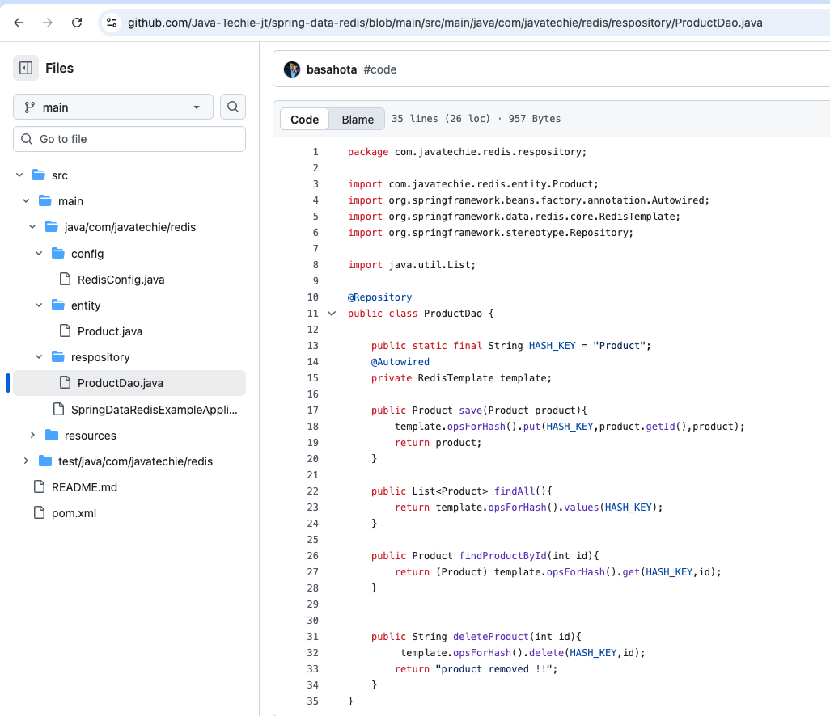

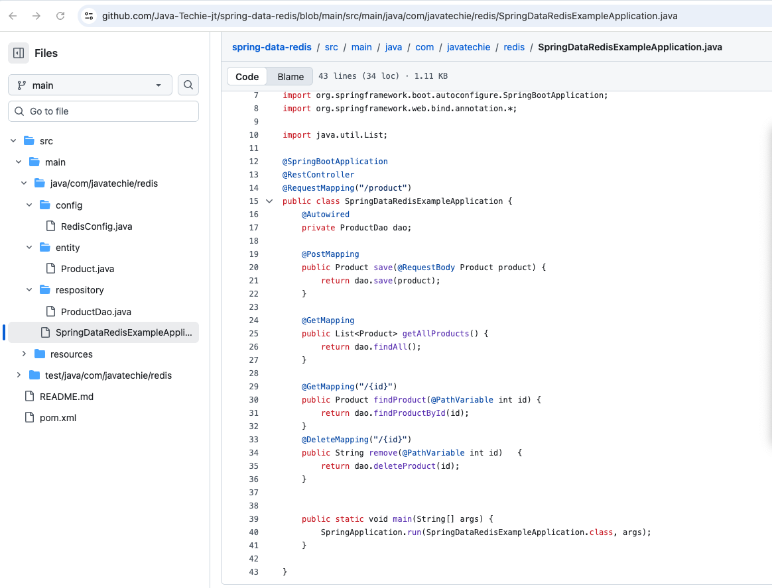
Test these endpoints – so that and we come to know how redis can be use as database.
Now let us focus on how to use it as cache

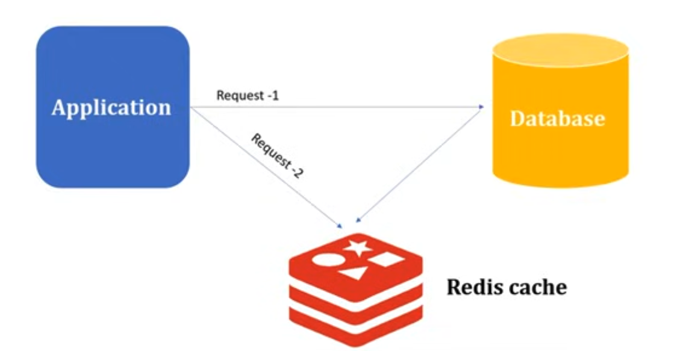


Add Enable Caching annotation (line number 18)
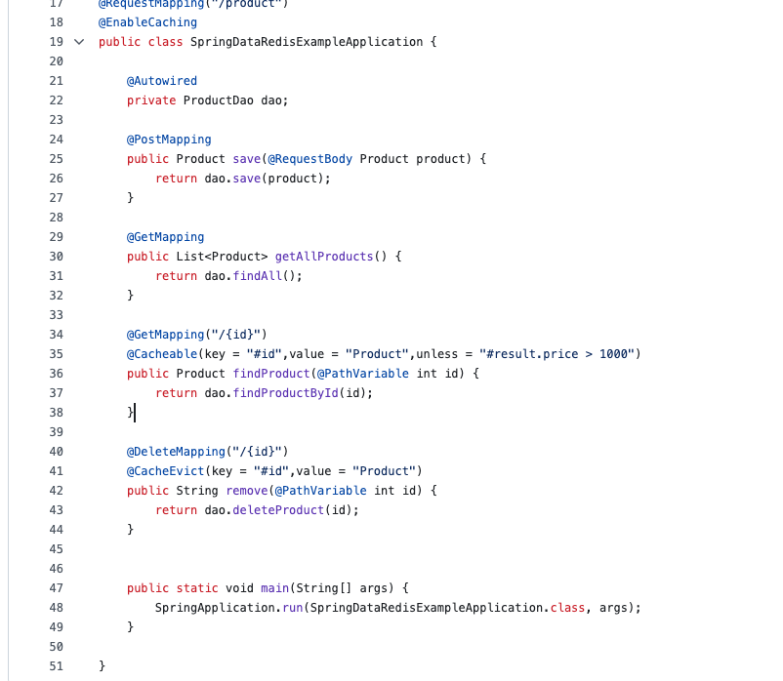
And either in the controller or in the service layer add
@cachable to cache to fetch record
@cacheEvict to cache a delete record
@cachePut to cache an updated record
Added log at DB level to cache the method.
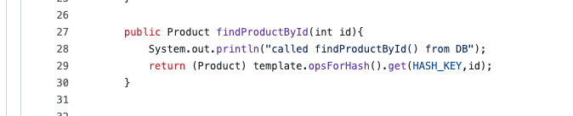

First hit (DB call happened)
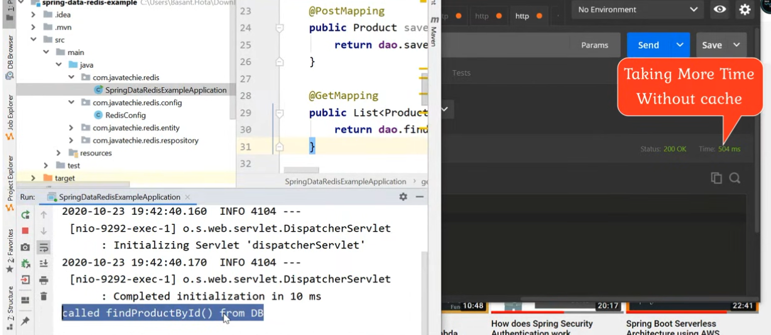
Second time same call took very less time. You won’t see DB log from the second call onwards.
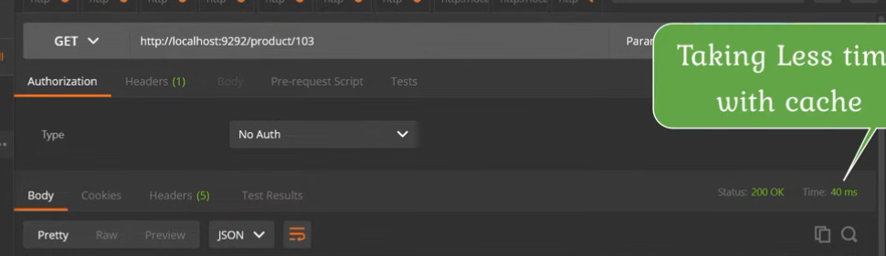
We can add more condition which needs to be cached.
Only price less than 1000 will be cached.
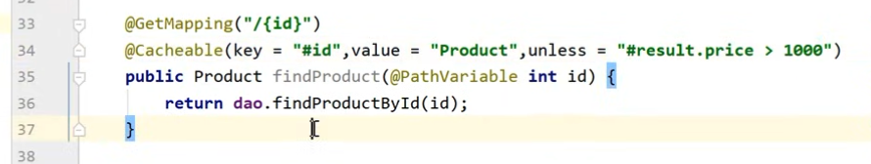
We can test this against below 3 products
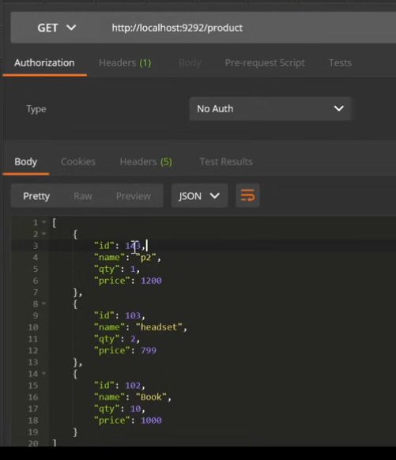

Now we can use Redis as message broker.
