NAME: KUMUD MOHAN ZIMAL

ROLL NO: 65

BRANCH: SE COMPS-3

|  |
| --- |
| **Experiment No. 2** |
| **To implement Insertion Sort** |
| Date of Performance: |
| Date of Submission: |

## Experiment No. 2

**Title:** Insertion Sort

**Aim:** To study, implement and Analyze Insertion Sort Algorithm

**Objective:** To introduce the methods of designing and analyzing algorithms

#### Theory:

Insertion sort is a simple sorting algorithm that works similar to the way you sort the playing cards in your hands. The array is virtually split into a sorted and an unsorted part. Values from the unsorted part are picked and placed at the correct position in the sorted part.

#### Example:

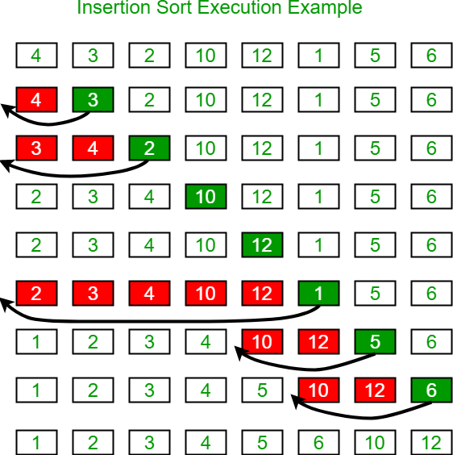

**Algorithm and Complexity:**

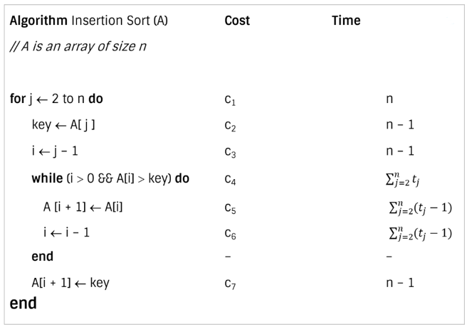

**Best case analysis:**

* Let size of the input array is n. Total time taken by algorithm is the summation of time taken by each of its instruction.

* The best case offers the lower bound of the algorithm’s running time.
* When data is already sorted, the best scenario for insertion sort happens.
* In this case, the condition in the while loop will never be satisfied, resulting in tj = 1.

**Worst case analysis:**

* The worst-case running time gives an upper bound of running time for any input.
* The running time of algorithm cannot get worse than its worst-case running time.
* Worst case for insertion sort occurs when data is sorted in reverse order.
* So we must have to compare A[j] with each element of sorted array A[1 … j – 1]. So, tj = j

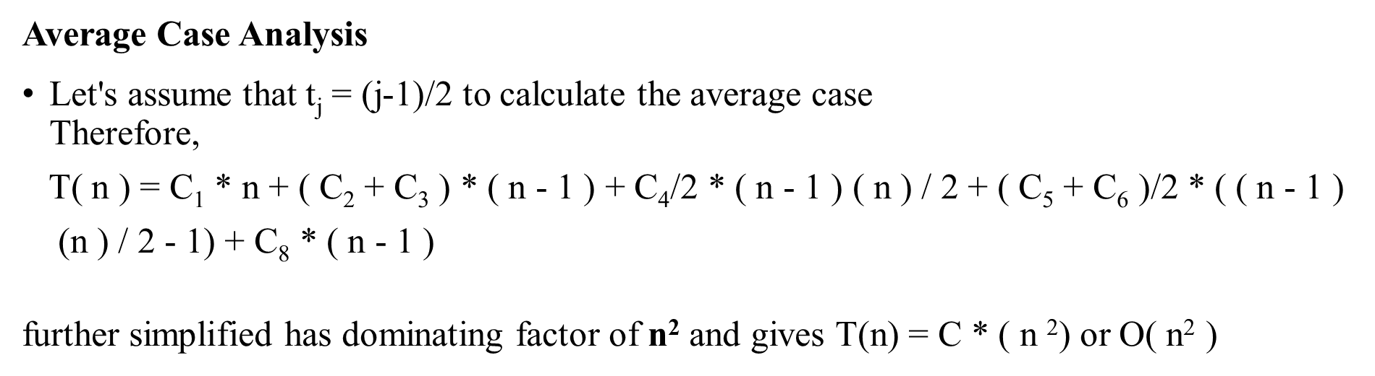

**Code:**

#include <stdio.h>

#include<conio.h>

void insertionSort(int arr[], int n)

{

int i, key, j;

for (i = 1; i < n; i++) {

key = arr[i];

j = i - 1;

while (j >= 0 && arr[j] > key) {

arr[j + 1] = arr[j];

j = j - 1;

}

arr[j + 1] = key;

}

}

int main()

{

int i;

int arr[] = {100,97,42,21,5};

int n = 5;

clrscr();

insertionSort(arr, n);

for (i = 0; i < n; i++)

printf("%d\n", arr[i]);

return 0;

}

**Output:**

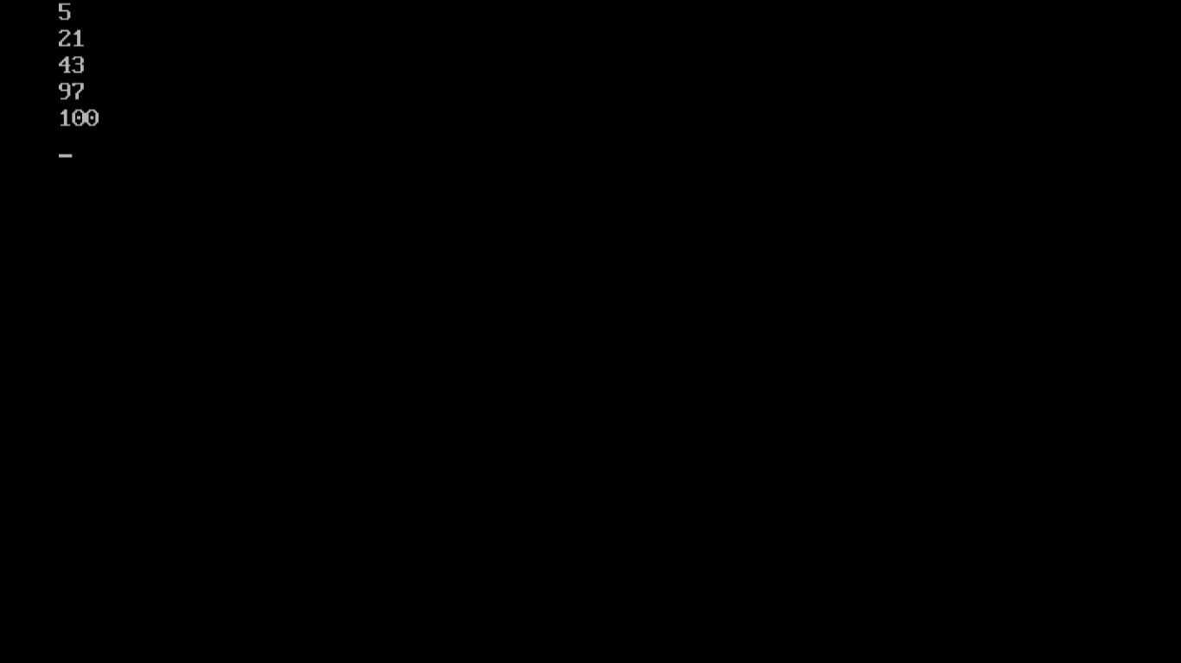

**Conclusion:**

Implementation of insertion sort is very easy as compared to sorting algorithms like quick sort, merge sort or heap sort. Very efficient in the case of a small number of elements. If the elements are already in sorted order it won't spend much time in useless operations and will deliver a run time of O(n) .