**NAME: KUMUD MOHAN ZIMAL**

**ROLL NO:65 BRANCH:COMPS- 3**

|  |
| --- |
| Experiment No. 2 |
| To implement Conditional Statements and Loop in python |
| Date of Performance: 9/1/2024 |
| Date of Submission: 23/1/2024 |

**EXPERIMENT 2**

Title: To implement Conditional Statements and Loop in python

Aim: To study, and implement Conditional Statements and Loop in python

Objective: To introduce Conditional Statements and Loop in python

Theory:

1. Conditional Statements

There comes situations in real life when we need to do some specific task and based on some

specific conditions and, we decide what should we do next. Similarly there comes a situation

in programming where a specific task is to be performed if a specific condition is True. In such

cases, conditional statements can be used. The following are the conditional statements

provided by Python.

if

if..else

Nested if

if-elif statements.

Let us go through all of them.

if Statement

If the simple code of block is to be performed if the condition holds true than if statement is

used. Here the condition mentioned holds true then the code of block runs otherwise not.

if..else Statment

In conditional if Statement the additional block of code is merged as else statement which is

performed when if condition is false.

Nested if Statement

if statement can also be checked inside other if statement. This conditional statement is called

nested if statement. This means that inner if condition will be checked only if outer if

condition is true and by this, we can see multiple conditions to be satisfied.

if-elif Statment

The if-elif statement is shoutcut of if..else chain.While using if-elif statement at the end else

block is added which is performed if none of the above if-elif statement is true.

2. Looping in python

Python programming language provides following types of loops to handle looping

requirements. Python provides three ways for executing the loops. While all the ways provide

similar basic functionality, they differ in their syntax and condition checking time.

While Loop:

In python, while loop is used to execute a block of statements repeatedly until a given a

condition is satisfied. And when the condition becomes false, the line immediately after the

loop in program is executed.

for in Loop:

For loops are used for sequential traversal. For example: traversing a list or string or array

etc. In Python, there is no C style for loop, i.e., for (i=0; i<n; i++). There is “for in” loop

which is similar to for each loop in other languages. Let us learn how to use for in loop for

sequential traversals.

CODE:

num = float(input("Enter a number: "))

if num % 2 == 0:

print("Even number")

else:

print("Odd number")

number1 = float(input("Enter number 1: "))

number2 = float(input("Enter number 2: "))

number3 = float(input("Enter number 3: "))

if number1 > number2 and number1 > number3:

print(number1, "is greater")

elif number2 > number1 and number2 > number3:

print(number2, "is greater")

else:

print(number3, "is greater")

print("Output from for loop:")

for i in range(11):

print(i)

print("Output from while loop:")

i = 0

while i <= 10:

print(i)

i += 1

OUTPUT:

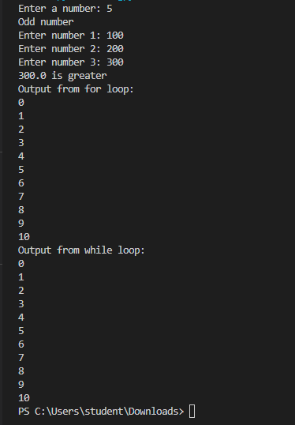

Conclusion: In conclusion, the provided Python code successfully implemented conditional statements and loops. The code first determined whether a given number is even or odd using an 'if..else' statement. It then identified the greatest among three numbers using 'if-elif' statements. Finally, the code demonstrated the use of loops, including a 'for' loop to print numbers from 0 to 10 and a 'while' loop achieving the same result. Overall, the experiment effectively showcased the practical application of conditional statements and loops in Python.