|  |
| --- |
| Experiment No. 5 |
| Exploring Files and directories: Python program to append data to existing file and then dis la the entire file |
| Date of Performance: |
| Date of Submission: |

NAME: KUMUD MOHAN ZIMAL CLASS:SE-3 ROLL NO:65

# Experiment No. 5

Title: Exploring Files and directories: Python program to append data to existing file and then display the entire file

Aim: To Exploring Files and directories: Python program to append data to existing file and then display the entire file

Objective: To Exploring Files and directories

Theory:

Directory also sometimes known as a folder are unit organizational structure in computer's file system for storing and locating files or more folders. Python now supports a number of APIs to list the directory contents. For instance, we can use the Path.iterdir, os.scandir, os.walk, Path.rglob, or os.listdir functions.

Python too supports file handling and allows users to handle files i.e., to read and write files, along with many other file handling options, to operate on files. The concept of file handling has stretched over various other languages, but the implementation is either complicated or lengthy, but alike other concepts of Python, this concept here is also easy and short. Python treats file differently as text or binary and this is important. Each line of code includes a sequence of characters and they form text file. Each line of a file is terminated with a special character, called the EOL or End of Line characters like comma {,} or newline character. It ends the current line and tells the interpreter a new one has begun. Let's start with Reading and Writing files.

Working of open() function

We use open () function in Python to open a file in read or write mode. As explained above, open ( ) will return a file object. To return a file object we use open() function along with two arguments, that accepts file name and the mode, whether to read or write. So, the syntax being: open(filename, mode). There are three kinds of mode, that Python provides and how files can be opened:

' r ", for reading.

' w ", for writing.

' a ", for appending.

' r+ ", for both reading and writing

Code:

file = open('supriya.txt','w') str = input('Enter text:') file.write(str) file = open('supriya.txt','a') stro = input("Enter text to append:

file.write("\n"+str0) file = open('supriya.txt','r') strl =file.read()

print(strl)

file.close()

output

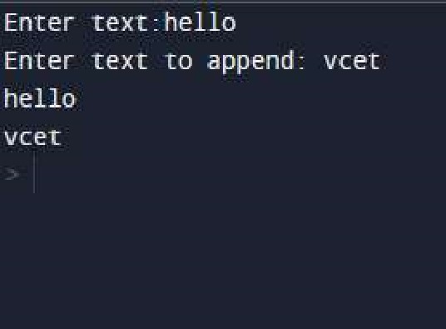



an existing file and then view the updated content. It provides a simple and straightforward way to perform these operations in Python. However, it's important

o handle errors such as file not found or permission denied situations in a real-world

application. Additionally, for large files or performance-critical applications, more

efficient approaches may be necessa