|  |
| --- |
| Experiment No. 7 |
| Creating GUI with python containing widgets such as labels, textbox radio checkboxes and custom dialo boxes |
| Date of Performance: |
| Date of Submission: |

NAME :KUMUD MOHAN ZIMAL CLASS:SE-3 ROLL NO:65

# Experiment No. 7

Title: Creating GUI with python containing widgets such as labels, textbox, radio, checkboxes and custom dialog boxes

Aim: To study and create GUI with python containing widgets such as labels, textbox, radio, checkboxes and custom dialog boxes

Objective: To introduce GUI, TKinter in python

Theory:

Python offers multiple options for developing GUI (Graphical User Interface). Out of all the GUI methods, tkinter is the most commonly used method. It is a standard Python interface to the Tk GUI toolkit shipped with Python. Python with tkinter is the fastest and easiest way to create the GUI applications. Creating a GUI using tkinter is an easy task.

To create a tkinter app:

Importing the module — tkinter

Create the main window (container) Add any number of widgets to the main window

Apply the event Trigger on the widgets.

Importing tkinter is same as importing any other module in the Python code. Note that the name of the module in Python 2.x is 'Tkinter' and in Python 3.x it is 'tkinter'.

Code:

list.append(2); list.append(4); list.append(5); list.append(7); # for element in list:

# print(element)

list.insert(3,9)

for element in list:

print(element)

#Replacement list.remove(5) list.insert(2, I l) for element in list: print(element) print(list.index(4)) print(list.index(2)) print(len(list))

Output:

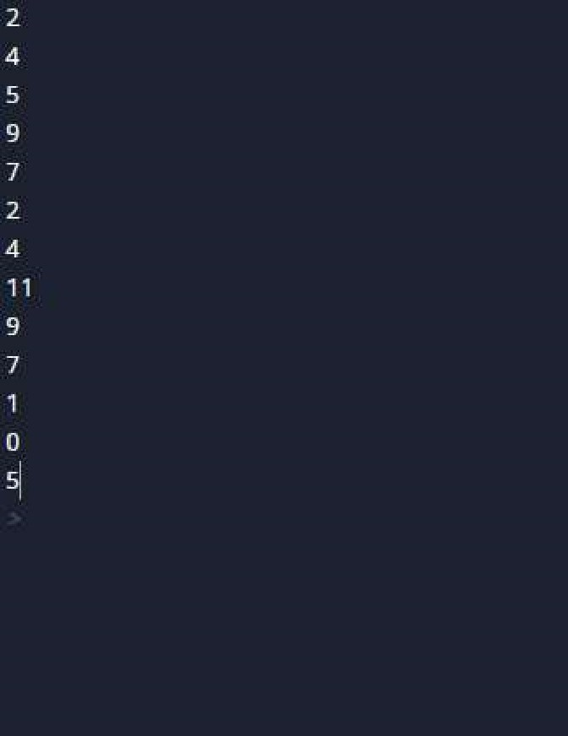

Conclusion:

This program creates a GUI using Tkinter, a built-in Python library for creating graphical user interfaces.

* Various widgets such as labels, entry boxes, radio buttons, checkboxes, and buttons are used to create a simple form interface.
* Interaction with the user is facilitated through the use of callbacks. For example, the "Submit" button triggers the 'submit()' function, which retrieves data from the form and displays it using a messagebox.
* Additionally, a custom dialog box is created using the 'messagebox.showinfo()' function, providing a simple way to display information to the user in a pop-up dialog.
* Tkinter provides a convenient and easy-to-use framework for creating GUI applications in

Python, making it suitable for developing basic user interfaces for a wide range of applications. However, for more complex applications with advanced features and styling, other GUI frameworks or libraries may be more appropriate.

Ex eriment No. 8