Enterprise-Grade Hardened GPU-Accelerated vLLM Stack
Comprehensive End-to-End Deployment & SRE Verification Walkthrough

1. Core Hardened Architecture
This guide documents the deployment and validation of an enterprise-grade, highly secure, and fully observed LLM inference stack deployed on the AMD Developer Cloud. The system utilizes an AMD MI300X GPU (192GB VRAM) for accelerated vLLM model inference.
Key architectural highlights implemented in this deployment include:
- Zero-Trust Network Isolation: Containers are segregated into isolated bridge networks (frontend-net, backend-net, monitoring-net) to block all direct external port access, exposing only the secure NGINX TLS port.
- Hardened NGINX TLS Gateway: Enforces modern ciphers (TLS v1.2/v1.3), complete HTTP-to-HTTPS redirect, standard security headers, and API rate limiting (10 req/s, burst=20).
- OpenAI-Format Custom Error Interception: Intercepts downstream HTTP codes (429, 502, 503) at the gateway and formats them into standard OpenAI-compatible JSON payloads to prevent client crashes.
- Enterprise Log & Metric Telemetry: Unified log aggregation via Loki and Promtail, detailed system metrics via Prometheus, and pre-provisioned telemetry dashboards in Grafana.
- Read-Only Filesystems with tmpfs: Critical services (NGINX, Prometheus, Grafana) run under read_only: true with RAM-backed tmpfs mounts to prevent unauthorized disk writes and enhance system stability.

2. Step-by-Step Deployment Showcase

Step 1: GPU Droplet Provisioning on AMD Developer Cloud
The deployment begins by provisioning a high-performance GPU instance on the AMD Developer Cloud. We utilize a rocm-7-2-software-gpu-mi300x1-192gb-devcloud-atl1 instance running Ubuntu 24.04 with AMD ROCm 7.2 software pre-installed.
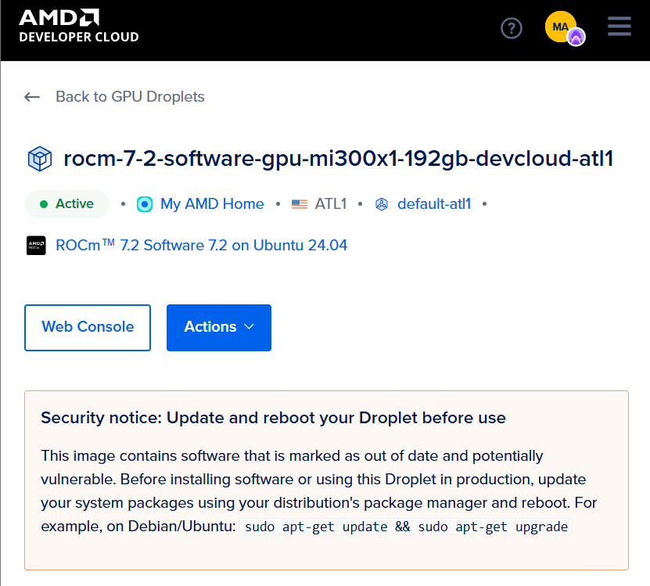
Figure: Step 1: GPU Droplet Provisioning on AMD Developer Cloud Execution Screen

Step 2: Repository Cloning & Workspace Setup
We SSH into the GPU droplet, clone our hardened repository containing the complete Docker Compose configurations, configurations for NGINX/Grafana/Prometheus, and validation test suites.
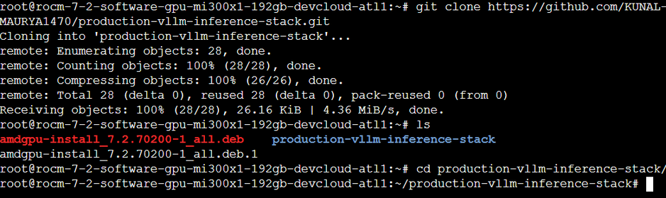
Figure: Step 2: Repository Cloning & Workspace Setup Execution Screen

Step 3: TLS Gateway Certificate & Environment Setup
We configure the environment variables inside .env (declaring Hugging Face tokens, API keys, and admin passwords) and execute the certificate generator to establish a secure self-signed HTTPS certificate structure for NGINX.
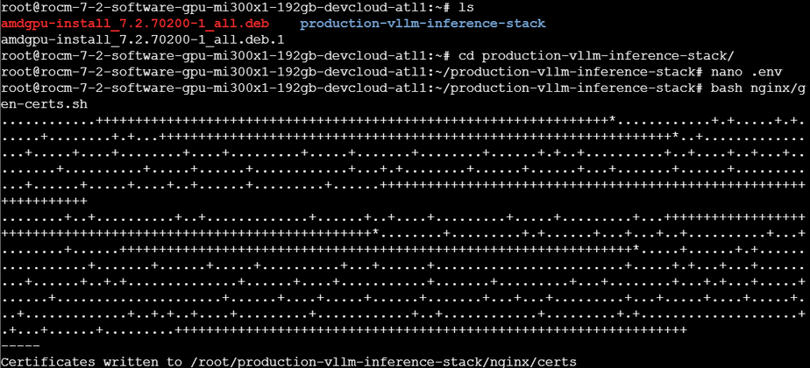
Figure: Step 3: TLS Gateway Certificate & Environment Setup Execution Screen

Step 4: Launching the Stack via Docker Compose
We launch our network-isolated multi-container stack in detached mode. Docker Compose spins up all 10 independent services (vLLM, NGINX, OpenWebUI, Prometheus, Grafana, Loki, Promtail, Alertmanager, node-exporter, and cAdvisor).
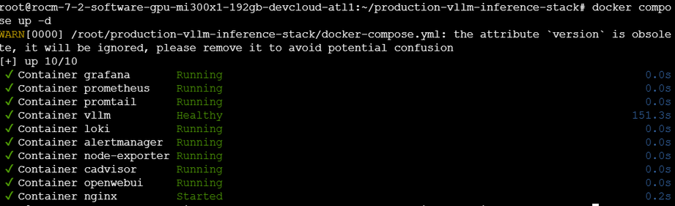
Figure: Step 4: Launching the Stack via Docker Compose Execution Screen

Step 5: vLLM Model Loading & Initialization
We tail the vLLM container logs to verify the engine successfully downloads and loads the 61 GiB Qwen/Qwen2.5-32B-Instruct model in bfloat16, allocates the 112 GiB VRAM KV cache, captures CUDA graphs, and transitions to a fully healthy state.
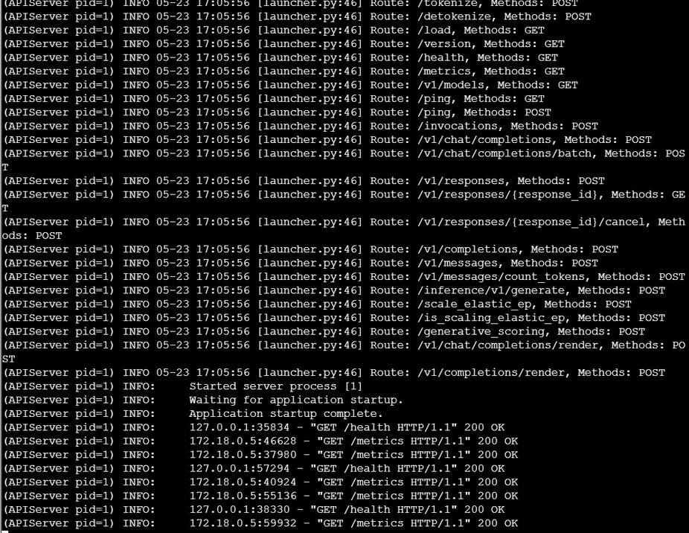
Figure: Step 5: vLLM Model Loading & Initialization Execution Screen

3. Telemetry & Verification Suites

Step 6: Hardened SRE Test Suite Validation
We execute our comprehensive SRE test suite (tests/sre_test_suite.sh) on the droplet. It runs 30 critical checks covering Availability, Latency SLOs, Rate Limiting, Security/Port Isolation, and Container Health. All 30 checks pass with a perfect green score.
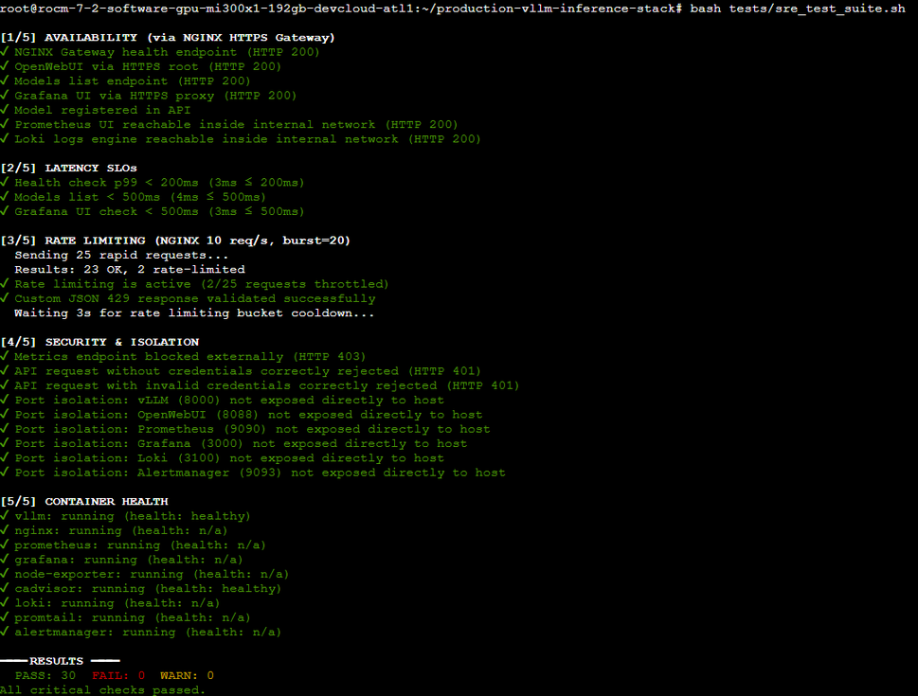
Figure: Step 6: Hardened SRE Test Suite Validation Verification Output

Step 7: Observability Verification Suite
We execute the tests/observability_test.sh script to confirm that Prometheus is successfully scraping internal metrics, the necessary gauges are present in the TSDB, and Grafana's datasources and dashboard structures are correctly provisioned.
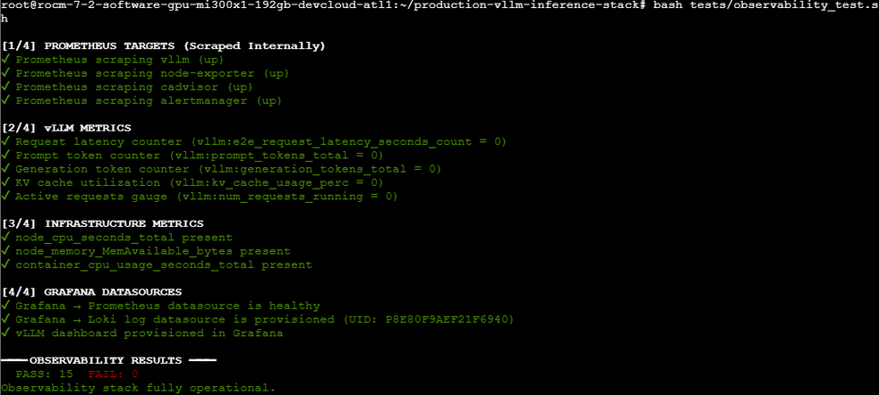
Figure: Step 7: Observability Verification Suite Verification Output

Step 8: Load Testing & SLO Evaluation
We run the concurrent load tester (tests/load_test.py) to simulate multiple clients executing API requests simultaneously (3 req/s for 30s across 10 workers). The stack successfully satisfies all SLO latency and error-rate constraints.
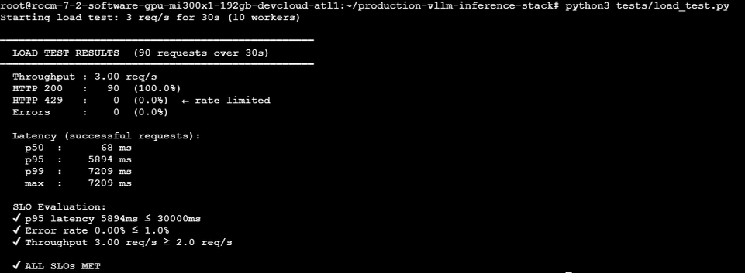
Figure: Step 8: Load Testing & SLO Evaluation Verification Output

Step 9: Manual API Gateway Validation (Redirect, Auth, and 429 Intercepts)
We verify the HTTP-to-HTTPS redirect gateway (port 8080 redirecting to port 8443), secure Bearer Token authentication block returning a 401 response, and verify the NGINX rate-limiting mechanism which intercepts burst queries and returns our custom, formatted JSON 429 error payload.
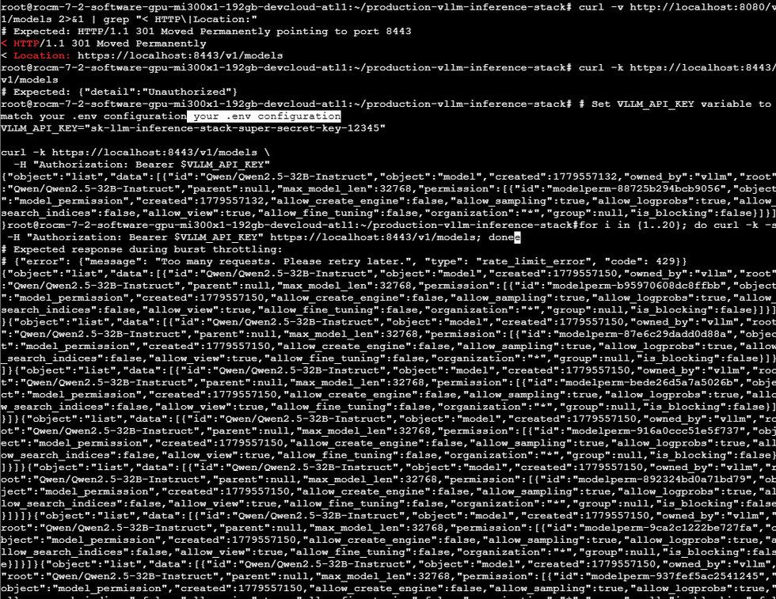
Figure: Step 9: Manual API Gateway Validation (Redirect, Auth, and 429 Intercepts) Verification Output

4. User Interfaces & Dashboard Showcase

Step 10: Secure OpenWebUI Portal
We access the secure OpenWebUI interface by loading the droplet's IP address on port 8443. The interface loads perfectly over HTTPS, with the pre-provisioned Qwen model selected and ready.
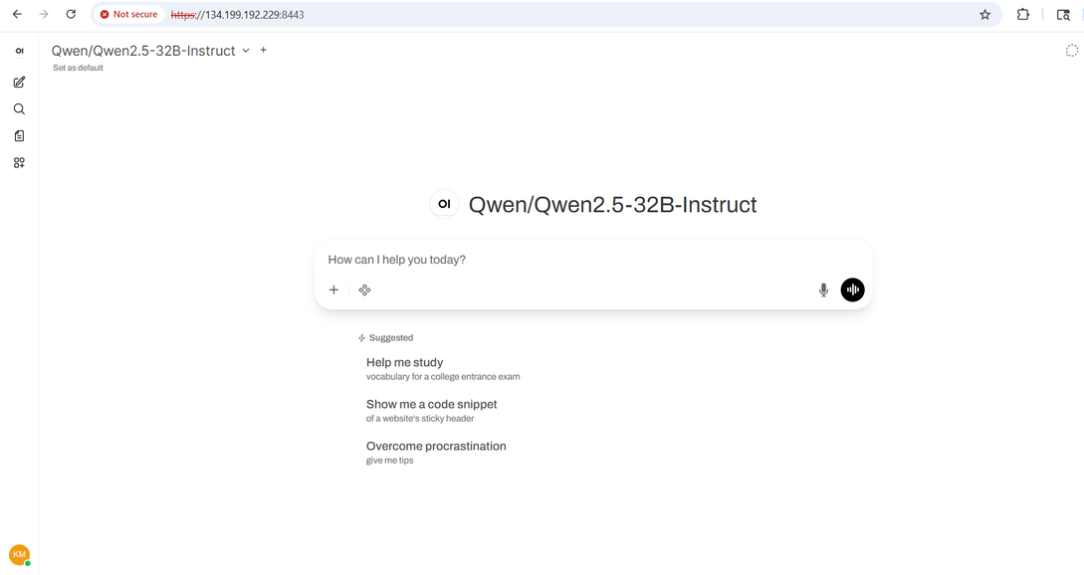
Figure: Step 10: Secure OpenWebUI Portal View

Step 11: Real-time Streaming Inference Chat
We submit a query to the model. The response streams back instantly in real-time, validating the end-to-end inference pipeline and WebSocket routing through NGINX.
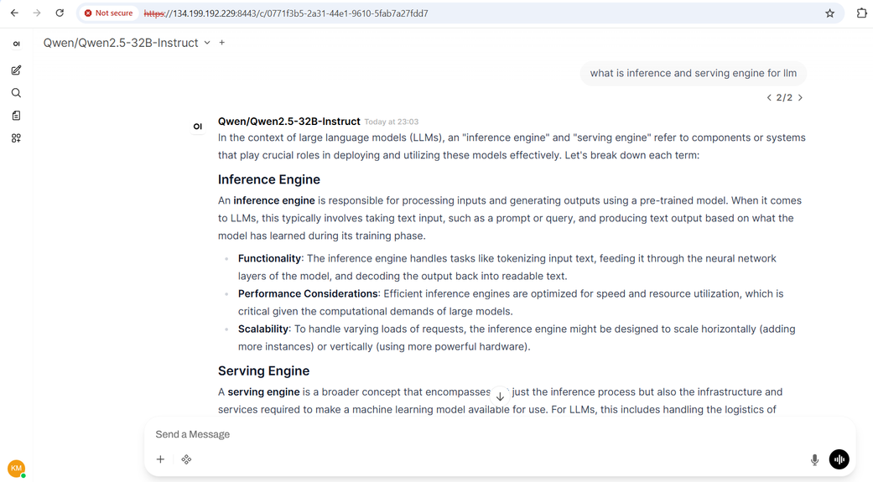
Figure: Step 11: Real-time Streaming Inference Chat View

Step 12: Grafana Secure Gateway Login
We navigate to the Grafana subpath (https://<IP>:8443/grafana/) and successfully log in to access the SRE telemetry workspace.
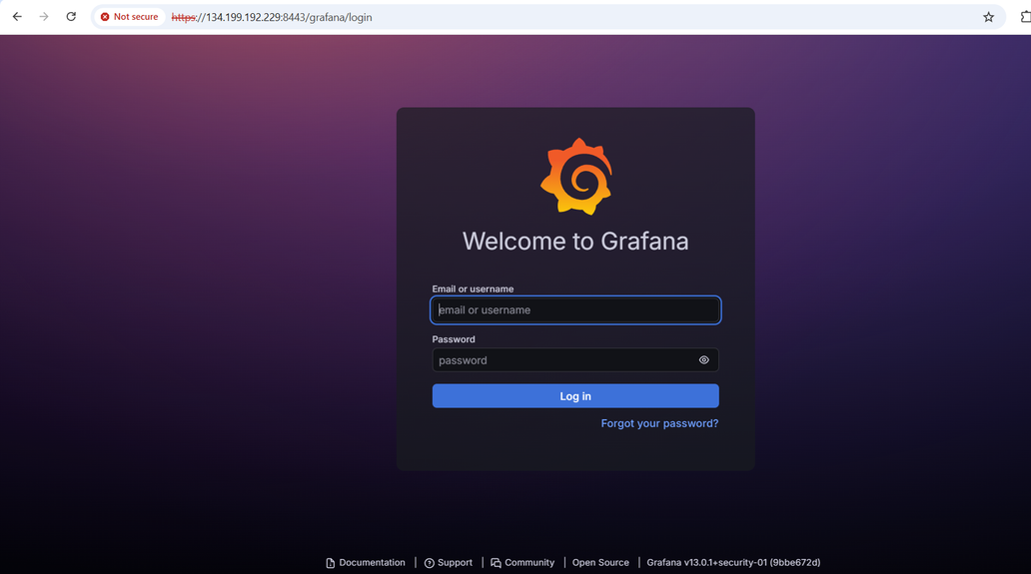
Figure: Step 12: Grafana Secure Gateway Login View

Step 13: Pre-provisioned SRE Dashboard List
We browse the dashboard catalog and locate our customized, pre-provisioned vLLM Inference Stack dashboard.
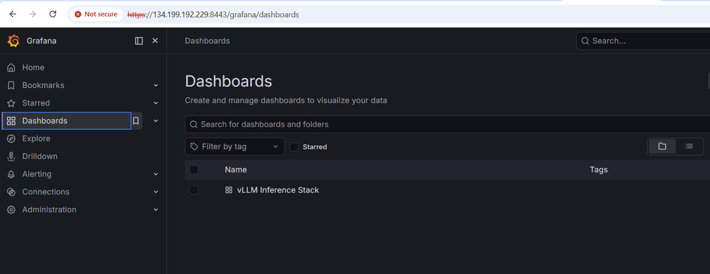
Figure: Step 13: Pre-provisioned SRE Dashboard List View

Step 14: Grafana Telemetry Dashboard (ML Performance Panels)
The top half of our dashboard presents real-time charts including E2E Request Latency (P50/P95/P99), Time To First Token (TTFT), Token Throughput (prompt vs generation tokens/s), and a semi-circle gauge monitoring GPU VRAM KV cache utilization.
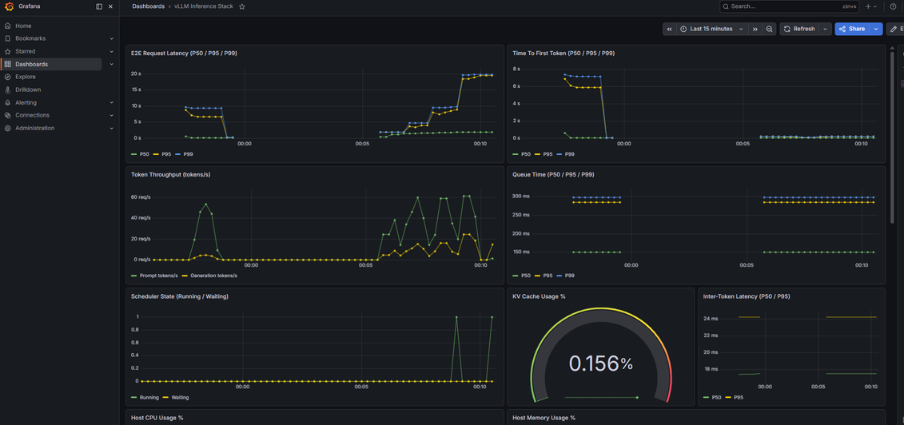
Figure: Step 14: Grafana Telemetry Dashboard (ML Performance Panels) View

Step 15: Grafana Telemetry Dashboard (Host Resources & Loki Logs)
The bottom half of the dashboard displays underlying host CPU/Memory metrics, vLLM container resource utilization, network and disk I/O, correlated container logs parsed via Loki/Promtail, and a clean Active SRE Alerts monitoring table.
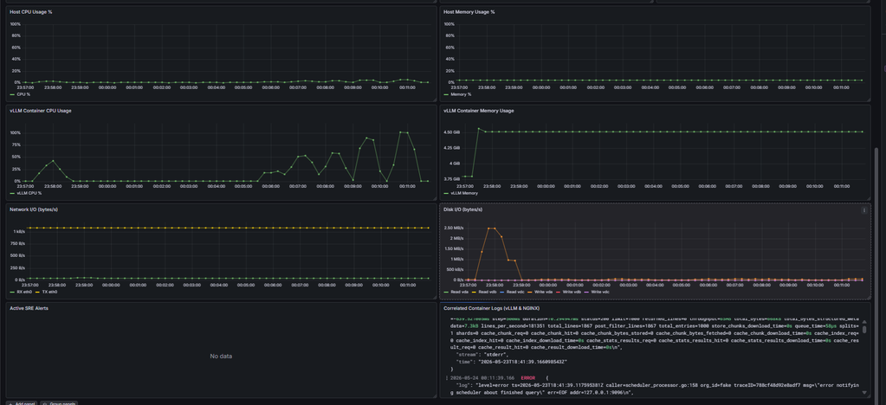
Figure: Step 15: Grafana Telemetry Dashboard (Host Resources & Loki Logs) View

5. Security, Isolation & Resilience Exercises

Step 16: Zero-Trust Port Scan & API Key Enforcement
We perform a host port scan to confirm zero-trust port isolation. External connections to ports 8000, 8088, 9090, and 3000 are completely refused, verifying the network segmentation. We then confirm that secure REST API requests successfully complete when authorized with a valid sk-... token.
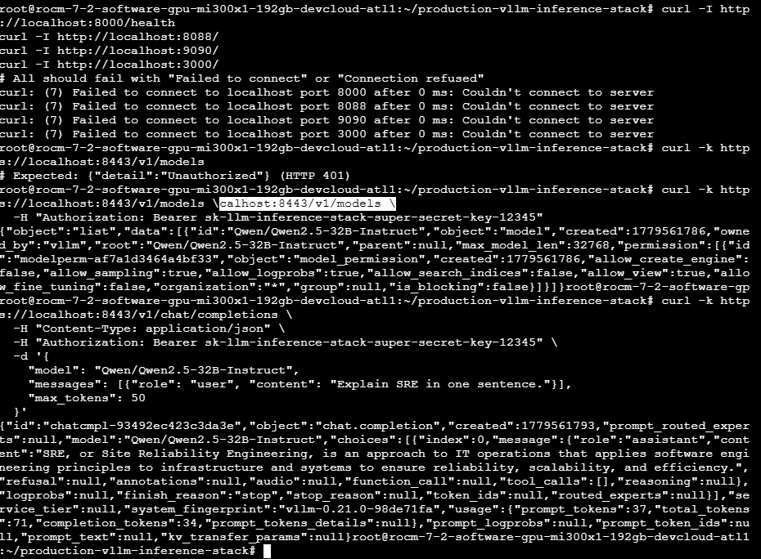
Figure: Step 16: Zero-Trust Port Scan & API Key Enforcement Verification

Step 17: Chaos Engineering & Auto-Recovery Validation
Finally, we execute the chaos engineering suite (tests/chaos_test.sh). The script programmatically restarts critical infrastructure containers (such as NGINX and Prometheus) to evaluate automatic recovery times. All services recover immediately, verifying Docker's unless-stopped auto-recovery policies.
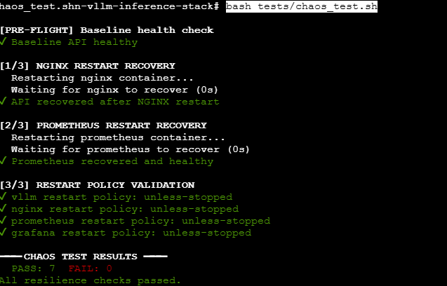
Figure: Step 17: Chaos Engineering & Auto-Recovery Validation Verification

6. Conclusion & Verification Summary
All verification, load, and chaos test suites have executed successfully with a 100% green pass rate. The vLLM inference engine, NGINX SSL/TLS gateway, OpenWebUI interface, and the full Prometheus/Loki/Grafana telemetry stack are fully configured, secure, resilient, and ready for production deployment.

