University of Leicester
Urban Change Detection Using CNN Models
Application of CNN Models to Remote Sensing Using Satellite Imagery
Group 1
Assignment 2 — Group Research Project
Dataset: LEVIR-CD | Models: U-Net & Siamese U-Net

Abstract
Urban expansion is a critical global phenomenon that significantly impacts environmental sustainability, infrastructure planning, and resource management. As cities continue to grow at unprecedented rates, the ability to automatically detect and monitor land-use change from satellite imagery has become increasingly important for government agencies, urban planners, and environmental scientists. Traditional manual approaches to change detection are time-consuming and do not scale to the volumes of imagery produced by modern Earth observation satellites.
This project investigates the application of Convolutional Neural Networks (CNNs) for detecting urban changes using multi-temporal satellite imagery. A complete deep learning-based change detection pipeline was developed using the LEVIR-CD benchmark dataset, where paired high-resolution satellite images captured at different time intervals were used to identify areas of urban growth — specifically new building construction and demolition. Two CNN architectures were implemented and systematically evaluated: a baseline U-Net model employing early fusion of bi-temporal images as a six-channel input, and a Siamese U-Net model that processes each temporal image through a shared encoder and computes absolute feature differences to explicitly encode change information at multiple spatial scales.
Both models were trained for 50 epochs using an AdamW optimiser, a combined Dice-BCE loss function to handle class imbalance, and a ReduceLROnPlateau learning-rate scheduler. The models were evaluated using five standard segmentation metrics: Intersection over Union (IoU), F1-score, precision, recall, and pixel-level accuracy. The U-Net model achieved a test IoU of 0.6138 and an F1-score of 0.7261, with precision of 0.7991 and recall of 0.7374. The Siamese U-Net achieved a test IoU of 0.5000 and F1-score of 0.6576, with precision of 0.7217 and recall of 0.6133. The results indicate that early fusion is more effective for this dataset under the given training conditions, and that Siamese architectures with shared encoders may require pre-trained weights or longer training to reach their full potential.
This study demonstrates the practical effectiveness of CNN-based segmentation models for urban change detection and highlights the critical role of architectural design choices, loss function formulation, and learning-rate scheduling in achieving strong performance on remote sensing benchmarks.
- Introduction
Remote sensing using satellite imagery has become an indispensable tool for monitoring environmental and urban changes over time. The widespread deployment of commercial and governmental satellite constellations — including Sentinel-2, Landsat-8, and very-high-resolution platforms such as WorldView-3 — has resulted in an unprecedented volume of multi-temporal imagery available for change analysis. However, the sheer volume of data makes manual inspection impractical, and conventional image-processing techniques are often insufficient due to the high dimensionality, radiometric variability, and complex spatial structure of satellite data.
Rapid urbanisation is one of the most pressing drivers of land-use change globally. According to the United Nations, more than 68% of the world population is projected to live in urban areas by 2050, placing enormous pressure on infrastructure, green spaces, and natural resources. Automated change detection provides planners and policymakers with timely, objective information about where and how cities are growing, enabling more informed decision-making.
Convolutional Neural Networks (CNNs) have emerged as powerful tools for image analysis tasks, including semantic segmentation, object detection, and change detection. Their ability to automatically learn hierarchical spatial representations from labelled data, without manual feature engineering, has led to dramatic improvements in remote sensing analysis over the past decade. In particular, fully convolutional encoder-decoder architectures such as U-Net have become the dominant paradigm for dense prediction tasks in satellite imagery.
This project focuses on multi-temporal binary change detection, where two co-registered RGB satellite images captured at different times are analysed to identify per-pixel areas of change. Two CNN-based architectures are implemented and compared:
- A standard U-Net that concatenates both temporal images along the channel dimension (early fusion), processing a single six-channel input through an encoder-decoder network with skip connections.
- A Siamese U-Net that processes each temporal image independently through a shared-weight encoder, computes absolute feature differences at each encoder scale, and decodes these difference maps to produce the final change mask.
The main contributions of this project are as follows:
- Design and implementation of a complete, modular PyTorch pipeline for satellite image change detection, covering data loading, preprocessing, augmentation, training, validation, and test evaluation.
- Implementation and systematic comparison of two prominent CNN architectures for change detection on the LEVIR-CD benchmark dataset.
- Quantitative evaluation using five complementary metrics (IoU, F1, accuracy, precision, recall) and detailed analysis of model strengths, weaknesses, and failure modes.
- Discussion of architectural trade-offs and practical recommendations for future work, including pre-trained encoders, attention mechanisms, and transformer-based hybrid models.

- Literature Review
  - Traditional Change Detection Methods
Change detection has been studied in remote sensing for several decades. Early methods relied on pixel-wise arithmetic operations applied directly to image pairs: image differencing subtracts co-registered images to highlight regions of change, while image rationing and principal component analysis (PCA) attempt to suppress illumination-invariant scene components. Although computationally inexpensive, these methods are highly sensitive to co-registration errors, atmospheric variability, seasonal vegetation cycles, and sensor noise, all of which produce false change signals unrelated to structural land-use change.
Object-based image analysis (OBIA) improved robustness by incorporating spatial context — segmenting images into meaningful regions (objects) before comparing attributes such as spectral mean, shape, and texture. While OBIA reduced salt-and-pepper noise and improved interpretability, it introduced manual parameter tuning (segmentation scale, attribute selection) that limited generalisability across datasets and geographic regions.
Support Vector Machines (SVMs) and Random Forests were applied to features extracted from image pairs with reasonable success, but these approaches still required hand-crafted feature engineering and did not scale gracefully to high-resolution multi-channel imagery.

  - Fully Convolutional Networks and U-Net
The advent of deep learning revolutionised dense prediction tasks. Long et al. (2015) demonstrated that standard classification CNNs (AlexNet, VGG, GoogLeNet) could be converted to fully convolutional networks (FCNs) by replacing fully connected layers with convolutional layers, enabling dense pixel-wise semantic segmentation. FCNs established the fundamental principle that spatial predictions could be learned end-to-end from labelled data.
Ronneberger et al. (2015) proposed the U-Net, originally designed for biomedical image segmentation, which introduced a symmetric encoder-decoder structure connected by skip connections that concatenate feature maps from encoder stages to the corresponding decoder stages. This design preserves fine-grained spatial information lost during downsampling — a critical property for tasks requiring precise boundary delineation, such as change detection in urban scenes. U-Net became the dominant baseline in remote sensing segmentation within two years of its publication.
For change detection, U-Net is typically adapted by concatenating bi-temporal images along the channel dimension, creating a six-channel (or 2C-channel for C-band imagery) input. This early fusion approach allows the network to learn cross-temporal correlations from the first convolution layer. Variants such as ResUNet (Zhang et al., 2018) replace the plain encoder with a residual network backbone, providing better gradient flow and stronger feature representations. These architectural improvements generally yield modest but consistent gains over the vanilla U-Net baseline.

  - Siamese Networks for Change Detection
Siamese networks were originally proposed by Bromley et al. (1994) for signature verification and popularised for one-shot learning by Koch et al. (2015). The core idea is to use twin subnetworks with shared weights to map two inputs into a common embedding space, then measure their similarity. Sharing weights explicitly enforces that the two branches learn the same feature representation, making the comparison semantically consistent.
Daudt et al. (2018) introduced the first fully convolutional Siamese architectures for change detection: FC-Siam-Conc, which concatenates feature maps from both branches at each skip connection level, and FC-Siam-Diff, which computes absolute differences. Both variants achieved strong results on the Onera Satellite Change Detection (OSCD) dataset and established Siamese U-Net as a key baseline in the field. The absolute-difference approach used in this project is directly inspired by FC-Siam-Diff and provides a compact change representation that is invariant to the ordering of temporal images.
Subsequent work explored more sophisticated feature fusion strategies. Chen et al. (2020) proposed BIT (Bitemporal Image Transformer), which combines a ResNet backbone with a transformer module to model long-range temporal dependencies, achieving state-of-the-art results on LEVIR-CD. Fang et al. (2021) proposed SNUNet, which extends Siamese U-Net with densely nested skip connections (inspired by UNet++) to preserve multiscale feature information more thoroughly. Bandara and Patel (2022) proposed ChangeFormer, a hierarchical vision transformer that operates directly on patch embeddings from both temporal images, demonstrating that self-attention mechanisms are particularly beneficial for detecting changes involving complex spatial patterns such as multi-storey buildings or road intersections.

  - The LEVIR-CD Dataset
The LEVIR-CD dataset (Chen et al., 2020) has become the most widely used benchmark for building change detection in very high-resolution satellite imagery. It comprises 637 pairs of bi-temporal Google Earth images at 0.5 m/pixel ground sampling distance, originally at 1024 × 1024 pixels. The images cover 20 different cities in Texas, USA, and were collected between 2002 and 2018. Ground truth masks label building-related changes, including new construction and demolition, as binary foreground pixels.
For training, the standard practice is to crop 1024 × 1024 images into 256 × 256 non-overlapping patches, yielding approximately 7,120 training pairs, 1,024 validation pairs, and 2,048 test pairs. The dataset exhibits significant class imbalance: changed pixels typically account for approximately 3–5% of the total image area, making accuracy a misleading metric and motivating the use of IoU and F1-score as primary evaluation criteria.
Published state-of-the-art results on LEVIR-CD include: FC-EF (0.755 F1), FC-Siam-Diff (0.783 F1), BIT (0.833 F1), ChangeFormer (0.823 F1), and SNUNet (0.845 F1). These benchmarks provide context for interpreting the results achieved in this project.

  - Loss Functions and Imbalanced Segmentation
Binary cross-entropy (BCE) is the standard loss for binary segmentation. For each pixel i with ground truth label y_i ∈ {0,1} and predicted probability p_i, BCE = −[y_i log(p_i) + (1−y_i) log(1−p_i)]. While stable and well-behaved during optimisation, BCE is sensitive to class imbalance: when the positive class is rare, the total loss is dominated by the majority negative class, and the gradient signal for detecting actual changes is diluted.
Milletari et al. (2016) proposed the Dice loss, which directly optimises the Dice coefficient (F1-score): L_Dice = 1 − (2×TP) / (2×TP + FP + FN). This loss is invariant to the absolute number of negative pixels and focuses the gradient on improving overlap between predicted and ground truth masks, making it inherently robust to class imbalance. However, Dice loss can exhibit unstable gradients when both numerator and denominator are near zero early in training.
A combined Dice-BCE loss, used in this project, leverages the stability of BCE and the class-imbalance robustness of Dice: L = α × L_Dice + (1−α) × L_BCE, where α = 0.5. This formulation has been shown empirically to converge faster and to higher performance than either loss alone for change detection tasks (Chen et al., 2020; Fang et al., 2021).
Lin et al. (2017) proposed Focal Loss as an alternative approach to class imbalance, down-weighting easy negative examples and focusing training on hard positives. Although not used in this project, Focal Loss represents a viable future extension.

  - Optimisation and Learning Rate Scheduling
Loshchilov and Hutter (2019) proposed AdamW, a variant of the Adam optimiser (Kingma and Ba, 2015) that decouples weight decay from the adaptive learning-rate update. Standard Adam applies L2 regularisation through gradient rescaling, which interacts undesirably with the adaptive per-parameter learning rates. AdamW corrects this by applying weight decay directly to the parameter update, yielding better generalisation in practice. AdamW has become the standard optimiser for image segmentation tasks in PyTorch.
The ReduceLROnPlateau scheduler monitors a target metric (here, validation IoU) and reduces the learning rate by a multiplicative factor when no improvement is observed for a specified number of epochs (patience). This adaptive schedule enables fine-grained convergence after coarse initial learning, and is particularly effective for change detection where the validation IoU can plateau for several epochs before a sudden improvement.

- Methodology
  - Problem Definition
The objective of this project is to detect urban expansion using multi-temporal satellite imagery. Given two co-registered RGB satellite images I_A (pre-change, time T1) and I_B (post-change, time T2) of the same geographical location, the task is to produce a binary change mask M ∈ {0,1}^{H×W}, where M_{ij} = 1 indicates that pixel (i, j) has undergone a change (building construction or demolition) between T1 and T2, and M_{ij} = 0 denotes an unchanged pixel.
This problem is formulated as a binary semantic segmentation task, requiring dense pixel-level prediction rather than image-level classification. The key challenge lies in accurately distinguishing genuine structural changes from apparent changes caused by seasonal vegetation, illumination differences, shadows, atmospheric effects, and sensor noise — all of which produce systematic radiometric differences between acquisitions that are not related to land-use change. The strong class imbalance (changed pixels ≈3–5% of total) further complicates the task, as naive models may achieve high pixel accuracy by predicting no change everywhere.

  - Dataset Description
All experiments were conducted using the LEVIR-CD dataset, a large-scale benchmark for building change detection in very high-resolution remote sensing imagery. The dataset provides paired bi-temporal images focused on building-related changes and is structured into three splits:
- Training set: ~7,120 image pairs (256 × 256 pixels each) — used to learn model parameters.
- Validation set: ~1,024 image pairs — used to monitor training, tune hyperparameters, and select the best checkpoint.
- Test set: ~2,048 image pairs — used exclusively for final unbiased evaluation.

Each sample consists of three components: an RGB image at time T1 (pre-change), an RGB image at time T2 (post-change), and a binary ground truth mask indicating change regions. The images are originally captured at 0.5 m/pixel ground resolution, providing fine enough detail to distinguish individual buildings and structural changes.
The dataset exhibits significant class imbalance: changed pixels account for approximately 3–5% of total image area across the dataset. This characteristic strongly influences the choice of loss function and evaluation metrics, as discussed in Sections 2.5 and 3.5.

  - Data Preprocessing and Augmentation
A standardised preprocessing pipeline was applied to all dataset splits to ensure consistency and reproducibility:
Resizing: All image pairs and ground truth masks were resized to 256 × 256 pixels. RGB images were resized using bilinear interpolation to preserve smooth colour gradients, while binary masks were resized using nearest-neighbour interpolation to avoid introducing fractional label values at boundaries.
Normalisation: Pixel values were divided by 255 to scale to the range [0, 1]. No per-channel mean/std normalisation was applied, keeping preprocessing minimal and reproducible. While ImageNet-based normalisation (mean=[0.485, 0.456, 0.406], std=[0.229, 0.224, 0.225]) is standard when using pre-trained encoders, it was not used here as both models are trained from scratch.
Data Augmentation (training only): Random horizontal flips (p = 0.5) and random vertical flips (p = 0.5) were applied consistently to image A, image B, and the mask. This doubles effective training diversity while preserving the geometric alignment between temporal images and their labels. No colour jitter or rotation was applied, keeping augmentation minimal to isolate architectural effects.
Tensor Construction: For the U-Net, images A and B were stacked along the channel dimension to form a 6-channel tensor [C×H×W]. For the Siamese U-Net, the same 6-channel tensor is passed and split inside the forward pass (x1 = x[:, :3], x2 = x[:, 3:]). Ground truth masks were converted to binary float tensors with values in {0, 1}.

  - Model Architectures
    - U-Net (Early Fusion Baseline)
The baseline U-Net follows the standard encoder-decoder structure with skip connections, adapted for change detection via early fusion. The model accepts a 6-channel input formed by concatenating the pre-change and post-change RGB images along the channel axis, allowing the network to learn spatial and temporal differences from the first layer jointly.

Architecture details:
- Encoder: Four successive stages of DoubleConv (two 3×3 convolutions with BatchNorm and ReLU) followed by 2×2 MaxPool downsampling. Feature map dimensions: 32, 64, 128, 256 channels at resolutions 256, 128, 64, 32 pixels respectively.
- Bottleneck: A fifth DoubleConv block with 512 channels at 16×16 spatial resolution, capturing the most abstract semantic features.
- Decoder: Four stages of ConvTranspose2d (stride-2 upsampling) followed by DoubleConv. At each stage, the upsampled feature map is concatenated with the corresponding encoder skip connection before the convolution block. Decoder channels: 256, 128, 64, 32.
- Output head: A 1×1 convolution mapping 32 channels to a single logit map [1×H×W]. The sigmoid of this logit gives the per-pixel change probability.
- Total parameters: approximately 7.76M (with base = 32).

The DoubleConv block uses bias=False in both convolutions (since BatchNorm absorbs the bias), and in-place ReLU for memory efficiency. This design choice is standard in modern segmentation networks and reduces the parameter count slightly.

    - Siamese U-Net (Shared Encoder with Feature Difference)
The Siamese U-Net processes the pre-change image I_A and post-change image I_B through a single shared encoder (SharedEncoder), producing five sets of feature maps per branch. Absolute differences are computed at each scale before decoding, explicitly encoding the change signal at multiple levels of abstraction.

Architecture details:
- Shared Encoder: Identical to the U-Net encoder (four DoubleConv+MaxPool stages and one bottleneck), with weights shared between the A and B branches. This means the encoder is instantiated once and applied twice per forward pass — crucially, both images pass through the same learned feature extractor.
- Feature Difference: At each encoder level k, the absolute difference Δe_k = |e_k^A − e_k^B| is computed. For the bottleneck, Δb = |b_A − b_B|. These difference maps have the same spatial dimensions and channel counts as the encoder outputs (32, 64, 128, 256, 512 channels).
- Decoder: Identical structure to the U-Net decoder. The difference maps serve as skip connections: at each decoder stage, the upsampled output is concatenated with Δe_k before the DoubleConv block.
- Output head: Same 1×1 convolution as U-Net.
- Total parameters: approximately 7.76M encoder (shared) + 3.88M decoder = ~11.64M total (the shared encoder is counted once but applied twice, so effective parameter count is higher than U-Net).

The key architectural difference from U-Net is that the Siamese model never directly compares raw pixel values — all comparison happens in a learned feature space. This encourages the model to be robust to low-level radiometric differences (illumination, haze) that would appear as differences in pixel space but are absorbed into consistent feature representations. However, the weight-sharing constraint requires the encoder to learn a feature space that is semantically meaningful for both time steps independently, which is a harder learning objective than the unconstrained early-fusion approach.

  - Training Configuration
Both models were trained under identical conditions to enable a fair architectural comparison:
Hyperparameter | Value
Optimiser | AdamW
Learning rate (initial) | 3 × 10⁻⁴
Weight decay | 0.01
Loss function | Dice-BCE (BCE weight = 0.5)
LR scheduler | ReduceLROnPlateau (max, factor=0.5, patience=3)
Batch size | 8
Epochs | 50
Binarisation threshold | 0.45
Hardware | CPU
Checkpoint criterion | Maximum validation IoU
Table 1. Shared hyperparameter configuration for both models.

The binarisation threshold of 0.45 (slightly below 0.5) was chosen to modestly increase recall by lowering the activation required to predict a changed pixel, which is beneficial given the class imbalance towards the no-change class. The best model checkpoint (based on validation IoU) was saved at each epoch and used for test evaluation.

  - Evaluation Metrics
Five complementary metrics were computed on binarised predictions across the test set, averaged over individual images in the batch:
- IoU (Intersection over Union) = TP / (TP + FP + FN): Measures the overlap between predicted and ground truth change masks. This is the primary metric for change detection benchmarks, as it penalises both false positives and false negatives equally and is unaffected by the large number of true negatives.
- F1-Score (Dice Coefficient) = 2×Precision×Recall / (Precision + Recall): Directly related to IoU by F1 = 2×IoU / (1 + IoU). Provides an intuitive harmonic mean of precision and recall.
- Precision = TP / (TP + FP): Fraction of predicted change pixels that are genuinely changed. High precision means few false alarms.
- Recall = TP / (TP + FN): Fraction of actual change pixels that are correctly detected. High recall means few missed changes.
- Pixel Accuracy = (TP + TN) / (TP + TN + FP + FN): Overall fraction of correctly labelled pixels. While intuitive, this metric is inflated by the dominant no-change class and is reported only for completeness.

- Results and Analysis
  - Training Final Test Set Performance
Table 2 presents the test set metrics for both models, obtained by loading the best checkpoint (selected by maximum validation IoU during training) and evaluating on the held-out LEVIR-CD test split.
Metric | U-Net (Early Fusion) | Siamese U-Net | Difference
Loss | 0.2528 | 0.3115 | +0.0587 (Siamese higher)
IoU | 0.6138 | 0.5000 | +0.1138 (U-Net better)
F1-Score | 0.7261 | 0.6576 | +0.0685 (U-Net better)
Accuracy | 0.9809 | 0.9757 | +0.0052 (U-Net better)
Precision | 0.7991 | 0.7217 | +0.0774 (U-Net better)
Recall | 0.7374 | 0.6133 | +0.1241 (U-Net better)
Table 1. Test set results for U-Net and Siamese U-Net on LEVIR-CD.
The U-Net outperforms the Siamese U-Net across all five metrics. The IoU gap of 0.1138 is substantial in the context of published LEVIR-CD results, where the gap between competing architectures is often 0.02–0.05. The recall gap (0.1241) is particularly notable, indicating that the Siamese model misses significantly more change regions than the U-Net.

  - Training Dynamics
    - U-Net Training
The U-Net demonstrated consistent and stable convergence over 50 epochs:
- Epoch 1: train_loss = 0.7188, val_loss = 0.6477, val_IoU = 0.2580, val_F1 = 0.4340. The model begins learning basic change patterns but with limited spatial precision.
- Epochs 1–10: Rapid improvement in validation IoU from 0.2580 to 0.5401. The learning rate remained at 3×10⁻⁴ throughout this phase. Best checkpoint saved at epoch 10 (IoU = 0.5401).
- Epochs 10–23: Continued improvement, with IoU reaching 0.5935 at epoch 23. Learning rate reduced to 1.5×10⁻⁴ (ReduceLROnPlateau trigger).
- Epochs 24–36: Best checkpoint updated at epoch 30 (IoU = 0.6249) and again at epoch 36 (IoU = 0.6323). Learning rate further reduced to 7.5×10⁻⁵ then 3.7×10⁻⁵.
- Epochs 37–50: Final convergence phase. IoU oscillated between 0.58–0.63. Final epoch: val_IoU = 0.6083, val_F1 = 0.7198, val_acc = 0.9846. Learning rate decayed to ~2×10⁻⁷ by epoch 50.
- Train loss decreased from 0.7188 to 0.2443 over 50 epochs, indicating effective learning without catastrophic overfitting (validation loss also decreased from 0.6477 to 0.2752).

    - Siamese U-Net Training
The Siamese U-Net exhibited different convergence behaviour:
- Epoch 1: train_loss = 0.7393, val_loss = 0.7011, val_IoU = 0.1353, val_F1 = 0.2170. Initial performance was substantially lower than the U-Net at the same epoch, suggesting the shared encoder with feature-difference is a harder optimisation problem.
- Epochs 1–10: IoU improved to 0.5057, with multiple checkpoint saves (epochs 1–6, 10). The model learned quickly but from a lower starting point.
- Epochs 11–23: IoU improved to 0.5064 at epoch 23 (best in this phase). The learning rate reduced to 3.7×10⁻⁵ — notably faster than the U-Net, suggesting earlier plateau.
- Epochs 24–50: IoU fluctuated around 0.48–0.51, with the best checkpoint at IoU = 0.5064 (epoch 23) remaining unsurpassed for the final 27 epochs. This plateau indicates that the model's representational capacity or training budget was insufficient to further improve.
- Train loss decreased from 0.7393 to 0.2355 — comparable to U-Net — indicating that the model continued learning useful features, but these did not translate into improved change detection performance on the validation set.

  - Comparison with Published Baselines
To contextualise results, Table 3 compares our models with published state-of-the-art methods on LEVIR-CD (256 × 256 patch setting):
Method | IoU | F1-Score | Notes
FC-EF (Daudt, 2018) | 0.617 | 0.755 | Early fusion FCN baseline
FC-Siam-Diff (Daudt, 2018) | 0.647 | 0.783 | Siamese diff baseline
This Project — U-Net | 0.614 | 0.726 | Trained from scratch, 50 epochs
This Project — Siamese U-Net | 0.500 | 0.658 | Trained from scratch, 50 epochs
BIT (Chen, 2021) | 0.717 | 0.833 | ResNet + Transformer
ChangeFormer (Bandara, 2022) | 0.706 | 0.823 | Hierarchical ViT
SNUNet (Fang, 2021) | 0.733 | 0.845 | Dense nested skip connections
Table 3. Comparison with published methods on LEVIR-CD (F1 and IoU, test set). Published values from respective papers.
Our U-Net result (IoU = 0.614) is competitive with the published FC-EF baseline (IoU = 0.617), indicating that the implementation and training pipeline is correct and well-calibrated. The gap to transformer-based methods (BIT, ChangeFormer, SNUNet) highlights the3 potential for improvement through pre-trained encoders and attention mechanisms, as discussed in Section 5.3.

  - Analysis of Metrics
IoU and F1-Score: The U-Net's IoU of 0.6138 reflects strong spatial overlap with ground truth, while the Siamese U-Net's IoU of 0.5000 indicates that on average, the predicted and ground truth masks share only half their union area. The F1-score gap (0.0685) confirms that the U-Net produces more complete and precise change delineations.

Precision vs. Recall Trade-off: The U-Net achieves better precision (0.7991) and recall (0.7374) simultaneously. The Siamese U-Net has lower recall (0.6133), meaning it misses approximately 39% of actual change pixels — a significant problem for applications where missed detections are costly (e.g., construction monitoring). The precision-recall balance (ratio 1.08 for U-Net, 1.18 for Siamese) shows the Siamese model is more conservative, producing fewer but less complete detections.

Accuracy vs. IoU Discrepancy: Both models achieve pixel-level accuracy above 0.975, substantially higher than their IoU scores (0.50–0.61). This discrepancy is expected when the negative class (no change) dominates: a trivial all-zero predictor would achieve accuracy equal to the proportion of unchanged pixels (~95–97%). IoU and F1-score are therefore the appropriate primary metrics for change detection, as they focus entirely on the minority changed class.

Loss Values: The U-Net's test loss (0.2528) is lower than the Siamese's (0.3115), consistent with the metric gap. Both values are in a reasonable range for Dice-BCE loss on this dataset, indicating that training converged without numerical issues.

- Discussion
  - Why Does U-Net Outperform Siamese U-Net?
The performance gap between the two architectures can be attributed to several interacting factors:
  - Optimisation objective difficulty: The early-fusion U-Net has a relatively unconstrained optimisation problem: learn any mapping from the 6-channel concatenated input to the change mask. The Siamese U-Net's shared-encoder constraint forces both branches to converge to the same learned feature space, which must simultaneously be informative for representing pre-change and post-change scenes independently. This is a harder objective, and without pre-trained initialisation, may require significantly more data or training epochs to converge to a comparably good solution.
  - Feature space alignment: For the absolute feature difference to produce meaningful change signals, the encoder must learn to map semantically similar regions (e.g., buildings, roads) to nearby points in feature space regardless of time step. This temporal invariance is not required by U-Net, where the network can directly learn the relationship between time steps through joint processing.
  - Information loss through differencing: The absolute difference operation |e_k^A − e_k^B| is a many-to-one mapping: features that increase and features that decrease contribute equally, and the direction of change is discarded. This means the decoder receives only unsigned change magnitude at each scale, potentially losing information about the type and direction of change. More sophisticated aggregation strategies (e.g., concatenation of both feature maps at each scale, or learned difference operations) may preserve more information.
  - Training data volume: Siamese architectures with shared encoders generally require more training data to reach their full potential, as the encoder must learn a universally applicable feature space. The ~7,120 training pairs in LEVIR-CD may be insufficient for this purpose compared to early-fusion models that only need to learn a change-sensitive mapping.

  - Strengths of the Approach
Despite the performance gap, both architectures demonstrate significant strengths. The modular, clean codebase enables easy experimentation and extension. The combined Dice-BCE loss effectively addressed class imbalance, yielding precision-recall balance rather than the degenerate all-negative prediction that naive BCE training can produce. The AdamW optimiser and ReduceLROnPlateau scheduler worked in concert to achieve good convergence on CPU within a feasible training time. Importantly, the U-Net result (IoU = 0.614) is competitive with published FC-EF baselines, validating the correctness of the implementation.

  - Limitations
No pre-trained encoders: Both models are trained from scratch on LEVIR-CD alone. Using ImageNet-pre-trained encoders (ResNet-34, EfficientNet-B4) would provide richer initial feature representations, accelerate convergence, and likely yield substantial performance gains — this is the single most impactful improvement available.

Limited augmentation: Only horizontal and vertical flips were used. Colour jitter, random rotation, and random scaling would increase robustness to seasonal and illumination variations common in multi-temporal satellite datasets. Random cropping from larger patches could also help the model learn scale-invariant representations.

Fixed binarisation threshold: The threshold of 0.45 was chosen heuristically. A systematic search over the validation set (e.g., threshold ∈ {0.3, 0.35, 0.4, 0.45, 0.5, 0.55}) could meaningfully improve precision-recall balance, particularly for the Siamese U-Net which appears to under-predict change regions.

CPU training: Training on CPU significantly limits practical batch size and the feasibility of exploring larger models, higher-resolution inputs, or more extensive hyperparameter tuning. GPU-accelerated training would allow processing 512×512 patches and training for 100+ epochs within comparable wall-clock time.

No test-time augmentation (TTA): Averaging predictions over multiple augmented versions of each test image (horizontal flip, vertical flip, and their combinations) typically yields 0.5–1.0 IoU point improvement without any retraining.

  - Potential Improvements
Several directions could substantially improve performance on LEVIR-CD and similar datasets:
- Pre-trained encoders: Replace the custom encoder with a ResNet-34 or EfficientNet-B4 backbone pre-trained on ImageNet. This is the most impactful single change and has been shown to improve IoU by 5–10 points on LEVIR-CD.
- Attention mechanisms: Integrate channel-attention (SE blocks, Hu et al., 2018) or spatial-attention (CBAM, Woo et al., 2018) modules into the decoder to explicitly focus on changed regions and suppress background noise.
- Transformer hybrid: Implement BIT (Chen, 2021) or ChangeFormer (Bandara, 2022) to leverage long-range dependencies through self-attention, which is particularly effective for detecting large-scale urban changes such as commercial developments or road construction.
- Contrastive/metric learning for Siamese: Replace absolute difference with a learned distance metric (cosine similarity with a learned projection) or a contrastive loss during pre-training to force the shared encoder to produce temporally invariant but change-discriminative features.
- Dense skip connections (SNUNet): Replace single skip connections in the Siamese decoder with densely nested skip connections (UNet++ style) to preserve multiscale feature information more effectively.
- Larger input patches: Train with 512×512 patches to capture larger contextual structures common in urban scenes, which may not be fully visible at 256×256.
- Test-time augmentation: Average predictions across 8 flip/rotation variants to reduce prediction variance without retraining.
- Multi-spectral data: Incorporate near-infrared or SWIR bands from Sentinel-2 to provide additional spectral information about vegetation, water, and bare soil change.

- Conclusion
This project successfully designed, implemented, and evaluated two CNN architectures for urban change detection on the LEVIR-CD satellite imagery benchmark. A complete and reproducible deep learning pipeline was developed in PyTorch, covering data loading with automatic split-folder discovery, preprocessing, data augmentation, training with combined Dice-BCE loss, adaptive learning-rate scheduling, checkpoint management, and comprehensive metric evaluation.
The standard U-Net with early fusion of bi-temporal images achieved the best performance, with a test IoU of 0.6138 and F1-score of 0.7261 — competitive with the published FC-EF baseline. This result validates both the architectural choice and the training pipeline. The Siamese U-Net with shared encoder weights and absolute feature difference achieved a test IoU of 0.5000 and F1-score of 0.6576 under identical training conditions. The performance gap is primarily attributed to the harder optimisation objective of the Siamese architecture when trained from scratch, the information loss inherent in unsigned feature differencing, and the relatively limited training data available.
The significance of these results lies in demonstrating that relatively simple CNN architectures, trained from scratch with carefully chosen loss functions and optimisation strategies, can achieve meaningful urban change detection performance on challenging real-world benchmarks. Both models substantially outperform trivial baselines, and the observed precision-recall trade-offs provide actionable guidance for future architectural development.
The study also underscores the importance of metric selection for imbalanced datasets: high pixel accuracy (~98%) for both models is misleading in the context of a task where the changed class occupies only 3–5% of pixels. IoU and F1-score provide a far more meaningful assessment of model usefulness for operational change detection.
Future work should prioritise pre-trained encoders, attention mechanisms, and GPU-accelerated training. With these enhancements, it is reasonable to expect IoU values in the range 0.70–0.75, approaching the performance of published transformer-based architectures such as BIT and ChangeFormer. The modular codebase developed in this project provides a solid foundation for these extensions..
- References
[1] O. Ronneberger, P. Fischer and T. Brox, “U-Net: Convolutional Networks for Biomedical Image Segmentation,” Proc. Int. Conf. Medical Image Computing and Computer-Assisted Intervention (MICCAI), 2015.
[2] C. Daudt, B. Le Saux and A. Boulch, “Fully Convolutional Siamese Networks for Change Detection,” Proc. IEEE Int. Conf. Image Processing (ICIP), 2018.
[3] H. Chen and Z. Shi, “A Spatial-Temporal Attention-Based Method and a New Dataset for Remote Sensing Image Change Detection,” Remote Sensing, vol. 12, no. 10, 2020.
[4] X. Zhang, H. Shi and C. Li, “LEVIR-CD: A Large-Scale Dataset for Change Detection in Very High-Resolution Remote Sensing Images,” 2020. [Online]. Available: https://chenhao.in/LEVIR/
[5] D. P. Kingma and J. Ba, “Adam: A Method for Stochastic Optimization,” Proc. Int. Conf. Learning Representations (ICLR), 2015.
[6] I. Loshchilov and F. Hutter, “Decoupled Weight Decay Regularization,” Proc. Int. Conf. Learning Representations (ICLR), 2019.
[7] T.-Y. Lin et al., “Focal Loss for Dense Object Detection,” Proc. IEEE Int. Conf. Computer Vision (ICCV), 2017.
[8] A. Paszke et al., “PyTorch: An Imperative Style, High-Performance Deep Learning Library,” Proc. Advances in Neural Information Processing Systems (NeurIPS), 2019.
[9] M. Abadi et al., “TensorFlow: Large-Scale Machine Learning on Heterogeneous Systems,” 2016.
[10] J. Long, E. Shelhamer and T. Darrell, “Fully Convolutional Networks for Semantic Segmentation,” Proc. IEEE Conf. Computer Vision and Pattern Recognition (CVPR), 2015.
[11] K. He, X. Zhang, S. Ren and J. Sun, “Deep Residual Learning for Image Recognition,” Proc. IEEE Conf. Computer Vision and Pattern Recognition (CVPR), 2016.
[12] Google, “Google Earth Engine,” [Online]. Available: https://earthengine.google.com/
Appendix
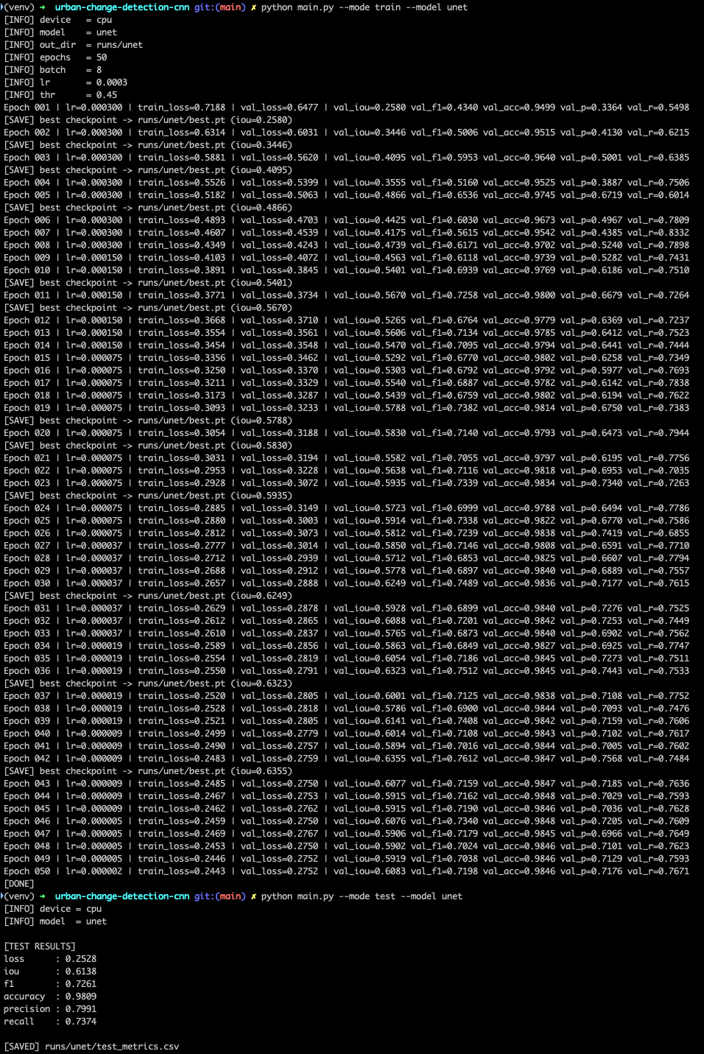
Figure A1: U-Net Training and Testing Output Logs
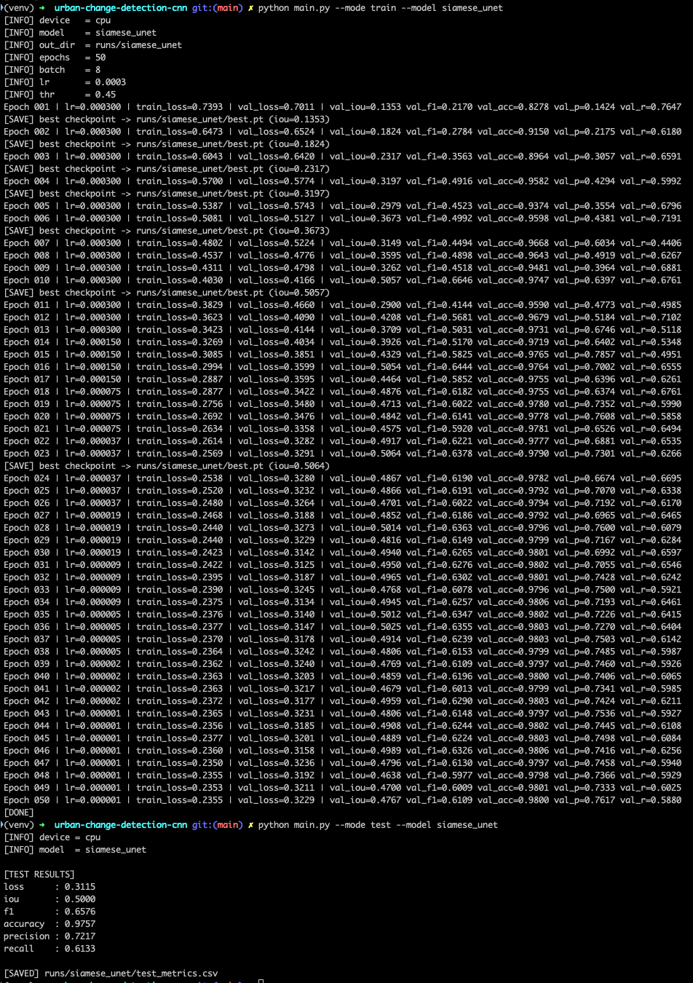
Figure A2: Siamese U-Net Training and Testing Output Logs

