INTERNSHIP REPORT ON PROGRAMMER ANALYST TRAINEE INTERN AT COGNIZANT

Internship Report submitted to
Shri Ramdeobaba College of Engineering & Management, Nagpur in partial fulfillment of requirement for the award of degree of

Bachelor of Technology (B.Tech)
In

COMPUTER SCIENCE AND ENGINEERING & EMERGING TECHNOLOGIES (DATA SCIENCE)
by

DISHA VASANI
Of

VIII Semester
Guide

Prof. Nikita Katariya and Prof. Shubham Tayade

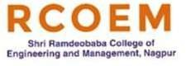

Department of Computer Science and Engineering & Emerging Technologies (Data Science)

SHRI RAMDEOBABA COLLEGE OF ENGINEERING & MANAGEMENT, NAGPUR
(An Autonomous Institute Affiliated to Rashtrasant Tukdoji Maharaj Nagpur University Nagpur)

SHRI RAMDEOBABA COLLEGE OF ENGINEERING & MANAGEMENT, NAGPUR

(An Autonomous Institute Affiliated to Rashtrasant Tukdoji Maharaj Nagpur University Nagpur)
Department of Computer Science and Engineering & Emerging Technologies (Data Science)

CERTIFICATE
This is to certify that the Internship Report on Programmer Analyst Traine Intern at Cognizant is a bonafide work of Disha Vasani submitted to the Rashtrasant Tukdoji Maharaj Nagpur University, Nagpur in partial fulfillment of the award of a Bachelor of Engineering, in Computer Science and Engineering & Emerging Technologies (Data Science) has been carried out at the Cognizant, Bangalore during the academic year 2024-2025.

Date:15th May 2025 Place: Nagpur

Mr. Kavin Kumar Dr. P. Voditel Industry Mentor, H.O.D
Cognizant Pvt. Limited Department of Computer Science and Engineering

Prof. Nikita Katariya & Prof. Shubam Tayade Dr. Parag Jawarkar Internal Guide Dean-CDPC
Department of Computer Science and Engineering (Data Science)

Dr. M. B. Chandak Principal

DECLARATION

I, hereby declare that the Project titled Internship Report On Programmer Analyst Trainee Intern At Cognizant submitted herein, has been carried out in Cognizant, Bangalore. The work is original and has not been submitted earlier as a whole or part for the award of any degree / diploma at this or any other institution / University.
Date: 06/06/2025 Place: Nagpur

Disha Vasani Roll No.: 04


APPROVAL SHEET

This report entitled “ Programmer Analyst Traine Intern at Cognizant” by Disha Vasani is approved for the degree of Bachelor of Technology in Computer Science and Engineering & Emerging Technologies (Data Science).
Date: 06/06/2025 Place: Nagpur

Prof. Nikita Katariya Prof. Shubham Tayade
Internal Guide Internal Guide
Department of CSE Department of CSE

Dr. P. Voditel
H.O.D
Department of CSE & ET

ABSTRACT

This report summarizes my eighth-semester internship as a Programmer Analyst Trainee at Cognizant Technology Solutions, under the Artificial Intelligence and Analytics (AIA) business unit. The internship focused on hands-on experience with Informatica PowerCenter and IICS for data integration and transformation.
Initial training covered SQL, Python, Unix, ETL, and data w arehousing, forming the foundation for two major projects: an interim project on Student Report using PowerCenter and a final project on University Analytics using IICS. My responsibilities included requirement analysis, data mapping, workflow development, and result validation, following best practices and Agile methodology.
The internship enhanced my technical skills in enterprise data tools and cloud platforms while strengthening my problem-solving, communication, and collaboration abilities, preparing me for a career in AI and Data analytics.

TABLE OF CONTENTS

Content | Page No.
Declaration | 3
Abstract | 5
List of figures | 7
1. Introduction | 8
2 Tools and Technology used | 10
2.1 Informatica PowerCenter | 11
2.2 Informatica Cloud | 11
2.3 Python | 12
2.4 SQL | 13
2.5 Data warehousing | 14
2.6 Shell scripting | 15
2.7 Unix | 16
3 Internship Domain | 17
4 Working Methodology | 20
5 Interim and Final Evaluation | 22
6 About Internship role and Work | 25
7 Conclusion and Outcome | 27

LIST OF FIGURES

Figure Number | Figure Name | Page Number
1.1 | Cognizant | 8
1.2 | Informatica | 8
2.1 | Informatica Powercenter | 11
2.2 | IICS Cloud | 11
2.3 | Python Programming | 13
2.4 | SQL | 14
2.5 | Data Warehousing | 15
2.6 | Shell scripting | 16
3.1 | Skilled covered in Internship | 18
4.1 | Logical Architecture Diagram for HealthCare | 23
4.2 | Logical Architecture Diagram for | 25
5.1 | Internship Completion mail | 29

CHAPTER 1

INTRODUCTION

The internship program is a vital component of the academic curriculum, providing students with practical exposure to industry practices, real-world problem-solving, and professional development. As part of my eighth-semester internship, I undertook a role as a Programmer Analyst Trainee at Cognizant Technology Solutions, a IT Consulting and Outsourcing Leader around the globe.


Fig 1.1 Cognizant

This internship report outlines my experience as a Programmer Analyst Trainee at Cognizant, where I was placed in the Artificial Intelligence and Analytics (AIA) business unit. The primary focus of my internship was to gain expertise in Informatica PowerCenter and IICS tools, key technologies used for enterprise data integration and transformation. Additionally, the internship involved an initial training phase to brush up on foundational skills in SQL, Python, data warehousing, ETL concepts, and Unix, which were essential for the work I did during the projects.
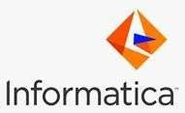

Fig 1.2 Informatica

I contributed to two significant projects: an interim project on a Student Report System and a final project on a University Analytics System. The interim project was carried out using Informatica PowerCenter, where I worked on building and optimizing ETL pipelines for processing transactional data. The final project was completed using IICS (Informatica

Intelligent Cloud Services), which provided a cloud-based platform for data integration, and involved integrating academic and administrative data to generate business intelligence insights.
My key responsibilities included analyzing business requirements, creating data mappings, designing and developing workflows in Informatica PowerCenter and IICS, and validating the results using SQL and Python. I also applied best practices in modular design, error handling, and performance tuning. The internship was conducted under Agile methodologies, allowing close collaboration with mentors and team members to align the projects with business objectives.
This internship provided a comprehensive understanding of data integration, cloud technologies, and analytics, significantly enhancing my skills and preparing me for a future career in AI and Data analytics.

CHAPTER 2

TOOLS AND TECHNOLOGY USED
During my internship at Cognizant, I had the opportunity to work with a modern data and
analytics technology stack. The tools and platforms listed below were integral to carrying out my responsibilities efficiently and gaining a deeper understanding of data flows and insights generation.

Informatica PowerCenter

    - ETL Tool: Used to extract data from various sources, transform it as per business logic, and load it into target systems (like data warehouses).
    - Components Used: Worked with Designer, Workflow Manager, Workflow Monitor, and Repository Manager.
    - Data Integration: Helped in integrating data from multiple heterogeneous sources such as databases, flat files, and ERP systems.
    - Mapping Creation: Designed and developed mappings to define data flow and transformations using different transformations like Expression, Lookup, Joiner, Aggregator, etc.
    - Workflow Development: Created workflows to schedule and manage the execution of mappings and sessions.
    - Error Handling: Implemented error handling and data validation using built-in PowerCenter features.
    - Scheduling & Monitoring: Scheduled ETL jobs and monitored them for performance and failures using Workflow Monitor.
    - Real-Time Experience: Gained hands-on experience in troubleshooting ETL issues, optimizing data flows, and improving performance.


Fig. 2.1 Informatica powercenter

Informatica Cloud
    - Informatica Cloud Data Integration: Designed and executed cloud mappings and tasks to extract, transform, and load data across cloud and on-premise sources.
    - Taskflows: Created task flows to orchestrate complex ETL pipelines with conditional logic and parallel processing.
    - Secure Agent: Worked with Secure Agent to connect on-premise data sources securely with cloud services.
    - Connectivity: Integrated data from cloud applications (like Salesforce, Workday, etc.) and databases using pre-built connectors.
    - Monitoring and Logging: Monitored task runs, reviewed logs, and managed failures using the IICS Monitoring dashboard.
    - User Interface: Gained experience with the modern, web-based UI of IICS which simplifies development and management of integration jobs.
    - Data Synchronization: Used Data Synchronization tasks for simple one-to-one data movement with minimal transformation.
    - Cloud-based ETL Tool: Used for performing data integration tasks in the cloud, offering a scalable and flexible alternative to on-premise PowerCenter.

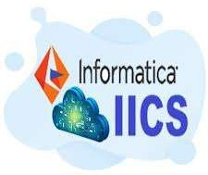

Fig. 2.2 IICS cloud

Python

    - Scripting Language: Used for automating repetitive tasks and preprocessing data before ETL or analysis.
    - Data Handling: Utilized libraries like Pandas and NumPy for data manipulation, cleaning, and transformation.
    - API Integration: Wrote Python scripts to consume REST APIs and fetch data from web/cloud platforms.
    - File Handling: Automated reading/writing of CSV, Excel, and JSON files to support data integration workflows.
    - Error Handling & Logging: Implemented basic error handling and logging in Python scripts for better reliability and debugging.

    - Scheduling: Scheduled Python scripts using task schedulers (like Windows Task Scheduler or cron) for regular data processing jobs.

    - Learning Outcome: Strengthened understanding of programming fundamentals, modular coding, and working with real-world data.



Fig. 2.3 Python Programming

SQL (Structured Query Language)

    - Data Extraction: Used SQL queries to retrieve specific data from relational databases for analysis or ETL processes.
    - Joins & Subqueries: Worked with inner joins, outer joins, and subqueries to combine and filter data across multiple tables.
    - Data Transformation: Applied SQL functions and expressions to clean, filter, and transform raw data as per business logic.
    - Database Interaction: Interacted with databases such as Oracle, SQL Server, or MySQL for data validation and testing.
    - Query Optimization: Improved performance of queries by analyzing execution plans and using indexing techniques.
    - DDL & DML Commands: Used Data Definition Language (like CREATE, ALTER) and Data Manipulation Language (like SELECT, UPDATE, INSERT) to work with tables and data.
    - Hands-on Practice: Gained practical experience writing efficient queries and troubleshooting database-related issues.

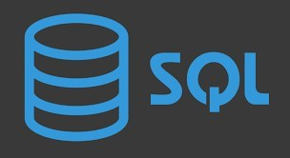
Fig. 2.4 SQL

Data Warehousing

    - Centralized Data Storage: Worked with data warehouses to store large volumes of historical and integrated data from multiple sources.
    - ETL Integration: Understood how ETL tools like Informatica PowerCenter and IICS load data into the warehouse after transformation.

    - Dimensional Modeling: Learned concepts like star schema and snowflake schema to organize data for easier reporting and analysis.

    - Fact and Dimension Tables: Worked with fact tables (transactional data) and dimension tables (descriptive data) to support business intelligence needs.
    - Data Consistency & Quality: Ensured that only cleaned, validated, and consistent data was loaded into the warehouse.
    - Performance Optimization: Gained insights into indexing, partitioning, and query optimization techniques to enhance warehouse performance.
    - Reporting Support: Enabled downstream reporting and analytics tools (like Tableau or Power BI) to access structured data efficiently.

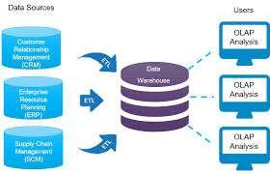
Fig. 2.5 Data Warehousing

Shell Scripting

    - Automation: Used shell scripts to automate repetitive tasks such as file transfers, log management, and job scheduling.
    - ETL Support: Created scripts to trigger Informatica workflows, monitor job statuses, and handle pre/post-processing in the ETL process.
    - File Handling: Wrote scripts to manage and manipulate files (like .csv, .txt) — renaming, archiving, compressing, and cleaning them.
    - Scheduling with Cron: Scheduled scripts using cron jobs to run at defined times or intervals automatically.
    - Error Logging: Implemented basic error logging in scripts to capture runtime issues and improve reliability.
    - Command-line Operations: Improved proficiency in Linux/Unix commands to navigate the system and manage processes efficiently.
    - Integration: Integrated shell scripts with other tools like Python or SQL to build end-to-end automation workflows.


Fig. 2.6 Shell Scripting

Unix

    - Command-line Proficiency: Gained hands-on experience working in the Unix/Linux terminal for day-to-day tasks.

    - File System Management: Navigated directories, managed files (create, move, copy, delete), and set permissions using Unix commands.
    - Process Management: Used commands like ps, top, kill, and nohup to monitor and manage running processes.
    - ETL Environment Support: Supported Informatica and Python scripts running in a Unix environment for data processing and automation.
    - Shell Scripting: Developed basic shell scripts in Unix for task automation, scheduling, and file handling.
    - Scheduling Jobs: Used crontab to schedule scripts and data jobs for automatic execution.
    - Log Analysis: Reviewed and analyzed log files using tools like grep, tail, and awk for troubleshooting and debugging.

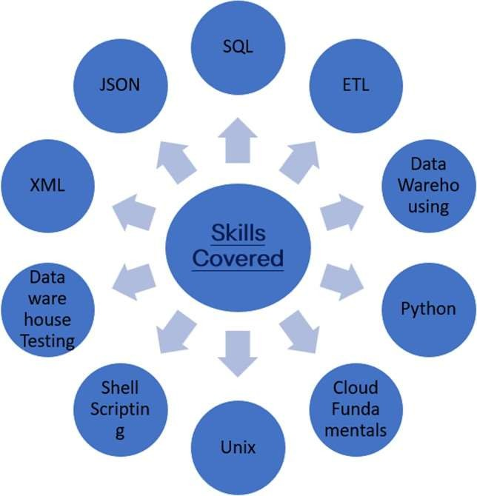

Fig. 3.1 Skilled Covered in internship

CHAPTER 3

INTERNSHIP DOMAIN

Overview of the Domain

Informatica in Artificial Intelligence (AI) Analytics focuses on preparing and managing data that is used to train and run AI models. Informatica is a powerful data integration tool that helps in collecting, cleaning, organizing, and moving data across various systems. In AI, the quality and structure of data play a very important role. Without good data, even the best AI algorithms won't give useful results. Informatica ensures that data is in the right format, complete, and error-free before it is used in AI and machine learning processes.

Relevance of the Domain

This domain is highly relevant because:

- AI models require large amounts of clean data.

- Informatica tools help make the data ready for analysis by AI systems.

- It supports industries like finance, healthcare, retail, and telecom, where AI is being rapidly adopted.
- It also ensures data governance and security, which are essential in AI.

Problem Areas in the Domain

Some common challenges in this domain include:

- Data quality issues – missing or incorrect data.

- Integration problems – combining data from multiple sources is hard.

- Scalability – managing huge datasets efficiently.

- Real-time processing – AI often needs data in real time, which is tough to maintain.

Importance of Data in the Domain

Data is the fuel for AI. The success of AI analytics depends heavily on:

- Accurate, timely, and well-organized data.

- Informatica ensures the data used in AI is trustworthy and usable.

- It enables data cleansing, data transformation, and metadata management, which are key for training effective AI models.

Key Learnings from the Domain

- Good data management is the foundation of successful AI projects.

- Informatica plays a vital role in preparing and delivering high-quality data.

- Understanding the data pipeline is as important as building AI models.

- Real-world AI applications require robust data handling solutions, and Informatica is one of the leaders in this space.

CHAPTER 4

WORKING METHODOLOGY
This internship at Cognizant was structured into well-defined phases to ensure a comprehensive learning and development experience. It provided a balanced mix of theoretical instruction, hands-on application, and soft skills enhancement. The methodology adopted is detailed below:

Delta Assessment and Foundational Learning

The internship commenced with the Delta Assessment phase, aimed at establishing a strong foundation in core technical skills. Participants underwent structured training and hands-on practice in SQL, Python, and Unix, reinforcing key concepts through problem-solving exercises. The program also included Udemy certification modules and behavioral training sessions to foster communication and workplace readiness. This phase concluded with an assessment, in which I achieved a perfect score of 100%.

Interim Project: Training, Practice, and Team Collaboration

Before beginning the project work, a short training on Informatica PowerCenter was conducted. This covered essential ETL concepts and tool-specific features. Following the training, interns were given hands-on assignments involving small problem statements, which helped reinforce practical understanding of the tool.
Subsequently, we progressed to the Interim Project, a team-based initiative focused on a Credit Card Management System, where we applied our PowerCenter knowledge in a collaborative setting. This project emphasized real-time data integration and transformation, enabling us to gain practical experience in building ETL workflows and managing project timelines through effective team coordination.

Final Evaluation: Advanced Cloud-Based Project

The final project phase began with an overview session on Informatica Intelligent Cloud Services (IICS) to familiarize us with its architecture and cloud-specific components. We then

transitioned into the main task—an advanced-level individual project titled University Analytics System. This project involved end-to-end implementation using IICS, including defining KPIs, building data pipelines, and delivering actionable dashboards. It highlighted the transition from on-premise systems to cloud environments and demanded higher levels of autonomy and technical proficiency.

Communication and Behavioral Training

Throughout the internship, behavioral training sessions were conducted once or twice a week, focusing on holistic development. These included modules on interview preparation, storytelling, communication skills, conference call etiquette, and other activities aimed at enhancing creative thinking, articulation, and professional conduct. These sessions played a vital role in shaping our workplace readiness and boosting confidence for real-world scenarios.

Evaluation and Continuous Feedback

Evaluation was an integral part of both project phases. Interviews were conducted after the interim and final projects, assessing both technical delivery and communication skills. I was awarded a "Green Grade" in both evaluations, indicating strong performance. Regular feedback from mentors and peers helped identify areas for improvement and guided personal and technical growth throughout the internship.

CHAPTER 5

INTERIM AND FINAL EVALUATION PROJECT

INTERIM EVALUATION
HEALTH CARE REPORT

As part of our interim project, we worked on a data-driven application titled “Health Care Report”. The main goal of this project was to handle and transform a large dataset of student information to generate useful academic insights. We used ETL (Extract, Transform, Load) techniques within Informatica Cloud, a powerful data integration platform, to carry out data cleaning, transformation, and loading processes effectively.
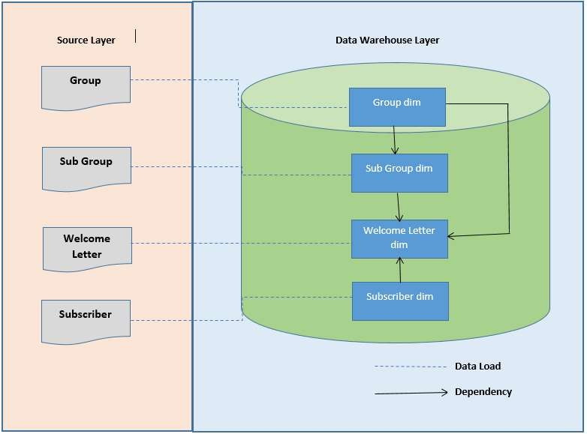
Fig. 4.1 Logical Architectural Diagram for HealthCare

The project was designed to address specific academic reporting needs. To achieve this, we developed four main components that allowed us to extract meaningful insights from raw student data. Each component was built with a clear focus on transforming raw inputs into structured and analytical outputs, forming a mini data warehouse model.

The first component was the Group Dimension, which holds key details about various academic departments such as Group ID, Group name, and Group type. This table plays a central role in identifying and categorizing group details based on the group they belong to. It serves as a reference table and supports filtering of data during analysis.
Next, we created the Subgroup Dimension, which stores basic student-related data. This includes fields such as subgroup ID, name, gender, and group ID (linked from the group table). The subgroup dimension allowed us to view personal information for each student and was crucial in linking individual performance with departmental records.
The core of our analysis was based on the Subscriber Fact Table, which captured the actual performance of each group and subgroup. This table includes information like subgroup ID, subgroup name, and group ID. It acts as the central table in our data model, supporting calculations such as total and average group, comparisons.
In last Dimension, we combined all the above three dimension so that we can identify all the group, subgroup and subscribers according to there respective common attributes or data. Also, at the end we converted all these data into the XSD format in simple word we can say that in XML format.
Throughout the project, we used Informatica Cloud to build workflows, perform data transformations, and automate the loading of final structured data into the target tables. The use of cloud-based ETL tools helped us understand the real-world process of handling enterprise-level data with flexibility and accuracy.
In conclusion, this project gave us hands-on experience with ETL tools and helped us understand the end-to-end data transformation process, from raw data to meaningful analysis. It also improved our knowledge of data warehousing concepts like dimension tables, fact tables, and aggregates. The Student Report project laid a strong foundation for working with large datasets and deriving valuable academic insights, which can help institutions in better planning and decision-making.

FINAL EVALUATION
UNIVERSITY ANALYTICS SYSTEM
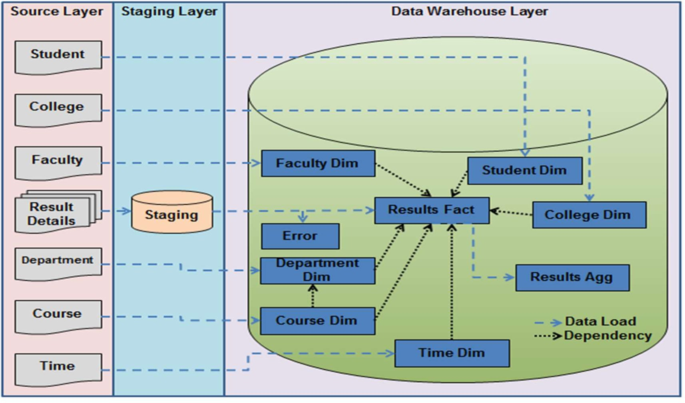

Fig. 4.2 Logical Architecture Diagram for University

Fig. 4.2 Logical Architecture Diagram for University

CHAPTER 6

ABOUT INTERNSHIP ROLE AND WORK
During my eighth-semester internship at Cognizant from January 23 to April 14, 2025, I worked as a Programmer Analyst Trainee under the Artificial Intelligence Analytics (AIA) domain. Throughout the internship, I was trained in various essential technologies including SQL, Python, Unix shell scripting, data warehousing (DW) concepts, data testing, and cloud fundamentals. These areas formed the foundation of my understanding of enterprise-level data processing and analytics. Additionally, I was introduced to Informatica and its cloud services, which I used extensively to build and manage ETL workflows during both group and individual projects.

I had significant hands-on experience with Python, SQL, and Unix shell scripting, which helped me understand how data is processed, cleaned, and validated in real-world scenarios. Working with these tools daily strengthened my problem-solving skills and improved my ability to write efficient scripts for automation and data handling tasks. The training was not just theoretical but also project-driven, allowing me to apply what I learned in practical settings.

My journey began with an interim group project titled Student Report, where our team of five to six members was responsible for managing and transforming student data. We collaborated closely to clean raw data, apply transformation logic, and load it into structured formats suitable for analysis. This project helped me understand the basics of building data pipelines and working collaboratively to solve data-related challenges.

Following this, I undertook a more advanced individual project titled University Analytics System. This final project required me to handle both current and historical data and build end-to-end data flows independently. I designed efficient workflows in Informatica Cloud, ensured data accuracy and consistency, and also created comprehensive documentation including testing and validation reports. This project significantly strengthened my ability to work independently and manage complex data systems while meeting tight deadlines.

In addition to the technical skills, I became familiar with basic shell scripting, which was useful for supporting automation in data workflows. I also had the opportunity to learn corporate behavioral standards. The work culture at Cognizant was highly engaging and supportive. We participated in daily training sessions, weekly behavioral improvement workshops, and regular interactions with mentors, including my mentor Kavin Kumar and our point of contact Akash Nair. These activities not only improved my technical proficiency but also helped enhance my communication skills, body language, and professional etiquette during meetings.

One of the key challenges I faced during the internship was working on virtual machines (VMs), which often slowed down the development process. Despite these limitations, I was able to maintain efficiency and deliver work on time, learning to balance speed with accuracy. Most importantly, this internship gave me exposure to a completely new field—data engineering, which I now find very exciting and would like to pursue further in my career.

In summary, the internship experience at Cognizant gave me a holistic view of how data engineering operates in real-world scenarios. I not only learned technical tools like Informatica and Informatica Cloud but also gained valuable insight into working in a professional corporate environment, collaborating across teams, and contributing meaningfully to data-driven projects.

CHAPTER 7

CONCLUSION AND OUTCOME

The eighth-semester internship at Porter as a Business Analyst Intern has been a deeply enriching and transformative experience. Over the course of the internship, I had the opportunity to work on multiple high-impact projects that spanned across key business areas such as partner onboarding, order fulfillment optimization, supply hygiene management, document verification through blacklisting features, data quality monitoring, and dashboard performance optimization. Each of these projects provided a real-world context for applying analytical skills, understanding business processes, and delivering data-driven solutions that support operational efficiency and strategic decision-making.
One of the most valuable aspects of this internship was the exposure to a fast-paced, agile work environment where cross-functional collaboration, structured thinking, and rapid iteration were essential. I gained proficiency in industry-standard tools such as Snowflake, Metabases, DBT, PostgreSQL, and Monte Carlo, enhancing my capabilities in data modeling, visualization, anomaly detection, and performance optimization. Additionally, I developed a strong understanding of logistics and supply chain dynamics, learning how metrics such as fulfillment rate, turnaround time, and cancellation scores influence daily operations and long-term business outcomes.
The outcome of my work was reflected in tangible process improvements, including improved onboarding funnel visibility, predictive planning for supply adequacy, reduction of unreliable partner behavior, and improved data reliability for downstream reporting. The dashboards and frameworks I developed were actively used by operations teams, enabling faster and more informed decision-making.
This internship not only helped me build technical and analytical competencies but also honed my communication, presentation, and problem-solving skills. It prepared me to think critically about business problems, collaborate effectively with diverse stakeholders, and take ownership of projects from problem definition to solution delivery. The experience has strengthened my foundation as an aspiring data professional and provided a solid platform to contribute meaningfully in future roles.
In conclusion, the internship was a significant milestone in my academic and professional journey, offering practical insights, impactful contributions, and the confidence to take on complex, data-driven challenges in the industry.

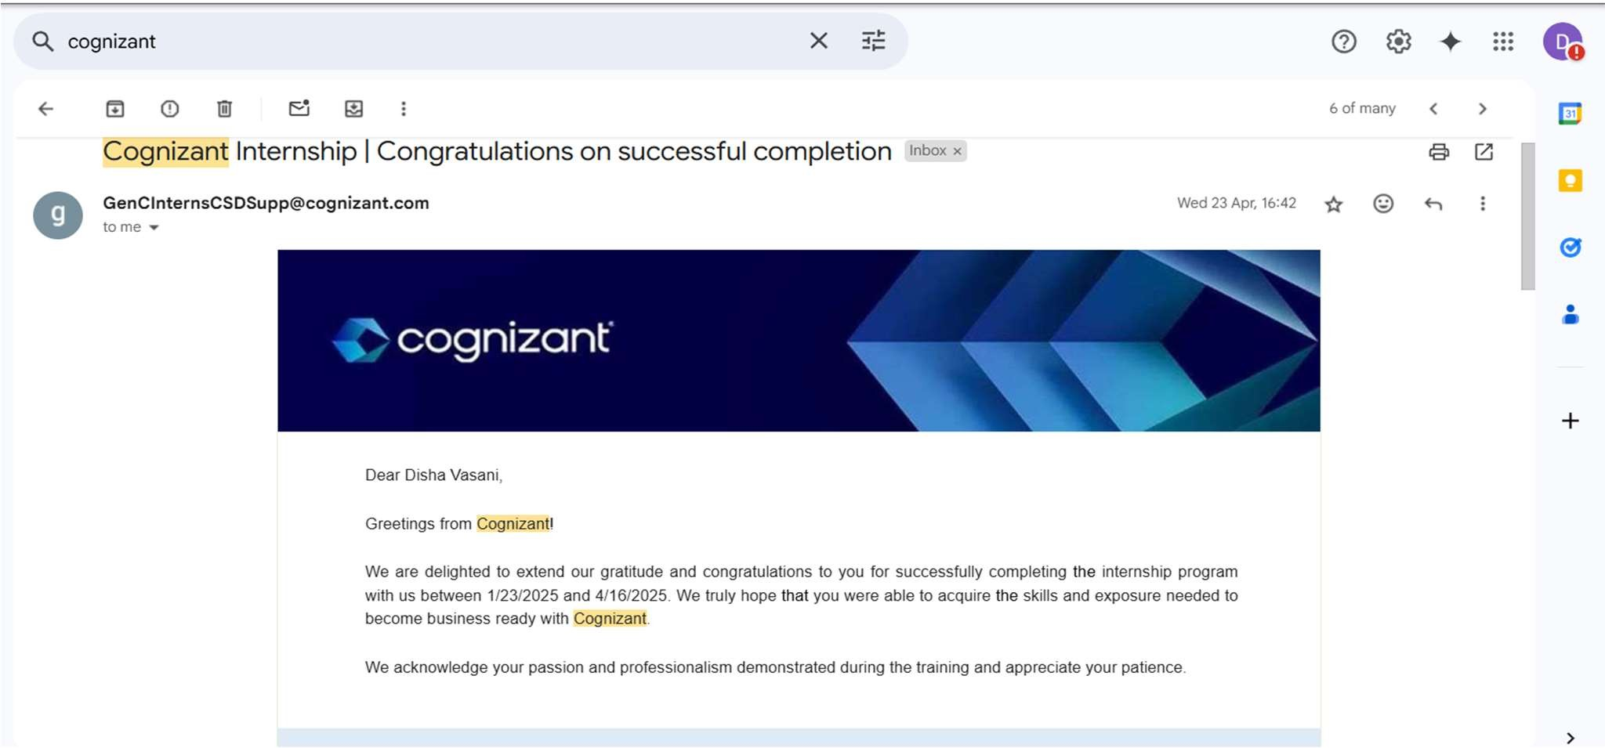

Fig. 5.1 Internship Completion Mail

