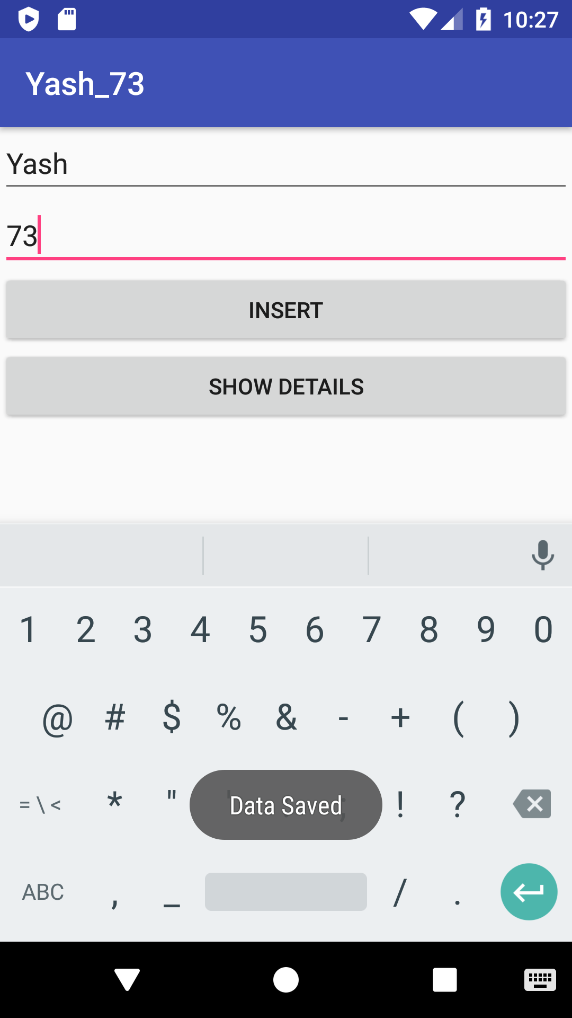

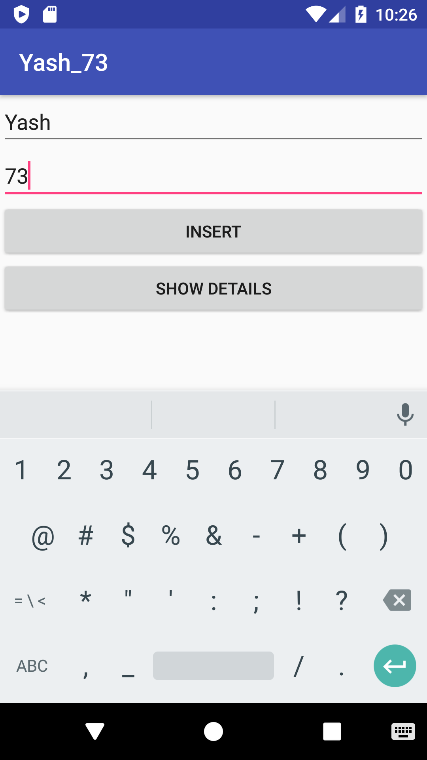

Activity.xml:

*<?***xml version="1.0" encoding="utf-8"***?>*<**LinearLayout xmlns:android="http://schemas.android.com/apk/res/android"  
 xmlns:app="http://schemas.android.com/apk/res-auto"  
 xmlns:tools="http://schemas.android.com/tools"  
 android:layout_width="match_parent"  
 android:layout_height="match_parent"  
 android:orientation="vertical"  
 tools:context="com.student.shibu022.MainActivity"**>  
  
 <**EditText  
 android:id="@+id/txtName"  
 android:layout_width="match_parent"  
 android:layout_height="wrap_content"** />  
  
  
 <**EditText  
 android:id="@+id/txtMobile"  
 android:layout_width="match_parent"  
 android:layout_height="wrap_content"** />  
  
 <**Button  
 android:layout_width="match_parent"  
 android:layout_height="wrap_content"  
 android:id="@+id/btnSave"  
 android:text="Insert"**/>  
  
 <**Button  
 android:layout_width="match_parent"  
 android:layout_height="wrap_content"  
 android:id="@+id/btnGetDetails"  
 android:text="Show Details"**/>  
  
</**LinearLayout**>

Mainactivity.java:

**package** com.student.shibu022;  
  
**import** android.support.v7.app.AppCompatActivity;  
**import** android.os.Bundle;  
**import** android.view.View;  
**import** android.widget.Button;  
**import** android.widget.EditText;  
**import** android.widget.Toast;  
  
**public class** MainActivity **extends** AppCompatActivity {  
 Button **btnSave**;  
 EditText **txtName**;  
 EditText **txtMobile**;  
 Button **btnGetDetails**;  
 DBHelper1 **dbHelper**;  
 @Override  
 **protected void** onCreate(Bundle savedInstanceState) {  
 **super**.onCreate(savedInstanceState);  
 setContentView(R.layout.***activity_main***);  
  
 **btnSave**=(Button)findViewById(R.id.***btnSave***);  
 **txtName**=(EditText)findViewById(R.id.***txtName***);  
 **txtMobile**=(EditText)findViewById(R.id.***txtMobile***);  
 **btnGetDetails**=(Button)findViewById(R.id.***btnGetDetails***);  
 **dbHelper**=**new** DBHelper1(**this**);  
  
 **btnSave**.setOnClickListener(**new** View.OnClickListener() {  
 @Override  
 **public void** onClick(View v) {  
 String name=**txtName**.getText().toString();  
 String Mobile=**txtMobile**.getText().toString();  
  
 **long** res=**dbHelper**.saveDetails(name,Mobile);  
  
 **if**(res==-1){  
 Toast.*makeText*(MainActivity.**this**, **"Data Not Saved"**, Toast.***LENGTH_SHORT***).show();  
 }  
 **else**{  
 Toast.*makeText*(MainActivity.**this**,**"Data Saved"**,Toast.***LENGTH_SHORT***).show();  
 }  
 }  
 });  
 }  
}

DBHelper.java:

**package** com.student.shibu022;  
  
**import** android.content.ContentValues;  
**import** android.content.Context;  
**import** android.database.Cursor;  
**import** android.database.sqlite.SQLiteDatabase;  
**import** android.database.sqlite.SQLiteOpenHelper;  
  
*/**  
 * Created by Student on 11-02-2020.  
 */***public class** DBHelper1 **extends** SQLiteOpenHelper {  
 **public** DBHelper1(Context c){  
 **super**(c,**"SYCSDatabase.DB"**,**null**,1);  
 }  
  
 @Override  
 **public void** onCreate(SQLiteDatabase db) {  
 String qry=**"CREATE TABLE DETAILS (ID INTEGER PRIMARY KEY AUTOINCREMENT,NAME TEXT, MOBILE TEXT)"**;  
 db.execSQL(qry);  
 }  
  
 @Override  
 **public void** onUpgrade(SQLiteDatabase db, **int** oldVersion, **int** newVersion) {  
  
  
 }  
 **public long** saveDetails(String name,String Mobile){  
 SQLiteDatabase db=**this**.getWritableDatabase();  
  
 ContentValues val = **new** ContentValues();  
 val.put(**"NAME"**,name);  
 val.put(**"MOBILE"**,Mobile);  
 **long** res=db.insert(**"DETAILS"**,**null**,val);  
 **return** res;  
 }  
  
 */*public Cursor getDetails(){  
 SQLiteDatabase db=this.getReadableDatabase();  
  
 String qry="Select * from DETAILS";  
  
 }*/*}

