Opening

a=[0 0 0 0 0 0 0 0 0 0 0 0 0 0;

0 1 1 1 1 0 0 0 0 1 1 1 1 0;

0 1 1 1 1 0 0 0 0 1 1 1 1 0;

0 1 1 1 1 1 1 1 1 1 1 1 1 0;

0 1 1 1 1 1 1 1 1 1 1 1 1 0;

0 1 1 1 1 0 0 0 0 1 1 1 1 0;

0 1 1 1 1 0 0 0 0 1 1 1 1 0;

0 0 0 0 0 0 0 0 0 0 0 0 0 0; ]

se1= strel('Square',3);

Im2=imerode(a, se1);

Im3=imdilate(Im2, se1);

subplot(2,1,1);

imshow(a);

title('original Image');

subplot(2,1,2);

imshow(Im3);

title('Opening Image')

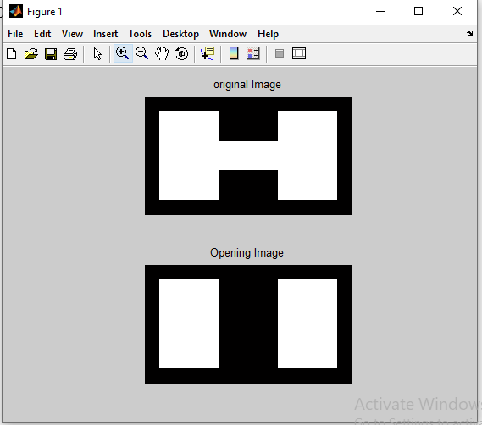

closing

a=[0 0 0 0 0 0 0 0 0 0 0 0 0 0;

0 1 1 1 1 0 0 0 0 1 1 1 1 0;

0 1 1 1 1 0 0 0 0 1 1 1 1 0;

0 1 1 1 1 1 1 1 1 1 1 1 1 0;

0 1 1 1 1 1 1 1 1 1 1 1 1 0;

0 1 1 1 1 0 0 0 0 1 1 1 1 0;

0 1 1 1 1 0 0 0 0 1 1 1 1 0;

0 0 0 0 0 0 0 0 0 0 0 0 0 0; ]

se1= strel('Square',3);

Im2=imdilate(a, se1);

Im3=imerode(Im2, se1);

subplot(2,1,1);

imshow(a);

title('original Image');

subplot(2,1,2);

imshow(Im3);

title('Closing Image')

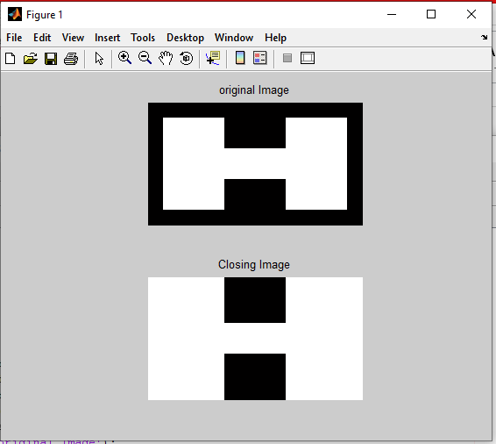

Laplesian

clear;

clc;

img1=imread('D:\TYCS37\img.jpg');

img=rgb2gray(img1);

p=double(img);

w=[-1 -1 -1;-1 8 -1;-1 -1 -1]

[row col]=size(p)

for i=2:1:row-1

for j=2:1:col-1

p1(i,j)=[(w(1)\*p(i-1,j-1))+(w(2)\*p(i-1,j))+(w(3)\*p(i-1,j+1))+(w(4)\*p(i,j-1))+(w(5)\*p(i,j))+(w(6)\*p(i,j+1))+(w(7)\*p(i+1,j+1))+(w(8)\*p(i+1,j))+(w(9)\*p(i+1,j+1))];

end

end

figure(1)

imshow(uint8(p))

title('Original Image');

figure(2)

imshow(uint8(p1))

title('Laplasian Image');

