Contrast Stretching

clear all;

clc;

img = imread('D:\TYCS37\img.jpg');

p = double(img)-50;

subplot(1,2,1);

imshow(uint8(p));

title('original image');

r1=100;

s1=150;

r2=140;

s2=240;

l=s1/r1;

m=(s2-s1)/(r2-r1);

n=(255-s2)/(255-r2);

s=size(p);

redPlane = p(:,:,1);

greenPlane = p(:,:,2);

bluePlane = p(:,:,3);

for x=1:s(1);

for y=1:s(2);

if((redPlane(x,y)>0 && (redPlane(x,y)<r1)))

r(x,y)=redPlane(x,y)\*l;

end

if((redPlane(x,y)>r1) && (redPlane(x,y)<r2))

r(x,y)=(m\*(redPlane(x,y)-120))+s1;

end

if((redPlane(x,y)>r2) && (redPlane(x,y)<256))

r(x,y)=(n\*(redPlane(x,y)-150))+s2;

end

end

end

for x=1:s(1);

for y=1:s(2);

if((greenPlane(x,y)>0 && (greenPlane(x,y)<r1)))

g(x,y)=greenPlane(x,y)\*l;

end

if((greenPlane(x,y)>r1) && (greenPlane(x,y)<r2))

g(x,y)=(m\*(greenPlane(x,y)-120))+s1;

end

if((greenPlane(x,y)>r2) && (greenPlane(x,y)<256))

g(x,y)=(n\*(greenPlane(x,y)-150))+s2;

end

end

end

for x=1:s(1);

for y=1:s(2);

if((bluePlane(x,y)>0 && (bluePlane(x,y)<r1)))

b(x,y)=redPlane(x,y)\*l;

end

if((bluePlane(x,y)>r1) && (bluePlane(x,y)<r2))

b(x,y)=(m\*(bluePlane(x,y)-120))+s1;

end

if((bluePlane(x,y)>r2) && (bluePlane(x,y)<256))

b(x,y)=(n\*(bluePlane(x,y)-150))+s2;

end

end

end

op(:,:,1)=r

op(:,:,2)=g

op(:,:,3)=b

op=uint8(op);

subplot(1,2,2)

imshow(uint8(op));

title('contrast image');

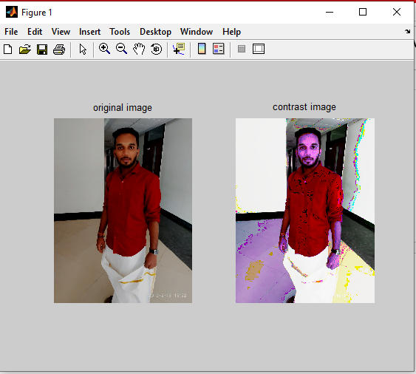

Pseudo

clear all;

clc;

img=imread('D:\TYCS37\img.jpg');

subplot(1,3,1);

imshow(img);

title('Original Image');

redPlane = img(:,:,1);

greenPlane = img(:,:,2);

bluePlane = img(:,:,3);

op(:,:,1)=greenPlane

op(:,:,2)=bluePlane

op(:,:,3)=redPlane

subplot(1,3,2);

imshow(op);

title('changed image1');

oppa(:,:,1)=bluePlane

oppa(:,:,2)=redPlane

oppa(:,:,3)=greenPlane

subplot(1,3,3);

imshow(oppa);

title('changed image2');

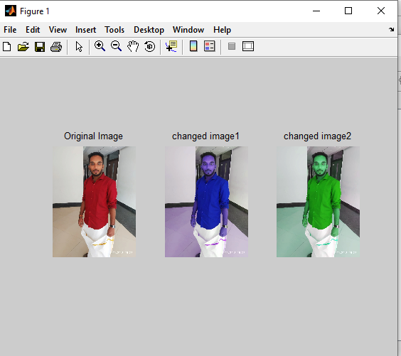

Sharpening

clear;

clc;

img1=imread('D:\TYCS37\img.jpg');

img=rgb2gray(img1);

p=double(img);

w=[1/9 1/9 1/9;1/9 8 1/9;1/9 1/9 1/9]

[row col]=size(p)

for i=2:1:row-1

for j=2:1:col-1

p1(i,j)=[(w(1)\*p(i-1,j-1))+(w(2)\*p(i-1,j))+(w(3)\*p(i-1,j+1))+(w(4)\*p(i,j-1))+(w(5)\*p(i,j))+(w(6)\*p(i,j+1))+(w(7)\*p(i+1,j+1))+(w(8)\*p(i+1,j))+(w(9)\*p(i+1,j+1))];

end

end

figure(1)

imshow(uint8(p))

title('Original Image');

figure(2)

imshow(uint8(p1))

title('Laplasian Image');

