**Industrial Internship Report on**

**”Crop and Weed Detection”**

**Prepared by**

**Kunchala Ajith Kumar**

|  |
| --- |
| *Executive Summary* |
| This report provides details of the Industrial Internship provided by upskill Campus and The IoT Academy in collaboration with Industrial Partner UniConverge Technologies Pvt Ltd (UCT).  This internship was focused on a project/problem statement provided by UCT. We had to finish the project including the report in 6 weeks’ time.  My project was Crop and Weed Detection.  This internship gave me a very good opportunity to get exposure to Industrial problems and design/implement solution for that. It was an overall great experience to have this internship. |

**TABLE OF CONTENTS**

1 Preface 3

2 Introduction 5

2.1 About UniConverge Technologies Pvt Ltd 5

2.2 About upskill Campus 9

2.3 Objective 11

2.4 Reference 11

2.5 Glossary 11

3 Problem Statement 12

4 Existing and Proposed solution 13

5 Proposed Design/ Model 15

5.1 High Level Diagram (if applicable) 16

5.2 Low Level Diagram (if applicable) 17

5.3 Interfaces (if applicable) 18

6 Performance Test 19

6.1 Test Plan/ Test Cases 19

6.2 Test Procedure 21

6.3 Performance Outcome 23

7 My learnings 25

8 Future work scope 26

# Preface

Data science is an interdisciplinary field that involves extracting knowledge and insights from large and complex datasets using various techniques, including statistical analysis, machine learning, and data visualization. The upskill and UCT had given a great opportunity to improve knowledge about data science and machine learning. Every week of this internship have learned a new thing from it. At week 1 we have got to know about upskills and UCT also introduction to the data science and machine learning.

After week 1 we have chosen a problem statement and started understanding about data set provided by the upskill team. From week 2 started learning about big data and other things related to data science and machine learning. The internship process went into deep from week 3, in week 3, week4, week5 we gained much better knowledge about the domain and also with that knowledge we started working on our projects. We also submitted a weekly report which contains about our project and internship status.

I was a great opportunity to enhance the skills and gain more knowledge provided by upskill campus and UCT. It helps in career development and path making to the success in career development. The internship program was planned very well which guides the student in good way to achieve their success.

I have chosen the crop and weed detection as my problem statement. Weed is an unwanted thing in agriculture. Weed use the nutrients, water, land and many more things that might have gone to crops. Which results in less production of the required crop. The farmer often uses pesticides to remove weed which is also effective but some pesticides may stick with crop and may causes problems for humans.

We aim to develop a system that only sprays pesticides on weed and not on the crop Which will reduce the mixing problem with crops and also reduce the waste of pesticides.

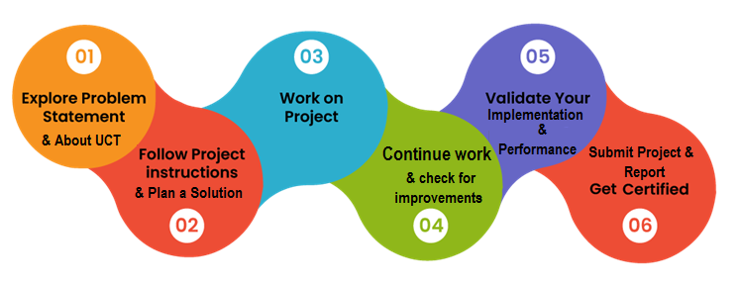

It was a very good learning experience as participating this internship I gained lots of knowledge in this internship process. This internship process contains six weeks total, where each week is very unique with information and knowledge.

I thank each and every one who helped me in this process of internship. I specially thank upskill Campus and UCT for giving this opportunity. I thank all the peers who helped me directly and indirectly.

# Introduction

## About UniConverge Technologies Pvt Ltd

A company established in 2013 and working in Digital Transformation domain and providing Industrial solutions with prime focus on sustainability and RoI.

For developing its products and solutions it is leveraging various**Cutting Edge Technologies e.g. Internet of Things (IoT), Cyber Security, Cloud computing (AWS, Azure), Machine Learning, Communication Technologies (4G/5G/LoRaWAN), Java Full Stack, Python, Front end**etc.



1. UCT IoT Platform **(****)**

**UCT Insight** is an IOT platform designed for quick deployment of IOT applications on the same time providing valuable “insight” for your process/business. It has been built in Java for backend and ReactJS for Front end. It has support for MySQL and various NoSql Databases.

* It enables device connectivity via industry standard IoT protocols - MQTT, CoAP, HTTP, Modbus TCP, OPC UA
* It supports both cloud and on-premises deployments.

It has features to  
• Build Your own dashboard  
• Analytics and Reporting  
• Alert and Notification  
• Integration with third party application(Power BI, SAP, ERP)  
• Rule Engine

 

1. **Smart Factory Platform (****)**

Factory watch is a platform for smart factory needs.

It provides Users/ Factory

* with a scalable solution for their Production and asset monitoring
* OEE and predictive maintenance solution scaling up to digital twin for your assets.
* to unleased the true potential of the data that their machines are generating and helps to identify the KPIs and also improve them.
* A modular architecture that allows users to choose the service that they what to start and then can scale to more complex solutions as per their demands.

Its unique SaaS model helps users to save time, cost and money.

 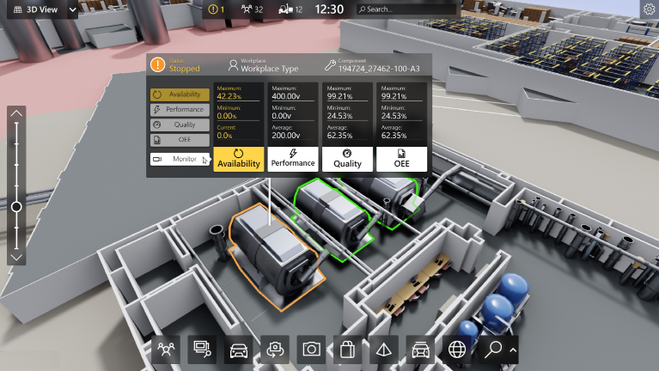

1. 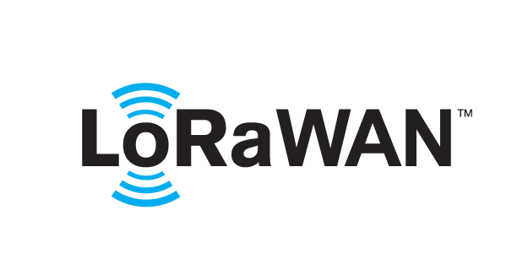 based Solution

UCT is one of the early adopters of LoRAWAN teschnology and providing solution in Agritech, Smart cities, Industrial Monitoring, Smart Street Light, Smart Water/ Gas/ Electricity metering solutions etc.

1. Predictive Maintenance

UCT is providing Industrial Machine health monitoring and Predictive maintenance solution leveraging Embedded system, Industrial IoT and Machine Learning Technologies by finding Remaining useful life time of various Machines used in production process.



## About upskill Campus (USC)

upskill Campus along with The IoT Academy and in association with Uniconverge technologies has facilitated the smooth execution of the complete internship process.

USC is a career development platform that delivers **personalized executive coaching** in a more affordable, scalable and measurable way.



Seeing need of upskilling in self paced manner along-with additional support services e.g. Internship, projects, interaction with Industry experts, Career growth Services

<https://www.upskillcampus.com/>

upSkill Campus aiming to upskill 1 million learners in next 5 year

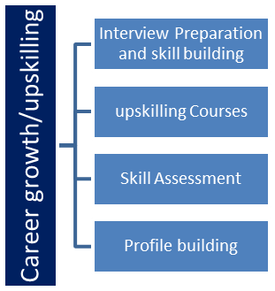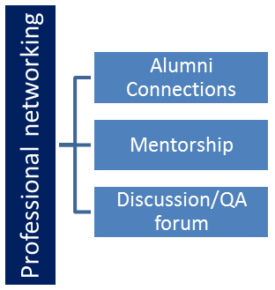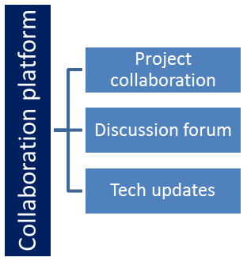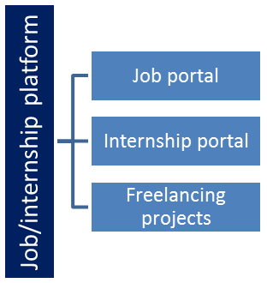

## The IoT Academy

The IoT academy is EdTech Division of UCT that is running long executive certification programs in collaboration with EICT Academy, IITK, IITR and IITG in multiple domains.

## Objectives of this Internship program

The objective for this internship program was to

 ☛ get practical experience of working in the industry.

 ☛ to solve real world problems.

 ☛ to have improved job prospects.

 ☛ to have Improved understanding of our field and its applications.

 ☛ to have Personal growth like better communication and problem solving.

## Reference

[1]

[2]

[3]

## Glossary

|  |  |
| --- | --- |
| Terms | Acronym |
|  |  |
|  |  |
|  |  |
|  |  |
|  |  |

# Problem Statement

Weed is an unwanted thing in agriculture. Weed use the nutrients, water, land and many more things that might have gone to crops. Which results in less production of the required crop. The farmer often uses pesticides to remove weed which is also effective but some pesticides may stick with crop and may causes problems for humans.

We aim to develop a system that only sprays pesticides on weed and not on the crop Which will reduce the mixing problem with crops and also reduce the waste of pesticides.

Weed Competition: Weeds are unwanted plants that grow alongside cultivated crops. They compete with crops for resources such as nutrients, water, and sunlight, leading to reduced crop growth and yield. By diverting these essential resources away from the desired crops, weeds hinder their development and limit agricultural productivity.

Pesticide Use: Farmers commonly employ pesticides as a means of weed control. Traditional pesticide application methods involve spraying chemicals over the entire field, targeting both weeds and crops. This broad-spectrum approach effectively eliminates weeds but also increases the chances of pesticide residues on the crops, which can have detrimental effects on human health.

Health and Environmental Risks: The presence of pesticide residues on crops poses health risks to consumers. Ingesting or coming into contact with these residues can lead to acute or chronic health problems. Moreover, the excessive use of pesticides can also harm beneficial insects, pollinators, soil organisms, and the overall ecosystem.

Waste of Pesticides: Indiscriminate pesticide application contributes to wastage. Spraying pesticides over the entire field, including areas without weed infestation, leads to unnecessary pesticide usage. This not only adds to the financial burden for farmers but also increases the environmental impact due to the excessive release of chemicals.

# Existing and Proposed solution

There are several ways to control weeds in agriculture. Some of the existing solutions include:

* Hand cultivation with hoes
* Powered cultivation with cultivators
* Smothering with mulch
* Lethal wilting with high heat
* Burning
* Chemical control with herbicides (weed killers)

It’s important to note that some weed control methods can have negative effects on the environment and human health if not used properly. Farmers should always follow safety guidelines when applying pesticides or other chemicals to crops. Additionally, there are many organic and natural weed control methods that can be used as alternatives to chemical treatments. These include hand weeding, mulching, and cover cropping.

**Benefits of the Proposed System:**

Improved Crop Yield: By selectively spraying pesticides on weeds, the proposed system ensures that crops receive the necessary resources for optimal growth and development. This results in increased crop yields and improved agricultural productivity.

Reduced Health Risks: Minimizing pesticide residues on crops mitigates the potential health risks associated with consuming contaminated produce. By limiting exposure to harmful chemicals, the system contributes to safer and healthier food production.

Environmental Sustainability: The targeted weed control system reduces the overall use of pesticides, minimizing the negative impact on the environment. By avoiding the blanket application of chemicals, beneficial insects, pollinators, and soil organisms are better preserved, maintaining a balanced ecosystem.

Cost Efficiency: Precision spraying of pesticides reduces the amount of chemicals required for weed control. This leads to cost savings for farmers by optimizing pesticide usage and reducing the financial burden associated with weed management.

In conclusion, developing a system that selectively sprays pesticides on weeds while minimizing their application on crops addresses the challenges associated with weed control in agriculture. This approach enhances crop yield, reduces health risks, promotes environmental sustainability, and improves cost efficiency, making it a promising solution for weed management in modern agriculture.

## Code submission (GitHub link)

<https://github.com/KUNCHALAAJITH/CROP_AND_WEED_DETECTION>

## Report submission (GitHub link) :

<https://github.com/KUNCHALAAJITH/CROP_AND_WEED_DETECTION>

# Proposed Design/ Model

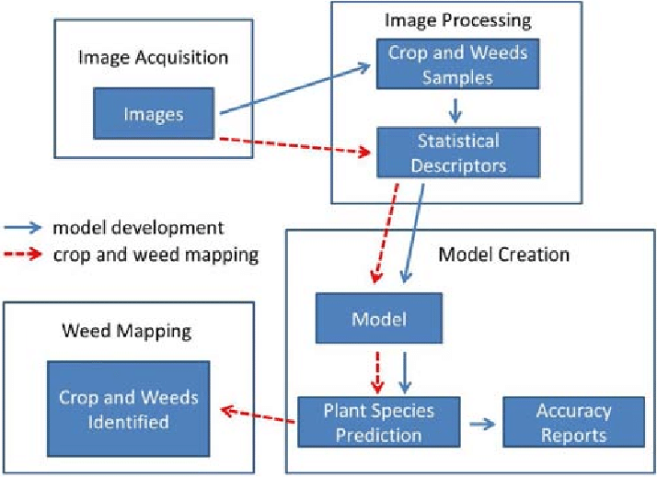

## High Level Diagram (if applicable)

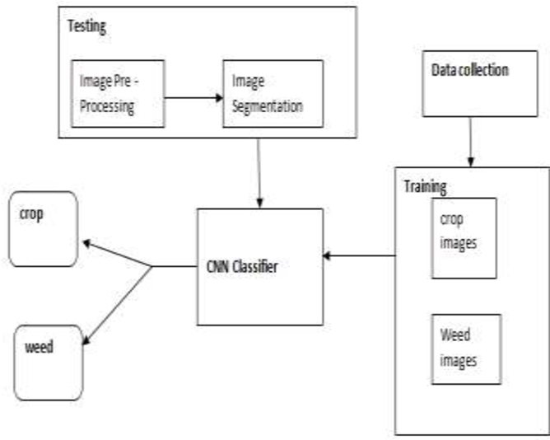

Figure 1: HIGH LEVEL DIAGRAM OF THE SYSTEM

## Low Level Diagram (if applicable)

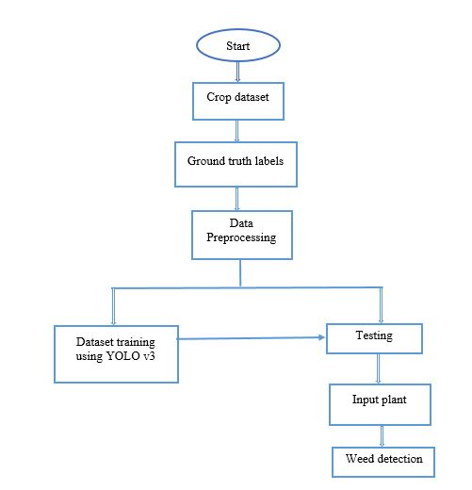

## Interfaces (if applicable)

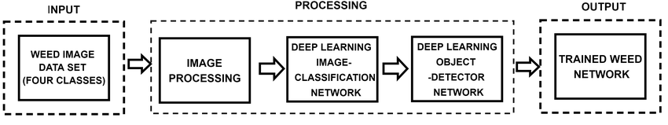

# Performance Test

This is very important part and defines why this work is meant of Real industries, instead of being just academic project.

Here we need to first find the constraints.

How those constraints were taken care in your design?

What were test results around those constraints?

Constraints can be e.g. memory, MIPS (speed, operations per second), accuracy, durability, power consumption etc.

In case you could not test them, but still you should mention how identified constraints can impact your design, and what are recommendations to handle them.

## Test Plan/ Test Cases

Test Plan for Crop and Weed Detection using ML:

1. Objective:

The objective of this test plan is to verify the accuracy and effectiveness of the crop and weed detection system using machine learning algorithms.

2. Test Environment:

* Hardware: Appropriate hardware for running the ML algorithms (e.g., GPU, CPU)
* Software: ML libraries/frameworks (e.g., TensorFlow, PyTorch), programming language (e.g., Python), data preprocessing tools (e.g., OpenCV), dataset (labeled images), testing framework (e.g., pytest)

3. Test Data:

* Prepare a dataset of labeled images containing various crops and weed species.
* Split the dataset into training and testing sets.

4. Test Cases:

4.1. Data Preprocessing:

* Verify that the dataset is properly preprocessed, including resizing, normalization, and conversion to appropriate formats.
* Confirm that the training and testing datasets are correctly separated.

4.2. Model Training:

* Ensure that the ML model is trained on the training dataset without errors.
* Validate that the model converges and reaches an acceptable accuracy level.
* Verify that the model is saved successfully for later use.

4.3. Crop Detection:

* Provide input images of different crops to the trained model and verify that it correctly detects the crop species.
* Check if the detection results match the expected crop labels for each image.

4.4. Weed Detection:

* Present input images containing different weed species to the trained model and verify that it accurately detects the weed species.
* Ensure that the detected weed labels match the expected weed species for each image.

4.5. Robustness and Performance:

* Test the system's performance by measuring the inference time for detecting crops and weeds on different hardware configurations.
* Evaluate the system's robustness by providing it with images of varying quality, lighting conditions, and backgrounds.
* Verify that the system maintains accuracy and stability under different scenarios.

4.6. Boundary Cases:

* Test the system's behavior when presented with images containing multiple crops or weed species.
* Validate that the system handles images with occlusions, partial views, or overlapping plants.

5. Test Execution and Reporting:

* + Execute each test case, record the results, and note any issues or failures.
  + Document the accuracy of crop and weed detection, inference time, and any observed limitations or improvements needed.
  + Generate a test report summarizing the overall performance of the system.

6. Test Coverage:

* Ensure that the test cases cover various crop and weed species.
* Validate different image qualities and scenarios to achieve high test coverage.

## Test Procedure

Test Procedure for Crop and Weed Detection using ML:

1. Test Setup:

* + Set up the required hardware and software environment, including ML libraries, programming language, and necessary tools.
  + Install and configure the testing framework (e.g., pytest) if applicable.
  + Ensure that the dataset and trained model are available.

2. Data Preprocessing:

* + Load the dataset and perform necessary preprocessing steps, such as resizing, normalization, and format conversion.
  + Split the dataset into training and testing sets.

3. Model Training:

* + Train the ML model using the training dataset.
  + Monitor the training process, including loss and accuracy metrics.
  + Save the trained model for later use.

4. Crop Detection Testing:

* + Select a sample of images containing different crop species.
  + Provide the sample images as input to the trained model.
  + Verify that the model accurately detects the crop species in each image.
  + Compare the detected crop labels with the expected crop labels.

5. Weed Detection Testing:

* + Choose a set of images containing various weed species.
  + Input the images to the trained model for weed detection.
  + Validate that the model correctly identifies the weed species in each image.
  + Compare the detected weed labels with the expected weed labels.

6. Robustness and Performance Testing:

* + Measure the inference time of the model for crop and weed detection on different hardware configurations.
  + Test the system's performance with images of varying quality, lighting conditions, and backgrounds.
  + Verify that the accuracy and stability of the system are maintained under different scenarios.

7. Boundary Case Testing:

* + Prepare images with multiple crop or weed species present.
  + Provide these images to the model and verify that it handles the situation appropriately, detecting and labeling the different species correctly.
  + Test the system's ability to handle occlusions, partial views, or overlapping plants.

8. Test Reporting:

* + Document the test results, including the accuracy of crop and weed detection, inference time, and any observed limitations or issues.
  + Summarize the overall performance of the system in a test report.
  + Report any failures, bugs, or areas that require improvement.

9. Test Iteration:

* + Based on the test results, make necessary adjustments to the ML model, data preprocessing, or test cases.
  + Repeat the testing process to validate the changes made.
  + Continue iterating until the desired accuracy and performance levels are achieved.

## Performance Outcome

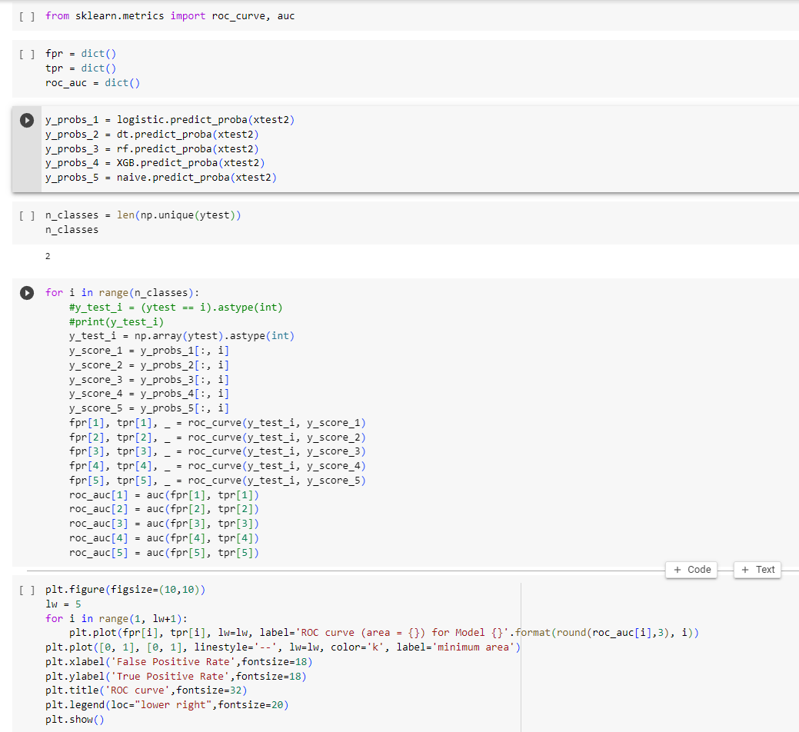

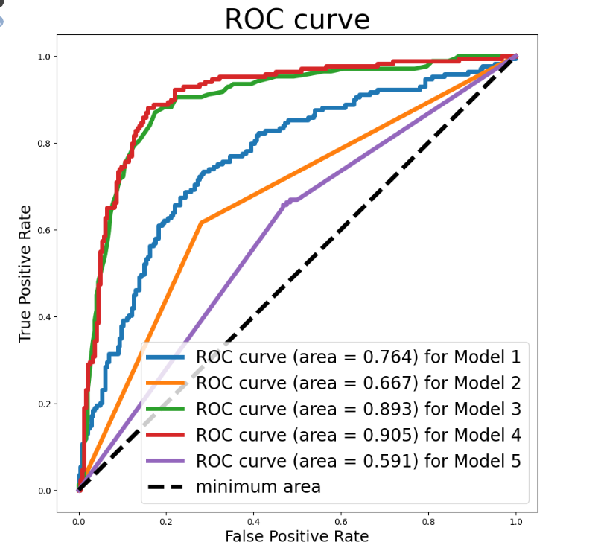

# My learnings

Data science involves extracting insights and knowledge from data through various techniques such as data analysis, data visualization, and predictive modeling. It encompasses a wide range of skills including statistics, programming, and domain expertise. By applying data science techniques, businesses can make informed decisions, identify patterns, and solve complex problems.

Machine learning, a subset of artificial intelligence, focuses on the development of algorithms and models that enable computers to learn from data and make predictions or take actions without being explicitly programmed. Machine learning techniques include supervised learning, unsupervised learning, and reinforcement learning. These techniques find applications in various fields, such as image and speech recognition, natural language processing, recommendation systems, and fraud detection.

Learning about data science and machine learning can provide several benefits for career growth:

Enhanced problem-solving skills: Data science and machine learning involve a structured approach to problem-solving, which can be applied to a wide range of real-world challenges. This analytical mindset can make you a valuable asset in any industry.

In-demand skills: Data science and machine learning are in high demand across industries. By acquiring proficiency in these fields, you increase your chances of finding lucrative job opportunities and career advancement.

Versatility: The skills acquired in data science and machine learning can be applied to various domains. This versatility allows you to explore different industries and work on diverse projects, expanding your professional horizons.

Competitive advantage: In a data-driven world, organizations are increasingly relying on data-driven insights to gain a competitive edge. By mastering data science and machine learning, you can contribute to strategic decision-making processes and position yourself as an invaluable asset within your organization.

Innovation and automation: Machine learning techniques enable automation and the development of intelligent systems. By leveraging these technologies, you can drive innovation, streamline processes, and create new products or services that enhance efficiency and customer satisfaction.

Continuous learning: Data science and machine learning are rapidly evolving fields. By engaging in continuous learning and staying up to date with the latest advancements, you can remain relevant and adaptable in an ever-changing technological landscape.

# Future work scope

The future scope of this problem statement encompasses several potential advancements and areas of exploration:

Sensor Technology and Machine Learning: The integration of advanced sensor technologies, such as hyperspectral imaging, computer vision, and machine learning algorithms, can enable the identification and differentiation of weed species from crops. These technologies can help develop automated weed detection systems that can accurately distinguish between weeds and crops in real-time, facilitating targeted pesticide application.

Robotics and Automation: The use of robotics and automation in agriculture has gained significant attention in recent years. Future scope lies in developing autonomous robotic systems equipped with precision spraying mechanisms. These robots can navigate through the fields, detect and classify weeds, and selectively spray herbicides only on the identified weed populations. Such systems can minimize the use of pesticides, reduce human labor, and improve overall efficiency in weed management.

Integrated Pest Management (IPM) Approaches: The future scope also includes integrating precision weed management systems with broader IPM strategies. IPM focuses on using a combination of pest control methods, including cultural, biological, and chemical measures, to minimize the use of pesticides. By combining precision weed management with other IPM practices, farmers can achieve effective weed control while promoting sustainable agricultural practices.

Sustainable and Environmentally Friendly Alternatives: Alongside precision weed management systems, the future scope emphasizes the development and adoption of sustainable and environmentally friendly alternatives to conventional herbicides. This can include exploring organic weed control methods, such as thermal weeding, steam treatments, or the use of natural herbicides derived from plant extracts. Research in this area can lead to the formulation of safer and more sustainable weed management solutions.

Data-driven Decision Support Systems: Developing data-driven decision support systems can assist farmers in making informed weed management choices. By integrating data from various sources, including weather conditions, soil health, weed growth patterns, and crop information, these systems can provide real-time recommendations on the optimal timing and dosage of herbicide application. This approach maximizes the effectiveness of weed control while minimizing environmental impact.

Collaboration and Knowledge Sharing: The future scope also involves fostering collaboration between researchers, agronomists, farmers, and technology developers. Sharing knowledge and best practices can accelerate the development and adoption of precision weed management systems. Collaborative efforts can include establishing research networks, organizing workshops, and creating platforms for information exchange to facilitate the implementation of these systems at a broader scale.