

**Program :**B.tech(CSE)

**Specialization :**AIML

**Course Title :**AI Assisted Coding

**Course Code :**24CS002PC215

**Semester :**3rd semester

**Academic Session :**2025-2026

**Name of Student :**Kurapati Akshitha

**Enrollment No. :**2403A52021

**Batch No. :**02

**Date :**07/10/2025

LAB ASSIGNMENT-11.3

TASK DESCRIPTION-1: Stack class implementation  
Task: Ask AI to implement a stack class with push(), pop(), peek() and  
is_empty() methods

Prompt:-

create a python class to implement a stack class with push(), pop(), peek() and is_empty() methods with user input.

Code :-

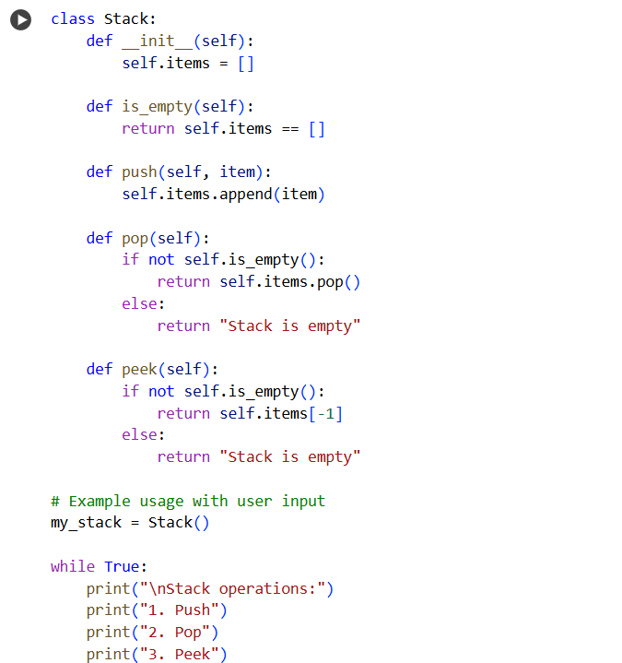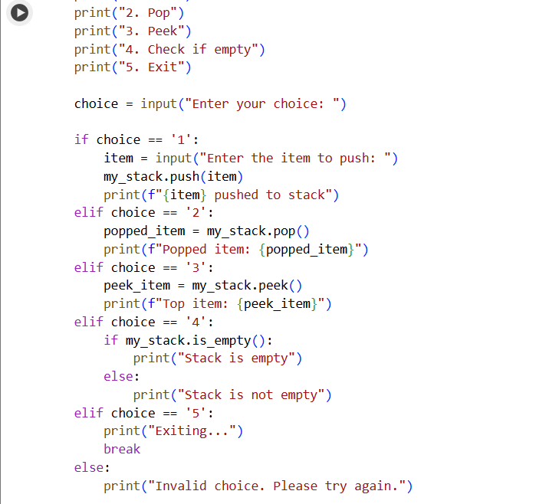

Output:-

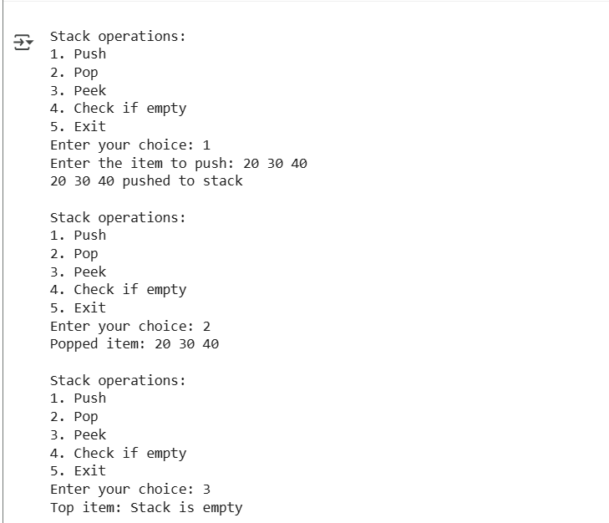

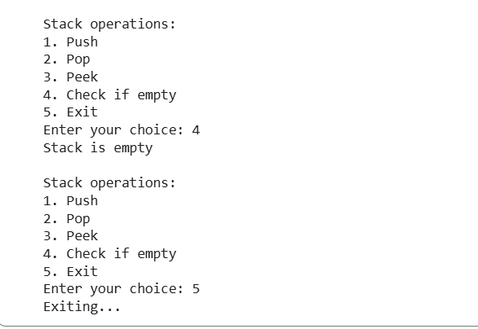

TASK DESCRIPTION-2: Queue Implementation  
Task: Use AI to generate a Queue class with enqueue(), dequeue(), and  
is_empty().

Prompt:-

Create a Queue class in Python with enqueue(), dequeue(), and is_empty() methods.

Code:-

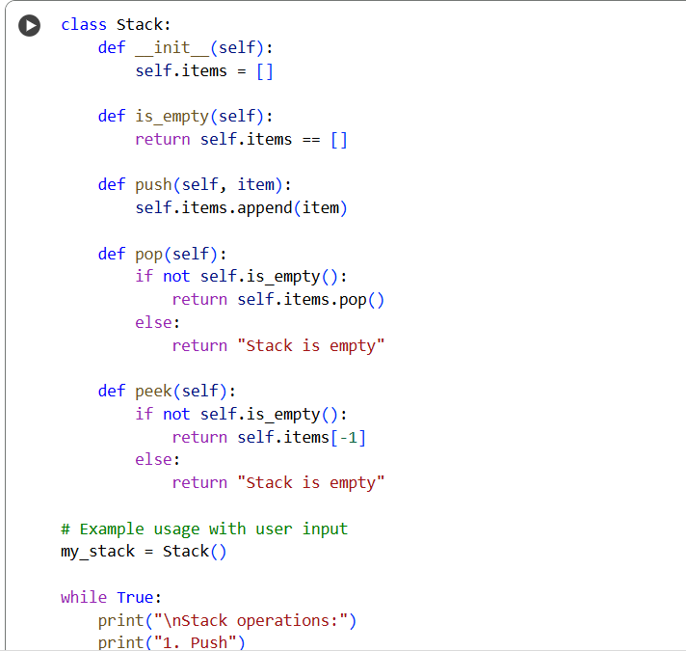 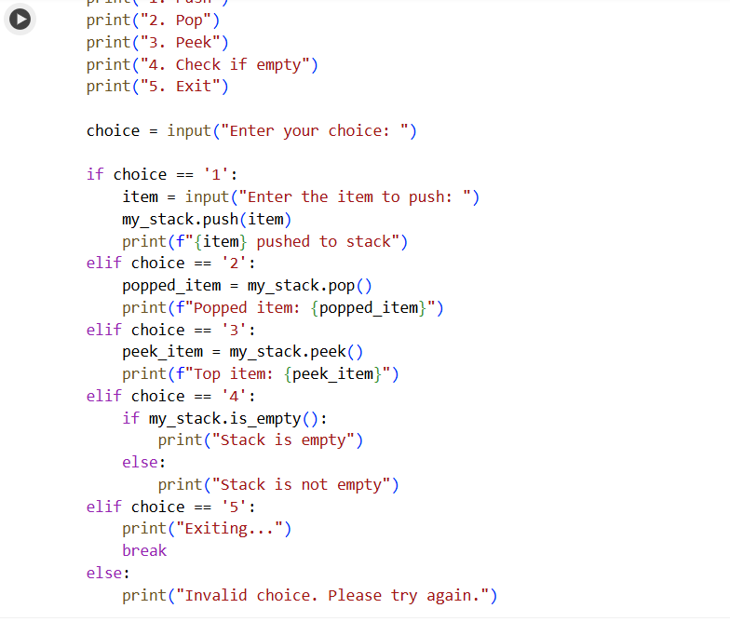

Output:-

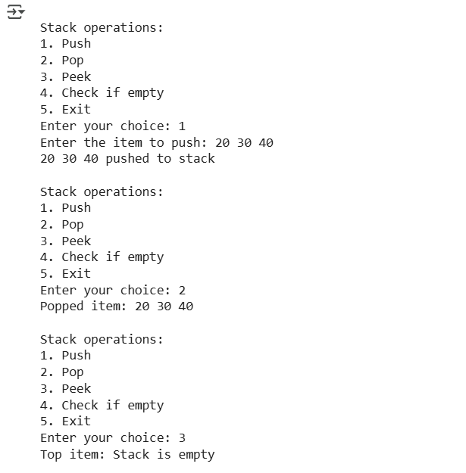

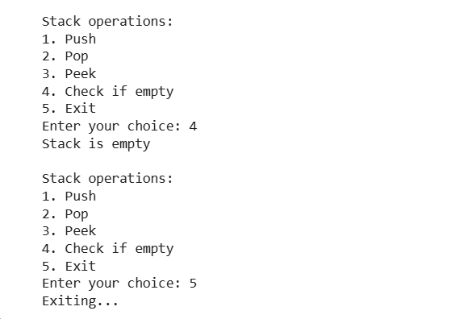

TASK DESCRIPTION-3: • Linked List Implementation  
Task: Ask AI to create a singly linked list with insert_at_end(),  
insert_at_beginning(), and display().

Prompt:-

Create a python class that create a singly linked list with insert_at_end(), insert_at_beginning(), and display() with user input.

Code:-

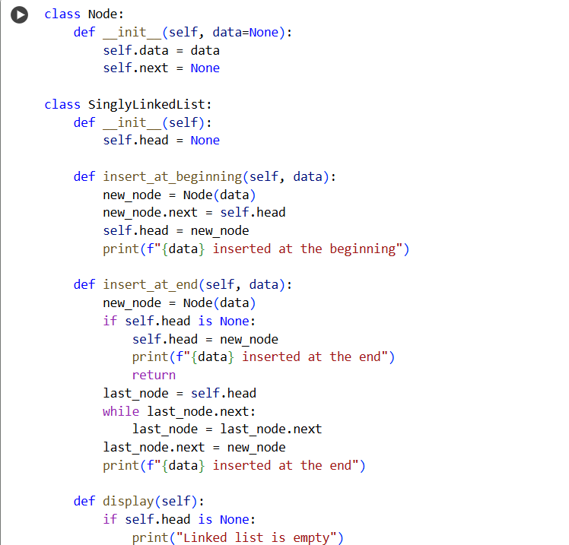

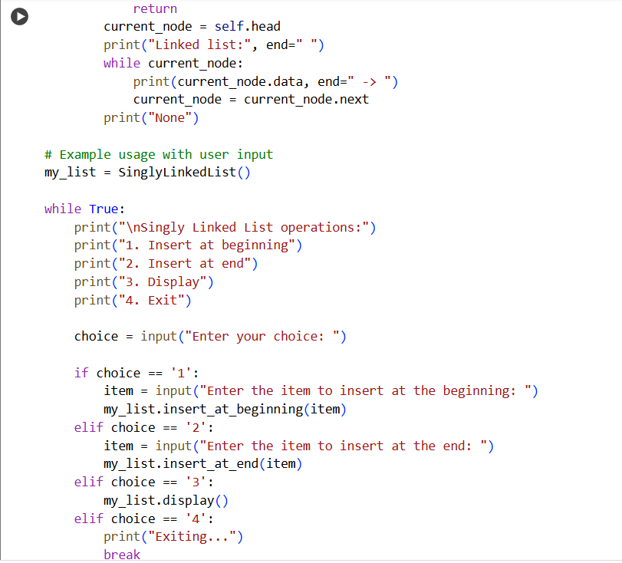

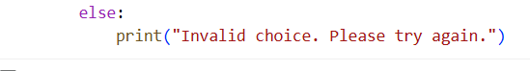

Output:-

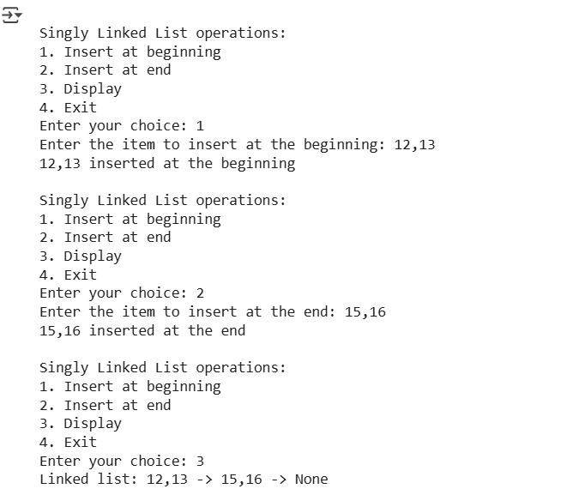

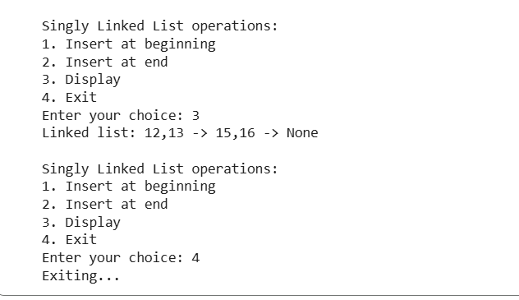

TASK DESCRIPTION-4:- Binary Search Tree (BST)  
Task: Ask AI to generate a simple BST with insert() and  
inorder_traversal().

Prompt:-

Create a python class to generate a simple BST with insert() and inorder_traversal() with user input.

Code:-

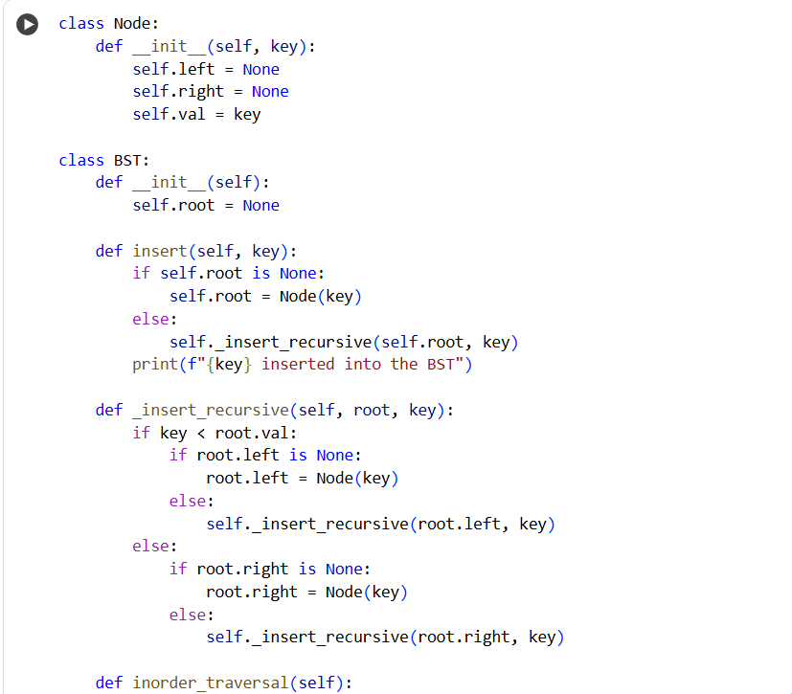

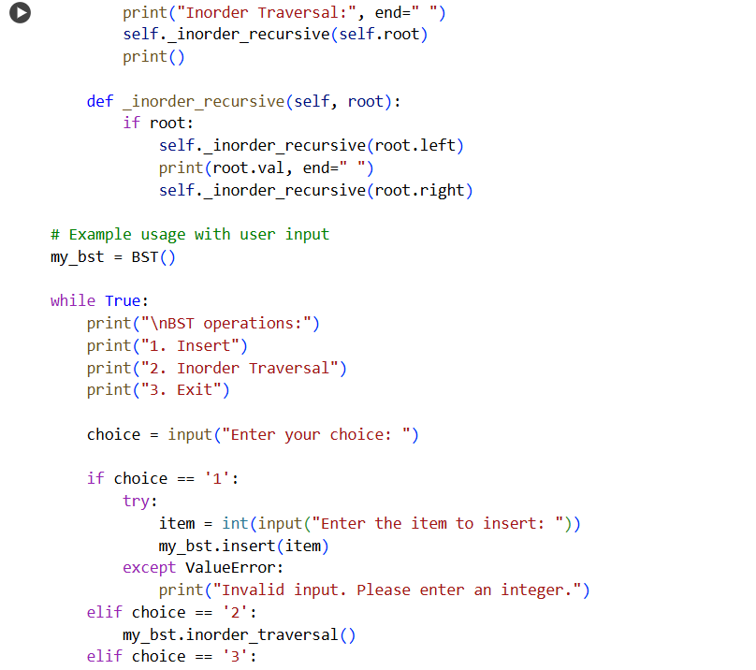

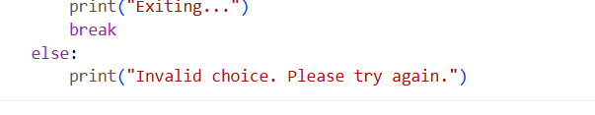

Output:-

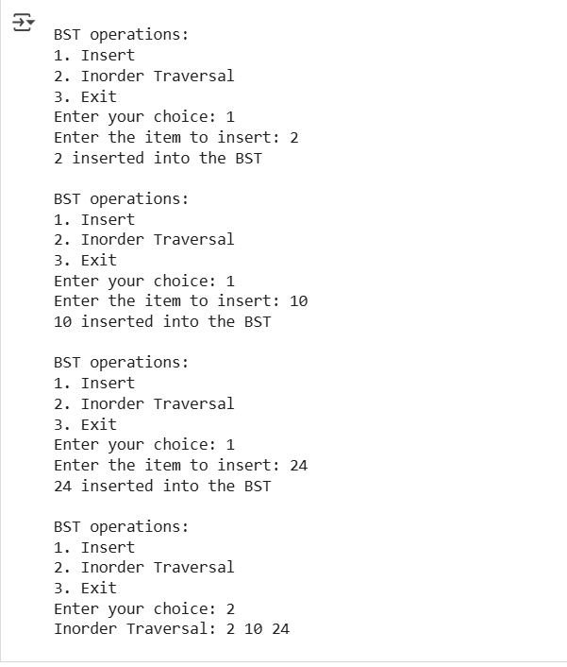

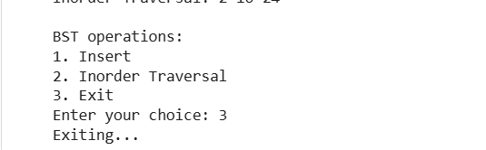

THANK YOU