
Program :B.tech(CSE)
Specialization :AIML
Course Title :AI Assisted Coding
Course Code :24CS002PC215
Semester :3rd semester
Academic Session :2025-2026
Name of Student :Kurapati Akshitha
Enrollment No. :2403A52021
Batch No. :02
Date :28/10/2025
LAB ASSIGNMENT-13.2
TASK DESCRIPTION-1: Remove Repetition
Task: Provide AI with the following redundant code and ask it to
refactor
Python Code
def calculate_area(shape, x, y=0):
if shape == "rectangle":
return x * y
elif shape == "square":
return x * x
elif shape == "circle":
return 3.14 * x * x
Prompt:-
Refactor the following redunant function using a dictionary-based dispatch or modular functions for cleaner design.def calculate_area(shape, x, y=0): if shape == "rectangle": return x * y elif shape == "square": return x * x elif shape == "circle": return 3.14 * x * x with user input.
Code :-
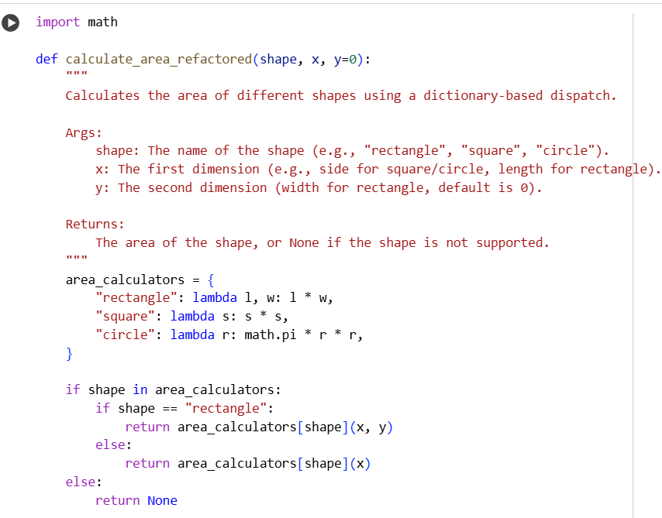
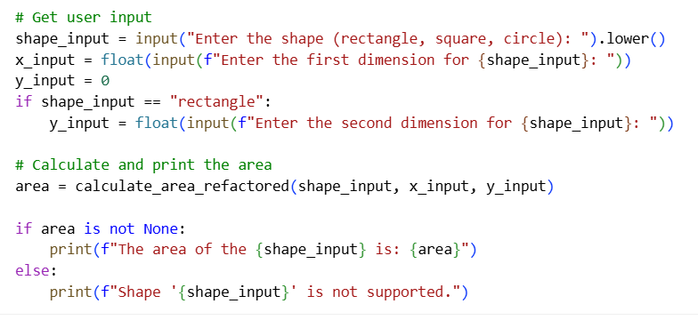
Output:-
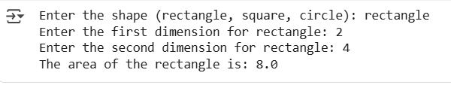
TASK DESCRIPTION-2: Error Handling in Legacy Code
Task: Legacy function without proper error handling
Python Code
def read_file(filename):
f = open(filename, "r")
data = f.read()
f.close()
return data
Prompt:-
The following legacy code doesn’t handle file errors properly. Refactor it using with open() and try-except blocks for safer file handling. def read_file(filename): f = open(filename, "r") data = f.read() f.close() return data with user input.
Code:-
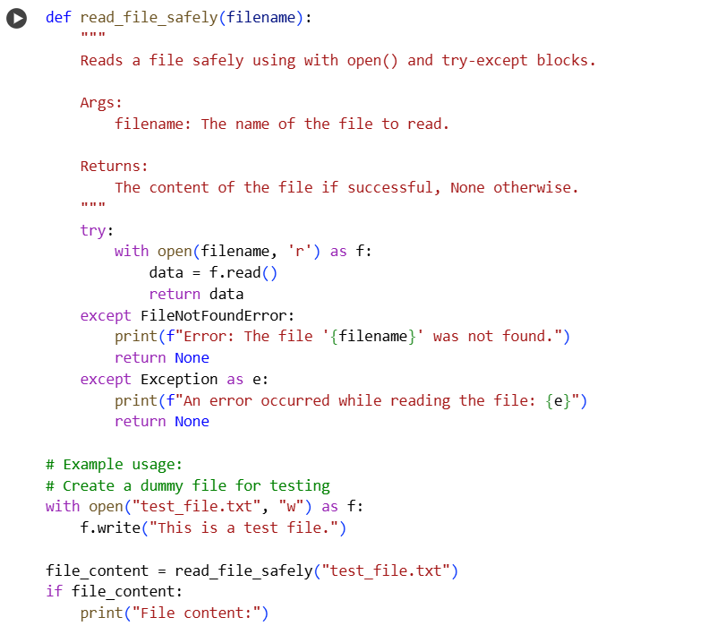
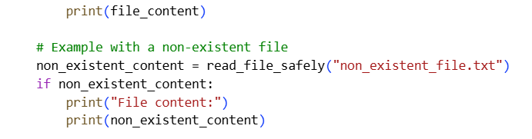
Output:-
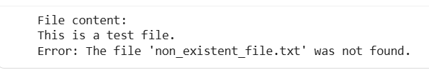TASK DESCRIPTION-3: • Complex Refactoring
Task: Provide this legacy class to AI for readability and modularity
improvements:
Python Code
class Student:
def __init__(self, n, a, m1, m2, m3):
self.n = n
self.a = a
self.m1 = m1
self.m2 = m2
self.m3 = m3
def details(self):
print("Name:", self.n, "Age:", self.a)
def total(self):
return self.m1+self.m2+self.m3
Prompt:-
Refactor this legacy class for better readability, naming, and modularity. Add docstrings, improve variable names, and make the marks handling more Pythonic.class Student: def __init__(self, n, a, m1, m2, m3): self.n = n self.a = a self.m1 = m1 self.m2 = m2 self.m3 = m3 def details(self): print("Name:", self.n, "Age:", self.a) def total(self): return self.m1+self.m2+self.m3 with user input.
Code:-
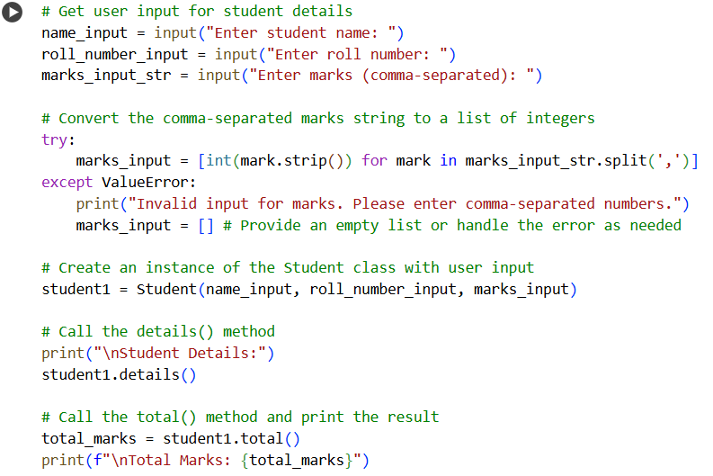
Output:-
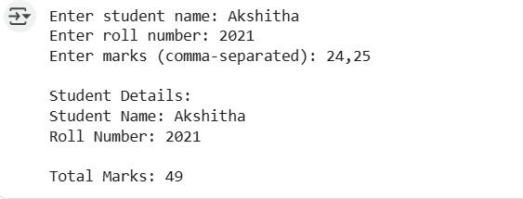
TASK DESCRIPTION-4:- Inefficient Loop Refactoring
Task: Refactor this inefficient loop with AI help
Python Code
nums = [1,2,3,4,5,6,7,8,9,10]
squares = []
for i in nums:
squares.append(i * i)
Prompt:-
The following code uses an inefficient loop to generate squares. Refactor it using a more Pythonic and efficient approach. nums = [1,2,3,4,5,6,7,8,9,10] squares = [] for i in nums: squares.append(i * i) with user input.
Code:-
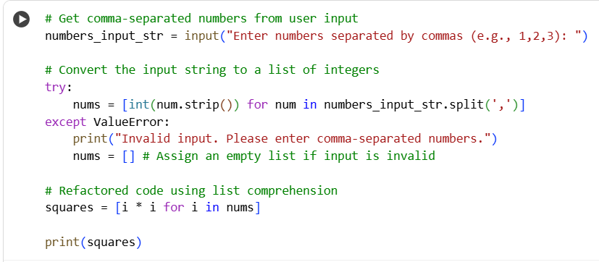
Output:-
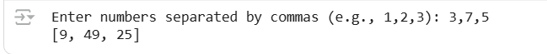

THANK YOU

