
Program :B.tech(CSE)
Specialization :AIML
Course Title :AI Assisted Coding
Course Code :24CS002PC215
Semester :3rd semester
Academic Session :2025-2026
Name of Student :Kurapati Akshitha
Enrollment No. :2403A52021
Batch No. :02
Date :22/10/2025
LAB ASSIGNMENT-12.3
TASK DESCRIPTION-1: Linear Search implementation
Write python code for linear_search() function to search a value
in a list and extract it’s index.
Prompt:-
Give me a Python code for a function named linear_search() that searches for a given value in a list and returns its index with user input.
Code :-
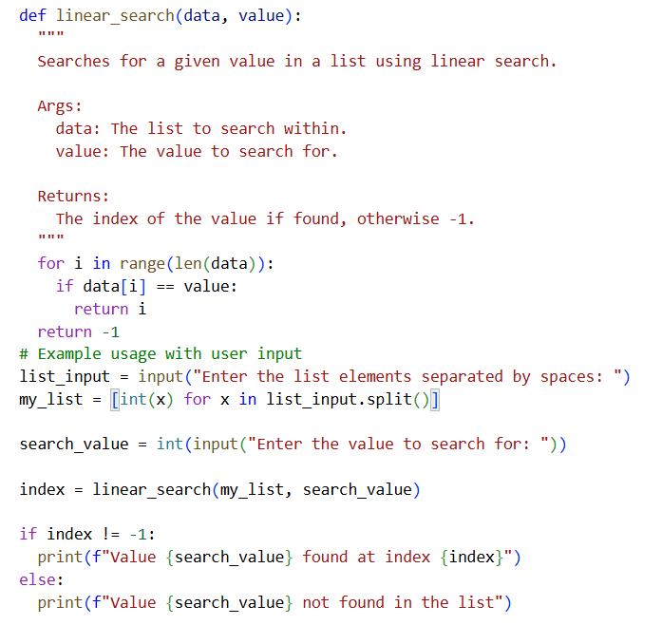
Output:-
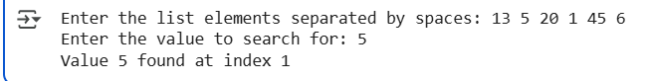
TASK DESCRIPTION-2: Sorting Algorithms
Task: Ask AI to implement Bubble Sort and check sorted output
Prompt:-
Give me a python code that implement Bubble Sort and check sorted output with user input.
Code:-

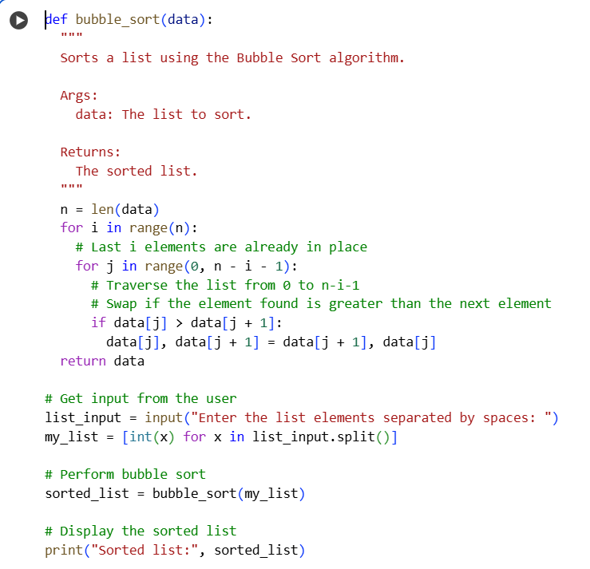
Output:-
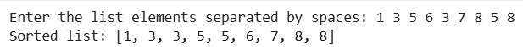
TASK DESCRIPTION-3: • Optimization
Task: Write python code to solve below case study using linear optimization
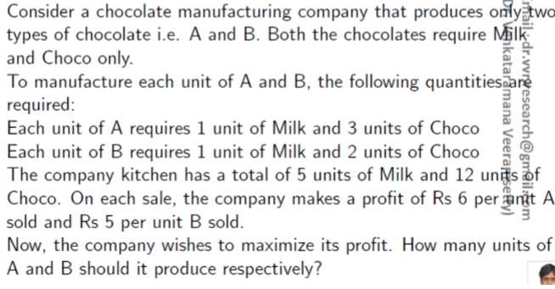
Prompt:-
Write Python code using linear optimization (PuLP library) to solve the following problem: A chocolate manufacturing company produces two types of chocolates — A and B. Each unit of A requires 1 unit of Milk and 3 units of Choco. Each unit of B requires 1 unit of Milk and 2 units of Choco. The company has 5 units of Milk and 12 units of Choco available. The profit per unit is Rs 6 for A and Rs 5 for B. The company wants to maximize its total profit. Write the Python code using the PuLP library to find how many units of A and B should be produced to maximize profit with user input.
Code:-
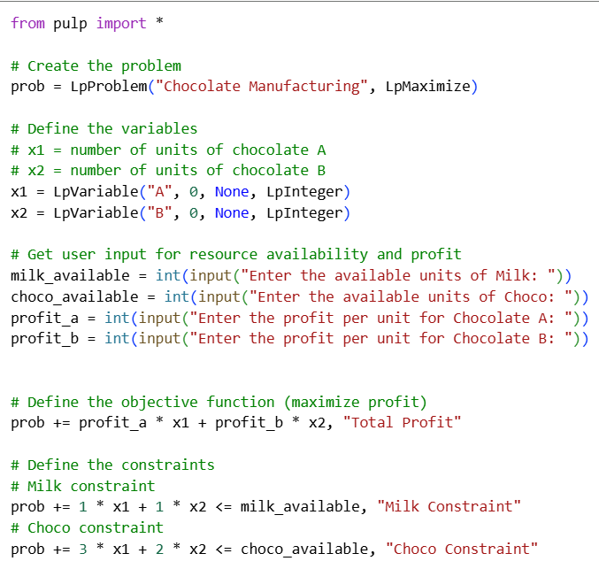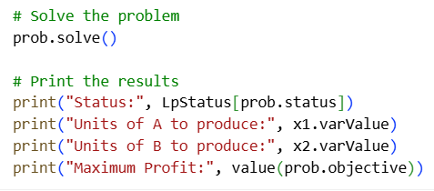
Output:-
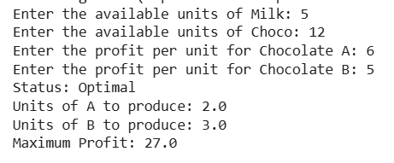
TASK DESCRIPTION-4:- Gradient Descent Optimization
Task: Write python code to find value of x at which the function
f(x)=2X3+4x+5 will be minimum.
Prompt:-
write Python code to find the value of x where the function f(x) = 2x^3 + 4x + 5 becomes minimum using Gradient Descent.and Define the function f(x) and its derivative.Use a learning rate and iteration loop.Show how the value of x updates in each step.Finally, print the x value where the function is minimum and the corresponding f(x) with user input.
Code:-
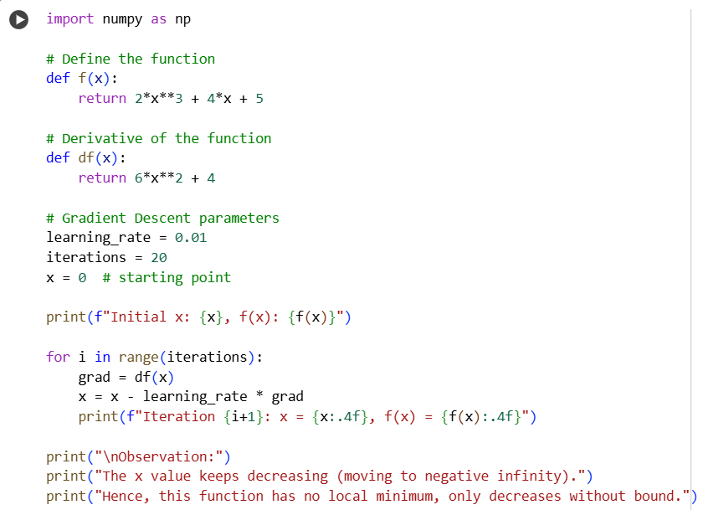
Output:-
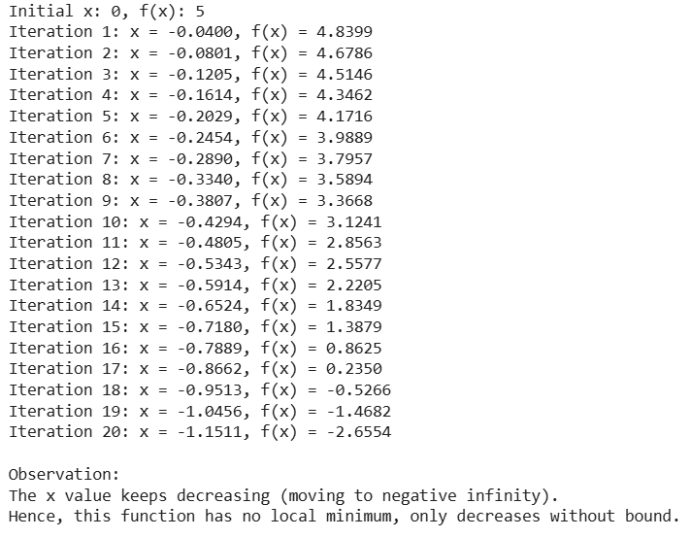

THANK YOU

