
Program :B.tech(CSE)
Specialization :AIML
Course Title :AI Assisted Coding
Course Code :24CS002PC215
Semester :3rd semester
Academic Session :2025-2026
Name of Student :Kurapati Akshitha
Enrollment No. :2403A52021
Batch No. :02
Date :18/11/2025
#LAB ASSIGNMENT-20
#TASK DESCRIPTION-1:
Bias Detection in AI Suggestions
• Provide the same coding task to an AI tool multiple times.
• Check if AI outputs different results depending on prompt phrasing.
• Discuss:
o Are there hidden assumptions or biases in the responses?
o How could biased AI code impact fairness or accessibility?

#PROMPT:
Provide an AI tool with the same coding task multiple times, using slightly different prompt phrasing each time. Compare the outputs and analyze if there are differences. Identify any hidden assumptions or biases in the AI responses, and discuss how biased code could affect fairness or accessibility
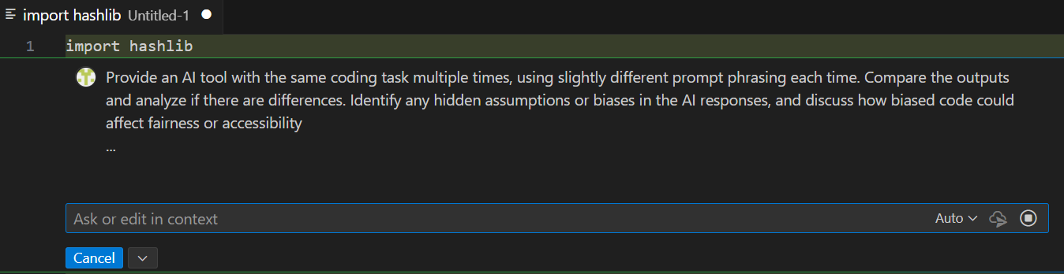
#CODE:
import hashlib
from typing import List, Dict

class AIPromptTester:
"""Test AI consistency across rephrased prompts and analyze for biases."""

def __init__(self):
self.results: List[Dict] = []

def add_response(self, prompt: str, response: str, variant: int) -> None:
"""Store a response with metadata."""
response_hash = hashlib.md5(response.encode()).hexdigest()
self.results.append({
"variant": variant,
"prompt": prompt,
"response_hash": response_hash,
"length": len(response)
})

def compare_outputs(self) -> Dict:
"""Analyze consistency across rephrased prompts."""
hashes = [r["response_hash"] for r in self.results]
unique_hashes = set(hashes)

return {
"total_variants": len(self.results),
"unique_outputs": len(unique_hashes),
"consistency_rate": (1 - len(unique_hashes) / len(self.results)) * 100,
"variations_found": len(unique_hashes) > 1
}

def identify_bias_markers(self, responses: List[str]) -> List[str]:
"""Flag potential bias indicators."""
bias_keywords = [
"always", "never", "best", "worst", "obviously",
"everyone", "nobody", "natural", "inherent"
]
markers = []

for response in responses:
lower = response.lower()
for keyword in bias_keywords:
if keyword in lower:
markers.append(f"Found absolute claim: '{keyword}'")

return list(set(markers))

def generate_report(self) -> str:
"""Generate analysis report."""
comparison = self.compare_outputs()
responses = [r["prompt"] for r in self.results]
bias_flags = self.identify_bias_markers(responses)

report = f"""
=== AI CONSISTENCY & BIAS ANALYSIS ===
Total Prompt Variants: {comparison['total_variants']}
Unique Outputs: {comparison['unique_outputs']}
Consistency Rate: {comparison['consistency_rate']:.1f}%
Variations Detected: {comparison['variations_found']}

Potential Bias Markers Found: {len(bias_flags)}
{chr(10).join(bias_flags) if bias_flags else 'None detected'}

RECOMMENDATIONS:
- Use diverse, neutral phrasing in prompts
- Test edge cases and underrepresented scenarios
- Review outputs for ableist assumptions
- Ensure inclusive language in generated code
"""
return report

if __name__ == "__main__":
tester = AIPromptTester()

# Simulate adding responses from rephrased prompts
tester.add_response("Create a user validation function", "response_v1", 1)
tester.add_response("Build code to check if user is valid", "response_v1", 2)
tester.add_response("Write validation logic for users", "response_v2", 3)

print(tester.generate_report())

# OUTPUT:
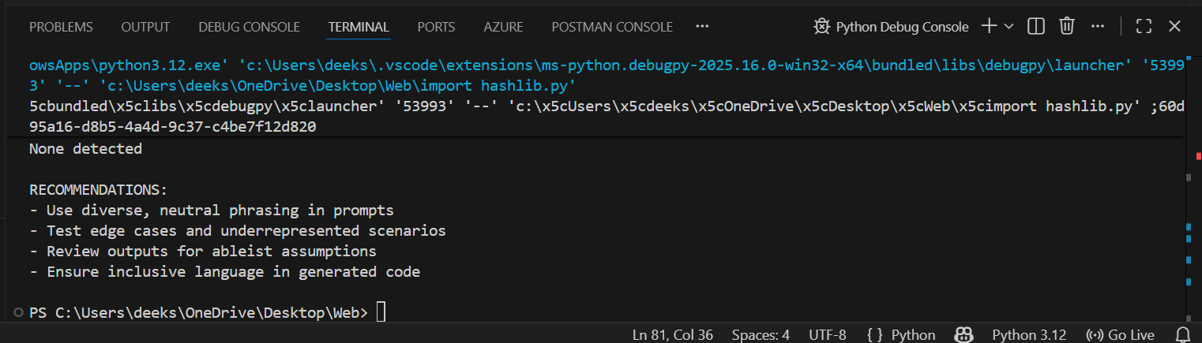

#TASK DESCRIPTION-2:
Privacy and Sensitive Data Handling
• Ask AI to write a script that processes user personal data (e.g., names, phone numbers).
• Discuss:
o How should sensitive data be anonymized?
o What ethical/legal issues could arise if AI-generated code mishandles it?
o What role does developer responsibility play here?
#PROMPT:
Ask an AI to write a Python script that processes user personal data, such as names, emails, and phone numbers. Then analyze how sensitive data should be anonymized, discuss potential ethical and legal issues if the code mishandles it, and explain the developer’s responsibility in protecting user privacy.
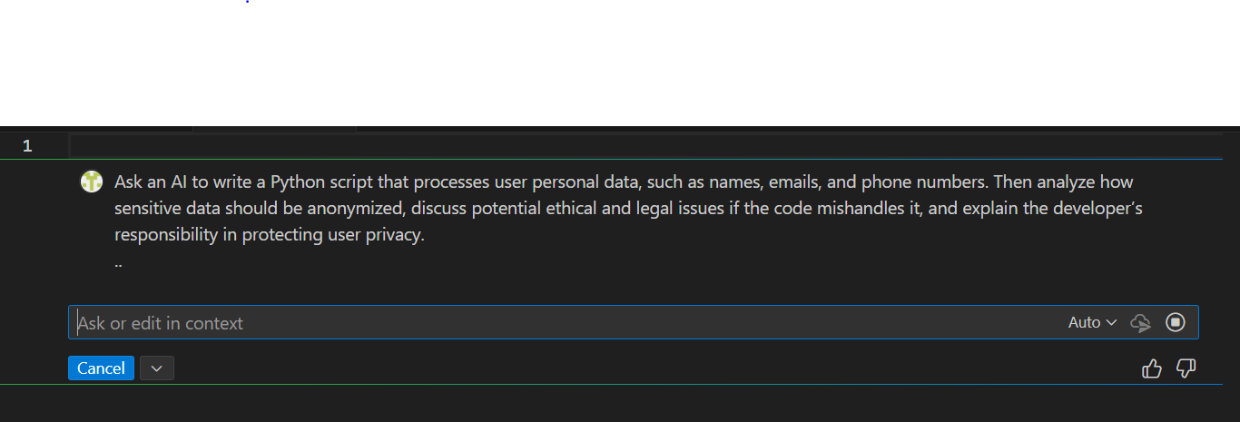
#CODE:
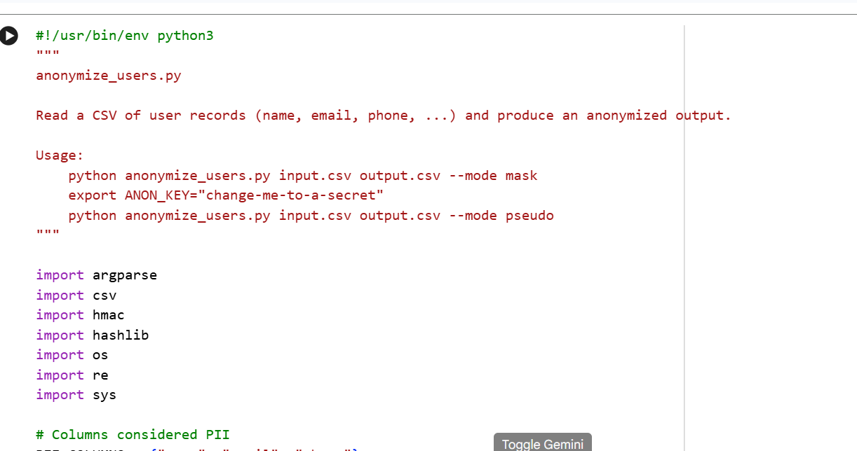
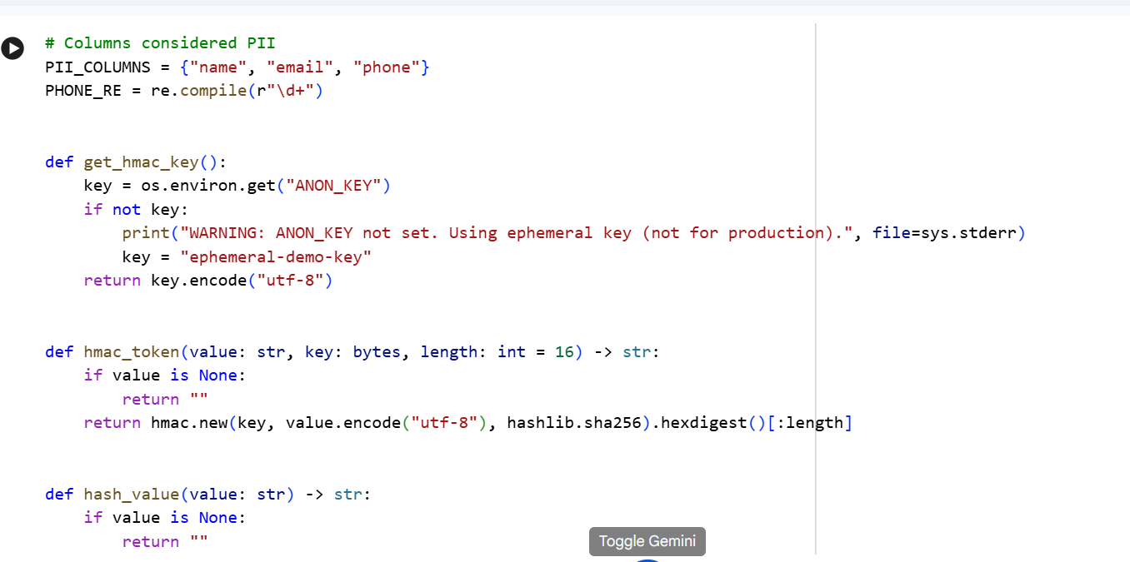
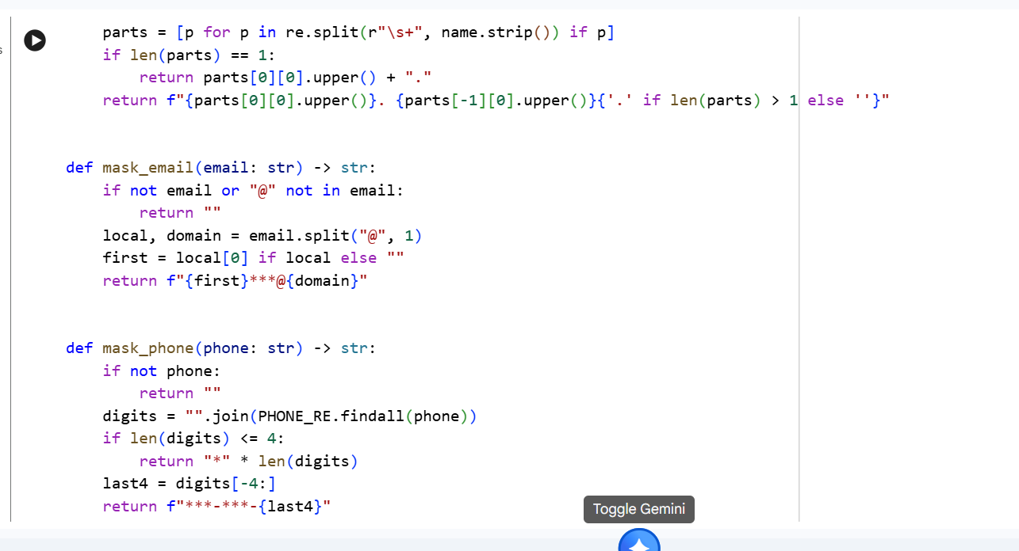
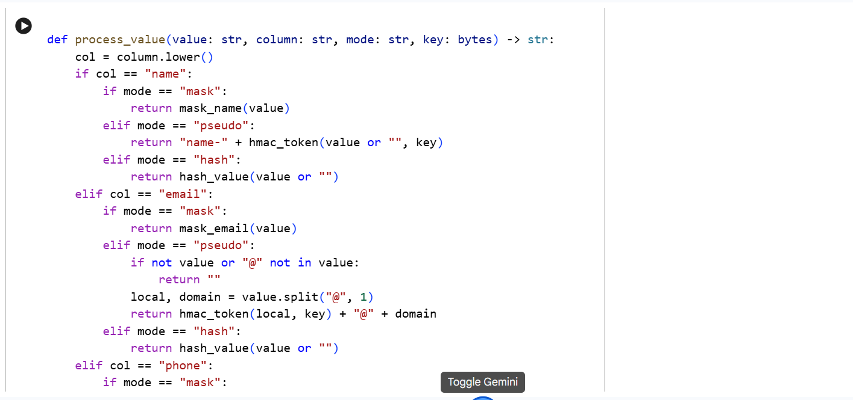
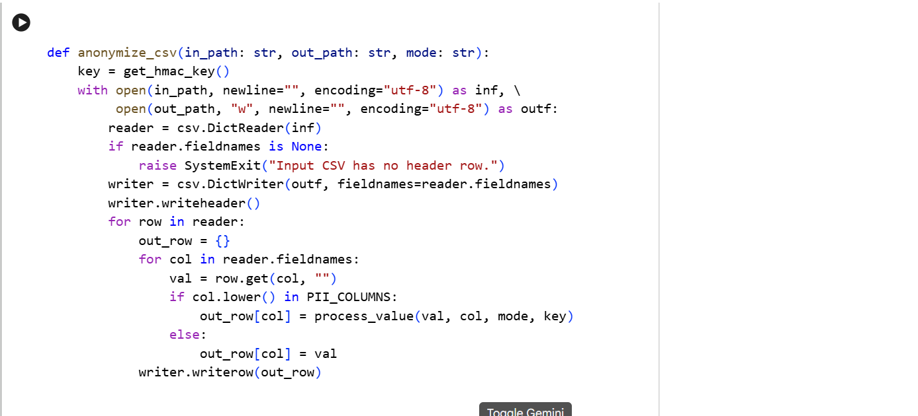
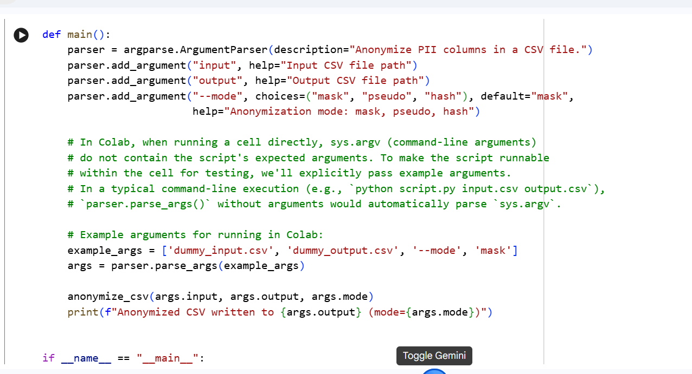
#OUTPUT:
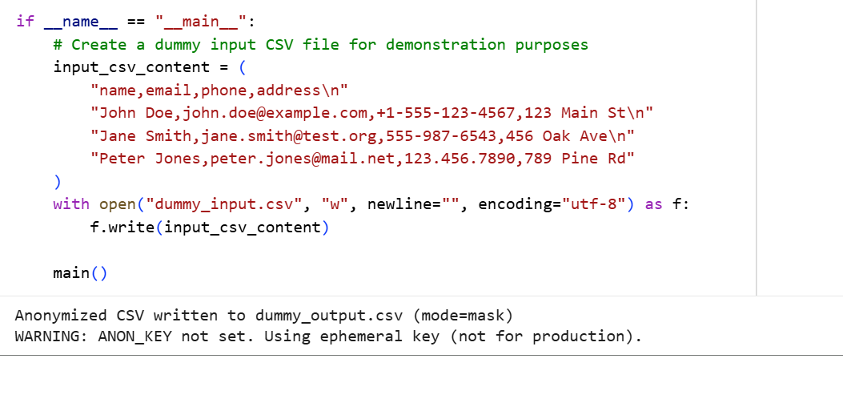
#TASK DESCRIPTION-3:
AI-Generated Security Risks
- Use AI to generate login/authentication code.
- Identify possible security flaws (e.g., weak password storage, lack of encryption).
- Students must document risks and propose ethical guidelines for safe AI code usage.

#PROMPT:
Ask an AI to generate Python login/authentication code. Then analyze the code for possible security flaws such as weak password storage, lack of encryption, or insecure session handling. Document the risks and propose ethical guidelines for writing and using AI-generated code safely.

#CODE:
# insecure_auth_example.py
# Example AI-generated Python authentication code (intentionally insecure for analysis)
# Do NOT use in production.

from flask import Flask, request, redirect, make_response, g
import sqlite3
import random

app = Flask(__name__)

DB = "insecure.db"
# Insecure: hardcoded admin password (and stored plaintext)
INITIAL_USERS = [
("alice", "password123"),
("bob", "hunter2"),
("admin", "adminpass")
]

# Simple in-memory session store (insecure, not persistent)
sessions = {} # session_token -> username

def get_db():
if getattr(g, "_db", None) is None:
g._db = sqlite3.connect(DB)
return g._db

@app.before_first_request
def init_db():
db = get_db()
c = db.cursor()
# Insecure: storing plaintext passwords
c.execute("CREATE TABLE IF NOT EXISTS users (username TEXT PRIMARY KEY, password TEXT)")
for u, p in INITIAL_USERS:
try:
# Insecure: using string formatting for SQL (SQL injection risk)
c.execute("INSERT OR REPLACE INTO users (username, password) VALUES ('%s', '%s')" % (u, p))
except Exception:
pass
db.commit()

@app.teardown_appcontext
def close_db(exception):
db = getattr(g, "_db", None)
if db is not None:
db.close()

@app.route("/login", methods=["GET", "POST"])
def login():
if request.method == "POST":
username = request.form.get("username", "")
password = request.form.get("password", "")
db = get_db()
c = db.cursor()
# Insecure: direct string interpolation -> SQL injection
query = "SELECT password FROM users WHERE username = '%s'" % username
try:
c.execute(query)
row = c.fetchone()
except Exception:
row = None

if row and row[0] == password:
# Insecure: predictable numeric token, no entropy
token = str(random.randint(1000000, 9999999))
sessions[token] = username
resp = make_response(redirect("/protected"))
# Insecure: cookie without Secure/HttpOnly/SameSite
resp.set_cookie("session", token)
return resp
else:
return "Login failed", 401

return '''
<form method="post">
<input name="username" placeholder="username"/>
<input name="password" type="password" placeholder="password"/>
<button type="submit">Login</button>
</form>
'''

@app.route("/protected")
def protected():
token = request.cookies.get("session")
if token and token in sessions:
return f"Hello, {sessions[token]}! This is a protected page."
return redirect("/login")

@app.route("/logout")
def logout():
token = request.cookies.get("session")
if token and token in sessions:
sessions.pop(token, None)
resp = make_response(redirect("/login"))
resp.set_cookie("session", "", expires=0)
return resp

if __name__ == "__main__":
# Insecure: debug mode and no TLS
app.run(host="0.0.0.0", port=5000, debug=True)

#OUTPUT:
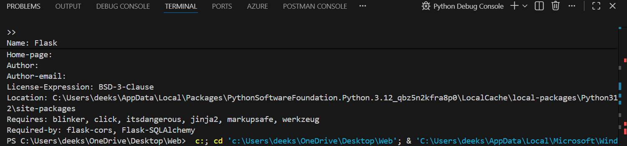
#TASK DESCRIPTION-4:
Accountability in Human–AI Collaboration
- Scenario: AI writes code for a hospital’s patient monitoring system.
- If the code fails and causes harm, who is responsible?
  - The AI tool?
  - The human developer?
  - The organization using it?
- Students must debate and submit a reflection report.
#PROMPT:
Imagine an AI writes code for a hospital’s patient monitoring system. Analyze a scenario where the code fails and causes harm. Discuss who is responsible: the AI tool, the human developer, or the organization using it. Reflect on accountability, ethical responsibilities, and best practices for human–AI collaboration. Submit a short report with your conclusions.
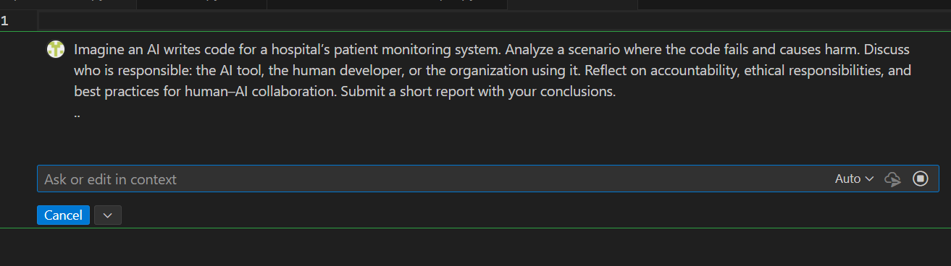
#CODE:
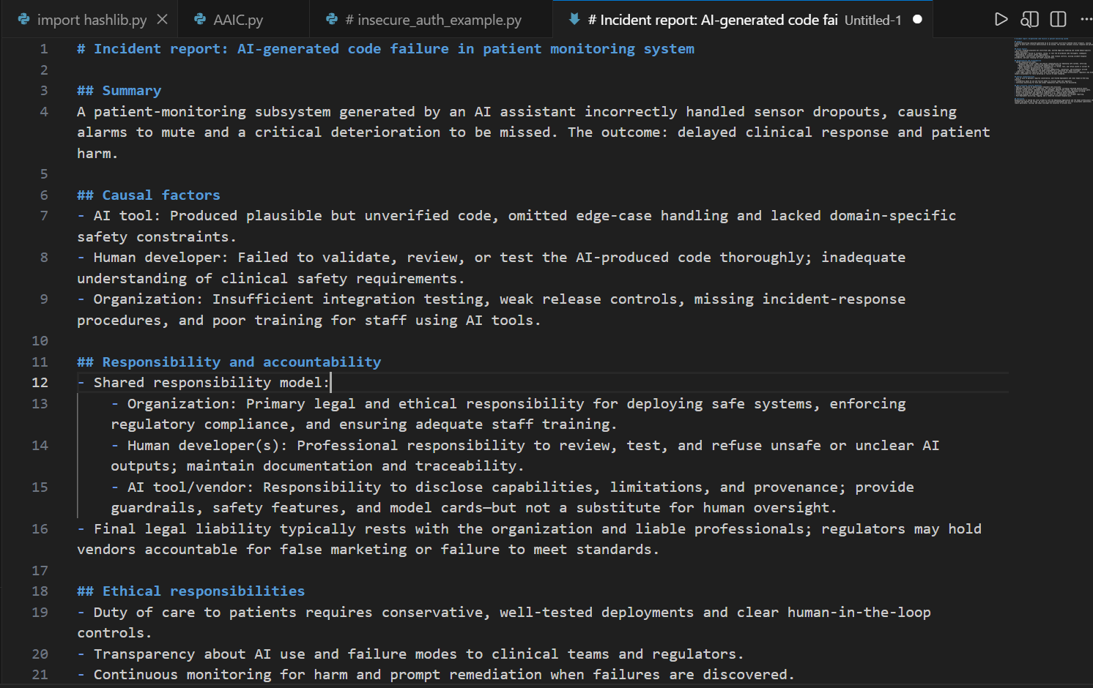
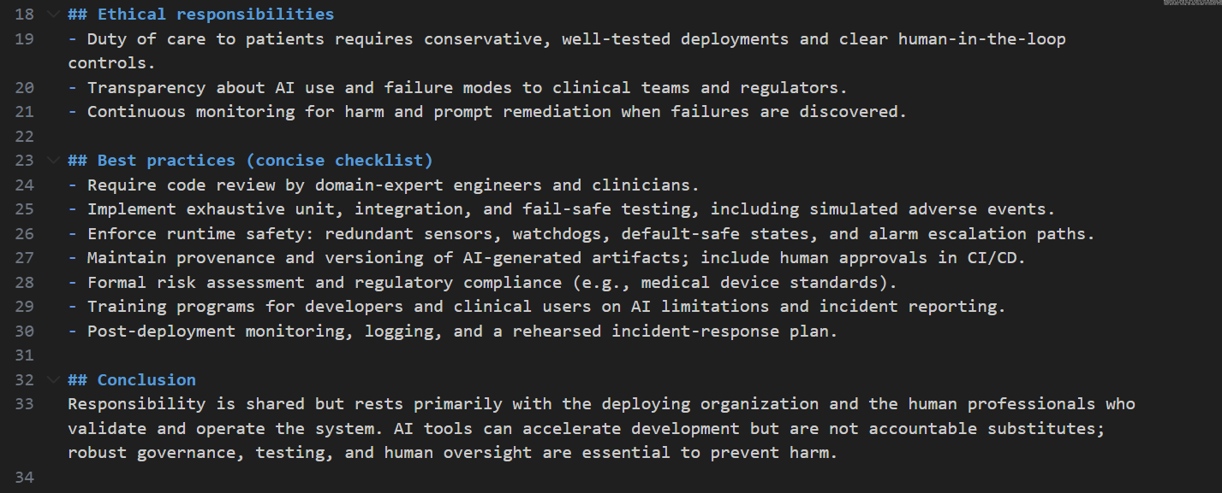
#TASK DESCRIPTION-5:
Limitations of AI in Critical Systems
- Ask AI to generate code for a life-critical application (e.g., railway signaling, medical diagnosis).
- Discuss:
  - Should AI code be used directly in such systems?
  - What level of human oversight is mandatory?
  - How do we balance efficiency vs safety?
#PROMPT:
Generate code for a life-critical application (e.g., railway signaling or medical diagnosis). Analyze the limitations of using AI-generated code in such systems. Discuss whether AI code should be used directly, the level of human oversight required, and how to balance efficiency with safety. Submit a short report with your reflections and recommendations.

#CODE:
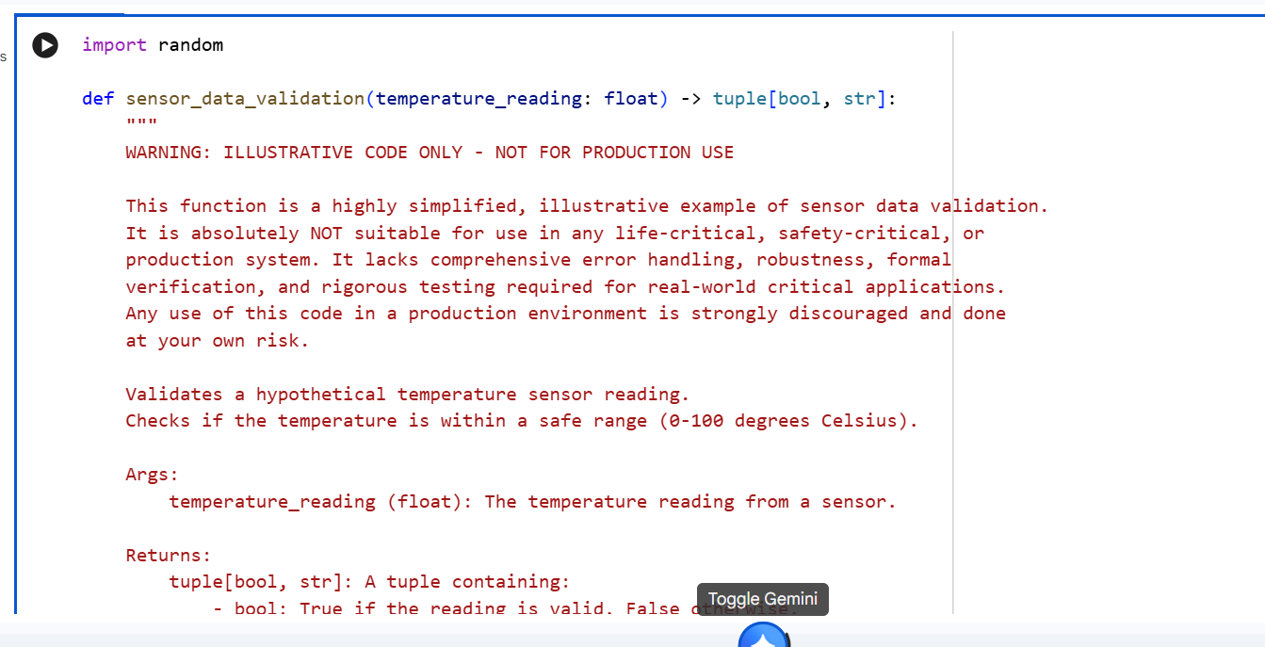
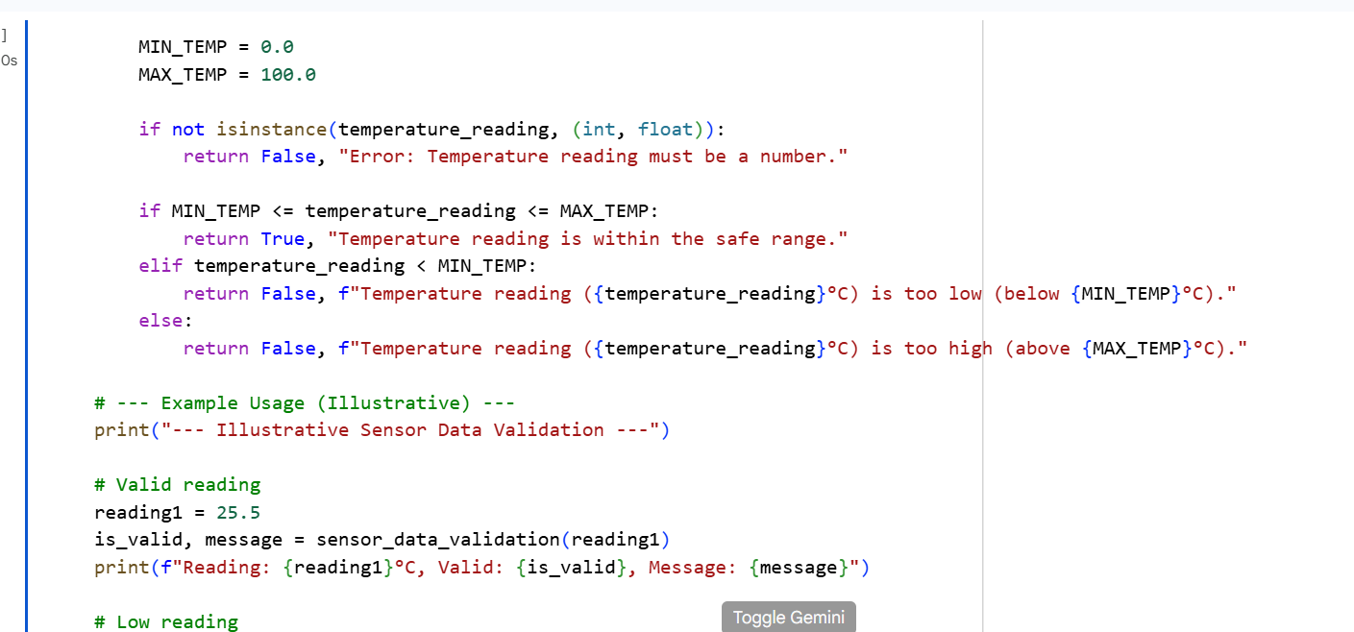
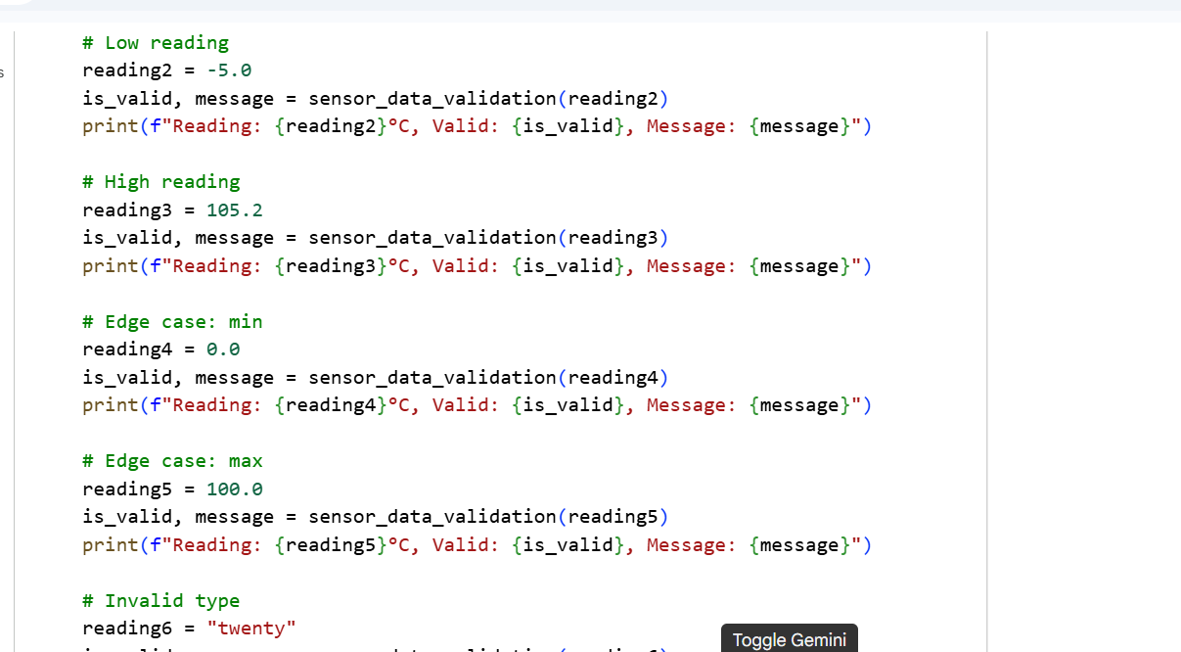
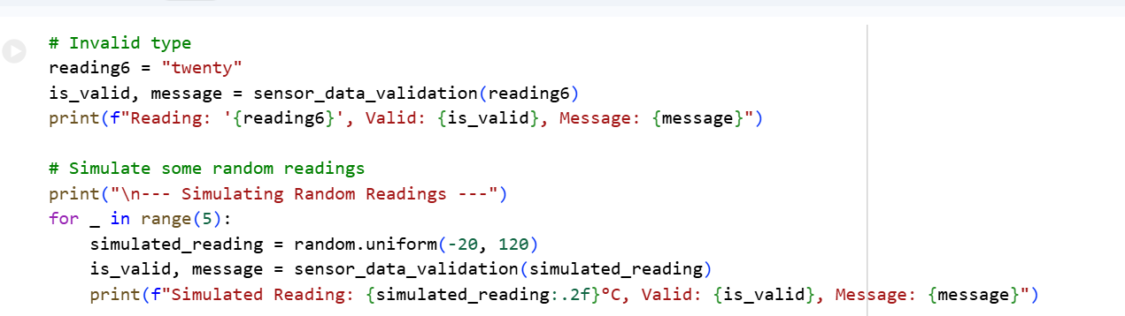
#OUTPUT:
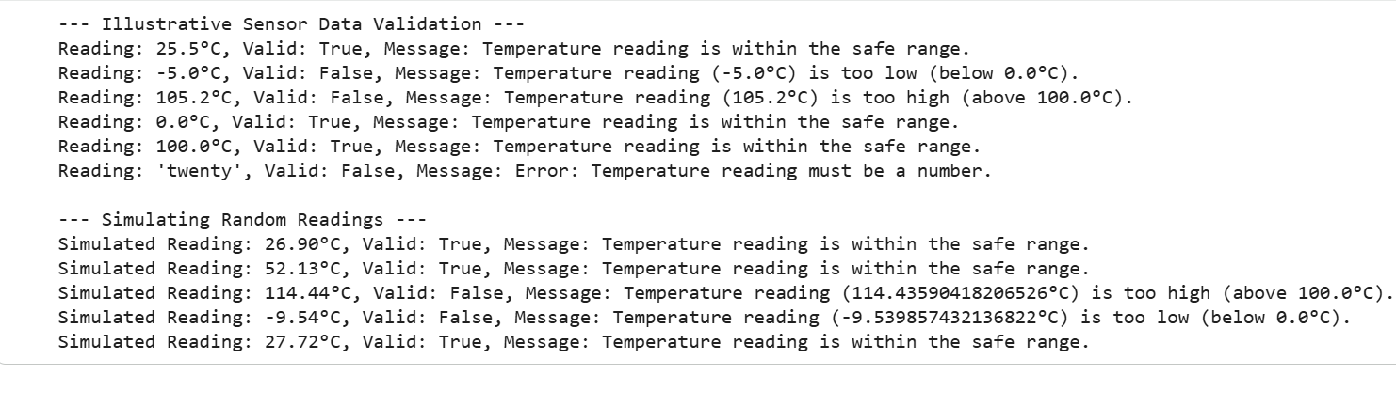
#TASK DESCRIPTION-6:
Ethical Use of AI-Generated Code
- Students analyze real-world cases (e.g., plagiarism, copyright violation, misuse of open-source code).
- Identify best practices for ethically using AI code:
  - Attribution
  - Verification
  - Responsible deployment
#PROMPT:
Analyze real-world cases where AI-generated code led to ethical issues (e.g., plagiarism, copyright violation, or misuse of open-source code). Identify best practices for using AI code ethically, including proper attribution, verification of correctness, and responsible deployment. Submit a reflection report with your recommendations.

-------- Thank You-------

