WEEK 1 DELIVERABLE
Predicting E-Commerce Delivery Delays
Data Science Project Plan and Strategy Design (Python)
Author: [Kuruwa Sravani] Date: 6 October 2026 Estimated effort: 33 hours over 4 weeks
Note: This is a planning document for a hypothetical project. No real dataset is used; all data sources, figures and targets are illustrative assumptions made for planning purposes.

1. Project Background

1.1 The Problem
Imagine a mid-sized Indian e-commerce company, "QuickKart", that ships about 40,000 orders per day across more than 300 cities through a network of warehouses, regional hubs and third-party courier partners. Customers are promised a delivery date at checkout, but a significant share of orders arrive later than promised. Today the company only finds out about a delay after it has happened, when the customer complains or the tracking page stops updating.
This project plans a data science solution that predicts, at the time an order is shipped, how likely it is to be delayed and by roughly how many days, so that the operations team can act before the customer is affected.

1.2 Motivation
- Customer experience: late deliveries are consistently one of the top reasons for poor ratings, cancellations and repeat-purchase loss.
- Cost: each delayed order generates support contacts, re-delivery attempts and sometimes refunds or vouchers. Even a small reduction in delays saves a large amount at 40,000 orders per day.
- Operational visibility: the operations team currently reacts to delays rather than anticipating them. A risk score lets them re-route parcels, switch couriers or message customers early.
- Honest delivery promises: predicted delay risk can later feed into the delivery date shown at checkout.

1.3 Why This Problem Suits Data Science and Python
Delivery delays depend on many interacting factors (distance, courier, season, weather, warehouse load, pin-code, product type), and the relationships between them are non-linear and hard to capture with simple rules. The company also already records large amounts of structured historical data, so supervised learning is practical. Python is the natural choice because its ecosystem covers the whole workflow: pandas for data handling, matplotlib and seaborn for visualisation, scikit-learn and XGBoost for modelling, and SHAP for explaining predictions.

1.4 Problem Statement
Given the details of an order at the time it is dispatched, predict (a) whether it will be delivered later than the promised date, and (b) by how many days, so that high-risk orders can be flagged for early intervention.

2. Project Objectives
The objectives are written to be specific and measurable (SMART). The numerical targets are planning assumptions that would be confirmed with stakeholders in a real project.
# | Objective | Measure of success
O1 | Build a clean, documented dataset by combining order, courier, location, weather and calendar data. | Less than 2% missing values in model features; data dictionary completed.
O2 | Identify the main drivers of delivery delay through exploratory analysis. | At least 5 evidence-backed insights, each supported by a chart.
O3 | Build a classification model that predicts whether an order will be late. | Recall on the 'late' class of at least 75% and ROC-AUC of at least 0.80 on the test set.
O4 | Build a regression model that estimates the number of days of delay. | Mean absolute error of 1 day or less on the test set.
O5 | Make the results explainable and usable for operations staff. | Feature importance / SHAP summary and a short, non-technical findings report.

3. Project Scope

3.1 In Scope
- Historical order and shipment data for the past 12 months (assumed to be available as CSV exports).
- Supporting data: courier performance statistics, pin-code to region mapping, public holiday calendar and daily weather by city.
- Data cleaning, exploratory analysis, feature engineering, model training and evaluation, all in Python.
- A binary classifier (late / on time) and a regression model (days of delay), compared against a simple baseline.
- A written report and visualisations summarising findings and recommendations.

3.2 Out of Scope
- Real-time streaming predictions and production deployment (APIs, cloud hosting, monitoring).
- Changing the company's courier contracts, routing software or checkout system.
- Deep learning or computer-vision approaches; the project uses structured tabular data only.
- Customer-level personal data beyond what is needed for delivery (no names, phone numbers or addresses).
- International shipments and returns / reverse logistics.

3.3 Assumptions
- Historical data contains the promised delivery date and the actual delivery date for each order.
- Data access has been approved and personal identifiers are removed before analysis.
- Only information available at dispatch time may be used as a model input, to avoid data leakage.

4. Methodology and Strategy
The project follows the standard data science lifecycle, adapted into eight stages with a checkpoint at the end of each stage. If model results are poor, the process loops back to feature engineering or cleaning, as shown in Figure 1.
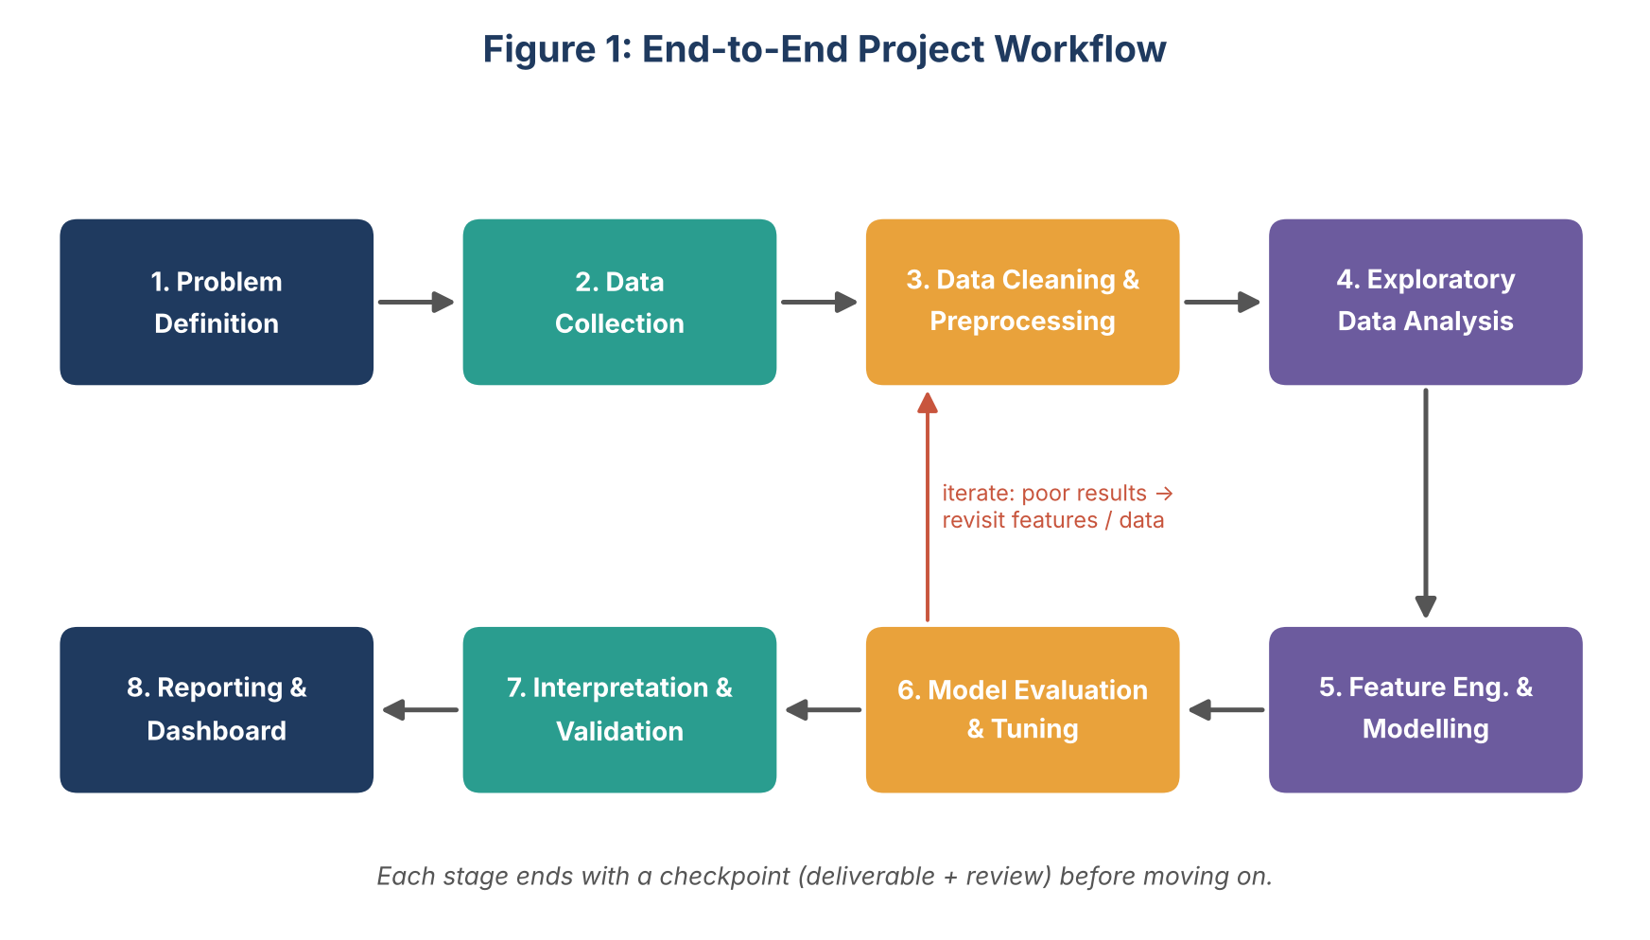
Figure 1: End-to-end project workflow with an iteration loop

4.1 Data Collection
The planned sources and how each would be accessed with Python are listed below.
Source | Content (examples) | How it is loaded
Order and shipment logs | Order ID, order date, dispatch date, promised date, actual delivery date, product category, weight, payment type, origin warehouse, destination pin-code | pandas.read_csv (chunked if large)
Courier performance | Courier name, historical on-time rate by lane, average transit days | pandas.read_csv
Weather data | Daily rainfall and temperature by city | requests to a free public weather API, saved to CSV
Calendar data | National and regional holidays, festival sale periods | Manually compiled CSV / holidays library
Pin-code reference | Pin-code, city, state, tier (metro / tier 2 / tier 3) | pandas.read_csv

All raw files will be stored unchanged in a raw-data folder (or a local SQLite / Parquet store). Every later step reads from raw data and writes to a separate processed folder, so the whole pipeline can be re-run from scratch.

4.2 Data Cleaning and Preprocessing
- Profiling first: check shape, data types, missing-value counts, duplicates and basic statistics using df.info(), df.describe() and a missing-value summary.
- Missing values: drop rows missing the target (actual delivery date); impute numeric fields such as weight with the median per category; fill categorical gaps with an explicit 'Unknown' label.
- Duplicates and errors: remove duplicate order IDs; flag impossible values (delivery before dispatch, negative weight) and correct or remove them.
- Date handling: convert all date columns with pd.to_datetime and derive the target: delay_days = actual_date - promised_date; is_late = delay_days > 0.
- Outliers: inspect with box plots and the IQR rule; cap extreme values (winsorising) rather than deleting rows, unless they are clearly data errors.
- Joining: merge supporting tables on pin-code, city, courier and date; check row counts before and after each merge to catch accidental duplication.

4.3 Exploratory Data Analysis (EDA)
EDA is used to understand the data and to generate hypotheses before modelling. Planned analyses:
- Overall late-delivery rate and its distribution (class balance check).
- Late rate by courier, origin warehouse, destination tier, product category and day of week.
- Monthly and weekly trends, with festival-sale periods highlighted.
- Relationship of distance, weight and rainfall with delay days (scatter plots, correlation heatmap).
- Courier-by-region heatmap to spot weak lanes.
Each insight is recorded with its supporting chart so that it can be reused in the final report.

4.4 Feature Engineering
Feature group | Examples
Time-based | Day of week, month, is_weekend, is_holiday, days to nearest festival sale, dispatch hour
Geographic | Approximate distance between warehouse and destination, same-state flag, destination tier
Order-based | Package weight, product category, payment type (prepaid / cash on delivery), promised transit days
Courier-based | Courier's 30-day rolling on-time rate on the lane, courier volume that day
Weather | Rainfall and temperature at destination on dispatch day and the following 2 days

Categorical variables will be one-hot or target encoded inside a scikit-learn Pipeline, and numeric variables scaled where needed, so that exactly the same transformations are applied to training and test data.
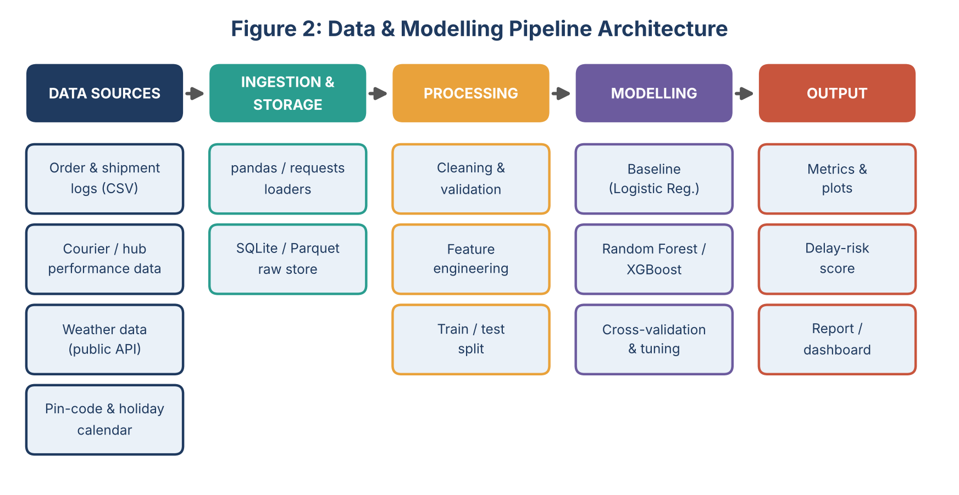
Figure 2: Data and modelling pipeline architecture, from sources to outputs

4.5 Modelling Strategy
- Baseline: logistic regression (classification) and linear regression (days of delay). These are simple and interpretable and set the benchmark that other models must beat.
- Tree-based models: Random Forest, then gradient boosting (XGBoost or LightGBM), which usually perform best on mixed tabular data.
- Data split: 80/20 train-test split. Because delays change over time, a time-based split (train on earlier months, test on the latest month) will be compared against a random stratified split to check that the model generalises forward in time.
- Class imbalance: if late orders are a small minority, use class weights or SMOTE (applied only on training folds) and judge the model with recall and PR-AUC, not accuracy.
- Tuning: RandomizedSearchCV with 5-fold cross-validation on the training set only.

4.6 Evaluation Strategy
Task | Metrics | Why
Classification (late / on time) | Recall, precision, F1, ROC-AUC, PR-AUC, confusion matrix | Missing a real delay is costlier than a false alarm, so recall on the 'late' class is the primary metric; accuracy alone would be misleading if delays are rare.
Regression (days of delay) | MAE, RMSE, R-squared | MAE is easy to explain to operations staff (average error in days).
Explainability | Permutation importance, SHAP summary plot | Shows which factors drive predicted delays and builds trust in the model.

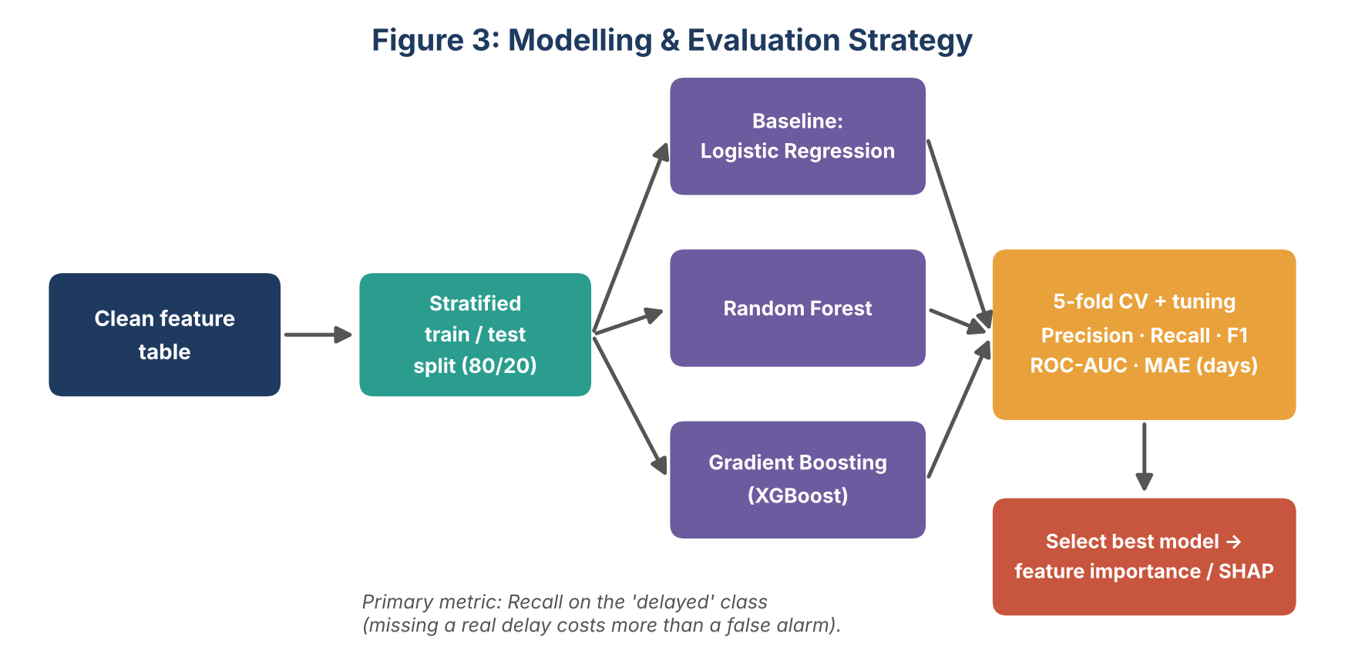
Figure 3: Modelling and evaluation strategy
Final model selection will weigh performance, stability across cross-validation folds, and interpretability. The selected model will also be checked for data leakage (for example, by confirming that no feature uses information from after dispatch) and for fairness across regions, so that remote pin-codes are not systematically mis-scored.

5. Timeline and Effort Estimate
The project is planned for a total of 33 hours over four weeks, within the 30 to 35 hour target. Time is weighted towards data preparation and exploration, because these stages typically take the most effort in practice.
Week | Phase | Main activities | Hours
1 | Problem definition and planning | Define the problem, objectives, scope, success metrics; set up Python environment and project folders | 3
1 | Data collection and ingestion | Gather files, load with pandas, call weather API, build data dictionary | 4
2 | Data cleaning and preprocessing | Profile data, handle missing values / duplicates / outliers, merge tables | 5
2 | Exploratory data analysis | Statistics, visualisations, hypothesis checks, record insights | 5
3 | Feature engineering | Create time, geographic, courier and weather features; build preprocessing pipeline | 3
3 | Model building | Baseline, Random Forest, XGBoost; cross-validation and tuning | 5
4 | Evaluation and interpretation | Test-set evaluation, error analysis, SHAP, leakage and fairness checks | 3
4 | Reporting and documentation | Final report, charts, recommendations, code clean-up and README | 5
Total |  |  | 33

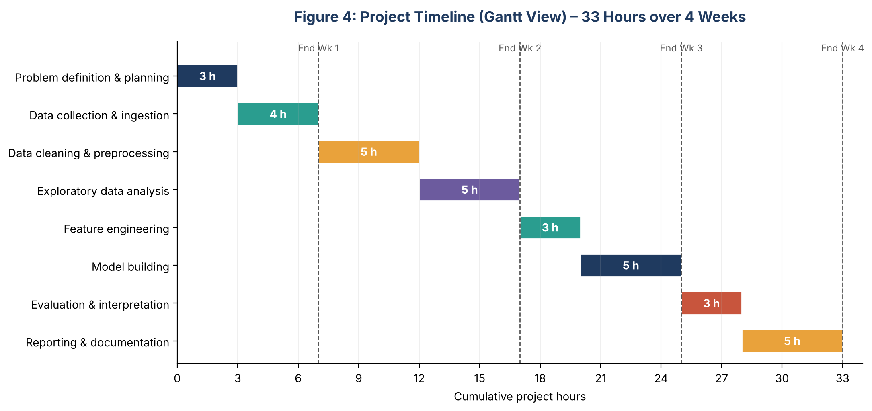
Figure 4: Project timeline as a Gantt-style chart of cumulative hours
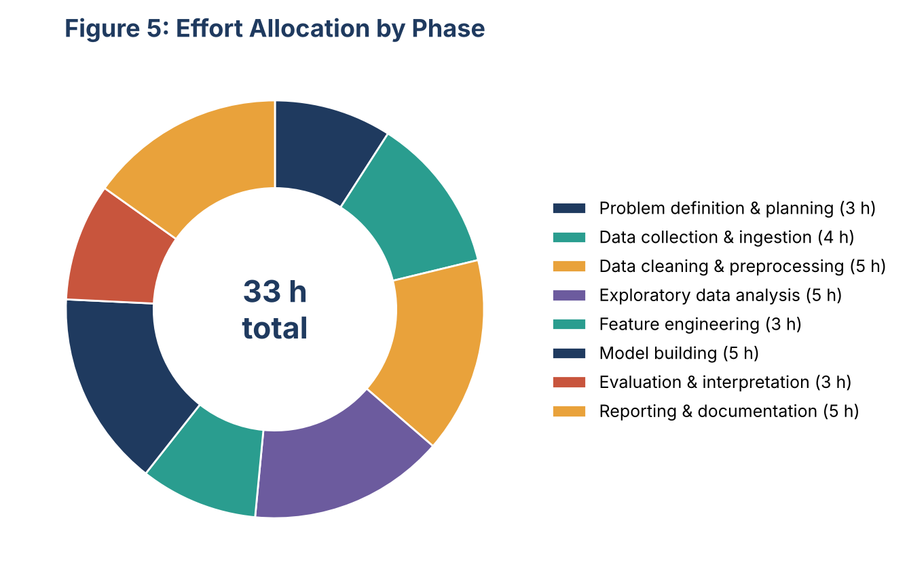
Figure 5: Share of total effort by phase

6. Tools and Python Libraries
Purpose | Tool / library | Planned use
Environment | Python 3.11, Jupyter Notebook / VS Code, Git | Interactive development and version control
Data handling | pandas, NumPy | Loading, cleaning, merging, aggregating and feature creation
Data access | requests, SQLite (sqlite3), pyarrow | Calling the weather API; storing raw and processed data
Visualisation | matplotlib, seaborn, plotly | EDA charts, heatmaps, model result plots
Statistics | SciPy, statsmodels | Hypothesis tests, correlation analysis
Machine learning | scikit-learn, XGBoost / LightGBM, imbalanced-learn | Pipelines, models, cross-validation, tuning, handling class imbalance
Explainability | SHAP | Feature contribution plots
Documentation | Markdown, python-docx, free-form diagram tools | Reports and workflow diagrams

7. Expected Outcomes and Benefits

7.1 Deliverables
- A cleaned, documented and reproducible dataset together with a data dictionary.
- A set of EDA findings with supporting visualisations.
- A trained and validated classification model and delay-days regression model, with a comparison against the baseline.
- An explainability summary showing the top drivers of delay.
- A final report with actionable recommendations, and well-commented Python notebooks / scripts.

7.2 Expected Business Benefits
- Early warning: operations can intervene on high-risk orders before they become late (for example, by switching courier or prioritising the parcel).
- Lower cost: fewer re-deliveries, refunds and support tickets.
- Better customer communication: proactive delay notifications and more realistic delivery promises.
- Data-driven courier management: evidence for which courier-region combinations perform poorly, supporting contract discussions.

7.3 Benefits of the Chosen Approach
Starting with a simple baseline and moving to tree-based models gives a fair measure of the value added by complexity. Using pipelines and cross-validation keeps the evaluation honest and reproducible. Choosing recall as the primary metric aligns the model with the real business cost of a missed delay. Explainability tools make the model's output understandable to non-technical users, which is essential for adoption.

8. Anticipated Challenges and Mitigation
Challenge | Why it matters | Mitigation
Poor data quality (missing or inconsistent dates, duplicates) | Wrong delay labels would mislead every later step | Thorough profiling early; validation rules (delivery cannot precede dispatch); document every cleaning decision
Class imbalance (few late orders) | A model can score high accuracy by predicting 'on time' for everything | Use recall / PR-AUC, class weights, SMOTE on training folds only, and a threshold chosen from the precision-recall curve
Data leakage | Using post-dispatch information inflates results and fails in real use | List features by availability time; build features only from dispatch-time data; use time-based validation
Changing patterns over time (festival sales, new couriers) | A model trained on past data may degrade | Time-based test split; include seasonality features; recommend periodic retraining
External data limits (weather API rate limits or gaps) | Missing weather values could reduce feature quality | Cache API responses locally; fall back to monthly city averages where data is missing
Overfitting with complex models | Great training scores but weak performance on new orders | Cross-validation, regularisation, early stopping, hold-out test set used only once
Time overrun | Data preparation often takes longer than planned | Built-in checkpoints; keep model scope to three algorithms; prioritise objectives O1 to O3 if time is short
Privacy and fairness | Customer data is sensitive; remote regions may be scored unfairly | Remove personal identifiers; analyse errors by region and tier before finalising the model

9. Conclusion
This plan sets out a complete, realistic path from a business problem to an explainable predictive solution using Python. It defines clear objectives and boundaries, a stage-by-stage methodology with checkpoints, an effort estimate of 33 hours, the tools to be used, and the main risks with their mitigations. The same structure of defining the problem, preparing data, exploring, modelling, evaluating and communicating can be reused for the technical tasks in the coming weeks.

