WEEK 2 DELIVERABLE
Exploratory Data Analysis and Visualization Framework
A reusable, Python-based plan for exploring any dataset
Author: [Your Name] Date: 6 October 2026 Estimated effort: 33 hours
Note: No dataset is provided for this task, so the framework is written to apply to any tabular dataset. For concreteness, examples refer to the delivery-delay project planned in Week 1. All plots shown are drawn from synthetic data purely to illustrate each chart type.

1. Introduction to Exploratory Data Analysis

1.1 What is EDA?
Exploratory Data Analysis (EDA) is the first, investigative phase of working with a dataset. Before building any model or drawing conclusions, the analyst examines the data using summary statistics and visualisations to understand its structure, quality, patterns and surprises. The term was popularised by the statistician John Tukey, who argued that analysts should look at their data openly, with curiosity, before testing formal hypotheses.
In practice, EDA answers questions such as: What does each column mean and how is it stored? How many rows and columns are there? Which values are missing, duplicated or impossible? How is each variable distributed? Which variables move together? Are there groups, trends or seasonal patterns?

1.2 Why EDA Matters
- Prevents wrong conclusions: errors such as swapped units, impossible dates or duplicated records are caught before they distort a model.
- Guides modelling choices: the shape of distributions, relationships between variables and class balance determine which models, transformations and metrics make sense.
- Generates useful features and hypotheses: patterns found in EDA (for example, delays rising sharply in festival weeks) become features and questions for later stages.
- Builds domain understanding: EDA is how an analyst learns what the data actually says, which is essential for explaining results to non-technical stakeholders.
- Saves time and cost: problems found early are cheap to fix; problems found after deployment are not.

1.3 Where EDA Fits in the Project
In the Week 1 plan, EDA is stage 4 of the project and receives 5 of the 33 planned hours, with cleaning running alongside it. This Week 2 document expands that stage into a full, reusable framework. It does not depend on any particular dataset: the same steps, checks and chart choices can be applied to sales data, health records, sensor logs or survey results, with small adjustments described in Section 10.

1.4 Guiding Principles
- Look before you leap: inspect the raw data before any transformation, and keep the raw file untouched.
- Question everything: every surprising number is either an insight or a data error until proven otherwise.
- Go from simple to complex: one variable, then two, then many.
- Visualise as well as summarise: different datasets can share identical summary statistics but look completely different when plotted.
- Document as you go: record each decision (what was changed and why) so the analysis can be reproduced and defended.

2. Understanding the Data: Types and Structures
The type of a variable decides which summaries, plots and tests are appropriate. The first step of EDA is therefore to classify every column correctly, not just to accept the type Python guesses on loading.

2.1 Variable Types
Type | Description | Examples (delivery project) | pandas dtype
Numeric - continuous | Measured values that can take any value in a range | Package weight, distance in km, rainfall in mm | float64
Numeric - discrete | Counts; whole numbers | Number of items in an order, number of delivery attempts | int64
Categorical - nominal | Labels with no natural order | Courier name, product category, payment type | object / category
Categorical - ordinal | Labels with a meaningful order | City tier (metro, tier 2, tier 3), customer rating 1 to 5 | category (ordered)
Binary / boolean | Two possible values | is_late, is_holiday, is_prepaid | bool / int64
Date and time | Timestamps and dates | Order date, dispatch time, delivery date | datetime64
Text | Free-form strings | Customer feedback, address notes | object
Identifiers | Unique keys, not for analysis as numbers | Order ID, customer ID | object / int64
Geospatial | Coordinates or area codes | Pin-code, latitude and longitude of hub | object / float64

2.2 Data Structures and Sources
- Structured (tabular): rows and columns in CSV, Excel or SQL tables; the main focus of this framework and loaded with pandas.
- Semi-structured: JSON or API responses; flattened with pandas.json_normalize before analysis.
- Time series: observations ordered in time; require a datetime index, resampling and attention to seasonality.
- Unstructured: text, images, audio; need specialised preprocessing and are outside the scope of this framework, although text columns can be explored with simple word counts.

2.3 First-Look Inspection Checklist
Every new dataset starts with the same quick inspection. The table lists each question and the pandas call that answers it.
Question | Python code
How big is the data? | df.shape
What are the columns and types? Any nulls? | df.info()
What do the first and last rows look like? | df.head(), df.tail(), df.sample(5)
Summary of numeric columns | df.describe()
Summary of text / categorical columns | df.describe(include='object')
Missing values per column (count and %) | df.isna().sum(), df.isna().mean() * 100
Duplicate rows | df.duplicated().sum()
Number of unique values per column | df.nunique()
Memory used | df.memory_usage(deep=True)

3. The EDA Process
Figure 1 shows the eight-step process followed for any dataset. Each step has a clear output, and the red arrow reminds us that EDA is iterative: a finding at a later step often sends the analyst back to check or fix earlier work.
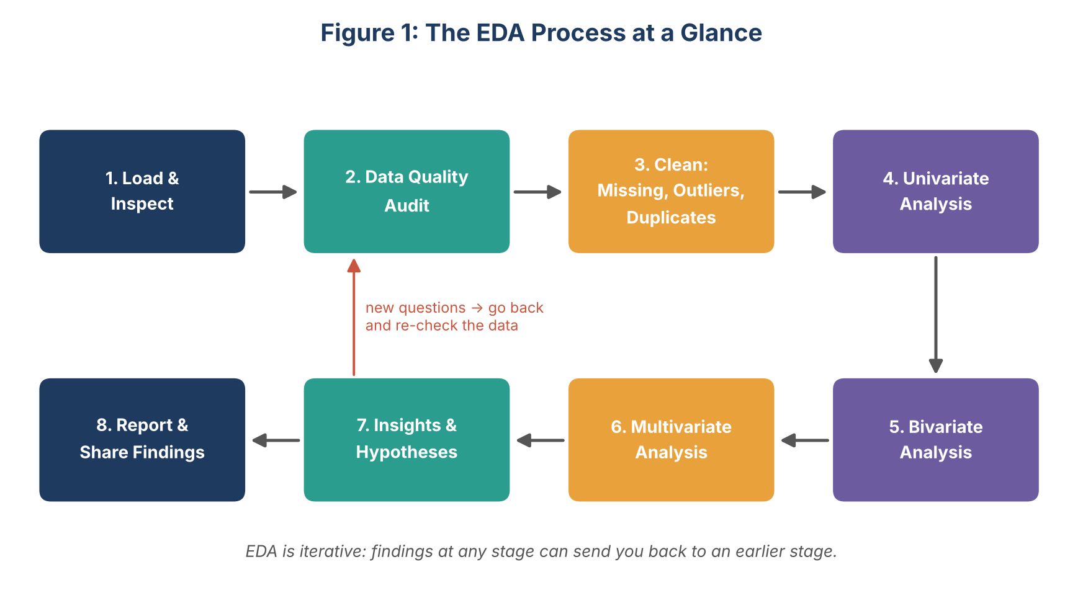
Figure 1: The EDA process at a glance
Step | Purpose | Output
1. Load and inspect | Read data, check shape, types and first rows | Data profile and data dictionary draft
2. Data quality audit | Measure missing values, duplicates, invalid values and inconsistent labels | Quality report table
3. Clean | Handle missing data, outliers, duplicates and type errors | Cleaned dataset plus a log of every change
4. Univariate analysis | Study each variable on its own | Distribution plots and summary statistics
5. Bivariate analysis | Study pairs of variables, especially each feature against the target | Relationship plots and test results
6. Multivariate analysis | Study interactions among three or more variables | Correlation matrix, pair plots, grouped summaries
7. Insights and hypotheses | Interpret patterns and decide what they mean for modelling | Findings log
8. Report and share | Communicate clearly to the intended audience | Report and presentation

4. Data Quality: Missing Values, Outliers and Errors

4.1 Handling Missing Data

Step 1: Detect and understand the pattern
Count missing values per column and per row, and visualise where they occur (for example with a heatmap of df.isna() or the missingno library). It is just as important to ask why the data is missing, because the reason determines the correct treatment.
Mechanism | Meaning | Example | Implication
MCAR (missing completely at random) | Missingness has no relation to any variable | A sensor randomly fails to record | Safe to drop or impute; least bias
MAR (missing at random) | Missingness depends on other observed variables | Weight is more often missing for one courier's records | Impute using the related variables, e.g. group-wise
MNAR (missing not at random) | Missingness depends on the missing value itself | Customers with very late deliveries skip the rating | Simple imputation can bias results; add a missing-indicator and treat with caution

Step 2: Choose a treatment
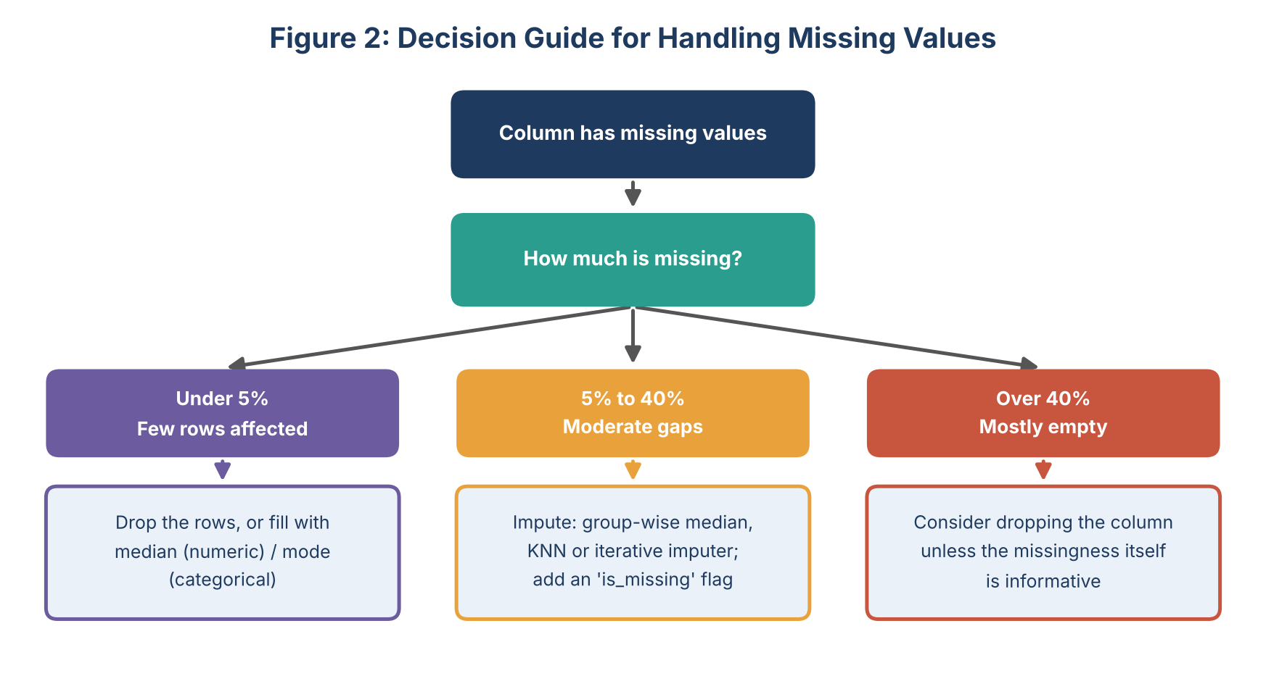
Figure 2: Decision guide for handling missing values
Method | How (pandas / scikit-learn) | When to use | Watch out for
Drop rows | df.dropna(subset=[...]) | Very few rows affected; MCAR | Losing data; bias if not random
Drop column | df.drop(columns=[...]) | Column mostly empty and not informative | Dropping a column whose missingness carries information
Mean / median fill | df[col].fillna(df[col].median()) | Numeric columns; median for skewed data | Reduces variance; hides real uncertainty
Mode / 'Unknown' | df[col].fillna('Unknown') | Categorical columns | Rare categories can become over-represented
Group-wise fill | df.groupby('cat')[col].transform(lambda s: s.fillna(s.median())) | Missingness depends on a category (MAR) | Groups with very few rows
Forward / backward fill | df[col].ffill() | Time series with slowly changing values | Long gaps give stale values
KNN / iterative imputer | KNNImputer, IterativeImputer | Moderate missingness with correlated features | Slower; must be fitted on training data only
Missing-indicator flag | df[col + '_missing'] = df[col].isna() | Alongside imputation, when missingness may be informative | Adds extra columns

4.2 Detecting and Treating Outliers
An outlier is a value far from the rest of the data. It may be an error (a typo, a unit mix-up) or a genuine rare event (a parcel delayed by a flood). The analyst's job is to find outliers, decide which type each is, and treat it accordingly. Outliers must never be deleted automatically.
Method | Rule | Best for
Visual inspection | Box plots, histograms, scatter plots | First look at any numeric variable
IQR rule | Outlier if below Q1 - 1.5 x IQR or above Q3 + 1.5 x IQR | Skewed or non-normal data; robust and simple
Z-score | Outlier if the absolute z-score is above 3 | Roughly bell-shaped data
Modified z-score (MAD) | Uses the median and median absolute deviation | Small samples or heavy tails
Domain rules | Weight below 0, delivery before dispatch, age above 120 | Detecting impossible values
Multivariate methods | Isolation Forest, Local Outlier Factor | Points unusual only in combination of variables

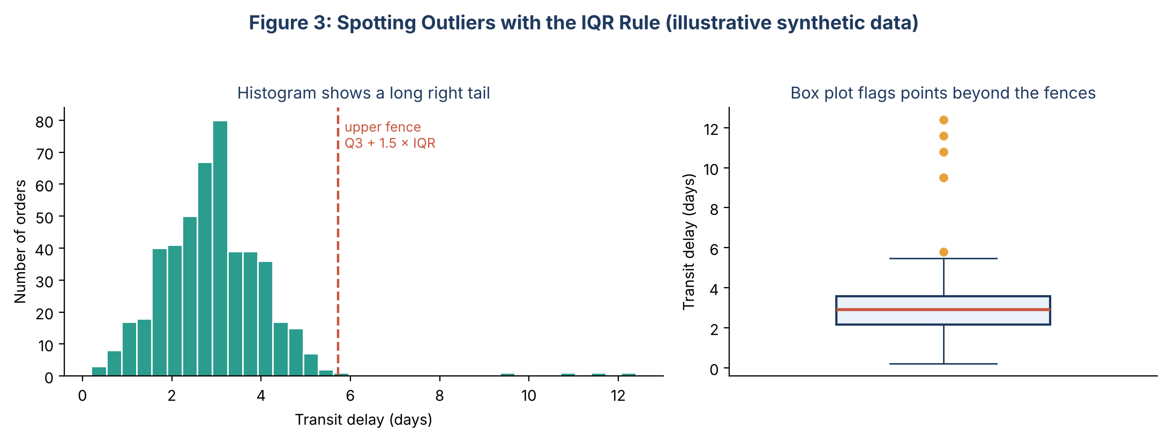
Figure 3: Spotting outliers with the IQR rule
Treatment options: (1) correct the value if the true value is known; (2) remove it only if it is clearly an error; (3) cap (winsorise) at the fences to limit influence; (4) transform the variable (for example a log transform) to reduce skew; (5) keep it and use robust methods when it is a real and important event. Whatever is chosen, the decision and the number of affected rows are written to the cleaning log.

4.3 Other Quality Checks
- Duplicates: check full-row duplicates and duplicates on the key (such as order ID); decide whether to keep first, last or merge.
- Inconsistent labels: 'Delhi', 'delhi ' and 'New Delhi' should be standardised with string cleaning (strip, lower, mapping).
- Wrong data types: dates stored as text, numbers stored with currency symbols; convert with pd.to_datetime and pd.to_numeric.
- Logical consistency: cross-column rules such as dispatch date not later than delivery date, or a total equal to the sum of its parts.
- Class balance: if there is a target variable, check how the classes are distributed, as this affects later metrics.

5. Data Exploration Techniques

5.1 Univariate Analysis (one variable)
Univariate analysis describes each variable individually. It reveals the typical value, the spread, the shape of the distribution and the presence of unusual values.
Variable type | Statistics to compute | Plots to draw | What to look for
Numeric | Mean, median, mode, min, max, standard deviation, quartiles, skewness, kurtosis | Histogram, KDE curve, box plot, violin plot | Skew, multiple peaks, gaps, extreme values
Categorical | Counts, percentages, number of categories, most common value | Bar chart (sorted), horizontal bar for long labels | Dominant or very rare categories, spelling variants
Binary target | Proportion of each class | Bar chart or simple count table | Class imbalance
Date and time | Earliest and latest date, gaps, records per period | Line chart of counts over time | Missing periods, spikes, seasonality
Text | Length, word counts, most frequent words | Histogram of lengths, bar chart of top words | Empty or very long entries

5.2 Bivariate Analysis (two variables)
Bivariate analysis studies how two variables relate, and especially how each candidate feature relates to the target variable. The right method depends on the combination of variable types.
Combination | Summary / test | Suitable plots
Numeric vs numeric | Pearson correlation (linear), Spearman correlation (monotonic, robust to outliers) | Scatter plot with trend line, hexbin plot for large data, joint plot
Categorical vs numeric | Group mean / median, t-test (2 groups), ANOVA or Kruskal-Wallis (3 or more groups) | Box plot, violin plot, bar chart of group means with error bars
Categorical vs categorical | Cross-tabulation, chi-square test, Cramer's V | Grouped or stacked bar chart, heatmap of the contingency table
Anything vs time | Resampled mean or count, rolling average, seasonal comparison | Line chart, seasonal plot, calendar heatmap
Feature vs binary target | Target rate per category or per binned numeric range | Bar chart of target rate, overlaid histograms or density plots for each class

5.3 Multivariate Analysis (three or more variables)
- Correlation matrix and heatmap: shows all pairwise linear relationships at once and exposes groups of redundant variables (multicollinearity).
- Pair plot (scatter-plot matrix): shows distributions and pairwise scatter plots for a selected set of numeric variables, optionally coloured by the target.
- Grouped and pivot summaries: pivot_table or groupby across two or more categories, such as late rate by courier and destination tier, displayed as an annotated heatmap.
- Colour, size and facets: add a third variable to a scatter plot through colour or marker size, or split a chart into small multiples (facet grid) by a category.
- Dimensionality reduction: PCA to see how many underlying dimensions the data has and to plot high-dimensional data in two dimensions.
- Cluster exploration: KMeans or hierarchical clustering to look for natural groups of observations (exploratory only).
- Interaction checks: test whether the relationship between two variables changes across levels of a third (for example, distance matters more for one courier than another).

5.4 Statistical Tests Used to Support Visual Findings
Charts suggest patterns; simple tests help judge whether a pattern is likely to be real rather than chance. Tests are used as supporting evidence, not as the main goal of EDA.
Question | Test | Python function
Is a numeric variable approximately normal? | Shapiro-Wilk, Q-Q plot | scipy.stats.shapiro, statsmodels qqplot
Do two groups differ in mean? | Independent t-test or Mann-Whitney U | scipy.stats.ttest_ind, mannwhitneyu
Do three or more groups differ? | ANOVA or Kruskal-Wallis | scipy.stats.f_oneway, kruskal
Are two categorical variables associated? | Chi-square test of independence | scipy.stats.chi2_contingency
Are two numeric variables related? | Pearson or Spearman correlation | df.corr(method='spearman')

6. Visualization Strategy

6.1 Design Principles
- Start with the question: choose the chart that answers a specific question (distribution, comparison, relationship, composition, trend), not the one that looks most impressive.
- Keep it simple and honest: start bar charts at zero, avoid 3D effects and unnecessary decoration, and do not truncate axes to exaggerate differences.
- Label everything: every chart has a clear title (ideally stating the takeaway), axis labels with units, and a legend only when it is needed.
- Use colour with purpose: a consistent palette across the report; one highlight colour for the main message; colour-blind-safe palettes; never rely on colour alone.
- Limit clutter: no more than about six categories per chart; group rare categories as 'Other'; use transparency for dense scatter plots.
- Be consistent: the same colour for the same category in every chart, same fonts and sizes, same date formats.

6.2 Choosing the Right Plot
Goal | Recommended plots | Library and function
See the distribution of one numeric variable | Histogram, KDE, box plot, violin plot, ECDF | sns.histplot, sns.kdeplot, sns.boxplot, sns.violinplot
Compare categories | Bar chart, lollipop chart, horizontal bar | sns.barplot, sns.countplot, plt.barh
Compare distributions across groups | Box plot, violin plot, strip / swarm plot, overlaid KDEs | sns.boxplot(x=cat, y=num), sns.violinplot
Show relationship between two numeric variables | Scatter plot with trend line, hexbin, joint plot | sns.scatterplot, sns.regplot, plt.hexbin, sns.jointplot
Show many relationships at once | Correlation heatmap, pair plot | sns.heatmap(df.corr()), sns.pairplot
Show change over time | Line chart, area chart, rolling average, calendar heatmap | df.plot.line, plt.plot, plotly.express.line
Show composition (parts of a whole) | Stacked bar, 100% stacked bar, treemap (pie only for 2 to 4 parts) | df.plot.bar(stacked=True), plotly.express.treemap
Show two categorical variables together | Grouped bar, heatmap of cross-tab | sns.countplot(hue=...), sns.heatmap(pd.crosstab(a, b))
Show missing data | Missing-value heatmap or bar of % missing | missingno.matrix, sns.heatmap(df.isna())
Show geography | Choropleth or point map | plotly.express.choropleth, folium
Split by a third variable | Facet grid / small multiples | sns.FacetGrid, sns.relplot, plotly facet_col

6.3 Examples of Planned Plots
Figure 4 shows the six most-used plot types in the framework. They are drawn from synthetic data only to demonstrate what each chart looks like and what kind of insight it supports.
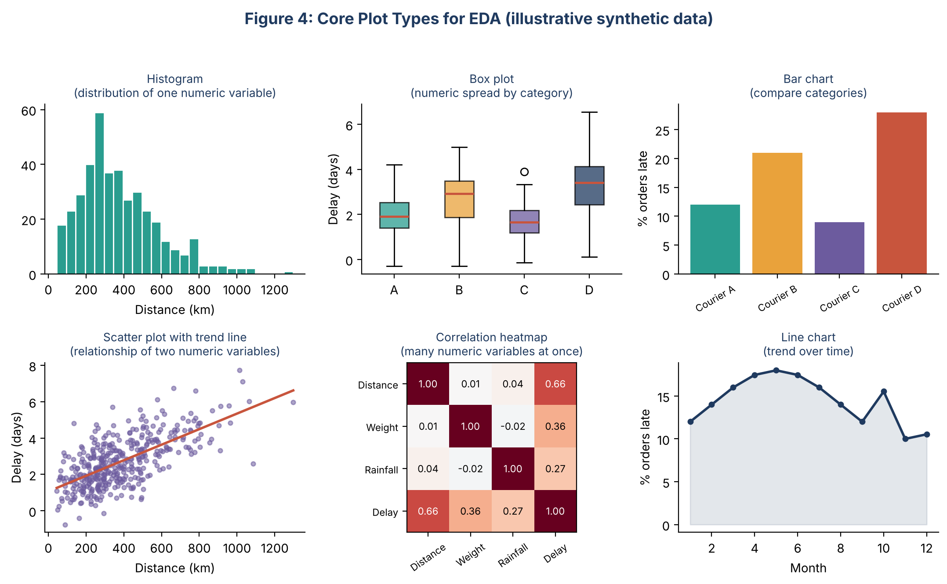
Figure 4: Core plot types for EDA (illustrative synthetic data)
Plot | Example question for the delivery project | Insight it could reveal
Histogram | How far do parcels travel, and how are delivery times distributed? | A right-skewed distribution suggesting a log transform
Box plot | How does delay differ across couriers? | One courier with a higher median and wider spread
Bar chart | What percentage of orders are late for each courier? | A ranking of weak and strong couriers
Scatter plot | Does delay grow with distance? | A positive, roughly linear trend with growing spread
Correlation heatmap | Which numeric features move together with delay? | Distance and weight are most associated; rainfall is weaker
Line chart | How does the late rate change month by month? | Seasonal peaks and a spike in sale months

6.4 Static versus Interactive Visuals
- Static (matplotlib, seaborn): used for the written report and slides, because they are reproducible, easy to export as PNG or SVG and consistent in print.
- Interactive (plotly): used during exploration and for optional dashboards, where hovering, zooming and filtering help to inspect individual points or large datasets.

6.5 Visual Style Standards
Element | Standard
Palette | One categorical palette of 5 to 6 colour-blind-safe colours; one sequential palette for magnitude; one diverging palette for correlations (centred on zero)
Fonts and sizes | One sans-serif font; title 13 to 14 pt, axis labels 10 to 11 pt, tick labels 9 pt
Figure size | About 10 x 5 inches for wide charts, 6 x 4 inches for single panels; saved at 200 dpi
Titles | Describe the finding, e.g. 'Courier D has the highest late rate (28%)'
Annotations | Highlight key points (thresholds, outlier fences, peaks) with a short text label
Source and notes | State the data source, time period and any filters below the chart
File naming | Numbered and descriptive, e.g. 04_late_rate_by_courier.png

7. Tools and Python Libraries
Library / tool | Role in EDA | Typical use
pandas | Core data handling | Loading data, inspection (info, describe), cleaning, groupby and pivot tables, merging, resampling time series
NumPy | Numerical computing | Fast array maths, percentiles, random sampling, log and other transforms
matplotlib | Base plotting library | Fully customised static charts, multi-panel figures, saving images
seaborn | Statistical visualisation | Distribution, relationship and categorical plots; heatmaps; pair plots; attractive defaults
plotly | Interactive charts | Hover, zoom and filter; maps; dashboards and shareable HTML charts
SciPy / statsmodels | Statistics | Normality tests, t-test, ANOVA, chi-square, correlation, Q-Q plots
scikit-learn | Preprocessing and light modelling | Imputers (SimpleImputer, KNNImputer), scalers, PCA, KMeans, IsolationForest
missingno | Missing-data visualisation | Matrix and bar views of missing values and their co-occurrence
ydata-profiling (optional) | Automated profile report | A quick first-pass HTML report to compare with the manual analysis
Jupyter Notebook / VS Code | Interactive environment | Combining code, charts and written notes in one document
Git | Version control | Tracking changes to notebooks and scripts

7.1 Reusable Starter Code
The following skeleton shows how the standard checks would be wrapped into a reusable function that can be run on any new dataset. It is a planning illustration, not output from a real dataset.
import pandas as pd
import numpy as np
import seaborn as sns
import matplotlib.pyplot as plt

def first_valid(s):
return s.dropna().iloc[0] if s.notna().any() else None

def quick_profile(df: pd.DataFrame) -> pd.DataFrame:
"""One-row-per-column summary used at the start of every EDA."""
return pd.DataFrame({
'dtype': df.dtypes.astype(str),
'missing_%': (df.isna().mean() * 100).round(2),
'unique': df.nunique(),
'example': df.apply(first_valid),
})

def iqr_outliers(s: pd.Series) -> pd.Series:
q1, q3 = s.quantile([0.25, 0.75])
iqr = q3 - q1
return (s < q1 - 1.5 * iqr) | (s > q3 + 1.5 * iqr)

def plot_numeric(df, col):
fig, ax = plt.subplots(1, 2, figsize=(10, 4))
sns.histplot(df[col], kde=True, ax=ax[0])
sns.boxplot(x=df[col], ax=ax[1])
fig.suptitle(f'Distribution of {col}')
fig.savefig(f'figures/{col}_distribution.png', dpi=200, bbox_inches='tight')

8. Documentation and Reporting Plan

8.1 Documenting During the Analysis
- Structured notebook: one Jupyter notebook per stage (01_load_inspect, 02_cleaning, 03_univariate, 04_bivariate, 05_multivariate), each starting with its purpose and ending with a short 'What I learned' note.
- Data dictionary: a table of every column with its meaning, type, unit, allowed values and source.
- Cleaning log: a running table recording each change, the reason, the number of rows affected and the date.
- Findings log: one row per insight with the evidence (chart file name), the implication and a follow-up action.
- Reproducibility: fixed random seeds, a requirements.txt file, raw data kept read-only, and notebooks that run top to bottom without manual steps.
- Version control: commit after each stage with a meaningful message.

# | Finding | Evidence | Implication / action | Confidence
F1 | Example: Late rate is highest for Courier D (28%) | 04_late_rate_by_courier.png | Include courier as a feature; review lane performance | High
F2 | Example: Delay rises with distance | 05_distance_vs_delay.png | Create distance and distance-band features | High
F3 | Example: Late rate spikes in festival months | 06_monthly_late_rate.png | Add festival-calendar features | Medium
Table: Template of the findings log (rows are examples of the format only).

8.2 From Analysis to Report
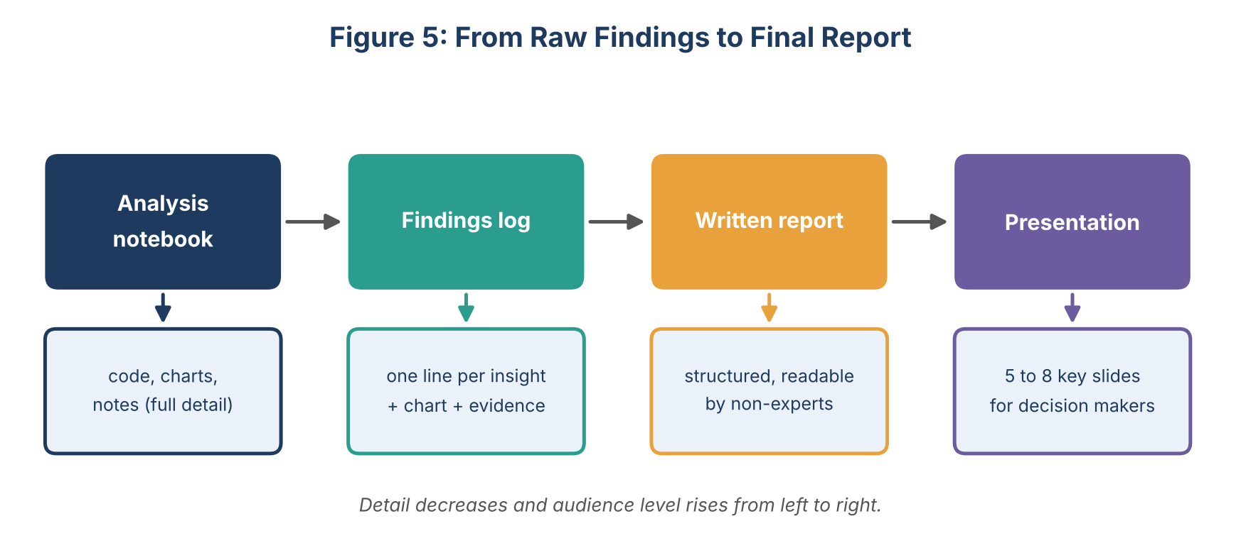
Figure 5: From raw findings to final report

8.3 Proposed Structure of the Final EDA Report
Section | Content | Typical length
1. Executive summary | Purpose, data used, 3 to 5 key findings and main recommendation | Half a page
2. Data description | Source, time period, size, data dictionary, known limitations | 1 page
3. Data quality and cleaning | Missing values, outliers, duplicates found; what was done and why | 1 to 2 pages
4. Univariate findings | Key distributions and notable single-variable observations | 1 to 2 pages
5. Relationships | Bivariate and multivariate results, strongest drivers of the target | 2 to 3 pages
6. Implications | What the findings mean for modelling and for the business; proposed features | 1 page
7. Limitations and next steps | Data gaps, assumptions, unanswered questions, recommended next analysis | Half a page
Appendix | Full cleaning log, data dictionary, additional charts, code references | As needed

8.4 Presentation Outline (5 to 8 slides)
- Title and objective: the question the analysis serves.
- Data overview: what data was used and how reliable it is.
- Data quality: the main problems found and how they were handled.
- Three to four key insights, each as one chart with a headline sentence.
- What this means: implications and recommended actions.
- Next steps and open questions.

8.5 Communicating to Different Audiences
- Technical team: full notebooks, methods, statistical details and code.
- Managers and business stakeholders: headline findings, simple charts, business impact, no jargon.
- Reviewers and tutors: clear logic from question to evidence to conclusion, with all decisions justified.

8.6 Final Review Checklist
- Does every chart have a title, labelled axes with units and a stated source?
- Is each claim backed by a chart or number, and do the numbers match the notebook?
- Are limitations and uncertainty stated honestly?
- Can another person re-run the analysis from the raw data and get the same results?
- Is the report understandable by someone who has not seen the data?

9. Timeline and Effort Estimate
The EDA work is planned at 33 hours, within the 30 to 35 hour guideline. The largest shares go to quality checks and relationship analysis, which usually reveal the most important insights.
Phase | Main activities | Hours
Planning and dataset checklist | Define questions, create data dictionary template, set up notebooks and folders | 3
Data loading and inspection | Load data, run first-look checklist, classify variable types | 3
Data quality audit and cleaning | Missing values, outliers, duplicates, type fixes, cleaning log | 6
Univariate analysis | Statistics and distribution plots for every variable | 4
Bivariate and multivariate analysis | Feature-versus-target analysis, correlations, pair plots, grouped summaries, tests | 6
Visualisation design and polish | Apply style standards, annotate, build interactive versions where useful | 4
Documentation and reporting | Findings log, written report, presentation slides | 5
Review and revision | Check numbers, wording, reproducibility and checklist | 2
Total |  | 33

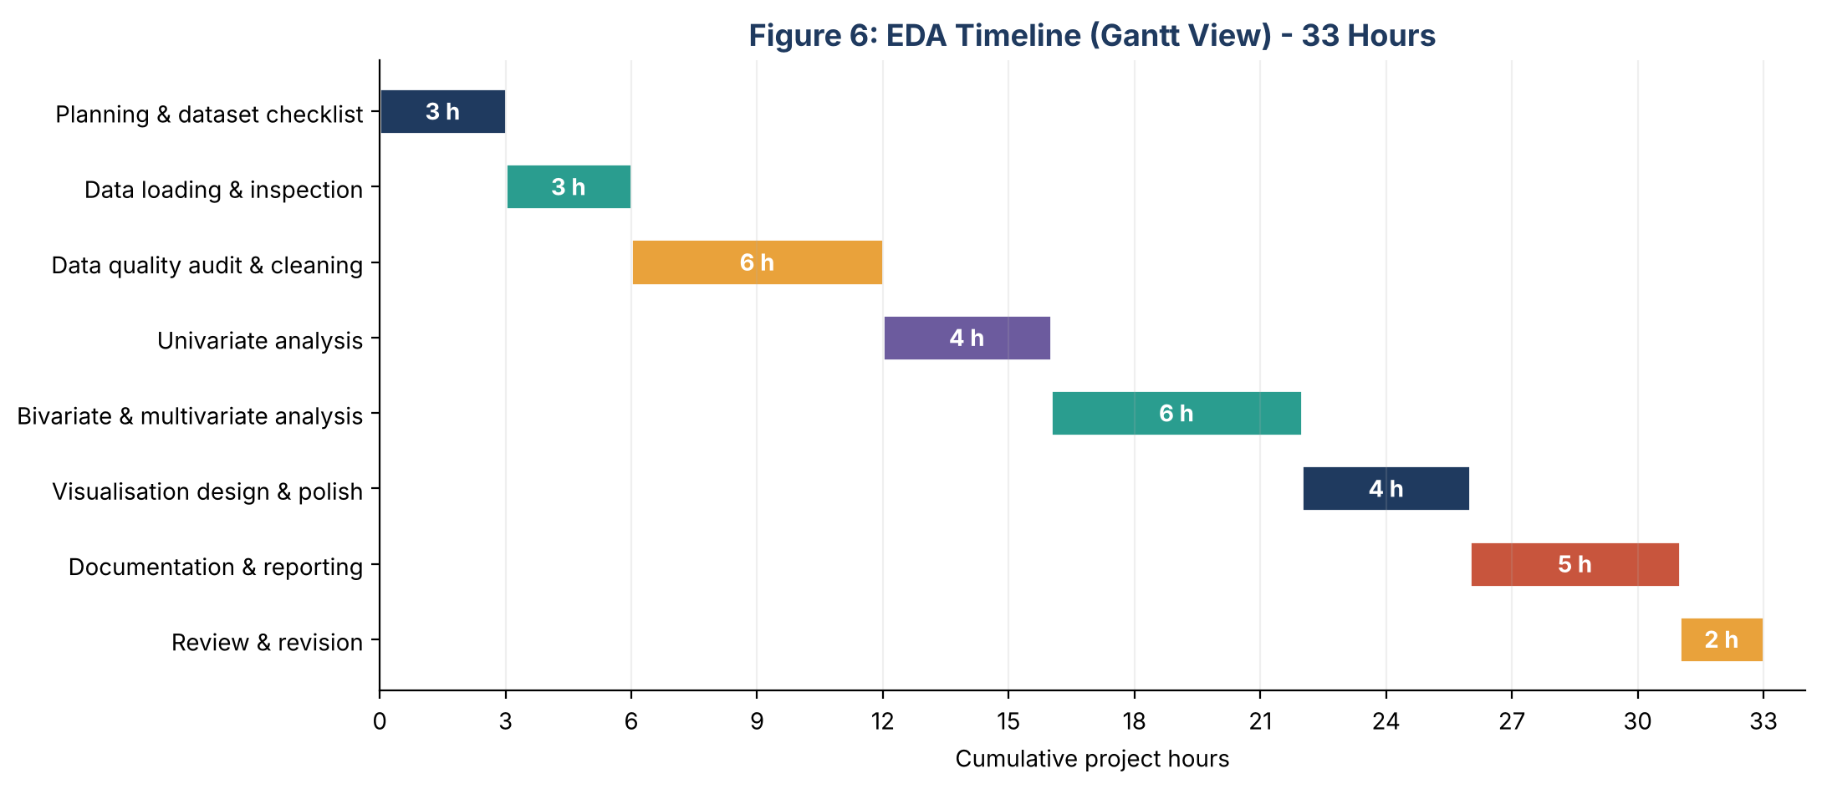
Figure 6: EDA timeline as a Gantt-style chart

10. Adapting the Framework to Other Datasets
The framework is deliberately generic. Only the emphasis changes with the type of data, as shown below.
Dataset type | Extra emphasis | Typical additions
Sales / retail transactions | Time trends, seasonality, category and region comparisons | Rolling averages, Pareto charts, basket analysis
Healthcare / patient records | Missing data, units and ranges, privacy, class imbalance | Clinical-range validity rules, survival-style time plots, careful handling of sensitive fields
Time series / sensor logs | Datetime index, gaps, trend, seasonality, stationarity | Resampling, decomposition, autocorrelation plots
Survey data | Ordinal scales, non-response, text answers | Likert-scale stacked bars, cross-tabs, word frequencies
Financial data | Skewed values, extreme events, currency and date alignment | Log scales, return distributions, outlier review with domain experts
Text-heavy data | Length, vocabulary, language, duplicates | Word-frequency bars, n-gram counts

11. Common Pitfalls and How to Avoid Them
Pitfall | Risk | How to avoid it
Skipping the data dictionary | Misreading what columns mean | Write or request definitions before analysis; confirm units
Treating all outliers as errors | Deleting real and important events | Investigate each type; keep a log; use capping or robust methods
Confusing correlation with causation | False business conclusions | Use careful wording ('is associated with'); look for confounders
Data leakage in exploration | Using information not available at prediction time | Mark the prediction moment; exclude later-stage columns from feature ideas
Over-plotting and cluttered charts | Hidden patterns, confused readers | Use transparency, sampling, hexbin or faceting
Misleading charts | Wrong impression (truncated axes, 3D, unequal scales) | Follow the design principles in Section 6.1
Fitting imputers on all data | Information leaking from the test set | Fit imputers and scalers on training data only, inside a pipeline
Undocumented decisions | Results that cannot be reproduced or defended | Cleaning log, findings log, version control
Analysis without a purpose | Endless, unfocused charts | Anchor the work to the project objectives and the target variable

12. Conclusion
This document sets out a complete and reusable framework for exploratory data analysis and visualisation. It explains how to classify data types, run a structured eight-step process, handle missing values and outliers, apply univariate, bivariate and multivariate techniques, choose appropriate plots, use the main Python libraries, and document and communicate results. Because the steps are tied to variable types and analytical questions rather than to a particular dataset, they can be applied to any tabular data. The framework prepares the ground for the practical data-handling work that follows, starting with the cleaning and exploration stages of the delivery-delay project.

