This is a Python program that shows how to create an API using FASTAPI framework that serves trades from a mocked database

I have used an example data that contains the following entities:

1. Id
2. Counterparty
3. InstrumentId
4. InstrumentName
5. Trader
6. AssetClass
7. Price
8. TradeType
9. Date

I have taken various number of fields so as to understand various functionalities and various methods that can be used

The job was to retrieve all the trades, or trades by ID or custom filtered trades if necessary.

The first function “get_trades” lets you get the trades that have been included in the database

The same function is also used to get filtered trades, which have been filtered according to following: assetClass, startDate, EndDate, maxPrice, minPrice, tradeDate, tradeType

The next function “get_trades_id” however, is used to retrieve the trades according to their Id

This is a mocked database. It is a stationary database, i.e it doesn’t have any notable functionalities or can work on a server so this is called a RESTAPI.

Its is a FASTAPI application so it can run using the below commad

uvicorn main:fsapi –reload

The trades data will be visible on <http://127.0.0.1:8000/trades>, after running the commad

If you want to view a particular trade based on the id it will be visible on [http://127.0.0.1:8000/trades/[trades_id](http://127.0.0.1:8000/trades/%5btrades_id)]

If you want to view a filtered trade, it will be viewable on <http://127.0.0.1:8000/trades?’filtering>’

Example <http://127.0.0.1:8000/trades?tradeType=Buy&maxPrice=7000.0>

**OUTPUT:**

Command Prompt Output

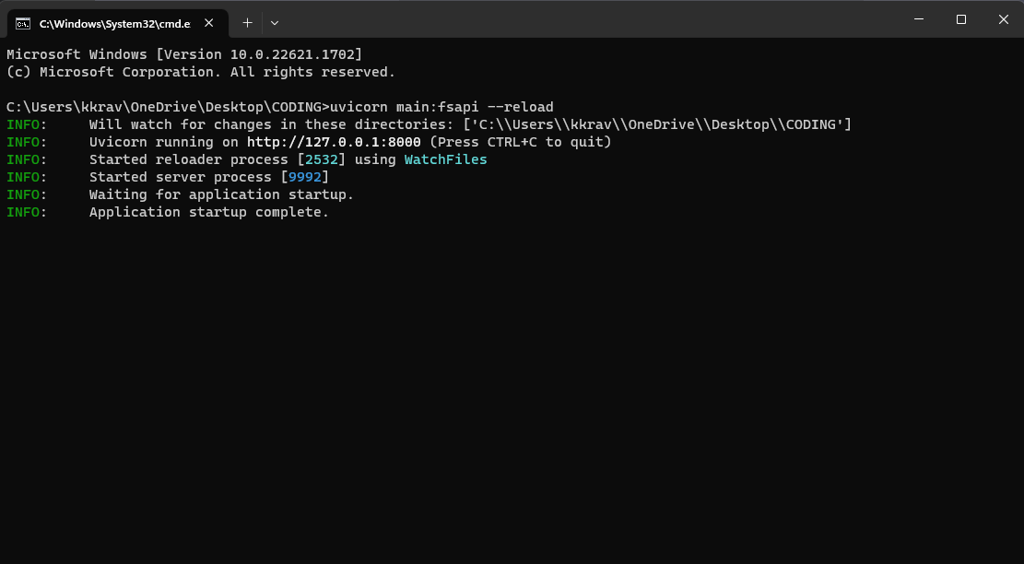

Overall Trades

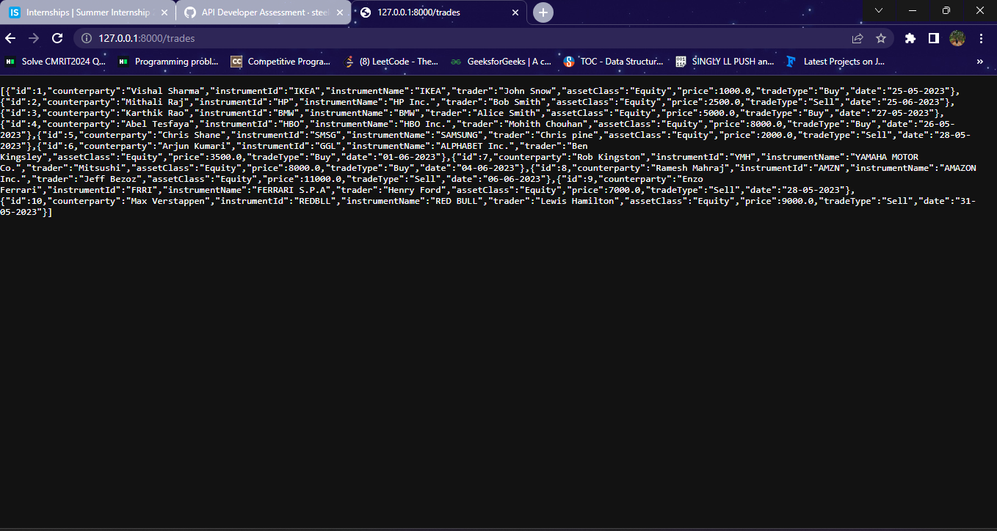

Trades by Id

