Game Design Document

Fill up the Following document

1. Write the title of your project.

METEOR JUMP

1. What is the goal of the game?

THE GOAL OF THE GAME IS TO DESTROY ALL METEORS AND REACH THE FINISHING LINE

1. Write a brief story of your game?

Jack is a space runner and has entered a asteroid belt and goal is to help him to get out of here and reach safely out.

1. Which are the playing characters of this game?

* Playing characters are the ones which respond to the user based on the input from the user
* Cars, monkeys, dinos, wizards etc, are the playing characters in the game.

|  |  |  |
| --- | --- | --- |
| Number | Character Name | What can this character do? |
| 1 | Space ship | Fly, move, shoot |
| 2 | laser | Destroy meteor and move forward |
| 3 |  |  |
| 4 |  |  |
| 5 |  |  |
| 6 |  |  |
| 7 |  |  |
| 8 |  |  |

1. Which are the Non Playing Characters of this game?

* Non Playing characters are the ones which don't have an action or a behaviour when the user interacts with the game.
* Hurdles, stones, bananas, coins, etc are non playing characters in the game.

|  |  |  |
| --- | --- | --- |
| Number | Character Name | What can this character do? |
| 1 | meteor | Destroy space craft and move |
| 2 |  |  |
| 3 |  |  |
| 4 |  |  |
| 5 |  |  |
| 6 |  |  |
| 7 |  |  |
| 8 |  |  |

Draw your imagination of this game. What does this game look like?

* Draw the game either on your computer or on paper,
* Add images of scenes of the game to show each of the playing and non-playing characters at least once.

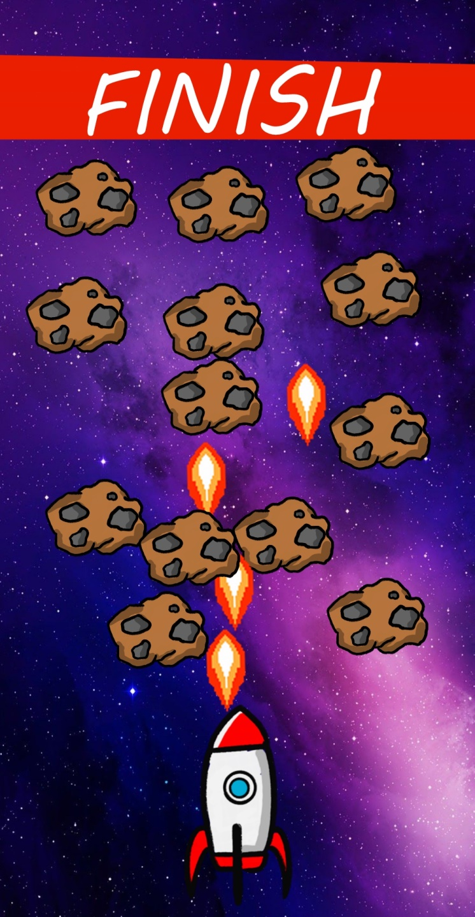

How do you plan to make your game engaging?

Meteor can kill the destroy space ship if touched and player can overcome them by destroying him and reaching the finishing line.