##### ****BEHAVIOURAL DESIGN:****

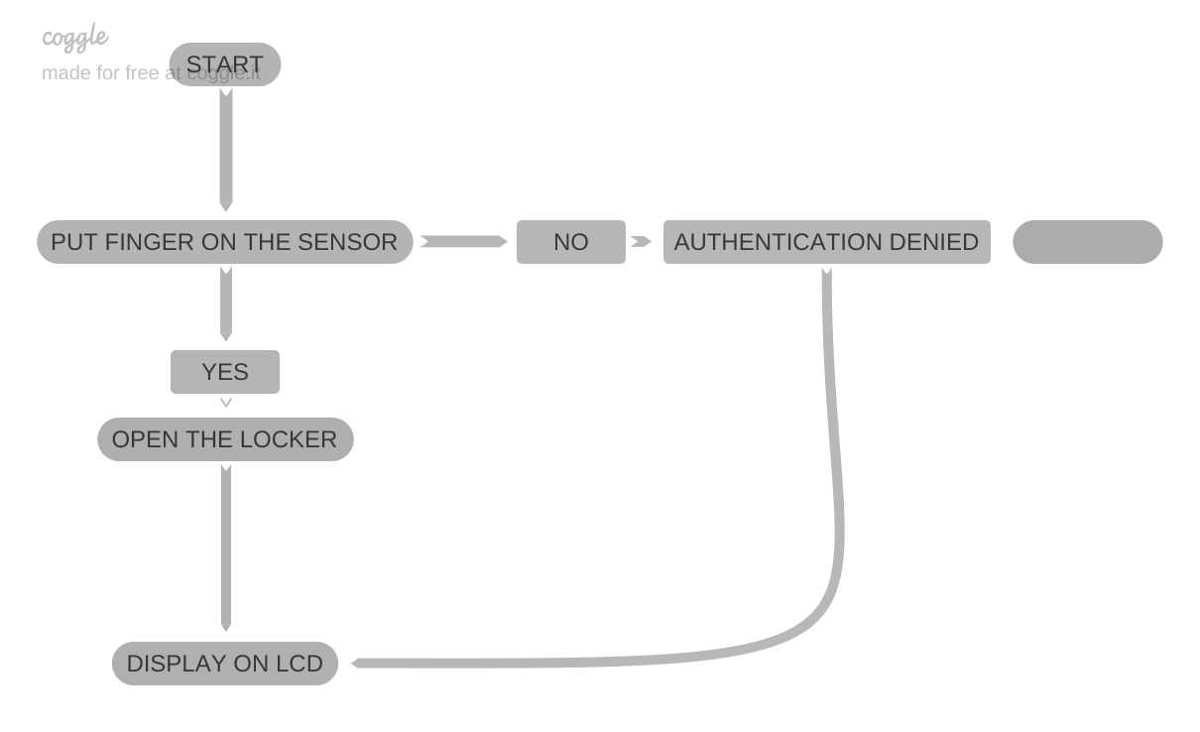

##### ****BLOCK/STRUCTURAL DESIGN:****

