CHNDHURAN

College of Engineering and Technology

Naan Mudhalvan Project

Brand Name : VJ Restaurant

Category : Healthy Food Restaurant

Team Leader : SANGEETHA K

Team Members: ANITHA PL

DINESH V

SELVAM S

|  |
| --- |
| **Creating A Google Business Profile** |

Projects Link:  **<https://www.google.com/search?q=VJ+Restaurant&stick=H4sIAAAAAAAA_-NgU1I1qDBOMjCwTEoyMzY2NjKwNDe1AgoZW1pYGhgbJptYGKempKUsYuUN81IISi0uSSwtSswrAQBPu2MTOQAAAA&hl=en&mat=CSvrZgCEdF_bElYBl7_Ll_L9Wcc7wdrzscURWnvPO3zamxkgBhCa61v7r5Q5eNC2fchab2-u6FESC7M9XoFF_ACD1j8>**

Step:1Business Name

**VJ Restaurant**, where culinary artistry meets warmth and flavor. Our eclectic menu offers a delectable fusion of global cuisines, served with a side of hospitality that feels like home. Join us for a gastronomic journey you won't soon forget.

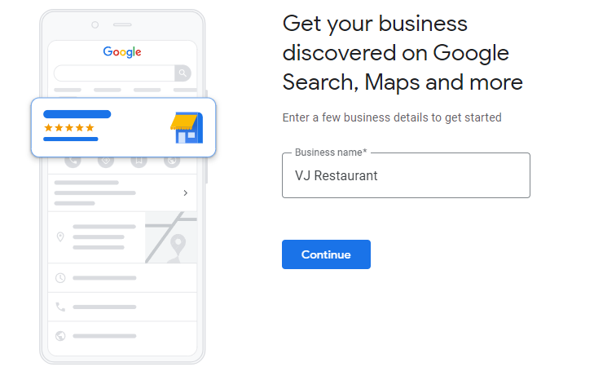

Step:2 Business Type

A cozy local gem serving delectable, home-style cuisine. Our diverse menu features classic dishes and daily specials, prepared with love. Visit us for a memorable dining experience

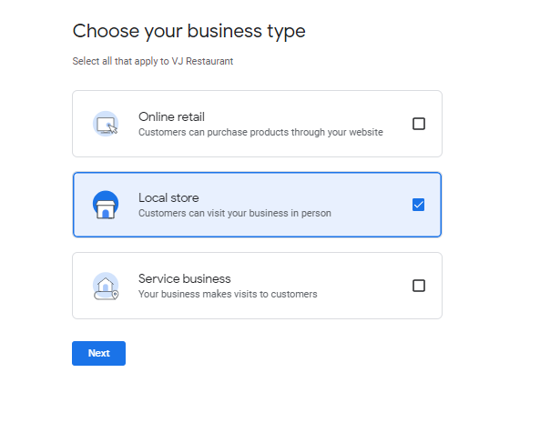

Step:3 Business Category

VJ Restaurant is your go-to Healthy Home Restaurant, where we blend wholesome ingredients and culinary creativity to serve up delectable, nutrition-packed dishes. We're dedicated to nourishing your body and delighting your taste buds, all in the comfort of your own home

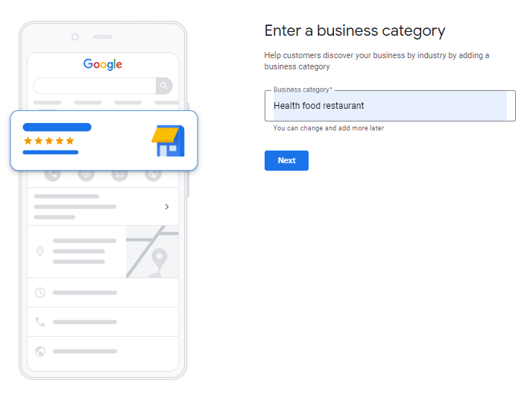

Step:4 Business Address

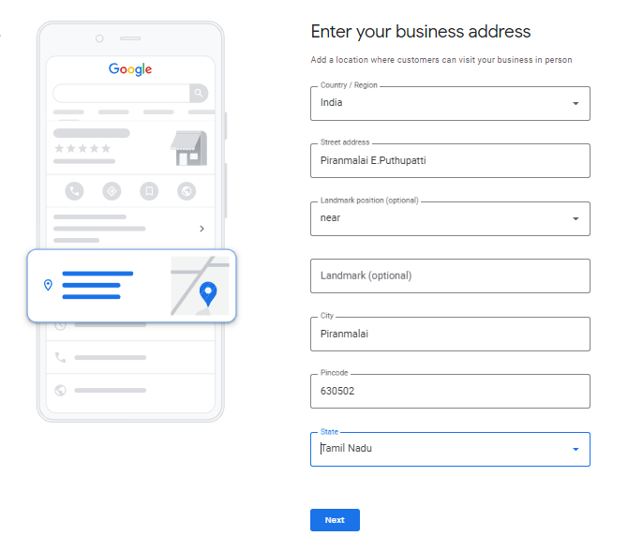

Step:5 Contact Details

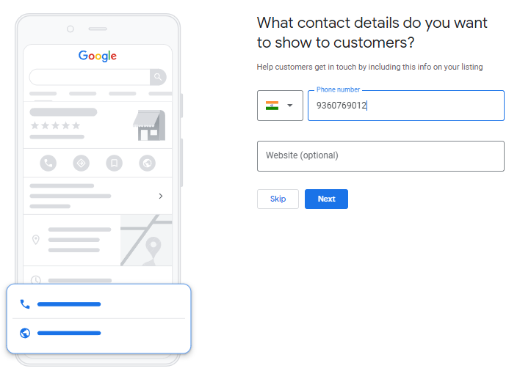

Step:6 Location

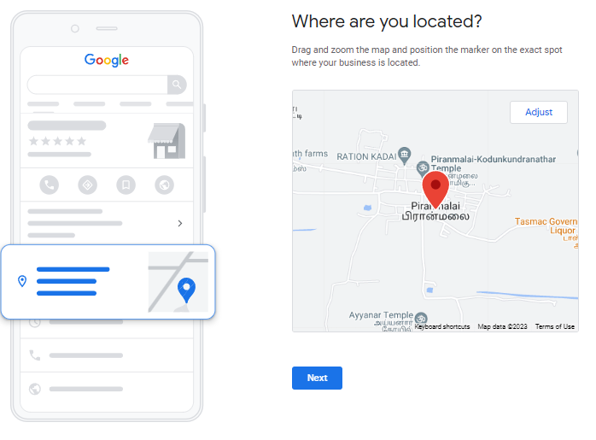

Step:7 Verification

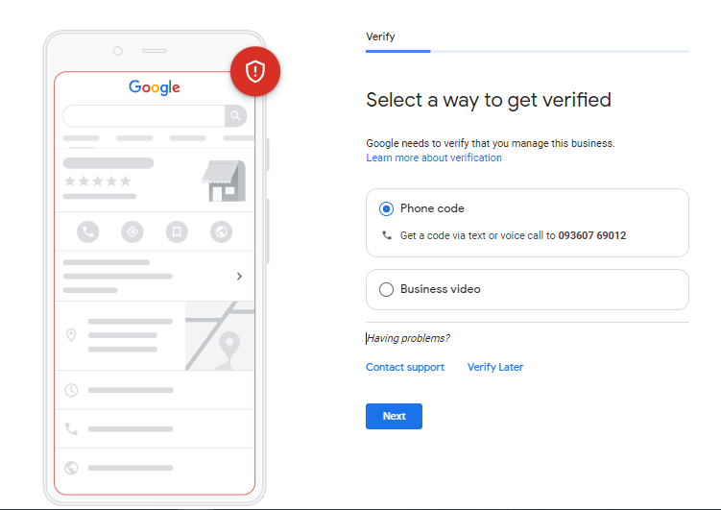

Step:8 Business Hours

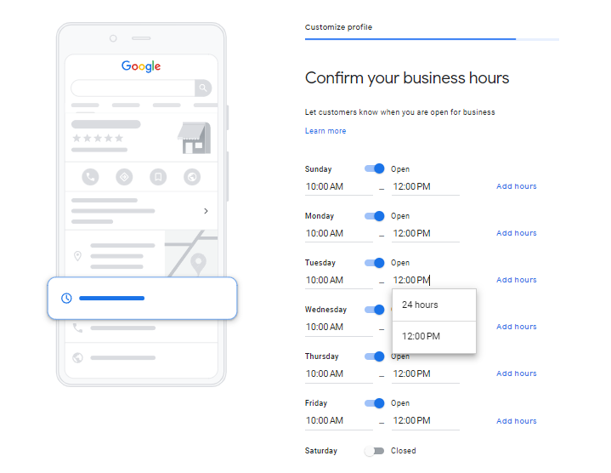

Step:9 Business Description

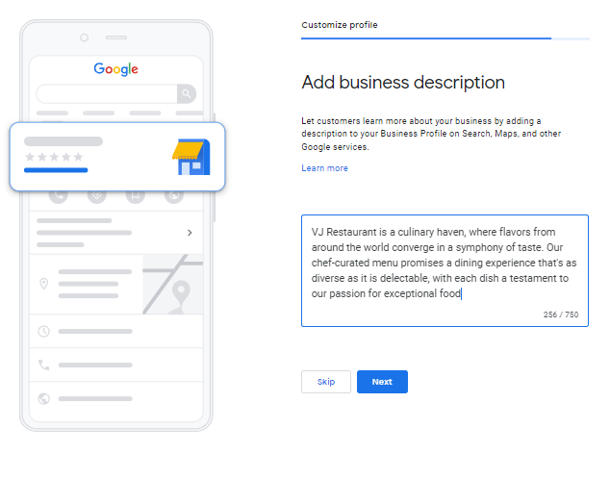

Step:10 Upload Photos

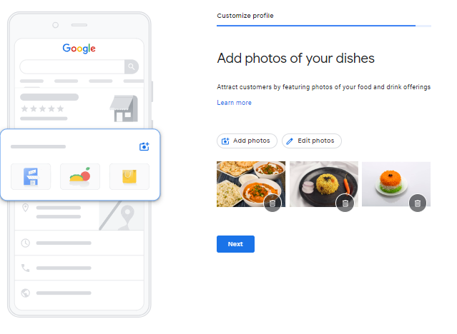

Step:11 Claim Your Business



Step:12 Visibility

Click “Edit Profile , Read Reviews ,Performance , Edit Menu ”

