|  |
| --- |
| **PROJECT REPORT** |

1. **INTRODUCTION:**
   1. Overview:

A Google Business Profile (formerly known as Google My Business) is a powerful tool that allows businesses to establish a prominent online presence. It provides an overview of a business's information, making it readily available to potential customers when they perform relevant searches on Google Search and Google Maps.

* 1. Purpose:

The primary purpose of a Google Business Profile account is to enhance a business's online visibility and accessibility to potential customers. It serves as a digital store front where businesses can provide essential information such as their name, address, phone number, and hours of operation.

1. **PROBLEM DEFINITION & DESIGN THINKING:**
   1. Emphathy Map:

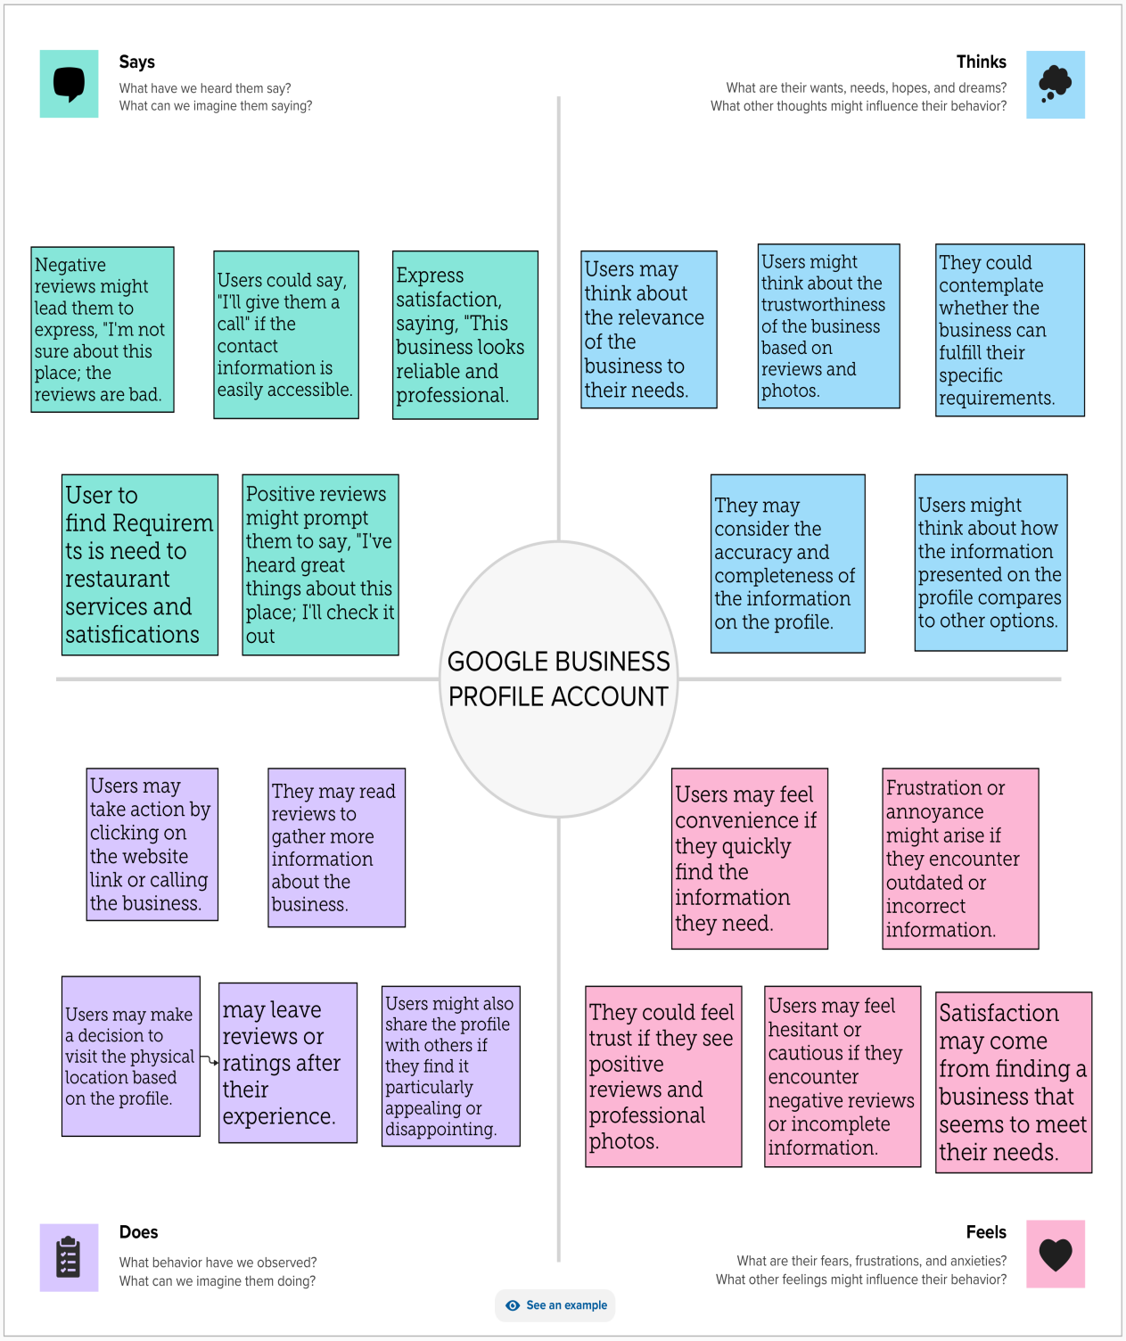

* 1. Ideation & Brainstorming Map:

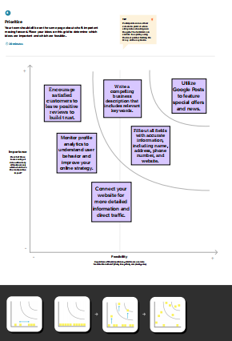

1. **RESULT:**

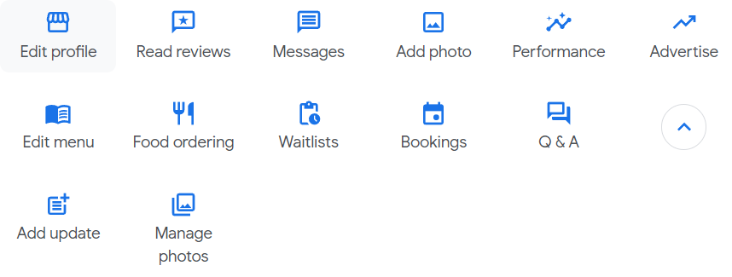

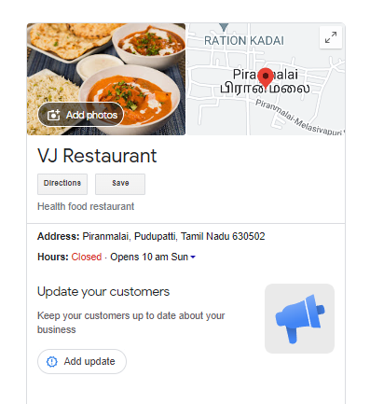

1. **ADVANTAGES & DISADVANTAGES:**

ADVANTAGES:

**Enhanced Visibility**: Boosts local search rankings, ensuring customers find your business easily.

**Customer Trust**: Reviews and accurate info build credibility, influencing customer choices and trust.

DISADVANTAGES:

**Risk of Misinformation**: Inaccurate or outdated information may harm your business reputation and customer trust.

**Negative Reviews Impact:** Negative reviews can harm your reputation; managing them effectively is crucial to mitigate damage.

1. **APPLICATIONS:**

**Local SEO:** Enhances local search visibility, helping potential customers discover your business more easily.

**Customer Engagement:** Allows for direct interaction with customers through reviews, posts, and messages, fostering relationships.

1. **CONCLUSION:**

Google Business Profile is a powerful tool that provides businesses with the means to enhance their online presence, engage with customers, and gain valuable insights. By maintaining an accurate and appealing profile, businesses can increase their visibility, build trust, and leverage data-driven decisions to succeed in the digital age.