DEVELOPER(S) CONTRIBUTION | TASK 1

Log Task 1: Developer Feature Plan and Story Splitting
KV6014 Challenge 5 | Group 6 | ROSE-Pulse community event management system | 12 October 2026
STATUS Developer contribution for insertion into the team Log Task. Source-based screenshots and tested demo behavior are separated from proposed production work.

1. Problem and intended development outcome
ROSE supports cervical cancer screening activities for women in Malaysian B40 communities. Limited medical staff and screening supplies mean attendance must be balanced against each event's safe capacity. Promotion often relies on community leaders, WhatsApp messages and printed flyers. The organisation cannot consistently measure outreach activity or predict the final number of attendees. Some participants have limited digital access or network connectivity. [S1, S2]
DEVELOPER OBJECTIVE Build a lightweight, mobile-first workflow that connects promotion, controlled registration, attendance and operational reporting. A booking must never be shown as confirmed until an authorised server has accepted it.

2. Pain points, requirements and success criteria
Challenge | Functional response | Acceptance target
Overcrowding or unused capacity | Event time slots, total capacity, public and leader quota pools, waitlist and cancellation. | For each slot, server-confirmed bookings never exceed capacity; cancellation does not free more than one place.
Unclear outreach results | Unique leader referral attribution, printed flyer reporting and an operations dashboard. | Display self-reported activity separately from link clicks, registrations and actual attendance.
Low digital confidence | Mobile guest registration without a participant account; leader-assisted proxy registration. | A new participant can request a place with the minimum approved fields and receive an accessible status.
Unstable internet at the venue | Offline-safe check-in queue with pending, synced, failed and conflict states. | Staff can retain approved pending records safely and reconcile once online; no false success display.
Participant privacy and field permissions | Restricted staff access, verified self-service capabilities and data minimisation. | A public visitor cannot obtain another participant's private record or perform staff actions.

3. Proposed user journey
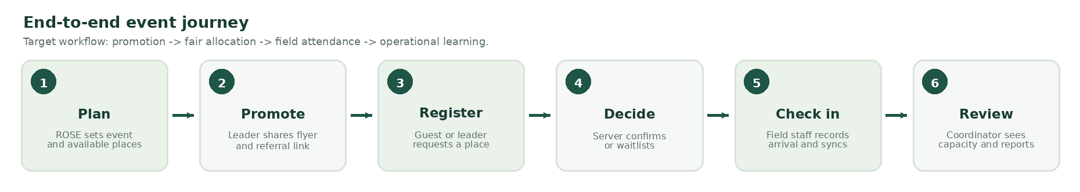
Figure 1. Proposed ROSE service journey. Server validation and offline reconciliation remain integration work.
The system supports four roles: (1) ROSE Coordinator, (2) Community Leader, (3) Participant, and (4) Field Staff. Each role performs a small set of actions instead of navigating a general-purpose ticketing system. The participant and proxy flows converge on the same authoritative registration service.

4. Functional scope mapped to ten user stories
Story | Role / intended capability | Current evidence (12 Oct 2026)
US01 | Coordinator creates events and time slots; enforces quota and waitlist. | Partial local demo: one session and quota states; no verified backend transaction.
US02 | Coordinator gives each leader a unique referral URL and QR code. | Not implemented; the current link is an example / demo value.
US03 | Coordinator reviews registrations, outreach and attendance. | Partial aggregate mock; conversion attribution and live reporting absent.
US04 | Leader shares accessible WhatsApp text and printable flyer. | Partial demo; usable message/print concept, no production referral QR.
US05 | Leader reports flyer distribution and offline promotional activity. | Partial self-reported demo; server data model and role verification pending.
US06 | Leader registers participants from a reserved community quota. | Partial single-leader mock; authentication and multi-leader rules pending.
US07 | Participant requests a place without creating an account. | Partial mobile demo with synthetic sample identities; real verification pending.
US08 | Participant receives SMS reminder and can cancel. | Cancellation demo; SMS provider, secure token and delivery audit absent.
US09 | Field Staff checks in participants under weak connectivity. | Partial local queue and manual search; no QR, true offline PWA or server sync.
US10 | Field Staff manages no-shows and walk-ins safely. | Blocked pending approved expiry and release policy.

5. Story splitting: small development tasks
Each user story is split into UI tasks, service/data tasks and observable acceptance tests. Proposed behaviors are not represented as completed production features.

5.1 Event control and outreach (US01 to US05)
Story | Implementation slices | Check before closure
US01 | 1. Event create/edit view.  2. Time-slot and quota data model.  3. Waitlist transition rules.  4. Transaction-safe capacity and cancellation tests. | Server authority, approval of FIFO/pool policy, multi-user final-seat race.
US02 | 1. Leader ID and referral schema.  2. Signed/unguessable leader link and QR.  3. Store attributed registrations.  4. Prevent link spoofing in reports. | PM approval of metrics and referral attribution model.
US03 | 1. Capacity/attendance counters.  2. Register/cancel/check-in updates.  3. Outreach activity and conversion definitions.  4. Filter and permission checks. | Numbers trace to server records; flyer counts must not be labelled confirmed reach.
US04 | 1. Plain-language message template.  2. Insert event/date/leader link.  3. Copy and print/export.  4. Test low-end mobile layout. | Accessible sharing and valid per-leader referral URL.
US05 | 1. Short outreach form.  2. Source/channel/date metadata.  3. Save report with operation ID.  4. Display self-reported figures. | Approved schema, permissions and duplicate submit handling.

5.2 Registration, attendance and messaging (US06 to US10)
Story | Implementation slices | Check before closure
US06 | 1. Staff/leader sign-in boundary.  2. Select reserved leader pool.  3. Proxy registration form.  4. Repeat form safely for next person. | Leader cannot use another leader's quota; overbooking fails safely.
US07 | 1. Minimal guest form.  2. Validation + consent.  3. Request with stable operation key.  4. Display confirmed/waiting/unknown receipt. | No account requirement; privacy-safe lookup and server duplicate prevention.
US08 | 1. Cancellation confirmation.  2. Scoped secure cancellation token.  3. Server status transition and waitlist promotion.  4. SMS schedule and delivery states. | Repeat cancellation releases exactly one slot; reminder is not claimed delivered without provider proof.
US09 | 1. Secure read-only roster cache.  2. Manual/QR lookup.  3. Durable pending check-in queue.  4. Online reconciliation and conflict UI. | Restart persistence, two devices, stale roster, permission and duplicate sync tests.
US10 | 1. Agree no-show grace period.  2. Compute release eligibility on server.  3. Authorise walk-in record.  4. Update remaining capacity atomically. | Do not enable automatic release without PM-approved policy and real transaction tests.

6. Proposed delivery increments and dependencies
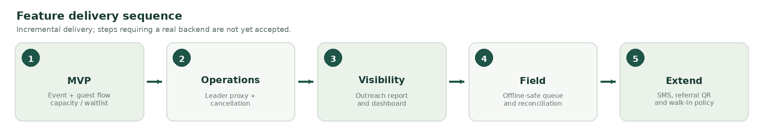
Figure 2. Increment-based development plan; actual order depends on backend contract availability and team decisions.
Increment | Deliverable / demo | Dependencies
0: Baseline | Existing four-role synthetic frontend, local tests, controlled source documents. | Prototype proof only; not a live system.
1: Essential bookings | Real event, guest request, quota decision, waitlist and cancellation in DB. | Backend build/run, request-response contract, transaction tests.
2: Community coordination | Leader proxy, printable messages, referral attribution, outreach report, coordinator summary. | Staff identity, referral schema, data permissions.
3: Field operations | Scoped roster, check-in, offline queue, sync, conflict and restart persistence. | Roster revision, durable local store, authenticated sync and field QA.
4: Policy-led features | SMS reminders, no-show release, walk-ins, optional multilingual content. | Budget, SMS provider, consent, PM policy and user testing.

7. Frontend visual evidence and planned improvements
The unchanged NU ROSE_DEMO_English_v1.2.1.html source was executed in sandboxed Chromium using page.set_content. Twelve targeted UI checks passed: role switching, synthetic booking/waitlist, leader proxy/outreach, quota rejection, pending check-in, manual demo sync, cancellation and blocked walk-ins. Captures use in-memory demo state; no storage fixture, live backend or real offline synchronization was used. [S4]
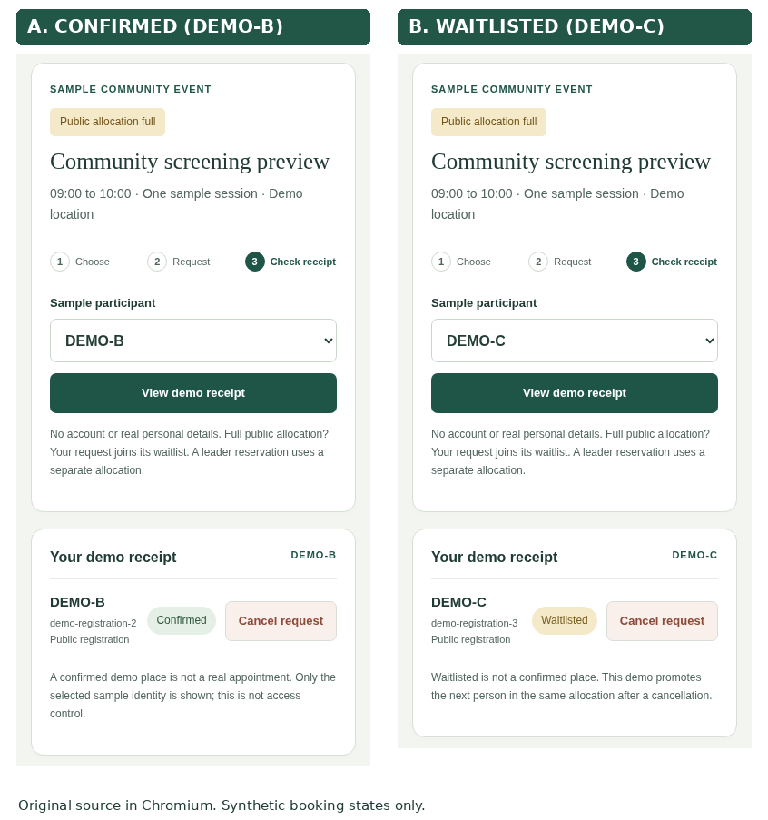
Figure 3. Actual Participant screen captures: DEMO-B confirmed and DEMO-C waitlisted. Screenshots cropped from the unchanged standalone NU v1.2.1 frontend in Chromium, 390px viewport.
These different receipt states show the intent of US07 and the local waitlist part of US01, but they do not represent live reservations.
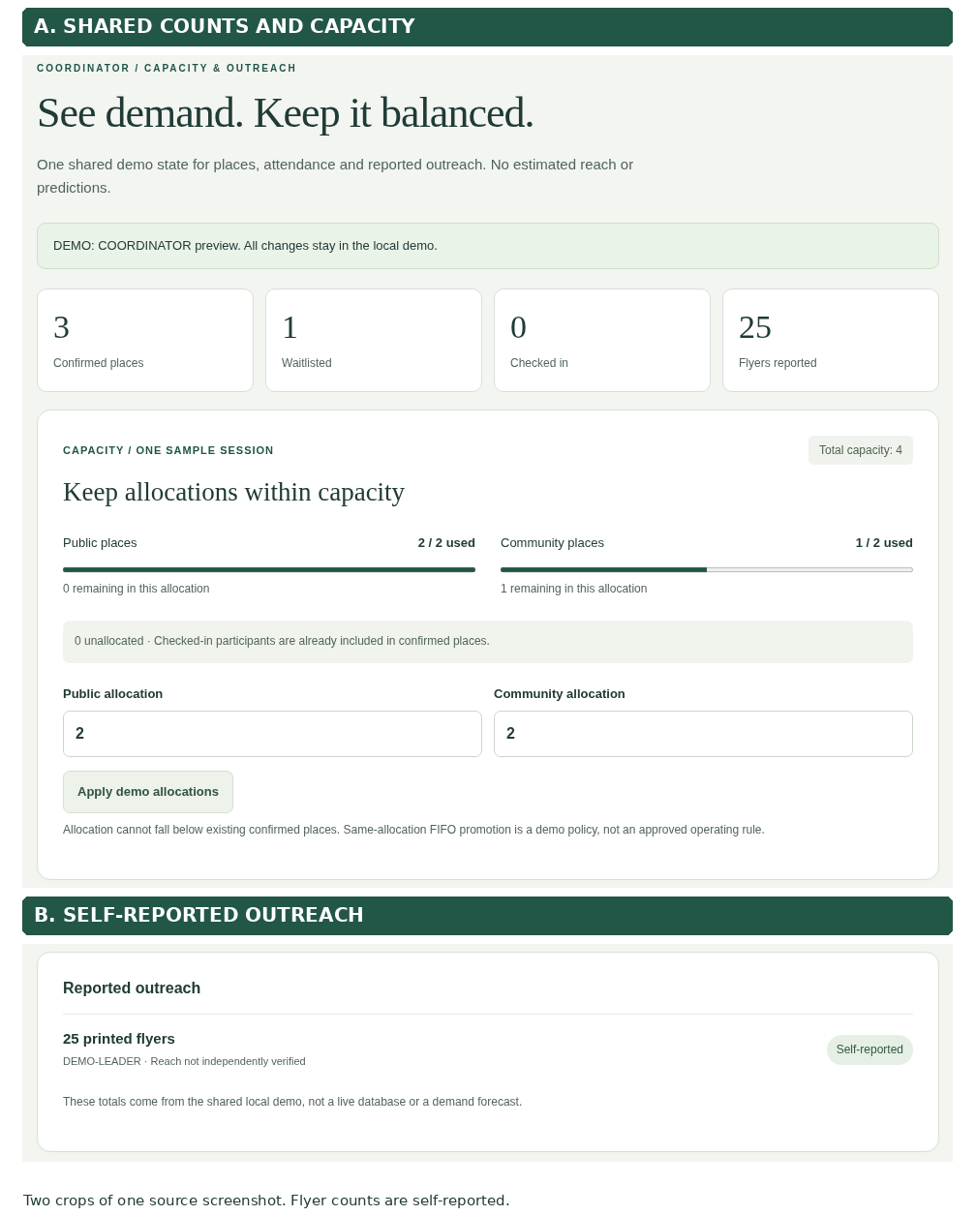
Figure 4. Actual Coordinator screen capture, showing mock capacity and self-reported outreach. Two regions of the same 1440px screenshot were cropped and stacked; no UI values were changed.
Participant interaction emphasizes a short request/receipt sequence. The Coordinator view separates capacity, registration and self-reported outreach. Next development work is real guest verification, backend quota authority and live attribution.

8. Acceptance criteria and handoff checklist
Area | Acceptance evidence before claiming completion
Requirements | Every feature maps to US01 to US10; PM confirms fields, data permissions, waitlist and walk-in policies.
UI and accessibility | Mobile 320/390px and desktop viewports, keyboard focus, clear empty/full/failed/pending states, human user review.
Integration | Actual API and DB response recorded; registration persists across refresh/restart; IDs and statuses follow agreed schemas.
Safety and offline | One final place cannot be confirmed twice; duplicate request is idempotent; offline sync conflicts remain visible.
Collaboration | Backend branch SHA, API schema and seeded examples shared with frontend; designer and security review the relevant changes.
Submission | Developer section replaces the obsolete AI recommendation feature block in Log Task 1; PM receives the updated document for team ZIP assembly.

SCOPE AND EVIDENCE As at 12 October 2026, the NU v1.2.1 candidate reports 56/56 Node, 65/65 Python and 78/78 injected DOM checks. These are local mock/isolated tests, not live API, real offline persistence, actual SMS or production acceptance. [S4]

9. Internal evidence used
- [S1] NU imported SharePoint: Client_Requirement_Notes / Overview on the Challenge 5.docx (problem statement).
- [S2] NU imported SharePoint: Role_Deliverables / PM / User Stories / User Stories & Mapping.docx (US01 to US10).
- [S3] NU imported SharePoint: Role_Deliverables / DEVELOPER / Features Review.docx (proposed feature breakdown and unresolved choices).
- [S4] NU_Feature_Coverage_v1.2.1.md and NU_Verification_v1.2.1.json (TASK-005, historical test summary). New visual proof: NU_v1.2.1_Browser_Capture_Evidence.json, six source screenshots and crop_provenance.json, under docs/dev/evidence/LOG_DOCX_20261012. Source SHA256: 3949160d0317c2b32ceadb00adca263db507f55c5577cb7ed4aa05e48cd8292e.
- [S5] NU/grp_c5/00_Dev_Workspace/docs/api/INTEGRATION.md and docs/dev/DEV_FLOW.md. CURRENT.md is the older v1.2.0 workspace record; the supplementary v1.2.1 candidate evidence is listed separately in S4.
- [S6] NU imported SharePoint: Admin_and_Log_Tasks / Log Task 1 26_27_GP 6.docx (coursework deliverable requirement).

