DEVELOPER(S) CONTRIBUTION | TASK 2

Log Task 2: Developer Technical Specification and Competitor Differentiation
KV6014 Challenge 5 | Group 6 | ROSE-Pulse community event management system | 12 October 2026
STATUS Developer contribution for insertion into the team Log Task. Source-based screenshots and tested demo behavior are separated from proposed production work.

1. Technical objective and design constraints
ROSE-Pulse is a proposed lightweight platform to coordinate free screening events in low-resource Malaysian communities. It should support capacity-safe booking, community leader outreach and proxy registration, and reliable field operations when the network is unstable. The technical objective is to connect those responsibilities through a small, testable system with the backend as the source of truth for capacity and registration status. [S1, S2]
IMPLEMENTATION BOUNDARY The available NU frontend is a tested synthetic prototype, not an authenticated production app. Austin supplied 15 implementation/API claims, representing 11 distinct HTTP method/path pairs; schemas, deployed service, database and live integration are not yet verified. [S4, S5]

2. Technology decisions and alternatives
Layer | Current evidence | Proposed choice / decision rationale
Frontend UI | HTML, CSS and JavaScript in a standalone local mock; four role views. | Reuse the team repository framework after inspection. A mobile-first web/PWA approach is a candidate, not a final stack selection.
API boundary | Mock service and separate guarded HTTP adapter scaffold. | Service interface maps domain operations into real requests once backend contract, authentication and errors are accepted.
Offline client | Simulated local pending/retry/conflict flow; no real cross-device reconciliation. | Service Worker for offline shell and IndexedDB for durable approved local operations, subject to browser/security tests.
Backend | Austin reported several operations but the repository and running server were not verified in this review. | Keep existing usable backend and database; require server-side capacity transactions, unique constraints and idempotency.
Authentication | Prototype role switch is only a demonstration and does not protect APIs. | Authorised Coordinator, Leader and Field Staff identity; guest-facing short-lived capability for private self-service.
SMS / messaging | No real SMS delivery or provider configuration. | Provider integration only after cost, consent, template, scheduler, time-zone and delivery-audit decisions.
Testing | NU v1.2.1 candidate: 56/56 Node, 65/65 Python, 78/78 injected DOM; no backend E2E. | Add real request/response contract, DB persistence, load/concurrency, offline restart and device acceptance.

3. Proposed technical architecture
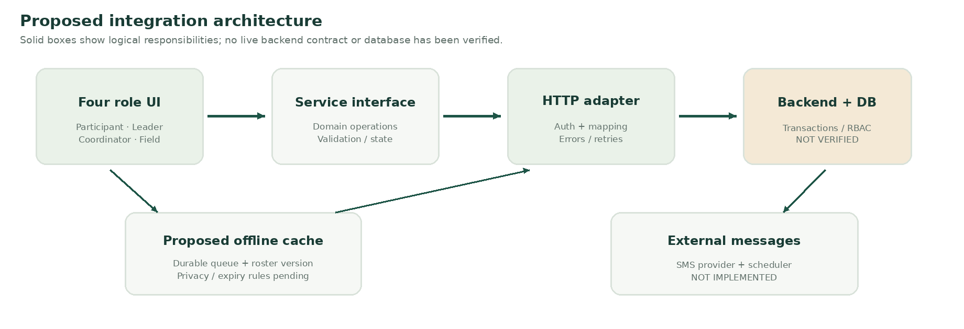
Figure 1. Proposed component diagram. The adapter and offline store are explicit boundaries; live backend and messaging remain unverified.
The frontend renders domain states and asks a service layer to perform operations. In mock mode, the service uses synthetic fixtures. In live mode, a dedicated adapter must translate identifiers, request shapes and error responses from the verified backend. A successful UI click is never treated as database proof.

4. Domain model and essential invariants
Concept | Core fields / purpose | Rule or invariant
Event / TimeSlot | Public event ID, location, local time zone, slot ID, status, total capacity. | No registration confirmed for a cancelled event; dates use an agreed time-zone representation.
QuotaPool | Slot ID, public / leader pool, allocation and usage. | Sum of allocated pools never exceeds total slot capacity.
Registration | Opaque registration ID, slot, pool, status, minimal participant identity. | Confirmed count cannot exceed server capacity; guests cannot read others' records.
Referral / Outreach | Leader ID, source, link token, reported flyer count and channel. | Self-reported reach is not the same as clicks, registrations or attendance.
CheckInOperation | Operation ID, registration ID, device, roster revision, client status. | Retry cannot duplicate attendance; conflict is visible, not silently overwritten.
Idempotency record | Stable request key, payload fingerprint, server result. | Same operation never produces a second side-effect; same key with changed payload is rejected.

5. Known API handoff and integration gaps
The following paths are transcribed from Austin's reported handoff. They are not certified, tested or necessarily present in the actual backend. Do not build a live client against them without verifying the source branch and request/response contract. [S5]
Reported endpoint / operation | Intended frontend use | What must be confirmed
POST /users; POST /auth/login | Provision/login for staff and leaders; NOT guest signup. | Role and session model, credentials, lifecycle, who may register.
GET /users/{id}; PUT /users/{id} | View or update an authorised account. | Object ownership, permissions, full vs partial PUT, errors.
POST /events | Coordinator creates an event. | Time slots, allocations, schema, uniqueness and returned identifiers.
GET /events/{public_id} | Get public event details and capacity display. | Public-safe response, caching and ID mapping.
POST /register | Create a registration or waitlist request. | Server transaction, pool, confirmed/waiting/rejected statuses, operation key.
GET /register/{id} | Read a registration result or receipt. | Opaque secure guest capability; no guessable ID authorisation.
PUT /register/{id} | Cancel or transition registration status. | Allowed actors, atomic waitlist promotion, repeated cancellation handling.
POST /api/v1/events/{eventId}/brochures/generations | Optional brochure generator claim. | Prioritisation, upload/job response, provider isolation; not essential MVP.
GET /api/v1/events/{eventId}/registration-form | Optional application form retrieval. | JSON vs file/HTML response, access role and encoding.
No supplied concrete route | Referral analytics, outreach, staff roster, check-in sync, walk-ins, SMS trigger. | Back-end owner must identify real routes or approve additional contract; do not invent paths.

6. Request / response contract and connection flow
For each agreed endpoint, record: method/path, backend commit SHA, environment base URL, request field types, required/optional values, participant/leader/slot identifiers, response schema, HTTP error envelope, allowed roles, time zone, idempotency behavior, and at least one real request/response fixture. Mixed unversioned and /api/v1 paths should remain unaltered until the backend author confirms their meaning. [S5]
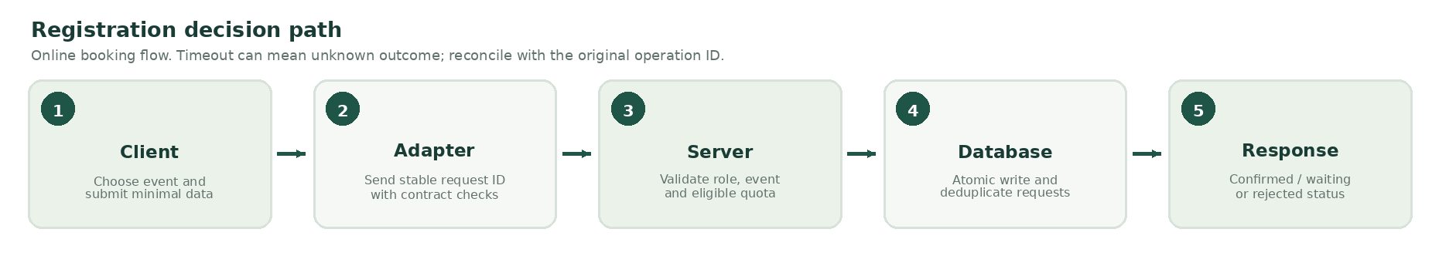
Figure 2. Server-authoritative registration process. The frontend never confirms a cached last place.
Example requirement: if two valid requests compete for one remaining place, at most one may become CONFIRMED. The other result must follow a team-approved waiting or rejection policy. The server, not a disabled button, enforces this rule.
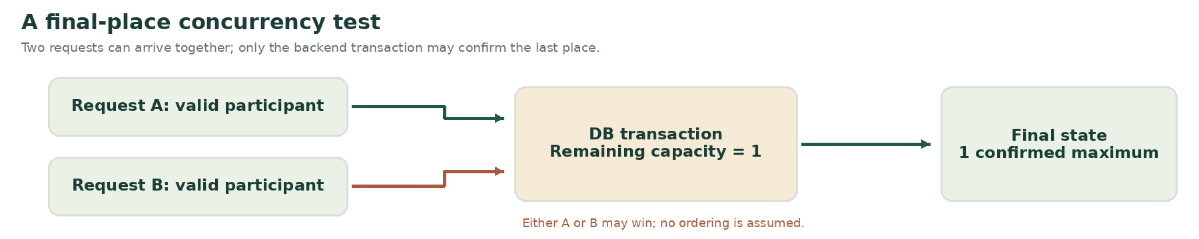
Figure 3. Concurrency invariant for the final available place. A real HTTP + DB race test is still required.

7. Offline-first check-in design and safeguards
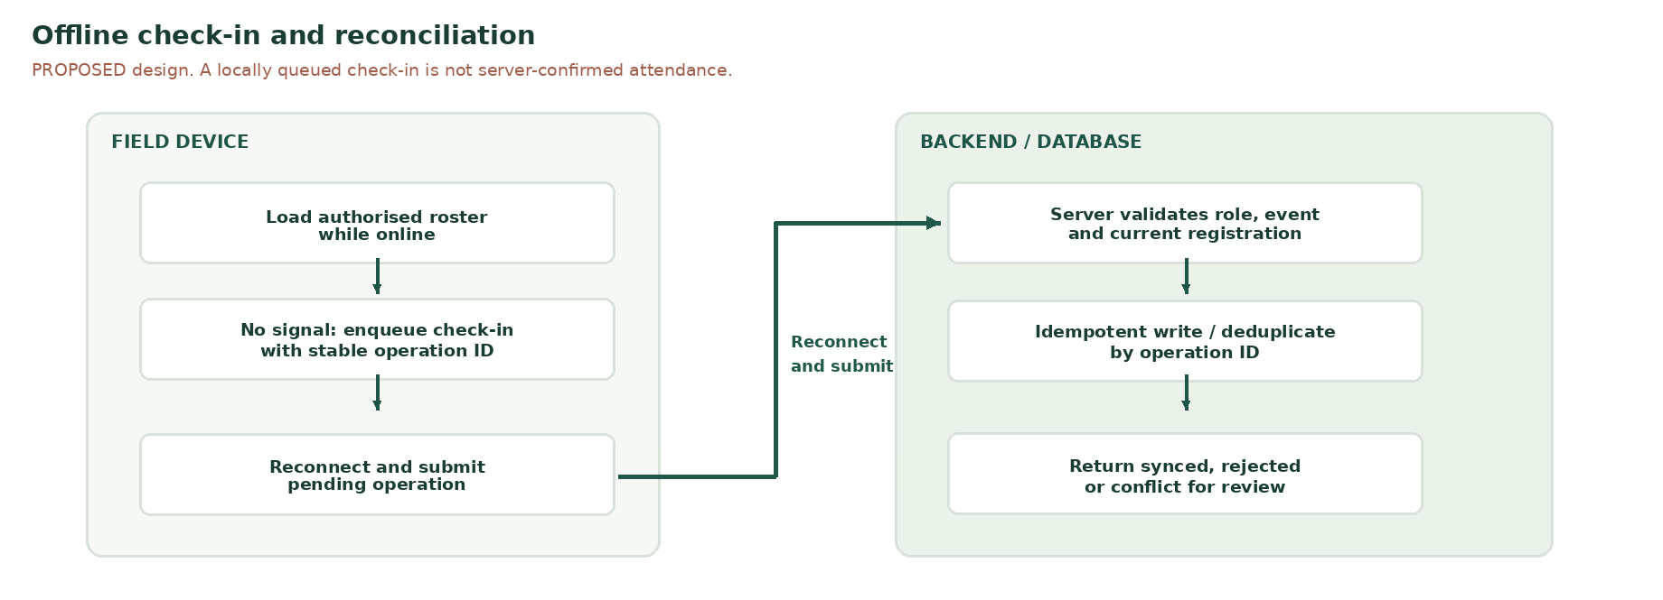
Figure 4. Proposed offline and reconnect procedure. Only a server-accepted record is counted as authoritative attendance.
- Before losing connectivity, authorised staff may download a minimal, scoped roster with a revision number and a validity window. Do not cache unnecessary health or identity data.
- While offline, the device may save a signed-in staff action as PENDING_SYNC with a stable operation ID. This is a local record only.
- After reconnecting, a trusted API validates authentication, event, registration, operation ID and roster age, then returns SYNCED, REJECTED or CONFLICT.
- An expired roster, duplicate scan, revoked staff account or concurrent device check-in must be handled explicitly. A conflict requires visible review rather than silent overwrite.
- Production acceptance requires refresh/restart persistence and two-device reconciliation tests. The available demo has not passed those acceptance criteria.

8. Example frontend views and status messaging
These are genuine screenshots from the unchanged NU ROSE_DEMO_English_v1.2.1.html executed in sandboxed Chromium with page.set_content. The run passed 12 targeted UI checks and captured six views. It used about:blank, in-memory demo state and no storage fixture. Simulated offline check-in and manual demo sync are not real network or database tests. Screenshot crops do not alter UI values. [S4]
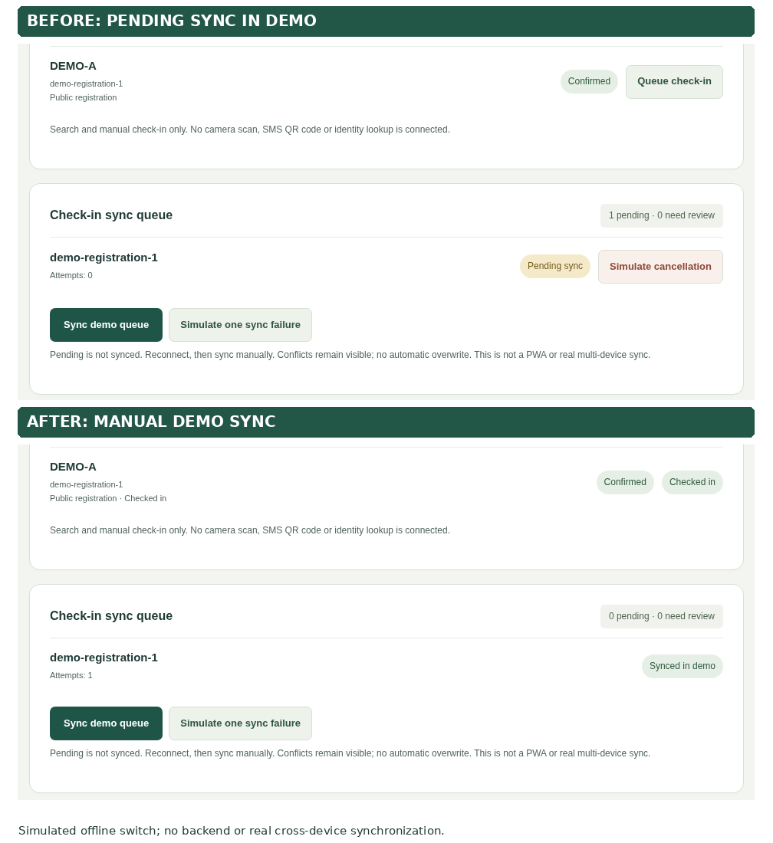
Figure 5. Field Staff before and after MANUAL DEMO sync, captured at 1440px in one browser run. Pending in the browser is not server-confirmed attendance; crops show the same DEMO-A record.
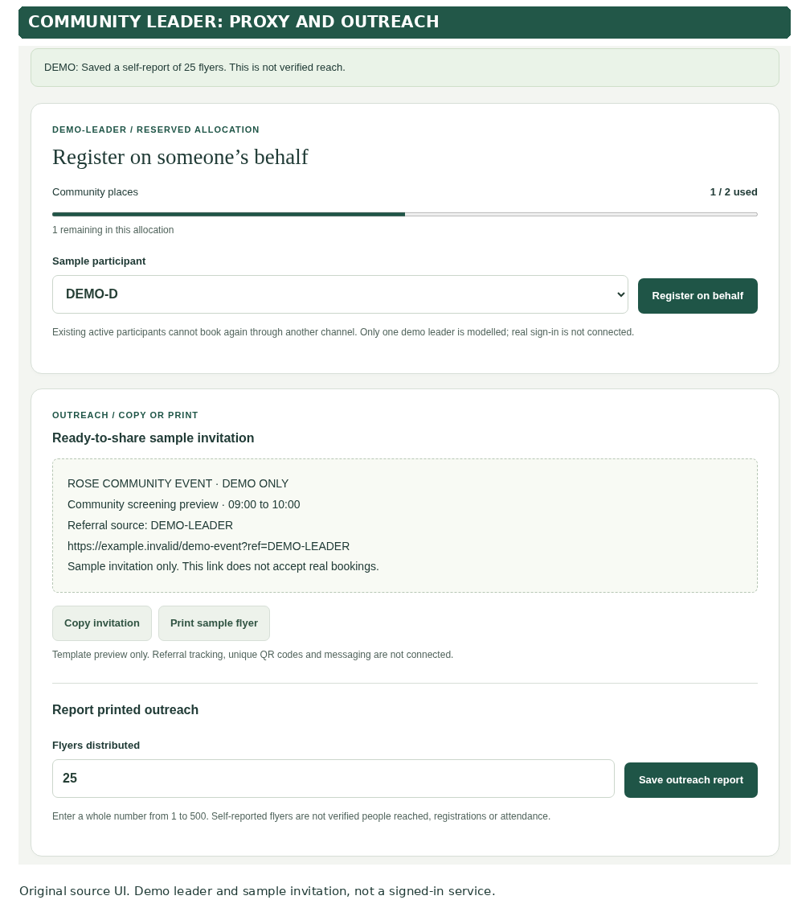
Figure 6. Actual Community Leader browser capture: assisted registration and self-reported printed outreach. Demo values and role selection are not authenticated.
The UI must distinguish CONFIRMED, WAITING and UNKNOWN_OUTCOME. Field Staff must also distinguish PENDING_SYNC from server-accepted attendance, with explicit failure and conflict handling. A production roster may not be made public.

9. Competitor comparison and proposed engineering differentiation
The team identified seven candidates. The table below focuses on five with independently reviewed public product documentation as of 12 October 2026. A documented feature is not exclusive to ROSE. Unknown or untested aspects are not described as missing capabilities. [W1-W5]
Platform | Documented capability (official source) | ROSE-specific design hypothesis to validate
Ticket Tailor | Event waitlist; online/offline check-in app with synchronization. [W1] | ROSE seeks a combined community-leader quota, referral report and screening-capacity workflow.
Eventbrite | Managed waitlist and ticket-release workflow. [W2] | ROSE emphasizes no-account low-literacy access, outreach visibility and controlled field permissions.
SimplyBook.me | Appointment booking notifications, configurable SMS/email reminders. [W3] | ROSE would couple reminders to leader outreach and a scarce public / reserved quota model.
CommCare | Mobile offline form storage and automatic sync when connected. [W4] | ROSE proposes one screening-event workflow. Compare its quota and referral integration against configured CommCare apps, not just a blank form.
KoboToolbox | Cached web forms, offline submission queue and upload after reconnection while the form stays open. [W5] | ROSE needs server-authoritative slot allocation and event waitlist, with outreach/attendance states.

TextIt and Ticket2U also appear on the PM's candidate list. This draft does not assign them unsupported technical limitations. Their feature-level evidence and the PM's final selection require confirmation before the team describes a final USP. [S3]
USP EVIDENCE RULE The proposed differentiation is the integration of no-account guest access, leader-reserved quota/proxy booking, promotion attribution and field-safe sync for an NGO. No claim is made that individual features are invented by ROSE or absent from other products.

10. Security, privacy and operational decisions
Concern | Proposed technical control | Decision / test
Access control | RBAC validated at every backend operation; demo role selector is never treated as authentication. | Confirm Coordinator, Leader and Field Staff permissions and login method.
Sensitive details | Data minimisation; encrypted transport; scoped local roster; approved retention and deletion. | PM/Security choose fields and retention; do not assert legal compliance without review.
Public cancellation | Unpredictable, narrowly-scoped self-service token; mutation never triggered by a GET. | Check token expiry, replay, guessed IDs and message preview bots.
Quota consistency | Database transaction, unique constraints and idempotency ledger. | Two final-place requests yield at most one confirmation; replay produces no duplicate.
Weak networks | Explicit PENDING / UNKNOWN / SYNCED / CONFLICT, retry with original operation ID. | Airplane-mode, browser restart, stale roster and two-device tests.
SMS and webhooks | Provider callback verification, retries, scheduling zone, consent and delivery audit. | No claims of working SMS until provider and actual delivery tests are recorded.

11. Verification plan and release criteria
Check | Evidence required | Current state
Local logic and DOM | Re-run unit, source and injected DOM checks on exact candidate code. | NU v1.2.1 candidate: 56/56 Node, 65/65 Python, 78/78 DOM reported PASS.
Browser navigation | Open actual deployed/local app URL with realistic browser storage and device permissions. | NOT RUN / environment navigation blocked; injected DOM checks are separate.
API contract | Exercise real backend with agreed request/response fixtures and errors. | NOT VERIFIED; backend source and schema unavailable to this record.
Persistence | Refresh/restart app/server and verify registration/cancellation stays correct. | NOT RUN on a real DB.
Concurrency | 20 simultaneous requests for one available place plus retries and cancellation race. | NOT RUN against a real backend.
Offline sync | Disconnect, queue, restart, reconnect, submit twice, verify server dedup and conflicts. | NOT RUN as genuine multi-device offline workflow.
Acceptance and delivery | PM policy sign-off, security review, real-device usability, reproducible commit and rollback. | PENDING; no production deployment or submission claimed.

12. Engineering workflow and next integration milestone
- G0: Lock requirements US01 to US10 and record which uncertain features are deferred.
- G1: Obtain backend branch/full SHA, setup instructions, environment variable names, seeded test DB and runtime evidence.
- G2: Preserve and test the existing mock UI; isolate transport calls behind the service adapter.
- G3: Approve schema, authentication, error and idempotency contract with the backend owner.
- G4: Wire one real path end to end: guest request -> backend quota decision -> persisted receipt -> cancellation -> refreshed capacity.
- G5: Run multi-device/offline/race tests and PM, Designer and Security review.
- G6: Create a reviewed reproducible release with explicit rollback and synthetic demo data.
The first technically meaningful target is a persisted and repeatable registration transaction, not additional decorative mock screens. Implement the smallest working slice in the team's existing architecture and expand only after G3/G4 evidence exists.

13. Internal and official evidence index
- [S1] NU imported SharePoint: Client_Requirement_Notes / Overview on the Challenge 5.docx.
- [S2] NU imported SharePoint: PM / User Stories / User Stories & Mapping.docx and Developer / Features Review.docx.
- [S3] NU imported SharePoint: Admin_and_Log_Tasks / Potential Competitors List - for Log Task 2.docx.
- [S4] NU_Feature_Coverage_v1.2.1.md and NU_Verification_v1.2.1.json (TASK-005, historical test summary). New visual proof: NU_v1.2.1_Browser_Capture_Evidence.json, six source screenshots and crop_provenance.json, under docs/dev/evidence/LOG_DOCX_20261012. Source SHA256: 3949160d0317c2b32ceadb00adca263db507f55c5577cb7ed4aa05e48cd8292e.
- [S5] NU/grp_c5/00_Dev_Workspace/docs/api/INTEGRATION.md and docs/dev/DEV_FLOW.md. CURRENT.md is the older v1.2.0 workspace record; the supplementary v1.2.1 candidate evidence is listed separately in S4.
- [S6] NU imported SharePoint: Admin_and_Log_Tasks / Log Task 2 26_27_GP 6.docx (brief; 13 October 2026, 23:59, Blackboard).
- [W1] Ticket Tailor Help Centre, waitlist and offline check-in, reviewed 12 October 2026: https://help.tickettailor.com/en/articles/2748053-how-to-set-up-a-waitlist-for-your-event ; https://help.tickettailor.com/en/articles/9546560-why-use-the-ticket-tailor-check-in-app
- [W2] Eventbrite Help Center, event waitlist and ticket release, reviewed 12 October 2026: https://www.eventbrite.com/help/en-us/articles/811539/how-to-set-up-an-event-waitlist/ ; https://www.eventbrite.com/help/en-us/articles/817355/how-to-manually-release-tickets-to-the-waitlist/
- [W3] SimplyBook.me Help, notification and reminder settings, reviewed 12 October 2026: https://help.simplybook.me/wiki/Adjusting_notifications
- [W4] CommCare by Dimagi, official platform overview and offline functionality FAQ, reviewed 12 October 2026: https://commcare.dimagi.com/
- [W5] KoboToolbox Documentation, Collecting data using web forms (offline data collection and reconnect upload), reviewed 12 October 2026: https://support.kobotoolbox.org/data_through_webforms.html

