# CS 111 PA #2

For this PA, you will be using C++ to calculate various mathematical formulas. While our current programming "toolbox" contains only a few items, we can still combine what we know to perform simple computations. In this programming assignment, you will use user I/O and mathematical computation to calculate simple formulas.

## Expected Functionality

Your program must be capable of computing the following equations:

* Newton's 2nd Law: $F=M*A$
* Volume of a cylinder: $V=π*{radius}^{2}*height$
* Distance between two points: $D=\sqrt{{(x_{1}-x_{2})}^{2}+{(y_{1}-y_{2})}^{2}}$
* Tangent line: $\tan\left(θ\right)=\frac{sin⁡(θ)}{cos⁡(θ)}$

Note that common mathematical functions can be found in the <[cmath](http://www.cplusplus.com/reference/cmath/)> library.

## Test Cases / Output

Below are test cases for you to compare your program against. Note that the prompts need to be listed in the order depicted.

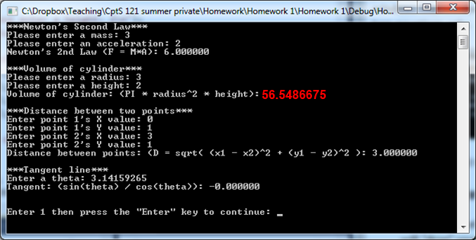

## Deliverables

You must submit your assignment through Canvas no later than midnight on Wednesday, September 12, 2018.

## Grading Criteria

Your assignment will be judged by the following criteria (50 points possible):

* (10 pts) The program runs without crashing
* (10 pts) Newton's 2nd law is computed correctly
* (10 pts) The volume of a cylinder is computed correctly
* (10 pts) The distance between two points is computed correctly
* (10 pts) The tangent is computed correctly