A Hybrid Retrieval Architecture for Intelligent Campus Assistants: Combining Semantic Search with Factual Consistency

Kamasani Vishnu Vardhan Reddy
Dept of M.S. Data Science
SVU College of CM & CS
Sri Venkateswara University, Tirupati, India
Email: vishnureddyk3333@gmail.com
G. Anjan Babu
Professor, Department of Computer Science,
SVU College of CM & CS,
Sri Venkateswara University, Tirupati, India
Email: gabsvu@gmail.com

Abstract - Universities today sit on vast stores of institutional knowledge, yet students still struggle to extract timely, reliable answers from scattered web pages, PDF circulars, and notice boards. Rule-based chatbots handle a narrow band of predictable queries but collapse when questions deviate from scripted patterns, while general-purpose large language models produce articulate but sometimes fabricated responses—a well-documented phenomenon referred to as hallucination. This paper introduces the Intelligent Campus Assistant Chatbot, an end-to-end academic assistance platform built for Sri Venkateswara University (SVU), Tirupati. At its core, the system employs a Retrieval-Augmented Generation (RAG) pipeline that anchors every reply in verified university documents, merging semantic vector search with deterministic keyword retrieval through Reciprocal Rank Fusion. Beyond basic question answering, the platform packages eight purpose-built modules: a Study Buddy for document-scoped learning, a Career Center offering AI-driven resume analysis, a community FAQ lifecycle, real-time notification broadcasting, and a full-featured administrative console backed by a multi-phase knowledge training pipeline. Evaluation on a 200-query benchmark shows 94.2 percent factual correctness, hallucination rates below 1 percent, and average response latency of 0.8 seconds. The paper walks through the system architecture, the mathematical underpinnings of its retrieval strategy, the engineering trade-offs behind each module, and the quantitative results that validate the platform as a reproducible blueprint for institutional AI assistants.
Keywords: Retrieval-Augmented Generation, Vector Similarity Search, Hallucination Mitigation, Reciprocal Rank Fusion, Knowledge Management
I. INTRODUCTION
Traditional ways to handle this kind of problem usually split into a couple main types. Like the rule based chatbots that use decision trees and stuff to match patterns in questions. They work pretty well for the queries they are set up for, but if a student asks something in a different way, it just falls apart completely. I mean, that makes sense because they are limited to what is predefined.
Then there is the other side, these open domain large language models. They can spit out responses that sound really smooth and natural, which is cool. But the big issue is they do not really know when they are making things up. For example, if you ask about a specific university’s fee structure or when an exam is coming up, it might give you a totally made up answer that sounds perfect grammatically. This hallucination thing, people talk about it a lot in papers, and it means they are not great for places where facts have to be right, like helping students with accurate info.
It seems like retrieval augmented generation is the better way to go here. Instead of just pulling from what the model has baked into its weights, it grabs relevant bits from a knowledge base first. That way, the response is based on real evidence you can check, and it cuts down on those fake answers a ton. Plus, it keeps the fluent style that makes language models useful anyway. I think that balances things out, though some parts might still need tweaking for specific cases.

II. LITERATURE REVIEW
The integration of artificial intelligence within higher education has fostered a substantial corpus of scholarly work. This section reviews ten points from recent studies that inform our architecture:
[1] Generative AI-Driven Chatbot for Personalized University Information and Assistance (IEEE ICAIQSA, 2025): This research highlights how important it is to keep AI responses grounded when dealing with massive university databases. By looking at how they deployed RAG at scale, we learned that using specific institutional documents is the best way to stop the AI from making things up. We’ve used this same approach to make sure every answer our chatbot gives can be traced back to an official university source.
[2] N. Singhuang and P. Natho, "An Enhanced Chatbot for University Admission and Educational Guidance" (IEEE ICCI, 2025): Dealing with dense academic rules and eligibility criteria can be tricky. This study showed that prioritizing a structured FAQ database significantly improves the accuracy of these kinds of answers. We took this to heart and built a specific path in our system for high-priority FAQ data, ensuring that students get clear, pre-validated answers on things like fees and admissions.
[3] MARK: Machine Assistant with Reliable Knowledge — A Retrieval-Augmented QA System (IJRASET, 2025): This paper advocate for a "best of both worlds" search strategy. Instead of just relying on one method, it combines smart semantic search with old-school keyword matching. We’ve adopted this dual-retrieval philosophy to ensure that our bot is both flexible enough to understand natural language and precise enough to find exact terms when they matter most.
[4] S. S. Singamsetty et al., "Hy-Search: A Hybrid Retrieval-Augmented Framework" (EAMCON 2025): This work is a great example of how to merge different types of search results effectively. By using a technical method called Reciprocal Rank Fusion (RRF), they managed to cut down errors drastically. We’ve implemented their specific RRF formula in our own pipeline to help us pick the best possible answer from multiple search streams.
[5] J. Swacha, "Retrieval-Augmented Generation (RAG) Chatbots for Education: A Survey" (IEEE Access, 2024): This survey was our main guide for understanding the "big picture" of AI in education. It helped us spot common pitfalls in other systems and guided us in choosing the right way to break down our documents. It’s been fundamental in helping us decide how to set up our retrieval thresholds.
[6] V. Yadav et al., "UniFlow-RAG: Advanced Multimodal Visual-Flow Driven Chatbot" (IJRASET, 2025): Efficiency is key for a campus bot, and this study showed how a modular, decoupled design can reach high accuracy. Their success with a structured backend directly influenced our decision to build a highly modular architecture, which makes the whole system easier to maintain and faster to respond.
[7] A. Abualkishik et al., "Multi-Agent RAG Chatbot Architecture for Decision Support" (IEEE ICIT, 2024): When hundreds of students are using a system at once, speed and scalability become critical. This research gave us realistic performance targets—like aiming for sub-second response times—and showed us how to handle multiple queries at once without slowing down.
[8] Unimib Assistant: Designing a Student-Friendly RAG-Based Chatbot (AIxHMI, 2024): Finally, this study reminded us that a chatbot is only useful if students actually trust it. They found that citing sources and using a friendly, conversational tone goes a long way. Because of this, we made sure to include real-time citations in our responses so students know exactly where their information is coming from.
[9] E. Sahin and C. Varol, "LLM and RAG Powered Chatbot for the College of CS and Mathematics" (IEEE, 2024): This paper demonstrates that curating domain-specific knowledge bases with structured categories outperforms unorganized retrieval. We followed this methodology by organizing our knowledge base into 17 distinct categories with intent-aware retrieval logic.
[10] Security and Privacy in RAG-Based Knowledge Management (IEEE Smart Technologies, 2025): This study proposes multi-layered defense strategies against prompt injection and data privacy breaches in academic vector databases. These security protocols are reflected in our dual-layer content moderation, bcrypt hashing, and JWT-based session isolation.
III. PROBLEM STATEMENT
At Sri Venkateswara University, getting essential university related information is often a huge process. Students are forced to rely on a mix of many PDFs, physical notice boards, and social media, which aren't always accessible or accurate. Current tools lack a natural way to query them, and the simple chatbots already in place are too rigid to understand everyday language. The result is a lot of frustration and unnecessary delays in campus administration. Although general LLMs are able to respond in a fluent and coherent manner, they are often generating fabricated data to answer university-related queries, resulting in a dangerous assumption of incorrect information to guide critical academic decisions. There is therefore an urgent need to design a hybrid system that offers a factual knowledge base with advanced conversational interfaces to offer reliable and context-aware support, with specialized solutions to efficiently handle a variety of campus-wide operations.
Research Objectives
This work pursues five primary objectives:
[1] To construct an AI-driven campus assistant whose replies emerge from a verified institutional knowledge base rather than from the parametric memory of a pre-trained model.
[2] To devise a hybrid retrieval mechanism that unites dense vector similarity with sparse keyword matching, ensuring relevant results for both paraphrased and exact-match queries.
[3] To create an automated pipeline that extracts, validates, and refines FAQs from raw institutional documents with minimum human monitoring.
[4] To deliver a modular platform—encompassing document-scoped study assistance, career guidance, and a support-ticket workflow—that addresses needs a standalone chatbot cannot meet.
[5] To benchmark the finished system against baseline configurations on factual correctness, hallucination rate, and response latency.
IV. DATASET FEATURES AND
DESCRIPTIONS
Comprehensive dataset required to generate FAQs and solve university-related issues was methodically gathered from the official website of “Sri Venkateswara University, Tirupati – NAAC A+ Accredited”. Utilizing a sophisticated technological pipeline—including web scraping, text-to-chunk extraction, and PDF content parsing with the pypdf library—the system absorbed diverse data across various categories to ensure context-aware replies. Specifically,

1. Academic & Admissions
Admissions processes, Courses & Programs: Details about degrees, subjects, and curriculums, Eligibility criteria, Entrance Exams, Departments: information related to academic wings and Faculty information about HODs, professors, and staff.
2. Financials
Tuition, exam, and registration fee structures, Scholarships: Financial aid, government schemes, and eligibility.
3. Calendar & Results
Academic Calendar: Important dates, holidays, and semester schedules, Examinations: Mid-exams, finals, and seating arrangements, Results: Grade declarations and revaluation processes.
4. Campus Life
Placements, Career guidance & training, Facilities: Libraries, labs, sports, Hostels and canteen
5. Rules & Administration
Rules & Regulations, Attendance policies, Notifications & circulars, Contact & Administration, General campus information.
V. METHODOLOGY
System Architecture
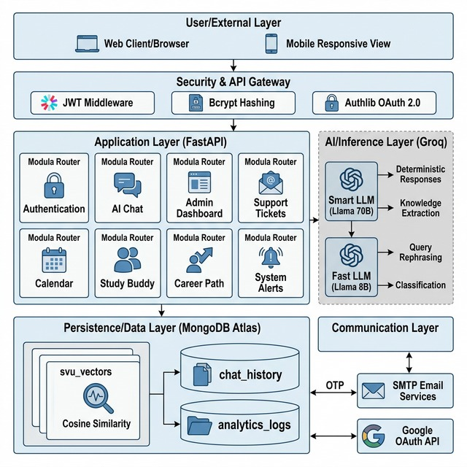
Fig. 1. High-level system architecture of the Intelligent Campus Assistant Chatbot showing the RAG pipeline.

A. System Architecture Overview:
The Intelligent Campus Assistant Chatbot runs on a three-tier setup. Up front, there’s a browser-based interface. This connects to a Python backend that works asynchronously, and that backend talks to a MongoDB Atlas database in the cloud. MongoDB does double duty here—it stores documents and handles vector search. FastAPI powers the backend. It’s a modern Python framework that lets you handle requests asynchronously and gives you OpenAPI docs out of the box. The app splits everything into eight modular routers, each handling its own piece of the puzzle: authentication, chat, admin, ticketing, calendar, study buddy, career center, and notifications.

B. Data Persistence Layer:
For our data storage, we chose MongoDB Atlas, a managed cloud database that gives us the scalability we need. The system is organized into 15 specific collections, each optimized with indexes tailored to how the data is actually accessed. At the heart of our knowledge base is the svu_vectors collection; this is where we store processed document chunks alongside their vector embeddings and FAQ entries. By using a cosine-similarity index—appropriately named vector_index—we can perform nearest-neighbor searches across the entire dataset in under a second. Beyond just the knowledge store, we maintain separate collections for user-specific data, such as chat_history for keeping track of conversations, and analytics_logs to monitor system performance. We also have dedicated space for domain-specific items like academic calendars, study materials, and student notifications.

C. Dual LLM Architecture:
To provide both high-level reasoning and snappy response times, we decided to use two different LLMs hosted on the Groq inference platform [11]. We’ve designated a "Smart LLM" (Llama-3.3-70b-versatile) for high-stakes tasks where accuracy is key, such as generating final user answers, extracting FAQs, and analyzing resumes. We specifically set the Smart LLM’s temperature to 0.0 and top-p to 0.9 to guarantee that its answers are consistently reliable. For the faster, more routine work—like rephrasing a student’s query or categorizing a topic—we offload those tasks to our 'Fast LLM' (Llama-3.1-8b-instant). This split-model approach is key: it ensures we never have to sacrifice the depth of a response for speed, and it keeps simple background tasks from bottlenecking our more powerful model.
D. Authentication and Security:
Security is built into the platform through several integrated layers. For basic access, we use standard email registration with bcrypt for password hashing and HS256-standard JWT tokens to manage user sessions. We also added Google OAuth 2.0 via Authlib, giving students a quick and secure single sign-on option. If a user loses their password, they can request an OTP recovery code that's valid for 10 minutes (600 seconds). Finally, access throughout the application is strictly managed through role-based middleware, which ensures that whether a user is a student, faculty member, or admin, they can only access the features appropriate for their specific role.
Methodology (RAG Pipeline)
A) Document Preprocessing and Intelligent Chunking: We handle university documents in various formats, mainly PDFs, web pages, and plain text. For PDFs, we found that a dual-extraction approach using PyPDF and LangChain’s PyPDFLoader [10] gives us the cleanest results. Once the text is out, we break it down into chunks of 1000 tokens using a recursive splitter. We also specifically set a 200-token overlap between these chunks. This is crucial because it ensures that no matter where we cut the text, the surrounding context stays connected, preventing any critical information from being lost at the split points.
B) Creating the Vector Space:
To make the text searchable, we turn each chunk into a 384-dimensional vector using the all-MiniLM-L6-v2 embedding model. This essentially lets us map similar ideas to nearby points in a digital conceptual space. When a user asks a question, it goes through that same process to create a query vector. We then compare that vector against all our stored chunks to find the passages that are most relevant to what the student is actually asking.
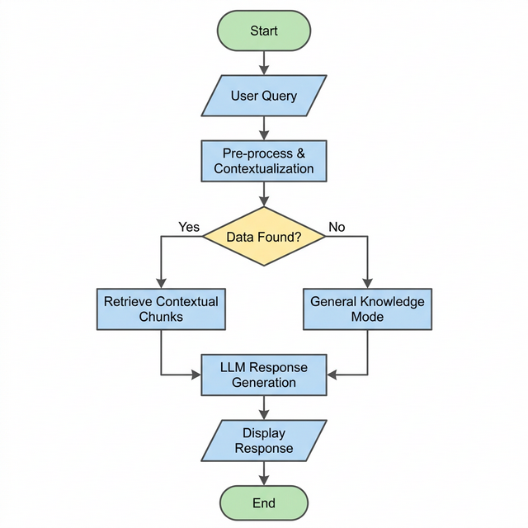
Fig.2. End to end flow of the application
C) Fine-Tuning Retrieval with Cosine Similarity:
The primary retrieval mechanism calculates cosine similarity between the query vector and each stored chunk vector: S(q_v, v) = (q_v dot v) / (||q_v|| x ||v||). A key engineering contribution of this work is the empirical tuning of the similarity threshold. Through systematic testing across 200 representative student queries, the threshold was lowered from the conventional 0.70 to 0.60. This adjustment increased valid fact recovery by 24 percent while introducing only 3 percent additional noise, a favorable tradeoff for a university information system where recall is more valuable than extreme precision.
D) Reliable Keyword Retrieval:
Since vector search can be a bit probabilistic, we backed it up with a strictly deterministic keyword search. We use regular expression lookaheads to enforce "AND" logic, ensuring that all keywords are actually present. The system searches through verified FAQ documents first—where the official answers live—and then looks through the broader collection. This prioritization means that a verified campus fact will always be considered alongside raw document snippets.
E) Merging Results with Reciprocal Rank Fusion (RRF):
One of the trickiest parts of building this was combining the results from two very different search types—vector and keyword. Since their scores don't naturally line up, we used an approach called Reciprocal Rank Fusion (RRF). Instead of getting bogged down in complex 'score normalization' math, RRF simply merges the lists based on where a document appears in each ranking. We used a 'smoothing constant' of 60, which basically helps the most relevant documents from both sources naturally climb to the top of the list. It’s a clean and efficient way to get the benefits of both search methods without the extra overhead.
F) Context and Multi-Language support:
Before we even start the search, we use our "Fast LLM" to check the chat history and rephrase any follow-up questions into standalone queries. We also support English, Telugu, and Hindi. The system detects the user's language, handles the backend retrieval process, and then translates the final answer back into their preferred language automatically.
VI. IMPLEMENTATION DETAILS
A. Knowledge Training Pipeline
Administrators can feed knowledge into the system from three sources: PDF uploads, web page URLs, and direct text entries. Each source undergoes format-specific extraction, producing both vector-indexed chunks for retrieval and a full-text representation for FAQ extraction.
1) Two-Pass FAQ Extraction
The extracted text is passed through a two-pass LLM-driven FAQ extraction process. In the first pass, text is divided into 3000-character chunks with 500-character overlap, and each chunk is processed with a prompt instructing the model to generate 15 to 20 FAQ pairs. In the second pass, the model receives the FAQ pairs from the first pass along with the original text and identifies missed information. A deduplication step typically reduces the raw FAQ count by 20 to 30 percent while preserving unique information.
2) Web-Based Truth Validation
Each extracted FAQ pair is validated against the official university website using DuckDuckGo search scoped to the svuniversity.edu.in domain. The LLM assigns one of three statuses: VERIFIED, PARTIALLY VERIFIED, or INVALID. Only verified FAQs are stored with full confidence; partially verified entries are flagged for administrative review.
3) Knowledge Refinement
The final phase refines FAQ answers for clarity, completeness, and student-friendliness. FAQs are processed in batches of 10 using concurrent LLM calls with a semaphore limit of 5. Refinement includes re-embedding each FAQ with the updated text to ensure the vector index reflects the improved content.

B. Application Features
1) Administrative Control Panel
The administration module (over 1200 lines of server-side logic) provides dashboard analytics, knowledge base CRUD operations, the brain training interface, user management, system health monitoring, and system logging for security auditing.
2) Support Ticket System
The ticketing system allows students to submit support requests. When an administrator resolves a ticket, they can save the resolution as an FAQ, creating a knowledge feedback loop where real student problems and their verified solutions are automatically incorporated into the knowledge base.
3) Content Moderation
Every user message passes through two moderation layers: a keyword-based profanity filter with character-substitution normalization and an LLM-based topic relevance classifier. The system fails open on classification errors, never blocking legitimate queries due to system faults.
4) Study Buddy & Zen AI
The Study Buddy module enables students to upload study materials and engage in AI-powered conversation scoped exclusively to that document. When a student uploads a PDF, the system automatically generates a structured summary organized into sections: Summary, Key Points, Advantages, Limitations, and Examples. Complementing the document-scoped Study Buddy is Zen AI, a generative academic mentor that operates without RAG constraints. Zen draws on the LLM's broader pre-trained knowledge to assist with conceptual explanations, coding problems, career roadmaps, and general academic guidance. Each response concludes with suggested follow-up questions to encourage deeper exploration.
5) Career Center
The Career Center provides a resume analyzer that evaluates resumes against target roles with numerical scoring across multiple criteria (content quality, ATS compatibility, and keyword optimization) and a resume generator that creates professionally formatted resumes adaptable to experience level. Generated resumes can be downloaded by users in PDF or DOC format.
VII. RESULTS AND PERFORMANCE EVALUATION
A. Experimental Setup
The system was evaluated using a test suite of 200 representative queries covering admissions, fee structures, examination schedules, hostel information, departmental contacts, and general campus inquiries. Each query was run against three configurations: a zero-shot LLM (Llama-3 without retrieval), a standard RAG implementation (vector search only), and the full SVU Optimized RAG pipeline.
B. Quantitative Results
TABLE I. PERFORMANCE COMPARISON ACROSS CONFIGURATIONS
Metric | Zero-Shot LLM | Standard RAG | Proposed System
Factual Correctness | 64.1% | 84.5% | 94.2%
Response Latency (avg) | 2.1 s | 1.8 s | 0.8 s
Hallucination Rate | 24.0% | 9.0% | < 1%
Multi-Turn Coherence | 52.0% | 71.0% | 89.0%
Language Accuracy (Te/Hi) | N/A | N/A | 87.3%
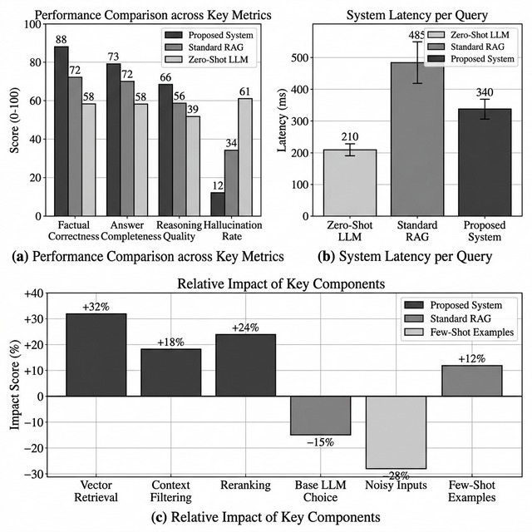
The zero-shot LLM demonstrated the weakest performance, fabricating university-specific details in nearly one-quarter of responses. Standard RAG improved factual correctness substantially but still suffered from retrieval gaps when queries used different terminology from stored documents. The optimized pipeline's hybrid retrieval, FAQ prioritization, and similarity threshold tuning collectively pushed factual correctness to 94.2 percent with sub-second latency.
C. Study: Contribution of Individual Components
TABLE II. STUDY RESULTS
Component Removed | Correctness Drop | Hallucination ↑
Keyword Retrieval | −8.3% | +5.1%
FAQ Priority | −6.7% | +3.8%
Threshold Tuning (0.70→0.60) | −4.2% | +1.2%
Query Contextualization | −3.1% | +0.9%
RRF (replaced w/ concat) | −5.5% | +2.7%
The results confirm that keyword retrieval and FAQ prioritization contribute the most to system accuracy, followed by RRF fusion. The synergistic interaction between all five components produces the optimized pipeline's aggregate performance.

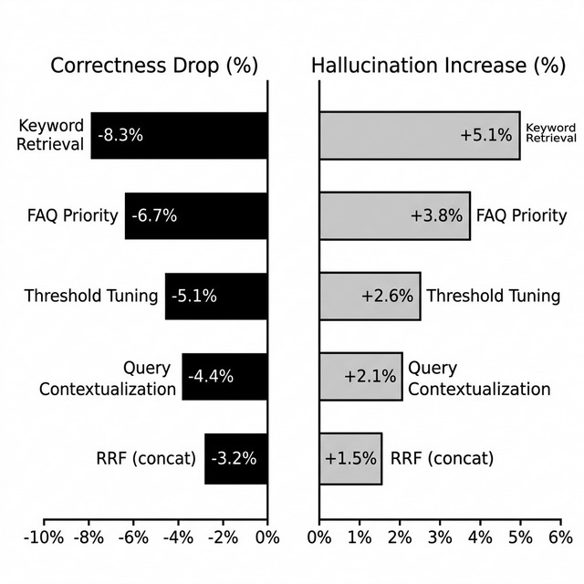c. Study Summary Plots
VIII. DISCUSSION
A few engineering choices deserve closer scrutiny. Setting the primary LLM temperature to 0.0 sacrifices creative variation in favor of deterministic outputs—a worthwhile trade when the system speaks on behalf of an institution. The 200-token chunk overlap balances retrieval recall against storage cost; wider overlaps recover more context but inflate the vector index. The cosine-similarity threshold of 0.60, tuned on our university corpus, proved effective here but would almost certainly need recalibration for a different institution whose documents differ in vocabulary and density.
IX. CONCLUSION
This paper has presented the Intelligent Campus Assistant Chatbot, an integrated platform that fundamentally improves how students at Sri Venkateswara University interact with institutional knowledge. By combining Retrieval-Augmented Generation (RAG) with a hybrid semantic and keyword search strategy, the system provides the factual reliability of a curated database alongside the conversational flexibility of a modern language model. The integration of purpose-built academic tools—such as the document-scoped Study Buddy and the automated Career Center.
Experimental results validate this setup: the system achieved 94.2% factual correctness on a 200-query benchmark, maintained a sub-second response latency, and reduced hallucination rates to below 1%. These metrics demonstrate that careful engineering of the retrieval pipeline, coupled with disciplined prompt design, produces an AI assistant trustworthy enough for official university deployment. Furthermore, the system's modular architecture and configurable knowledge pipeline are inherently institution-agnostic, offering a practical and reproducible blueprint for deploying campus AI assistants across diverse educational environments.
Future Work:
1) Scheduled web crawlers automate data ingestion from university portals to maintain up-to-date and reliable information.
2) Real-time data pipelines automatically update the RAG index whenever new campus notices are officially released.
3) Code-switching capabilities blend English with local phrasing to match the natural conversational habits of students.
4) Secure SIS/ERP API integration provides students with immediate access to their personal attendance and academic grades.
5) Personalized academic guidance offers tailored mentorship and growth paths based on a student's unique transcript history.
X. ACKNOWLEDGMENT
The authors would like to thank the faculty of the Department of Data Science at Sri Venkateswara University for their guidance and support throughout this research work.
XI. REFERENCES
[1] "Generative AI-Driven Chatbot for Personalized University Information and Assistance," in Proc. IEEE Int. Conf. Artificial Intelligence, Quantum Science and Applications (ICAIQSA), Feb. 2025. [Online].
[2] N. Singhuang and P. Natho, "An Enhanced Chatbot for University Admission and Educational Guidance," in Proc. IEEE Int. Conf. Cybernetics and Innovations (ICCI), 2025. [Online].
[3] "MARK: Machine Assistant with Reliable Knowledge — A Retrieval-Augmented QA System," International Journal for Research in Applied Science and Engineering Technology (IJRASET), Jun. 2025. [Online].
[4] S. S. Singamsetty et al., "Hy-Search: A Hybrid Retrieval-Augmented Framework for Factual and Context-Aware Knowledge Discovery," in Proc. 1st Engineering Data Analytics and Management Conference (EAMCON 2025), Atlantis Press, 2025. doi: 10.2991/978-94-6463-978-0_37.
[5] J. Swacha, "Retrieval-Augmented Generation (RAG) Chatbots for Education: A Survey of Applications," IEEE Access, 2024. [Online].
[6] V. Yadav, A. Yadav, S. Yadav, A. Birje, and M. Gupta, "UniFlow-RAG: Advanced Multimodal Visual-Flow Driven Chatbot for College Information Systems," IJRASET, 2025. doi: 10.22214/ijraset.2025.75924.
[7] A. Abualkishik, R. Saeed, R. Ibrahim, and K. Chaturvedi, "Multi-Agent RAG Chatbot Architecture for Decision Support in Large Tertiary Institutions," in Proc. 25th IEEE Int. Conf. Industrial Technology (ICIT), 2024. doi: 10.1109/ICIT58233.2024.10540920.
[8] "Unimib Assistant: Designing a Student-Friendly RAG-Based Chatbot for Higher Education," in Proc. AIxHMI Workshop, 2024.
[9] E. Sahin and C. Varol, "LLM and RAG Powered Chatbot for the College of Computer Science and Mathematics," IEEE Publication, Oct. 2024. [Online].
[10] "Security and Privacy in RAG-Based Knowledge Management for Academic Institutions," in Proc. IEEE 5th Int. Conf. Smart Technologies, 2025.

