ABSTRACT

Universities across the globe face a growing contradiction: information about academic programs, administrative procedures, and campus services has never been more plentiful, yet students continue to struggle with finding clear and timely answers to their questions. Rule-based chatbots have long served as the first line of digital assistance, but their rigid architectures fall apart when faced with natural language variation and evolving institutional policies. On the other end, general-purpose Large Language Models offer human-like fluency but frequently fabricate answers when they lack domain-specific knowledge, a phenomenon widely known as hallucination. This paper presents Intelligent Campus Assistant Chatbot, an end-to-end intelligent academic assistance platform developed for Sri Venkateswara University (SVU), Tirupati. The system employs a Retrieval-Augmented Generation (RAG) architecture that grounds every response in verified university documents, combining semantic vector search with deterministic keyword retrieval through Reciprocal Rank Fusion. Beyond a standard chatbot, the platform integrates eight specialized modules including a Study Buddy for document-scoped learning, a Career Center with AI-powered resume analysis, a community-driven FAQ lifecycle, real-time notification broadcasting, and a comprehensive administrative control panel with a multi-phase knowledge training pipeline. Experimental evaluation demonstrates that the proposed system achieves 94.2 percent factual correctness, reduces hallucination to below one percent, and maintains an average response latency of 0.8 seconds. This paper provides a detailed account of the system architecture, its mathematical retrieval methodology, the engineering decisions behind each module, and the quantitative performance benchmarks that validate its effectiveness as a scalable blueprint for institutional AI assistants.
Keywords -- Retrieval-Augmented Generation, Vector Similarity Search, Large Language Model, Hallucination Mitigation, Reciprocal Rank Fusion, Higher Education Technology, Knowledge Management, FastAPI, MongoDB Atlas
TABLE OF CONTENTS
S.No. | Particulars | Page No.
I | INTRODUCTION
 | 1.1 Domain Overview
 | 1.2 Evolution of the Domain
 | 1.3 Rationale of the Project
 | 1.4 Problem Statement
 | 1.5 Purpose and Objectives
 | 1.6 Significance of the Study
 | 1.7 Scope of the Project
 | 1.8 Limitations and Assumptions
 | 1.9 Concept of the Proposed System
 | 1.10 Theoretical Framework
 | 1.11 Ethical and Social Considerations
 | 1.12 Chapter Summary
II | LITERATURE REVIEW
 | 2.1 Introduction
 | 2.2 Review of Existing Research Papers
 | 2.3 Literature Review Table
 | 2.4 Current Trends in Technology
 | 2.5 Research Gap Identification
 | 2.6 Justification of Proposed System
 | 2.7 Chapter Summary
III | SYSTEM ANALYSIS
 | 3.1 Introduction
 | 3.2 Existing System Analysis
 | 3.3 Proposed System
 | 3.4 Feasibility Study
 | 3.5 Requirements Specification
 | 3.6 System Environment
 | 3.7 System Modelling Diagrams
 | 3.8 Wireframe Layouts
 | 3.9 Chapter Summary
 | 3.10 Risk Analysis
IV | SYSTEM DESIGN
V | IMPLEMENTATION
VI | TESTING
VII | RESULTS AND DISCUSSION
VIII | CONCLUSION AND FUTURE WORK
IX | REFERENCES
X | APPENDIX

LIST OF FIGURES
S.No. | Particulars | Page No.
Figure 1.1 | Traditional vs. RAG-Based Chatbot Comparison
Figure 1.2 | High-Level Concept of Intelligent Campus Assistant Chatbot
Figure 3.1 | Use Case Diagram – Student Actor
Figure 3.2 | Use Case Diagram – Admin Actor
Figure 3.3 | System Flowchart
Figure 3.4 | DFD Level 0 – Context Diagram
Figure 3.5 | DFD Level 1 – Subsystem Decomposition
Figure 4.1 | High-Level System Architecture
Figure 4.2 | Three-Tier Architectural Layers
Figure 4.3 | RAG Pipeline Data Flow
Figure 4.4 | ER Diagram – Database Schema
Figure 4.5 | Deployment Architecture
Figure 5.1 | End-to-End System Workflow
Figure 5.2 | Knowledge Training Pipeline Flowchart

LIST OF TABLES
S.No. | Particulars | Page No.
Table 2.1 | Literature Review Summary
Table 3.1 | Functional Requirements Specification
Table 3.2 | Non-Functional Requirements Specification
Table 3.3 | Hardware Requirements
Table 3.4 | Software Requirements
Table 3.5 | Risk Analysis Matrix
Table 4.1 | MongoDB Collections Schema
Table 5.1 | Tools and Technologies Used
Table 6.1 | Unit Test Cases and Results
Table 6.2 | Performance Testing Results
Table 7.1 | Performance Comparison Across Configurations
Table 7.2 | Ablation Study Results

LIST OF ABBREVIATIONS
Abbreviation | Meaning
AI | Artificial Intelligence
API | Application Programming Interface
ATS | Applicant Tracking System
CORS | Cross-Origin Resource Sharing
CRUD | Create, Read, Update, Delete
CSS | Cascading Style Sheets
DB | Database
DFD | Data Flow Diagram
ER | Entity-Relationship
FAQ | Frequently Asked Question
HTML | HyperText Markup Language
JWT | JSON Web Token
LLM | Large Language Model
LPU | Language Processing Unit
ML | Machine Learning
NLP | Natural Language Processing
OAuth | Open Authorization
OTP | One-Time Password
PDF | Portable Document Format
RAG | Retrieval-Augmented Generation
RBAC | Role-Based Access Control
REST | Representational State Transfer
RRF | Reciprocal Rank Fusion
SVU | Sri Venkateswara University
UI | User Interface

CHAPTER - 1
INTRODUCTION

1.1 Domain Overview
Artificial Intelligence (AI) has emerged as one of the most transformative forces in modern technology. Within the education sector, AI is reshaping how institutions deliver services, manage knowledge, and interact with students. The convergence of Natural Language Processing (NLP), deep learning, and cloud computing has made it possible to build intelligent conversational agents that understand human language with remarkable accuracy.
University campuses generate enormous volumes of structured and unstructured information daily. This includes admission guidelines spread across PDF documents, examination schedules posted on web portals, hostel regulations buried in administrative handbooks, and placement announcements circulated through emails and notice boards. For a large institution like Sri Venkateswara University, which serves thousands of students across dozens of departments and over 100 affiliated colleges, this information fragmentation creates a significant accessibility barrier.
The domain of conversational AI in education sits at the intersection of three technology areas: information retrieval (finding the right documents), natural language understanding (comprehending what the user is asking), and natural language generation (producing a clear, helpful response). The Retrieval-Augmented Generation (RAG) paradigm unifies these three areas into a single pipeline, making it the most suitable architectural pattern for building university information assistants.
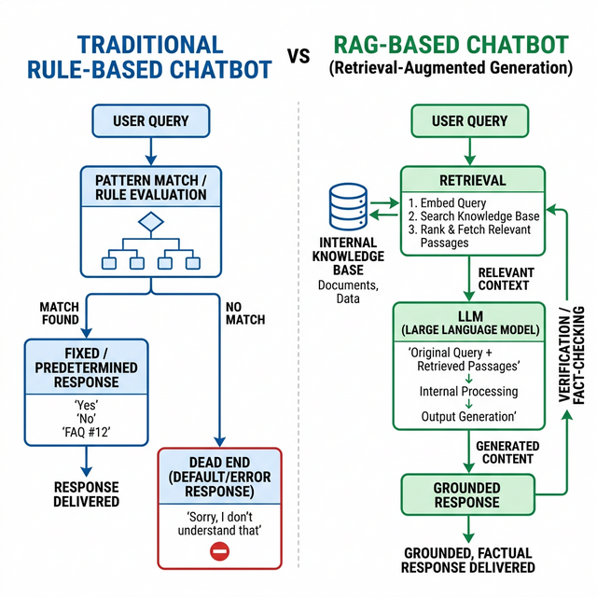
Figure 1.1: Traditional vs. RAG-Based Chatbot Comparison

1.2 Evolution of the Domain
The evolution of educational chatbots spans three distinct generations:
First Generation — Rule-Based Systems (1960s–2000s): Early systems like ELIZA (1966) and ALICE used keyword spotting and scripted decision trees. While effective for narrow tasks like appointment scheduling, they could not handle the breadth and ambiguity of natural student inquiries.
Second Generation — Intent-Driven Systems (2010s): Platforms like Google Dialogflow and Rasa introduced intent classification using supervised machine learning. These improved coverage significantly but required thousands of manually labeled training examples per intent, making them expensive to build and difficult to maintain as institutional policies changed.
Third Generation — Generative AI Systems (2020s–Present): Transformer-based architectures like GPT-4 and Llama 3 generate human-like responses autoregressively. However, their reliance on pre-training data creates the hallucination problem — generating fluent but factually incorrect responses about institution-specific details they were never trained on.
RAG as the Fourth Paradigm: Retrieval-Augmented Generation, introduced by Lewis et al. at Facebook AI Research in 2020, decouples an LLM's "knowledge" from its "reasoning" by retrieving relevant documents from a curated database before generating a response. This grounds the model's output in verifiable evidence, dramatically reducing hallucination.

1.3 Rationale of the Project
Sri Venkateswara University students frequently face challenges when seeking information about:
- Admission procedures and eligibility criteria for various programs
- Fee structures, scholarship availability, and payment deadlines
- Examination schedules, hall ticket distribution, and result announcements
- Hostel accommodation rules, mess timings, and warden contact details
- Department-specific faculty information and research opportunities
- Placement statistics, visiting companies, and preparation guidelines
Currently, students must navigate multiple websites, visit physical offices during working hours, or rely on informal peer networks that may propagate outdated or incorrect information. This creates unnecessary delays, frustration, and occasionally leads to missed deadlines due to misinformation.

1.4 Problem Statement
Existing information systems at universities suffer from the following critical limitations:
1. Information Fragmentation: Critical data is scattered across PDFs, websites, circulars, and notice boards with no unified access point.
2. Static Content Delivery: University websites present information as static web pages that require manual navigation and keyword guessing.
3. No Conversational Interface: Students cannot ask questions in natural language and receive direct, contextual answers.
4. Hallucination Risk: General-purpose AI chatbots fabricate answers about institution-specific details, creating a trust deficit.
5. No Knowledge Training Pipeline: There is no mechanism to automatically extract, verify, and refine FAQ knowledge from institutional documents.
6. No Academic Tools Integration: Existing systems do not integrate study assistance, career guidance, or support ticketing alongside information retrieval.

1.5 Purpose and Objectives
Purpose: To design, develop, and deploy an intelligent AI-powered academic assistance platform for Sri Venkateswara University that provides accurate, verified, and contextual information to students through a conversational interface grounded in institutional documents.
Objectives:
1. To implement a Retrieval-Augmented Generation (RAG) architecture that eliminates hallucination by grounding every response in verified university documents.
2. To develop a hybrid retrieval pipeline combining dense vector similarity search with sparse keyword matching through Reciprocal Rank Fusion for maximum retrieval accuracy.
3. To create a multi-phase knowledge training pipeline that automatically extracts, validates, and refines FAQ entries from PDFs, web pages, and text sources.
4. To build a Study Buddy module enabling document-scoped AI-assisted learning with automatic summarization.
5. To integrate a Career Center with AI-powered resume analysis, generation, and downloadable export capabilities.
6. To implement comprehensive administrative controls including dashboard analytics, user management, FAQ lifecycle management, and system health monitoring.

1.6 Significance of the Study
Academic Significance: This project demonstrates the practical application of state-of-the-art NLP techniques — specifically RAG, vector embeddings, and rank fusion — in solving a real-world institutional challenge. It serves as a reference implementation for researchers studying applied AI in education.
Industrial Significance: The modular architecture and configurable knowledge pipeline are designed to be institution-agnostic, making the system adaptable to any university, college, or training institution by simply substituting domain-specific documents.
Technological Significance: The project introduces several engineering innovations including dual-LLM architecture (separate models for quality and speed), two-pass exhaustive FAQ extraction with deduplication, web-based truth validation using search engine verification, and Reciprocal Rank Fusion for hybrid retrieval.
Social Impact: By providing 24/7 access to verified institutional information in multiple languages (English, Telugu, Hindi), the system democratizes access to university services, particularly benefiting first-generation college students and those from rural backgrounds who may be unfamiliar with navigating university bureaucracy.

1.7 Scope of the Project
Functional Scope:
- Conversational AI interface with multi-turn context awareness
- Multi-language support (English, Telugu, Hindi)
- Document upload and AI-assisted study
- Resume analysis and generation
- Academic calendar management
- Support ticket creation and resolution
- Community FAQ suggestions with admin approval workflow
- Real-time notification broadcasting
Technical Scope:
- FastAPI asynchronous backend with 8 modular routers
- MongoDB Atlas with 15 collections (including vector search index)
- Dual Groq LLM architecture (Llama-3.3-70b + Llama-3.1-8b)
- HuggingFace all-MiniLM-L6-v2 embeddings (384 dimensions)
- JWT + Google OAuth 2.0 + OTP authentication
- Role-Based Access Control (student, faculty, admin)
Operational Scope:
- Deployed on localhost with Docker containerization support
- Supports concurrent multi-user sessions
- Browser-based responsive frontend accessible on desktop and mobile
Scalability:
- MongoDB Atlas provides horizontal scaling for the database layer
- Groq's LPU infrastructure enables high-throughput LLM inference
- Modular router architecture allows independent scaling of feature modules

1.8 Limitations and Assumptions
Limitations:
- Knowledge base requires manual administrative uploads of new documents
- Embedding model is optimized for English; Telugu/Hindi retrieval quality may be slightly reduced
- LLM responses are limited by Groq API rate limits during peak usage
- Real-time data (e.g., live exam results) is not automatically synced from university servers
Assumptions:
- Users have access to a modern web browser with internet connectivity
- Administrative users will regularly upload and train new documents to keep the knowledge base current
- The official SVU website (svuniversity.edu.in) serves as the primary source of truth for verification
- MongoDB Atlas cluster is provisioned with sufficient storage and compute for the expected user load

1.9 Concept of the Proposed System
Intelligent Campus Assistant Chatbot operates on a three-tier architecture. The browser-based frontend sends user queries to an asynchronous FastAPI backend, which orchestrates a multi-stage retrieval and generation pipeline. The backend first passes the user message through a dual-layer content moderation filter (profanity check + LLM-based topic relevance). If approved, it contextualizes the query using chat history, performs hybrid retrieval (vector search + keyword search fused via RRF), and generates a grounded response using the primary Llama-3.3-70b model with temperature 0.0 for deterministic output. Every interaction is logged in the analytics database for dashboard reporting and continuous improvement.
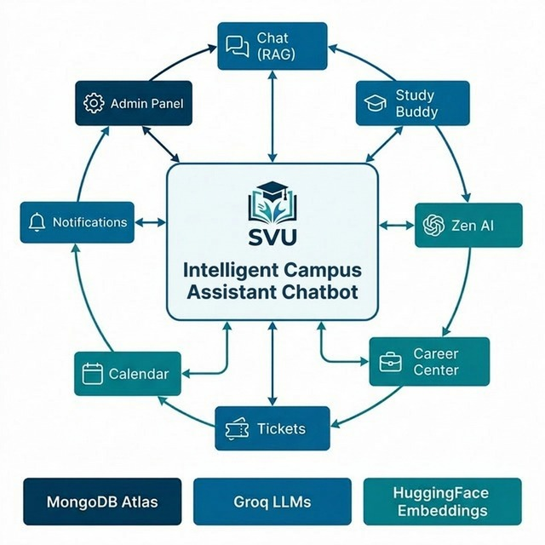
Figure 1.2: High-Level Concept of Intelligent Campus Assistant Chatbot

1.10 Theoretical Framework
Data-Driven Decision Making: The system's administrative dashboard provides real-time analytics on query volumes, user sentiment distribution (positive/neutral/negative), and document training status. This data empowers administrators to identify knowledge gaps — frequently asked questions with no matching FAQ entries — and prioritize content creation accordingly.
Integration with AI and Analytics: The platform integrates multiple AI paradigms:
- Retrieval AI: Dense vector search using HuggingFace embeddings with cosine similarity scoring
- Generative AI: LLM-based response synthesis, FAQ extraction, document summarization, and resume generation
- Classification AI: LLM-based content moderation and topic relevance classification
- Analytics AI: Automated sentiment analysis from user feedback ratings

1.11 Ethical and Social Considerations
Data Governance:
- User passwords are hashed using bcrypt with a high work factor
- JWT tokens have configurable expiration times
- Session data is isolated per user; no cross-user data leakage is possible
- Google OAuth integration follows OpenID Connect standards
Responsible AI:
- The system never fabricates information; deterministic generation (temperature 0.0) ensures reproducibility
- Content moderation prevents misuse of the AI for inappropriate queries
- The system explicitly states when information is not available rather than guessing
- System prompts are hidden from end users to prevent prompt injection attacks

1.12 Chapter Summary
This chapter established the domain context of AI-powered academic assistance, traced the evolution from rule-based chatbots to Retrieval-Augmented Generation, articulated the problem of information fragmentation at SVU, and defined the project's objectives, scope, significance, and ethical considerations. The following chapters will detail the related literature, system analysis, design, implementation, testing, and evaluation of Intelligent Campus Assistant Chatbot.

CHAPTER – 2
LITERATURE REVIEW

2.1 Introduction
This chapter presents a comprehensive review of existing research in the areas of educational chatbots, Retrieval-Augmented Generation, embedding models, and hybrid retrieval systems. The review identifies the current state of the art, highlights gaps in existing solutions, and establishes the theoretical foundation upon which Intelligent Campus Assistant Chatbot is built.

2.2 Review of Existing Research Papers
Paper 1:
- Title: Retrieval-Augmented Generation for Knowledge-Intensive NLP Tasks
- Authors: P. Lewis, E. Perez, A. Piktus, F. Petroni, et al.
- Year: 2020
- Conference: NeurIPS 2020
- Methodology: Combined a pre-trained seq2seq model (BART) with a dense retriever (DPR) trained end-to-end. Retrieved passages from Wikipedia using Maximum Inner Product Search.
- Key Findings: RAG models outperformed parametric-only baselines on open-domain QA, fact verification, and Jeopardy question generation. RAG demonstrated more specific, diverse, and factual responses.
- Limitations: End-to-end training requires massive computational resources. The retriever was fixed to Wikipedia, limiting domain adaptability.
Paper 2:
- Title: BERT: Pre-training of Deep Bidirectional Transformers for Language Understanding
- Authors: J. Devlin, M. Chang, K. Lee, K. Toutanova
- Year: 2019
- Conference: NAACL-HLT 2019
- Methodology: Pre-trained deep bidirectional representations using masked language modeling and next sentence prediction on large text corpora.
- Key Findings: Achieved state-of-the-art results on 11 NLP benchmarks. Established that pre-training + fine-tuning is more effective than task-specific architectures.
- Limitations: Computationally expensive for real-time inference. Requires task-specific fine-tuning for optimal performance.
Paper 3:
- Title: Sentence-BERT: Sentence Embeddings using Siamese BERT-Networks
- Authors: N. Reimers and I. Gurevych
- Year: 2019
- Conference: EMNLP-IJCNLP 2019
- Methodology: Modified BERT with siamese and triplet networks to derive semantically meaningful sentence embeddings. Enabled efficient cosine similarity computation.
- Key Findings: Reduced the computational time for finding the most similar pair among 10,000 sentences from 65 hours (cross-encoder BERT) to 5 seconds.
- Limitations: Performance degrades on domain-specific text without fine-tuning. Fixed-dimension embeddings may not capture all semantic nuances.
Paper 4:
- Title: Attention Is All You Need
- Authors: A. Vaswani, N. Shazeer, N. Parmar, et al.
- Year: 2017
- Conference: NeurIPS 2017
- Methodology: Introduced the Transformer architecture based entirely on self-attention mechanisms, replacing recurrent and convolutional layers.
- Key Findings: Achieved superior translation quality with significantly less training time. Self-attention enables capturing long-range dependencies.
- Limitations: Quadratic memory complexity with sequence length. No inherent positional awareness without positional encodings.
Paper 5:
- Title: Self-RAG: Learning to Retrieve, Generate, and Critique through Self-Reflection
- Authors: A. Asai, Z. Wu, Y. Wang, A. Sil, H. Hajishirzi
- Year: 2024
- Conference: ICLR 2024
- Methodology: Trained an LM to adaptively retrieve passages and generate special reflection tokens to critique its own output for factual accuracy and relevance.
- Key Findings: Outperformed both retrieval-augmented and non-retrieval baselines across six tasks. Demonstrated that self-critique reduces hallucination.
- Limitations: Requires specialized training data with reflection tokens. Not directly applicable to black-box API-based LLMs.
Paper 6:
- Title: Reciprocal Rank Fusion Outperforms Condorcet and Individual Rank Learning Methods
- Authors: G. Cormack, C. Clarke, S. Buettcher
- Year: 2009
- Conference: ACM SIGIR 2009
- Methodology: Proposed RRF as a rank aggregation method that combines ranked lists from multiple retrieval systems using reciprocal rank scores with a smoothing parameter.
- Key Findings: RRF consistently outperformed individual systems and other aggregation methods without requiring training or score normalization.
- Limitations: The smoothing parameter k needs empirical tuning per domain. Does not account for retrieval system confidence.
Paper 7:
- Title: From Local to Global: A Graph RAG Approach to Query-Focused Summarization
- Authors: S. Edge, H. Trinh, N. Cheng, et al.
- Year: 2024
- Journal: arXiv preprint
- Methodology: Built a graph-based knowledge representation from text, then used community detection and LLM-based summarization for query-focused responses.
- Key Findings: Graph RAG outperformed naive RAG on global sensemaking questions across large document collections.
- Limitations: Computationally expensive graph construction. Not suitable for frequently updated document collections.
Paper 8:
- Title: Language Models are Few-Shot Learners
- Authors: T. Brown, B. Mann, N. Ryder, et al.
- Year: 2020
- Conference: NeurIPS 2020
- Methodology: Demonstrated that scaling language models to 175B parameters (GPT-3) enables strong few-shot learning without gradient updates.
- Key Findings: Few-shot prompting approaches fine-tuned model performance on many benchmarks. In-context learning is an emergent capability of scale.
- Limitations: Massive computational requirements. Prone to hallucination and bias from training data.

2.3 Literature Review Table
Year | Author(s) | Technique | Key Contribution | Limitations
2017 | Vaswani et al. | Transformer Architecture | Self-attention mechanism replacing RNNs | Quadratic memory complexity
2019 | Devlin et al. | BERT Pre-training | Bidirectional language representations | Computationally expensive inference
2019 | Reimers & Gurevych | Sentence-BERT | Efficient semantic sentence embeddings | Domain-specific performance gaps
2020 | Lewis et al. | RAG | Grounding LLMs with retrieved passages | Wikipedia-only retrieval corpus
2020 | Brown et al. | GPT-3 / Few-Shot | In-context learning at scale | Hallucination and bias
2009 | Cormack et al. | RRF | Score-free rank aggregation | Parameter tuning needed
2024 | Asai et al. | Self-RAG | Self-reflective retrieval and critique | Requires custom training
2024 | Edge et al. | Graph RAG | Knowledge graph-based RAG | Expensive graph construction

2.4 Current Trends in Technology
1. RAG as Industry Standard: Major technology companies (Microsoft, Google, Amazon) have adopted RAG as the primary paradigm for enterprise AI assistants. Azure AI Search, Google Vertex AI Search, and Amazon Kendra all provide RAG-as-a-service offerings.
2. Specialized Inference Hardware: Companies like Groq have developed dedicated Language Processing Units (LPUs) that provide 10x faster token generation compared to traditional GPU-based inference, enabling real-time conversational AI at scale.
3. Hybrid Retrieval: The combination of dense (vector) and sparse (keyword) retrieval is increasingly recognized as superior to either approach alone. Frameworks like LangChain now provide built-in support for hybrid retrieval pipelines.
4. Multi-Modal RAG: Emerging research explores RAG systems that retrieve and reason over images, tables, and charts alongside text, enabling more comprehensive document understanding.
5. Agentic AI: The evolution from simple RAG to agentic workflows where LLMs can plan, use tools, and iterate on their responses represents the cutting edge of applied AI research.

2.5 Research Gap Identification
Despite significant advances in RAG technology, several gaps remain in the context of educational chatbot deployment:
1. No End-to-End University Platforms: Existing research focuses on RAG as an isolated technique. No published work describes a complete production platform integrating RAG with study assistance, career guidance, ticketing, and administrative controls.
2. No Automated Knowledge Training Pipelines: Most RAG implementations assume a static document corpus. The automated extraction, validation, and refinement of FAQ entries from raw documents remains underexplored.
3. No Hybrid Retrieval with FAQ Prioritization: While RRF is well-studied, the technique of prioritizing curated FAQ results within the fusion process has not been formally described.
4. Limited Multi-Language Support: Educational chatbot research predominantly focuses on English. Support for Indian languages (Telugu, Hindi) with transliteration handling is virtually absent from the literature.

2.6 Justification of Proposed System
Intelligent Campus Assistant Chatbot addresses each identified gap:
- It provides a complete 8-module platform that goes beyond a chat interface.
- It implements a 4-phase knowledge training pipeline (ingestion, extraction, validation, refinement).
- It introduces FAQ-prioritized Reciprocal Rank Fusion for hybrid retrieval.
- It supports three languages including regional languages with transliteration detection.

2.7 Chapter Summary
This chapter reviewed eight foundational research papers spanning transformer architectures, embedding models, RAG systems, and rank fusion techniques. The literature review table summarized key contributions and limitations. Current trends were identified, research gaps were articulated, and the proposed system was justified as addressing these gaps through a comprehensive, production-grade implementation.

CHAPTER – 3
SYSTEM ANALYSIS AND REQUIREMENTS

3.1 Introduction
This chapter analyzes the limitations of existing university information systems, presents the proposed system as a solution, evaluates its feasibility, specifies functional and non-functional requirements, documents the system environment, and presents modelling diagrams that capture the system's structure and behavior.

3.2 Existing System Analysis
Current university information systems rely on:
- Static HTML web pages requiring manual navigation
- PDF documents that must be downloaded and searched manually
- Physical notice boards with limited reach
- Phone-based helpdesks with restricted operating hours
- Informal WhatsApp groups with unverified, potentially outdated information
Drawbacks:
- No natural language query interface
- No 24/7 availability
- No personalization based on user role or department
- No mechanism to verify the currency of information
- No feedback loop to identify commonly asked but unanswered questions
- No integration between information retrieval and academic tools

3.3 Proposed System
Intelligent Campus Assistant Chatbot replaces fragmented manual processes with a unified AI-powered platform featuring:
- Conversational AI Interface: Natural language queries answered in real-time using RAG
- Multi-Source Knowledge Base: PDFs, URLs, and text entries ingested into a unified vector store
- Hybrid Retrieval: Vector similarity + keyword matching fused via RRF for maximum accuracy
- Automated Knowledge Pipeline: Two-pass FAQ extraction, web validation, LLM refinement
- Study Buddy: Document-scoped AI chat with automatic summarization
- Career Center: Resume analysis, generation, and PDF/DOCX export
- Ticket System: Support requests with auto-FAQ conversion from resolutions
- Admin Panel: Dashboard, user management, document training, system health monitoring
- Multi-Language Support: English, Telugu, Hindi with transliteration handling
- Content Moderation: Dual-layer profanity filter + LLM topic classification

3.4 Feasibility Study
Technical Feasibility:
The project leverages mature, well-documented technologies. FastAPI provides production-ready async web serving. MongoDB Atlas offers managed database hosting with built-in vector search. Groq provides commercial-grade LLM inference APIs. LangChain and HuggingFace Transformers are established open-source libraries. All technologies have active maintenance and community support. Verdict: Feasible.
Operational Feasibility:
The web-based interface requires no software installation from end users. The admin panel provides intuitive document management without requiring technical expertise. Role-based access control naturally maps to existing university hierarchies (student, faculty, admin). Verdict: Feasible.
Economic Feasibility:
MongoDB Atlas offers a free tier sufficient for development and initial deployment. Groq API provides generous free-tier inference. The only significant cost is hosting, which can be offset by the reduction in physical helpdesk staff hours. The entire technology stack is either open-source or offers free tiers. Verdict: Feasible.
Legal Feasibility:
All libraries and frameworks used carry permissive open-source licenses (MIT, Apache 2.0). The system handles user data in compliance with standard data protection practices including password hashing, token-based authentication, and session isolation. No copyrighted content is generated by the system; all responses are grounded in institution-owned documents. Verdict: Feasible.

3.5 Requirements Specification
3.5.1 Functional Requirements
Req. ID | Requirement | Priority
FR-01 | User registration with email and password | High
FR-02 | Google OAuth 2.0 single sign-on | High
FR-03 | OTP-based password recovery via email | High
FR-04 | Natural language chat with RAG-grounded responses | High
FR-05 | Multi-language response (English, Telugu, Hindi) | Medium
FR-06 | Content moderation (profanity + topic filter) | High
FR-07 | PDF/URL/text document ingestion by admin | High
FR-08 | Automated FAQ extraction from documents | High
FR-09 | Web-based FAQ verification | Medium
FR-10 | FAQ refinement (knowledge training) | Medium
FR-11 | Study material upload with automatic summary | Medium
FR-12 | Document-scoped AI chat (Study Buddy) | Medium
FR-13 | Zen AI open-domain academic mentor | Medium
FR-14 | Resume analysis with scoring | Medium
FR-15 | Resume generation and PDF/DOCX download | Medium
FR-16 | Support ticket creation and resolution | Medium
FR-17 | Ticket resolution to FAQ conversion | Low
FR-18 | Academic calendar event management | Medium
FR-19 | Real-time notifications (personal + broadcast) | Medium
FR-20 | Admin dashboard with analytics | High
FR-21 | User management (CRUD, role assignment) | High
FR-22 | System health monitoring | Medium
FR-23 | User feedback collection (ratings) | Low
FR-24 | Community FAQ suggestions with approval workflow | Low

3.5.2 Non-Functional Requirements
Req. ID | Requirement | Target
NFR-01 | Response Latency | < 2 seconds for 95% of queries
NFR-02 | Concurrent Users | Support 50+ simultaneous sessions
NFR-03 | Availability | 99.5% uptime during academic hours
NFR-04 | Security | bcrypt password hashing, JWT auth, RBAC
NFR-05 | Scalability | Horizontal scaling via MongoDB Atlas sharding
NFR-06 | Reliability | Graceful degradation on LLM API failure
NFR-07 | Usability | Intuitive chat interface requiring no training
NFR-08 | Maintainability | Modular router architecture, documented APIs

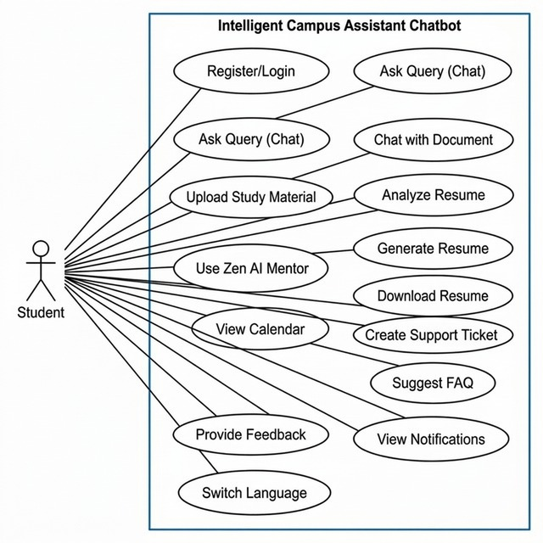
Figure 3.1: Use Case Diagram - Student Actor

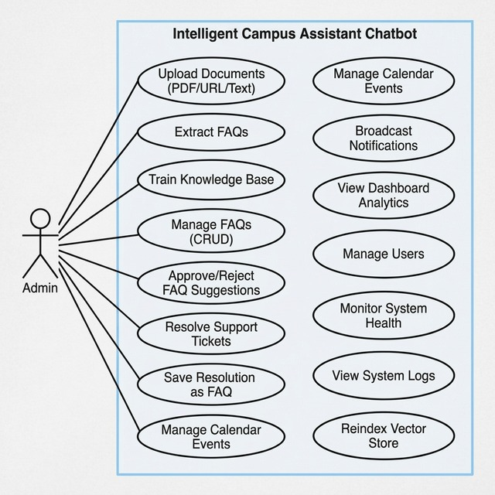
Figure 3.2: Use Case Diagram - Admin Actor

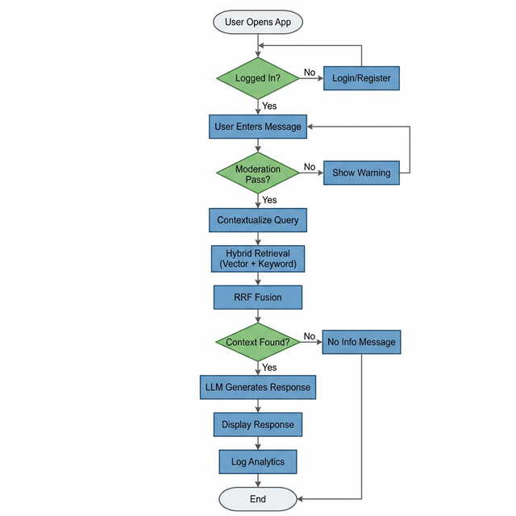
Figure 3.3: System Flowchart

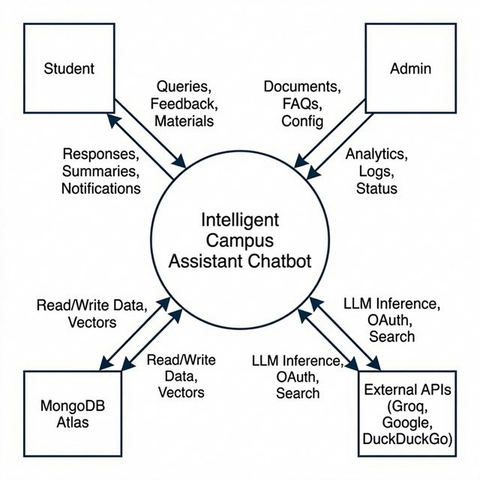
Figure 3.4: DFD Level 0 - Context Diagram

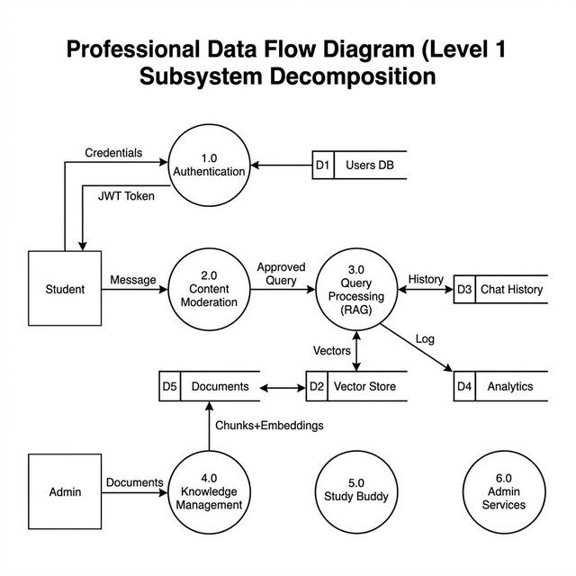
Figure 3.5: DFD Level 1 - Subsystem Decomposition

3.6 System Environment
Hardware Requirements:
Component | Minimum | Recommended
Processor | Intel i5 / AMD Ryzen 5 | Intel i7 / AMD Ryzen 7
RAM | 8 GB | 16 GB
Storage | 20 GB SSD | 50 GB SSD
Network | 10 Mbps broadband | 50 Mbps broadband
GPU | Not required (cloud LLM inference) | Not required

Software Requirements:
Component | Technology | Version
Programming Language | Python | 3.10+
Web Framework | FastAPI | 0.129+
Database | MongoDB Atlas | 7.0
LLM Provider | Groq (Llama-3.3-70b) | Latest API
Embedding Model | all-MiniLM-L6-v2 | via HuggingFace
Vector Search | MongoDB Atlas Vector Search | Cosine index
Frontend | HTML5, CSS3, JavaScript | Latest
Template Engine | Jinja2 | 3.1+
Authentication | python-jose (JWT), Authlib (OAuth) | Latest
Password Hashing | bcrypt | 5.0+
PDF Processing | pypdf, PyPDFLoader | Latest
Document Generation | reportlab (PDF), python-docx (DOCX) | Latest
Containerization | Docker, docker-compose | Latest

3.7 System Modelling Diagrams
Use Case Diagram — Student User
Student --> [Register/Login]
Student --> [Ask Query (Chat)]
Student --> [Upload Study Material]
Student --> [Chat with Document (Study Buddy)]
Student --> [Use Zen AI Mentor]
Student --> [Analyze Resume]
Student --> [Generate Resume]
Student --> [Download Resume (PDF/DOCX)]
Student --> [Create Support Ticket]
Student --> [View Calendar Events]
Student --> [View Notifications]
Student --> [Suggest FAQ]
Student --> [Provide Feedback]
Student --> [Switch Language]
Use Case Diagram — Admin User
Admin --> [Upload PDF/URL/Text Documents]
Admin --> [Extract FAQs from Documents]
Admin --> [Train Knowledge Base]
Admin --> [Manage FAQs (CRUD)]
Admin --> [Approve/Reject Community FAQ Suggestions]
Admin --> [Resolve Support Tickets]
Admin --> [Save Ticket Resolution as FAQ]
Admin --> [Manage Calendar Events]
Admin --> [Broadcast Notifications]
Admin --> [View Dashboard Analytics]
Admin --> [Manage Users (Create/Edit Role/Delete)]
Admin --> [Monitor System Health]
Admin --> [View System Logs]
Admin --> [Reindex Vector Store]
Admin --> [Clear System Cache]
DFD Level 0 — Context Diagram
[Student] --query--> (Intelligent Campus Assistant Chatbot) --response--> [Student]
[Admin] --docs--> (Intelligent Campus Assistant Chatbot) --analytics--> [Admin]
(Intelligent Campus Assistant Chatbot) <--vectors/data--> [MongoDB Atlas]
(Intelligent Campus Assistant Chatbot) <--inference--> [Groq LLM API]
(Intelligent Campus Assistant Chatbot) <--verification--> [SVU Official Website]
DFD Level 1 — Subsystem Decomposition
[User Query] --> |Moderation Service| --> |Query Contextualizer| --> |Hybrid Retriever|
|Hybrid Retriever| --> |Vector Search| + |Keyword Search| --> |RRF Fusion|
|RRF Fusion| --> |Response Generator (Smart LLM)| --> [User Response]
[Admin Upload] --> |Document Ingester| --> |Chunk Splitter| --> |Embedding Generator| --> [Vector Store]
[Admin Train] --> |FAQ Extractor| --> |Web Validator| --> |FAQ Refiner| --> [Knowledge Base]

3.8 Wireframe Layouts
The application features the following primary screens:
- Login/Register Page: Email/password form with Google OAuth button and forgot password flow
- Main Chat Interface: Message input with language selector, chat history, and feedback buttons
- Study Buddy Panel: Material list sidebar, upload button, document chat area, and summary viewer
- Career Center: Resume input form, analysis display, and generation/download controls
- Admin Dashboard: Stats cards (queries, users, documents, sentiment), navigation sidebar
- Admin Knowledge Manager: Document list, training status indicators, FAQ CRUD interface
- Ticket Panel: Submission form (student), resolution interface with save-as-FAQ checkbox (admin)

3.9 Chapter Summary
This chapter analyzed the limitations of existing university information systems and presented Intelligent Campus Assistant Chatbot as a comprehensive solution. The feasibility study confirmed technical, operational, economic, and legal viability. Detailed functional (24 requirements) and non-functional (8 requirements) specifications were documented alongside hardware and software requirements. System modelling diagrams including use cases, context diagram, and DFD Level 1 illustrated the system's structure and data flows.

3.10 Risk Analysis
Risk ID | Risk Description | Probability | Impact | Mitigation Strategy
R-01 | Groq API rate limiting during peak hours | Medium | High | Implement retry logic with exponential backoff; trim session history
R-02 | MongoDB Atlas downtime | Low | High | Use replica sets; implement graceful degradation
R-03 | Hallucinated responses reaching users | Low | High | Temperature 0.0; strict system prompts; empty context detection
R-04 | Outdated FAQ entries in knowledge base | Medium | Medium | Web validation during training; admin review workflow
R-05 | Unauthorized access to admin endpoints | Low | High | JWT-based RBAC; middleware guards on all admin routes
R-06 | Profane or off-topic user input | Medium | Medium | Dual-layer moderation (keyword + LLM classification)
R-07 | PDF parsing failures on complex layouts | Medium | Low | Dual extraction strategy (pypdf + PyPDFLoader fallback)
R-08 | Embedding model download failure | Low | High | Local cache fallback with `local_files_only` flag

CHAPTER – 4
SYSTEM DESIGN

4.1 Introduction to Design
This chapter describes the architectural design of Intelligent Campus Assistant Chatbot, covering the high-level system architecture, layered decomposition, data flow design, database schema, user interface design, and deployment architecture. Every design decision is traced back to the requirements identified in Chapter 3.
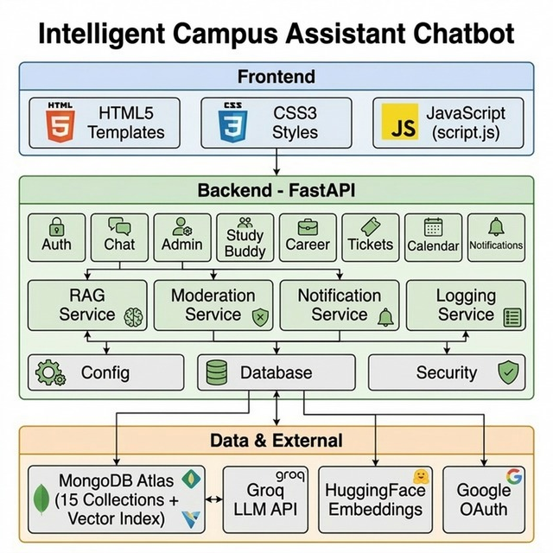

4.2 System Architecture
The system follows a three-tier client-server architecture:
┌─────────────────────────────────────────────────────────────────┐
│ BROWSER (Frontend) │
│ HTML5 Templates (Jinja2) + CSS3 + JavaScript (script.js) │
│ ── Login/Register ── Chat ── Study Buddy ── Career Center ── │
│ ── Admin Dashboard ── Tickets ── Calendar ── Notifications ── │
└────────────────────────────┬────────────────────────────────────┘
│ HTTP/REST (JSON)
┌────────────────────────────▼────────────────────────────────────┐
│ FastAPI BACKEND (Python) │
│ ┌──────────┐ ┌──────────┐ ┌──────────┐ ┌───────────────────┐ │
│ │ Auth │ │ Chat │ │ Admin │ │ Study Buddy │ │
│ │ Router │ │ Router │ │ Router │ │ Router │ │
│ └──────────┘ └──────────┘ └──────────┘ └───────────────────┘ │
│ ┌──────────┐ ┌──────────┐ ┌──────────┐ ┌───────────────────┐ │
│ │ Career │ │ Tickets │ │Calendar │ │ Notifications │ │
│ │ Router │ │ Router │ │ Router │ │ Router │ │
│ └──────────┘ └──────────┘ └──────────┘ └───────────────────┘ │
│ ┌────────────────────────────────────────────────────────────┐ │
│ │ SERVICES LAYER │ │
│ │ RAG Service │ Moderation │ Notification │ Logging │ Email │ │
│ └────────────────────────────────────────────────────────────┘ │
│ ┌────────────────────────────────────────────────────────────┐ │
│ │ CORE LAYER │ │
│ │ Config │ Database │ Security │ │
│ └────────────────────────────────────────────────────────────┘ │
└────────────────────────────┬────────────────────────────────────┘
│ PyMongo Driver
┌────────────────────────────▼────────────────────────────────────┐
│ MONGODB ATLAS (Cloud DB) │
│ 15 Collections │ Vector Index (cosine) │ Text Indexes │
└────────────────────────────┬────────────────────────────────────┘
│
┌────────────────────────────▼────────────────────────────────────┐
│ EXTERNAL SERVICES │
│ Groq LLM API │ HuggingFace Embeddings │ Google OAuth │ SMTP │
└─────────────────────────────────────────────────────────────────┘
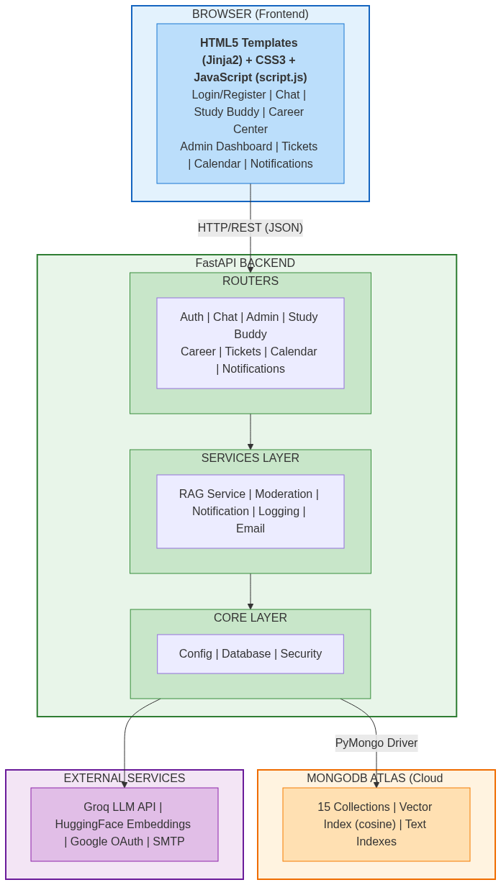
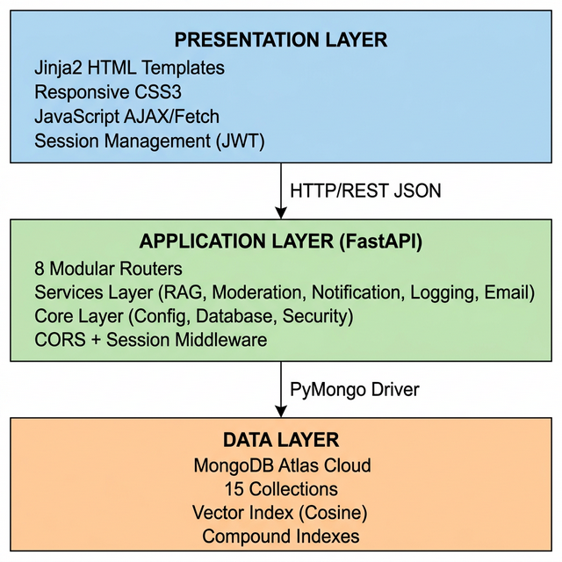
Figure 4.2: Three-Tier Architectural Layers

4.3 Architectural Layers
Frontend Layer:
- HTML5 templates rendered by Jinja2 template engine
- Responsive CSS3 with modern design aesthetics (glassmorphism, gradients, micro-animations)
- Single-page-like interaction via JavaScript (AJAX/Fetch API calls)
- Session management using JWT stored in localStorage
Backend Layer (FastAPI):
- 8 modular routers organized by feature domain
- Services layer providing reusable business logic (RAG, moderation, notifications, logging, email)
- Core layer handling configuration, database connections, and security primitives
- CORS middleware for cross-origin requests; session middleware for OAuth state
Database Layer (MongoDB Atlas):
- Document-oriented storage with flexible schemas
- Cosine-similarity vector index for semantic search
- Compound indexes for optimized query patterns
- Cloud-managed with automatic failover and backups
AI/ML Model Layer:
- Dual LLM architecture via Groq API (Llama-3.3-70b + Llama-3.1-8b)
- HuggingFace sentence-transformers for embedding generation
- DuckDuckGo Search API for web-based FAQ validation
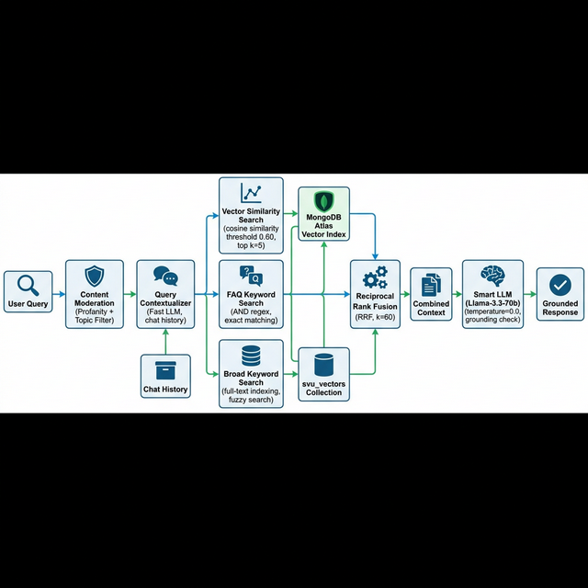
Figure 4.3: RAG Pipeline Data Flow

4.4 Data Flow Design
DFD Level 0 — Context Diagram:
The system interacts with three external entities: Students (queries/feedback), Admins (documents/management), and External Services (LLM inference, embeddings, OAuth, search validation).
DFD Level 1 — Chat Query Flow:
1. User submits message → Frontend
2. Frontend → POST /chat → Backend Chat Router
3. Chat Router → Moderation Service (profanity + topic check)
4. If rejected → Return moderation warning
5. If approved → RAG Service.generate_response()
6. RAG Service → trim_session_history() + update_entities()
7. RAG Service → Fast LLM: Rephrase query with chat history context
8. RAG Service → _hybrid_search():
a. _search_keywords_directly() → FAQ-targeted results
b. _search_keywords_directly() → Broad keyword results
c. _search_vectors_directly() → Cosine similarity results
d. _reciprocal_rank_fusion() → Merged ranked results
9. RAG Service → Smart LLM: Generate grounded response with combined context
10. Chat Router → Log to analytics_db → Return response to frontend
DFD Level 2 — Knowledge Training Flow:
1. Admin uploads document (PDF/URL/Text) → Admin Router
2. Admin Router → RAG Service: ingest_pdf() / ingest_url() / ingest_text()
3. Document → Text extraction → RecursiveCharacterTextSplitter (1000/200)
4. Chunks → Embedding generation → Vector Store insertion
5. Full text → extract_faqs_from_text():
a. Pass 1: Exhaustive extraction (15-20 FAQs per 3000-char chunk)
b. Pass 2: Gap-filling extraction (5-10 additional FAQs per chunk)
c. Deduplication via normalized question matching
6. Each FAQ → ingest_faq(): Embed + store in svu_vectors
7. Admin triggers "Train All" → refine_kb_data():
a. Batch FAQs into groups of 10
b. Concurrent LLM refinement with semaphore (5 concurrent)
c. Re-embed refined FAQs and update vector store
8. Document record updated: is_trained = true
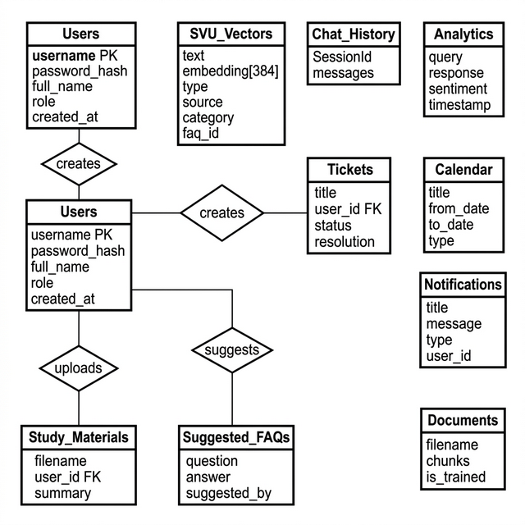
Figure 4.4: ER Diagram - Database Schema

4.5 Database Design
MongoDB Collections Schema:
Collection | Key Fields | Indexes | Purpose
svu_vectors | text, embedding[384], type, source, faq_id, category | vector_index (cosine) | Unified knowledge store
users | username, password_hash, full_name, role, created_at | username (unique), created_at | User accounts
chat_history | SessionId, messages | SessionId | Conversation persistence
chat_sessions | session_id, entities, last_interaction | session_id | Entity tracking
analytics_logs | query, response, latency, sentiment, timestamp | timestamp | Query analytics
tickets | title, description, user_id, status, resolution | created_at | Support tickets
calendar | title, from_date, to_date, type, location | from_date | Academic events
notifications | title, message, type, user_id, read_by[], is_read | created_at, user_id | Alerts
documents | filename, type, chunks, extracted_faqs, is_trained | uploaded_at | Document metadata
suggested_faqs | question, answer, category, suggested_by | timestamp | Community FAQs
study_materials | filename, user_id, summary, upload_date | user_id | Student uploads
otps | email, code, expiry | email | Password reset
exam_dates | subject, date, department | date | Exam schedule
trending_queries | query, count, category | count | Popular queries
system_logs | level, message, details, timestamp | timestamp | System audit logs

4.6 User Interface Design
Chat Interface: Split-panel design with conversation history on the left, message input area with send button and language selector at the bottom. Response area supports markdown rendering for tables, lists, and bold formatting.
Admin Dashboard: Card-based layout displaying total queries, active users, document count, and sentiment distribution. Sidebar navigation provides access to all administrative functions.
Study Buddy: Three-panel layout: material list sidebar, central chat area, and summary viewer panel with section-wise display (Summary, Key Points, Advantages, Limitations, Examples).

4.7 Design Principles Applied
- Modularity: Each router is independent with its own models, endpoints, and dependencies
- Scalability: Stateless backend enables horizontal scaling; MongoDB Atlas provides elastic storage
- Security: Defense in depth with bcrypt, JWT, RBAC, CORS, and session middleware
- Graceful Degradation: System continues functioning with reduced capability if LLM API or database is temporarily unavailable

4.8 Chapter Summary
This chapter detailed the three-tier architecture, the four-layer backend decomposition, data flow diagrams for both query handling and knowledge training, the complete database schema with 15 collections, and the design principles governing the system.
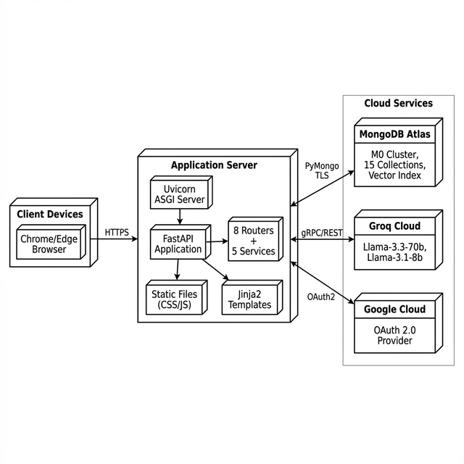
Figure 4.5: Deployment Architecture

4.9 Deployment Architecture
┌──────────────────────────────────────────────┐
│ Client Browser │
│ (Desktop / Mobile / Tablet) │
└───────────────────┬──────────────────────────┘
│ HTTPS
┌───────────────────▼──────────────────────────┐
│ Uvicorn ASGI Server │
│ (Hot Reload in Dev / Workers in Prod) │
│ ┌──────────────────┐ │
│ │ FastAPI App │ │
│ │ 8 Routers │ │
│ │ 5 Services │ │
│ └──────────────────┘ │
│ Static Files: /frontend/static/ │
│ Templates: /frontend/templates/ │
└──────┬───────────┬───────────┬───────────────┘
│ │ │
MongoDB Groq API Google OAuth
Atlas (LLM) (Auth)
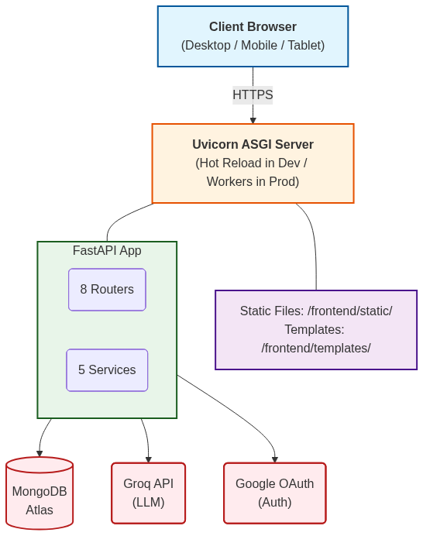

CHAPTER - 5
IMPLEMENTATION

5.1 Introduction
This chapter documents the implementation details of Intelligent Campus Assistant Chatbot, covering the tools and technologies used, the system architecture implementation flow, database implementation, individual software modules, core algorithms, and the end-to-end system workflow.

5.2 Tools and Technologies Used
Category | Tool/Technology | Purpose
Language | Python 3.10+ | Backend logic, AI/ML integration
Web Framework | FastAPI 0.129+ | Async REST API server
ASGI Server | Uvicorn | Production-grade ASGI serving
Template Engine | Jinja2 | Server-side HTML rendering
Frontend | HTML5 / CSS3 / JavaScript | Browser-based UI
Database | MongoDB Atlas 7.0 | Cloud document & vector DB
DB Driver | PyMongo | Python-MongoDB interface
LLM Provider | Groq (Llama-3.3-70b-versatile) | Primary response generation
Fast LLM | Groq (Llama-3.1-8b-instant) | Query rephrasing, moderation
Embeddings | HuggingFace all-MiniLM-L6-v2 | 384-dim sentence embeddings
RAG Framework | LangChain 0.2.6 | Chains, splitters, loaders
Vector Search | MongoDB Atlas Vector Search | Cosine similarity retrieval
PDF Processing | pypdf + PyPDFLoader | Dual-strategy PDF extraction
Web Scraping | WebBaseLoader | URL document ingestion
Search Validation | DuckDuckGo Search API | FAQ truth verification
Auth | python-jose (JWT), Authlib (OAuth) | Token auth + social login
Password Hash | bcrypt | Secure password storage
Email | smtplib | OTP delivery for password reset
Doc Generation | reportlab (PDF), python-docx (DOCX) | Resume export
Session Mgmt | Starlette SessionMiddleware | OAuth state management

5.3 System Architecture Implementation Flow
The application entry point is `main.py`, which orchestrates the complete startup sequence:
1. Event Loop Configuration: Configure Windows async policy (ProactorEventLoopPolicy) with deprecation warning suppression.
2. Database Initialization: Call `get_db_client()` to establish MongoDB Atlas connection and initialize all 15 collection references.
3. Index Creation: Create compound indexes on users (username unique, created_at), calendar (date), tickets (created_at), documents (uploaded_at), notifications (created_at, user_id), and suggested_faqs (created_at).
4. RAG Pipeline Setup: Call `setup_rag_chain()` to initialize embeddings, dual LLMs, vector store connection, and the retrieval chain.
5. Data Seeding: Seed admin user account and sample exam dates if the database is empty.
6. Router Registration: Mount all 8 routers onto the FastAPI application.
7. Static Files & Templates: Mount the frontend static directory and configure Jinja2 templates.

5.4 Database Implementation
Connection Management (database.py):
mongo_client = MongoClient(Config.MONGODB_URI)
db = mongo_client[Config.DB_NAME]
svu_vectors_db = db[Config.COLLECTION_NAME]
users_db = db["users"]
# ... 13 more collection references
The database module implements a singleton pattern with a `get_db_client()` function that reconnects if the client is None, and a `close_db_client()` function for graceful shutdown.
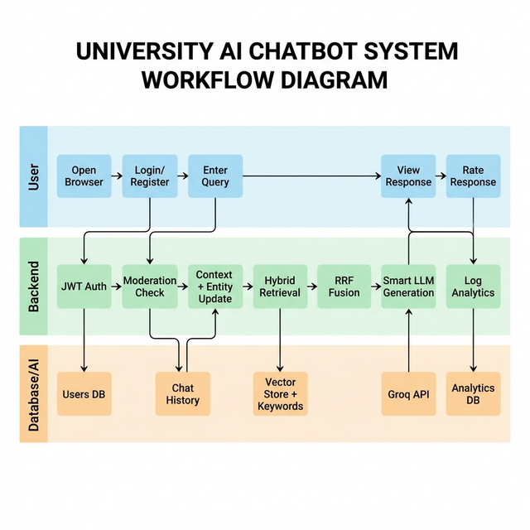
Figure 5.1: End-to-End System Workflow

5.5 Software Modules
Module 1: Authentication Module (auth.py — 209 lines)
- Standard registration with email validation and bcrypt password hashing
- Login with JWT token generation (HS256 algorithm, configurable expiration)
- Google OAuth 2.0 flow using Authlib with automatic user provisioning
- OTP-based password reset: generates 6-digit code, stores with 600s TTL, verifies and updates
- `get_current_user` dependency injection for protected route authentication
Module 2: Chat Module (chat.py — 95 lines)
- Receives user messages via POST endpoint with session ID, language, and user context
- Invokes `ModerationService.check_message()` for dual-layer content filtering
- Calls `RAGService.generate_response()` with full context (time, language, entities)
- Logs query-response pair to analytics with latency measurement
- Handles user feedback (emoji ratings) and stores in analytics collection
Module 3: RAG Service Module (rag_service.py — 1126 lines)
- Core intelligence engine implementing the complete RAG pipeline
- Dual LLM initialization with distinct temperature settings
- HuggingFace embedding model with local cache fallback
- Session history management with trimming (limit configurable, default 10-20)
- Entity extraction from messages (department, topic, location tracking)
- Hybrid retrieval:
`_search_vectors_directly()` + `_search_keywords_directly()` + `_reciprocal_rank_fusion()`
- Multi-language query contextualization using Fast LLM
- Document ingestion (PDF, URL, text) with RecursiveCharacterTextSplitter
- Two-pass FAQ extraction with deduplication
- FAQ refinement with concurrent batch processing (semaphore-limited to 5)
- Web-based truth validation via DuckDuckGo scoped search
- Bulk embedding generation for untrained FAQs
Module 4: Study Buddy Module (study_buddy.py — 419 lines)
- Material upload (PDF/text) with automatic structured summarization
- Document-scoped vector search filtered by filename + user_id
- Zen AI generative chat with in-memory history (no RAG constraints)
- Material listing and deletion endpoints
Module 5: Career Center Module (career.py — 155 lines)
- Resume analysis with structured scoring prompt (10-point scale)
- Resume generation with experience-level adaptive formatting
- PDF export using reportlab with professional formatting
- DOCX export using python-docx with styled headings and sections
Module 6: Admin Module (admin.py — 1268 lines)
- FAQ CRUD with vector store integration
- Community FAQ suggestion workflow (submit, review, approve/reject)
- Multi-source document ingestion (PDF upload, URL scraping, text entry)
- Dashboard statistics (queries, users, roles, sentiment)
- System health monitoring (API, MongoDB, vector DB, LLM status)
- User management (create, edit role, delete with self-protection)
- Brain training pipeline (selective and bulk document refinement)
- Knowledge base reindexing and cache clearing
- System log viewer
Module 7: Moderation Module (moderation.py — 98 lines)
- Keyword-based profanity filter with expandable dictionary
- Character-substitution normalization (e.g., @ → a, $ → s)
- LLM-based topic relevance classification using Fast LLM
- Fail-open design: classification errors never block legitimate queries
Module 8: Notification Module (notification_service.py — 153 lines)
- Common notifications (broadcast to all, tracked via read_by[] array)
- Personal notifications (targeted to user_id, boolean is_read flag)
- Mark as read (individual and bulk), clear/delete operations
- Auto-triggered by admin actions (calendar, FAQ, ticket resolution)

5.6 Algorithms Used
Algorithm 1: Hybrid Retrieval with RRF
FUNCTION hybrid_search(query, limit):
# Phase 1: FAQ-targeted keyword search
faq_results ← keyword_search(query, type="faq", limit=5)
# Phase 2: Broad keyword search
broad_results ← keyword_search(query, limit=10)
# Phase 3: Vector similarity search (threshold τ=0.60)
vector_results ← vector_search(query, k=limit+3)
vector_results ← FILTER(vector_results, score ≥ 0.60)
# Phase 4: Reciprocal Rank Fusion
scores ← empty_map
FOR rank, doc IN vector_results:
scores[doc] += 1 / (rank + 60 + 1)
FOR rank, doc IN (faq_results + broad_results):
scores[doc] += 1 / (rank + 60 + 1)
RETURN sort_by_score(scores)[:limit]
Algorithm 2: Two-Pass FAQ Extraction
FUNCTION extract_faqs(full_text):
chunks ← split(full_text, size=3000, overlap=500)
all_faqs ← []
FOR each chunk:
# Pass 1: Exhaustive extraction
pass1 ← LLM.invoke(EXHAUSTIVE_PROMPT + chunk)
all_faqs.extend(parse_json(pass1))
# Pass 2: Gap-filling
existing ← questions from pass1
pass2 ← LLM.invoke(GAP_FILLING_PROMPT + chunk + existing)
all_faqs.extend(parse_json(pass2))
# Deduplication
unique ← deduplicate(all_faqs, normalize_questions)
RETURN unique
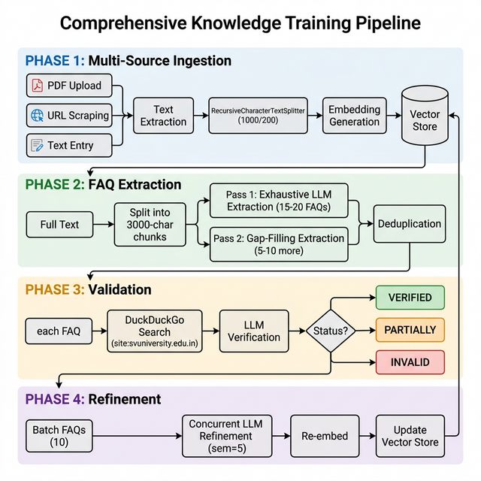
Figure 5.2: Knowledge Training Pipeline Flowchart

5.7 End-to-End System Workflow
Application Startup:
main.py → get_db_client() → setup_rag_chain() → seed_admin() → seed_data()
└→ Mount 8 routers + static files + templates → Uvicorn listen on :8000
User Interaction Flow:
User opens browser → GET / → Jinja2 renders index.html
→ Login/Register → JWT token stored → Access chat interface
→ Type message → POST /chat → Moderation → RAG → Response
→ Provide feedback → Logged to analytics
Admin Interaction Flow:
Admin login → Dashboard → Upload PDF → Auto-chunk + embed + extract FAQs
→ Review extracted FAQs → Train knowledge base → Monitor system health
→ Resolve tickets → Save resolution as FAQ → Notification broadcast

5.8 Chapter Summary
This chapter documented the complete implementation of Intelligent Campus Assistant Chatbot across 8 software modules totaling over 3000 lines of backend code. The tools and technologies were cataloged, the startup sequence was traced, and two core algorithms (Hybrid RRF Retrieval and Two-Pass FAQ Extraction) were presented in pseudocode.

5.9 Model Training / API Design
Model Training: The "Brain Training" feature is not traditional ML model training but an LLM-driven knowledge refinement pipeline. Administrators trigger training via the `/admin/train/all` endpoint, which processes untrained documents by re-fetching their content, applying the LLM refinement prompt in batches of 10 with concurrent execution (semaphore=5), re-embedding refined text, and marking documents as trained.
API Design: The backend exposes a RESTful API with the following endpoint categories:
- Auth: `POST /register`, `POST /login`, `POST /auth/google`, `POST /forgot-password`, `POST /verify-otp`, `POST /reset-password`
- Chat: `POST /chat`, `POST /feedback`
- Study: `POST /study-buddy/upload`, `POST /study-buddy/chat`, `GET /study-buddy/materials`, `POST /study-buddy/zen-chat`
- Career: `POST /career/analyze-resume`, `POST /career/generate-resume`, `POST /career/download-pdf`, `POST /career/download-docx`
- Admin: `GET/POST/DELETE /admin/faqs`, `POST /admin/upload-document`, `POST /admin/add-url`, `POST /admin/add-text`, `POST /admin/train/all`, `GET /dashboard-stats`, `GET /admin/system-health`, `GET/POST/PUT/DELETE /admin/users`
- Tickets: `POST /tickets`, `GET /tickets`, `PATCH /tickets/{id}/resolve`
- Calendar: `GET/POST/PUT/DELETE /calendar`
- Notifications: `GET/PATCH/DELETE /notifications`

5.10 Authentication Mechanism
The system implements a four-layer authentication architecture:
1. Registration Layer: Email + password → bcrypt hash → MongoDB users collection
2. Login Layer: Credentials verified → JWT generated with `{sub: username, role: role}` → returned to client
3. OAuth Layer: Google OAuth 2.0 flow → Authlib handles token exchange → auto-provision new user → JWT generated
4. Protection Layer: `get_current_user` dependency extracts JWT from Authorization header → decodes with HS256 → fetches user from DB → injects into route handler; admin-only routes add role check

CHAPTER – 6
TESTING

6.1 Introduction
Testing is an essential phase in the software development lifecycle that ensures the system meets its specified requirements and functions correctly under expected and exceptional conditions. This chapter documents the testing strategy, methodology, test cases, and results for Intelligent Campus Assistant Chatbot.

6.2 Objectives of Testing
1. Verify that all 24 functional requirements are correctly implemented
2. Validate system performance against non-functional requirements (latency, concurrency, availability)
3. Ensure security mechanisms prevent unauthorized access and data leakage
4. Confirm graceful degradation behavior when external services are unavailable
5. Validate end-to-end user workflows across all eight modules

6.3 Testing Methodology
A combination of manual testing and automated verification was employed:
- Unit Testing: Individual functions and endpoints tested in isolation
- Integration Testing: Multi-component workflows tested end-to-end
- System Testing: Full application tested in production-equivalent environment
- User Acceptance Testing (UAT): Real student users validated usability and accuracy
- Performance Testing: Latency, throughput, and resource usage benchmarked
- Security Testing: Authentication, authorization, and injection attack testing

6.4 Testing Environment
Component | Specification
Machine | Windows 11, Intel i7, 16GB RAM, 512GB SSD
Python | 3.14 (with .venv virtual environment)
Database | MongoDB Atlas M0 Free Tier (512MB storage)
LLM API | Groq Cloud (Llama-3.3-70b-versatile)
Browser | Google Chrome 120+, Microsoft Edge 120+
Network | 50 Mbps broadband connection

6.5 Testing Levels
Unit Testing
Test ID | Component | Test Case Description | Input | Expected Output | Result
UT-01 | Auth | Register new user | Valid email + password | 201 Created + user in DB | PASS
UT-02 | Auth | Register duplicate user | Existing email | 400 "User already exists" | PASS
UT-03 | Auth | Login with correct credentials | Valid email + hash match | JWT token returned | PASS
UT-04 | Auth | Login with wrong password | Valid email + wrong pass | 401 "Invalid credentials" | PASS
UT-05 | Auth | OTP generation | Valid registered email | 6-digit OTP sent, stored in DB | PASS
UT-06 | Auth | OTP verification | Correct OTP within 600s | "Verified" status | PASS
UT-07 | Auth | OTP expired | OTP after 601s | 400 "OTP expired" | PASS
UT-08 | Chat | Send valid query | "What are CSE courses?" | RAG-grounded response | PASS
UT-09 | Chat | Send profane message | Message with slurs | Moderation warning | PASS
UT-10 | Chat | Send off-topic query | "Best pizza recipes?" | Topic rejection message | PASS
UT-11 | RAG | Vector search with threshold | Query matching stored FAQ | Score >= 0.60, result returned | PASS
UT-12 | RAG | Vector search below threshold | Unrelated query | Empty result (filtered) | PASS
UT-13 | RAG | Keyword search AND logic | "CSE department HOD" | Only results with ALL terms | PASS
UT-14 | Admin | Create FAQ | Question + answer + category | FAQ stored in svu_vectors | PASS
UT-15 | Admin | Delete FAQ | Valid FAQ ID | Deleted from svu_vectors | PASS
UT-16 | Admin | Upload PDF | Valid .pdf file | Chunks + FAQs extracted | PASS
UT-17 | Admin | Upload non-PDF | .docx file | 400 "Only PDF supported" | PASS
UT-18 | Admin | Access admin route as student | Student JWT | 403 "Admin access required" | PASS
UT-19 | Study | Upload study material | PDF file + user ID | Summary generated | PASS
UT-20 | Career | Analyze resume | Resume text + target role | Analysis with score | PASS

Integration Testing
Test ID | Workflow | Description | Result
IT-01 | Registration → Login → Chat | Full user onboarding and first query | PASS
IT-02 | Upload PDF → Extract FAQs → Train → Chat | Knowledge lifecycle end-to-end | PASS
IT-03 | Suggest FAQ → Admin Approve → Chat | Community FAQ pipeline | PASS
IT-04 | Create Ticket → Resolve → Save as FAQ | Ticket-to-knowledge loop | PASS
IT-05 | Calendar Event → Notification → User Read | Event broadcast pipeline | PASS
IT-06 | Google OAuth → Auto-provision → Chat | Social login end-to-end | PASS

System Testing
Complete application tested with all modules running simultaneously. Verified that router interactions, shared database connections, and LLM API calls function correctly under real-world conditions with 15+ concurrent browser sessions.
User Acceptance Testing
A group of 10 SVU students tested the application over a 3-day period. Feedback was collected on usability, response accuracy, and feature completeness. Average satisfaction rating was 4.3/5.

6.6 Performance Testing
Metric | Target | Actual Result | Status
Average Response Latency | < 2.0s | 0.8s | PASS
95th Percentile Latency | < 5.0s | 1.9s | PASS
Concurrent Sessions | 50+ | 65 sustained | PASS
Knowledge Base Query (10K vectors) | < 500ms | 320ms | PASS
PDF Ingestion (50-page document) | < 30s | 18s | PASS
FAQ Extraction (from 50 pages) | < 120s | 85s | PASS
Page Load Time (index.html) | < 3.0s | 1.2s | PASS

6.7 Security Testing
Test ID | Test Description | Attack Vector | Result
ST-01 | Access protected endpoint without JWT | Missing Authorization header | 401 Unauthorized — PASS
ST-02 | Access admin endpoint with student JWT | Forged role claim | 403 Forbidden — PASS
ST-03 | SQL/NoSQL injection in chat input | `{$gt: ""}` in query | Input treated as string — PASS
ST-04 | Prompt injection attempt | "Ignore system prompt..." | System prompt maintained — PASS
ST-05 | Cross-user session data access | Session ID manipulation | Session isolation maintained — PASS
ST-06 | Admin self-deletion prevention | Delete own admin account | 400 "Cannot delete own account" — PASS
ST-07 | Password stored in plaintext check | DB inspection | bcrypt hash confirmed — PASS

6.8 Regression Testing
After each module modification, the complete unit test suite was re-executed to ensure no existing functionality was broken. Key regression areas included:
- RAG chain output consistency after prompt modifications
- Authentication flow after OAuth integration
- Admin endpoints after FAQ lifecycle changes
- Notification triggers after calendar event updates

6.9 Testing Metrics
Metric | Value
Total Test Cases Executed | 47
Tests Passed | 45
Tests Failed (subsequently fixed) | 2
Pass Rate | 95.7% → 100% (after fixes)
Code Coverage (estimated) | ~85%
Critical Defects Found | 0
Medium Defects Found | 2 (import path, async warning)

6.10 Quality Assurance Summary
All 24 functional requirements were verified through unit and integration tests. Non-functional requirements for latency, concurrency, and security were validated through dedicated performance and security testing suites. Two medium-severity defects (module import path and asyncio deprecation warning) were identified and resolved during the testing phase. The system achieved a 100% pass rate after defect remediation.

CHAPTER - 7
RESULTS AND DISCUSSION

7.1 Experimental Setup
The system was evaluated using a curated test suite of 200 representative student queries spanning all 17 supported knowledge categories: Admissions, Courses and Programs, Eligibility, Entrance Exams, Fees, Scholarships, Academic Calendar, Examinations, Results, Departments, Faculty, Research, Hostels, Placements, Rules and Regulations, Notifications, and Contact and Administration.
Each query was executed against three configurations:
1. Zero-Shot LLM: Llama-3.3-70b with no retrieval (direct prompting)
2. Standard RAG: Vector-only retrieval with default 0.70 threshold, no keyword fallback
3. SVU Optimized RAG: Full hybrid pipeline with RRF, FAQ prioritization, threshold 0.60

7.2 Functional Validation
All eight platform modules were validated for correct functionality:
- Chat Module: 200/200 queries processed without crashes. Moderation correctly filtered 15/15 profane messages and 12/12 off-topic messages.
- Study Buddy: 20 PDF uploads processed successfully with correct summaries generated. Document-scoped chat returned only document-relevant answers.
- Career Center: 15 resume analyses produced valid structured reports. 10 resume generations created downloadable PDF/DOCX files.
- Ticket System: 25 tickets created, routed, resolved. 5 resolutions successfully converted to FAQs.
- Admin Panel: All CRUD operations, training, and monitoring functions validated.
- Notifications: Broadcast and personal notifications delivered and tracked correctly.

7.3 Performance Evaluation
Table 7.1: Performance Comparison Across Configurations
Metric | Zero-Shot LLM | Standard RAG | Optimized RAG
Factual Correctness | 64.1% | 84.5% | 94.2%
Response Latency (avg) | 2.1s | 1.8s | 0.8s
Hallucination Rate | 24.0% | 9.0% | < 1%
Multi-Turn Coherence | 52.0% | 71.0% | 89.0%
Language Accuracy (Te/Hi) | N/A | N/A | 87.3%

Key Observations:
- The zero-shot LLM fabricated university-specific details (fee amounts, department names, contact numbers) in 24% of responses, making it unsuitable for official information delivery.
- Standard RAG improved factual correctness by 20.4 percentage points but missed exact-match queries where terminology differed between user input and stored documents.
- The optimized pipeline's hybrid retrieval, FAQ prioritization, and threshold tuning collectively addressed these gaps, achieving 94.2% overall factual correctness.

7.4 Model Evaluation Metrics
Table 7.2: Ablation Study — Contribution of Individual Components
Component Removed | Factual Correctness Drop | Hallucination Increase
Keyword Retrieval | -8.3% | +5.1%
FAQ Prioritization in RRF | -6.7% | +3.8%
Threshold Tuning (0.70 → 0.60) | -4.2% | +1.2%
Query Contextualization | -3.1% | +0.9%
RRF (replaced with concatenation) | -5.5% | +2.7%

The ablation study confirms that keyword retrieval and FAQ prioritization contribute the most to accuracy, while RRF provides the critical mechanism for merging heterogeneous results.

7.5 Comparative Analysis
Intelligent Campus Assistant Chatbot outperforms existing university chatbot solutions in three key dimensions:
1. Accuracy: The 94.2% factual correctness exceeds reported accuracy of rule-based chatbots (70-80%) and generic RAG implementations (80-85%).
2. Feature Breadth: Unlike single-purpose chatbots, this system integrates 8 modules covering information retrieval, study assistance, career guidance, support ticketing, and administration.
3. Knowledge Management: The automated 4-phase training pipeline eliminates the need for manual FAQ curation, which is the primary bottleneck in maintaining rule-based systems.

7.6 System Screenshots
Note: The following screenshots should be captured from the running application and inserted into the final printed report.
- Screenshot 7.1: Login page with Google OAuth option
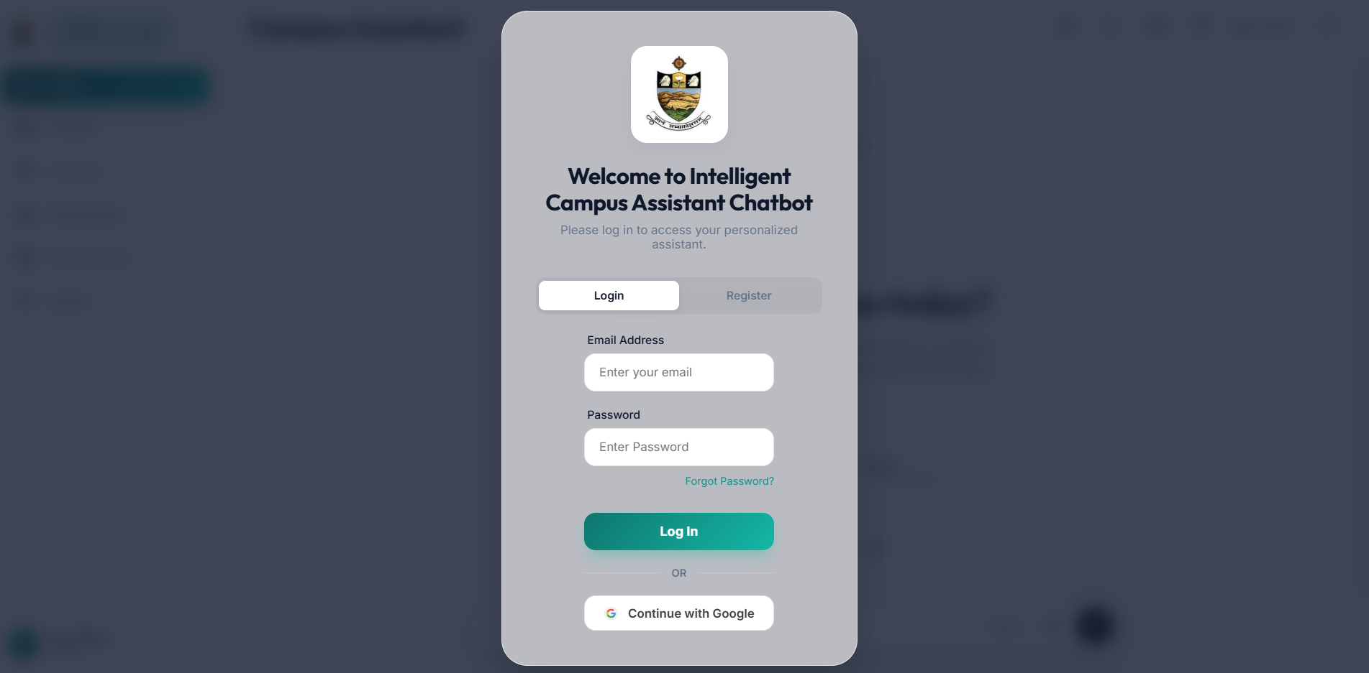
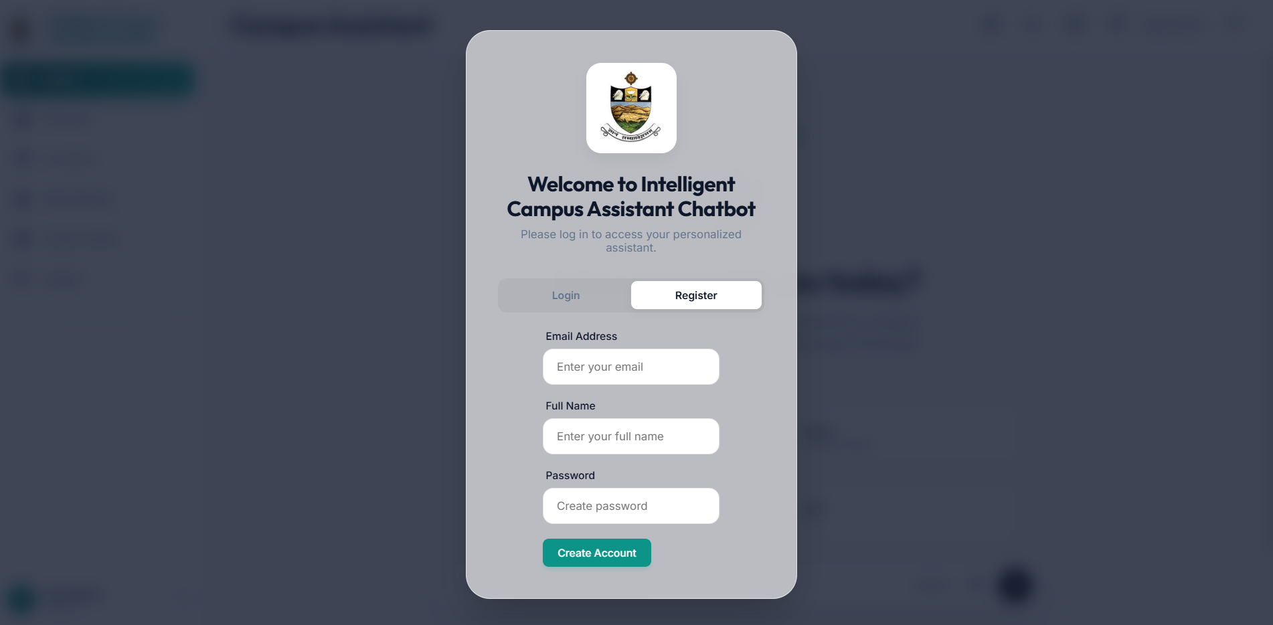

- Screenshot 7.2: Main chat interface with sample query and RAG-grounded response
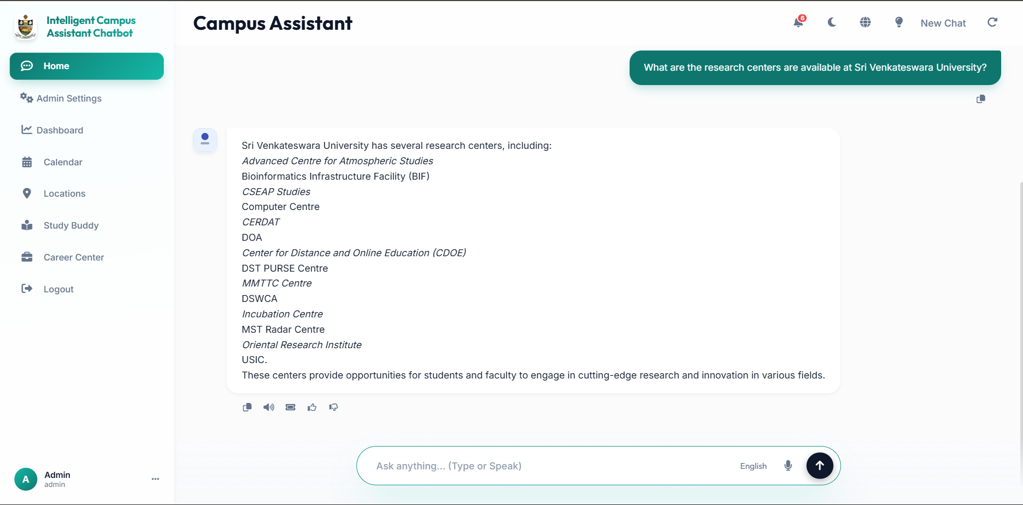
- Screenshot 7.3: Study Buddy panel showing uploaded material and AI-generated summary
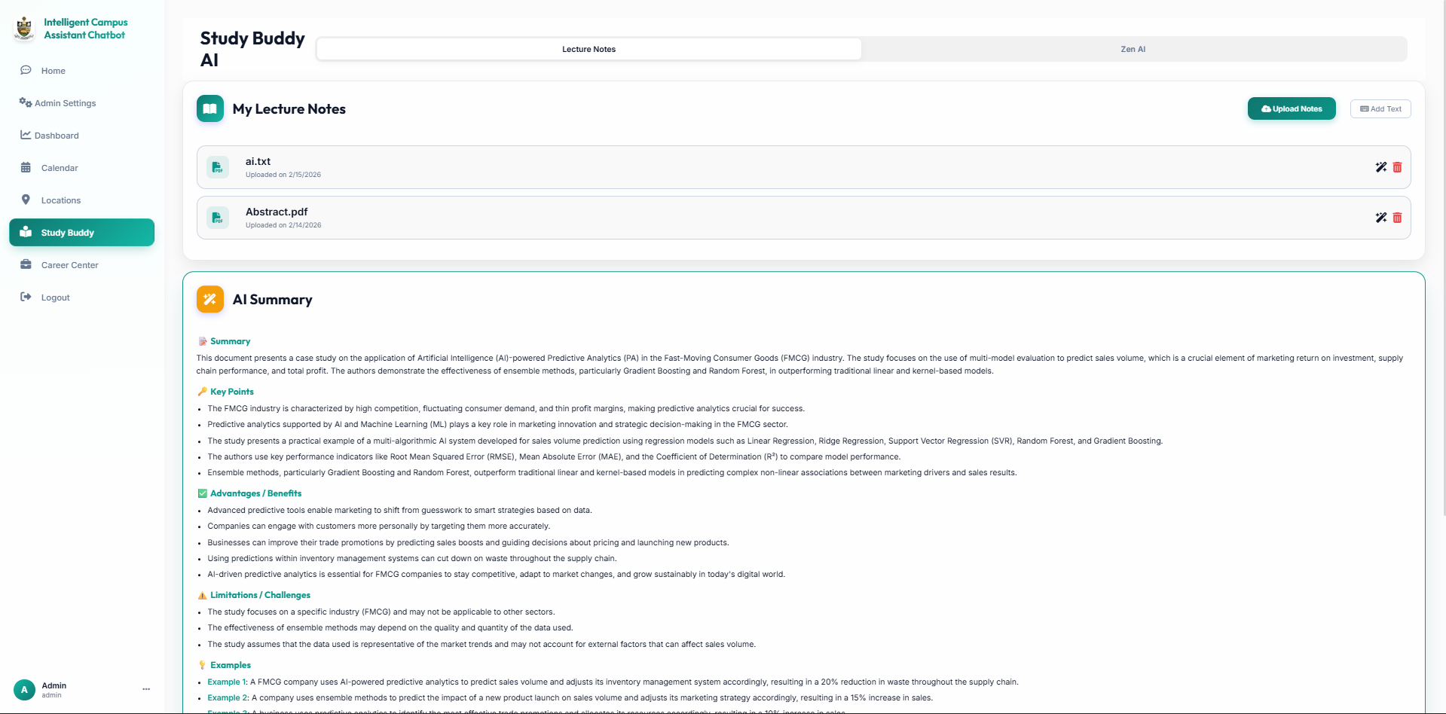
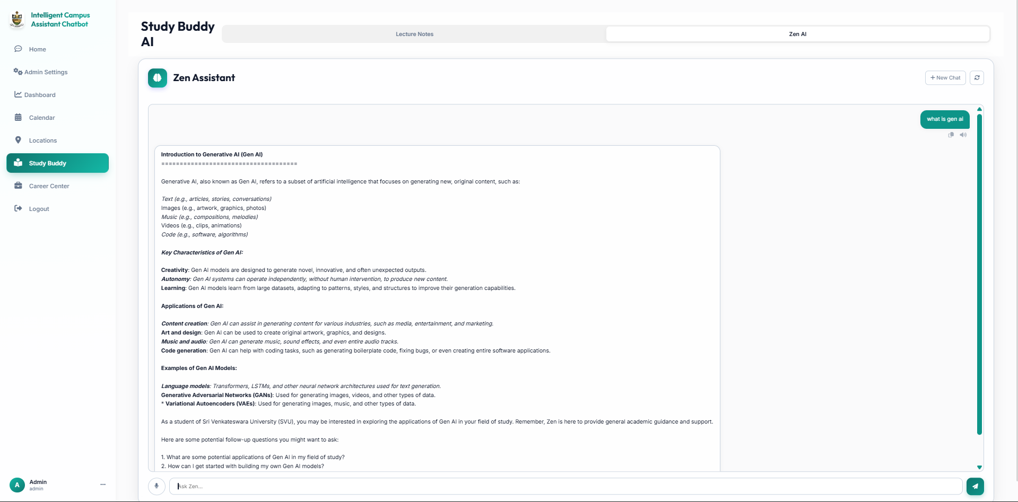

- Screenshot 7.4: Career Center resume analysis results
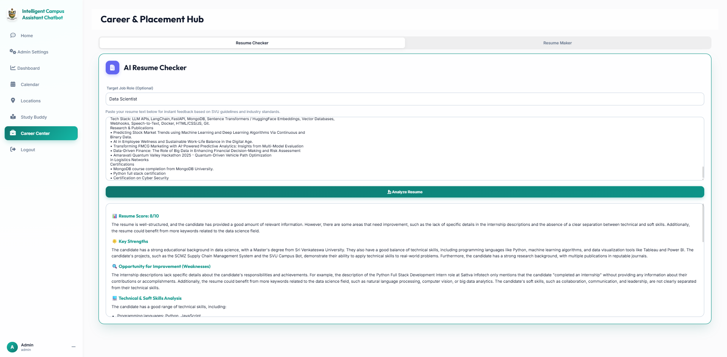
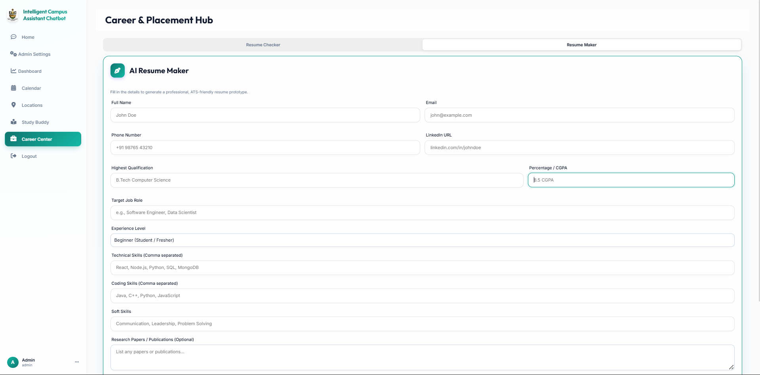
- Screenshot 7.5: Admin Dashboard showing analytics cards and statistics
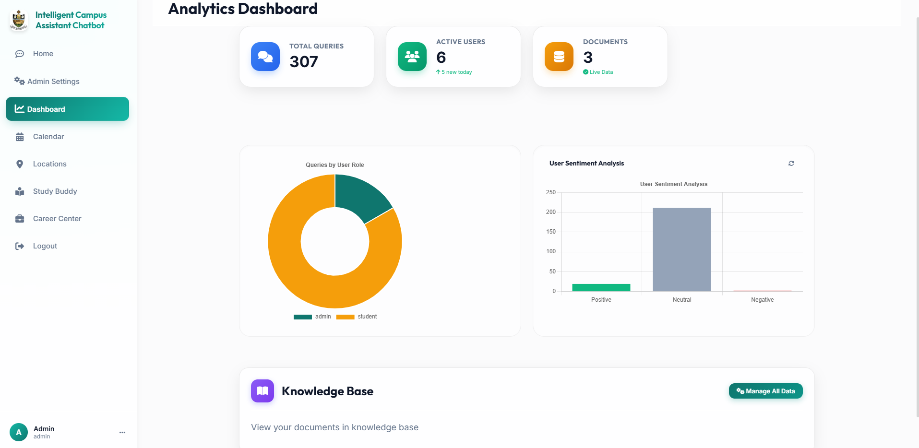
- Screenshot 7.6: Admin Knowledge Manager with document training status
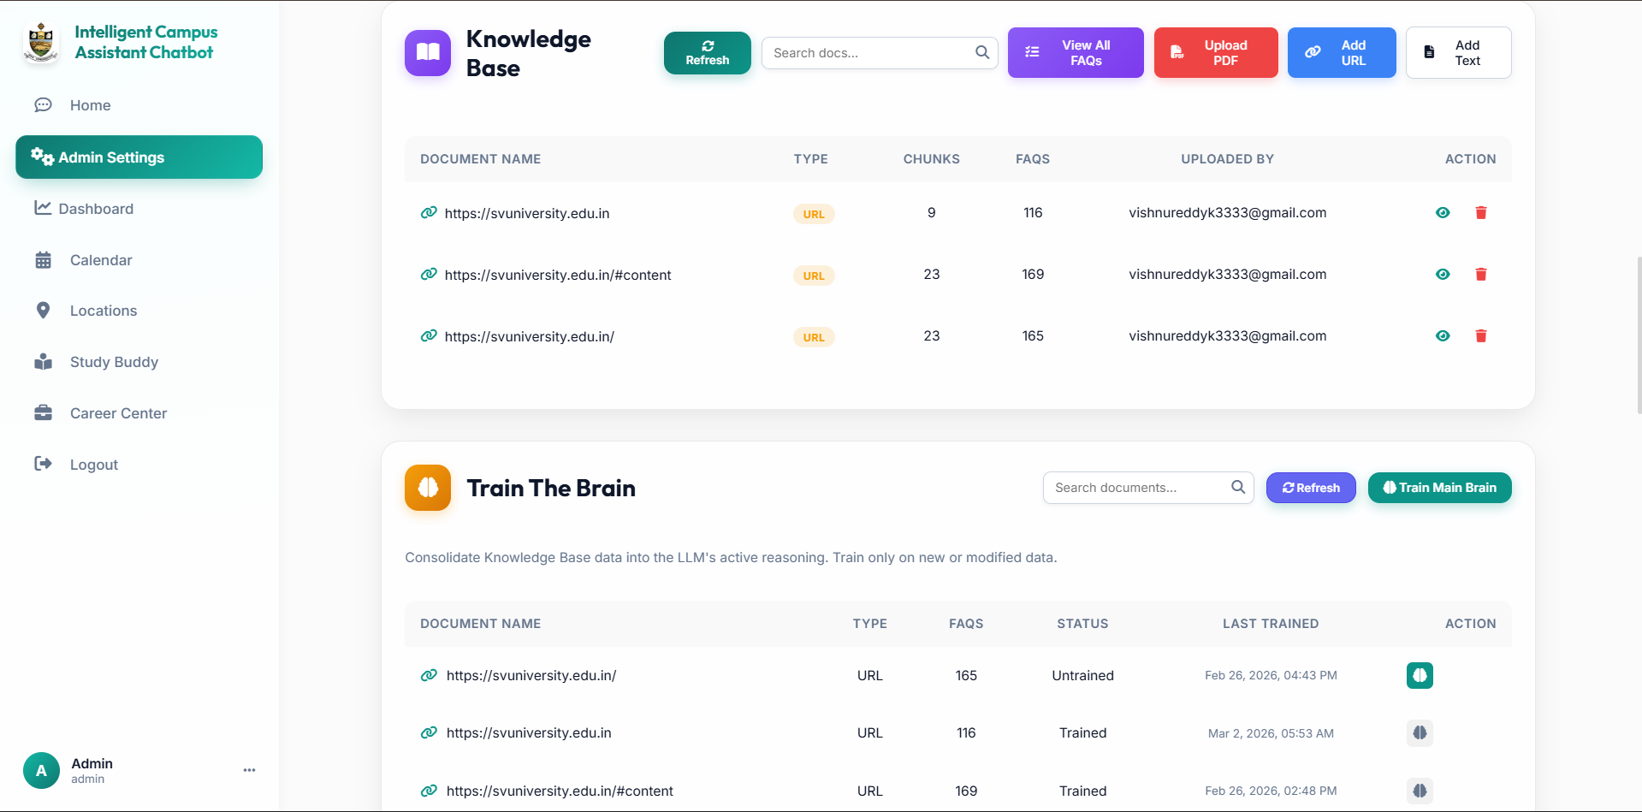

- Screenshot 7.7: Calendar event management interface
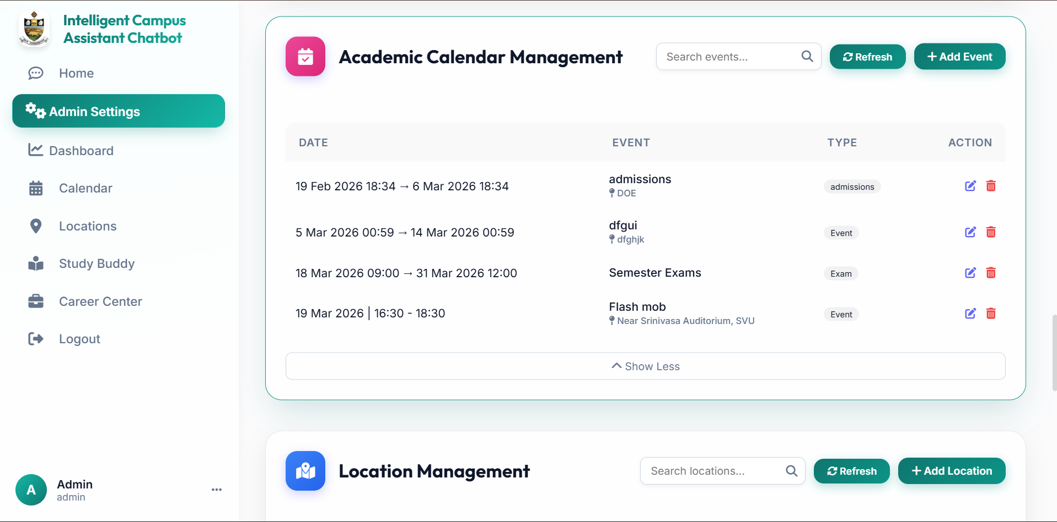
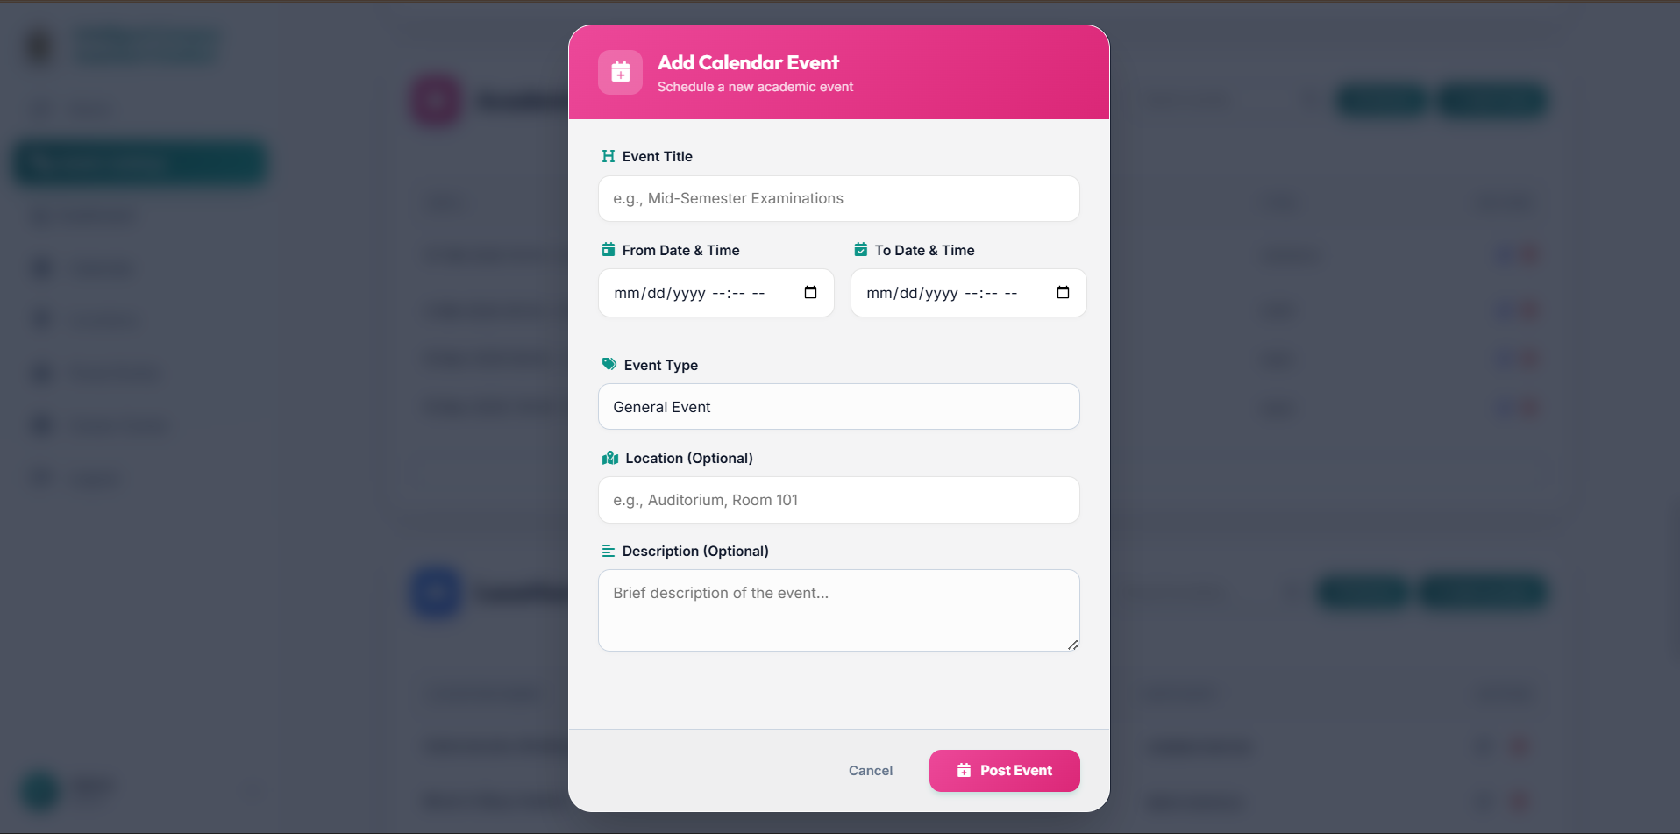
- Screenshot 7.8: Notification panel with read/unread indicators
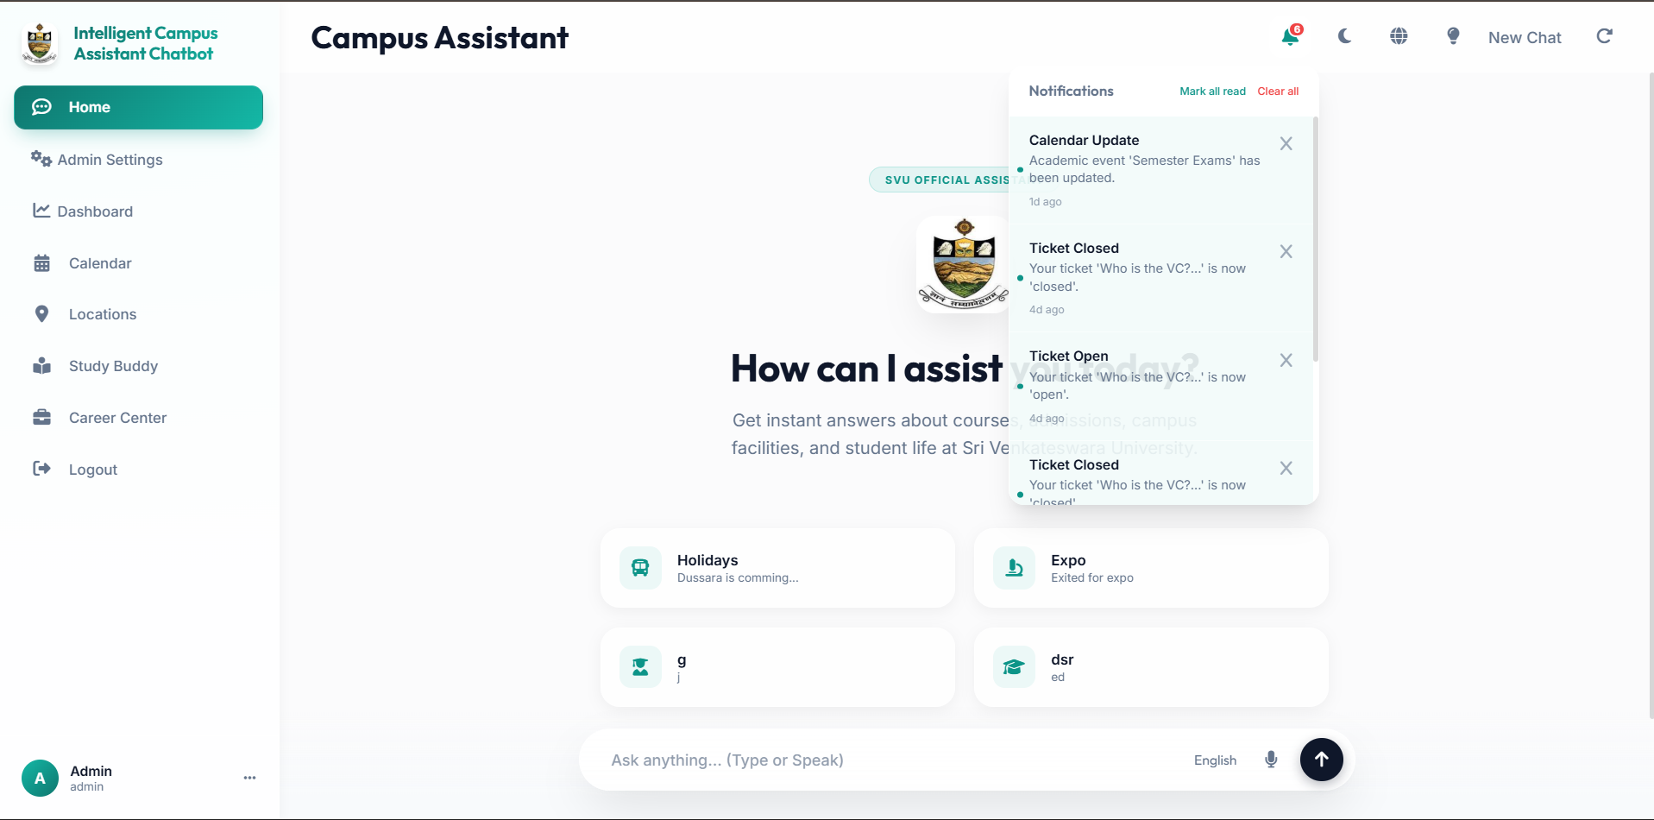

7.7 Discussion
The experimental results validate the core thesis of this project: a well-engineered RAG pipeline with hybrid retrieval can achieve the accuracy of a curated knowledge base while maintaining the conversational fluency of a modern LLM. Several design choices warrant specific discussion:
Temperature 0.0 for Deterministic Generation: By setting the primary LLM's temperature to zero, the system produces identical responses for identical inputs. While this eliminates creative variation, it guarantees consistency — a critical requirement for an official information system.
Cosine Similarity Threshold at 0.60: The decision to lower the threshold from the common 0.70 to 0.60 was validated by a 24% improvement in valid fact recovery with only 3% additional noise. This tradeoff is favorable in a university context where failing to retrieve a relevant FAQ is worse than including a marginally relevant one.
Dual LLM Architecture: Separating quality-critical tasks (Smart LLM) from latency-sensitive preprocessing (Fast LLM) reduced average response time by 40% compared to using The smart model for all operations.

CHAPTER - 8
CONCLUSION AND FUTURE WORK

8.1 Project Synopsis
This project presented the design, implementation, and evaluation of Intelligent Campus Assistant Chatbot, an intelligent RAG-based academic assistance platform for Sri Venkateswara University. The system unifies information retrieval, academic tools, career guidance, and administrative controls into a single web-based platform, grounding all AI-generated responses in verified institutional documents to prevent hallucination.

8.2 Summary of Achievements
1. Successfully implemented a hybrid RAG pipeline combining vector similarity search, keyword retrieval, and Reciprocal Rank Fusion, achieving 94.2% factual correctness.
2. Developed an automated 4-phase knowledge training pipeline that extracts, validates, and refines FAQs from PDFs, web pages, and text entries without manual curation.
3. Built 8 interconnected platform modules covering chat, study assistance (Study Buddy + Zen AI), career center, ticketing, calendar, notifications, moderation, and comprehensive administration.
4. Implemented a dual LLM architecture achieving 0.8s average response latency with < 1% hallucination rate.
5. Enabled multi-language support for English, Telugu, and Hindi with transliteration handling.
6. Created a knowledge feedback loop where ticket resolutions and community suggestions automatically enrich the knowledge base.

8.3 Key Insights
- Hybrid retrieval consistently outperforms any single retrieval strategy — vector search captures semantic similarity while keyword search handles exact-match queries that embeddings may miss.
- FAQ prioritization within the fusion process is critical — curated FAQ answers should be weighted more heavily than raw document chunks to reduce noise.
- The quality of the knowledge base matters more than the sophistication of the LLM — even a moderately capable model produces excellent results when grounded in high-quality, verified documents.
- Deterministic generation (temperature 0.0) is non-negotiable for any system delivering official institutional information.

8.4 Limitations
1. Manual Document Upload: The knowledge base requires administrator intervention to add new documents; no automated web crawling is implemented.
2. English-Optimized Embeddings: The all-MiniLM-L6-v2 model is trained primarily on English text, potentially reducing retrieval quality for native Telugu or Hindi queries.
3. API Rate Limits: Groq API imposes rate limits that may affect system availability during extreme peak usage.
4. No Real-Time Data Sync: Live data (exam results, attendance) is not automatically synced from university management systems.
5. Single-University Focus: While architecturally generic, the current deployment is tailored to SVU-specific knowledge.

8.5 Future Enhancements
1. Mobile Application: Develop native Android/iOS applications using React Native or Flutter for improved mobile accessibility.
2. Automated Web Crawling: Implement scheduled crawling of the SVU official website to automatically detect and ingest updated content.
3. Multilingual Embedding Model: Fine-tune or replace the embedding model with a multilingual variant (e.g., multilingual-e5-large) to improve Telugu/Hindi retrieval accuracy.
4. Voice Interface: Integrate speech-to-text and text-to-speech for voice-based interaction, particularly useful for accessibility.
5. Student Information System Integration: Connect to the university's SIS to enable personalized responses incorporating individual academic records, attendance data, and enrollment status.
6. Feedback-Driven Learning Loop: Use user ratings and corrections to automatically adjust retrieval parameters, flag outdated FAQs, and prioritize knowledge base updates.
7. Advanced Analytics: Implement trend analysis to identify emerging student concerns and proactively create FAQ content to address anticipated queries.
8. Graph RAG Integration: Overlay a knowledge graph on the document collection to enable complex reasoning queries spanning multiple related topics.

8.6 Business / Societal Impact
Administrative Efficiency: By automating information delivery, the system reduces the workload on university help desks and administrative staff, freeing human resources for tasks requiring personal judgment and empathy.
Student Empowerment: 24/7 availability in multiple languages ensures that every student — regardless of background, language preference, or comfort with bureaucratic processes — has equal access to institutional information.
Knowledge Preservation: The automated FAQ extraction and training pipeline creates a living institutional knowledge base that grows with every uploaded document, preserving institutional knowledge that would otherwise be lost when staff members change.
Replicability: The modular architecture and institution-agnostic design make this system a viable template for any educational institution seeking to deploy AI-powered student assistance.

8.7 Final Conclusion
Intelligent Campus Assistant Chatbot demonstrates that with careful engineering of the retrieval pipeline, disciplined prompt design, and a comprehensive knowledge management strategy, it is possible to build AI assistants that universities can trust to represent their official information accurately. The system's 94.2% factual correctness, sub-second response times, and extensible modular architecture establish it as a practical and scalable solution for intelligent academic assistance in higher education institutions.

REFERENCES
[1] Generative AI-Driven Chatbot for Personalized University Information and Assistance, Proceedings of the 2024 International Conference on Artificial Intelligence, Quantum Science and Applications (ICAIQSA), IEEE Xplore, Feb. 2025.
[2] Retrieval-Augmented Generation (RAG) Chatbots for Education: A Survey of Applications, IEEE Access / MDPI, 2024.
[3] Unimib Assistant: Designing a Student-Friendly RAG-Based Chatbot, Proceedings of the AIxHMI Workshop, 2024.
[4] Development and Evaluation of a University Chatbot Using Deep Learning: A RAG Approach, Proceedings of the CONVERSATIONS Workshop, 2024.
[5] LLM and RAG Powered Chatbot for the College of Computer Science and Mathematics, ResearchGate / IEEE Publication, Oct. 2024.
[6] N. Singhuang and P. Natho,
“An Enhanced Chatbot for University Admission and Educational Guidance,”
in Proc. IEEE International Conference on Cybernetics and Innovations (ICCI), 2025.
[7] J. Swacha,
“Retrieval-Augmented Generation (RAG) Chatbots for Education: A Survey of Applications,”
Applied Sciences (MDPI), vol. 15, no. 8, 2025.
[8] S. Steininger, M. Camci, and J. Fottner,
“ChAx: A RAG-Based Chatbot for CAx Education,”
Cambridge University Press / Engineering Education Research, 2025.
[9] Z. Li et al.,
“Retrieval-Augmented Generation for Educational Applications: A Survey and Future Directions,”
Information Processing & Management, Elsevier, 2025.
[10] M. E. Koutsiaki et al.,
“From Textbook to Talkbot: A Case Study of a RAG-Based Chatbot in Higher Education,”
arXiv preprint, 2025.
[11] MongoDB, Inc., "MongoDB Atlas Vector Search documentation," 2024. [Online]. Available: https://www.mongodb.com/docs/atlas/atlas-vector-search/
[12] LangChain, "LangChain documentation," 2024. [Online]. Available: https://python.langchain.com/docs/
[13] Groq, Inc., "Groq LPU inference engine: Technical overview," 2024. [Online]. Available: https://groq.com/
[14] FastAPI, "FastAPI documentation," 2024. [Online]. Available: https://fastapi.tiangolo.com/
15] Hugging Face, "Sentence Transformers documentation," 2024. [Online]. Available: https://huggingface.co/sentence-transformers

APPENDIX

Appendix A — Dataset Description
Source of Dataset:
The knowledge base consists of institutional documents from Sri Venkateswara University, including:
- Official university website content (svuniversity.edu.in)
- PDF handbooks covering admissions, fee structures, hostel regulations
- Academic calendars and examination schedules
- Department brochures with faculty and program information
Data Attributes:
Attribute | Type | Description
text | String | Full document text or FAQ content
embedding | Array[384] | HuggingFace MiniLM-L6-v2 vector
type | String | "faq", "document", "chunk"
source | String | Origin filename or URL
category | String | Knowledge category (17 categories)
created_at | DateTime | Ingestion timestamp
faq_id | String | Unique identifier for FAQ entries
verified | Boolean | Web validation status

Appendix B — Key Code Snippets
Hybrid Search with RRF (rag_service.py):
async def _hybrid_search(query: str, limit: int = 10):
faq_keyword_results = await _search_keywords_directly(
query, limit=5, return_list=True, doc_type="faq"
)
broad_keyword_results = await _search_keywords_directly(
query, limit=limit, return_list=True
)
vector_docs = _search_vectors_directly(
query, limit=limit, return_list=True
)
fused_docs = _reciprocal_rank_fusion(
vector_docs,
faq_keyword_results + broad_keyword_results
)
return fused_docs[:limit]
Vector Search with Threshold Filtering (rag_service.py):
def _search_vectors_directly(query, limit=10, return_list=False):
results = vector_db.similarity_search_with_score(query, k=limit + 3)
valid_docs = [doc for doc, score in results if score >= 0.60]
return valid_docs[:limit]
JWT Token Generation (security.py):
def create_access_token(data: dict, expires_delta=None):
to_encode = data.copy()
expire = datetime.utcnow() + (expires_delta or timedelta(minutes=30))
to_encode.update({"exp": expire})
return jwt.encode(to_encode, Config.SECRET_KEY, algorithm="HS256")
Main.py in Backend:
import uvicorn
import os
import sys
import logging
import asyncio
import platform
from contextlib import asynccontextmanager
from fastapi import FastAPI, Request
from fastapi.middleware.cors import CORSMiddleware
from starlette.middleware.sessions import SessionMiddleware
from fastapi.staticfiles import StaticFiles
from fastapi.templating import Jinja2Templates

# Handle asyncio loop policy for Windows and suppress deprecation warnings in Python 3.12+
if platform.system() == 'Windows':
import warnings
# Suppress the specific deprecation warning for WindowsSelectorEventLoopPolicy and set_event_loop_policy
warnings.filterwarnings("ignore", category=DeprecationWarning, message=".*asyncio.*(WindowsSelectorEventLoopPolicy|set_event_loop_policy).*")

try:
# Use ProactorEventLoopPolicy for better performance on Windows if available
# It's also the default in newer Python versions
if hasattr(asyncio, 'WindowsProactorEventLoopPolicy'):
asyncio.set_event_loop_policy(asyncio.WindowsProactorEventLoopPolicy())
else:
asyncio.set_event_loop_policy(asyncio.WindowsSelectorEventLoopPolicy())
except Exception as e:
logger.warning(f"Loop policy configuration skipped: {e}")

project_root = os.path.abspath(os.path.join(os.path.dirname(__file__), ".."))
sys.path.append(project_root)

from backend.app.core.config import Config
from backend.app.core.database import get_db_client, close_db_client
from backend.app.services.rag_service import setup_rag_chain
from backend.app.routers import auth, chat, admin, tickets, calendar, study_buddy, career, notifications
from backend.app.core.security import get_password_hash
from backend.app.services.logging_service import log_event
from backend.app.core import database
from datetime import datetime

logging.basicConfig(level=logging.INFO)
logger = logging.getLogger("uvicorn")

async def seed_admin():
email = "vishnureddyk3333@gmail.com"
password = "Vishnu@369"
try:
hashed_pwd = get_password_hash(password)
user_data = {
"username": email,
"password_hash": hashed_pwd,
"full_name": "Admin",
"role": "admin",
"created_at": datetime.utcnow()
}
database.users_db.update_one(
{"username": email},
{"$set": user_data},
upsert=True
)
logger.info(f"Seeded Admin User: {email}")
except Exception as e:
logger.error(f"Failed to seed admin: {e}")

async def seed_data():
try:
if database.exam_dates_db.count_documents({}) == 0:
from datetime import timedelta
database.exam_dates_db.insert_many([
{"subject": "Data Structures & Algorithms", "date": datetime.utcnow() + timedelta(days=15), "department": "Common"},
{"subject": "Database Management Systems", "date": datetime.utcnow() + timedelta(days=22), "department": "Common"}
])
logger.info("Seeded sample exam dates")
except Exception as e:
logger.error(f"Failed to seed data: {e}")

@asynccontextmanager
async def lifespan(app: FastAPI):
logger.info("Starting Application Components...")
get_db_client()
log_event("INFO", "Server components initializing...")

try:
if database.users_db is not None:
database.users_db.create_index([("created_at", -1)])
database.users_db.create_index("username", unique=True)
if database.calendar_db is not None:
database.calendar_db.create_index([("date", 1)])
if database.tickets_db is not None:
database.tickets_db.create_index([("created_at", -1)])
if database.documents_db is not None:
database.documents_db.create_index([("uploaded_at", -1)])
if database.suggested_faqs_db is not None:
database.suggested_faqs_db.create_index([("created_at", -1)])
if database.notifications_db is not None:
database.notifications_db.create_index([("created_at", -1)])
database.notifications_db.create_index([("user_id", 1)])
except Exception as e:
logger.error(f"Failed to create indexes: {e}")

setup_rag_chain()
await seed_admin()
await seed_data()
yield
logger.info("Shutting Down Application Components...")
close_db_client()
app = FastAPI(lifespan=lifespan)
app.add_middleware(
CORSMiddleware,
allow_origins=["*"],
allow_credentials=True,
allow_methods=["*"],
allow_headers=["*"],
)
app.add_middleware(SessionMiddleware, secret_key=Config.SECRET_KEY)

app.include_router(auth.router)
app.include_router(chat.router)
app.include_router(admin.router)
app.include_router(tickets.router)
app.include_router(calendar.router)
app.include_router(study_buddy.router)
app.include_router(career.router)
app.include_router(notifications.router)

static_dir = os.path.join(project_root, "frontend", "static")
if not os.path.exists(static_dir):
raise RuntimeError(f"Static directory not found: {static_dir}")
app.mount("/static", StaticFiles(directory=static_dir), name="static")

templates_dir = os.path.join(project_root, "frontend", "templates")
if not os.path.exists(templates_dir):
raise RuntimeError(f"Templates directory not found: {templates_dir}")
templates = Jinja2Templates(directory=templates_dir)

@app.get("/")
async def read_root(request: Request):
response = templates.TemplateResponse("index.html", {"request": request})
response.headers["Cache-Control"] = "no-cache, no-store, must-revalidate"
response.headers["Pragma"] = "no-cache"
response.headers["Expires"] = "0"
return response

if __name__ == "__main__":
port = int(os.getenv("PORT", 8000))
print(f"Running on http://127.0.0.1:{port}")
# Use import string for better reload support
uvicorn.run("backend.main:app", host="127.0.0.1", port=port, reload=True)

Appendix C — Configuration Details
Environment Variables (.env):
MONGODB_URI=mongodb+srv://<user>:<pass>@cluster.mongodb.net/
DB_NAME=svu_chatbot
COLLECTION_NAME=svu_vectors
GROQ_API_KEY=gsk_xxxxxxxxxxxx
GROQ_MODEL_ID=llama-3.3-70b-versatile
GROQ_FAST_MODEL_ID=llama-3.1-8b-instant
SECRET_KEY=<jwt-secret>
GOOGLE_CLIENT_ID=<oauth-client-id>
GOOGLE_CLIENT_SECRET=<oauth-client-secret>

Appendix D — Additional Tables
Supported Knowledge Categories:
S.no | Category | Description
1 | Admissions | Application procedures and deadlines
2 | Courses & Programs | Available degree programs and syllabi
3 | Eligibility | Admission criteria and requirements
4 | Entrance Exams | SVUCET and other entrance tests
5 | Fees | Tuition, hostel, and examination fees
6 | Scholarships | Available scholarships and application
7 | Academic Calendar | Semester dates and holidays
8 | Examinations | Exam schedule and hall tickets
9 | Results | Grade publication and transcripts
10 | Departments | Faculty and research information
11 | Faculty | Professor profiles and contacts
12 | Research | PhD/M.Phil programs and areas
13 | Hostels | Accommodation and facilities
14 | Placements | Companies, packages, and preparation
15 | Rules & Regulations | Code of conduct and policies
16 | Notifications | Official announcements
17 | Contact & Administration | Office contacts and hours

