Week 2 Task: Statistical Analysis & Predictive Modeling Report
Agribusiness Analytics division

1. Executive Summary & Problem Statement
Predictive agricultural analytics is vital to maintaining global food security, stabilizing market prices, and enabling farmers to plan input allocation effectively. This report outlines a structured approach to analyzing historical crop yields and modeling future patterns. The analysis uses the global crop production dataset to build predictive models for major crop yields (RICE, WHEAT, MAIZE, SOYBEAN) measured in Tonnes per Hectare (TONNE_HA).

2. Data Preprocessing & Exploratory Analysis
The raw dataset contains 20566 initial entries across various measures and crop indicators. Data cleaning steps included filtering for yield measures ('TONNE_HA'), dropping records with missing values, and subsetting the analysis to key regional locations with complete historical yield profiles.
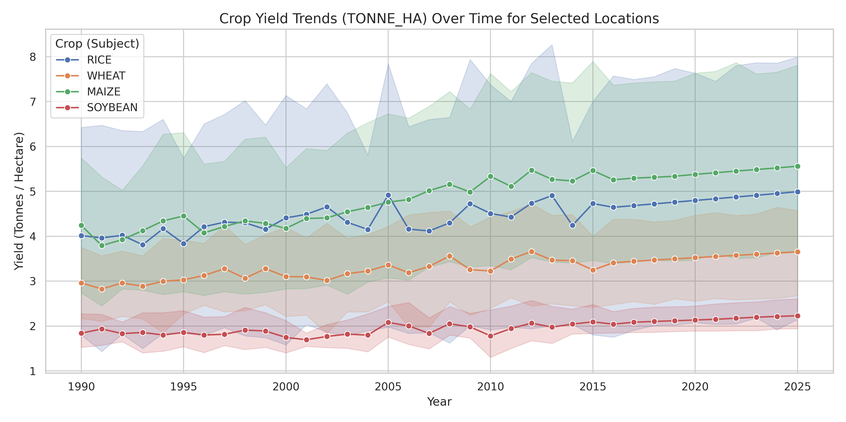
Figure 1: Historical Crop Yield Trends over Time by Crop Type
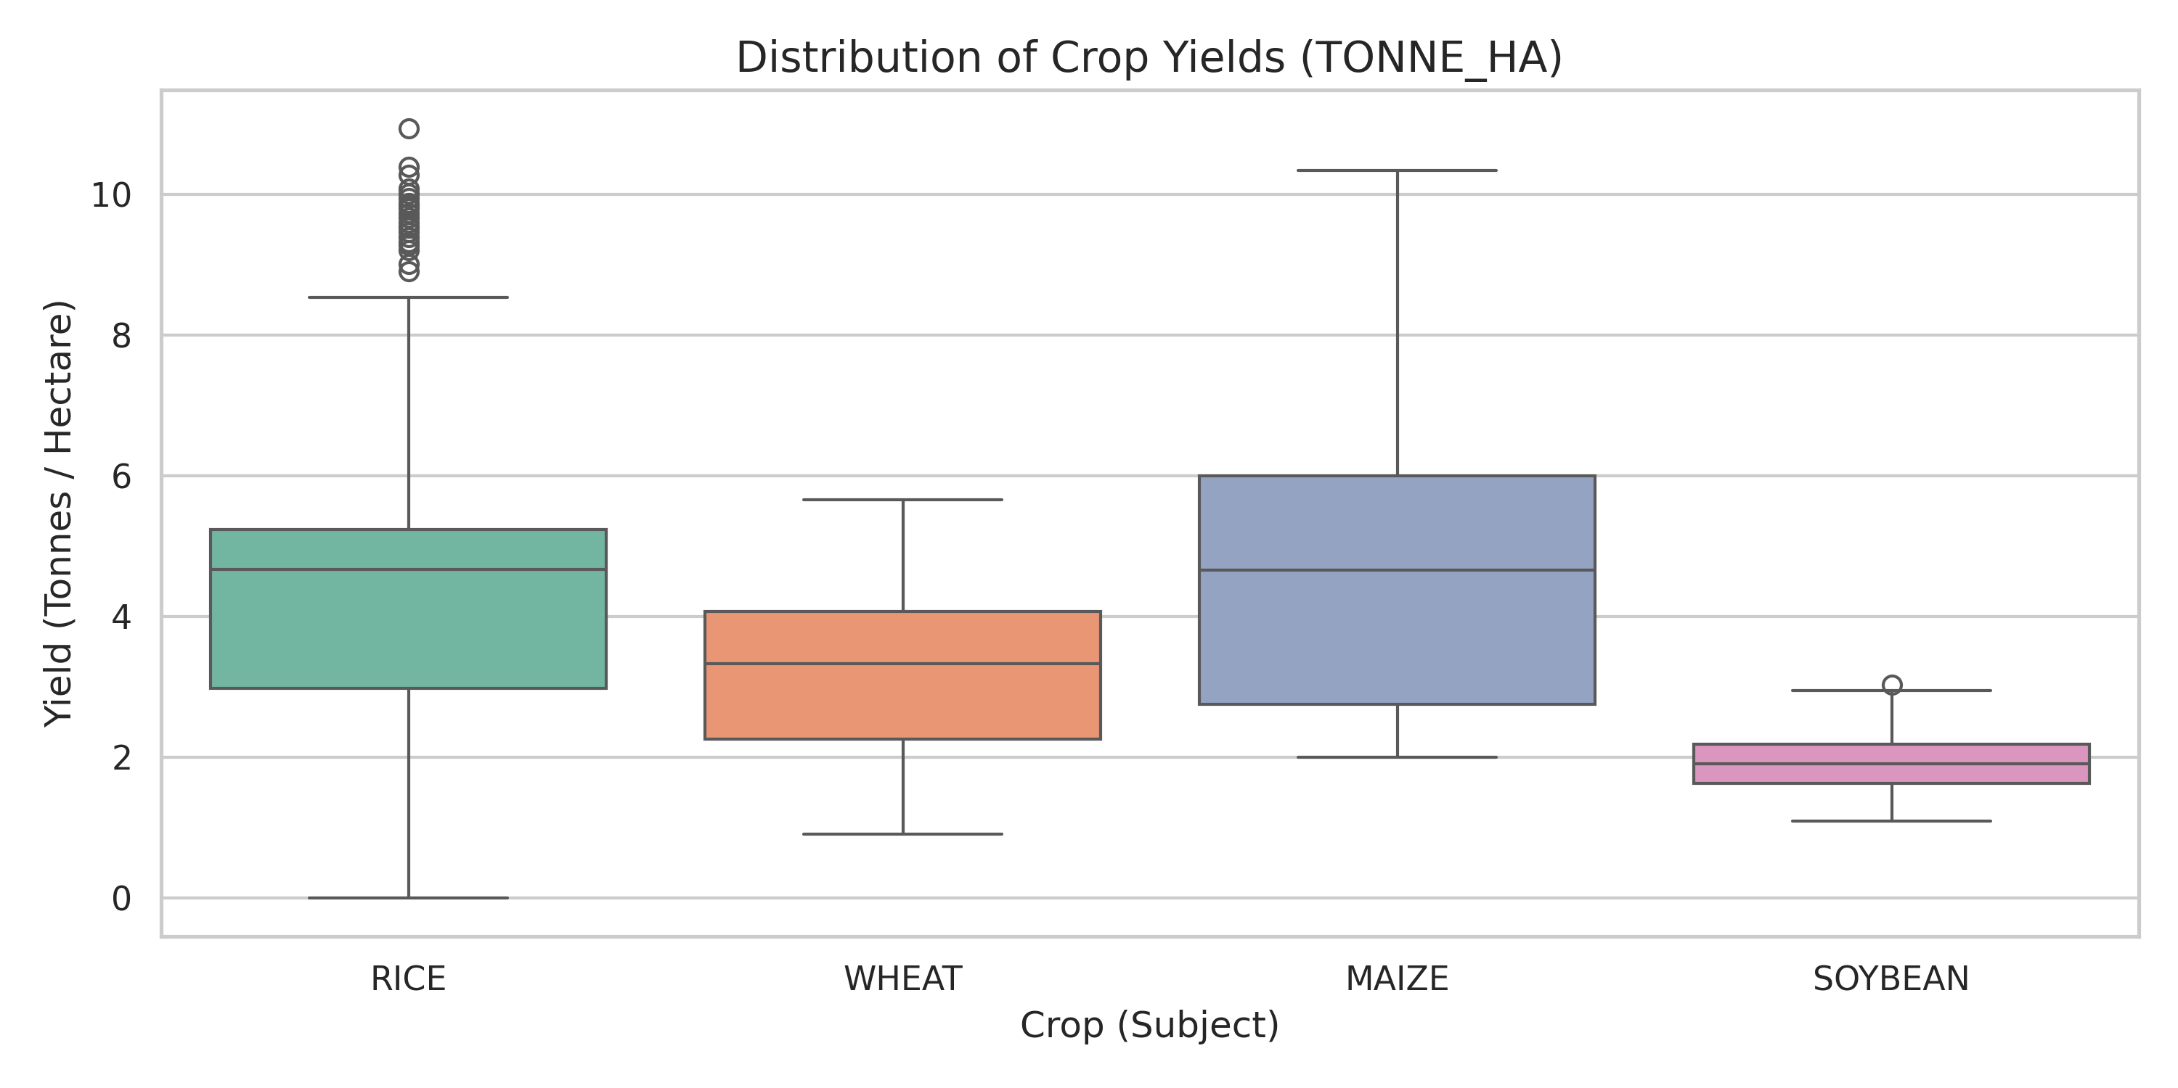
Figure 2: Statistical distribution of yields per crop category

3. Modeling Approach & Evaluation Metrics
A multiple linear regression framework was established to capture historical yield trajectories while controlling for crop subjects and location identities through categorical encoding. The model evaluates how yields evolve over time under specific regional variations.
Evaluation Metric | Value
Mean Absolute Error (MAE) | 1.4788 Tonnes/Ha
Root Mean Squared Error (RMSE) | 2.0083 Tonnes/Ha
R-squared Coefficient (R2) | 0.2457
Train-Test Split Ratio | 80% Train / 20% Test

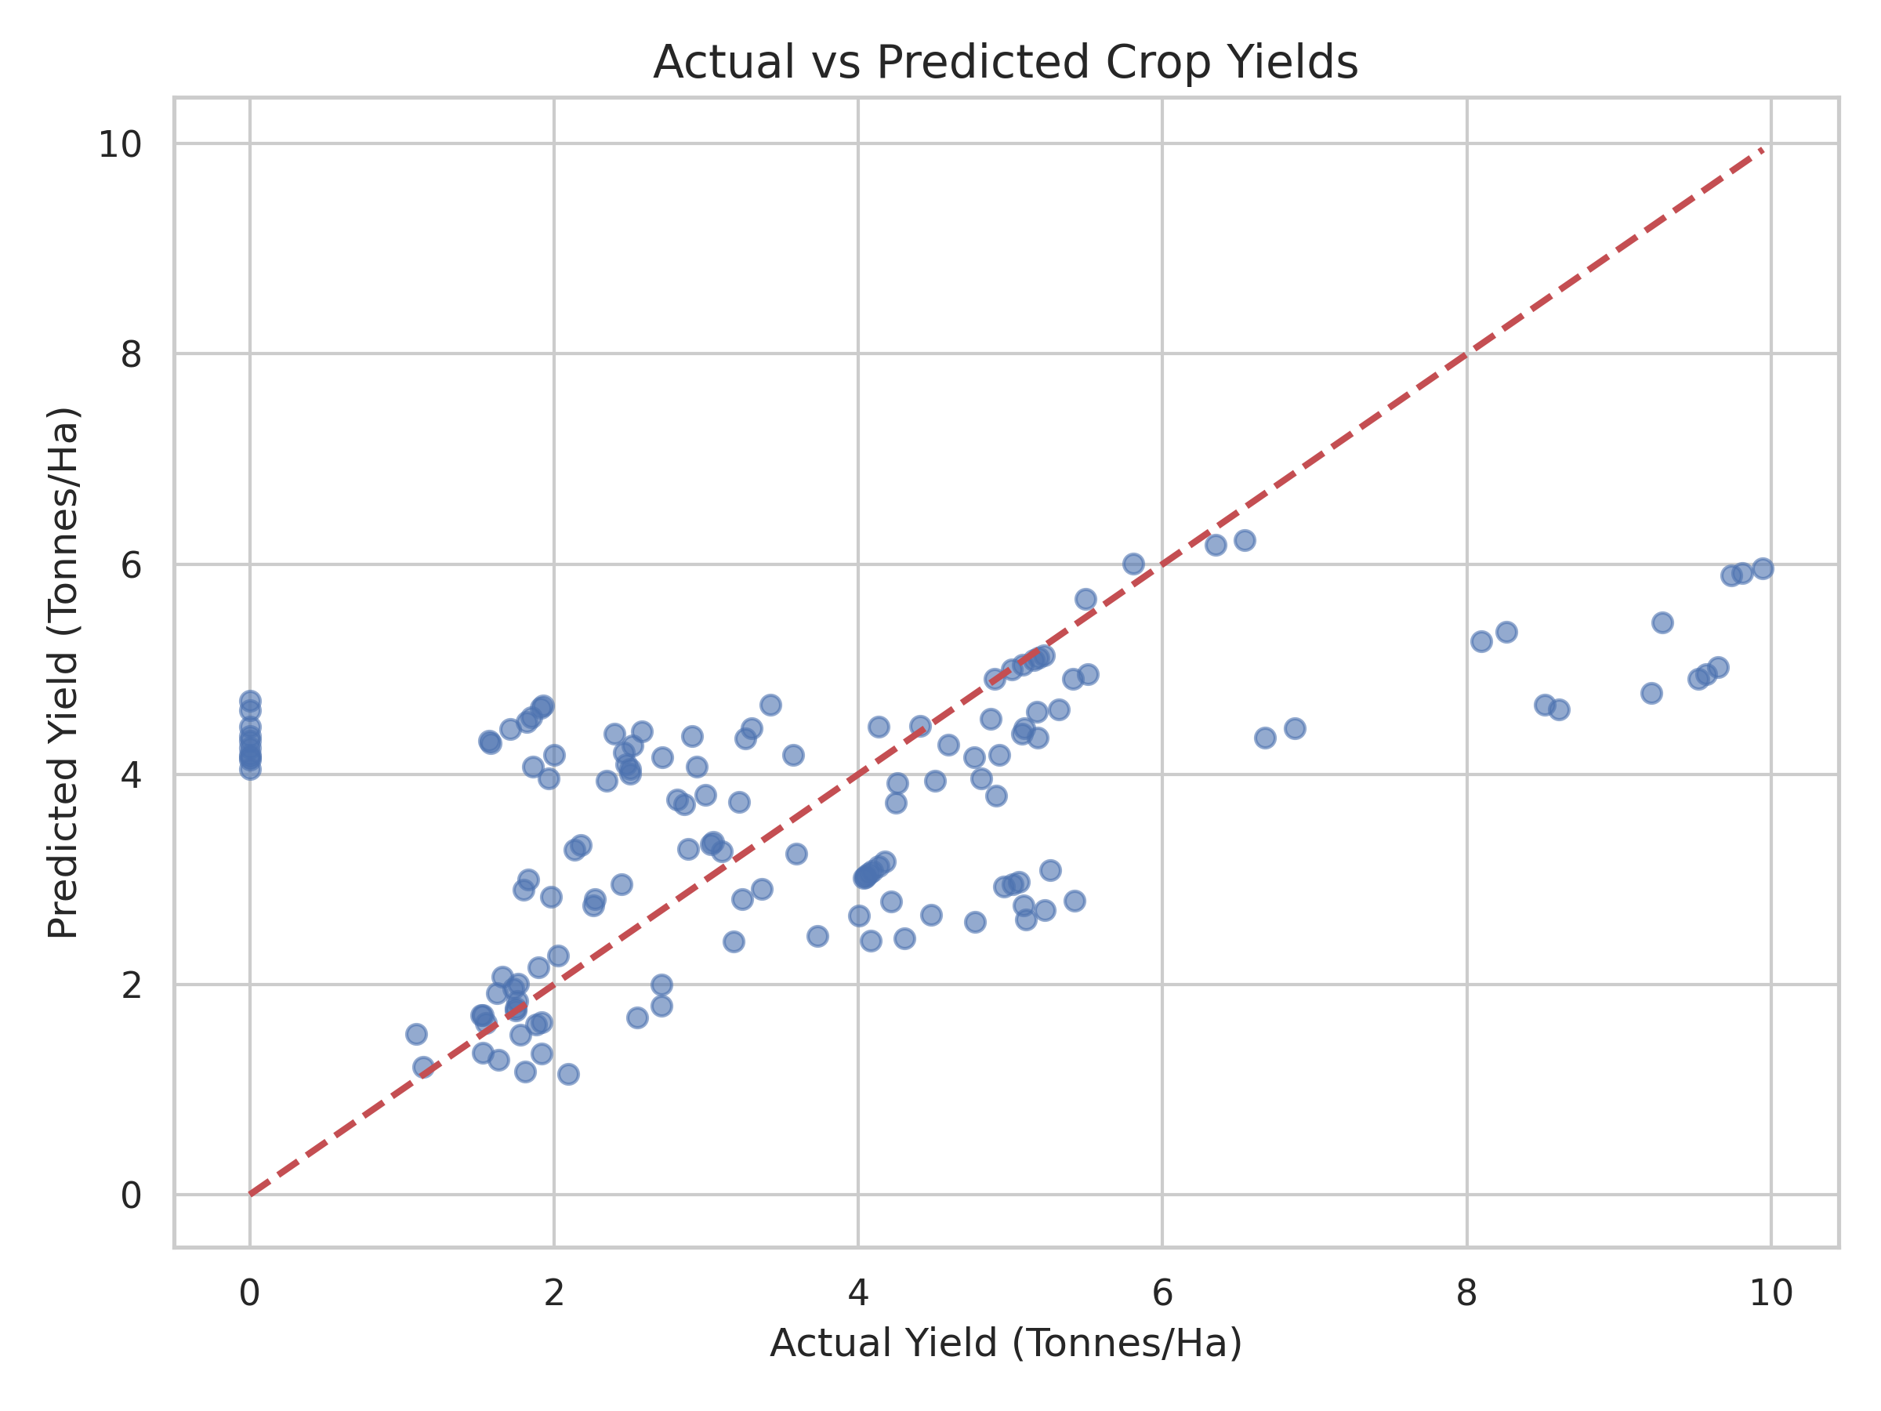
Figure 3: Regression Performance (Actual vs. Predicted Yields)

4. Agribusiness Implications & Future Recommendations
Implications & Strategic Insight:
- The predictive model can successfully help agribusiness firms project localized output to schedule logistical capacity and shipping contracts.
- Policymakers can utilize regression baselines to establish food reserve goals and target precision farming interventions where yields underperform the baseline projections.
Future Enhancements:
- Incorporate exogenous variables such as seasonal precipitation index, temperature anomalies, and soil fertilizer applications to improve the model R2 score.
- Transition from linear frameworks to non-linear tree-based ensembles (Random Forest, XGBoost) and deep recurrent architectures (LSTM) for capturing non-linear climatic fluctuations.

