First we need to create one virtualmachine in AWS console

Run the virtual machine in powershell by using public id

Command:ssh ubuntu@public id

Then install docker file by using dockerscript

$curl -fsSL https://get.docker.com -o get-docker.sh

$ sh get-docker.sh

$docker usermod -aG docker ubuntu

Exit

Relogin again

docker info

Now run hello-world

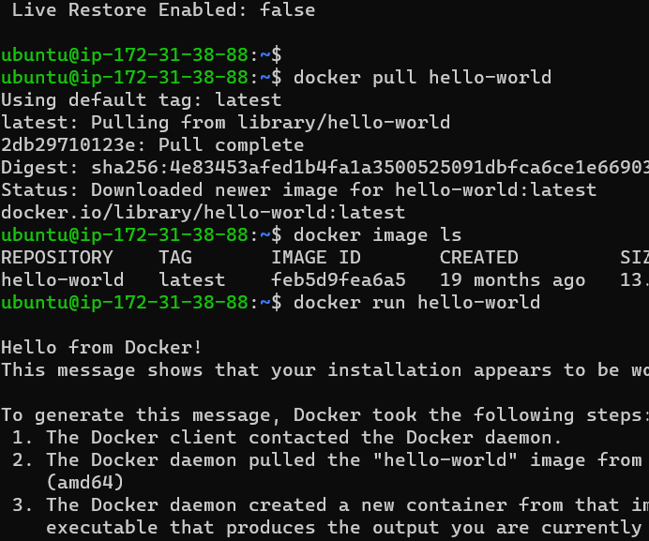

Size of imaga:13.3kb

Now run docker container nginx by using 8080 port

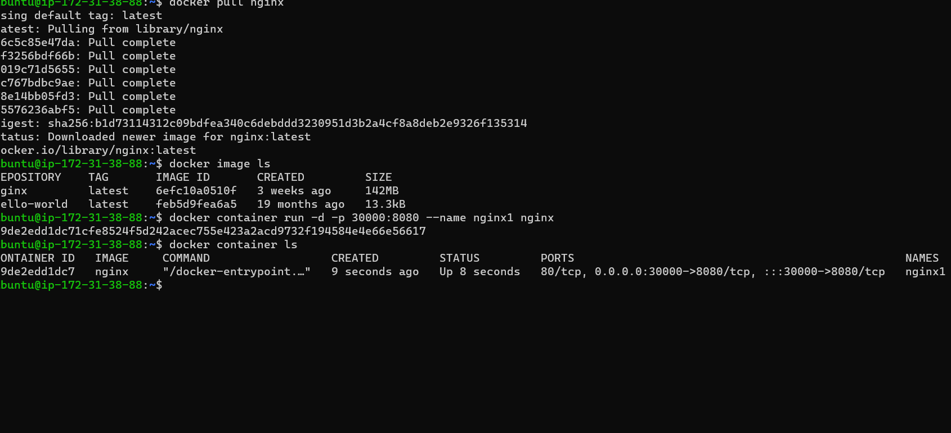

Now docker container life cycle

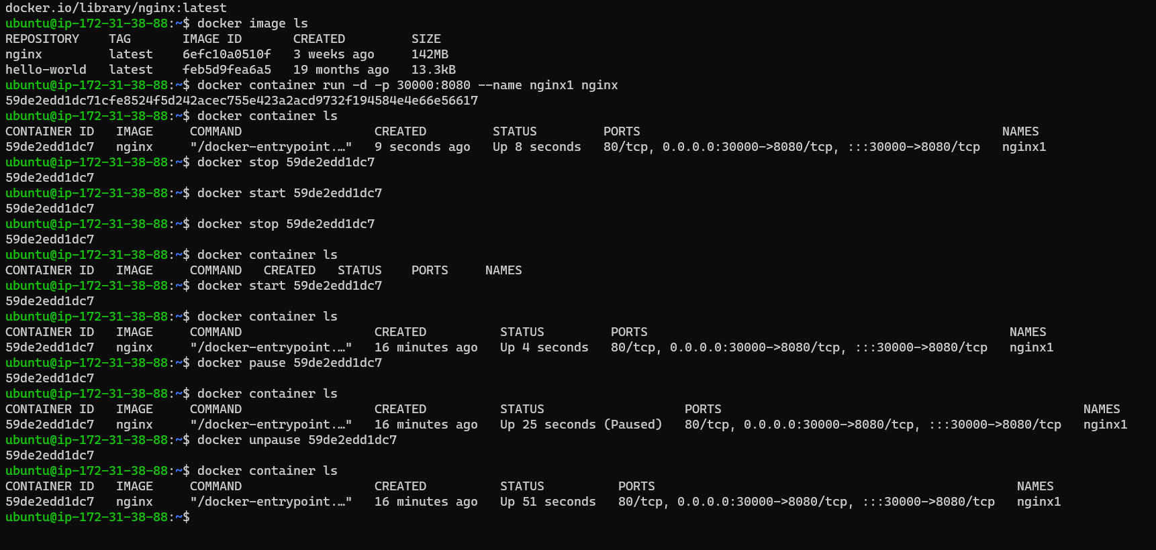

Docker is a software platform that allows you to built, test, and deploy application deeply

When we run docker container all the commands run inside the container by creating a container by pulling image…

In docker container code , runtime , system tool ,system liberties and settings are run in inside the container.

Docker runs prosses in isolates containers

Main features of Docker containers

1.easy&expandeble

2.security management

3.increase productivity

4,application isolation etc.

Docker Architecture:

Docker architecture is also called as client-server architecture.

Docker architecture talks to docker daemon . Means heavy lifting buildings running and distributing your docker containers.

Three parts of docker Architecture

\*Docker host

\*Docker network and storage compound

\*Docker hub