***Abstract***

**AIM**:

The aim of the present project is to **for assessing health-related quality of life and symptoms in brain cancer patients** using R.

**In-Details** :

Brain tumours is low compared to other common cancer sites such as lung and liver cancer.

Treatment of brain cancer remains a challenge despite recent improvements in surgery and multimodal adjuvant therapy. Drug therapies of brain cancer have been particularly inefficient, due to the blood–brain barrier and the non-specificity of the potentially toxic drugs.

**References: <https://www.sciencedirect.com/science/article/pii/S0959804910000316>**

**<https://www.cancer.gov/news-events/cancer-currents-blog/2020/microsatellite-instability-cancer-wrn>**

**DataSets:** Kaggle-data sets (here are the samples)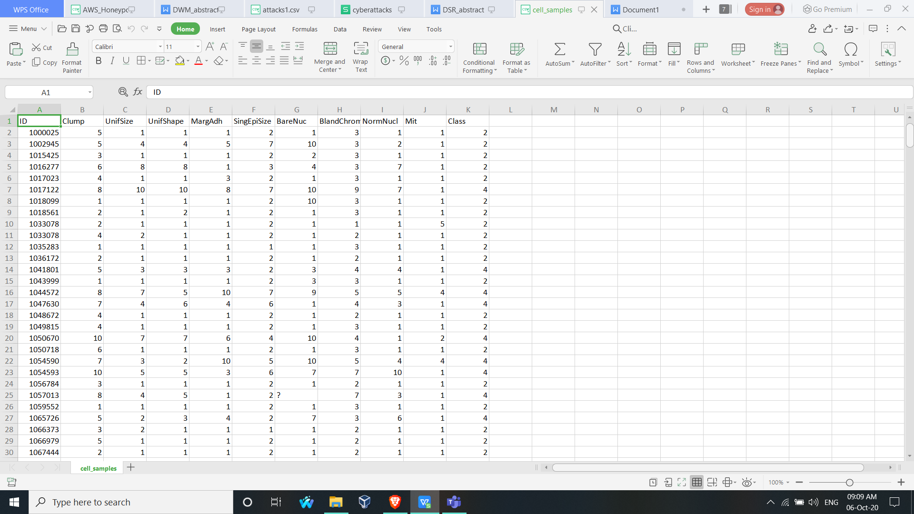

**Conclusion:**

Finally project suggest the patient with predictive results from the past and would help the People in immediate treatment at an early stage.

*Prevention is better than cure* (not just for medicine it works in an attack too)

By:

180060010 Kvssk.Pradeep

180050001 K.Gnanedra

180050050 D.Uday Kiran