Customer Churn Prediction
Minor Project Report

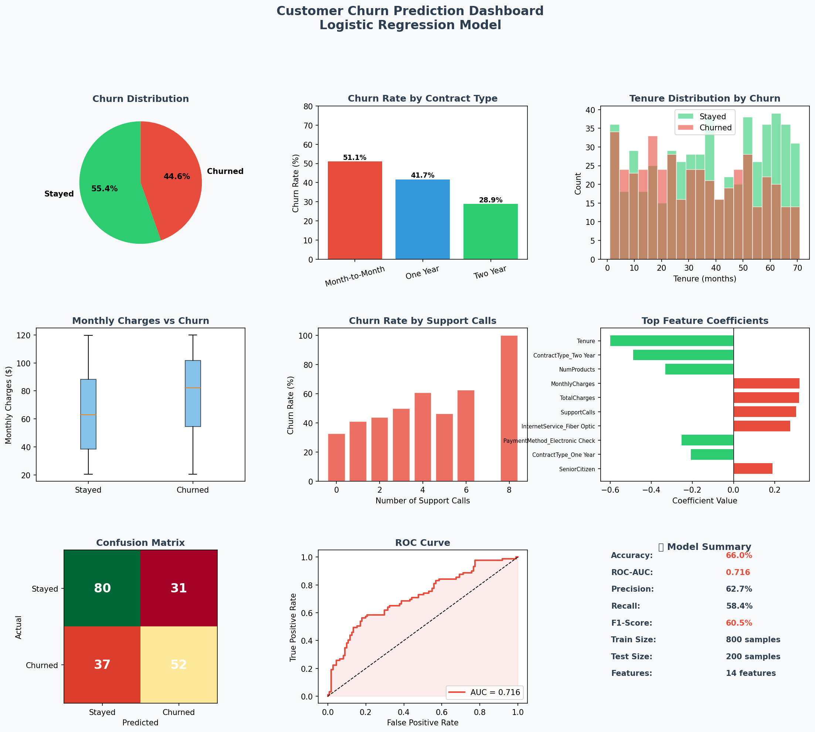

Project Type | Minor Project — Data Analytics Course
Tech Stack | Python · Pandas · Scikit-learn · Logistic Regression
Dataset | 1,000 synthetic customer records · 11 features
Model Result | Accuracy: 66.0% · ROC-AUC: 0.716

1. Introduction
Customer churn — the decision by a customer to stop using a company's product or service — is one of the most costly problems facing subscription-based businesses. Acquiring a new customer can cost five to seven times more than retaining an existing one. Therefore, being able to predict which customers are at risk of churning, and acting proactively to retain them, can have a significant impact on profitability.
This project builds a binary classification model using Logistic Regression to predict whether a customer will churn based on features such as tenure, contract type, monthly charges, internet service type, and number of support calls.

2. Project Objectives
- Generate and explore a realistic synthetic customer dataset.
- Perform data preprocessing and feature engineering.
- Build and evaluate a Logistic Regression model for churn prediction.
- Identify the most influential features driving customer churn.
- Visualise key findings in an analytical dashboard.
- Provide actionable business recommendations based on model insights.

3. Technology Stack
Technology | Version / Tool | Purpose
Python | 3.x | Core programming language
Pandas | 2.x | Data loading, cleaning, EDA
NumPy | 1.x | Numerical operations
Scikit-learn | 1.x | ML model & evaluation metrics
Matplotlib | 3.x | Data visualisation & dashboard
Logistic Reg. | sklearn.linear_model | Binary classification model

4. Dataset Description
A synthetic dataset of 1,000 customers was generated with realistic churn probabilities derived from real-world business logic (e.g., longer tenure → lower churn; Month-to-Month contracts → higher churn). The dataset contains the following features:
Feature | Type | Description
Tenure | Numerical | Months customer has been with the company
MonthlyCharges | Numerical | Monthly billing amount in USD
TotalCharges | Numerical | Cumulative charges paid
NumProducts | Numerical | Number of products/services subscribed
SupportCalls | Numerical | Number of customer support interactions
ContractType | Categorical | Month-to-Month / One Year / Two Year
InternetService | Categorical | DSL / Fiber Optic / No internet
PaymentMethod | Categorical | Electronic Check / Mailed Check / etc.
Gender | Categorical | Male / Female
SeniorCitizen | Binary | 1 if senior citizen, 0 otherwise
Churn | Target (0/1) | 1 = churned, 0 = retained

5. Methodology

5.1 Data Preprocessing
One-Hot Encoding: Categorical variables (Gender, ContractType, InternetService, PaymentMethod) were converted to binary dummy columns using pd.get_dummies().
Feature Scaling: All numeric features were standardised using StandardScaler (mean=0, std=1) within a Scikit-learn Pipeline to prevent dominance by high-magnitude features.
Train/Test Split: 80% of data used for training (800 samples), 20% for testing (200 samples). Stratified splitting preserved the class ratio.

5.2 Model — Logistic Regression
Logistic Regression is a linear model for binary classification. It models the probability that a given input belongs to the positive class (churn = 1) using the sigmoid function:
P(churn=1) = 1 / (1 + e^(-(β₀ + β₁x₁ + β₂x₂ + ... + βₙxₙ)))
The model was implemented using sklearn.linear_model.LogisticRegression with C=1.0 (L2 regularisation) and max_iter=500. A Scikit-learn Pipeline chained StandardScaler → LogisticRegression for clean, reproducible training.

6. Results & Evaluation
Metric | Class: Stayed (0) | Class: Churned (1) | Overall
Precision | 68% | 63% | —
Recall | 72% | 58% | —
F1-Score | 70% | 60% | 65%
Accuracy | — | — | 66%
ROC-AUC | — | — | 0.716

Interpretation: The model achieves 66% accuracy and a ROC-AUC of 0.716, indicating reasonable discriminative power for a baseline logistic regression model. The higher recall for "Stayed" customers (72%) means the model correctly identifies most retained customers, while the model correctly identifies 58% of actual churners (recall for class 1). In a real business scenario, recall for churners is the most critical metric since missing a churner is more costly than a false alarm.

7. Key Insights from Feature Coefficients
- Contract Type (Month-to-Month): Strongest positive predictor of churn. Customers on month-to-month contracts are significantly more likely to leave — they have no long-term commitment.
- Tenure: Strong negative predictor. The longer a customer stays, the less likely they are to churn — loyalty builds over time.
- Support Calls: More support interactions correlate with higher churn. Frustrated customers who contact support often may be close to leaving.
- Monthly Charges: Higher monthly bills slightly increase churn probability — price sensitivity is a real factor in retention.
- Number of Products: Customers with more products are less likely to churn due to higher switching costs and deeper engagement with the service.

8. Business Recommendations
Recommendation | Action
Incentivise Long-Term Contracts | Offer discounts or loyalty rewards to convert Month-to-Month customers to annual or bi-annual plans. This single factor has the highest impact on reducing churn.
Proactive Retention for High-Probability Churners | Use the model's churn probability score to flag at-risk customers and trigger personalised outreach — discount offers, account reviews, or dedicated support.
Improve Customer Support Experience | High support call frequency signals dissatisfaction. Investigate root causes and resolve recurring issues to reduce escalations and churn.
Bundle Products & Upsell | Encourage customers to subscribe to multiple services. Bundled customers have higher switching costs and tend to stay longer.
Monitor New Customers Closely | Short-tenure customers are at the highest risk. Onboarding programs and early check-ins can significantly improve early retention rates.

9. Conclusion
This project successfully demonstrates the end-to-end pipeline of a machine learning churn prediction system: from synthetic data generation and exploratory analysis, through preprocessing and model training, to evaluation and business interpretation. Logistic Regression provides a strong, interpretable baseline that directly ties feature coefficients to business insights.
Future improvements could include testing ensemble models (Random Forest, XGBoost), performing hyperparameter tuning via cross-validation, adding SHAP explainability, and deploying the model as a Flask web application for real-time churn scoring.

10. Key Code Snippet
# Scikit-learn Pipeline: Scale → Logistic Regression
from sklearn.pipeline import Pipeline
from sklearn.preprocessing import StandardScaler
from sklearn.linear_model import LogisticRegression
pipeline = Pipeline([
('scaler', StandardScaler()),
('model', LogisticRegression(max_iter=500, C=1.0, random_state=42))
])
pipeline.fit(X_train, y_train)
y_pred = pipeline.predict(X_test)
y_proba = pipeline.predict_proba(X_test)[:, 1]

Customer Churn Prediction | Data Analytics Minor Project | Logistic Regression

