NB RELEASE ORCHESTRATOR
Release Management Portal
"Structured releases. Full visibility. Every deployment, orchestrated."

Project Name | NB Release Orchestrator
Architecture | Monolithic Layered — Spring Boot 3.x (Java 17)
API Protocol | REST (Spring Web MVC)
Database | PostgreSQL 15
Frontend | React.js + TypeScript + Ant Design
Version | 1.0 — POC Implementation (In-progress)
Date | March 2026
Status | POC — Approved for Development
Classification | Confidential — Internal Use Only
Audience | Engineering, DevOps, Product, Release Management

NB Engineering | Platform & DevOps

1. Executive Summary
This document provides a comprehensive end-to-end guide for designing and building the NB Release Management Portal — a custom web portal integrated with Jira as the single source of truth for all production release requests. It enables cross-functional visibility across engineering, DevOps, product, and senior stakeholders throughout the full release lifecycle.

The Proof of Concept (POC) outlined here validates the core integration, ticket visibility, and workflow orchestration features before any production deployment.

1.1 The Problem
Production releases at NB are uncoordinated. Development teams raise Jira tickets that disappear into inboxes. DevOps engineers wait for email approvals. Product Owners have no visibility until something breaks. Release Managers juggle Confluence pages, spreadsheets, and Slack threads. Senior stakeholders are informed after the fact — if at all.

- No unified release dashboard — every team maintains a different source of truth
- No structured approval gate — DevOps receives verbal or email approval
- Manual, error-prone handoffs between development and operations
- Real-time deployment status invisible to non-technical stakeholders
- No auditable record of who approved what, when, and why

1.2 The NB Release Orchestrator Solution
NB Release Orchestrator is a custom web portal that integrates with Jira as the single source of truth for all release requests. When a development team raises a Release Change Request ticket in Jira, it automatically surfaces in the portal. All stakeholders — DevOps, Product Owners, Scrum Masters, Release Managers, and Senior Leadership — see a consistent, real-time view. Release Managers approve. DevOps deploys. Everyone has visibility.

Business Value Delivered
• Single source of truth for all production releases across all teams
• Structured approval gates with full audit trail for compliance
• Real-time deployment visibility — no more Slack status-checking
• Measurable KPIs: approval turnaround, deployment success rate, time-to-deploy
• Rollback orchestration with instant stakeholder notification

1.3 Architecture Decision: Monolithic Spring Boot for POC
The POC uses a Monolithic Layered Architecture on Spring Boot 3.x. The design uses clean package boundaries (Controller / Service / Repository / Domain) that map directly to future microservice extraction boundaries — ensuring the POC investment is preserved when the platform scales.

Consideration | Why Monolith Wins for POC
Deployment | Single executable JAR — one docker run command
Development Speed | Shared models, no inter-service contracts, one codebase
Team Size | 1–5 developers — microservices would add overhead
Debugging | Single log stream, single stack trace
Validation Goal | Validate UX and workflow logic, not infrastructure

1.4 Stakeholder Roles & Access
The portal enforces role-based access for seven distinct stakeholder groups. Each role sees exactly what they need and can only perform actions appropriate to their responsibility.

Role | Access Level | Primary Actions
Dev Team | Own team releases | Create tickets, view status, post-release verification
Cross-Dev | Read all releases | Comment only — no write actions
DevOps | Deploy queue | Initiate deployment, mark deployed, trigger rollback
Scrum Master | Read + export | CSV export for reporting — no approval or deploy
Product Owner | Read + comment | Add comments, no approval or deploy actions
Release Manager | Full portal access | Approve, reject, escalate to CAB, user admin
Stakeholder | Dashboard summary | Read-only high-level view — executive visibility

2. Technology Stack

2.1 Backend — Spring Boot 3.x (Java 17)
Layer | Technology | Version | Responsibility
Runtime | Java (OpenJDK) | 17 LTS | Application runtime — virtual threads ready
Framework | Spring Boot | 3.2.x | Auto-config, embedded Tomcat, dependency injection
Web API | Spring Web MVC | Included | REST controllers, request mapping, serialization
Security | Spring Security | 6.x | JWT auth, role-based method-level authorization
Data Access | Spring Data JPA + Hibernate | Included | Repository pattern, JPQL queries, entity management
Database | PostgreSQL | 15.x | Primary datastore — releases, users, approvals, audit
HTTP Client | Spring WebClient | Included | Non-blocking calls to Jira REST API
WebSocket | Spring WebSocket + STOMP | Included | Real-time dashboard push to browser clients
Events | Spring ApplicationEvents | Included | Decoupled internal event processing (@Async)
Email | Spring Mail + JavaMail | Included | Release notification emails via SMTP
API Docs | Springdoc OpenAPI | 2.x | Auto-generated Swagger UI at /swagger-ui.html
Testing | JUnit 5 + Mockito + Testcontainers | Included | Unit, integration, and DB-layer testing
Build | Apache Maven | 3.9.x | Dependency management, packaging
Container | Docker + Docker Compose | Latest | POC local deployment

2.2 Frontend — React.js + TypeScript
Layer | Technology | Version | Responsibility
Framework | React.js + TypeScript | 18.x | Portal UI — type-safe component development
UI Library | Ant Design | 5.x | Enterprise-grade component library
State | Zustand | 4.x | Lightweight global state — releases and auth
HTTP | Axios | 1.x | API calls to Spring Boot backend
Real-time | STOMP.js + SockJS | Latest | WebSocket connection to Spring STOMP broker
Charts | Recharts | 2.x | Dashboard KPI charts and status visualization
Build | Vite | 5.x | Fast dev server and production bundler

3. Architecture & Engineering Design

3.1 Layered Architecture Overview
NB Release Orchestrator follows the standard Spring Boot Layered Architecture with strict responsibility boundaries. Each layer has one job. This makes the codebase testable, maintainable, and ready for microservice extraction when the platform grows.

Layer | Package | Spring Annotations | Responsibility
Presentation | controller/ | @RestController, @RequestMapping | Accept HTTP requests, validate input, enforce auth
Service / Business | service/ | @Service, @Transactional | Business logic, workflow orchestration
Repository / Data | repository/ | @Repository, JpaRepository | Database queries, JPQL, Spring Data methods
Domain / Entity | domain/entity/ | @Entity, @Table, @Column | JPA entity definitions mapped to PostgreSQL
DTO / Transfer | domain/dto/ | @Valid, @JsonProperty | Inbound request and outbound response objects
Configuration | config/ | @Configuration, @Bean | Security, WebSocket broker, Jira client beans
Events | event/ | ApplicationEvent, @EventListener | Decoupled internal events for status changes
Security | security/ | @Component, @Bean | JWT provider, auth filter, user details service

3.2 Key Component Responsibilities
The following describes the high-level responsibility of each major component. Full code-level implementation is the engineering team's responsibility based on these boundaries.

Core Components — What Each Does
WebhookController — Validates HMAC-SHA256 signature, deserializes Jira payload, delegates to ReleaseService
ReleaseService — Core business logic: upsert releases, enforce state transitions, publish Spring events
ApprovalService — Approval workflow routing: direct approve (minor/hotfix) vs CAB escalation (major)
NotificationService — @EventListener: dispatches email + WebSocket push on every status change
AuditService — @EventListener: INSERT-only audit log. Never updates or deletes audit records
JiraService — Outbound Jira REST calls via WebClient: fetch issue details, sync status back to Jira
JwtTokenProvider — Generate and validate JWT tokens with role claims
JwtAuthFilter — OncePerRequestFilter: extract JWT from Authorization header on every request

3.3 State Machine — Release Lifecycle
The release workflow enforces strict state transitions. Invalid transitions are rejected at the service layer with HTTP 400. The state machine is implemented as explicit service logic — no library dependency required for POC.

# | From State | To State | Actor | Trigger
T1 | DRAFT | PENDING_REVIEW | Dev Team | Ticket submitted in Jira → webhook fires
T2 | PENDING_REVIEW | CAB_REVIEW | Release Mgr | Escalates via portal for major releases
T3 | PENDING_REVIEW | APPROVED | Release Mgr | Direct approve (minor/hotfix types)
T4 | PENDING_REVIEW | REJECTED | Release Mgr | Reject via portal with mandatory reason
T5 | CAB_REVIEW | APPROVED | CAB Member | CAB submits approval via portal
T6 | CAB_REVIEW | REJECTED | CAB Member | CAB rejects with reason
T7 | APPROVED | IN_PROGRESS | DevOps | DevOps clicks Initiate on portal
T8 | IN_PROGRESS | DEPLOYED | DevOps | DevOps marks Deployment Complete
T9 | DEPLOYED | VERIFIED | Dev/QA | Smoke tests pass — marked Verified
T10 | IN_PROGRESS | ROLLED_BACK | DevOps | Rollback triggered via portal button
T11 | ROLLED_BACK | PENDING_REVIEW | Dev Team | Ticket revised and re-submitted

Above Workflow in Jira Diagrammatic View
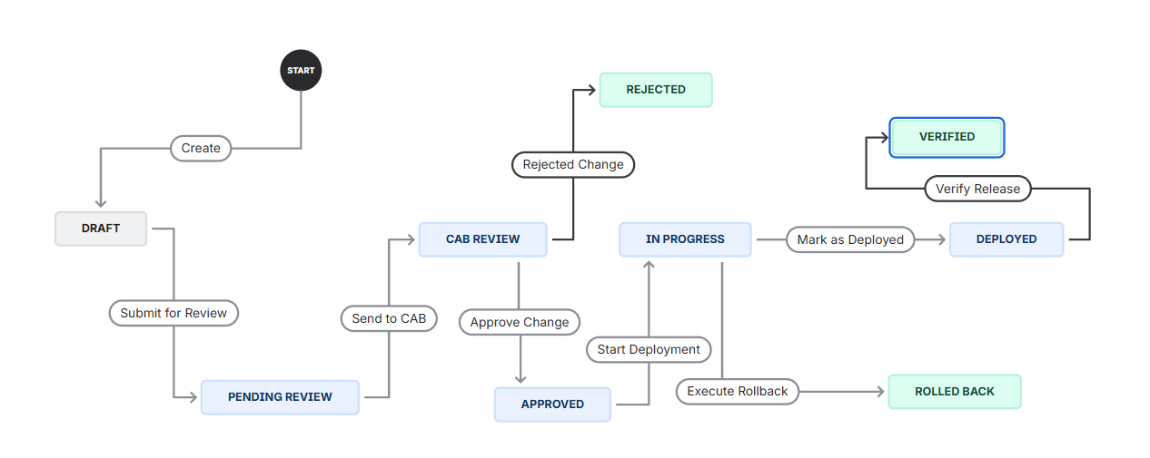

3.4 Event-Driven Notification Architecture
All notifications are driven by Spring ApplicationEvents — no external message broker required for POC. This keeps the system simple, testable, and decoupled without introducing Kafka or RabbitMQ complexity.

Event Flow (In Order)
1. Status change occurs (via webhook sync or portal action)
2. ReleaseService publishes ReleaseStatusChangedEvent
3. AuditService @EventListener — writes immutable record to audit_logs table
4. NotificationService @EventListener — determines recipients by role matrix
5. NotificationService dispatches @Async email via JavaMailSender
6. NotificationService broadcasts STOMP WebSocket to /topic/releases
7. React frontend receives STOMP message — dashboard updates without page refresh
8. Both delivery outcomes recorded in notifications table

4. REST API Design

4.1 Endpoint Specification
All endpoints are prefixed with /api/v1. Authentication is enforced via JWT Bearer token on all routes except /auth/login. Role enforcement is applied at the method level using @PreAuthorize.

Method | Endpoint | Role Required | Description
POST | /api/v1/auth/login | Public | Authenticate user, return signed JWT
GET | /api/v1/auth/me | Authenticated | Current user profile and role
GET | /api/v1/releases | All Authenticated | List all releases — pagination + filters
GET | /api/v1/releases/{id} | All Authenticated | Full details of one release ticket
PATCH | /api/v1/releases/{id}/status | REL_MGR, DEVOPS | Transition release to new workflow state
POST | /api/v1/approvals/{id} | REL_MGR, CAB | Submit approval or rejection decision
POST | /api/v1/releases/{id}/initiate | DEVOPS | Initiate production deployment
POST | /api/v1/releases/{id}/rollback | DEVOPS, REL_MGR | Trigger rollback
GET | /api/v1/releases/{id}/audit | All Authenticated | Immutable audit trail for a release
GET | /api/v1/dashboard/stats | All Authenticated | KPI summary: counts by status
GET | /api/v1/dashboard/calendar | All Authenticated | Scheduled releases for date range
GET | /api/v1/releases/export | SCR_MASTER, REL_MGR | Export release list as CSV
POST | /api/v1/webhooks/jira | Webhook (HMAC) | Receive Jira issue lifecycle events
GET | /api/v1/users | REL_MGR | List all portal users
PUT | /api/v1/users/{id}/role | REL_MGR | Change a user portal role

4.2 JWT Authentication
All API requests carry a signed JWT in the Authorization: Bearer <token> header. The JwtAuthFilter validates the token on every request before reaching any controller. Tokens expire after 24 hours for POC; reduce to 8 hours for production.

JWT Claim | Example Value | Purpose
sub | UUID | Subject — uniquely identifies the user
email | user@nb.com | User email for display and notifications
role | ROLE_RELEASE_MANAGER | Spring Security role for @PreAuthorize
iat | Unix timestamp | Issued at — for token age validation
exp | Unix timestamp + 86400s | Token expiry — 24 hours for POC

5. Database Schema Design

5.1 Schema Overview
NB Release Orchestrator uses PostgreSQL 15. The schema is initialized via a DDL script (init.sql) run once at setup. Spring Boot is configured with spring.jpa.hibernate.ddl-auto=validate so Hibernate validates but never modifies the schema.

Table | Primary Key | References | Description
users | id (UUID) | — | Portal user accounts with roles
releases | id (UUID) | users (assignee, manager) | Core release request records synced from Jira
approvals | id (UUID) | releases, users | Individual approval/rejection decisions
audit_logs | id (UUID) | releases, users | Immutable append-only action history
notifications | id (UUID) | releases | Log of all notifications sent (email + WebSocket)

5.2 Key Table: releases
The releases table is the central entity. Every Jira Release Change Request ticket maps to one row. The jira_ticket_key column is the deduplication key for webhook upserts.

Column | Type | Description
id | UUID PK | Internal NB Release Orchestrator identifier
jira_ticket_key | VARCHAR(50) UNIQUE | Jira issue key e.g. PROJ-1234 — deduplication key
jira_ticket_id | VARCHAR(50) UNIQUE | Internal Jira numeric ID — used for API calls
title | VARCHAR(500) | Issue summary from Jira
status | VARCHAR(50) | Workflow state — one of 9 defined values
release_type | VARCHAR(50) | Major / Minor / Hotfix / Rollback
target_environment | VARCHAR(50) | production / staging / uat
scheduled_date | TIMESTAMPTZ | Planned deployment datetime
services_impacted | TEXT | Newline-separated list of impacted services
deployment_steps | TEXT | Full deployment runbook
rollback_plan | TEXT | Steps to revert if deployment fails
devops_assignee_id | UUID FK | DevOps engineer responsible for deployment
release_manager_id | UUID FK | Release Manager accountable for this release
cab_approval_status | VARCHAR(50) | Change Advisory Board decision
post_release_notes | TEXT | Observations and outcomes after deployment
raw_jira_payload | JSONB | Complete raw webhook payload — preserved for debugging

5.3 Database Indexes
The following indexes are essential for dashboard query performance. Apply all of these at schema init time.

- idx_releases_status on releases(status) — all dashboard queries filter by status
- idx_releases_jira_key on releases(jira_ticket_key) — webhook upsert lookups
- idx_releases_scheduled on releases(scheduled_date DESC) — calendar view ordering
- idx_releases_devops on releases(devops_assignee_id) — DevOps queue filtering
- idx_audit_release on audit_logs(release_id) — audit trail lookups per release
- idx_audit_created on audit_logs(created_at DESC) — chronological audit ordering
- idx_approvals_release on approvals(release_id) — find all approvals for a release

6. Jira Configuration

6.1 Custom Issue Type Setup
A dedicated Jira Issue Type called 'Release Change Request' must be created and configured by a Jira Administrator before the portal can be used. This separates release governance from regular sprint issues and enables targeted webhook filtering.

JIRA ADMIN STEPS (ONE-TIME SETUP)
- Navigate to: Jira Settings → Issue Types → Add Issue Type
- Name: Release Change Request | Type: Standard | Icon: rocket/ship icon
- Assign the new issue type to your project via: Project Settings → Issue Types
- Create a dedicated workflow with the 9 states listed in Section 6.2
- Add all custom fields via: Jira Settings → Custom Fields → Add Custom Field
- Associate custom fields with the Release Change Request screen

6.2 Required Custom Fields
Field Name | Field Type | Jira Field ID | Values / Notes
Release Type | Single Select | customfield_10201 | Major / Minor / Hotfix / Rollback
Target Environment | Single Select | customfield_10202 | Production / Staging / UAT
Scheduled Release Date | Date Time Picker | customfield_10203 | ISO 8601 datetime
Services Impacted | Multi-line Text | customfield_10204 | One service per line
Deployment Steps | Multi-line Text | customfield_10205 | Numbered runbook steps
Rollback Plan | Multi-line Text | customfield_10206 | Steps to revert deployment
DevOps Assignee | User Picker | customfield_10207 | JIRA username
Release Manager | User Picker | customfield_10208 | Jira username
CAB Approval Status | Single Select | customfield_10209 | Pending / Approved / Rejected
Post Release Notes | Multi-line Text | customfield_10210 | Added after deployment

Example : Issue Type with all above Fields in Jira
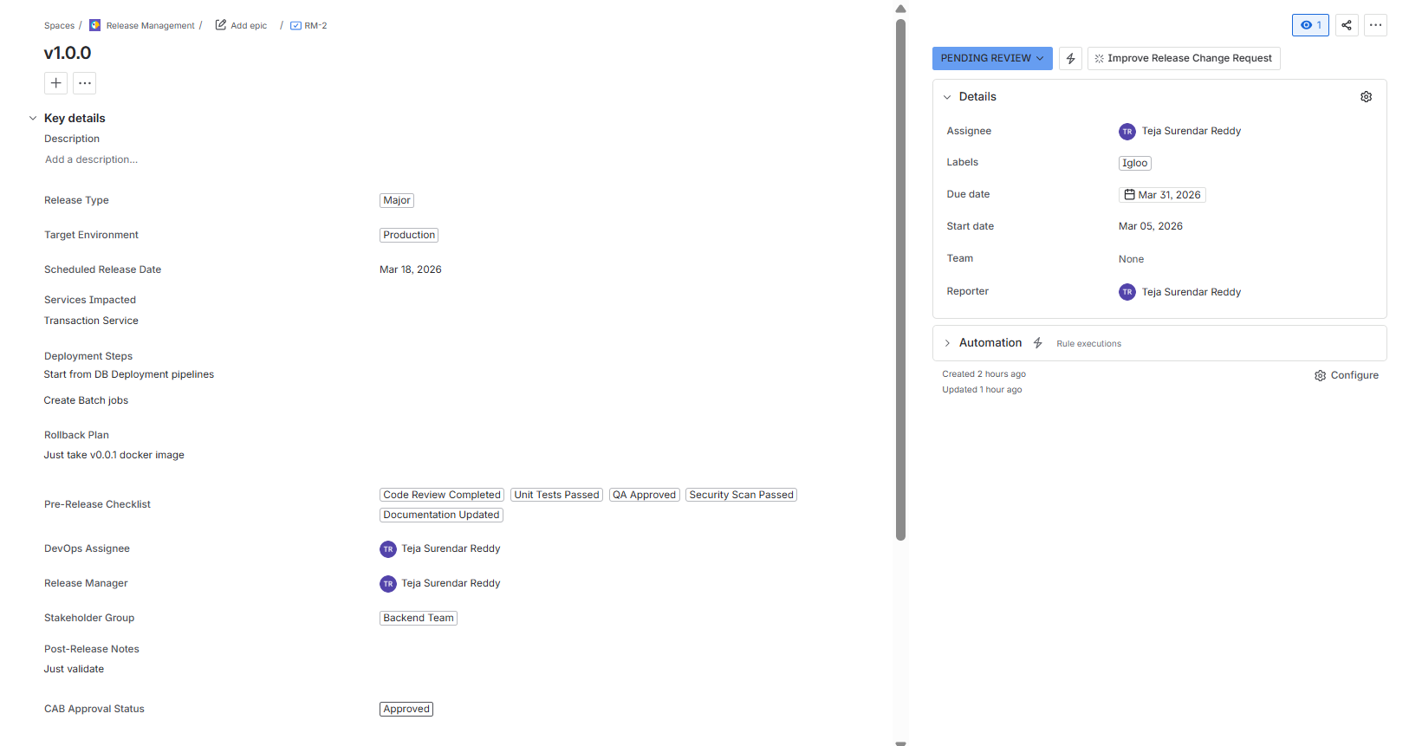

6.3 Webhook Configuration
The Jira webhook is the integration backbone. Every Jira event for Release Change Request tickets is pushed to the portal backend in real-time.

WEBHOOK SETUP (JIRA ADMIN)
- Navigate to: Jira Settings → System → WebHooks → Create a WebHook
- Name: NB Release Orchestrator Integration
- URL: https://<your-backend>/api/v1/webhooks/jira (use ngrok URL for POC)
- Events: jira:issue_created | jira:issue_updated | jira:issue_deleted
- JQL Filter: issuetype = 'Release Change Request'
- Secret Token: generate a random 32-character hex string — stored as JIRA_WEBHOOK_SECRET env variable

Every Jira webhook POST includes an X-Hub-Signature header containing an HMAC-SHA256 hash of the payload signed with your webhook secret. The WebhookController validates this signature before processing any event. Requests failing validation return HTTP 401.

7. POC Delivery Plan

7.1 Scope Boundaries
IN SCOPE — POC | OUT OF SCOPE — POC
- Spring Boot 3.x monolith REST API  - Jira webhook + REST sync integration  - JWT authentication — 7 roles  - PostgreSQL — DDL init script  - Approval workflow (approve/reject/CAB)  - WebSocket real-time dashboard  - Email notifications (JavaMail)  - React portal — 7 key screens  - Complete audit log trail  - CSV export for stakeholders | - OAuth 2.0 SSO / Active Directory  - Automated CI/CD pipeline triggers  - Kubernetes / HA production deployment  - Distributed cache (Redis cluster)  - Full CAB meeting scheduler  - Mobile PWA  - Slack bot integration  - ML-based release risk scoring  - Multi-tenant support  - Grafana / Datadog monitoring

7.2 4-Sprint Delivery Schedule (8 Weeks)

Sprint 1 — Weeks 1–2: Foundation, Database & Jira Integration
- Initialize Spring Boot 3.x project (Maven, Java 17, PostgreSQL, Spring Security, Spring Data JPA)
- Write and execute init.sql — create all 5 tables, types, indexes, seed 7 test users
- Configure Spring WebClient bean for Jira REST API (Basic Auth with API token)
- Build WebhookController with HMAC-SHA256 signature validation
- Implement ReleaseService.processJiraEvent() — upsert release from webhook payload
- Configure ngrok tunnel for exposing localhost:8080 to Jira Cloud webhook
- Write JUnit integration tests for webhook parsing and DB persistence
Deliverable: Jira ticket created → stored in PostgreSQL automatically within 2 seconds.

Sprint 2 — Weeks 3–4: API Layer, Auth, Events & Notifications
- Implement Spring Security 6 JWT filter chain — JwtTokenProvider + JwtAuthFilter
- Build all REST controllers: Auth, Release, Approval, Dashboard
- Implement release status state machine in ReleaseService (explicit transition validation)
- Build AuditService with @EventListener(ReleaseStatusChangedEvent) — INSERT-only audit log
- Build NotificationService with @EventListener and @Async — email + WebSocket push
- Configure Spring WebSocket + STOMP broker for real-time frontend updates
- Configure Spring Mail with SMTP (Mailhog for POC, Gmail for integration test)
- Write Postman collection testing all 15 endpoints with all 7 role tokens
Deliverable: Complete, secured REST API with real-time WebSocket and email notifications.

Sprint 3 — Weeks 5–6: Frontend React Portal (7 Screens)
- Bootstrap React + TypeScript + Vite + Ant Design + Zustand
- Build Login page — JWT auth, role-based redirect
- Build Dashboard — KPI cards, status chart, calendar strip, activity feed
- Build Release List — filterable, sortable table with role-based action buttons
- Build Release Detail — 4-tab layout: Overview, Approvals, Deployment Steps, Audit Trail
- Build DevOps Deploy Queue — approved tickets with Initiate/Rollback actions
- Build Audit Log page — org-wide audit with filter by action, actor, date
- Connect STOMP WebSocket — live dashboard updates, deployment progress, notification toasts
Deliverable: Full NB Release Orchestrator portal integrated with Spring Boot API.

Sprint 4 — Weeks 7–8: E2E Testing, UAT & POC Demo
- Full end-to-end lifecycle test: Jira ticket → portal sync → approve → deploy → verify
- JUnit 5 service layer unit tests with Mockito — 80% branch coverage target
- Spring Boot integration tests with Testcontainers (real PostgreSQL container)
- Cross-browser testing: Chrome, Firefox, Edge
- UAT — one representative from each of 7 stakeholder roles completes 8 test scenarios
- Load test webhook endpoint — 100 concurrent Jira events in 10 seconds (k6 or Gatling)
- Record full screen demo walkthrough of complete release workflow
- Prepare Architecture Decision Record (ADR) and production migration checklist
Deliverable: POC complete — stakeholder demo delivered.

7.3 UAT Sign-Off Scenarios
ID | Actor | Steps | Pass Criteria
S1 | Dev Team | Create Release Change Request in Jira with all fields | Ticket appears in portal within 5 seconds
S2 | Release Mgr | Open portal → Pending → approve ticket | Status APPROVED; DevOps receives email
S3 | DevOps | Open Deploy Queue → click Initiate on approved ticket | Status IN_PROGRESS; all stakeholders see live banner
S4 | All Roles | Open dashboard → trigger state change from another browser | Dashboard updates without page refresh within 2 sec
S5 | DevOps | During IN_PROGRESS → click Rollback → enter reason | Status ROLLED_BACK; audit log shows reason; all notified
S6 | Dev Team | Login as Dev user → attempt to click Approve button | Approve not visible; API returns HTTP 403
S7 | Release Mgr | Open release → Audit Trail tab → review full history | All transitions logged with actor, timestamp, old/new value
S8 | Scrum Master | Release List → Export CSV → open in Excel | All releases exported with correct fields and status values

8. POC Deployment Guide

8.1 Environment Variables
All sensitive configuration is injected via environment variables. Never commit secrets to version control. Create a .env file at the project root (add to .gitignore).

Variable | Example Value | Description
DB_USER | nbro_user | PostgreSQL username
DB_PASS | <strong-password> | PostgreSQL password
JIRA_BASE_URL | https://yourorg.atlassian.net | Jira Cloud base URL
JIRA_API_TOKEN | <api-token> | Jira API token (from Jira Account Settings)
JIRA_EMAIL | devops@nexbank.com | Jira account email for the API token
JIRA_WEBHOOK_SECRET | <32-char-hex> | Matches the secret set in Jira webhook config
JWT_SECRET | <256-bit-random> | JWT signing secret — minimum 32 characters
SMTP_USER | noreply@nexbank.com | Sender email address
SMTP_PASS | <app-password> | SMTP password or Gmail app password

8.2 Docker Compose Services
Service | Image | Port | Notes
postgres | postgres:15-alpine | 5432 | Primary datastore — persist data with named volume
backend | ./nb-release-backend | 8080 | Spring Boot JAR — depends on postgres
frontend | ./nb-release-portal | 3000 | React Vite build — depends on backend
mailhog (POC) | mailhog/mailhog | 1025/8025 | Catch-all SMTP for POC email testing

8.3 Quick Start Sequence
- Start Postgres: docker-compose up -d postgres (wait ~5s for readiness)
- Run init SQL: docker exec -it postgres psql -U nbro_user -d nb_release_orchestrator -f /tmp/init.sql
- Start backend: docker-compose up -d backend (Spring Boot validates schema on startup)
- Start frontend: docker-compose up -d frontend (React portal at http://localhost:3000)
- Expose backend for Jira: ngrok http 8080 → copy HTTPS URL to Jira Webhook config
- Test: Create a Release Change Request in Jira — confirm it appears in the portal within 5 seconds

9. Production Roadmap
The POC monolith is designed with clean package boundaries that map directly to future microservice extraction. The business logic investment is preserved at every phase.

Phase | Timeline | Architecture | Key Enhancements
POC | Weeks 1–8 | Spring Boot Monolith + Docker Compose | Core workflow, Jira sync, REST API, React portal, JWT auth
Prod v1 | Month 3–4 | Monolith + Kubernetes + HA Postgres | OAuth 2.0 SSO, Redis cache, Nginx HTTPS, K8s deployment
Prod v2 | Month 5–6 | Monolith + extended features | Slack bot, CI/CD triggers, analytics, calendar conflict detection
Hybrid | Month 7–12 | Extract Notification + Audit services | First two microservices — shared JWT, Kafka events
Microservices | Year 2 | Full service mesh | Per-service DBs, API gateway, distributed tracing, Kafka event bus

9.1 Architecture Decision Record Summary
Decision | Choice | Rationale
API Protocol | REST (Spring Web MVC) | Browser-compatible, industry standard. No gRPC overhead for POC.
Architecture | Monolithic Layered | Single deployable unit — fastest to build, easiest to debug, one log stream.
Authentication | JWT (stateless) | No server-side session state — horizontally scalable, easy to validate.
DB Schema Mgmt | Manual DDL init.sql | No migration tool dependency for POC. Flyway can be added in Prod v1.
ORM | Spring Data JPA + Hibernate | Standard Spring ecosystem — repository pattern, clean queries.
Real-time | Spring WebSocket + STOMP | Native Spring — browser SockJS client works everywhere.
Events | Spring ApplicationEvents + @Async | Zero-dependency internal decoupling — no Kafka/RabbitMQ needed.
State Machine | Explicit service logic | Avoids Spring State Machine complexity. Simple, readable, testable.

NB Release Orchestrator
Java 17 · Spring Boot 3.x · PostgreSQL · React.js
NB Engineering | Confidential | March 2026

