**General Questions**

1. I wanted to know if we can get more detailed information regarding the 25G indicator that will be attached to the vial packages. The website provided in the AIAA rule book says it does not deliver the indicators to India. In such a case, information such as maximum load or maximum height that would ideally trigger the indicator are crucial from the design point of view. I request you to make the information available to us at the earliest.

Answer: There is no additional information available other than that found on the Uline website. Impact shock is dependent on many factors such as drop height, material, angle, etc. It is up to each team to determine the best method to secure and deploy the vaccine vial packages without tripping the shock sensor.

1. Are flight controllers allowed onboard for stabilization purposes? Such as an electronic gyroscope.

Answer: Commercially procured (COTS) flight stabilization systems and gyros are allowed. Autopilots are not. An example of a COTS flight stabilization device is shown here:

[https://www.getfpv.com/frsky-s8r-8-16ch-receiver-w-3-axis-stabilization-smart-port-sbus.html?afid=aVlOV0hBdmd6THc9&in-stock=1&gclid=CjwKCAiA7dKMBhBCEiwAO_crFI36_JXEGWUSNt-hL_UPgyRf8OzNBwYpju5tBMDmWH6v6iay28g1dRoCONUQAvD_BwE](https://nam02.safelinks.protection.outlook.com/?url=https%3A%2F%2Fwww.getfpv.com%2Ffrsky-s8r-8-16ch-receiver-w-3-axis-stabilization-smart-port-sbus.html%3Fafid%3DaVlOV0hBdmd6THc9%26in-stock%3D1%26gclid%3DCjwKCAiA7dKMBhBCEiwAO_crFI36_JXEGWUSNt-hL_UPgyRf8OzNBwYpju5tBMDmWH6v6iay28g1dRoCONUQAvD_BwE&data=04%7C01%7Cdirector%40aiaadbf.org%7C6341223f250c47b98c6008d9adfb0ec0%7C036e8604b674406a80987cb72daf432b%7C0%7C0%7C637732116074455077%7CUnknown%7CTWFpbGZsb3d8eyJWIjoiMC4wLjAwMDAiLCJQIjoiV2luMzIiLCJBTiI6Ik1haWwiLCJXVCI6Mn0%3D%7C3000&sdata=QUaokjgxdjicKfRr0UWJtxTiNMbmyQCvlJ7syNHDM%2BA%3D&reserved=0))

1. The DBF rule mentions the capacity of the syringe as 30 ml. However, it seems to be important to have details on the dimensions (more importantly linear dimensions) of the particular syringe mentioned in the rule. It would be much appreciated if you provide detailed dimensions.

Answer: Syringe dimensions are provided below. Average weight is 0.65 ounces.

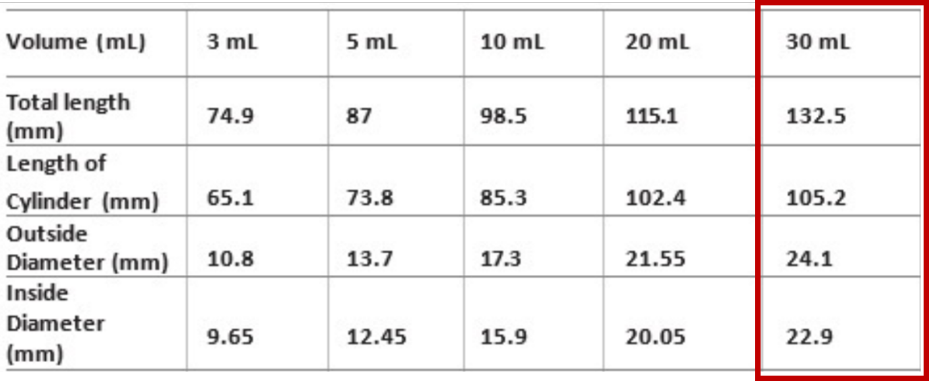

1. I wanted to know if ballast considered as part of aircraft configuration, that is if we use ballast in mission 1 do we have to carry the same in all the other missions?

Answer: Ballast can be configured differently for each mission as required to maintain stable flight of the aircraft. It does not need to be the same amount or location of ballast for all missions.

1. I am writing to inquire about "payload design" and "ground mission rules". Is it allowed to design a removable syringe rack that has a quick attach mechanism, provided it remains attached to the fuselage all the time except for the unloading phase of the ground mission? Our team aims to develop a fast way to unload the syringes by removing the rack and dropping all the syringes at once, during the ground mission. Do the rules permit teams to drop all the syringes at once in the ground mission or is it mandatory to remove the syringes one by one?

Answer: A removable syringe rack is allowed for loading and unloading but it must be in the aircraft for ALL three missions. There is no requirement on how the syringes are unloaded during the ground mission. Only the vaccine vial package must be unloaded remotely one at a time.

1. In this document, it was specified in detail that autopilots of any type are not allowed. However, my team is unsure, does the usage of a Pixhawk system alone break this rule? Even if the system is only intended to be used for gyroscopic, in-flight stabilization, and no pre-planned flight mapping, autopilot, or telemetry sharing whatsoever?

Answer: Autopilots of any kind are NOT allowed on the aircraft, regardless of their intended use.

1. During the ground mission, does the aircraft have to be deactivated, or can it be powered on and moving?

Answer: The aircraft propulsion system CANNOT be armed during the ground mission. The aircraft systems can be activated to assist in loading and unloading payloads and activating the remote drop requirement for the vaccine vial package. If the aircraft need to be moved between vaccine vial package remote drops, it can be moved manually by the crew member once the drop is complete.

1. Are we required to take off straight along the runway or can we take a diagonal path? (i.e allowed takeoff width)?

Answer: This will be determined solely by the flight director during the fly-off.

1. What is considered changing internal configuration between missions? (For example: if we have a spring involved in deployment for mission 3, can we manually move a part to compress it for mission 2?).

Answer: Restraining or securing components internal to the aircraft that are not being used for a particular mission is allowed.

1. Are magnets allowed?

Answer: Magnets are not allowed for securing safety critical items such as external doors or access panels, payloads, etc.

1. I have been informed that, in previous competitions, the controls system was not allowed to be powered by the propulsion battery via BEC. I cannot find anything in the current rules that prohibits this. Can you please advise on whether or not this is allowed for the 2022 competition?

Answer: The propulsion battery is required to be a separate battery from the receiver/flight controls battery.

1. Given the maximum propulsion battery stored energy is 100 W*h, and my team has opted to use a single 6s LiPo battery, the maximum charge our battery can contain is 3968 mA*h. Would it be acceptable to round this up to 4000 mA*h? If not, would it be acceptable to use a 4000 mA*h pack, but not charge it to full capacity?

Answer: NO to both questions.

1. Regarding the rule against autopilot, could you please help me understand the difference between an autopilot and the automatic system to fly the plane in case it disconnects? Does an autopilot mean a physical device that has the ability to fly the plane? Or does it mean utilization of said autopilot programs?

Answer: There is no difference between an autopilot and an automatic system to fly the plane – neither are allowed. In case of failed communications to the airplane or other system failure, the fail-safe must engage and immediate crash the airplane. Any kind of autopilot and the fail-safe requirement are conflicting implementations and only the fail-safe implementation is allowed.