**Characteristics of the YOLOv5 mode:**

1. **Adopting YOLOv5, it has the smallest network and faster speed. Although AP accuracy is slightly lost, it has certain advantages in model deployment and detection.**
2. **It is a one-time positioning and prediction, which can adaptively calculate the best anchor frame value of different training sets during each training.**

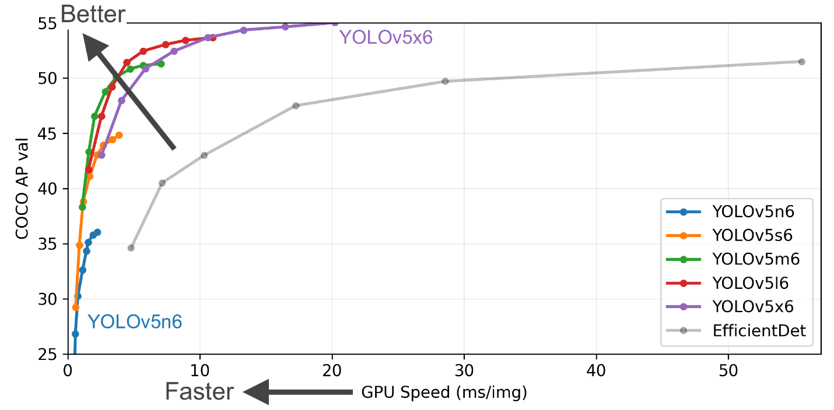

**Pretrained Checkpoints**

|  |  |  |  |  |  |  |  |  |
| --- | --- | --- | --- | --- | --- | --- | --- | --- |
| **Model** | **size** | **mAPval** | **mAPval** | **Speed** | **Speed** | **Speed** | **params** | **FLOPs** |
| **(pixels)** | **50-95** | **50** | **CPU b1** | **V100 b1** | **V100 b32** | **(M)** | **@640 (B)** |
|  |  |  | **(ms)** | **(ms)** | **(ms)** |  |  |
| YOLOv5n | 640 | 28 | 45.7 | 45 | 6.3 | 0.6 | 1.9 | 4.5 |
| YOLOv5s | 640 | 37.4 | 56.8 | 98 | 6.4 | 0.9 | 7.2 | 16.5 |
| YOLOv5m | 640 | 45.4 | 64.1 | 224 | 8.2 | 1.7 | 21.2 | 49 |
| YOLOv5l | 640 | 49 | 67.3 | 430 | 10.1 | 2.7 | 46.5 | 109.1 |
| YOLOv5x | 640 | 50.7 | 68.9 | 766 | 12.1 | 4.8 | 86.7 | 205.7 |
|  |  |  |  |  |  |  |  |  |
| YOLOv5n6 | 1280 | 36 | 54.4 | 153 | 8.1 | 2.1 | 3.2 | 4.6 |
| YOLOv5s6 | 1280 | 44.8 | 63.7 | 385 | 8.2 | 3.6 | 12.6 | 16.8 |
| YOLOv5m6 | 1280 | 51.3 | 69.3 | 887 | 11.1 | 6.8 | 35.7 | 50 |
| YOLOv5l6 | 1280 | 53.7 | 71.3 | 1784 | 15.8 | 10.5 | 76.8 | 111.4 |
| YOLOv5x6 | 1280 | 55 | 72.7 | 3136 | 26.2 | 19.4 | 140.7 | 209.8 |
| + TTA | 1536 | 55.8 | 72.7 | - | - | - | - | - |

**Reference List:**

1. <https://github.com/ultralytics/yolov5>

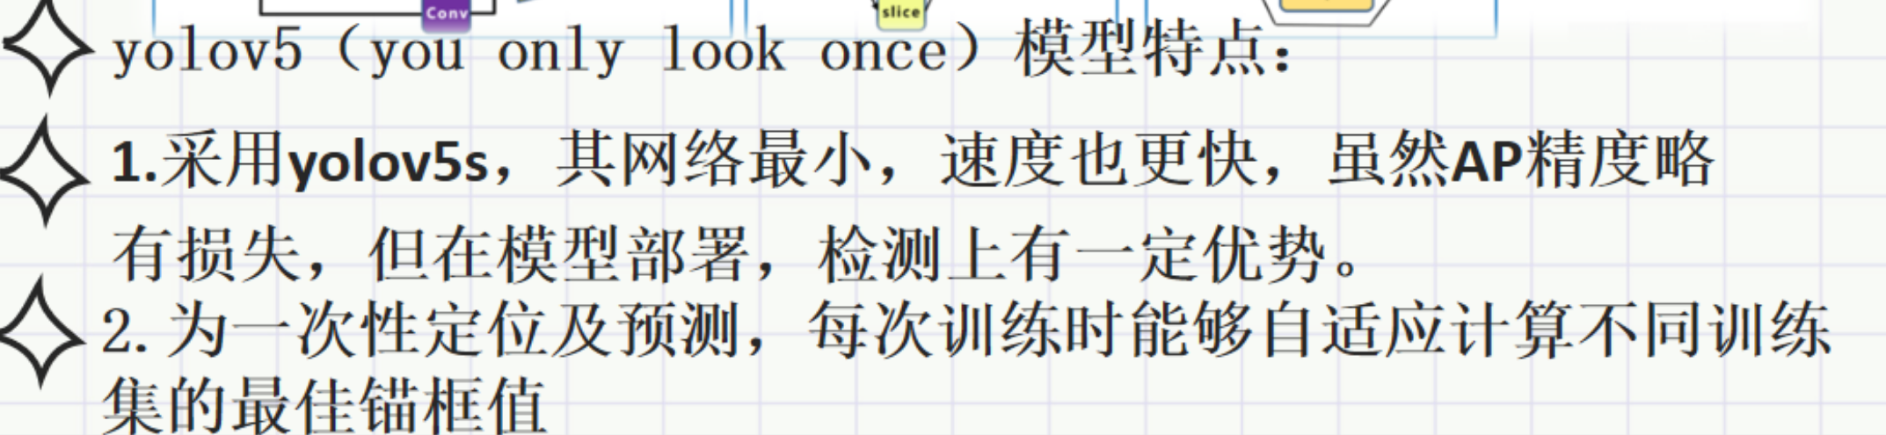

参考输出：

<https://github.com/Ernestoflores27/Garden_Defender/tree/YoloTraining/YoloTraining>(链接内容已无)