1. Create Subnet:

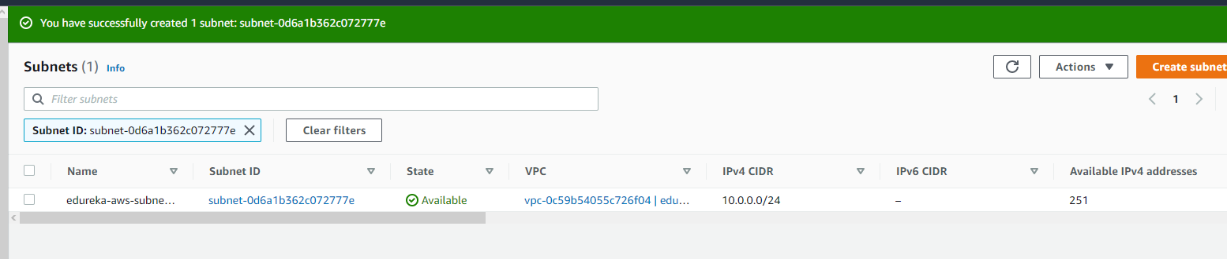

1. Create EC2 instance with public IP: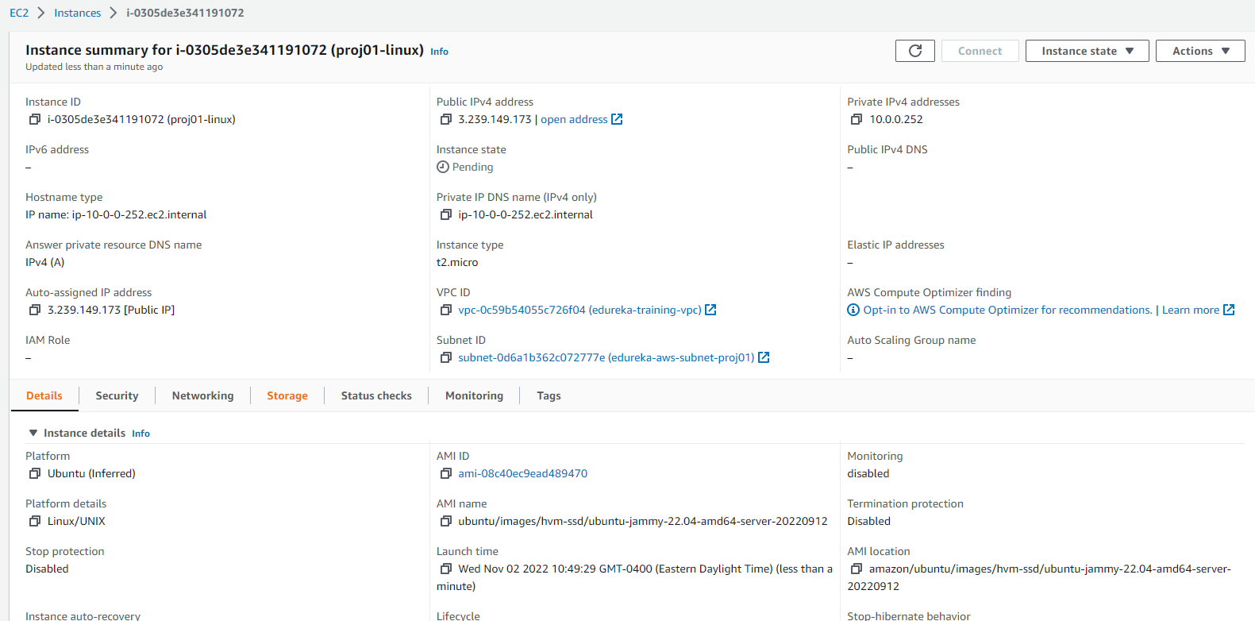
2. Create EC2 instance with Private IP 