**Edureka – AWS Solution Architect Certification Training Course: Project 2**

Goal: To architect a solution that is secure, scalable, highly available, and cost effective using AWS.

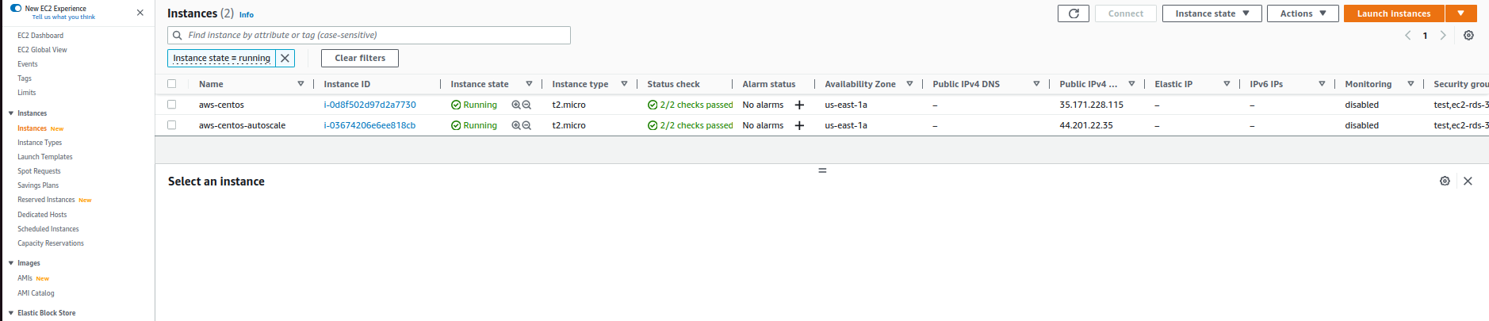

1: AWS Linux ami instance for Project 2

* Designed to host a dynamic website, where customers can enter their detail, then stored on a RDS database.
* Environment runs at least 2 EC2 servers at all time, bursting to 4 servers at high load
* 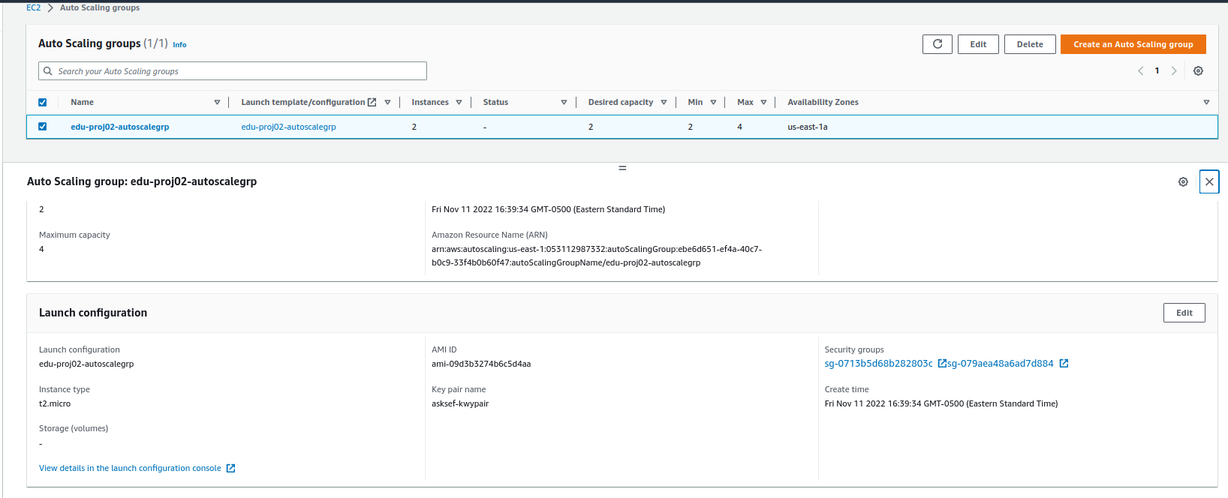
* Provides for PaaS solution with patching and backups
* 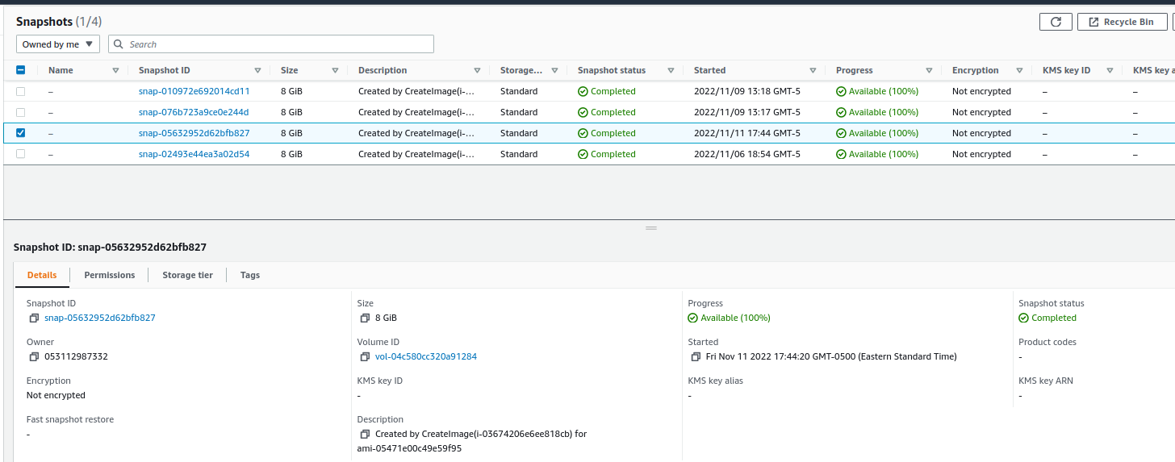
* Designed RDS environment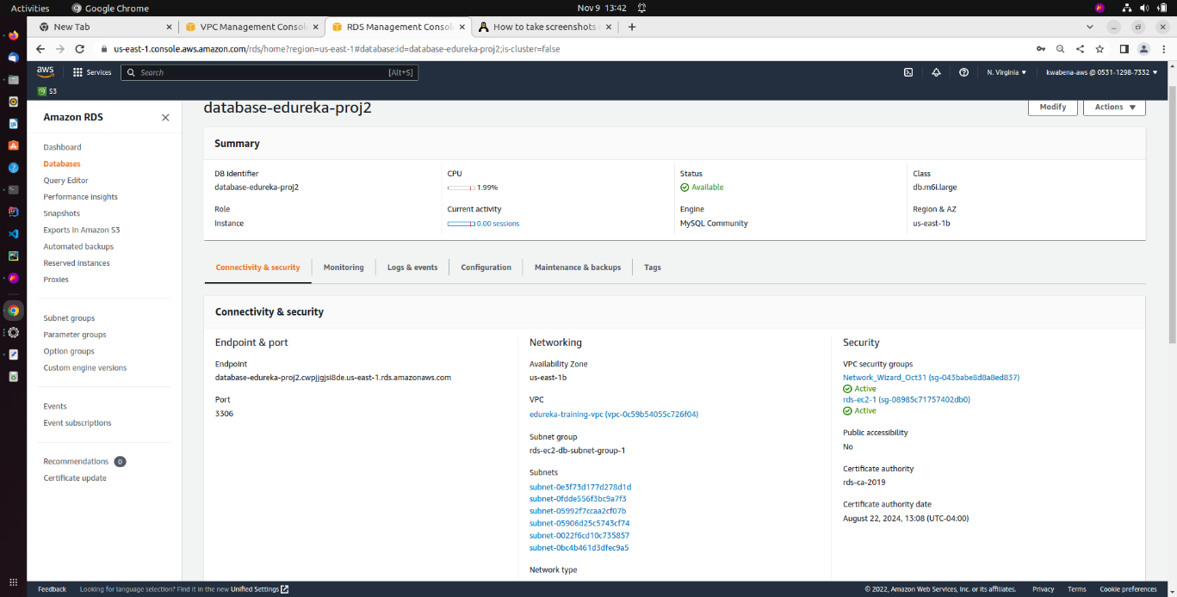

2: Amazon RDS instance for Project 2

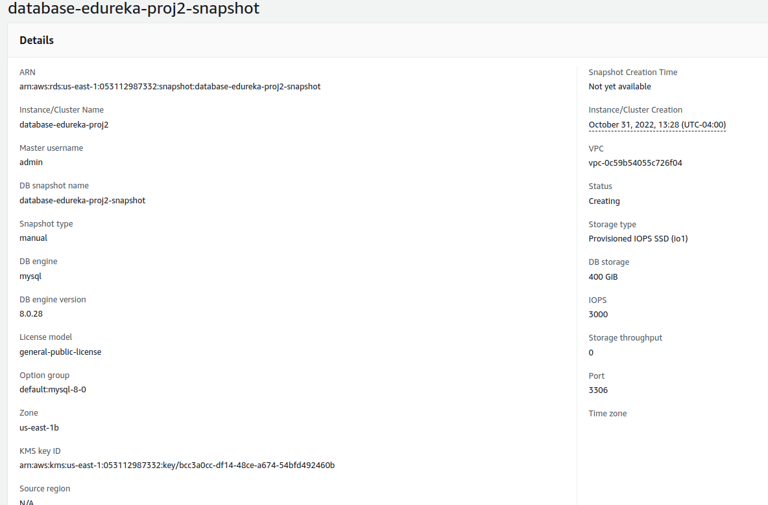

* Website for customer details

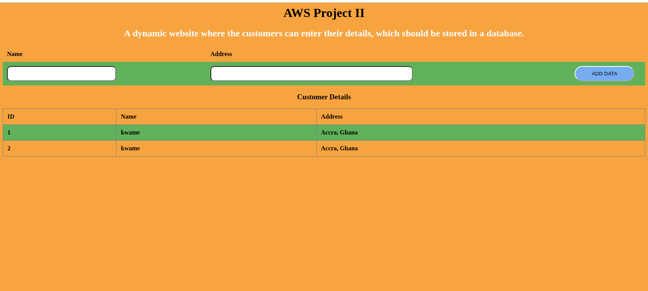

* Database contents

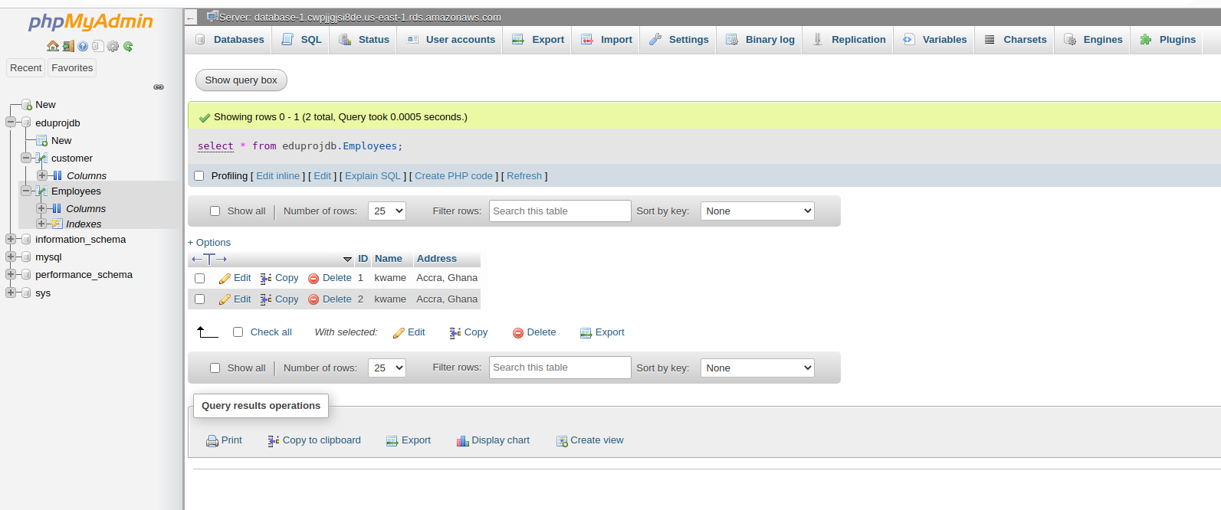

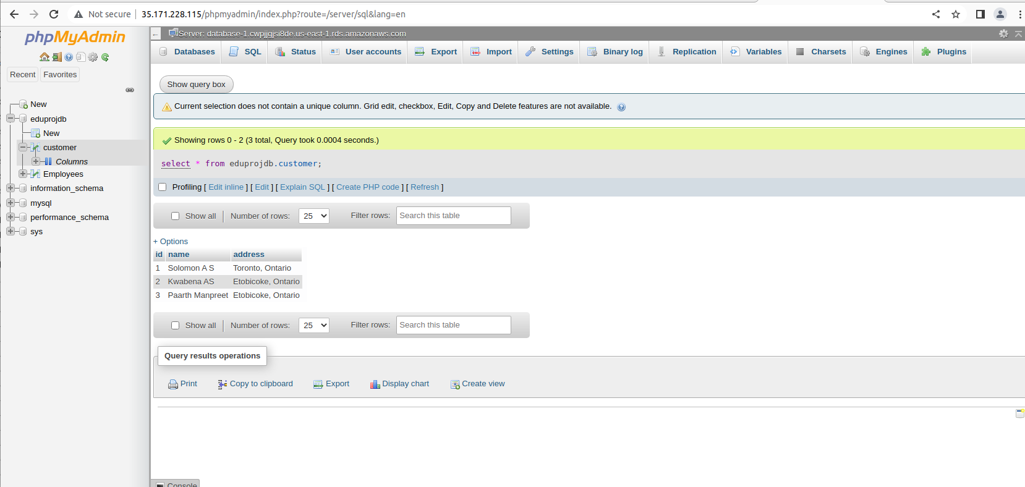

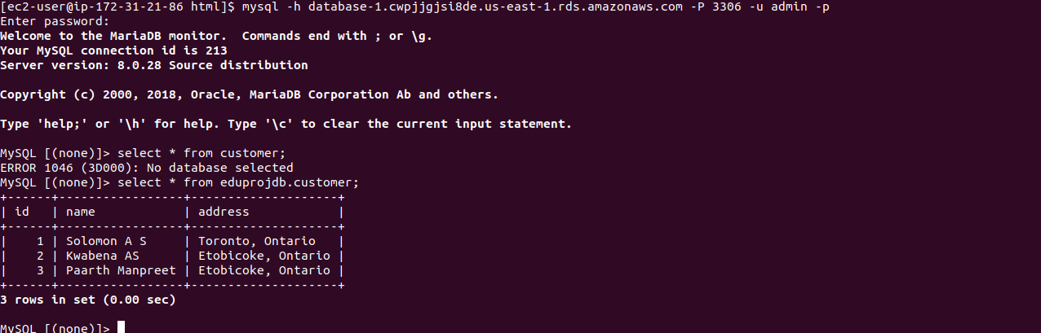

* EC2 instance definition with auto-scaling, monitoring

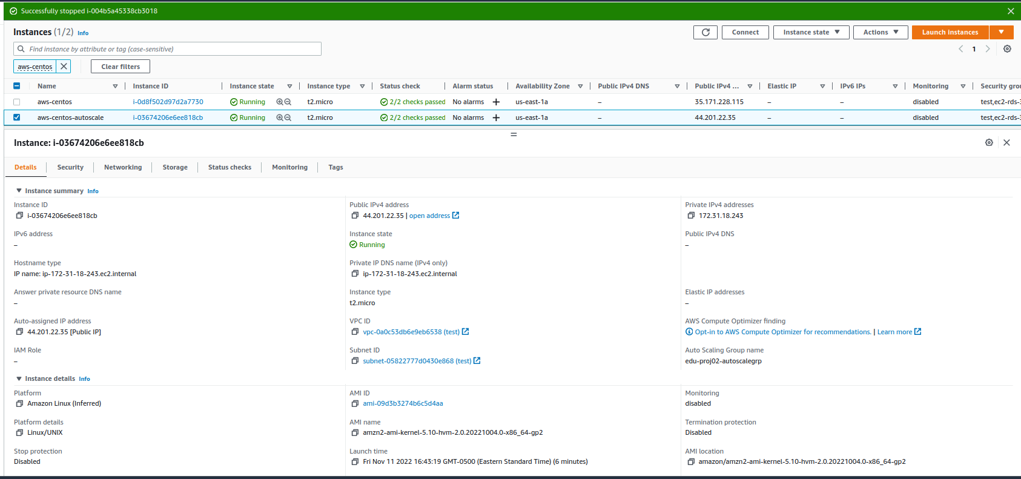

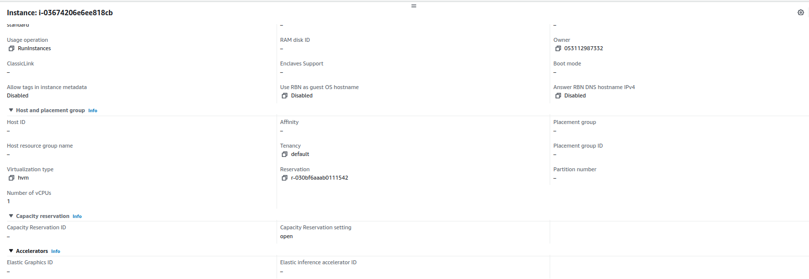

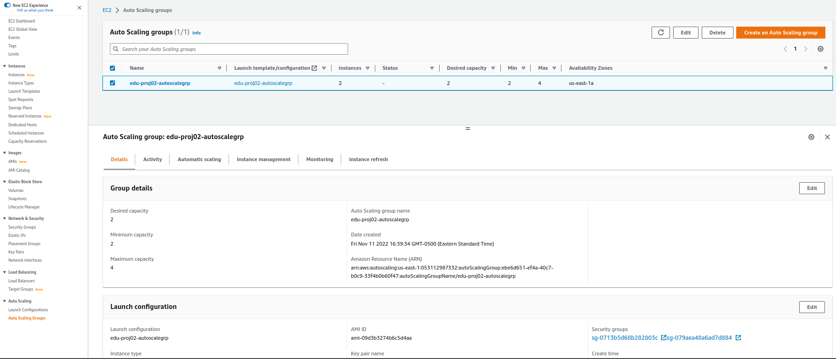

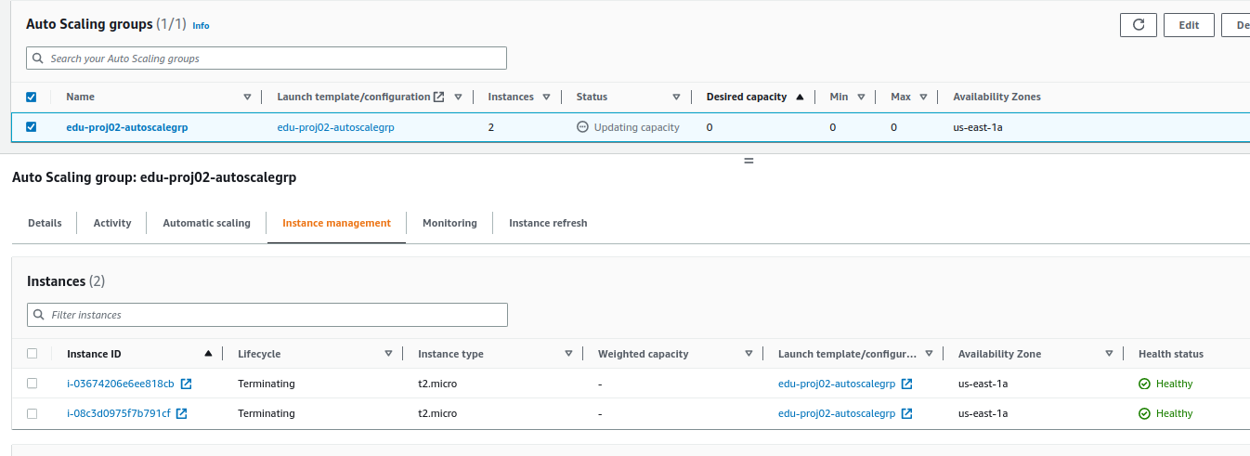

* Monitoring
* 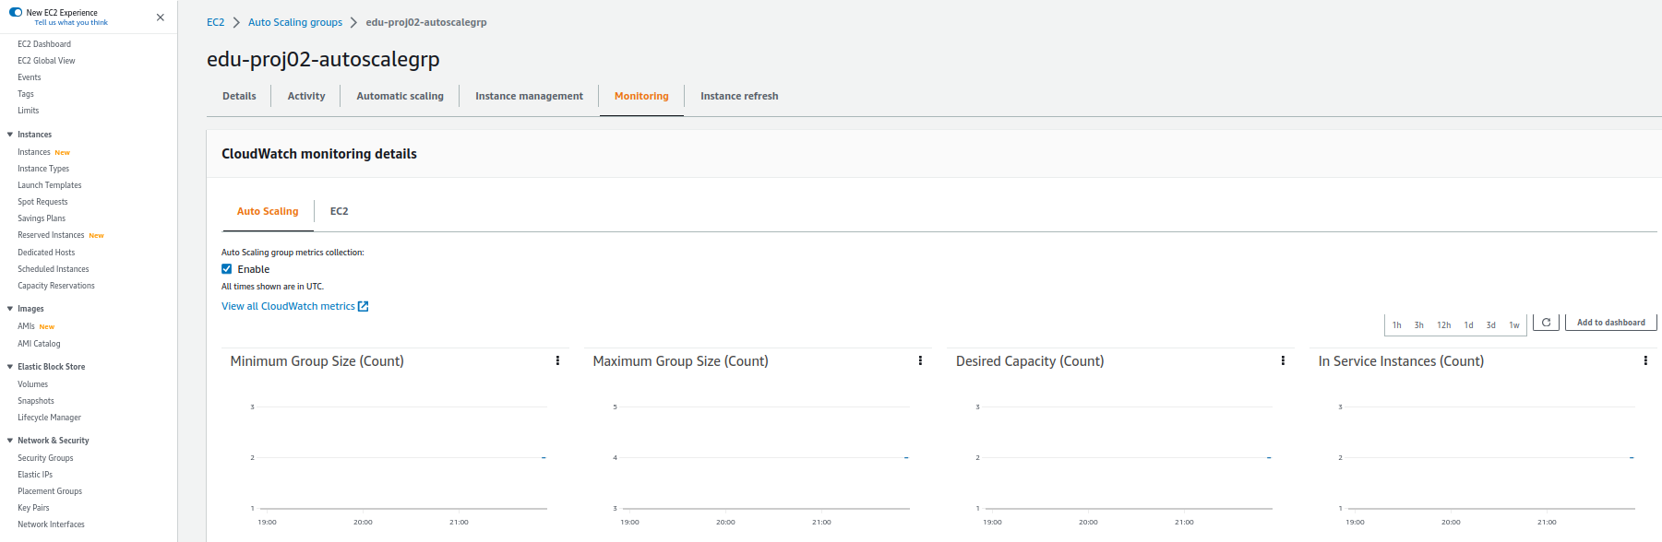

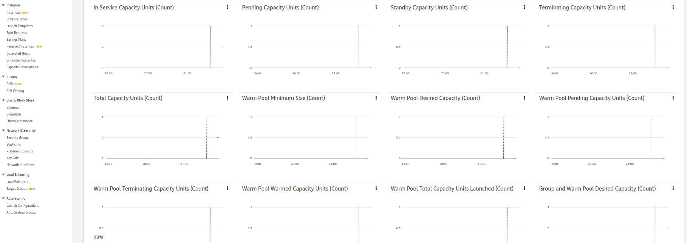

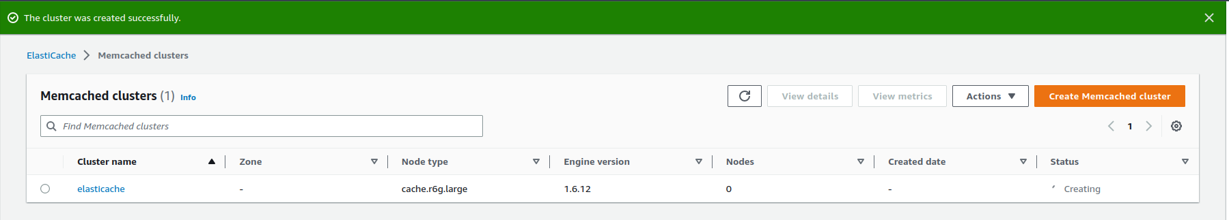

Backup:

* 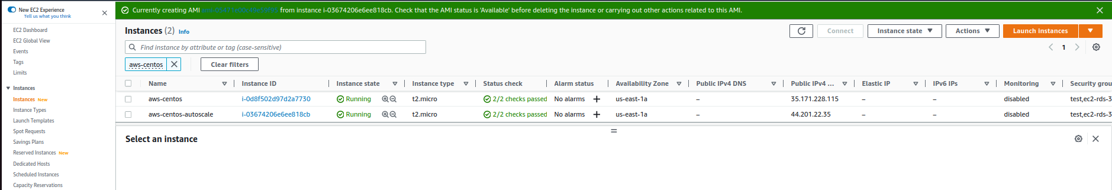
* Others – disaster recovery
* 
 