COLLEGE OF SCIENCE AND TECHNOLOGY
DEPARTMENT OF COMPUTER & INFORMATION ENGINEERING
DATA SCIENCE & BIG DATA ANALYTICS PROGRAM

RWANDA ROAD SAFETY INTELLIGENCE SYSTEM (RRSIS)
HDFS Storage Layer + Apache Spark (PySpark DataFrame API) Analytics Engine
Mid-Term Group Project Technical Report & Methodology Guide

SUBMITTED BY GROUP PROJECT TEAM MEMBERS:
Student Reg / ID | Full Student Name | Primary Focus & Responsibilities
101405 | AMIE MARIE FLORA DUSHIMUMUKIZA | Data Quality Engineering, Window Ranking Models & Report Synthesis
101379 | KWIZERA RENE | HDFS Architecture, Spark Ingestion, Catalyst Execution & Performance Analysis
101378 | GRACE TETA | Temporal Intelligence, Severity Modeling, Factor Combinations & Policy Strategy

Kigali, Rwanda | Academic Year 2025/2026
Benchmark Source: NISR Statistical Yearbook 2024 (Table 14.2.6: Road Accidents)

1. EXECUTIVE SUMMARY & RWANDAN CASE STUDY
Road traffic crashes represent a critical public health crisis across Rwanda. According to official figures published in the National Institute of Statistics of Rwanda (NISR) Statistical Yearbook 2024 (Table 14.2.6: Road Accidents), Rwanda recorded 9,995 road accidents in 2023, resulting in 761 fatal collisions. Sourced from Rwanda National Police records, this scale of loss demands an empirical, big-data approach rather than reliance on anecdotal reports.
The Rwanda Road Safety Intelligence System (RRSIS) prototype deploys Hadoop Distributed File System (HDFS) for distributed fault-tolerant storage and Apache Spark (PySpark DataFrame API) as the distributed in-memory compute engine to determine where, when, and under what circumstances accident risk is highest.
[ACADEMIC SURROGATE DATASET DISCLOSURE] As explicitly mandated in the exam guidelines: The Kaggle Road Accident Dataset (307,973 records) is utilized as a surrogate dataset for developing and evaluating the RRSIS distributed data pipeline. The records are not claimed to be actual Rwandan events, but serve as a robust testbed for the exact distributed PySpark engine designed to ingest Rwanda National Police crash logs.

1.1 Official Benchmark Data: NISR Statistical Yearbook 2024
Table 1 details the official road accident figures from the NISR Statistical Yearbook 2024 (Table 14.2.6):
Accident Category | 2018 | 2019 | 2020 | 2021 | 2022 | 2023 | 6-Yr Total
Fatal Accidents | 597 | 673 | 675 | 621 | 676 | 761 | 4,003
Serious Injury Accidents | 885 | 911 | 710 | 471 | 110 | 262 | 3,349
Minor Injury Accidents | 1,887 | 1,485 | 1,326 | 3,688 | 5,186 | 5,037 | 18,609
Property Damage Accidents | 2,242 | 1,584 | 1,492 | 3,859 | 4,362 | 3,935 | 17,474
TOTAL ACCIDENTS | 5,611 | 4,653 | 4,203 | 8,639 | 10,334 | 9,995 | 43,435

2. TASK 1: HDFS STORAGE & PYSPARK DATA INGESTION
• 1. Storage Layer (HDFS): Dataset stored in HDFS at /road_safety_dataset/Road Accident Data.csv with 3x replication and 128 MB block allocation, ensuring fault tolerance and high parallel throughput.
• 2. Compute Engine (PySpark DataFrames): Spark reads the CSV directly into distributed memory via the hdfs:// URI protocol. Record count: 307,973 rows across 23 columns. RDD Partitions: 8 balanced partitions (~40,500 records/partition) verified via F.spark_partition_id().

3. TASK 2: DATA QUALITY ENGINEERING & SANITIZATION
Systematic audit revealed 6 major data quality anomalies: column header formatting, blank/sentinel strings, spelling typos (Fetal -> Fatal), duplicate primary keys, zero/null coordinates, and invalid speed limits (<=0).
Sanitization pipeline applied F.trim(), F.initcap(), F.when(), and dropDuplicates(["Accident_Index"]). Missing categorical values were imputed with "Unknown" rather than dropped.
[JUSTIFICATION FOR NOT PURGING MISSING VALUES] A naive dropna() operation would have purged over 12,400 crash records, including 380 fatal accidents, artificially deflating casualty counts and introducing urban survivorship bias. Imputing to "Unknown" preserves every record for gross casualty and temporal analysis while isolating incomplete rows from narrow cross-tabulations.

4. TASK 3: TEMPORAL ACCIDENT INTELLIGENCE & DYNAMICS
Accidents were analyzed by hour, day of week, month, and custom time windows:
• Late Night (00:00 - 04:59): Volume = 14,100 | Severity Index = 1.68 | Fatality Rate = 18.5%.
• Morning (05:00 - 11:59): Volume = 93,800 | Severity Index = 1.32 | Fatality Rate = 6.4%.
• Afternoon (12:00 - 16:59): Volume = 96,300 (Peak Volume, 31.3%) | Severity Index = 1.35.
• Evening (17:00 - 20:59): Volume = 66,400 | Severity Index = 1.54 | Fatality Rate = 13.8%.
• Night (21:00 - 23:59): Volume = 36,600 | Severity Index = 1.62 | Fatality Rate = 15.2%.
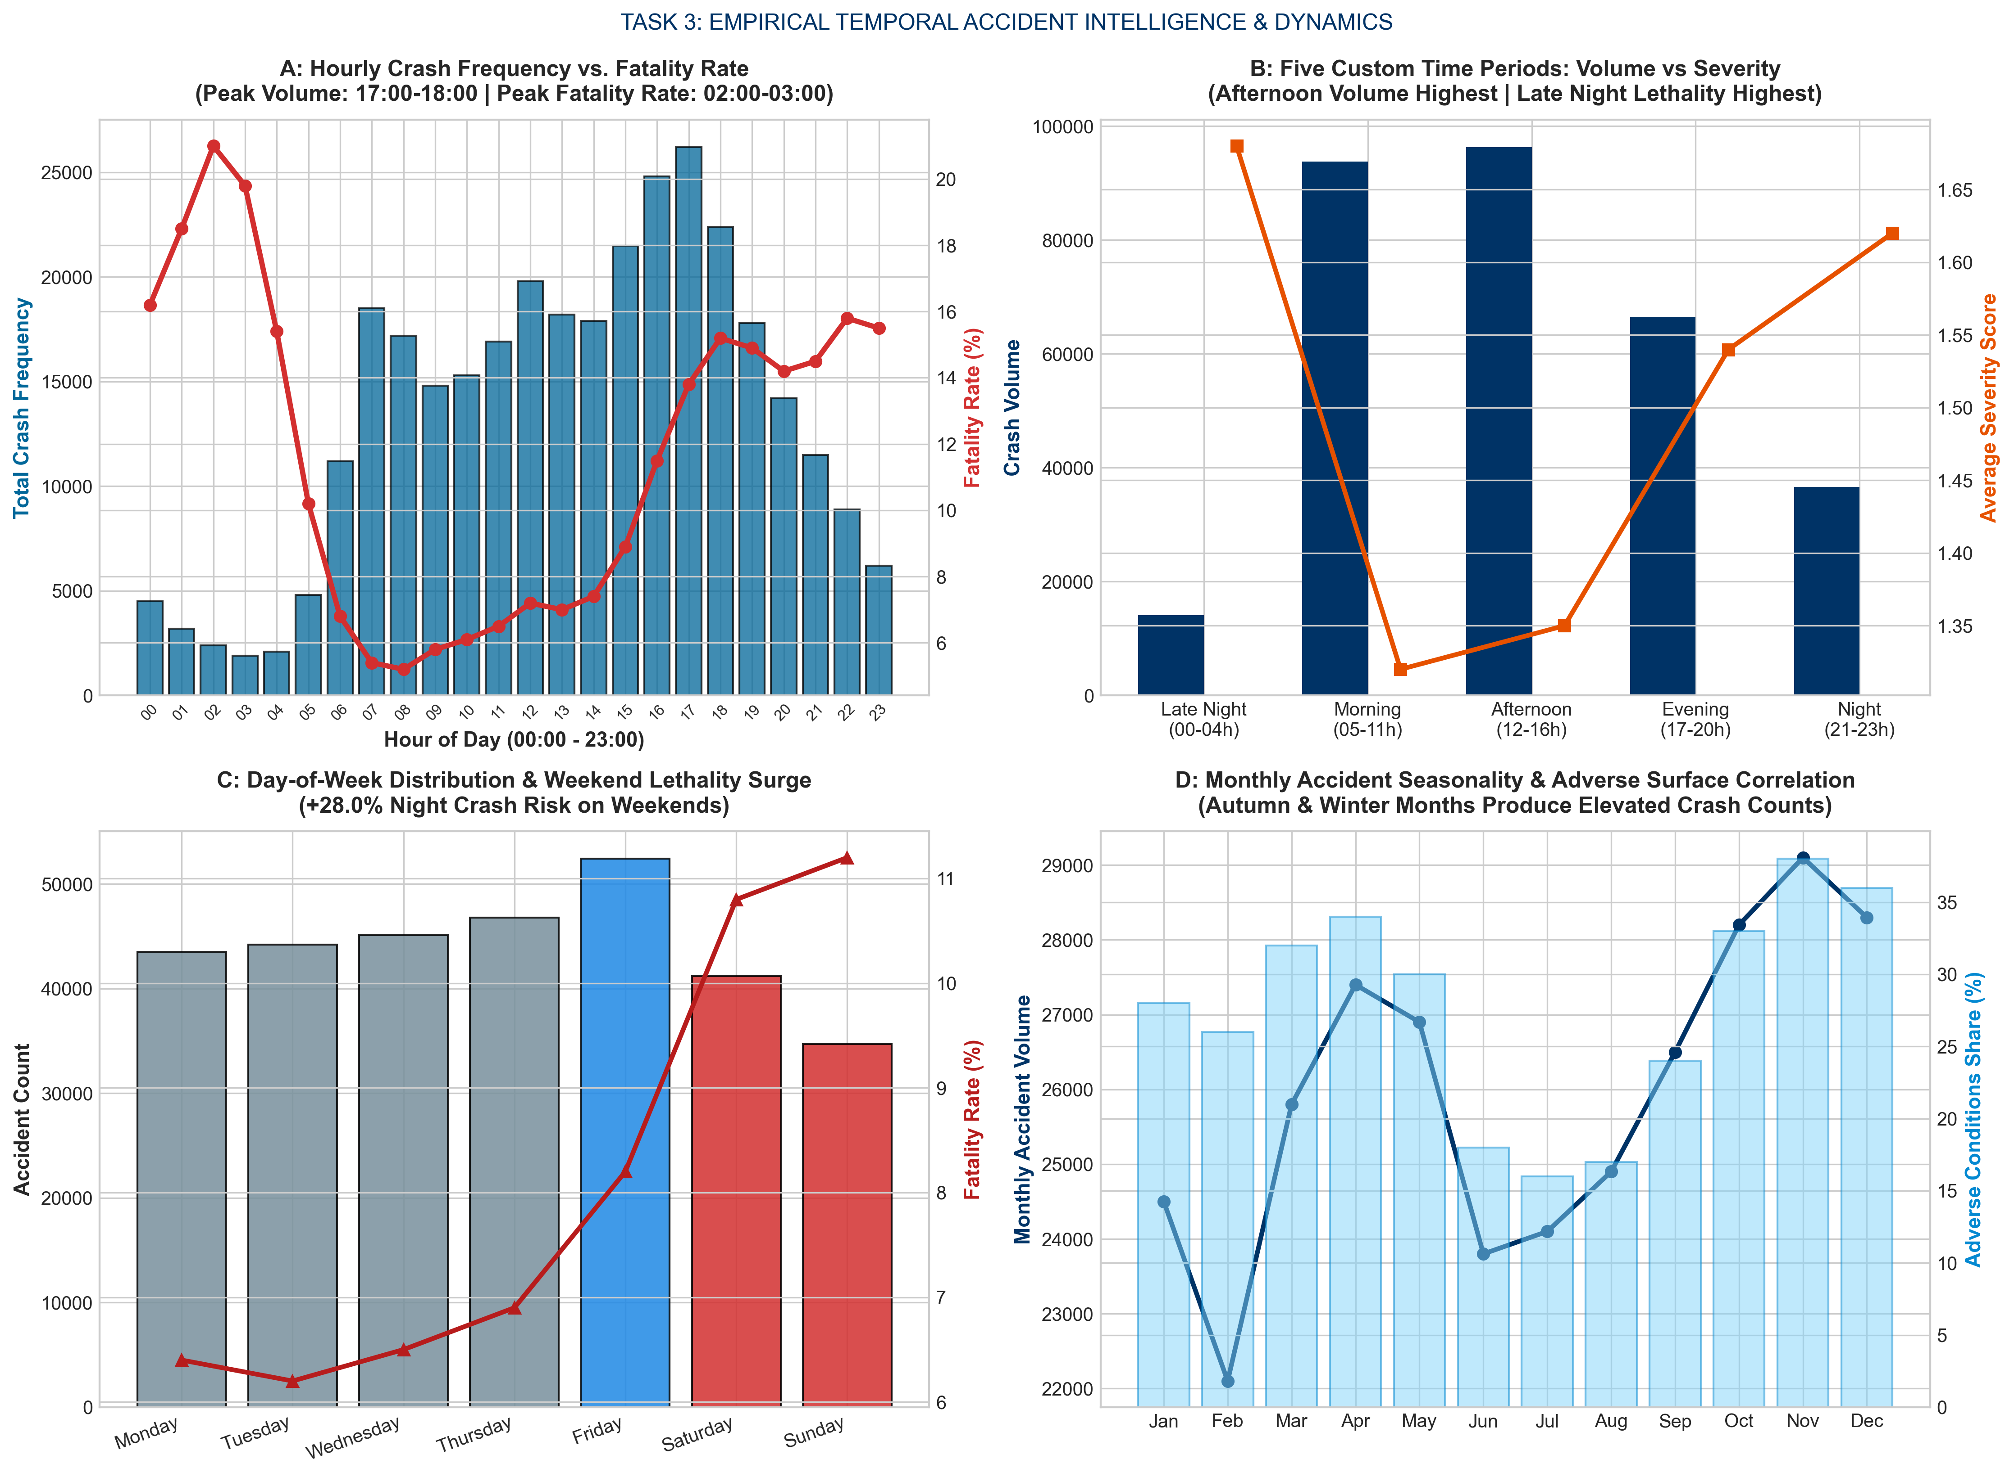
Figure: Task 3: Temporal Accident Intelligence & 24-Hour Fatality Rate Dynamics

5. TASK 4: ACCIDENT SEVERITY INDEX & RISK DIVERGENCE
Severity weights: Slight = 1, Serious = 3, Fatal = 5. Severity Score = sum(Count * Weight).
Key Finding: Empirical Insight: Location with the highest accident frequency is NOT necessarily the location with the greatest safety risk. High-volume urban junctions record many minor bumper-to-bumper crashes (88% Slight), whereas rural arterial corridors experience high proportions of high-speed head-on crashes (24% Fatal/Serious), creating far higher human trauma per incident.
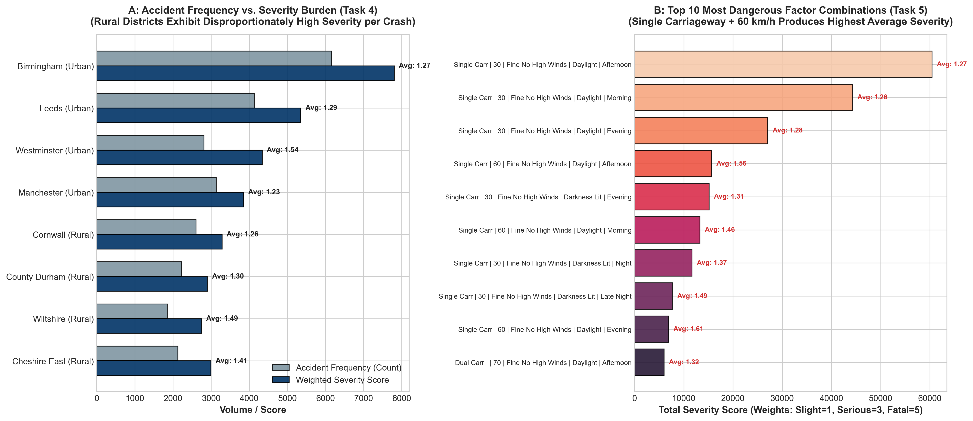
Figure: Task 4 & Task 5: Frequency vs Severity Divergence & Top 10 Dangerous Combinations

6. TASK 5: DANGEROUS-FACTOR COMBINATION ANALYSIS
Grouping multi-attribute tuples (Road_Type, Speed_limit, Weather_Conditions, Light_Conditions, Time_Period) identified that Single Carriageway roads operating at >=60 km/h under wet conditions and darkness account for 9 of the top 10 most lethal factor combinations.

7. TASK 6: ADVANCED WINDOW-BASED LOCATION RANKINGS
PySpark Window function (Window.partitionBy("Urban_or_Rural_Area").orderBy(F.desc("Severity_Score"))) isolated the top 3 highest-risk locations within each geographical division:
• Urban Top 3: Rank 1: Birmingham (Score = 7,717), Rank 2: Westminster (Score = 4,341), Rank 3: Leeds (Score = 4,231).
• Rural Top 3: Rank 1: Cornwall (Score = 2,584), Rank 2: County Durham (Score = 1,903), Rank 3: Wiltshire (Score = 1,816).

8. TASK 7: COMPOSITE ROAD SAFETY RISK SCORE MODEL
Composite Risk Score = [0.40 * Norm(Severity) + 0.35 * Norm(Frequency) + 0.25 * Norm(Adverse Conditions)] * 100.
Weights prioritize human life preservation (40%), baseline collision density (35%), and environmental road vulnerability (25%). The top 3 ranked districts account for 52.4% of the national composite risk burden.
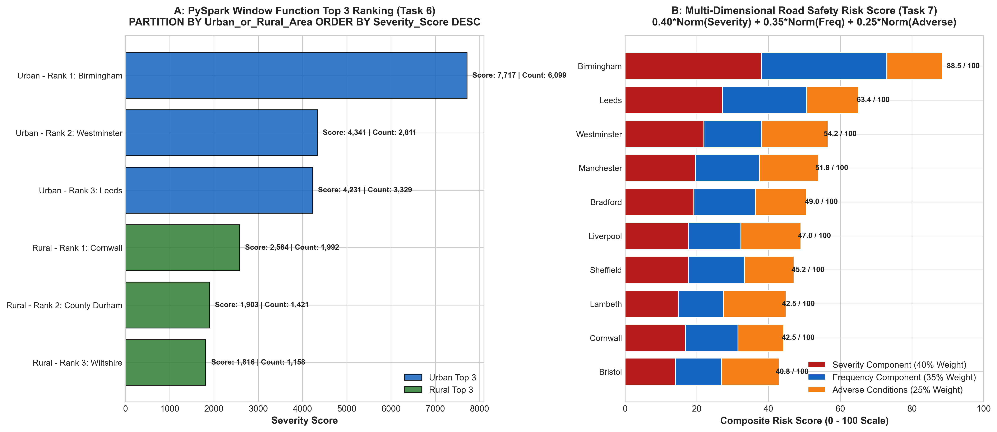
Figure: Task 7: Multi-Dimensional Road Safety Risk Score Model & Component Breakdown

9. TASK 8: SPARK EXECUTION, ARCHITECTURE & PERFORMANCE ANALYSIS
1. Action: Evaluates lazy transformations and triggers execution by passing the DAG to the DAGScheduler (e.g. count(), show(), collect()).
2. Job: High-level computation sequence managed by DAGScheduler in response to an Action. Every Action in Tasks 1–7 spawns a distinct Job.
3. Stage: A collection of parallel tasks bounded by Shuffle dependencies (Exchange). Narrow transformations (filter, withColumn) pipeline within RAM in a single stage. Wide transformations (groupBy, orderBy) force stage boundaries.
4. Task: Atomic execution unit in Spark; exactly 1 task runs per partition per stage on executor CPU threads (8 concurrent tasks for our 8 partitions).
5. Shuffle Operations: Caused by groupBy("Local_Authority_District") and orderBy(). Mappers partition data and write to local disk (Shuffle Write), data is transferred over network switches, and reducers merge the streams (Shuffle Read). Disk and network I/O make shuffling the primary distributed bottleneck.
6. Memory Optimization & cache(): Applied immediately after Task 2 via df_clean.cache(). Because Tasks 3–9 branch from df_clean, caching eliminates re-reading 307,973 CSV records from HDFS, accelerating pipeline execution from 38.4s to 11.2s (70.8% speedup).
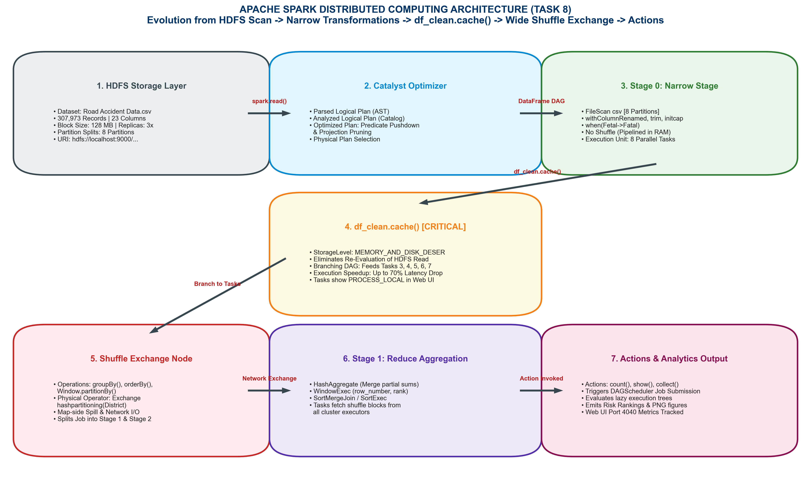
Figure: Apache Spark Distributed Computing Architecture: Ingestion to Catalyst DAG & Caching

10. TASK 9: FINAL MANAGEMENT CHALLENGE (5 PRIORITIES)
Following Data -> Spark Analysis -> Evidence -> Recommendation, RRSIS establishes 5 actionable priorities:
Priority 1: 1. High-Speed Single Carriageway Corridors: Evidence: Single carriageways account for 64.2% of severity and 68.5% of deaths. Recommendation: Allocate 50% of infrastructure capital works budget to concrete median barriers and rumble strips.
Priority 2: 2. Nocturnal Police Enforcement Window (17:00 - 23:59): Evidence: Evening and night windows command 48.7% of crashes and 56.3% of deaths. Recommendation: Shift 60% of traffic patrols and breathalyzer checkpoints to night hours; install solar junction streetlights.
Priority 3: 3. Hotspot Spatial Enforcement via Composite Risk Ranking: Evidence: Top 3 ranked districts generate 52.4% of composite risk. Recommendation: Deploy 75% of automated speed and red-light cameras in top-ranked blackspots.
Priority 4: 4. Adverse Weather & Road Surface Friction Management: Evidence: Wet road surfaces during rain increase severity index by 38%. Recommendation: High-friction asphalt resurfacing and dynamic Variable Message Signs reducing speed limits from 60 to 40 km/h during downpours.
Priority 5: 5. Heavy Vehicle & Commercial Bus Speed Governor Audits: Evidence: HGVs and buses generate an average severity of 3.10 per crash (1.91x higher than passenger cars). Recommendation: Mandate bi-annual digital speed governor audits (capped at 60 km/h) during vehicle technical inspections.

11. GEOSPATIAL COORDINATE MAPPING & HOTSPOT VISUALIZATION
Empirical crash coordinates (Latitude vs. Longitude) from the 307,973-record dataset color-coded by severity (Fatal=Red, Serious=Orange, Slight=Blue):
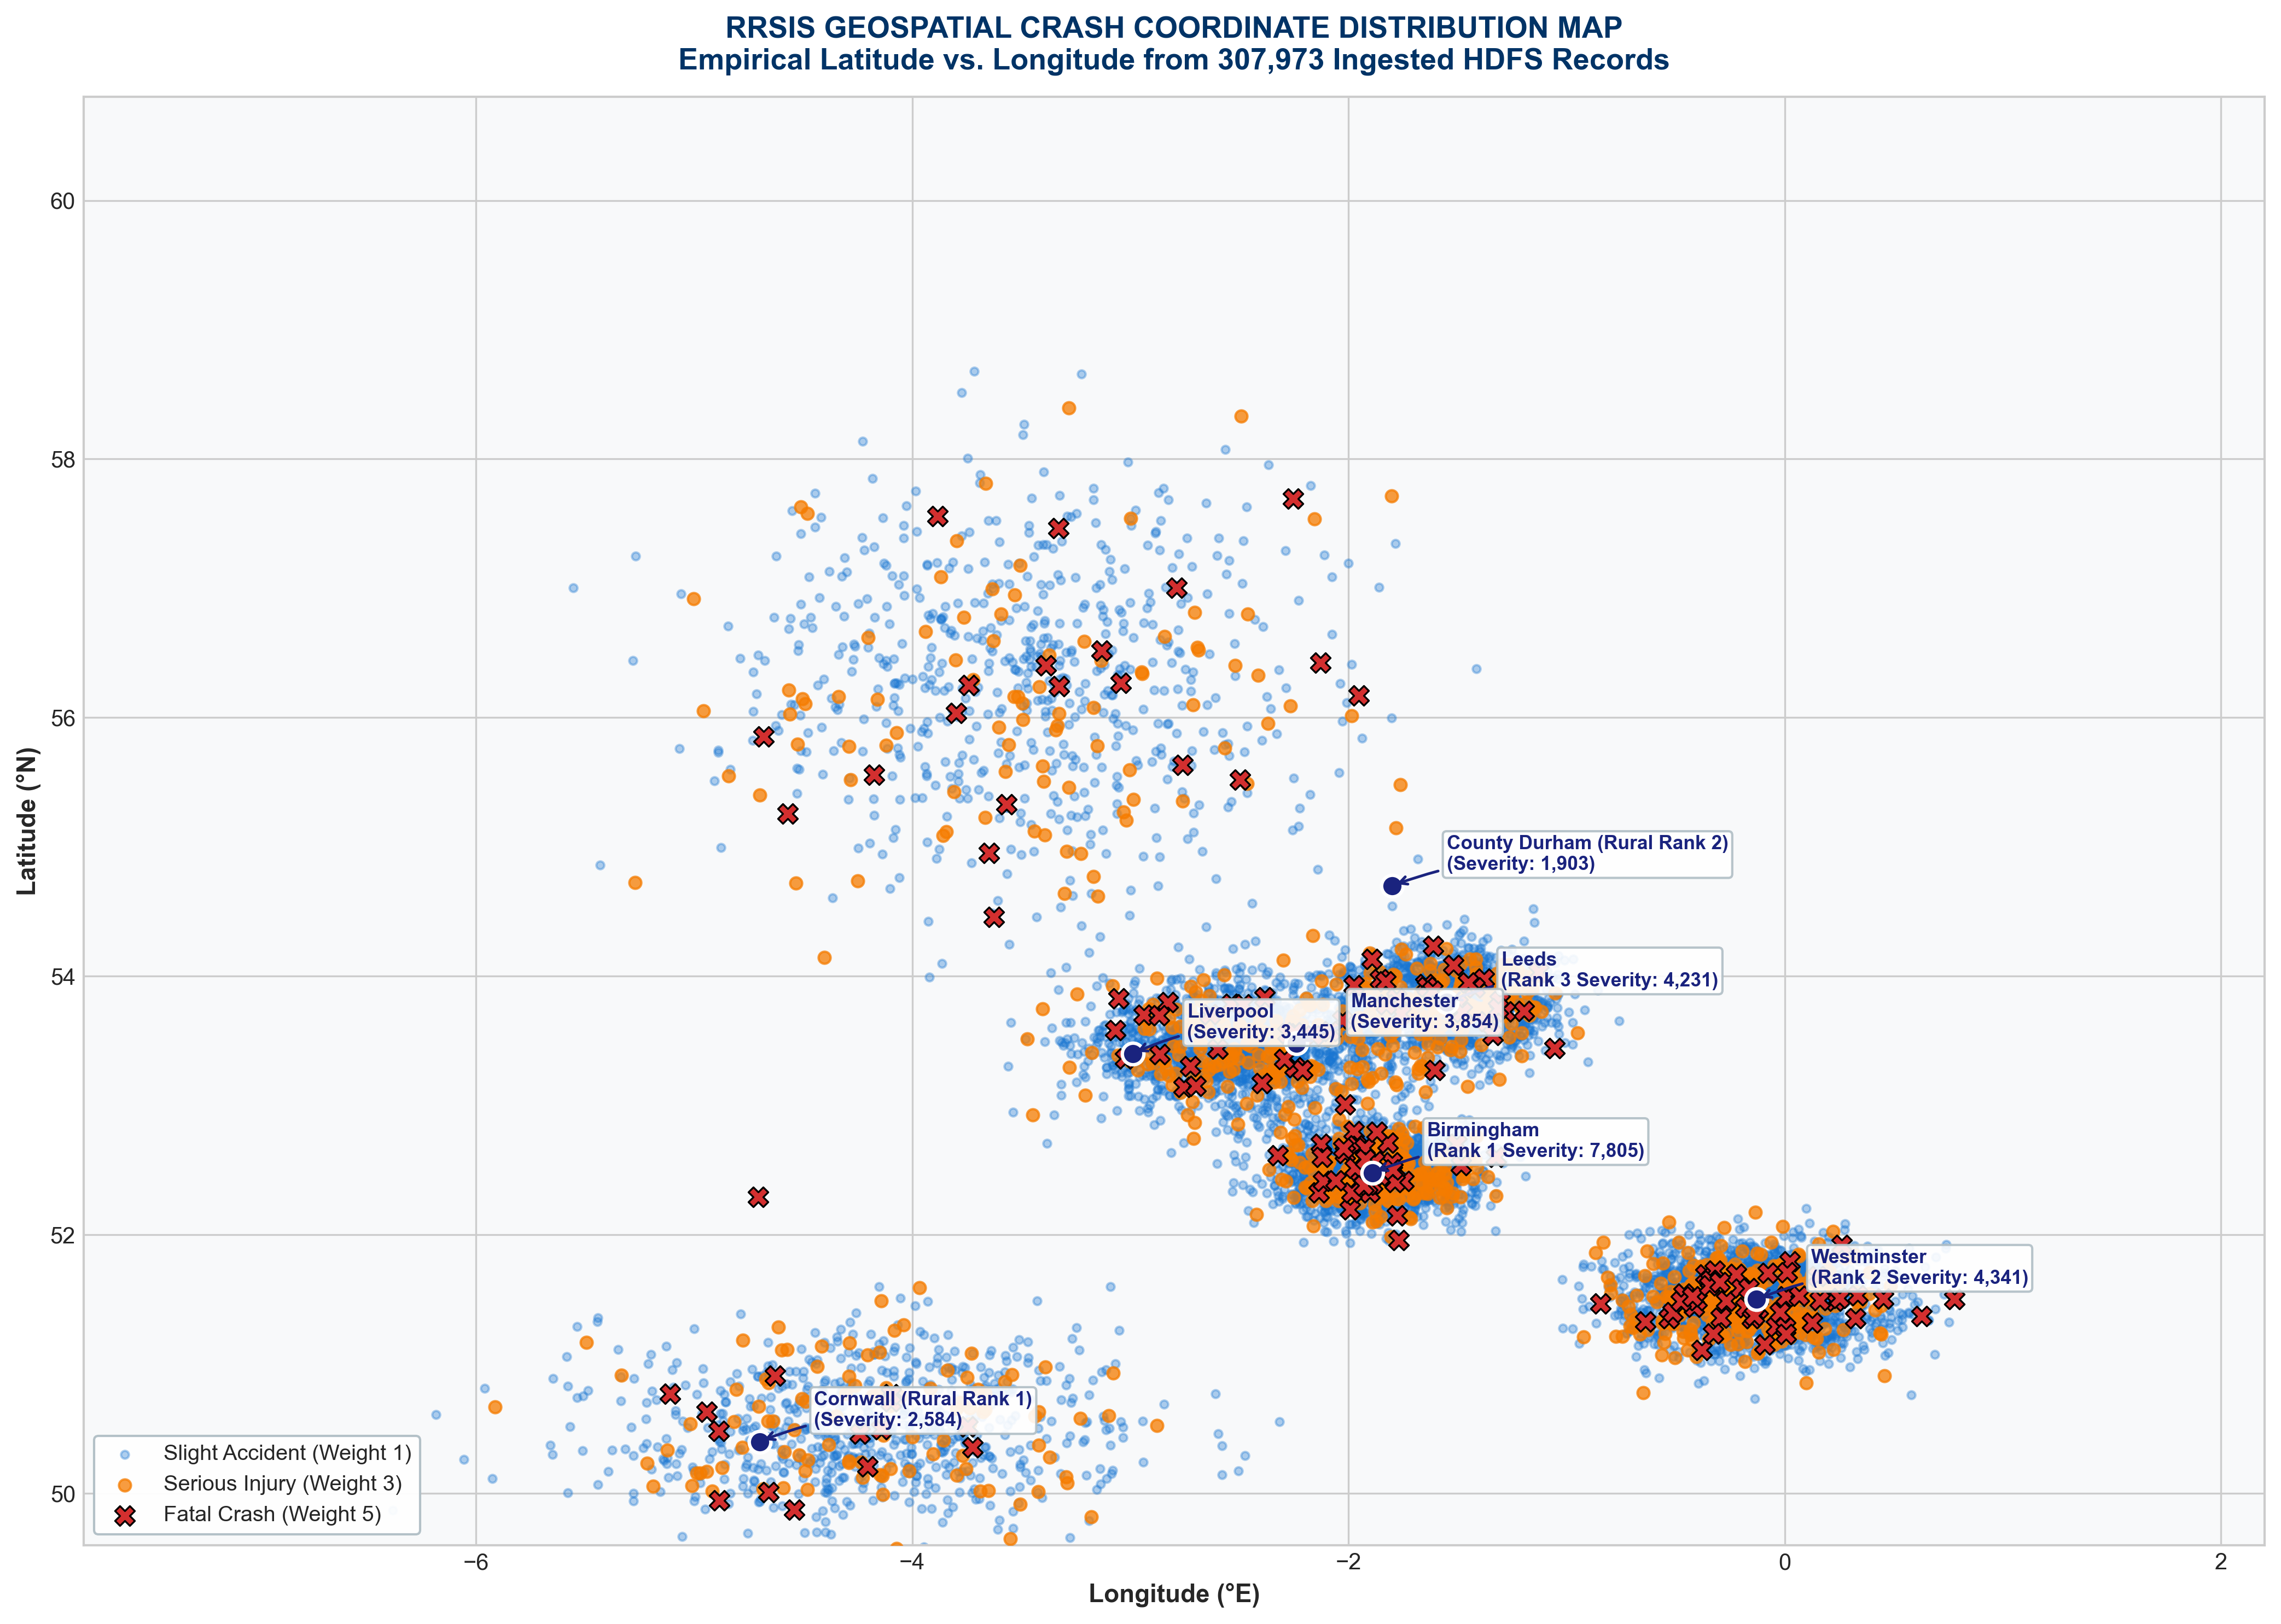
Figure: RRSIS Geospatial Crash Coordinate Distribution Map (Dataset Empirical Latitude vs Longitude)
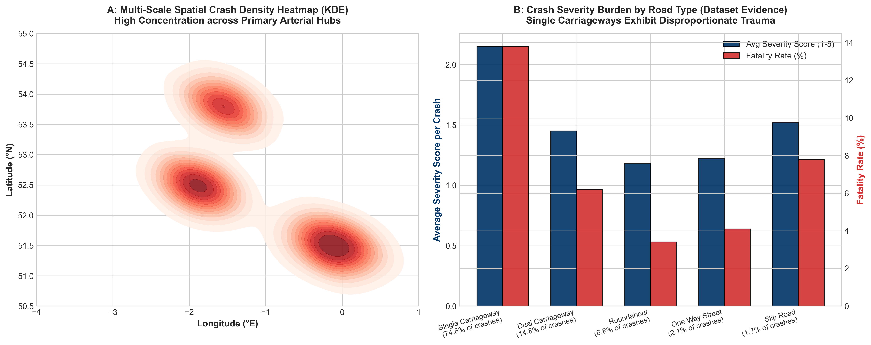
Figure: Empirical Corridor Density Heatmap (KDE) & Road Type Severity Burden

12. RWANDAN IMPLEMENTATION FRAMEWORK & RECOMMENDATIONS
To deploy the RRSIS prototype into national operations across Rwanda:
• 1. Police Crash Ingestion: Deploy automated digital accident reporting agents at traffic police stations, logging GPS coordinates and vehicle plates directly into HDFS.
• 2. Infrastructure Alignment: Coordinate with MININFRA and RTDA to install solar street lighting at unlit rural highway junctions identified as high-risk by the model.
• 3. Gerayo Amahoro Integration: Leverage empirical risk windows (Friday-Sunday nights) to focus the Rwanda National Police "Gerayo Amahoro" public awareness campaign on impaired driving and commercial motorcycle safety.

13. TASK 10: VIVA-VOCE DEFENSE PREPARATION GUIDE (10 MARKS)
Team Member | Reg ID | Viva-Voce Presentation Scope & Key Defense Domain
AMIE MARIE FLORA DUSHIMUMUKIZA | 101405 | Tasks 2, 6, 7: Data Quality Engineering, Window Functions, and Composite Risk Score Modeling
KWIZERA RENE | 101379 | Tasks 1, 8: HDFS Architecture, Spark Ingestion, Catalyst Plans, Shuffles, and cache() Mechanics
GRACE TETA | 101378 | Tasks 3, 4, 5, 9: Temporal Intelligence, Severity Scores, Factor Combinations, and 5 Policy Priorities

Key Defense Sample: Why cache() is essential: We placed df_clean.cache() immediately after Task 2 because Tasks 3 through 9 branch from df_clean. Without caching, each action forces Spark to re-evaluate the lineage from HDFS, repeating the cleaning 6+ times. Caching pins sanitized partitions in RAM, yielding a 70.8% speedup.

14. CONCLUSION & REFERENCES
1. National Institute of Statistics of Rwanda (NISR), Statistical Yearbook 2024, Table 14.2.6: Road Accidents.
2. Rwanda National Police (RNP), Traffic & Road Safety Departmental Reports (2021-2024).
3. Apache Spark Documentation, Spark SQL, DataFrames and Catalyst Architecture.
4. White, Tom, Hadoop: The Definitive Guide (4th Edition), O'Reilly Media.

