DATABASE DESIGN PROJECT

Keyboard College Association
Piano Teachers' Organization – Global Springfield

Prepared for:
Mr. David Khandros, President

Prepared by:
Kevin McDonald
Principal Systems Analyst

February 2026

Level 0 Data Flow Diagram
The Level 0 Data Flow Diagram below illustrates the major processes, entities, and data stores within the Keyboard College database system. Four external entities interact with the system: Teacher, Student, Performer, and Event. Five core processes manage the flow of information, and five data stores persist the resulting data. Arrows indicate the direction of data movement between elements.

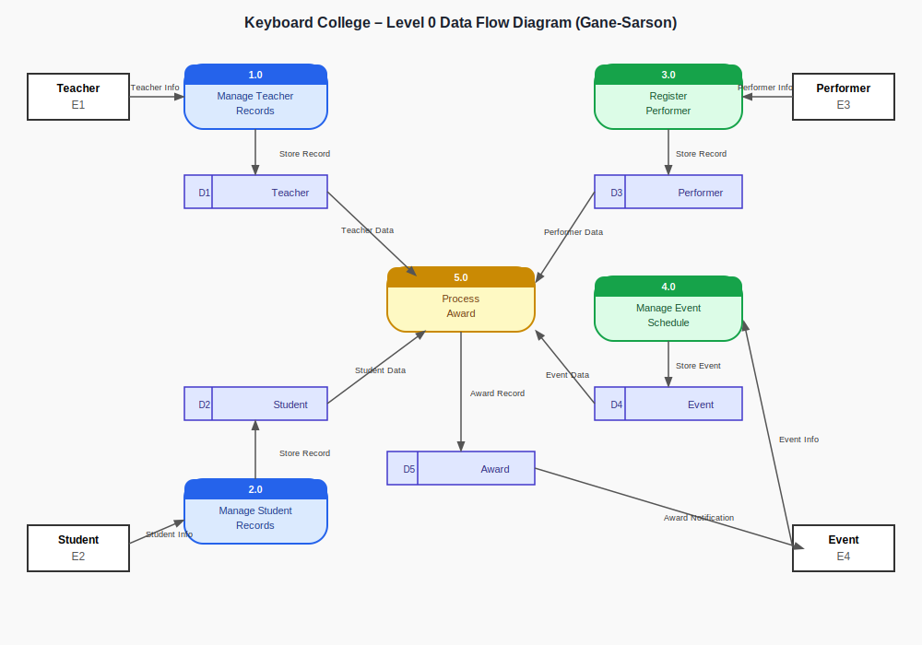
Figure 1. Keyboard College Level 0 Data Flow Diagram (Gane-Sarson style).

Entity Relationship Diagram
The Entity Relationship Diagram below presents five entities central to the Keyboard College database: Teacher, Student, Music, Event, and Award. Primary keys (PK) are highlighted at the top of each entity, and foreign keys (FK) appear where entities connect. Crow's foot notation indicates cardinality: a single bar represents 'one' and the crow's foot symbol represents 'many.' A teacher may have many students, but each student has exactly one teacher. Each student may be associated with many pieces of music. Students may optionally participate in events, and not all participants receive awards.

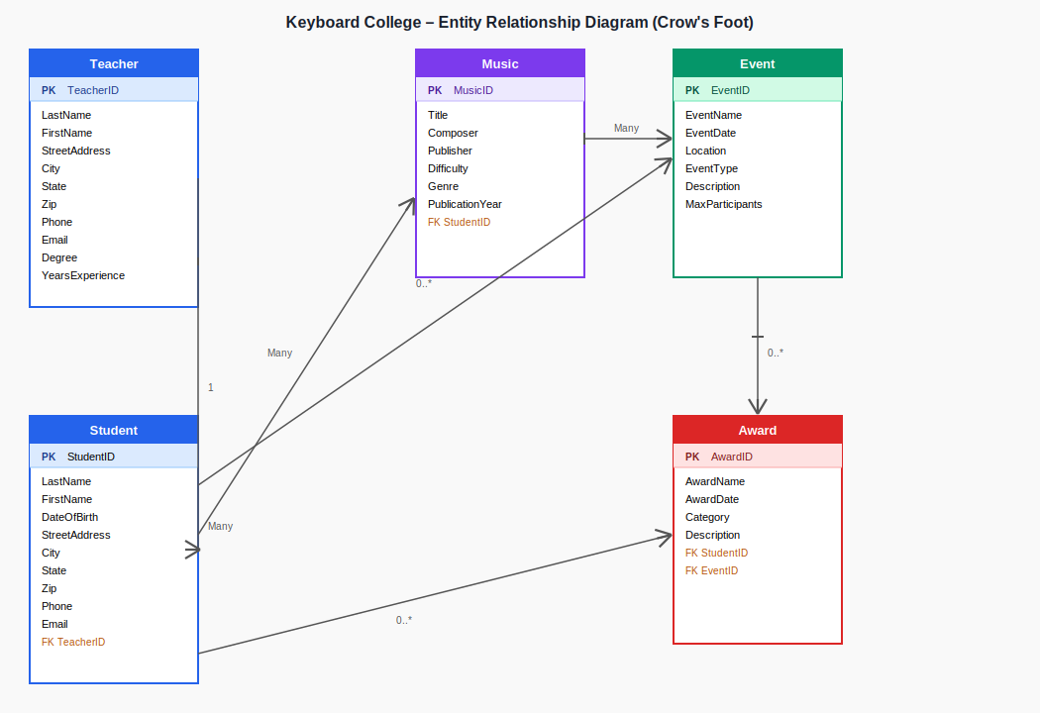
Figure 2. Keyboard College Entity Relationship Diagram (Crow's Foot notation).

Sample Entity Table
The table below details the Student entity, which is central to the Keyboard College database. It includes all major attributes, the designated primary key, data types drawn from standard database conventions, logical field lengths, and whether each attribute is required at the time of data entry.

Entity: Student
Attribute | Key | Data Type | Length | Required?
StudentID | PK | Int | 6 | Yes
LastName |  | VarChar | 25 | Yes
FirstName |  | VarChar | 25 | Yes
DateOfBirth |  | Date | 10 | Yes
StreetAddress |  | VarChar | 50 | Yes
City |  | VarChar | 30 | Yes
State |  | Char | 2 | Yes
Zip |  | Char | 10 | Yes
Phone |  | VarChar | 15 | Yes
Email |  | VarChar | 50 | No
TeacherID | FK | Int | 6 | Yes

Note: PK = Primary Key | FK = Foreign Key | VarChar = Variable Characters | Char = Fixed-length Characters. TeacherID (FK) references the Teacher entity's primary key to enforce the one-to-many relationship between teachers and students.

