Miyazaki Party Supplies Network Design:
Topology, Diagram, and Cabling Analysis

Kevin McDonald
IT510: Network Controls, Systems, and Standards
Purdue University Global
Professor [Professor Name]
[Month Day, Year]

Diagram and Topology Explanation

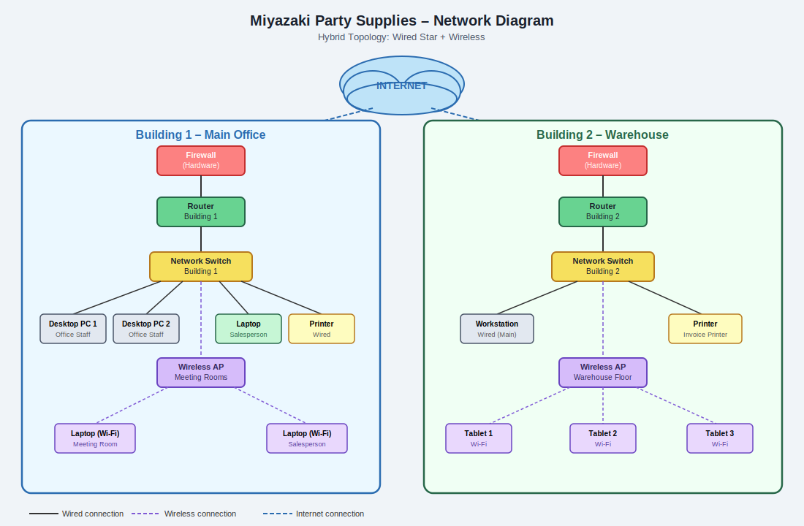
Figure 1. Miyazaki Party Supplies hybrid network topology diagram.
Both buildings utilize a star topology for their wired connections, with each device linking individually to a central network switch. This topology was selected because it is reliable and easy to manage — if one device experiences an issue, the remainder of the network continues to function without interruption. Building 1 incorporates a wireless access point to support the meeting rooms and the salespeople's temporary workspace, where mobility and flexible connectivity are the priority. Building 2 similarly employs a wireless access point to accommodate the tablet-based workflow that warehouse workers use while pulling inventory across the floor. The overall design is therefore a hybrid topology, combining the stability of wired star connections with the flexibility of wireless networking to meet the distinct operational demands of each facility.

Cabling Options and Decision

Coaxial cable is one of the oldest forms of network cabling, constructed with a central copper conductor surrounded by concentric insulating layers and a metallic shield that protects against electromagnetic interference. While this shielding was once a significant advantage in environments with high electrical noise, coaxial cable has largely been displaced in modern local area network deployments due to its comparatively limited bandwidth capacity and the rigidity that makes installation cumbersome (Meyers, 2022). In terms of cost, coaxial cable falls in a moderate range, though the expense of working around its physical inflexibility and the specialized connectors required means that any cost savings quickly erode during installation. For most contemporary business network projects, coaxial cable presents no meaningful performance or economic advantage over the alternatives available today.

Twisted pair cabling is currently the most widely deployed medium in business networking environments and represents the practical standard for new installations. The cable consists of multiple pairs of copper wires twisted around one another, a design that naturally reduces crosstalk and electromagnetic interference between adjacent wires. The most common variants are unshielded twisted pair (UTP) and shielded twisted pair (STP), with category ratings such as Cat5e, Cat6, and Cat6a determining the maximum supported data rates and transmission distances (Meyers, 2022). Cat6 cabling, for example, supports Gigabit Ethernet across distances up to 100 meters and is well suited to the demands of a modern office. Twisted pair is also the most affordable of the three cable types and is straightforward to terminate and install, making it the practical default choice for most wired office and light-industrial deployments.

Fiber optic cabling transmits data as pulses of light through strands of glass or plastic rather than as electrical signals through copper, and this fundamental difference produces dramatic advantages in both throughput and transmission distance. Because light signals are not subject to electromagnetic interference, fiber optic runs are immune to the noise sources that degrade copper cabling performance, and a single fiber strand can carry data at speeds that far exceed what any copper alternative supports (Axelos, 2021). Single-mode fiber is capable of sustaining signal integrity over distances of several kilometers, making it the preferred choice for inter-building or campus-wide connections. The significant trade-off is cost: fiber optic cable itself is more expensive than copper, and the transceivers, patch panels, and skilled labor required for proper termination and splicing add considerably to the total installation budget.

For Miyazaki Party Supplies, Cat6 twisted pair cabling is the recommended choice for all wired connections within each building. The distances involved in a standard office and warehouse environment fall comfortably within the 100-meter effective range of Cat6, and its cost efficiency is especially important given that two separate facilities will each require a complete independent wiring run from their respective routers and switches out to all endpoint devices. Coaxial cable offers no practical advantage in this scenario and should be excluded entirely. Fiber optic cabling, however, warrants consideration for the connection between the two buildings if they are separated by a significant distance on the property or across a parking area, since fiber handles longer runs without signal degradation and eliminates the grounding concerns that arise when copper conductors span between separate structures. A hybrid approach — Cat6 inside each building and a short fiber run between buildings — would represent both a technically sound and cost-conscious solution for the Miyazaki network.

References

Axelos. (2021). ITIL foundation: ITIL 4 edition. TSO.

Meyers, M. (2022). CompTIA A+ certification all-in-one exam guide (exams 220-1101 & 220-1102) (11th ed.). McGraw Hill.

