**Simulating Tropical Cyclone over the South-west Indian Ocean with MPAS: Sensitivity to cloud microphysics schemes**

Brian Kyanjo1 and Babatunde J. Abiodun2

1African Institute for Mathematical Sciences, Kigali, Rwanda

2Climate System Analysis Group, Department of Environmental and Geographical Science, University of Cape Town, Cape Town, South Africa

1. **Introduction**

Tropical cyclones (TCs), one of the strongest atmospheric features, are known for massive destruction of properties and human lifes, because they are associated with strong winds, heavy rains, and storm surges (Natural Disaster Profiles, 2020). Since the beginning of the 20th century, TCs have affected more than 629 million people and killed more than 1.33 million people in the tropics (Doocy, Dick, Daniels, & Kirsch, 2013). TCs, which usually form over warm tropical oceans (≥ 26oC), are warm-core low-pressure systems with 100 - 1000 km diameter. Once established, TCs sustain their strength by absorbing warm moisture as they continue to enlarge and will last as long as the atmospheric and oceanic conditions remain favorable over the ocean. After making a landfall, TCs can last for seven days and cause severe damages as they move inland or along the coastline (Doocy, Dick, Daniels, & Kirsch, 2013). The TCs that form over the southwest Indian Ocean (SWIO) are a threat to the neighboring countries, but Madagascar, Mauritius and La Reunion experience the most devastating and destructive impacts of the TCs, followed by the extensive coastline and the borders of Zimbabwe and Mozambique (World, 2020). For instance, in 2017, Tropical Cyclone Dineo, which formed on 13th February and made a landfall over Mozambique on 15th February (Moses & Ramotonto, 2018). Dineo produced heavy rains (> 200mm day-1) and damaging winds in Inhambane (southern province in Mozambique) and destroyed around 20000 homes, directly affected about 130,000 people, and killed seven people. Its widespread torrential rains and the associated storm surge produced massive floods that killed about 271 people and caused damages that exceeded $ 200 million in Zimbabwe (USD 2017) (Cyclone Dineo, 2020). Although Dineo weakened on February 17th, its remnant low still triggered heavy rainfall with flooding in Botswana. The flooding destroyed 650 households and public infrastructures (e.g. bridges, hospitals, schools, and fields), leaving hundreds of people homeless and poor (especially the low-income earners) (EPAPFR, 2017; Moses & Ramotonto, 2018). A month after the landfall, the impacts of Dineo landfall induced an outbreak of chlorella that infected 1,200 people and killed 2 people in Mozambique and Malawi (Cyclone Dineo, 2020). Despite the devastating impacts TCs over the region, from our best knowledge, there are still no reliable systems for providing early warning on TC occurrences over region. Hence, there is a need for more studies on how to improve simulation and prediction of TC characteristics over the SWIO. This will help reduce the devastating impacts of TCs in the region.

The Model for Prediction Across Scales (MPAS) is one of the atmospheric models that have great potential for providing reliable early warning information on TC occurrence and characteristics over the SWIO. Several studies have used MPAS to simulate different atmospheric features and processes, including real-time weather, seasonal forecasting of tropical cyclones, tornadoes, and convection (ncar.ucar.edu, n.d.). For instance, Fowler, et al. (2015) used MPAS to reproduce the frequency and locations of North Atlantic TCs using mesh refinement over the North Atlantic ocean. They show that MPAS simulations perform better than the Weather Research and Forecasting System (WRF) simulation because the smooth transitions between two grid resolutions in MPAS (i.e. variable mesh grid) helps the model to simulate smoother and more realistic mid-level jet structures and seasonal cloud patterns than the WRF simulations, which is influenced nested boundary condition problems. Harris and Zha (2020) also show that MPAS performs better than the High-Resolution Model (HiRAM) in simulating the frequency of TCs. Although HiRAM can run at high resolution, it ignores computation of vertical acceleration, and its representation of thunderstorms and convection are still small compared to those in observation and MPAS simulations (Harris and Zha (2020). However, despite the great potential of MPAS in simulating TC, no studies have investigated its capability in simulating tropical cyclones over the SWIO.

Successful simulations of TCs with any atmospheric model depend on how well microphysics processes are represented in the model. Microphysics contains resolved water vapour, cloud, and precipitation formation processes (Skamarock, 2008). The Weather Research and Forecasting System (WRF)-Single-Moment-Microphysics Class 6 (WSM6) and Thompson are two prominent microphysics schemes in MPAS. WSM6 is an extension of the Weather Research and Forecasting System (WRF)-Single-Moment-Microphysics Class 5 (WSM5) scheme after adding graupel to it as a prognostic variable (Stefano Federico, 2016). The particles associated with graupel in WSM6 are assumed to follow an exponential size distribution (Hong & Song-You, 2006). Contrarily, in Thompson, the distribution of the size of snow is assumed to be given by the sum of gamma and exponential distributions and depends on both temperature and water content in the snow (Skamarock, 2008). Observations show that Thompson assumes that the shape of snow is non-spherical with its diameter inversely proportional to its bulk density, making it different from WSM6, which assumes snow is spherical and has a constant radius (Skamarock, 2008). Furthermore, the vertical heating profiles of freezing and melting processes in WSM6 are computed with high accuracy towards the fall-time sub-steps, this reduces its sensitivity compared to Thompson (Skamarock, 2008). Stefano Federico (2016) used WSM6 in the Regional Atmospheric Modeling System (RAMS) at 5km horizontal grid resolution to simulate an idealized 2D thunderstorm and 3D real case heavy precipitation over Korea. WSM6 showed a positive and significant impact on the temporal storm evolution and precipitation at the surface (Stefano Federico, 2016). Lin Su (2018) implemented Thompson in the Weather Research and Forecast model coupled with chemistry (WRF-chem) to simulate the impact of dust on ice nucleation processes in the atmosphere during spring over East Asia. Although observations were consistent with satellite observations after evaluation of the effect of dust on ice nucleation processes, simulated ice crystal number concentration and ice water mixing ratio were found to be 7 and 15% much greater than the ones simulated without dust (Lin Su, 2018). However, according to past research, WSM6’s and Thompson's capability of simulating TCs over the SWIO hasn’t been tested yet.

**2.0 Methodology**

**2.1 Study Area**

Our study is the SWIO basin (0-40°S, 30-90°E), which is the main tropical cyclone basin in the southern hemisphere The SWIO cyclone season starting from 1st July to 30th June but more active between 15th November and 30th April (2018 - South-West Indian Ocean Tropical Cyclones). Cyclones in this basin are called TCs, and are named and classified after reaching 34 knots (10min Maximum Sustained winds (MSW)) near the center (2018 - South-West Indian Ocean Tropical Cyclones). For instance, on 13th February 2017, a TC that formed in the Mozambique channel was named Dineo by NASA (2017) after reaching 40 knots MSW. Although the highest number of cyclones form between January and March, on average 9-10 tropical systems form in the basin in each season with 4-5 becoming TCs (2018 - South-West Indian Ocean Tropical Cyclones ). AF Mavume (2010) research on climatology and landfall of TCs over SWIO showed that TCs develop in eastern Madagascar and the Mozambique channel. Observations show that 5% of TCs that form a landfall over Madagascar finally reach Mozambique, 65.4% of the 5% form within the greater SWIO basin and the remaining 34.5% evolve within the Mozambique channel (Jennifer M. Fitchett, 2014). Apart from cyclone Dineo whose remnants struck Botswana, research shows that in most cases, weakened TCs move further towards westward affecting South African countries but occasionally reach Botswana. The basin is monitored by TC Regional specialized Meteorological Centre (RSMC) La Reunion Meteo France which gives daily updates about TCs during the season.

cyclone Dineo that reached its peak strength on 15th February after making a landfall in Inhambane (Moses & Ramotonto, 2018).

**2.2 Characteristics of Tropical Cyclone Dineo**

The TC Dineo which is ranked as the 5th TC of the SWIO season developed from the Mozambique channel on 13th February 2017. At 10 am EST on the same day, it had reached MSW of about 40 knots and was dragging towards the south-southwest at 2 knots with a storm height of 9.9 miles (Sciences, n.d.). It was crawling with developing low-level circulation center, that consisted of deep convective bands which were binding into the partially exposed low-level center, with its eastern side composed of bulk thunderstorms as it approached Mozambique (Sciences, n.d.). On 14th February, Dineo’s northeastern quadrant consisted of extremely heavy precipitation in the bands of thunderstorms dropping at over 132 mm per hour (NASA Examines Ex-Tropical Cyclone Dineo's Rainfall, n.d.). At 10 am EST on 15th February, Dineo reached its peak strength with MSWs near 70 knots with a cloud-filled eye, at this point, it was near 23.5°S and 35.8°E which is just off Mozambique coast (NASA Examines Ex-Tropical Cyclone Dineo's Rainfall, n.d.). Later at around 12:30 pm EST on the same day, it made a landfall over Inhambane (Southern Mozambique) with dangerous storm surge, torrential rain and high winds (Tropical Cyclone Dineo hits Mozambique - Mozambique, n.d.). On the same day, Dineo’s clouds expanded over Inhambane, eastern Botswana, Swaziland, and northeastern South Africa (NASA Examines Ex-Tropical Cyclone Dineo's Rainfall, n.d.). In Swaziland, the intense storm with height about 8.4 miles produced rainfall falling at over 86 mm per hour (NASA Examines Ex-Tropical Cyclone Dineo's Rainfall, n.d.). At 7 pm EST, Ex-Tropical Cyclone Dineo was near 23.4°S and 34.1°E and moving to the west at 9 knots with MSWs at around 60 knots (NASA Examines Ex-Tropical Cyclone Dineo's Rainfall, n.d.). At 4:16 am EST on February 16th, Dineo’s storm elongated and progressed inland, its MSW had reduced to about 60 knots and was still dropping as it continued inland (NASA Examines Ex-Tropical Cyclone Dineo's Rainfall, n.d.). On 17th February Dineo weakened to a remnant low which struck Botswana and triggered heavy rains that initiated floods in the country (Oliver Moses, 2018).

**2.3 MPAS: model set-ups and simulation of Tropical Cyclone Dineo**

MPAS aids atmospheric development and simulation of components of the Earth system which are used in regional climate and weather studies through collaborative projects (MPAS, 2020). MPAS – Atmosphere (MPAS-A) is a non-hydrostatic atmosphere model that is part of MPAS and is led by the National Center for Atmospheric Research (NCAR) Earth System Laboratory (NESL)) (MPAS, 2020). It is used for real-time weather, seasonal forecasting of tropical cyclones, tornadoes, and convection (MPAS, 2020). MPAS models use centroidal Voronic tessellations in their horizontal meshes which provide a common software framework that gives an infrastructure for producing parallel execution, input, output, high-level driver program, and other software infrastructure (Www2.mmm.ucar.edu, n.d.). The supported important features of MPAS-A include fully-compressible, non-hydrostatic dynamics, split-explicit Runge-Kunta time integration, Exact conservation of dry-air mass and scalar, Positive-definite and monotonic transport options, Generalised terrain-following hight coordinate (Www2.mmm.ucar.edu, n.d.). Unstructured variable-resolution (horizontal) mesh integrations for the sphere and Cartesian planes is also a supported vital feature of MPAS-A (Www2.mmm.ucar.edu, n.d.). Version 6.0 of MPA-A consists of parameterizations of physical processes that are taken from the WRF Model (Www2.mmm.ucar.edu, n.d.). Explicitly Parameterizations of physical processes supported by MPAS-A include Radiation, Land-surface, Surface-layer, Boundary-layer, Convection, Cloud microphysics (Www2.mmm.ucar.edu, n.d.). Table .1 shows the set of parameterizations of physical processes and their respective schemes (Www2.mmm.ucar.edu, n.d.). MPAS-A consists of two components main components i.e. the model and initialization which are built as cores within the MPAS software framework (Www2.mmm.ucar.edu, n.d.). Both the model and initialization make use of software infrastructure and the same driver program but they are compiled as separate executables (Www2.mmm.ucar.edu, n.d.). The model component consists of physics and atmospheric dynamics, the initialization component consists of components for creating initial conditions for the atmospheric and land-surface state as well as update files for sea-surface temperature (SST) and sea ice (Www2.mmm.ucar.edu, n.d.).

| **Parameterization** | **Schemes** |
| --- | --- |
| Radiation | CAM, RRTMG both long and short wave radiation |
| Land-surface | NOAH land-surface model |
| Surface-layer | Monin-Obukhov and MYNN |
| Boundary-layer | YSU and MYNN PBL |
| Convection | Kain-Fritsch Tiedtke, New Tiedtke, and Grell-Freitas convection parameterizations |
| Cloud microphysics | WSM6, Kessler, and Thompson |

Table 1: set of parameterizations and their schemes.

The meteorological data (CFSR (ds094)) used for initializing the model to simulate TC Dineo was downloaded from the Research Data Archive website (Saha, S., et al. 2011). CFSR (ds094) dataset was used because TC Dineo occurred between the period of 2011 and 2020. Before downloading the data from the Research Data Archive (RDA) website, the period in which TC Dineo occurred was selected starting three days before and ending three days after its occurrence, to allow the model to spin up. On downloading, two datasets, SST and pressure levels, were downloaded from RDA. SST data sets were extracted for the entire period of occurrence of TC Dineo i.e. 10th/02/2017 to 20th/02/2017 while pressure levels were extracted for the first 6 hours of the occurrence of TC Dineo i.e. 13th/02/2017 at 00:00 to 13th/02/2017 at 06:00.

The building and running process of the model consists of several procedures: (1). Installation of MPI Implementation (OpenMPI, MPICH, MVAPICH2, etc), installation of the Parallel-netCDF library as well as serial NetCDF library, Parallel I/O library. (2). I cloned the MPAS source code directly from the MPAS GitHub repository by running git clone<https://github.com/MPAS-Dev/MPAS-Model.git> directly in my command line within the chpc server account which I created to run the simulations from. After cloning we then compiled both the init_atmosphere core and atmosphere core from the same MPAS source code using the gfortran compiler. The compilation produced executable files named init_atmosphere_model, atmosphere_model, and build-tables in the MPAS-directory. It also produced the default namelist and streams files named namelist.init_atmosphere and streams.init_atmosphere. This made possible a complete model simulation to be created using the following steps: (1). We created a run directory which We named case_studies. (2). Linked the init_atmosphere_model and atmosphere_model executables, physics lookup tables (*TBL, *DBL, *DATA) into the case_studies directory. (3). Copied the namelist.*, streams.*, files into the case_studies directory. (4). Downloaded 92km-25km variable resolution mesh (x4.163842.grid.nc) from *https* : *//mpas*−*dev.github.io/* website, then push it to the chpc account in the grid_rotate directory. (5). We used the grid_rotate utility by editing the namelist.input file to set the latitudes and longitudes to the center of interest, then use the grid_rotate utility to rotate the mesh to the new area of refinement, hence producing a new netCDF file used as an input in the streamlist file during static and terrestrial field processing. (6). Push both the downloaded datasets (SST and pressure levels) from the RDA website to the chpc server account into the sst and press directory respectively, run the executable file ungrib.exe to generate intermediate files for both sea surface temperature (SST) and pressure levels. (7). Edited the namelist and the stream files in the init_atmosphere directory, then run the init_atmosphere_model to create initial conditions. (8). Generate idealized initial conditions by interpolating the produced intermediate files with the land surface initial conditions, the created file is used as input in the streams.atmosphere file during model integration. (9). Performed model integration by editing namelist and streamlist files, then run atmosphere_model binary file to produce history and diagnostic files for the entire period of simulation. (10). The diagnostic files and the history files are remapped using the convert_mpas utility to produce a netCDF file name latlon.nc which is visualized and used to make analysis. Model integration simulation is simulated twice, for WSM6 and Thompson schemes. First of all, we start with WSM6 simply because it’s a default scheme in the mesoscale_reference suit under the &physics record in the namelist file. The second simulation is done by overriding the default WSM6 scheme with Thompson, this is done by adding a new namelist variable (config_microp_scheme = ’mp_thompson’) under the &physics record in the namelist file which makes the model to read Thompson scheme instead of WSM6 during integration.

**2.4 TC Dineo Detection and Tracking**

After diagnostic and history files have been generated during model integration as explained in section 3.8, convert_utility was used to generate a latlon file which contains mean sea level pressure (mslp), zonal wind component (u10), meridional wind component (v10), temperature_250hpa, temperature_500hpa and vorticity_850hpa variables. All these variables were created only for the domain in which TC Dineo occurred, this simplified the tracking because we dealt with a small data set.

The objective measures that we used for detecting and tracking TC Dineo in the tracking algorithm that uses a 6 hourly output data in the latlon file are similar to that described by Kleppek et al. (2008). (1). The minimum value of mslp over the entire domain termed as the centre of a low pressure system (TC) is determined. (2). 2 degrees from the centre of the TC, the warm core which is the average integrated temperature between 250 hpa and 500 hpa was calculated, this core is at least 1 degree Celsius warmer than the surrounding environment which is defined as a 10 × 10 block centered at the mslp. (3). The wind speed which is used to classify the intensity of TC Dineo according to the Saffir Simpson scale is calculated using u10 and v10 components over the domain. Then we searched for the maximum value of the wind speed within 5 of the cyclone center. (4). The minimum vorticity within 4 degrees of the cyclone centre is determined. Since we are in the SWIO basin, negative vorticity is associated with a cyclone spin.

TC Dineo was detected by comparing the calculated variables above with the cyclone threshold values as follows: (1). The maximum surface wind speed within 5 degrees of the cyclone centre must be greater than 17ms−1. (2). The minimum vorticity must be less than 3.5 × 10−5 s−1. (3). The warm core temperature must be at least 1 degree celsius greater than the surrounding environment. If the cyclone we have identified satisfies the above TC criteria, it is assigned a tracking ID of 1 otherwise 0 for the respective 6 hourly intervals in each day TC Dineo occurred. The output of the respective computed variables: Date, mslp, latitude, longitude, wind speed, vorticity and warm core temperature with their respective track IDs are visualized for the respective schemes to view the track path of TC Dineo.

**3.0 Results and Discussion**

Based on previous research, the capability of MPAS microphysics schemes: WSM6 and Thompson in tracking TCs over SWIO has not been investigated yet. Therefore we started the project by comparing various tracks from four different data sets: reanalysis (red), observation (green), WSM6 (blue), and Thompson (orange) as shown in figure 4.1 for the entire lifetime of cyclone Dineo.

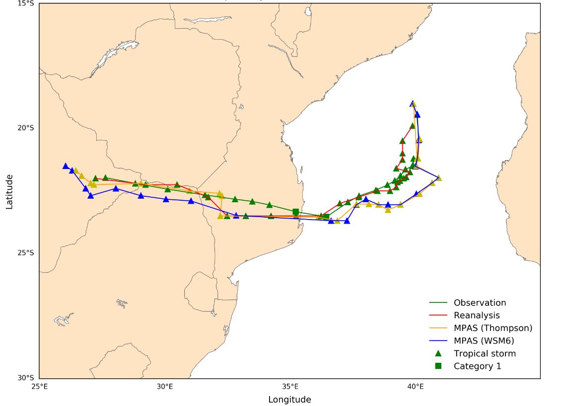

Figure 1. Track of cyclone Dineo

On figure 1, over water ( 19-24S; 35 - 42E), WSM6 and Thompson almost followed the same path as well as the observation and the reanalysis data, though the tracks started at different time intervals. At round (35E, 23.5S) before TC Dineo made landfall over Inhambane (southern Mozambique), it was guided by an easterly steering flow over the Mozambique channel that was induced by a 500 mb high-pressure system that prevailed over most southern Africa during the entire lifetime of TC Dineo (Moses and Ramotonto, 2018). At this location, all the tracks coincided, which means that the simulated data from MPAS, reanalysis, and the observation data sets were all consistent in tracing the position of TC Dineo at that location.

Over land, Thompson performed much better than WSM6 and observation in tracking the entire path of TC Dineo over land. This is due because Thompson consistently followed the same track as that of reanalysis. From the Mozambique coast to eastern Botswana, the observation and WSM6 trajectories are positively correlated, though the track from the simulated data set (WSM6) underestimated the track of TC Dineo as compared to the observation. Over the northern part of South Africa, WSM6 deviated a lot away from the tracks of the three data sets but all the tracks ended in eastern Botswana. This means that TC Dineo weakened and dissipated in the eastern part of Botswana which is consistent with observations from Moses and Ramotonto (2018) that TC Dineo weakened to a remnant low before it Botswana and dissipated on the same day after striking Botswana.

The small triangles along the trajectories of the various data sets represent the stage when the cyclone was still a tropical storm, the small green box indicates when TC Dineo had reached category 1. This was depicted by only the observation data set. This result is consistent with results visualized in figure 4.3 when varying wind speed with time.

Generally, MPAS (Thompson) performed much better than MPAS (WSM6) in terms of tracing the trajectory of TC Dineo and its remnant low.

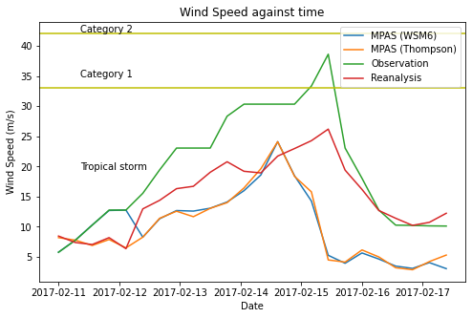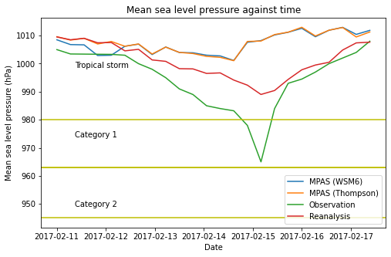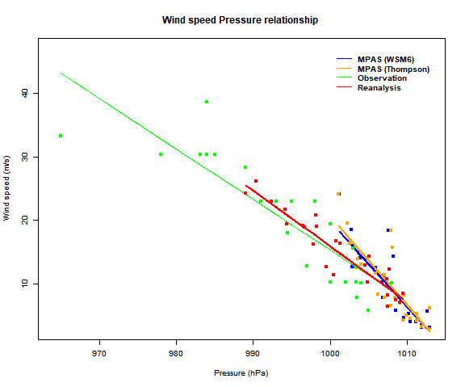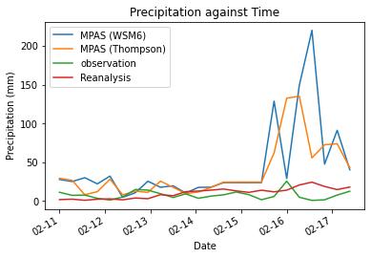

Figure 4.5 shows the variation of total precipitation against time for the entire lifetime of TC Dineo which formed on 11th February 2017. The data was obtained on a 6 hourly interval on each TC Dineo occurred. The total precipitation which is the sum of the accumulated convective and grid scale precipitation is obtained from four data sets: reanalysis (red), observation (green), WSM6 (blue), and Thompson (orange). For the first 5 days all the data sets almost produced the same total rainfall, however starting on 15th when TC Dineo reached its peak, the following days, the amount of rainfall that was produced was severe. WSM6 produced a lot of rainfall on 16th at around midday followed by Thompson, then reanalysis and finally the observation data set. Between 13th at 18:00 to 15th at around 12:00, WSM6 and Thompson are positively correlated. Moses and Ramotonto (2018) claims that the maximum observed rainfall (mm) recorded on 16th by 12 stations was 17 mm, on 17th was 270 mm by 66 stations and on 18th was 55.5 mm from 49 stations. This claim is consistent with predictions produced by WSM6.

Figure 4.2 shows the variation of the mean sea level pressure against time. TC Dineo reached its peak on 15th February and this is depicted by both observation and reanalysis data. Both WSM6 and Thompson almost predicted the day at which TC Dineo matured because they are positively correlated and their minimum point exists around the 15th. Looking at the trend of all the data sets, they are all gradually decreasing and then increasing again. This is so because TCs are low-pressure systems, therefore during their entire life time, the pressure of the eye keeps on reducing until it matures and then increases again, making its sustainable conditions unfavourable hence dissipating as shown on figure 4.2.

Figure 4.3 illustrates the variation of wind speed with time. All the data set curves are increasing to maximum and then decreasing to minimum. This is because when a cyclone is growing, the winds in the eye wall keep on increasing rapidly to maximum as the cyclone matures. On 14th at around 18:00 tending to 15th is when WSM6 and Thompson had their maximum wind speeds, this implies that the storm matured by then, this is consistent with the results in figure 4.2, because at that same time is when WSM6 and Thompson had the lowest values of pressure. The observation data curve reached category 1 but the rest of other data sets remained in the tropical storm region which contradicts with the observation data.

Figure 4.4 shows wind pressure relationship, the plot illustrates that the data sets are well correlated to each other, and it depicts that there is a strong relationship between WSPD and MSLP for all the data sets. The WSM6, Thompson and reanalysis data distributions are almost all coinciding, this means that these data sets follow the same trend.

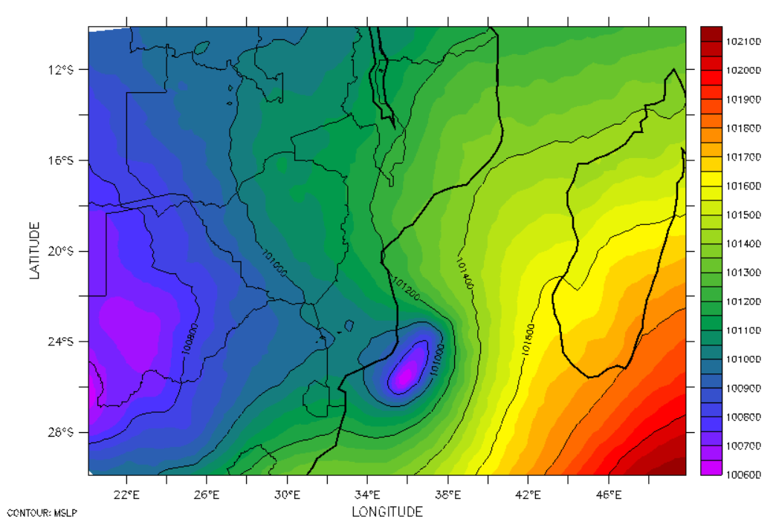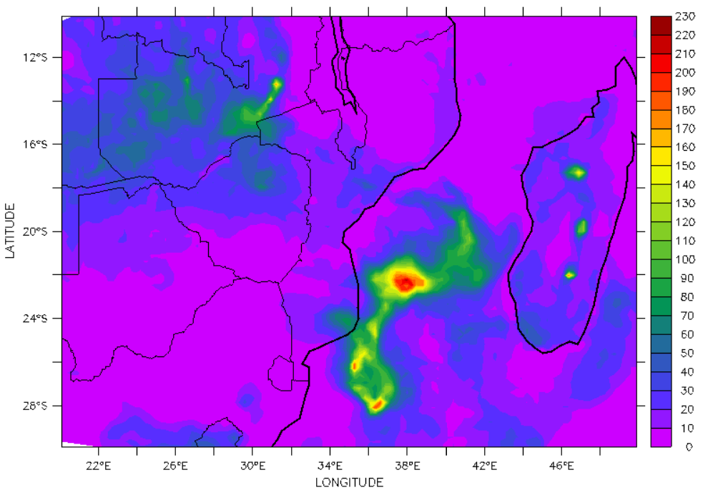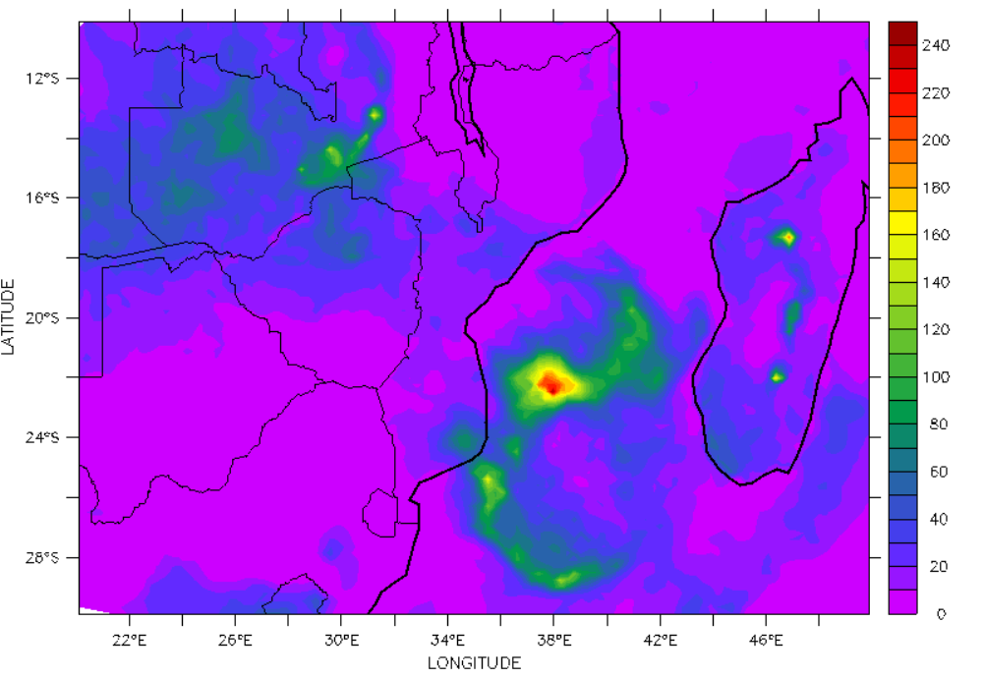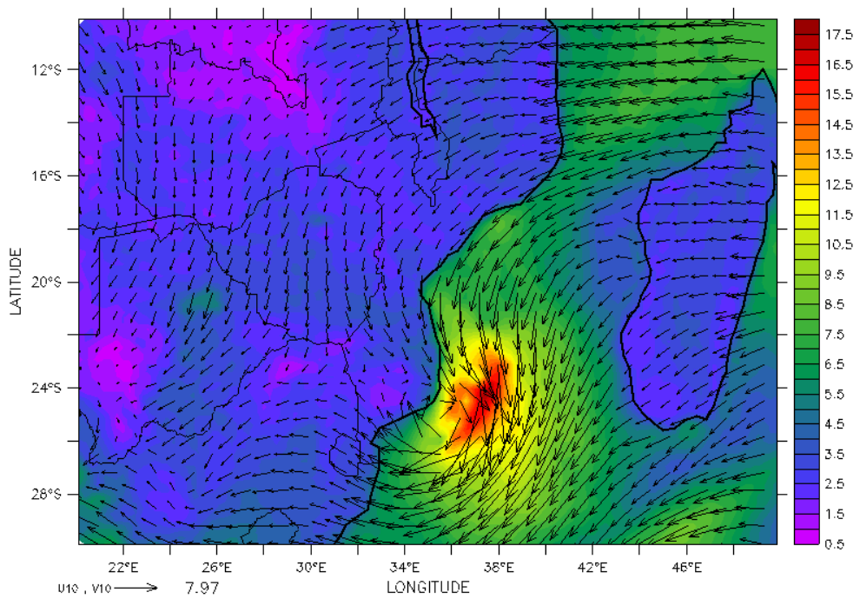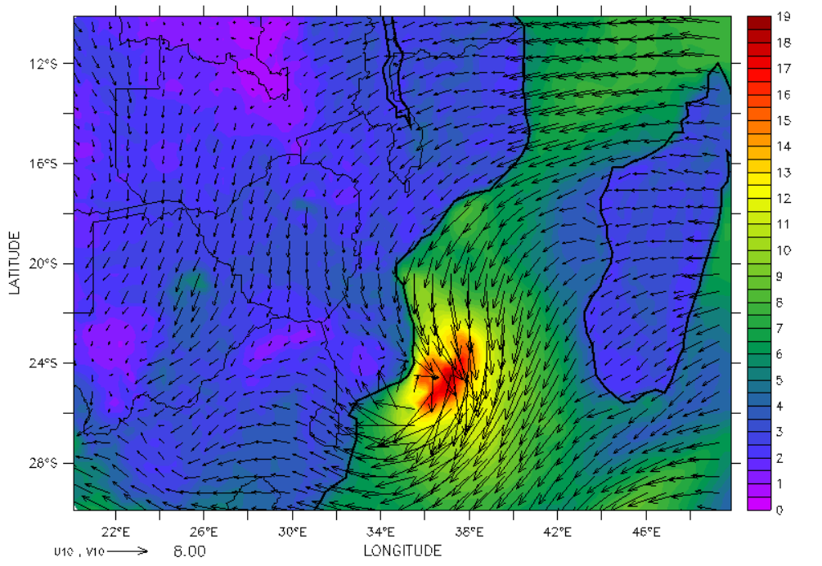

Figures 4.6 and 4.7 show the average mean sea level pressure on the day (15th February 2017) when TC Dineo reached its peak for both simulated MPAS (Thompson) and MPAS (WSM6) outputs respectively. From both figures, at around (36E, 25.5S), the small faint purple colour at the lowest pressure depicts the eye (centre of TC Dineo). This shows that TC Dineo was on its way to make a landfall over Inhambane. This result is consistent with observations made by Moses and Ramotonto (2018) hence both schemes simulated well the position of TC Dineo on the day it matured. However the eye in figure 4.6 is at a lower pressure (100800 Pa) compared to figure 4.7 which is 100100 Pa. This means that Thompson done well in forecasting the pressure of the eye compared to WSM6 even though both schemes under estimated the minimum pressure (96500 Pa) of TC Dineo on that day it matured.

Figures 4.8 and 4.9 describe the average sea surface temperature (sst) for the day 15th February when TC Dineo matured for both Thompson and WSM6 respectively. According to the spatial plots 4.8 and 4.9, the sst (dark red) in the domain were TC Dine formed and matured in, is 302.1 K. This is a favourable condition for TC to develop, therefore both schemes: Thompson and WSM6 simulated well one of the most important factor (sst) in the formation stages of TCs. On both figures, near Inhambane were TC Dineo made a landfall on 15th, both schemes estimated the average temperature of sea water that was necessary for TC Dineo to remain sustained.

**4.0 Conclusion**

The study compared the capability of two MPAS microphysics Schemes: WSM6 and Thompson in simulating TCs over the SWIO basin. The simulation was performed over nine days (11th/02/2017 - 19th/02/2017) for TC Dineo (case study). The model simulation was compared to 6 hourly ERA5 reanalysis and Regional Specialised Meteorological Centre (RSMC) observational data to assess the schemes' capability to simulate the spatial and temporal variations of TCs over the SWIO basin. TCS were detected and tracked using an unbiased tracking algorithm.

Thompson and WSM6 appropriately reproduced the fundamental dynamical structure of TC Dineo, which comprised of a warm core and a well-defined eye ringed by cyclonic winds that vanish gradually with increasing distance from the center. A similar structure was simulated by reanalysis with more advanced details in most aspects.

The reanalysis and the schemes reproduced well the spatial and temporal distribution of TC Dineo track, eye, WSPD, warm core, and vorticity over the SWIO basin. Thompson performed slightly better than WSM6 in almost all distributions in comparison to reanalysis. However, WSM6 did well in simulating the vertical cross-section of the WSPD compared to Thompson. Overall, MPAS (Thompson) illustrated good approximations with the Observations and reanalysis in both spatial and temporal variations in simulating TCs over the SWIO basin for the study period.

Both WSM6 and Thompson reproduced well the daily variation of TC Dineo although, in comparison to reanalysis and observation they overestimated the MSLP and underestimated WSPD on the peak day (15th of February). The two schemes both failed to represent the lowest MSLP of 964 hPa in the observation. However, in comparison with the reanalysis 989.02 hPa, Thompson, and WSM6 both simulated the same value of MSLP 100200 hPa at the eye.

The result from this study depicted that Thompson has assurance for simulating TCs over the SWIO basin compared to WSM6. However, further studies will intend to improve the performance of the schemes in predicting TCs over the basin. The first development would be using a higher resolution (3km) rather than 25 km variable resolution in conducting the simulations, in order to compare the impacts of grid resolution while using the two schemes in simulating TCs over the basin. Furthermore, various parameterization schemes coupled with Thompson and WSM6 in the same suit for 3km (convective permitting suit) and 25km (mesoscale reference suit) will also be investigated. Since different coupled parameterizations of different schemes in different suits impact TC simulation differently. The second improvement would be comparing the capability of all the three microphysics schemes: WSM6 (default), Thompson, and Kessler with two different resolutions: 3km and 25km in simulating TCs over the SWIO basin.

# References

Lin Su. (2018). Investigating the role of dust in ice nucleation within clouds and further effects on the regional weather system over East Asia – Part 1: model development and validation. *Atmospheric Chemistry and Physics, 18*(12), 8707-8725.

Stefano Federico. (2016). Implementation of the WSM5 and WSM6 Single Moment Microphysics Scheme into the RAMS Model: Verification for the HyMeX-SOP1. *Advances in Meteorology, 2016*, 1-17. Retrieved 04 06, 2020

Barnes. (n.d.). *Wiley Online Library*. Retrieved 02 22, 2020, from Google Scholar: agupubs.onlinelibrary.wiley.com/doi/full/10.1002/2015JD024697

(2017, 03 15). *Botswana: Floods DREF operation n° MDRBW003 Emergency Plan of Action Preliminary Final Report.* Botswana: International Federation of Red Cross And Red Crescent Societies. Retrieved from allAfrica: https://reliefweb.int/report/botswana/botswana-floods-dref-operation-n-mdrbw003-emergency-plan-action-preliminary-final

*Cyclone Dineo*. (2020, 3 15). Retrieved from En.wikipedia.org: https://en.wikipedia.org/wiki/Cyclone_Dineo

Doocy, S., Dick, A., Daniels, A., & Kirsch, T. (2013). The Human Impact of Tropical Cyclones: a Historical Review of Events 1980-2009 and Systematic Literature Review. *PLoS Currents*. doi:10.1371/currents.dis.2664354a5571512063ed29d25ffbce74

Fowler, L., Bruyère, C., Done, J., & Hashimoto, A. (2015). Tropical cyclone activity in nested regional and global grid-refined simulations. *Climate Dynamics, 47*(1-2), 497-508. doi:10.1007/s00382-015-2852-2

Hong, & Song-You. (2006). Hongandlim-JKMS-2006. *Journal of the Korean Meteorological Society*, 129-151.

Moses, O., & Ramotonto, S. (2018). Assessing forecasting models on prediction of the tropical cyclone Dineo and the associated rainfall over Botswana. *Weather and Climate Extremes, 21*, 102-109. doi:10.1016/j.wace.2018.07.004

*MPAS*. (2020, 03 01). Retrieved from Mpas-dev.github.io: https://mpas-dev.github.io/

ncar.ucar.edu. (n.d.). Retrieved 02 23, 2020, from wikipedia: //en.m.wikipedia.org/wiki/Model_for_Predicition_Across_Scales

Pilon, R. (n.d.). *RESEARCH PROFILES*. Retrieved 02 22, 2020, from Ocean Sciences: //miami.pure.elsevier.com/en/publications/roles-of-deep-and-shallow-convection-and-microphysics-in-mjo-

Shannon, D., & Dick, A. (2013). The Human Impact of Tropical Cyclones: a Historical Review of Events 1980-2009 and Systematic Literature Review. *PLoS Currents*. doi:10.1371/currents.dis.2664354a5571512063ed29d25ffbce74

Skamarock, W. C. (2008). NCAR TECHNICAL NOTE. In J. B. Klemp, *A Description of the Advanced Research WRF Version 3* (pp. 65-75). Boulder, Colorado, USA: Mesoscale and Microscale Meteorology Division.

*TROPICAL CYCLONES - Technical Hazard Sheet - Natural Disaster Profiles*. (2020, 03 15). Retrieved from World Health Organization: https://www.who.int/hac/techguidance/ems/tropical_cyclones/en/

*Tropical cyclones in the southwest Indian Ocean: new insights - World*. (2020, 03 15). Retrieved from ReliefWeb: https://reliefweb.int/report/world/tropical-cyclones-south-west-indian-ocean-new-insights

*Wikipedia*. (n.d.). Retrieved 02 21, 2020, from Wikipedia: //en.m.wikipedia.org/wiki/cloud_physics

Harris, L., & Zha, M. (2020, 04 02). *High-resolution Atmosphere Modeling – Geophysical Fluid Dynamics Laboratory*. Retrieved from Gfdl.noaa.gov: <https://www.gfdl.noaa.gov/high-resolution-atmosphere-modeling/>