**C099-F9P:**

The C099-F9P board is a convenient tool that allows customers to become familiar with the u-blox ZED-F9P high precision GNSS module. The board provides facilities for evaluating the product and demonstrating its key features. The C099-F9P application board offers:

* **A ZED-F9P** module for use as an **RTK rover or reference station**
* An ODIN-W2 short-range module to provide untethered operation using Bluetooth and Wi-Fi
* **Power supply** options comprising a USB connection, Li-Po (lithium polymer) cell with recharging ability, and 6-17 V DC input
* Small, **lightweight board (110x 55 mm)** withArduinoR3/Uno Shield connections for host expansion.

The C099-F9P board allows for two alternative firmware versions to be used with the ODIN-W2 short-range module.These are:

* C099-F9P **Mbed3** application firmware.This is the default ODIN-W2 firmware pre-loaded to C099-F9P boards.
* ODIN-W2 **u-connectXpress** software. This is the standard firmware for ODIN-W2 modules. See section 7.2on how to change to this firmware.

**Kit includes:**

1. 1 x application board with ZED-F9P
2. 1 x active multi-band GNSS antenna
3. 1 x Bluetooth / Wi-Fi antenna
4. USB cable

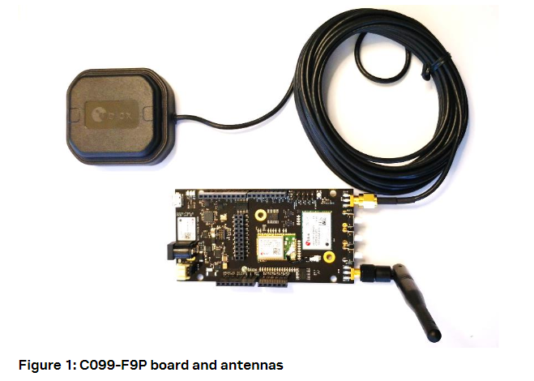

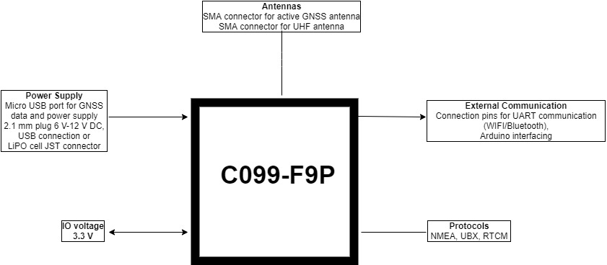

**Two Use Cases:**

The application board is designed to support evaluation of the most common use cases.

* The feature set supports using two C099-F9P application boards operating as Rover and Base, where the two boards communicate over a direct Wi-Fi connection.
* Another supported use case is pairing a mobile phone running an NTRIP client to the C099-F9P application board using Bluetooth.

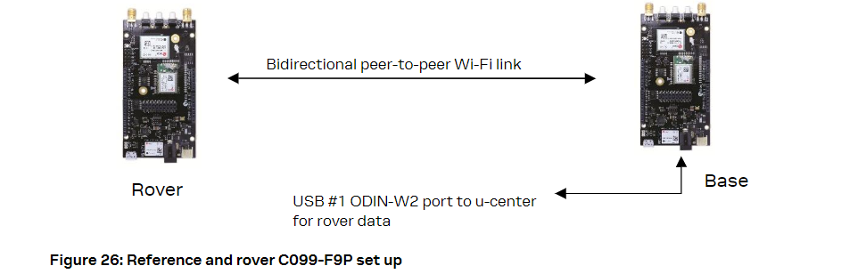

Mobile Hosting: A portable rover option is offered by an Android application which utilizes Bluetooth connection to a single C099-F9P.An example application is provided by Lefebure and it is available from Google Play Store: <https://play.google.com/store/apps/details?id=com.lefebure.ntripclient>.

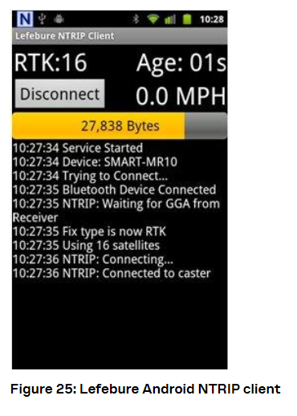

**Powering the board:**

The board can be powered from a variety of sources:

* The USB connection
* A 3.7V Li-Po Battery via a JST connector
* An external 6-12 V DC source via a 2.1mm connector; center pin V+.
* Also, the included USB-to-DC plug adapter cable can be used to provide an additional USB power source.

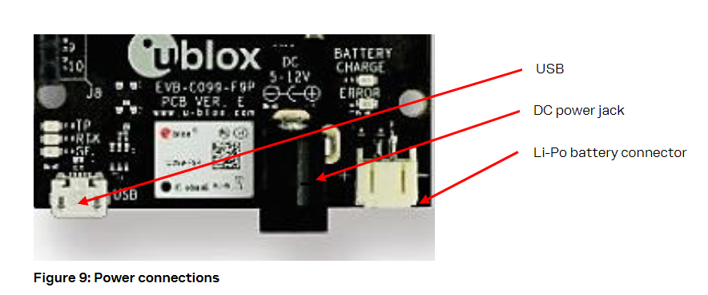

**User interfaces:**

The C099-F9P has a number of fixed connection options besides the wireless modes. There is also an additional Arduino R3 / Uno Interface for external host connection.

The USB connector on the board provides connection via an on-board hub providing:

* An FTDI USB bridge to ZED-F9P UART1 and ODIN-W2 UART COM ports.
* Dedicated connection to the ZED-F9P USB port.