**ZED-F9P:**

u-blox ZED-F9P takes GNSS precision to the next level:

• Delivers accuracy down to the centimeter-level: 0.01m + 1 ppm CEP

• Fast time to first fix and robust performance with multi-band, multi-constellation reception

• Compatible with leading correction services for global coverage and versatility

**Features:**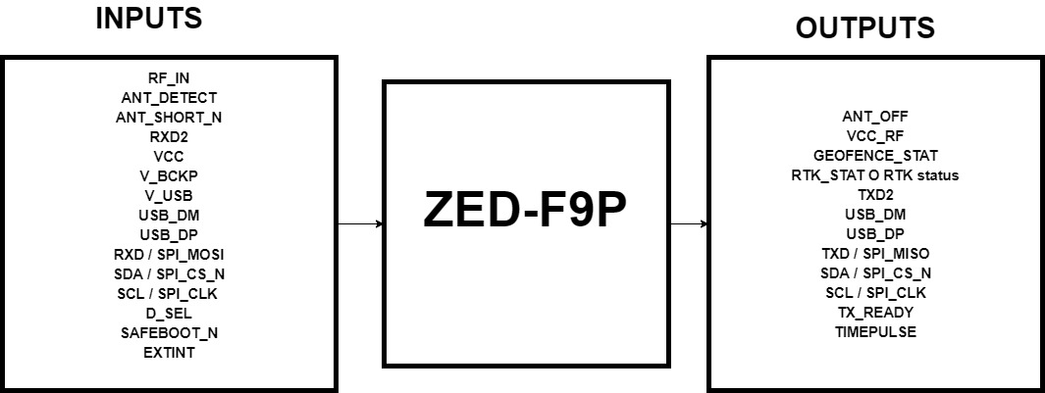

Receiver type: 184-channel u-blox F9 engine

GPS L1C/A L2C, GLO L1OF L2OF,

GAL E1B/C E5b, BDS B1I B2I,

QZSS L1C/A L2C

Nav. update rate: RTK up to 20 Hz1

Position accuracy: RTK 0.01 m + 1 ppm CEP

Convergence time: RTK < 10 sec

Sensitivity Tracking & Nav. -167 dBm

Anti-jamming

Anti-spoofing

Memory: Flash

Moving base: For attitude sensing and heading applications

**INTERFACES:**

Serial interfaces:

2 UART

1 SPI

1 USB

1 DDC (I2C compliant)

Digital I/O Configurable timepulse:

EXTINT input for wakeup

RTK fix status

GEOFENCE status

Timepulse:Configurable: 0.25 Hz to 10 MHz

Protocols: NMEA, UBX binary, RTCM version 3.3

**Package:**

54-pin LGA (Land Grid Array)

17 x 22 x 2.4 mm

**Environmental data, quality & reliability:**

Operating temp. −40 °C to +85 °C

Storage temp. −40 °C to +85 °C

**Electrical data:**

Supply voltage: 2.7 V to 3.6 V

Power consumption: 68 mA @ 3.0 V (continuous)

Backup supply: 1.65 V to 3.6 V

**Input:**

RF_IN: RF input

ANT_DETECT: Active antenna detect - default active high

ANT_SHORT_N: Active antenna short detect - default active low

RXD2: Correction UART input

VCC: Voltage supply

VCC: Voltage supply

V_BCKP: Backup supply voltage

V_USB: USB supply

USB_DM: USB data

USB_DP: USB data

RXD / SPI_MOSI: Host UART input if D_SEL = 1(or open). SPI_MOSI if D_SEL = 0

SDA / SPI_CS_N: I2C Data if D_SEL = 1 (or open). SPI Chip Select if D_SEL = 0

SCL / SPI_CLK : I2C Clock if D_SEL = 1(or open). SPI Clock if D_SEL = 0

D_SEL: Interface selector

SAFEBOOT_N: SAFEBOOT_N (for future service, updates and reconfiguration, leave OPEN)

EXTINT: External Interrupt

**Output:**

ANT_OFF: External LNA disable - default active high

VCC_RF: Voltage for external LNA

GEOFENCE_STAT: Geofence status, user defined

RTK_STAT O RTK status: 0 (RTK fixed), Blinking (receiving and using RTCM corrections), 1

(otherwise)

TXD2: Correction UART output

USB_DM: USB data

USB_DP: USB data

TXD / SPI_MISO: Host UART output if D_SEL = 1(or open). SPI_MISO if D_SEL = 0

SDA / SPI_CS_N: I2C Data if D_SEL = 1 (or open). SPI Chip Select if D_SEL = 0

SCL / SPI_CLK : I2C Clock if D_SEL = 1(or open). SPI Clock if D_SEL = 0

TX_READY: TX_Buffer full and ready for TX of data

TIMEPULSE: Time pulse

**Supported protocols:**

The ZED-F9P supports the following protocols:

|  |  |
| --- | --- |
| Protocol | Type |
| UBX | Input/output, binary, u-blox proprietary |
| NMEA | 4.10 Input/output, ASCII |
| RTCM 3.3 | Input/output, binary |

**Electrical specification:**

The limiting values given are in accordance with the Absolute Maximum Rating System

(IEC 134). Stress above one or more of the limiting values may cause permanent damage

to the device.

**Absolute Maximum Ratings:**

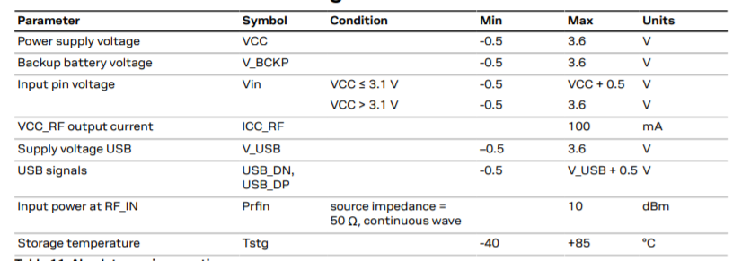

**Operating Conditions:**

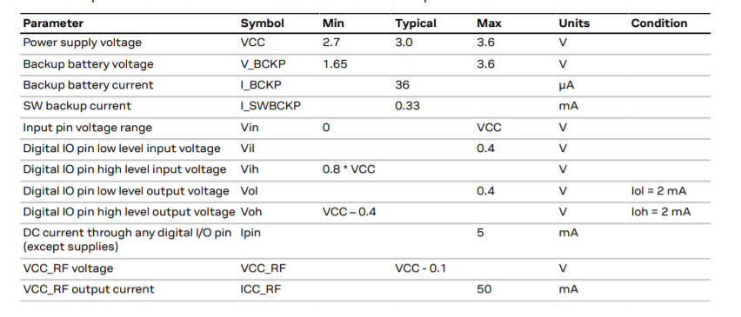

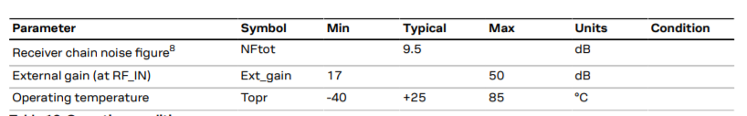

**Indicative Power Requirements:**

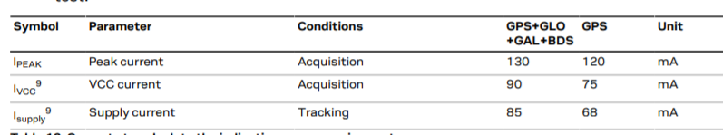

**Communications interfaces:**

There are several communications interfaces including **UART, SPI, I2C 10 and USB.** All the inputs have **internal pull-up resistors** in normal operation and can be left open if not used. All the PIOs are supplied by VCC, therefore all the voltage levels of the PIO pins are related to VCC supply voltage.

**Default interface setting:**

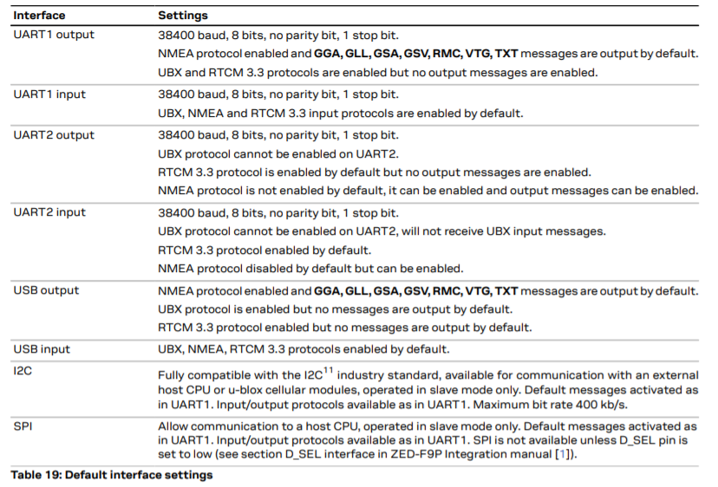

**ZED-F9P with Drone:**

